**SHOPPING CART USING JAVASCRIPT  
(LOCALTORAGE FOR PERSISTING DATA)**

**NB:** Attached is employment.sql file which must be loaded into msql database I order to test the app.

This application was built using JavaScript, jquery framework and Twitter Bootstrap css framework with mysql database as the backend data source. The following are the step I took in completing the task.

1. Fetch data from database using PHP and display on the page with each product having a button to enable users to add items to cart. Below is the picture of the display  
   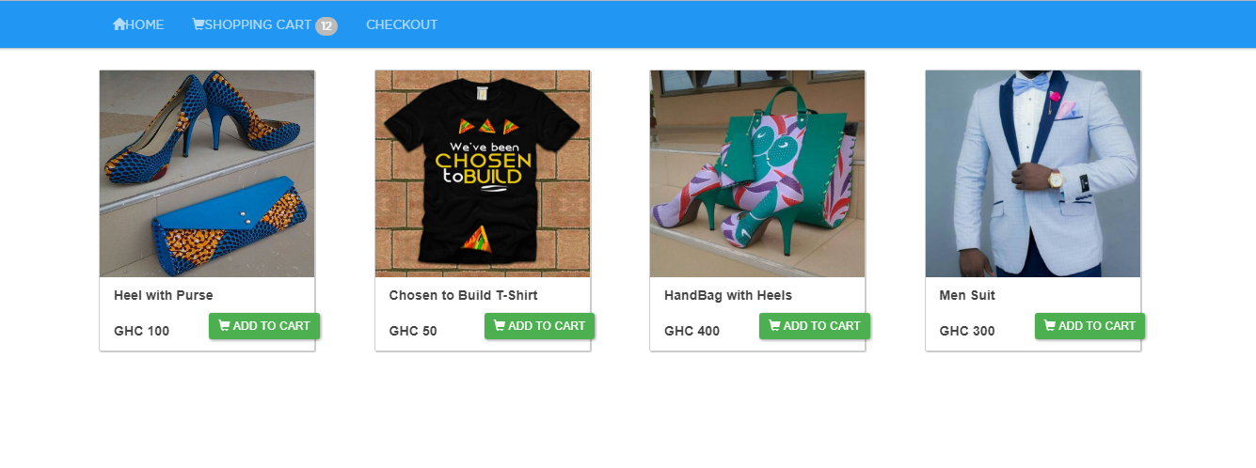
2. The main task of adding items to cart using the localstoarage for data persistence is done in the file shoppingcart.js.
3. I created a class called Product with the following properties (id, name,image,price,qty totalPrice).  
   Since an item can be added more than once, the qty and totalPrice properties help keep track of the total number of items and totalPrice of a particular item in cart.
4. Associated with this properties are **Getters** and **Setters** for each fields or properties
5. I also created a class called Cart with the following members.  
    i. AddtoCart() – Add items to cart   
    ii. getCartItems() –get All items from cart and display them.   
    iii. removeItem(id) – Reduce the number of particular item in cart by 1 using the passed product id  
    iv. removeAll(id) – Remove all items of a part item in cart using passed product id.  
     
   **ADDING ITEMS TO CART**  
   1. Before adding items to cart, I first check is the browser user is using support localstorage. This is done a function **checkBroswerStorage()**

2. If test from 1. Returns true , I went ahead to check is there is alredy an item(s) in cart. If this return null I will go ahead and add the new item to cart(localstorage). If there is, I check if the new product am about to add already has an instance in cart.  
3. If the item instance is already in cart, I just increase the qty property which denote quantity.  
4. If the item does not exist in cart, I add the item to an array and persist it to database(localstorage).  
NB: These steps are accomplished using **arrays** in javascript. The data is stored as array of object of type Product( from Product class created above)

**REDUCING A PARTICULAR ITEM QUANTITY.**

1. To reduce a particular item quantity in cart by one, I first pull the items from cart and loop through. When looping , I check if the id passed to removeItem(id) exist in cart data. When the item is found, I go ahead and reduce the quantity by 1.

**REMOVING ALL ITEMS OF PARTICULAR TYPE.**

1. To remove all item of particular type, I first pull the items from cart and loop through. When looping , I check if the id passed to removeAll(id) exist in cart data. When the item(s) is found, I go ahead and remove all items of that particular type.

**GET ALL ITEMS FROM CART**

1. I created a function called getCartItems() that pull all data from localstorage. With the help of for loop, I loop through data and append them one at a time to a table in the file shoppingcart.php.