**PHP SHOPPING CART USING SESSION FOR DATA PERSISTENCE  
NB:** Attached is an sql file use in testing the code.

This application was built using PHP, a little javascript (jquery framework) and Twitter Bootstrap css framework with mysql database as the backend data source.

PHP Files and what they do.

Index.php – The main file load when application run.  
Connect.php – The file with the class that connect to mysql database. Contains a method to retun all data from the database.  
Cart.php – This is where all the processing is done. Contains the following methods.   
 i. addToCart(id) –This receives the id of the product to add to cart. And insert the item into the cart as well.  
 ii. pullProduct(id)—This method pull product and return the item to be added to cart to be used by the addToCart() method.  
 iii. countCart() – Returns the total number of item in cart.  
 iv.removeOne()—Reduce the quantity of a particular item in cart by one(1)  
 v. removeAllItems($id) – Removes all item of a particular type from cart.  
 vi. deleteFullCart() -- Delete all items in cart by unsetting the session.  
  
Properties contained in Cart class:   
 items: An array of items in cart.  
 totalPrice: Total price of cart.  
 totalQty: Total Quantity of item in cart.  
  
   
  
The following are the step I took in completing the task.

1. Fetch data from database using PHP and display on the page with each product having a button to enable users to add items to cart. Below is the picture of the display  
   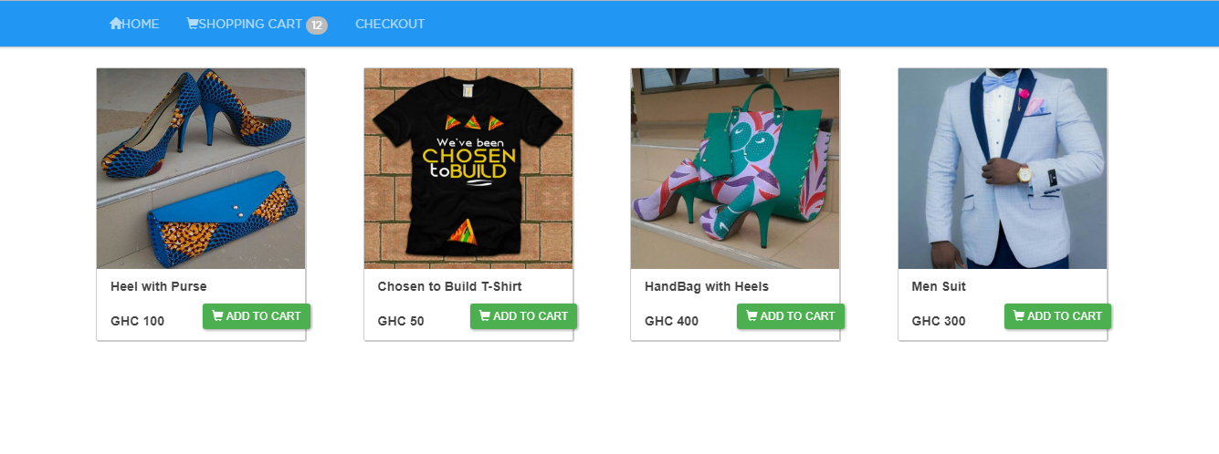
2. To add item to cart. I I first check if there is data already in PHP session cart. If there is, I passed that to constructor function to set the fields(items, totalQTy, totaPrice)  
   I then pass the id to the addToCart() which then get the old cart if any. If there is already an item in cart, I check to see if the passed id exist among those item using PHP array_key_exist().
3. If the item already exist in cart, I just increase the quantity and the price using the technique of associative array.(NB: This can be referenced from the code). I then set set the session variable with the object created.

**REDUCING THE CART ITEM.**

This is done the the removeOne($id). This receives the $id of the item, then loop through the items in cart. If the id is found, the item qty variable is reduced by 1 and the new cart values are set gain, overriding the old cart with new values.

**REMOVING ALL ITEM OF A PARTICULAR TYPE.**  
This is accomplished in the removeAllItems(id). This receives the id of items to be removed from cart. With For loop, search to see if the item exist in cart. If it does exist, the whole item of that particular item is removed. Thus item is not put into the session again, hence overriding the old cart values with the new ones.

**DELETING ALL ITEMS FROM CART**This is done in the deleteFullCart(). This simply unset the SESSION variable cart using the PHP unset();