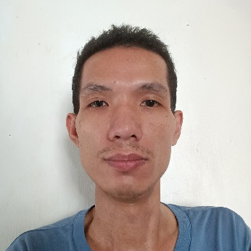

**SHERWIN M. SANGALANG**

San Joaquin, Santo Tomas, Batangas | 09267080720 | [sherwin.m.sangalang@gmail.com](mailto:sherwin.m.sangalang@gmail.com)

**EDUCATIONAL BACKGROUND**

**PRIMARY**

San Joaquin Elementary School

San Joaquin, Santo Tomas, Batangas

SY 2000

**TERTIARY**

**Associate in Information Technology**

Dalubhasaan ng Lungsod ng San Pablo (DLSP)

San Jose, San Pablo City, Laguna

SY 2010

**SECONDARY**

Alaminos National High School

Alaminos Laguna

SY 2004

**PERSONAL INFORMATION**

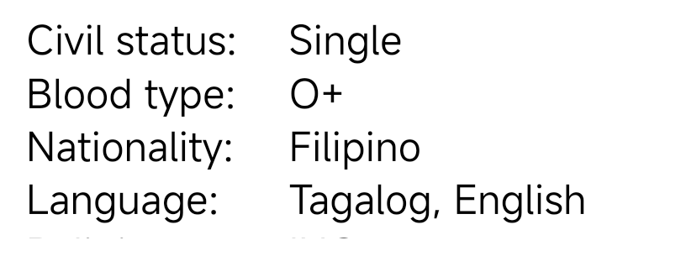

Birthday: January 13, 1987

Age: 38

Birth place: San Joaquin, Santo Tomas, Batangas

Gender: Male

Height: 5’4

Weight: 45 kg.

**WORK EXPERIENCE**

**YAZAKI-TORRES MFG. INC.**

Makiling, Calamba, Laguna

From 2005 to 2006

Operator / Parts Controller

**QUEENSHINE INTERNET SHOP**

San Joaquin, Santo Tomas, Batangas

From 2016 to Present

Operator

**SPI GLOBAL** (BPO)

Carmelray Industrial Park II

From Nov. 2010 to April 2011

Data Technician/Data entry

**SKILLS**

* Computer literate
* Data Entry
* Computer troubleshooting
* MS Office
* Adobe Photoshop
* Printing and Printer maintenance
* Basic HTML, CSS, and JavaScript
* Hard working and willing to learn

**CHARACTER REFERENCE**

**Mr. Nilo Sarmiento**

Brgy. Captain

San Joaquin Sto. Tomas, Batangas

0919 0727984

**SHERWIN M. SANGALANG**

Applicant’s Signature