Matt Winslow  
02/17/15  
DL EECE6013  
Homework 4a

**Simple Processor**

This project was to implement a simple processor that can add, or, and 2-bit inputs. KEY0 is used store the values in the switches in a register. KEY1 is used to execute the instruction.

The instructions are:  
Output A, output not A, output A+B, output A and B.

Inputs used: CLOCK_50, SW, KEY  
Outputs used: LED

Compilation Report:

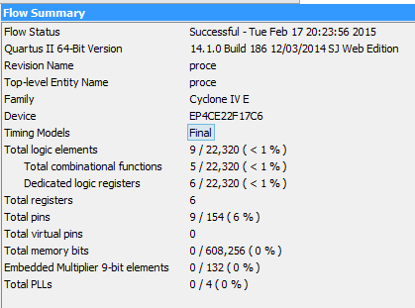

PowerPlay Power Analyzer:

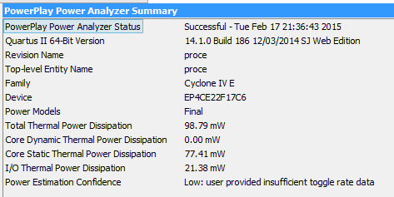

RTL Viewer:

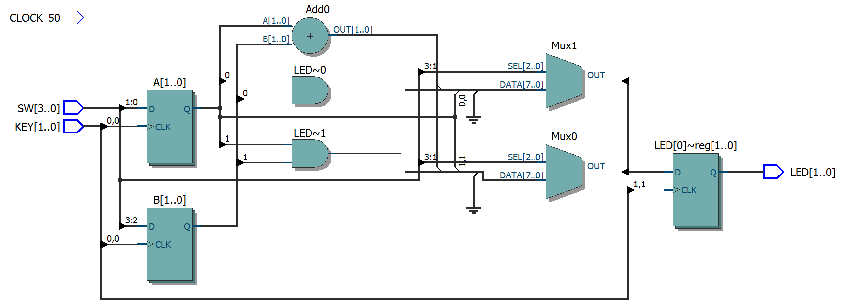

The output is in 2s-compliment (00 = 0, 01 = 1, 10 = -2, 11 = -1) and displays on 2 LEDs.

Here is a quick example of how this program works:

Flip switches 1 and 4.

Press KEY0 to store values, flip switches back.

Flip switch 3 (output A+B).

Press KEY1 to execute.

LED0 and LED1 light up.

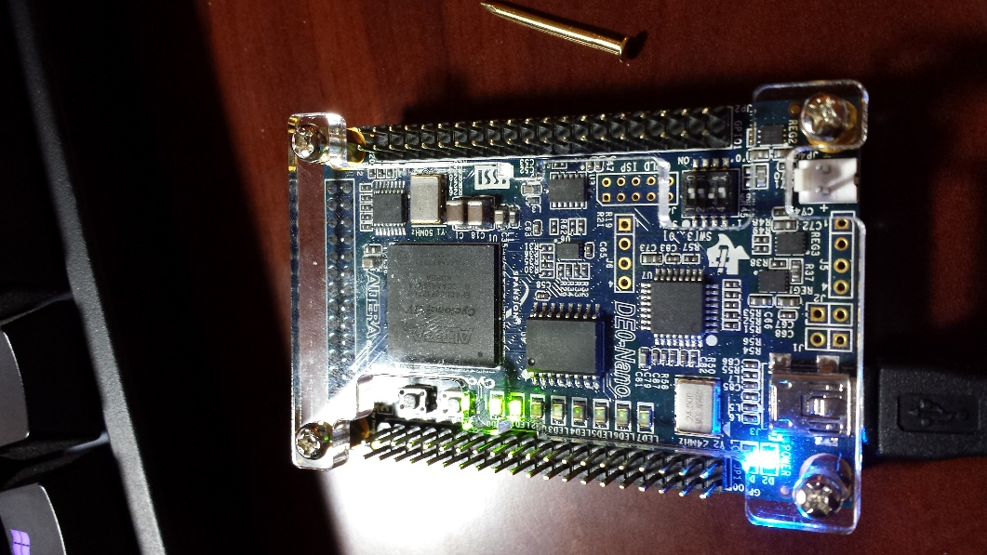

**Appendix A** (proce.v)

**module** proce**(**

**input** CLOCK_50**,**

**input** **[**3**:**0**]** SW**,**

**input** **[**1**:**0**]** KEY**,**

**output** **reg** **[**1**:**0**]** LED

**);**

**reg** **signed** **[**1**:**0**]** A **=** 0**;**

**reg** **signed** **[**1**:**0**]** B **=** 0**;**

// load A and B when KEY[0] is pressed

**always** **@(posedge** KEY**[**0**])** **begin**

A **<=** SW**[**1**:**0**];**

B **<=** SW**[**3**:**2**];**

**end**

// execute the instruction specified by the SW when KEY[1] is pressed

**always** **@(posedge** KEY**[**1**])** **begin**

**case** **(**SW**)**

1**:** LED **<=** A**;**

2**:** LED **<=** **~**A**;**

4**:** LED **<=** A **+** B**;**

8**:** LED **<=** A **&** B**;**

**default:** LED **<=** 2'bxx**;** // don't care if switch config is invalid

**endcase**

**end**

**endmodule**