Project B
Winson Karim (z5642004)
- Introduction
Vestra is a prototype systematic investment platform where market data, portfolio optimization, and financial news analytics are used to create a decision-support tool for investors. The platform builds twelve systematic funds in three different investment types which are US large-cap equities, major cryptocurrencies, and a combined of equity-crypto universe together. Moreover, it uses four portfolio construction strategies including Equal Weight, Minimum Variance, Risk Parity, and Maximum Sharpe. Each fund is assessed through a walk forward out of sample backtest and displayed on an interactive Streamlit application which shows performance statistics, growth of $1, drawdowns, and portfolio constituents.
Part B expands the data infrastructure created in Part A by moving from data collection to portfolio construction, sentiment analysis, and product development. Along with the twelve systematic funds, Vestra builds daily sentiment index for ten equity sectors with VADER model and finds out if the incorporation of sentiment improves portfolio results within an equity strategy. Also, in Part B, Vestra expands Part A’s Dynamic Asset Investability Score model where the assets are assessed based on Return Stability, Downside Resilience, and Liquidity Quality signals. However, instead of taking the assumption that each signal provides investment opportunity, sentiment and the scoring model are assessed empirically against portfolios without change.
The product is tailored towards a financially literate retail investor who seeks diversification but lacks the capability of developing their own optimization models. Vestra takes the quantified results and turns them into an investor’s journey which involves comparing funds, looking at each individual fund’s fact sheets, looking at guided or customized allocation schemes, sector sentiments, and using the investability analytics as another layer of risk-quality analysis. This report will focus on the process of fund design, out-of-sample performance, sentiments, and investability analysis tests as well as Streamlit implementation.
- Funds and Walk-Forward Backtest Design
Fund Architecture
Vestra defines each unique asset universe with portfolio method as an independent investable fund, resulting in 12 funds which are 4 equities with 50 US large cap equities split into 10 sectors, 4 crypto funds with ten largest cryptocurrencies, and 4 mixed funds that comprise all 60 assets. Such an approach enables the influence of both asset universe and portfolio construction methodology to be measured while significantly exceeding the minimum requirements for one mixed fund and two optimization methodologies.
There are four portfolio construction methods used. The Equal Weighting strategy creates a transparent baseline allocation by assigning the equal amount of the portfolio to every available asset, which eliminates the estimation risk factor. The Minimum Variance strategy aims at minimizing the estimates portfolio variance by allocating long-only weights. The Risk Parity methodology allocates portfolio weights in such way that the risk contribution from each holding will be evenly distributed (Maillard et al., 2010).
All the optimized portfolios are required to be long-only, with a maximum weight of each individual asset at 20%, and sum of portfolio weight equal to one, such restrictions prohibit any leverage and short positions, and decrease the probability of unstable historical estimates producing an extremely concentrated portfolio of just a small number of assets.
The first practical problem occurred while implementing the Minimum Variance methodology as sometimes when a portfolio with lower variance existed, the SLSQP algorithm have Equal Weight. The reason of the problem was the excessively small numerical value of daily covariances, resulting in the objective function approaching the stop criterion of the optimizer too closely. Therefore, the variance objective was scaled. Moreover, the solutions produced by the solver were checked explicitly for feasibility rather than accepting all solutions claimed as converged by the solver. It helped to avoid rejecting the correct solutions due to the false-negative convergence report. The Minimum Variance portfolio after the corrections was different from Equal Weight and had higher of low-volatility assets in synthetic tests.
Walk-forward backtest design
All portfolios are back tested using the roll forward out of sample procedure to avoid any look ahead bias. First, 252 observations are set aside as the estimation window and not used for the performance calculations, for each monthly rebalance, the weights of the portfolio are calculated based on historical data available up o that rebalance date and are kept unchanged until the next monthly rebalance.
The equity and combined portfolios use the equity trading calendar. The have their first live out-of-sample observation on 4 January 2021 and the evaluation ends on 29 December 2023, giving 753 live observations and 36 monthly rebalances. The crypto assets trade on a 7 day-per-week schedule, which shows that the 252-observation estimation window is filled much faster and the crypto portfolios start their live assessment on 10 September 2020. Equity and combined portfolios are annualized by assuming 252 trading days per year, while the crypto portfolios are annualized using 365 observations.
Calendar alignment becomes crucial for the combined universe. Crypto returns are initially calculated according to their original seven-day calendar and only then synchronized with equity trading days. This avoids misaligned crypto return calculations during weekend periods when the price can change, and equity prices are still available. Zero values are not imputed to missing return observations. The provided cryptocurrency returns also included returns observed on 1 January 2024, but those data were dropped because all Project B calculations end on 31 December 2023.
The Sharpe ratio is calculated with a zero risk-free rate. Similarly, no transaction costs are considered in the twelve-core fund backtests. This simplifies comparisons between different portfolio methods required by the research, but the problem of transaction costs will be considered in later sentiment and Dynamic Asset Investability Score (DAIS) experiments.
- Out-of-Sample Performance and Fund Comparison
Overall Performance
Table 1: Out-of-Sample Performance of Vestra’s 12 Systematic Funds
Table 1 shows the out-of-sample performance of Vestra’s twelve funds within the equity, crypto, and combined universes. It can be observed that portfolio performance is influenced most by the asset universe, as well as the portfolio construction technique. It is worth noting that while one strategy showed the best annualized return, it was not the best in term of risk-adjusted performance. In other words, crypto strategies achieved much higher return than the equity and combined portfolios. However, their high return was associated with extremely high volatility and maximum drawdown in the range of 80%. In contrast, the combined strategies were characterized by relatively low return and downside risk. This shows why Vestra considers annualized return, volatility, Sharpe ratio, and maximum drawdown when evaluating the funds.
Equity Funds
Within the equity universe, Equal Weight generated an annualized return of 12.64% with Sharpe ratio of 0.817, and maximum drawdown of -20.32%. These were better risk adjusted results in comparison with more complex Minimum Variance and Maximum Sharpe strategies. Minimum Variance strategy managed to generate the smallest equity drawdown of -15.39% and lower annualized volatility of 12.72%, indicating that the optimization process did decrease portfolio risk. But it is worth noting that such defensive approach may resulted in a lower annualized return of 5.57%, leading to rather poor Sharpe ratio of 0.489.
Such results clearly highlight the limitations of the approach using historical data for optimization purposes as historical estimates may provide imprecise guidance on subsequent out-of-sample values (Barroso & Saxena 2022). In this context, the more sophisticated portfolio construction strategy does not necessarily provide better out-of-sample performance. In case of Minimum Variance strategy, its goal was successfully achieved as the risk level was lowered. Similarly, Maximum Sharpe strategy also uses historical estimates of both expected return and covariance matrix. Thus, in such circumstances, the relatively good performance of Equal Weight strategy could be used as a benchmark.
Crypto Funds
Crypto investments were also found to have the highest returns in Vestra, but with significantly higher risk. The best risk-adjusted performance among the crypto strategies belongs to Crypto Minimum Variance with annualized return of 72.94% and Sharpe ratio of 1.093. However, its maximal drawdown is still -78.59%. Other crypto investments had equally poor maximal drawdown of about 80%, including -81.60% for Equal Weight and -82.17% for Maximum Sharpe.
Hence, the good historical performance of crypto funds cannot be considered separately from the risk. A drawdown of nearly 80% implies that the investor will likely experience very large losses before making profit despite apparently good long-run annualized performance. Thus, the performance of crypto investments reveals the difference between good statistical performance and the reality of investability. By considering Vestra’s target client, this means that these strategies should not be considered better funds.
Combined Funds
In term of returns, the combination of equity and crypto assets generated a more balanced set of results. Combined Maximum Sharpe generated the highest annualized return among all combined strategies at 17.80%, accompanied by 22.55% of volatility, Sharpe ratio of 0.839 and maximum drawdown of -23.26%. Meanwhile, Combined Minimum Variance generated only 5.64% annualized return but achieved the lowest volatility and maximum drawdown among all combined strategies at 12.75% and -15.57% correspondingly. Thus, these strategies are aimed at meeting investors goals, where Maximum Sharpe was aiming at achieving higher growth, while Minimum Variance was focusing on capital protection.
Combined Risk Parity Strategy showed the best trade-off between these two extremes. This strategy produced 13.97% annualized return with 16.02% of volatility, Sharpe ratio of 0.896 and maximum drawdown of -19.84%. Although the highest absolute return was not achieved, its Sharpe ratio was higher than for Combined Maximum Sharpe strategy, while the volatility was much lower. This combination of characteristics is especially important for Vestra since it shows that the optimal portfolio cannot be found based on returns only.
Together, the combined findings suggest potential diversification benefits from combining equities with cryptocurrencies (Bakry et al. 2021). The combined portfolios managed to avoid the 80% losses seen in the crypto portfolios without compromising the portfolio’s ability to gain from the higher returns generated by crypto assets. Nonetheless, this advantage was highly dependent on the method used to build the portfolios. Diversification was not just about including a new asset class but controlling the risk exposure of each class.
Growth, Drawdown and Portfolio Allocation
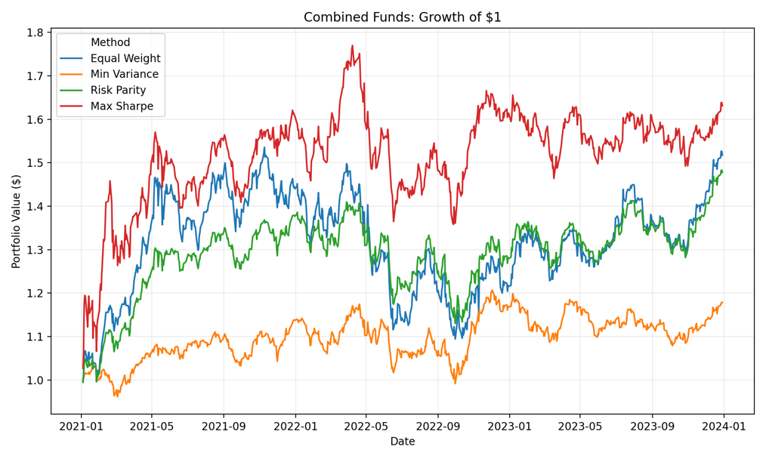
Figure 1: Growth of $1
Figure 1 shows the growth curve of one dollar invested in each of the four combined portfolios constructed by Vestra over the live out-of-sample period. The figure provides a visual representation of the route taken by the investment strategies in achieving the results reported in Table 1. Clearly the portfolio grows apart in time, implying that there is much room for variance in investor experience when using various portfolio building techniques on the same universe of assets. The increased terminal value of the portfolio does not come without increased fluctuation periods.
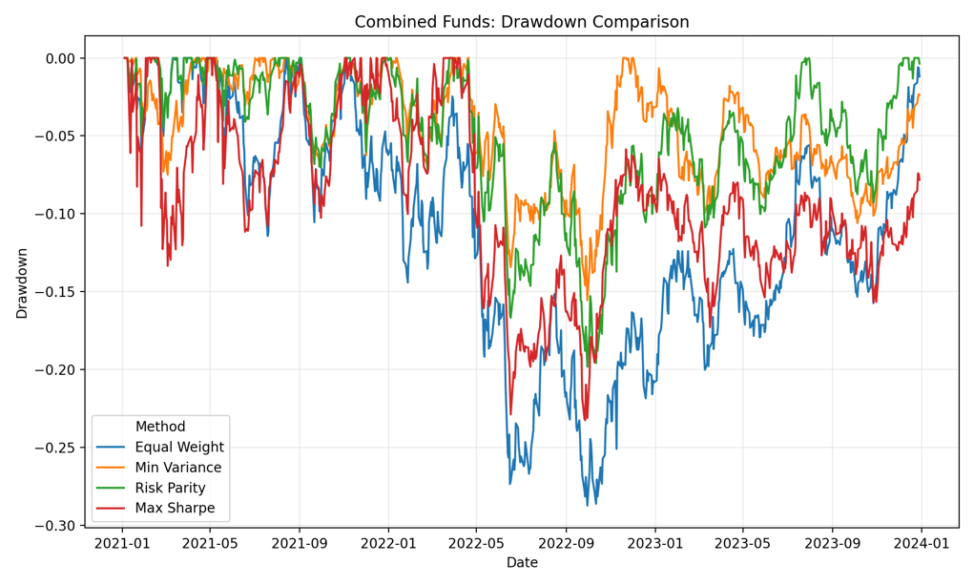
Figure 2: Drawdown Comparison Across Vestra Combined Funds
Figure 2 gives a better visual representation of the downside experience for each strategy by determining the loss of each strategy relative to its previous portfolio peak. This figure supports the results seen in Table 1. The strategy that gives the best downside protection is the Minimum Variance strategy due to its least sever drawdown of -15.57% whereas the Maximum Sharpe has the most severe drawdown at -23.26%. The Risk Parity is in between these two at -19.84%. This shows the risk-return trade-off in portfolio strategies.
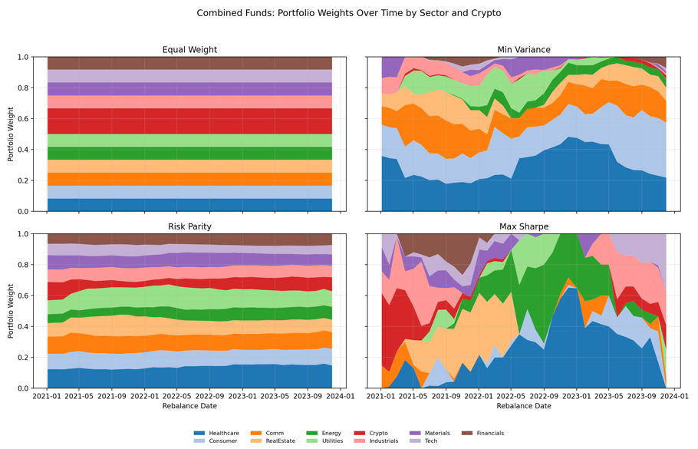
Figure 3: Combined Fund Portfolio Weights Over Time by Sector and Cryptocurrency
Figure 3 illustrates how the four combinations distribute capital across the ten equity sectors and cryptocurrency through time. While all four combined portfolios can invest in the same 60 securities, their allocations will be different since they all react differently to the historical information about risk and returns. Equal Weight is the least flexible strategy in terms of allocating capital, while the other three are flexible and can change allocations depending on the rolling window. Therefore, it clearly shows that the differences in performance seen in Table 1 are not only due to the investment universe but also to the way each strategy processes the historical information.
The dynamic allocations have some practical implications for Vestra. A portfolio strategy must not be introduced to investors by just using the name such as “Minimum Variance” or “Risk Parity”. The allocation will influence the actual investor experience. Thus, this explains why Vestra relies on these portfolios results for making fund comparisons and providing guidance to investors instead of using only historical return for making the funds.
Fund Selection and Investor Interpretation
The combination of these out-of-sample results does not suggest a universal top portfolio. Rather, the 12 portfolios are defined by their varying risk to reward ratios. In this context, equal weight is a transparent benchmark strategy, minimum variance focuses on reducing risk and maximum Sharpe attempts to maximize risk-adjusted returns based on return and covariance estimates.
For the combined universe of Vestra, risk parity was the most effective strategy that generated a Sharpe ratio of 0.896 while keeping the maximum drawdown of the portfolio at -19.84%. As such, risk parity may serve as a useful benchmark strategy for the upcoming investability system. At the same time, it would be wrong to claim that risk parity will generate better results in the future periods. In fact, these results indicate the reason why Vestra provides several portfolio strategies along with the analysis of their risk profiles and does not offer the best portfolio. This is the quantitative basis of the investor journey in Vestra, while the following sections will focus on financial news sentiment and Dynamic Asset Investability Score (DAIS) to improve investment decisions.
- Sector Sentiment Analysis and Portfolio Fusion
To generalize Vestra to financial news headlines, a daily sentiment index at the sector level is generated from financial news headlines. In the original dataset, there are 149,683 headlines in total, which are related to 50 equity tickers. Prior to computing the sentiment scores, duplicate news articles that are the exact copies with the same ticker, date, and headline title are removed. Then, news published on days without trading activities are mapped to the next available date on which the equities trade. Thus, aligning the news dataset with the calendar of the equity investment universe.
The VADER (Valence Aware Dictionary and Sentiment Reasoner) sentiment analysis tool is used to measure the direction and intensity of language (Hutto & Gilbert 2014). Moreover, VADER is a lexicon and rule-based model. The compound score will be considered as Vestra’s sentiment measure, where the scale ranges between -1 which indicates strongly negative language, and +1 which indicates strongly positive language.
Scores calculated for individual tickers are then compiled into ten Vestra equity sectors, where the five tickers comprising each sector receive equal weights. In case there is no news on a given trading day, the ticker is assigned a neutral score of zero, as opposed to carrying an old observation. This ensures that outdated information does not keep influencing the index if there is no new headline. The final set of sector sentiments has no missing observations and spans the entire period between 2 January 2020 and 29 December 2023.
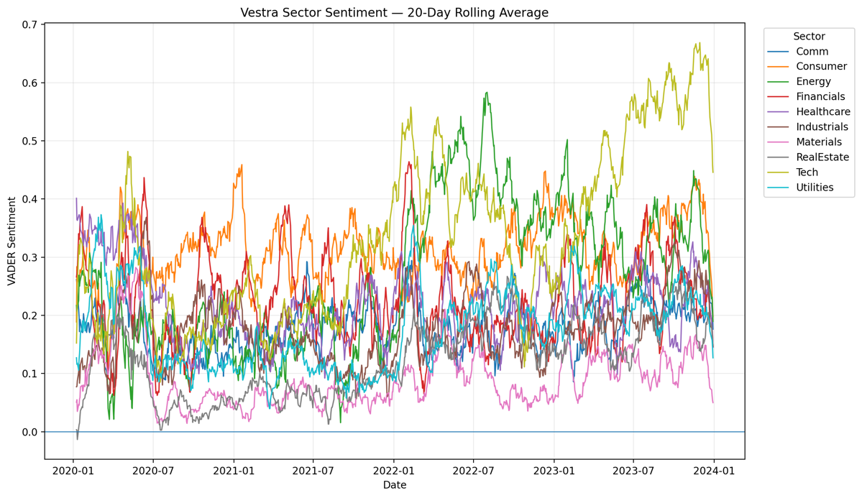
Figure 4: Vestra Sector Sentiment Index by Equity Sector
Figure 4 shows the 20-day moving average of the ten sector sentiment indices. The moving approach is chosen since daily headline sentiment is quite volatile, whereas smoothing will help detect larger changes in sector news tone. It can be seen from the figure that sentiment does not change in the same way across the stock market, with various sectors having period when there was relatively positive and negative news tone. Consequently, combining all headlines into one market sentiment measure will mean the loss of the information concerning news conditions by industry.
In Vestra, the sentiment index is mainly considered as the information tool for investors rather than the trading signal automatically. The Streamlit application enables investors to analyze individual sector trends and compare sector sentiment over time. Nevertheless, a descriptive signal becomes economically important for a portfolio strategy only if acting upon this information results in improved investment performance. That is why the assumption is tested directly within the structured and unstructured data fusion experiment.
Sentiment Fusion Experiment
The fusion strategy benchmarking uses the Equal Weight fund for the reasons outlined above since its weights do not change during any reconstitution. At each rebalance, the portfolio weight of the asset will be modified using the sentiment of its sector. The adjustment follows a multiplicative factor of:
Sentiment adjustment = 1 + (0.20 x Sector Sentiment)
Thus, when the sector sentiment is positive, it leads to an increase on the weight of the asset. After making the adjustment, the portfolio will then be normalized to ensure that weights add up to one, most importantly, the sector sentiment index is always lagged one trading day before influencing the portfolio’s weight. This shows that the portfolio weights calculated on T can only incorporate the sentiments from day T-1.
Table 2: Performance Comparison of Base and Sentiment-Augmented Equity Funds
From Table 2 above, the sentiment overlay did not help in improving the portfolio performance of the baseline portfolio. The returns for the Equity Equal Weight fund were an annualized return of 12.64%, annualized volatility of 16.17%, Sharpe ratio of 0.817, and maximum drawdown of -20.32%. With the introduction of sector sentiment, the annualized return slightly fell to 12.44% and volatility stayed roughly the same at 16.18%. The Sharpe ratio reduced to 0.806 and the maximum drawdown went down to -20.57%.
With the implementation of the sentiment strategy, there was some extra portfolio trading. This is because the average monthly turnover for the Equal Weight allocation using the Vestra weight-change measure is 0%, but with the sentiment overlay, the average monthly turnover was about 1.74%. The absence of transaction costs from the calculation of the return implied that there are more trading costs associated with this investment. Thus, the conclusion becomes even stronger in economic terms.
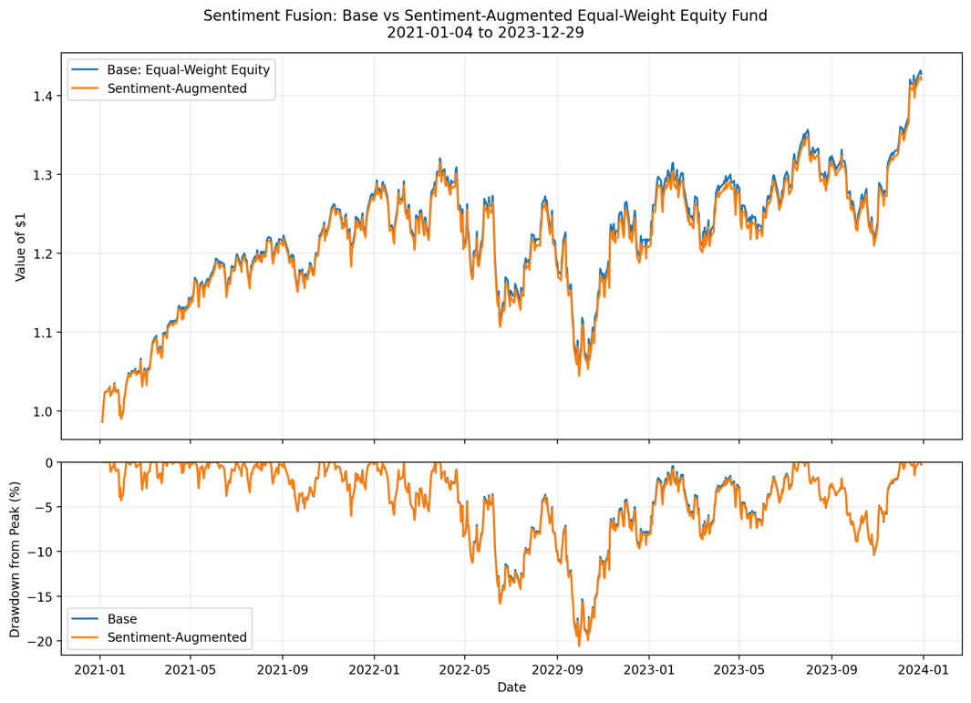
Figure 5: Sentiment Fusion
Figure 5 illustrates the effect of drawdown and growth curves of $1 from the two portfolios. These two portfolios are still like each other since the sentiment overlay changes and does not completely override the underlying Equal Weight portfolio. Moreover, the portfolio which uses sentiment overlay is unable to prove the superior cumulative wealth or downside curve which can justify its additional turnover cost. Thus, one may see the difference between the value of information and investment since the sentiment index in a certain sector may inform about the current news situation but not create superior returns while applying mechanical portfolio weighting.
Instead of choosing the right sentiment parameter and getting a positive result, Vestra keeps the negative result for its analysis. Such approach helps to avoid choosing the specification just because of its success within the out-of-sample period. Hence, this experiment provides the evidence against using the current VADER signal as an unconditional portfolio weight specification, not the evidence of the absence of valuable information in financial news. Other approaches may include financial-specific language model, highly unusual sentiment, persistence over few days or sentiment as the risk warning sign.
For the intended user of Vestra, this discovery will mean that sentiment is no longer a factor that will play a part in the product in a way that it does now. Sector sentiment will continue to be provided as a decision support feature, giving more information on top of the portfolio returns, but not as an indicator of any excess return potential. This separation of the two pieces of information which are an informational tool, and a proven investment strategy were critical to Vestra’s design.
- Dynamic Asset Investability Score and Innovation
Dynamic Asset Investability Score Methodology
The Dynamic Asset Investability Score (DAIS) represents Vestra’s primary development of the innovation introduced previously. In contrast to the prediction of the asset with the largest expected return in the future, DAIS attempts to add another metric for evaluation of the asset with desired investability properties. For each individual asset, the score consists of three dimensions which are Return Stability, Downside Resilience, and Liquidity Quality.
It is important to understand that an asset can produce high returns in the past but still be highly volatile, risky, or illiquid. First, Return Stability is calculated based on the 21-day rolling volatility get more stable ratings. Second, Downside Resilience is calculated based on the 21-day rolling downside semi-deviation, meaning it is focused only on negative returns of an asset. Liquidity Quality is calculated through the logarithm of median daily dollar trading volume.
Each component is normalized to a scale from 0 to 100 independently for equities and cryptocurrencies monthly. In other words, the stock is compared to other stocks, whereas the cryptocurrency is compared to other cryptocurrencies. This is done to exclude distortions caused by the substantially different levels of volatility and liquidity in the two types of assets. The resulting Project B dataset consists of 2,880 asset-months with 60 assets and 48 months (January 2020 to December 2023).
The three DAIS perspectives are kept showcasing the role of investor priorities in assessing the concept of investability. In the case of the Balanced perspective one-third of the weight is attributed to Return Stability Downside Resilience, and Liquid Quality. For the Risk-focused score, the shares are 50%, 30%, and 20% correspondingly, whereas for the Liquid-focused score they are 20%,20%, and 60%. Instead of saying that one is more valid than another, Vestra gives investors a chance to see the effect of prioritizing certain investability factors on their rankings.
Testing DAIS as a Portfolio Signal
While DAIS is indeed an effective framework for assessing asset quality, there is no automatic rule that high-scoring assets deserve higher allocations in the portfolio. Hence, Vestra decides to empirically examine the effectiveness of incorporating DAIS into an already working portfolio strategy. Combined Risk Parity is chosen as the benchmark since it gave the best risk-adjusted performance among the four combined funds of Vestra as the annual return was 13.97%, volatility 16.02%, Sharpe ratio 0.896, and maximum drawdown -19.84%.
In the first experiment, DAIS is used as a direct portfolio-weighting overlay. Every time the portfolio is rebalanced, the latest available DAIS score is used to adjust the existing Risk Parity weights. The neutral point is defined as a score of 50 when assets with higher sores receive a positive and those with lower scores receive a negative adjustment. Most importantly, only the information from the previous month is used to make the adjustment.
Table 3: DAIS Portfolio Overlay Performance
As can be seen from Table 3, the inclusion of DAIS overlay has failed to improve the risk-adjusted performance of the baseline portfolio. The annualized volatility has decreased from 16.02% to 15.70%, which implied that the score was moving the portfolio toward a little bit fewer volatile investment. Nevertheless, annualized return has dropped from 13.97% to 13.34% and Sharpe ratio has dropped from 0.896 to 0.876. Moreover, maximum drawdown has improved but only insignificantly from -19.84% to about -19.78%. Also, the average monthly turnover has grown from 2.25% to 3.17%, thus introducing more trades that would cost money to implement.
The result illustrates a key drawback of using an investability score as a signal about expected returns. DAIS was designed to capture stability, downside resilience and liquidity, not expected performance. Hence, the high DAIS score does not mean that increasing the portfolio weight on this security will increase its returns in the future.
DAIS Investability Guardrail
The second experiment tests DAIS from a defensive angle as opposed to using it to boost exposure to highly ranked assets. The objective of the DAIS guardrail is to screen out the assets that demonstrate poor investability attributes consistently and cut their performance weights without trying to choose winners for the future.
The three DAIS components for every asset class are ranked independently at each monthly rebalance based on data from preceding month. If an asset class component for an asset ranks within the bottom quartile of its respective asset class for at least two of its three components, the asset is marked. The marked asset gets its baseline portfolio weight reduced by a fixed 30%. The asset is not eliminated entirely, and the portfolio weight of marked assets is spread out among the other assets of the portfolio prior to normalization of weights.
Table 4: DAIS Investability Guardrail Comparison
The defensive guardrail showed a negative result. The annualized volatility dropped slightly from 16.02% to 15.76%. However, the annualized return fell from 13.97% to 13.27%. In addition, the Sharpe ratio went down from 0.896 to 0.869. Meanwhile, the maximum drawdown stayed roughly the same at -19.85%. The average monthly turnover rose sharply from 2.25% to 4.22%. On average, about 11.36 assets were marked out at every rebalancing.
Interpretation and Role Within Vestra
Both experiments give an essential conclusion for the development of Vestra. DAIS creates a clear methodology for assessing the stability, downside resilience, ad liquidity of assets. However, the out-of-sample analysis did not demonstrate the possibility of a mechanical transformation of asset features into portfolio weights. Both strategies somewhat reduced volatility. However, the decrease was enough to compensate for decreased return and increased turnover.
The negative conclusion is kept rather than changing the parameters of DAIS until getting a positive portfolio performance. In such way, the risk would be a fit of the investment strategy to a specific period and not evidence of its economic significance. In such way, the outcome will make the function of DAIS in Vestra different as the score will only be used as a decision-making tool.
Thus, the Streamlit application enables investor to compare the DAIS rankings of stocks and cryptocurrencies, along with looking at the return stability, downside resilience, and liquidity quality of the asset. But, from the DAIS and sentiment studies, good financial data does not mean better portfolio performance. Hence, Vestra relies on these indicators only as a decision-making tool unless there is empirical evidence on their investment value.
- Streamlit Application and Investor Journey
Vestra’s final stage involves converting the quantitative analysis into an interactive application Streamlit application aimed at retail investors who are financially knowledgeable. Rather than asking investors to understand the optimization results, Vestra uses an application that enables investors to journey by comparing the funds, evaluating each strategy, creating an allocation, analyzing sentiment of each sector and financially checking the asset investability.
In the Funds page, investors will be able to compare the twelve funds based on annualized returns, volatility, Sharpe ratios and maximum drawdown. Fund fact sheets contain additional data including growth of $1, maximum drawdown and portfolio positions. Vestra integrates fund analysis and portfolio construction using the Guided Allocation where profiles such as Defensive, Balanced, and Growth are used to create a baseline portfolio. Investors will then click “Use This Profile” and modify the suggested allocations via allocation builder to see how the portfolio performed historically.
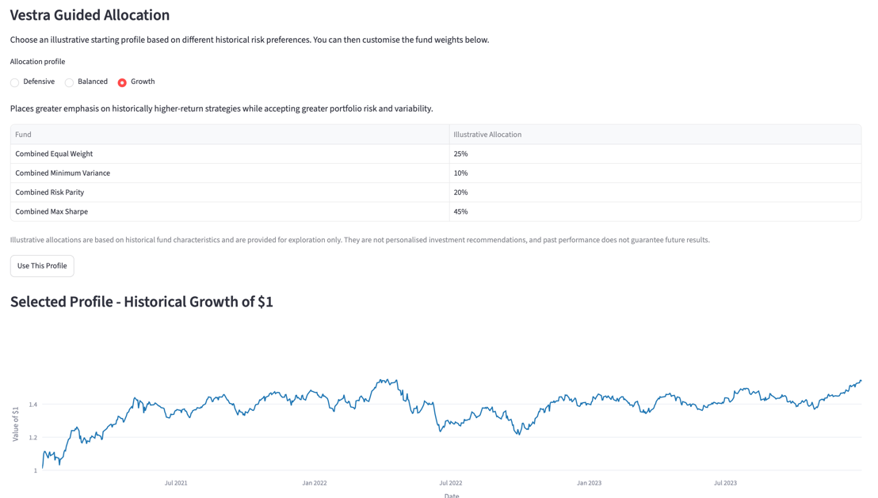
Figure 6: Guided Allocation
Sentiment and Investability are decision support elements rather than portfolio allocation triggers. While sector sentiment allows looking at the differences in the tone of financial news among sectors, DAIS let’s investors to compare stocks and cryptocurrencies individually using Return Stability, Downside Resilience, and Liquidity Quality.
Importantly, the application considers the empirical result of the previous sections. Given the absence of improvements to risk-adjusted portfolio returns using the sentiment overlay and DAIS tests, Vestra does not claim to have discovered excess return factors. Rather, they serve as indicators that complement the funds. This makes a clear distinction between information that may be used by investors and signals that have proved their investment value.
- Limitations and Future Development
There are several weaknesses to consider when interpreting its results. Firstly, the performance of all portfolios is measured by out-of-sample historical backtests and not actual investment performance. While the walk forward framework mitigates the issue of look ahead bias, the results still rely on the market environment experienced during the test period and do not ensure future performance.
Secondly, there is no deduction of trading costs from the portfolio performance results. It is especially important for the sentiment and DAIS experiments as both involved higher portfolio turnover. This could mean that the portfolio performance is overstated since they do not include the costs associated with implementing the system.
Thirdly, sentiment analysis employs VADER, which is a generic lexicon model rather than one that is tailored to financial language. Future iterations of Vestra should explore whether using Vader alongside financial domain language models can yield any between insights than what is currently being done.
DAIS continues to be a framework, and not a tested model for predicting returns. The DAIS portfolios experiments led to slight declines in volatility, but lower Sharpe ratios and higher turnover ratios. Further testing will thus be necessary before employing it in practice.
Lastly, Vestra is a prototype tool for making decisions as compared to a real-life investment tool. The output it generates now is based on historical data. For future work, market data, news, more types of assets, modeling of transaction costs, and additional testing can be considered without merging analytical information with personalized advice.
- Conclusion
Vestra illustrates an example of how portfolio optimization, financial news analytics, and asset investability measurements can be incorporated into an investment decision-support system. Twelve portfolios were formed in equity, cryptocurrency, and combined universes and tested using walk-forward-out-of-sample back testing. From the results, it was found that the high returns did not mean better investments, especially in cryptocurrency portfolios which had high returns with high volatility and drawdowns. In the combined universe, Risk Parity offered the best risk-adjusted performance over the testing period.
In additional, there was testing of the possibility of additional data to help with better portfolio construction. The VADER sentiment overlay, and two DAIS portfolio experiments did not show any improvement in risk-adjusted performance even when they provided useful data regarding the conditions of news and assets. Thus, Vestra utilizes sentiment and DAIS as analytical methods but not proven return generators.
In conclusion, the last Streamlit app converts the results into an investor story involving fund comparisons, asset allocation advice, sentiment analysis, and investability assessment. In general, the contribution of Vestra is not to find a better investment strategy, but to develop a transparent approach in which portfolio returns and additional financial data are tested before being used in decision-making.
Reference List
Bakry, W., Rashid, A., Al-Mohamad, S., & El-Kanj, N. (2021). Bitcoin and portfolio diversification: A portfolio optimization approach. Journal of Risk and Financial Management, 14(7), 282. https://doi.org/10.3390/jrfm14070282
Barroso, P., & Saxena, K. (2022, March). Lest We Forget: Learn from Out-of-Sample Forecast Errors When Optimizing Portfolios. https://primoa.library.unsw.edu.au/permalink/61UNSW_INST/cjtm7e/cdi_dipf_primary_3374615
Hutto, C. J., & Gilbert, E. (2014). VADER: A parsimonious rule-based model for sentiment analysis of social media text. Proceedings of the International AAAI Conference on Web and Social Media, 8(1), 216–225. https://doi.org/10.1609/icwsm.v8i1.14550
Maillard, S., Roncalli, T., & Teïletche, J. (2010). The Properties of Equally Weighted Risk Contribution Portfolios. Journal of Portfolio Management, 36(4), 60-70,10. https://wwwproxy1.library.unsw.edu.au/login?url=https://www.proquest.com/scholarly-journals/properties-equally-weighted-risk-contribution/docview/742655800/se-2

Appendix A
Complete Fund Performance Results
This appendix provides an additional comparison of Vestra’s twelve systematic funds by positioning each portfolio according to its annualized risk and return.
Figure A1: Risk-Return Comparison Across Vestra’s Twelve Systematic Funds
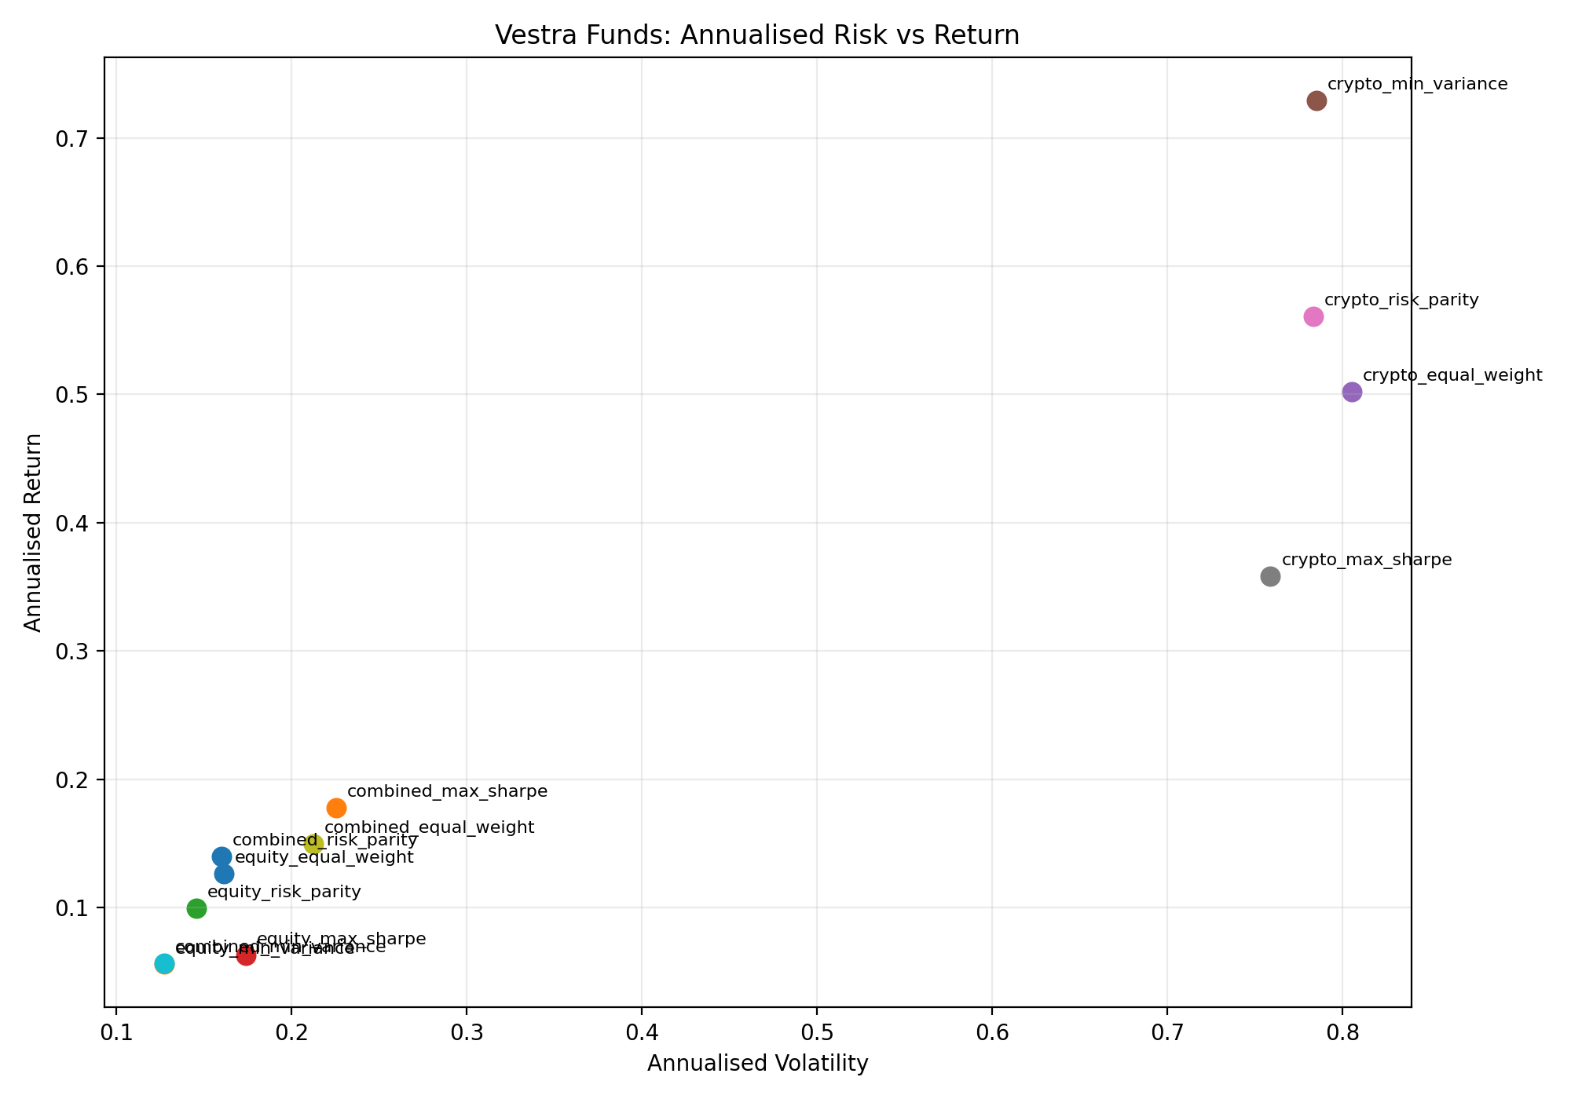
Note. The figure compares the annualized return and volatility of Vestra’s twelve systematic funds across the Equity, Crypto, and Combined asset universes.

Appendix B
Cryptocurrency Exposure Across Combined Portfolios
This Appendix adds to the evidence on the allocation of capital to cryptocurrency from the four Combined portfolios. It serves as an additional source of information to the more general analysis presented in Figure 3.
Figure B1: Cryptocurrency Weight Over Time Across Vestra’s Combined Funds
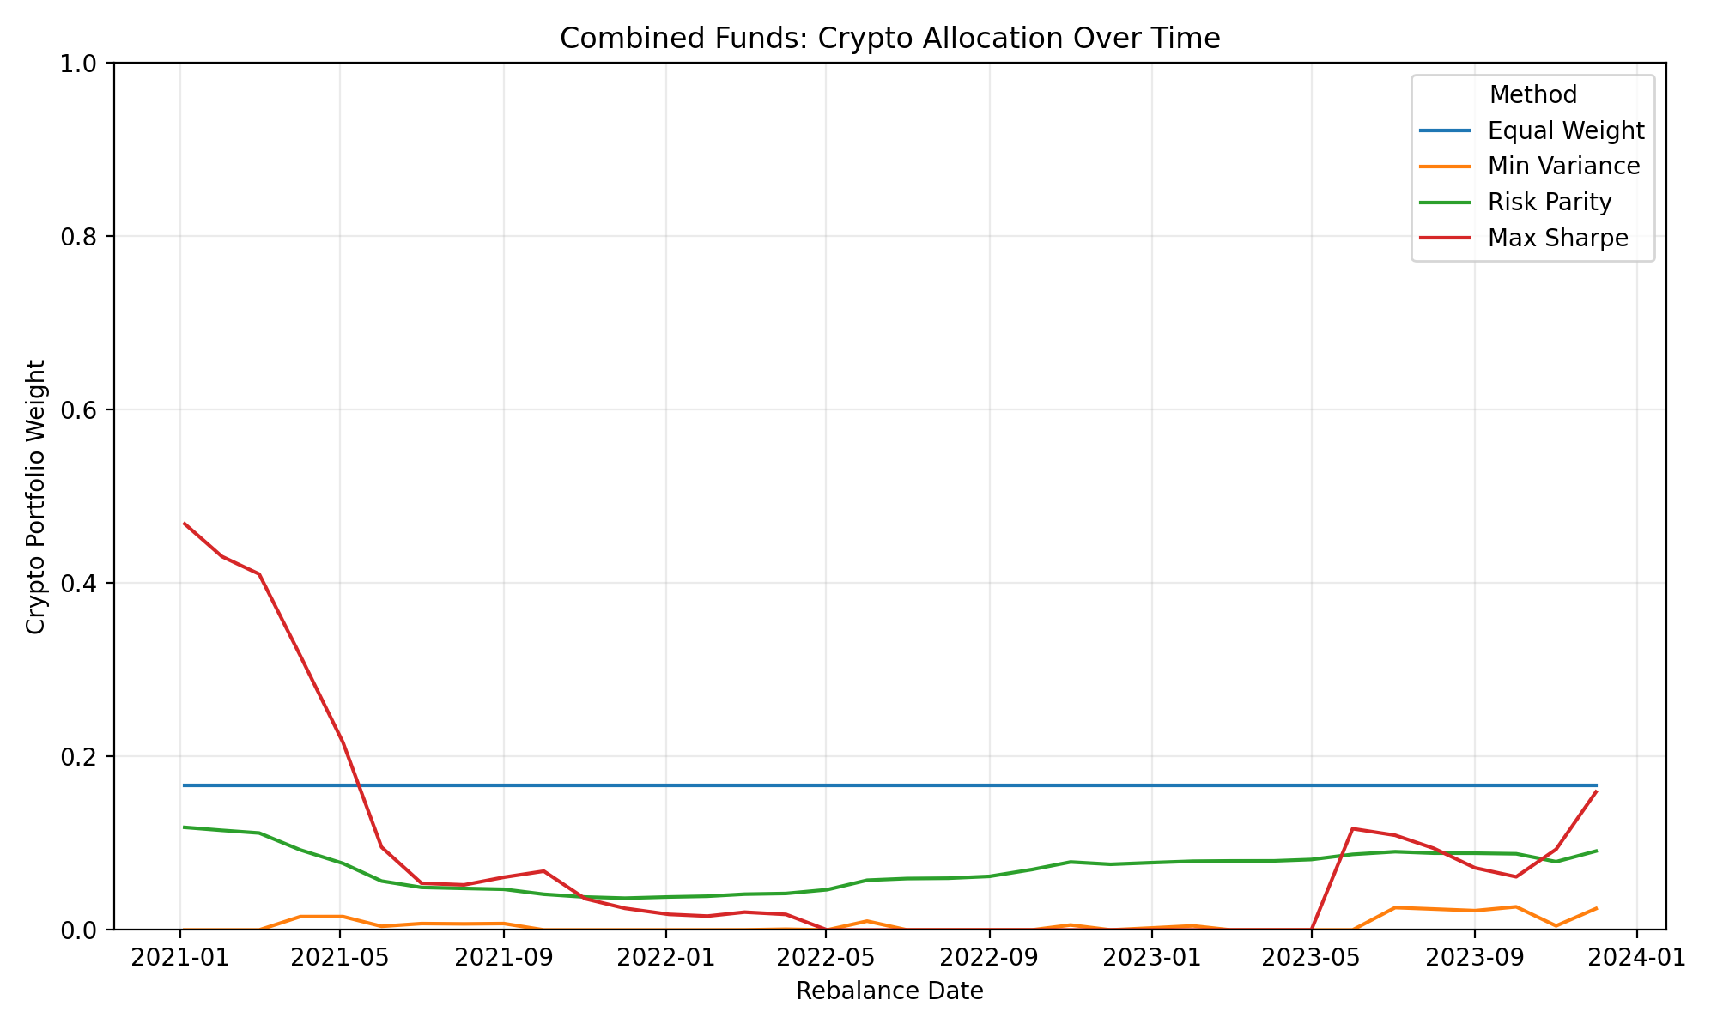
Note. The figure shows changes in total cryptocurrency exposure across the four Combined portfolio construction strategies during the out-of-sample period.

Appendix C

DAIS Ranking and Weight Sensitivity Analysis

This appendix serves to further validate the DAIS score by analyzing the impact on asset ranking when there is a re-weighting of Return Stability, Downside Resilience, and Liquidity Quality.

Table C1: DAIS Weight Sensitivity Analysis
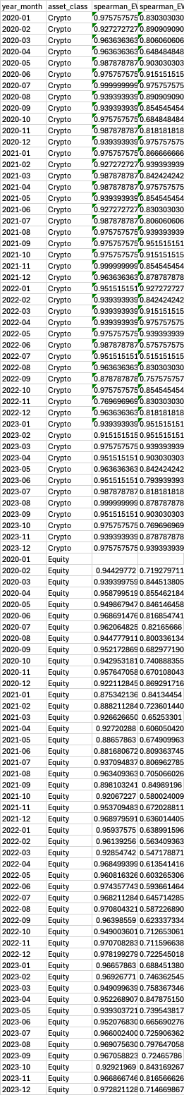
Table C2: Changes in Asset Rankings Across DAIS Specifications
Note. Tables C1 and C2 provide sensitivity evidence on how different component weightings affect DAIS scores and asset rankings.

Appendix D
DAIS Investor-Facing Analytics
This appendix demonstrated how the DAIS methodology developed and tested in Section V is translated into an investor-facing analytical tool within Vestra.
Figure D1: Vestra DAIS Asset Ranking Interface
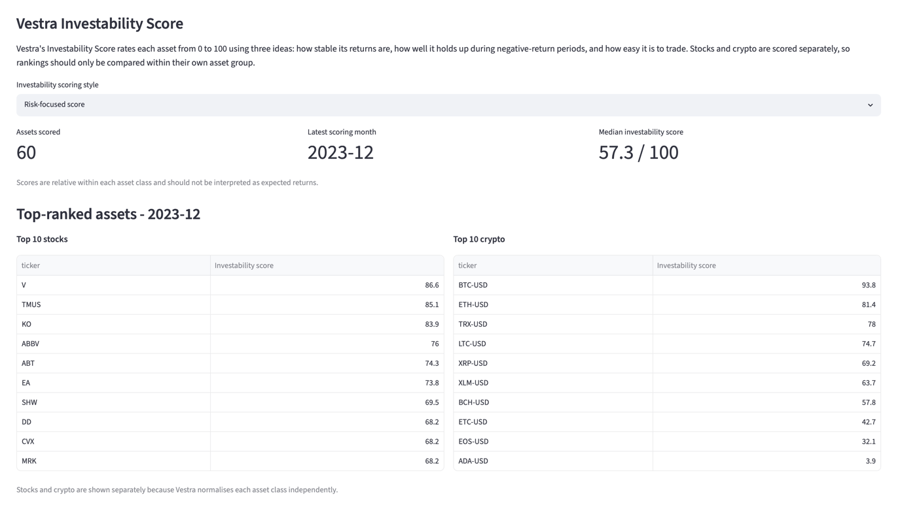
Note. The interface enables investors to compare the investability characteristics of stocks and cryptocurrencies under alternative DAIS perspectives.
Figure D2: Vestra Individual Asset Investability Analysis
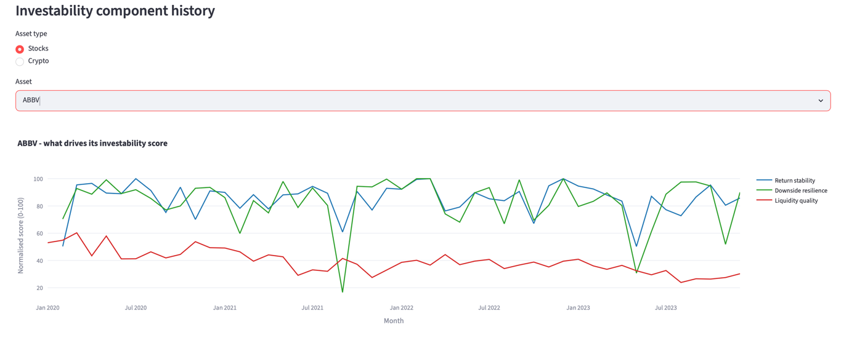
Note. The individual asset view allows investors to examine the components underlying an asset’s DAIS assessment rather than relying solely on its overall ranking.

Appendix E
Additional Vestra Investor Journey Functionality
This appendix demonstrates the functionality that comes after Guided Allocation.
Figure E1: Vestra Custom Allocation Builder
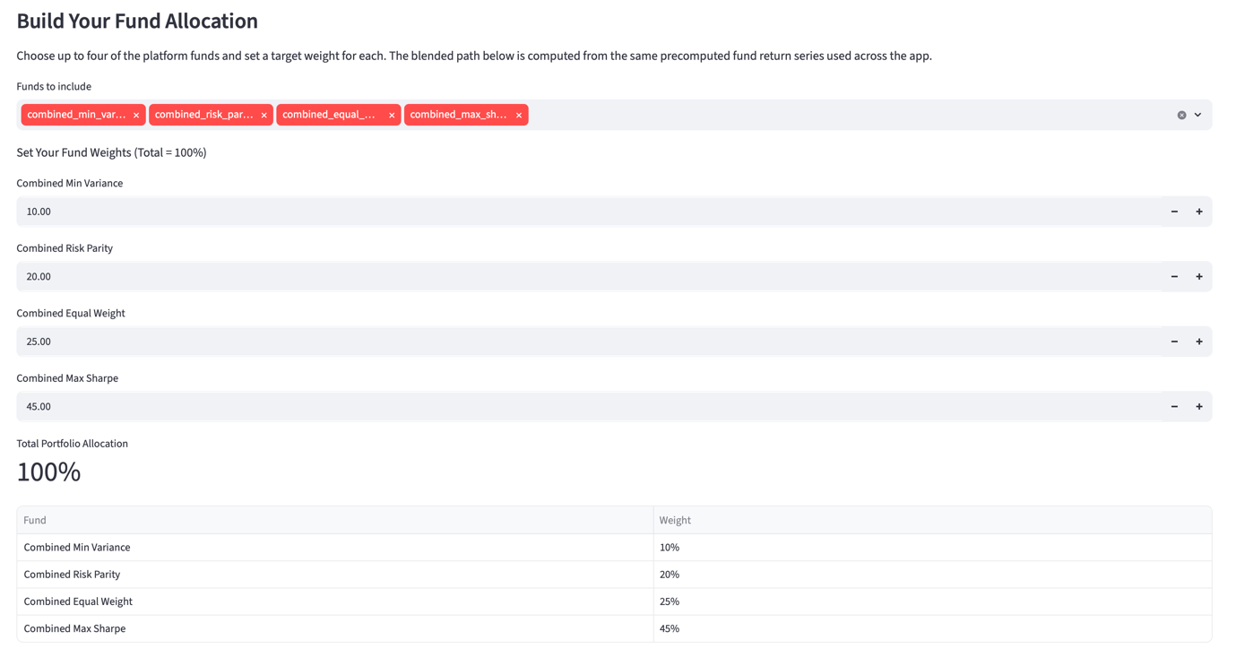
Note. The allocation builder allows investors to modify fund allocations after reviewing Vestra’s Guided Allocation profiles and examine the historical performance of the resulting portfolio.
Figure E2: Vestra Individual Fund Fact Sheet
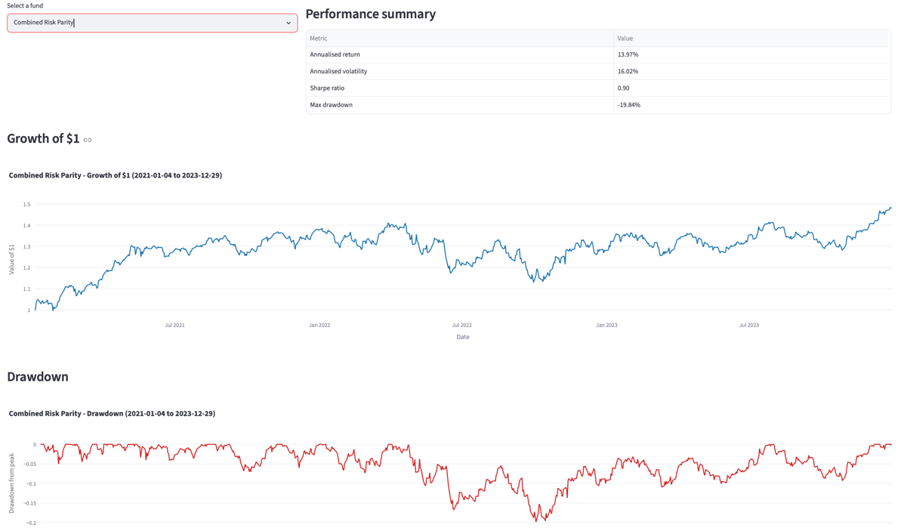
Note. The individual fund fact sheet provides investors with detailed performance, downside-risk, and portfolio-allocation information for a selected Vestra fund.

