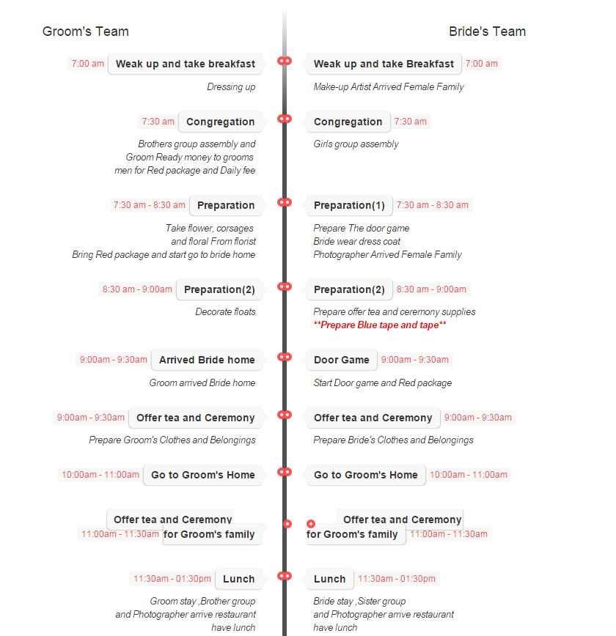**The Rundown Of the Big Day**

**A sample for day**

**The time and schedule can change**

**Due to the circumstances**

