**1- How to Perform a Comparison Between Two Treatments in the Database**

The application allows the user to perform a comparison of longitudinal TTP between a selected reference and test treatments. TTP data is represented using boxplots.



The user has the choice of presenting longitudinal TTP data of two treatments side-by-side, or using the overlay option (refer to check box). Numerical values (median and sample size) of TTP can be selected using check boxes.

**2- How to Perform a Comparison Between a Treatment in the Database and a User-Defined Treatment**

The application also allows the user to upload TTP data collected in new clinical trials and perform a comparison to any reference treatment. The user can upload TTP data by selecting the “Upload TTP data file for test treatment” checkbox.

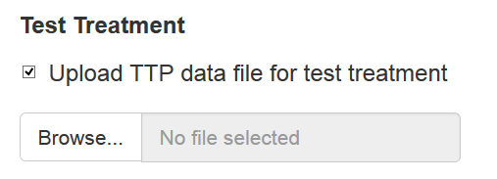

A browse button will open a navigation window for the use to select the file to be uploaded. The uploaded file must be in a comma-separated values (CSV) format with the following headers.

|  |  |  |  |  |  |  |  |  |  |  |  |  |  |  |
| --- | --- | --- | --- | --- | --- | --- | --- | --- | --- | --- | --- | --- | --- | --- |
| #ID | TIMEDAYS | TTP | WEEK | WEEKCAT | HIV | CAVITATION | CD4 | TRTDOSE | TRT | AGE | SEX | RACE | WT | STUDY |

Definition of Variables:

#"#ID" = Subject ID (string)

#"TIMEDAYS" = Time (Days, number)

**#"TTP" = TTP (Days,** number**)**

#"WEEK" = Time of TTP Observation (Week, **number**)

**#"WEEKCAT" = Week categories (**string**)**

#"HIV" = HIV status (Yes/No)

#"CAVITATION" = Presence of cavitation (Yes/No)

#"CD4" = CD4 count (units, string)

**#"TRTDOSE" = Treatment name with Dose when available (**string**)**

#"TRT" = Treatment name **(**string**)**

#"AGE" = Age (years, number)

#"SEX" = Sex (Female/Male)

#"RACE" = Race (Asian/Black or African American/Hispanic/Missing/Other/White)

#"WT" = Weight (kg, number)

#"STUDY" = Study name (string)

The current version of the application reads the column “TTP”, “WEEKCAT” and “TRTDOSE” for plotting purposes. Reading of other fields will be implemented in future versions.

Missing information can be entered as “.” in any field.