Simple Interest

p = int(input("Enter the Principal : "))

n = float(input("Enter the No. of Years: "))

r = float(input("Enter the Rate of Interest : "))

print("The SI = {}".format(p*n*r/100))

Output:

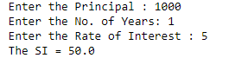

IncomeTaxCalculator

def calculateIncomeTax(income):

tax = 0;

if income <= 250000: #2 Lakh 50 thousand

tax = 0

elif income <= 500000: #5 Lakh

tax = (income - 250000) * 0.05

elif income <= 750000: #7 lakh 50 thousand

tax = (income - 500000) * 0.10 + 12500

elif income <= 1000000: #10 Lakh

tax = (income - 750000) * 0.15 + 37500

elif income <= 1250000: #12 lakh 50 thousand

tax = (income - 1000000) * 0.20 + 75000

elif income <= 1500000: #15 lakh

tax = (income - 1250000) * 0.25 + 125000

else:

tax = (income - 1500000) * 0.30 + 187500

print("you owe", tax, "Rupees in tax!")

calculateIncomeTax(5000000)

Output:



Multiplication Tables

for i in range(1,8):

print(" ")

for j in range (1,8):

print(i,"x",j,"=",(i*j),end='\t')

Output:

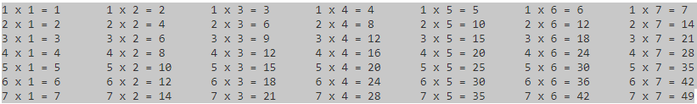

NumberConverter - Arrays

from array import array

a = array ('i', range(0,9))

x = int (input("enter a 3 digit number"))

a [2] = int(x%10)

a [1] = int(x/10%10)

a [0] = int(x/100)

for i in range (0,3):

if a [i] == 0:

print("zero",end=' ')

elif a [i] == 1 :

print("one",end=' ')

elif a [i] == 2 :

print("two",end=' ')

elif a [i] == 3 :

print("three",end=' ')

elif a [i] == 4 :

print("four",end=' ')

elif a [i] == 5 :

print("five",end=' ')

elif a [i] == 6 :

print("six",end=' ')

elif a [i] == 7 :

print("seven",end=' ')

elif a [i] == 8 :

print("eight",end=' ')

else:

print("nine",end=' ')

Output:



NumberToTextConverter – User Defined Functions

Words={0:"zero",1:"one",2:"two",3:"three",4:"four",5:"five",6:"six",7:"seven",8:"eight",9:"nine",10:"ten"}

def word_converter(value):

try:

if(isinstance(value,int)):

print(words[value])

elif(isinstance(value,str)):

for key, val in words.items():

if(val == value):

print(key)

except:

print("Some error occurred while executing the code....... :(")

Output:

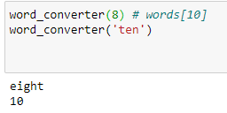

StudentInformation - lists

def getStudentDetails():

b = []

dno = input("Enter your Department Number: ")

name = input("Enter your Name:")

dob = input("Enter Date of Birth: ")

fname = input("Enter Father's name: ")

score = int(input("Enter your score: "))

b.extend([dno,name,dob,fname,score])

return b

a=[]

n = int(input("Enter total number of students: "))

for i in range(0,n):

a.append(getStudentDetails())

print(a)

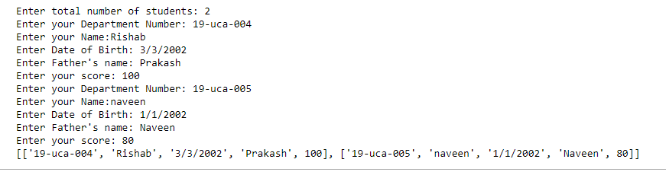

Student Information - Dictionary

dno={1:"19-UCA-013",2:"19-UCA-014",3:"19-UCA-015"}

name={1:"Carmel",2:"Francis",3:"Divagar"}

dob={1:"12-01-2001",2:"12-06-2000",3:"25-05-2002"}

mobile={1:"8056045990",2:"7305487090",3:"9234568741"}

for key in dno:

print(key, dno[key],name[key],dob[key],mobile[key])

Output:

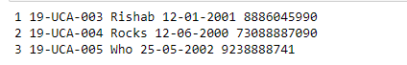

StandardDeviation

import math

n = int(input("Enter the number of Values: "))

weight = []

s = 0

for i in range(n):

w=0

weight.append(int(input("Enter the weight")))

s+=w

print(weight)

average = int(s/n)

d =0

for i in weight:

d += (i - average)**2

print(d)

d = d/(n-1)

print(d)

sd = math.sqrt(d)

print("The standard deviation is : {}".format(sd))

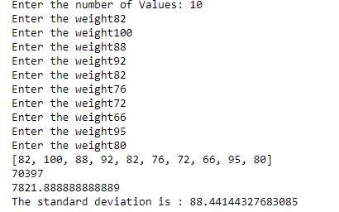

Stack Implementation – Modules

stack = []

while(True):

x = int(input("Enter your choice: [1]-Insert [2]-Delete [3]-Display"))

if(x==1):

v = int(input("Enter any integer value: "))

stack.append(v)

print(stack)

elif(x==3):

print(stack)

elif x ==2 :

stack.pop()

print(stack)

Output:

