SQL Queries - Assignment

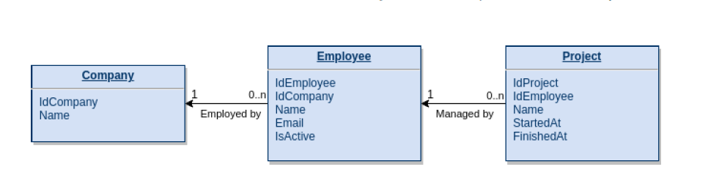
Query 1: Get the names of the running Projects
Explanation: A running project is one where FinishedAt is NULL (not yet finished).

SQL Query:
SELECT Name
FROM Project
WHERE FinishedAt IS NULL;

Query 2: Get the number of finished Projects per Company
Explanation: A finished project is one where FinishedAt is NOT NULL. We need to JOIN three tables: Project -> Employee -> Company, then group by company and count finished projects. In below given approach left join has to show companies which has 0 projects.

SQL Query:
SELECT
c.Name AS CompanyName,
COUNT(p.IdProject) AS FinishedProjectsCount
FROM Company c
LEFT JOIN Employee e ON c.IdCompany = e.IdCompany
LEFT JOIN Project p ON e.IdEmployee = p.IdEmployee
AND p.FinishedAt IS NOT NULL
GROUP BY c.IdCompany, c.Name
ORDER BY FinishedProjectsCount DESC;

Query 3: Get Company Names with 2+ Projects with the same Name
Explanation: Find companies where at least one project name appears 2 or more times/ has duplicated records. The given approach will first group by company name and project name then will filter the records which has count greater than or equal to zero.

SQL Query:
SELECT DISTINCT c.Name AS CompanyName
FROM Company c
INNER JOIN Employee e ON c.IdCompany = e.IdCompany
INNER JOIN Project p ON e.IdEmployee = p.IdEmployee
GROUP BY c.IdCompany, c.Name, p.Name
HAVING COUNT(p.IdProject) >= 2;

