Table of Contents
1. INTRODUCTION 3
2. PROJECT OBJECTIVES 4
3. RELEVANCE TO SUSTAINABLE DEVELOPMENT GOALS (SDGs) AND THE SIERRA LEONEAN CONTEXT 4
4. SYSTEM OVERVIEW 6
5. REFINEMENT OF THE PHYSICAL DATA MODEL 7
6. DATABASE DESIGN 10
7. DESIGN DECISIONS 14
8. DATABASE IMPLEMENTATION 17
9. DATA MANIPULATION 18
10. SQL QUERIES AND OUTPUTS 20
24
11. JOIN QUERY IMPLEMENTATION 25
25
. 26
USER MANAGEMENT AND DATABASE SECURITY 26
27
13. BENEFITS OF THE SYSTEM 28
14. CONCLUSION 31
15. REFERENCES 32

Abstract
This project presents the design and implementation of a Market Stall Allocation System using MySQL to improve the management of traders, stalls, allocations, registrations, and payment records within public markets in Sierra Leone. The system was developed to address challenges associated with manual record-keeping, including data duplication, misplaced records, inefficient stall allocation, and difficulties in generating accurate reports.
A relational database was designed using Conceptual, Logical, and Physical Data Models and implemented in MySQL through XAMPP and phpMyAdmin. The database consists of five interconnected tables: Market, Trader, Stall, Allocation, and Registration. Primary keys, foreign keys, constraints, and referential integrity rules were applied to ensure data accuracy, consistency, and security.
The system supports essential market management functions such as trader registration, stall allocation, payment tracking, and report generation through SQL queries. By providing a centralized and organized database, the system improves administrative efficiency, reduces errors, enhances accountability, and supports informed decision-making. The project demonstrates the practical application of relational database principles in solving real-world market management challenges and contributes to sustainable urban development in Sierra Leone in alignment with SDG 11: Sustainable Cities and Communities.

1. INTRODUCTION
Markets play a significant role in the economic development of our beloved Sierra Leone. They provide opportunities for small-scale traders, entrepreneurs, and local businesses to generate income and contribute meaningfully to the national economy. Despite this importance, many market authorities across the country still rely on manual, paper-based methods for managing trader information, stall allocation, registration records, and payment tracking. These traditional methods frequently result in misplaced records, duplication of information, delays in service delivery, and significant difficulty when generating accurate administrative reports.
To address these challenges, this project focuses on the design and implementation of a computerized Market Stall Allocation System using MySQL. The system has been developed to manage trader registration, market information, stall allocation, and registration payments in an efficient, accurate, and organized manner, replacing the inconsistent manual processes currently used in many Sierra Leonean markets.
This Final Project builds directly on the Conceptual Data Model (CDM), Logical Data Model (LDM), and Physical Data Model (PDM) designed individually by each group member during Assignment 1. The group reviewed all individual designs, reconciled differences in structure, naming conventions, data types, and constraints, and agreed on a single refined Physical Data Model, which was then implemented as a fully functional relational database in MySQL using XAMPP and phpMyAdmin.
The implementation of a relational database system allows market authorities to store, retrieve, update, and manage data accurately while maintaining data integrity and minimising redundancy. The system also supports informed decision-making through structured SQL queries that generate operational and financial reports on demand.

2. PROJECT OBJECTIVES
The primary objective of this project is to develop a functional relational database system capable of managing market stall allocation activities effectively for a public market in Sierra Leone.
The specific objectives of the project are to:
- Register and maintain accurate records of traders operating within the market.
- Maintain detailed and up-to-date trader records, including contact and business information.
- Manage available and occupied stalls across one or more market locations.
- Allocate stalls to registered traders in a controlled and auditable manner.
- Record registration information and associated fees collected from traders.
- Improve the overall efficiency of market administration.
- Minimise manual record-keeping errors and duplicate allocations.
- Provide quick, query-based access to trader, stall, and payment information.
- Maintain data integrity through the application of relational database principles, including primary keys, foreign keys, and referential integrity constraints.

3. RELEVANCE TO SUSTAINABLE DEVELOPMENT GOALS (SDGs) AND THE SIERRA LEONEAN CONTEXT
This project supports Sustainable Development Goal (SDG) 11: Sustainable Cities and Communities, which calls for cities and human settlements to be made inclusive, safe, resilient, and sustainable.
Markets are essential components of urban and community development in Sierra Leone. They serve as primary sources of livelihood for thousands of traders and as critical points of access to goods and services for the wider public. Effective management of market resources therefore contributes directly to sustainable economic growth, improved local governance, and better public service delivery at the community level.
The Market Stall Allocation System addresses several challenges that are commonly faced by market authorities operating under manual systems in Sierra Leone, including:
- Poor and inconsistent record management practices.
- Duplicate or conflicting stall allocations caused by the absence of a central record.
- Inefficient and slow trader registration processes.
- Difficulty tracking which stalls are occupied and which remain available.
- A lack of reliable reporting systems to support revenue tracking and planning.
By introducing a computerised database solution, this project promotes accountability, transparency, and efficient resource management within local markets, directly supporting the sustainable and well-managed urban communities envisioned under SDG 11.

4. SYSTEM OVERVIEW
The Market Stall Allocation System is designed to facilitate the day-to-day management of market operations by storing and organising information relating to traders, stalls, allocations, registrations, and market locations within a single relational database.
The system performs the following core functions:
- Stores and maintains trader information, including contact details and business category.
- Stores market information for one or more physical market locations.
- Stores stall information, including size, monthly rate, and current occupancy status.
- Records stall allocation details, linking a specific trader to a specific stall over a defined period.
- Maintains registration records and tracks associated registration fees.
- Tracks registration payments and outstanding balances.
- Produces operational and financial reports through structured SQL queries.
- Supports reliable data retrieval, update, and deletion through a controlled set of operations.
The resulting database provides a single, organised source of truth that allows market administrators to access accurate information quickly, reducing the delays and inconsistencies associated with manual record-keeping.

5. REFINEMENT OF THE PHYSICAL DATA MODEL
During Assignment 1, each group member independently designed a Conceptual Data Model, Logical Data Model, and Physical Data Model for the Market Stall Allocation System. As required by this Final Project, the group convened to review and compare all individual designs before agreeing on one improved and refined Physical Data Model for implementation.

5.1 Refinement Process
The review process involved comparing each member's entity names, attribute lists, data types, and key constraints. The group identified the following improvements during refinement:
- Standardised all table and column names to lower-case, underscore-separated naming (e.g., trader_id, allocation_date) for consistency across the schema.
- Resolved minor inconsistencies in data types between individual designs — for example, ensuring all monetary fields consistently use DECIMAL(10,2) rather than a mix of FLOAT and INT across different members' drafts.
- Added explicit DEFAULT values where appropriate (e.g., stall_status defaulting to 'Available', registration status defaulting to 'Paid') to reduce the chance of NULL values in operationally important fields.
- Introduced a national_id UNIQUE constraint on the trader table to prevent duplicate trader registrations, a gap present in some of the original individual designs.
- Clarified and explicitly defined the foreign key relationships and their referential actions (ON UPDATE CASCADE, ON DELETE RESTRICT) to protect historical allocation and payment records from accidental loss.
- Confirmed the conceptual relationships originally captured in the group's Conceptual Data Model (Market → Stall → Allocation ← Trader, and Allocation → Registration) were carried through consistently into the refined Physical Data Model.
The final implemented database reflects this single, well-structured, and logically consistent Physical Data Model, agreed upon collaboratively by the entire group before implementation began.

5.2 Conceptual Data Model (Reference)
The diagram below shows our group original Conceptual Data Model from Assignment 1, which defines the high-level entities and 1:N relationships that the refined Physical Data Model below is built upon.
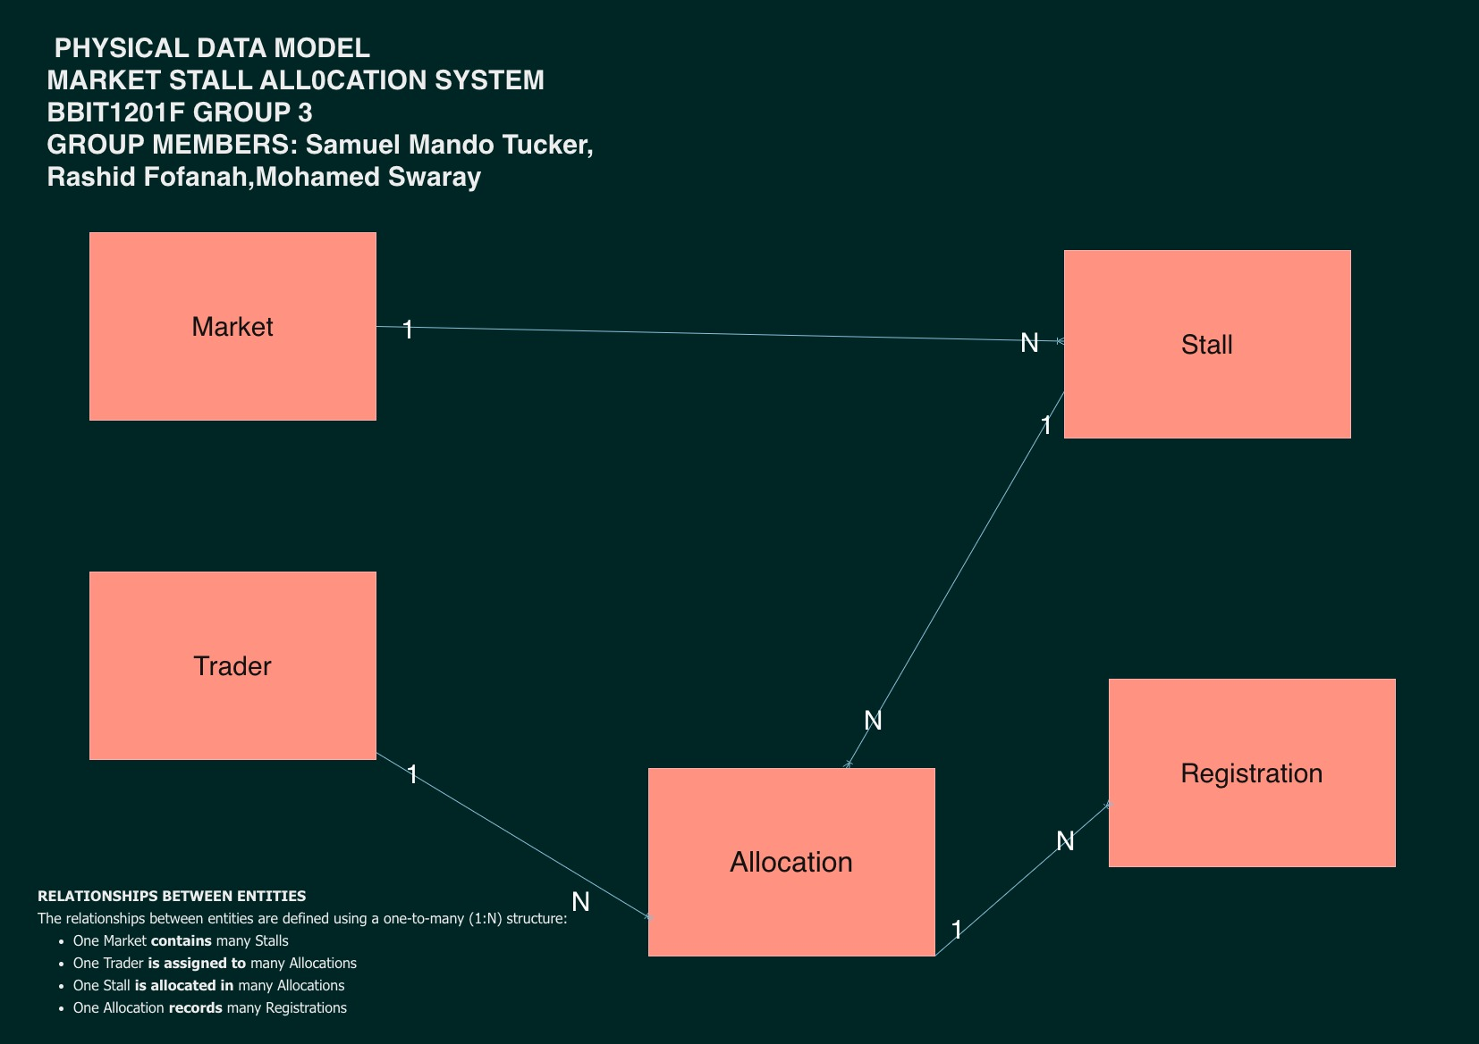
Figure 1: Conceptual Data Model — Market Stall Allocation System

5.3 Refined Physical Data Model
The refined Physical Data Model below shows the five entities of the system — market, trader, stall, allocation, and registration — with their primary keys (PK), foreign keys (FK), data types, and 1:N cardinalities as agreed by the group.
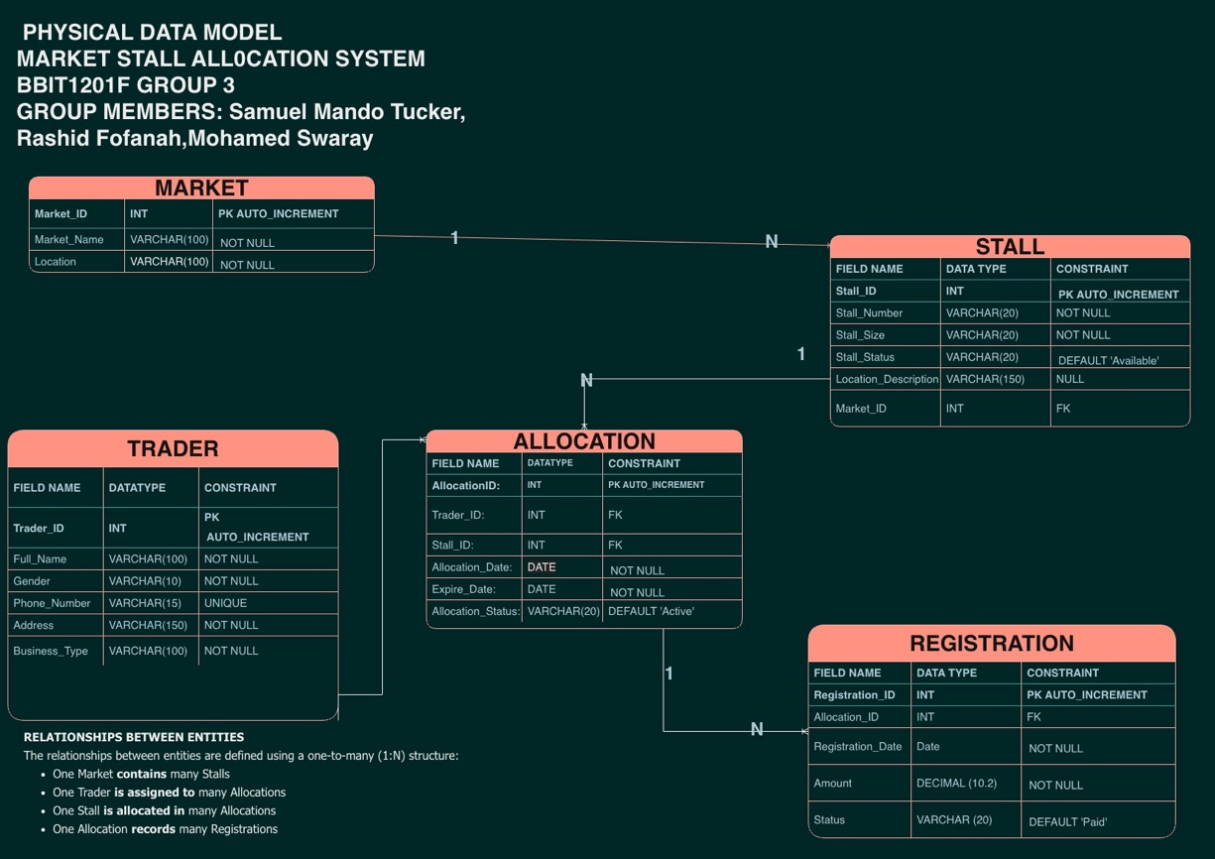
Figure 2: Refined Physical Data Model — Market Stall Allocation System

6. DATABASE DESIGN
The refined database consists of five interconnected tables, described in detail below.

6.1 Market Table
Field | Data Type | Constraint | Description
market_id | INT | PRIMARY KEY, AUTO_INCREMENT | Unique market identifier
market_name | VARCHAR(100) | NOT NULL | Name of the market
location | VARCHAR(150) | NOT NULL | Physical location of the market
market_type | VARCHAR(50) | DEFAULT 'General' | Category of market (e.g., General, Foodstuff)
contact_phone | VARCHAR(20) | — | Market office contact number

6.2 Trader Table
Field | Data Type | Constraint | Description
trader_id | INT | PRIMARY KEY, AUTO_INCREMENT | Unique trader identifier
full_name | VARCHAR(100) | NOT NULL | Trader's full name
phone_number | VARCHAR(20) | NOT NULL | Trader's contact number
business_type | VARCHAR(50) | NOT NULL | Category of goods or services sold
gender | VARCHAR(10) | — | Trader's gender
address | VARCHAR(150) | — | Trader's residential address
date_registered | DATE | DEFAULT CURRENT_DATE | Date the trader was registered
national_id | VARCHAR(20) | UNIQUE | National identification number

6.3 Stall Table
Field | Data Type | Constraint | Description
stall_id | INT | PRIMARY KEY, AUTO_INCREMENT | Unique stall identifier
market_id | INT | FOREIGN KEY → market | Market in which the stall is located
stall_number | VARCHAR(10) | NOT NULL | Stall reference number
stall_size | VARCHAR(20) | DEFAULT 'Medium' | Physical size category of the stall
monthly_rate | DECIMAL(10,2) | NOT NULL | Monthly rental rate for the stall
stall_status | VARCHAR(20) | DEFAULT 'Available' | Current occupancy status
date_added | DATE | DEFAULT CURRENT_DATE | Date the stall record was created

6.4 Allocation Table
Field | Data Type | Constraint | Description
allocation_id | INT | PRIMARY KEY, AUTO_INCREMENT | Unique allocation identifier
trader_id | INT | FOREIGN KEY → trader | Trader to whom the stall is allocated
stall_id | INT | FOREIGN KEY → stall | Stall being allocated
allocation_date | DATE | NOT NULL, DEFAULT CURRENT_DATE | Date the allocation began
expiry_date | DATE | — | Date the allocation expires
allocation_status | VARCHAR(20) | DEFAULT 'Active' | Active, Expired, or Inactive
remarks | VARCHAR(150) | — | Optional administrative notes

6.5 Registration Table
Field | Data Type | Constraint | Description
registration_id | INT | PRIMARY KEY, AUTO_INCREMENT | Unique registration identifier
allocation_id | INT | FOREIGN KEY → allocation | Allocation being paid for
amount | DECIMAL(10,2) | NOT NULL | Registration fee amount
payment_method | VARCHAR(30) | DEFAULT 'Cash' | Cash, Mobile Money, or Bank Transfer
status | VARCHAR(20) | DEFAULT 'Paid' | Paid or Outstanding
registration_date | DATE | NOT NULL, DEFAULT CURRENT_DATE | Date payment was recorded

7. DESIGN DECISIONS
The database was designed in accordance with relational database principles to ensure efficiency, accuracy, and long-term consistency of the stored data.

7.1 Data Types Used
INT — used for all primary keys because it supports automatic numbering (AUTO_INCREMENT) and guarantees unique identification of every record. Example:
trader_id INT AUTO_INCREMENT PRIMARY KEY

VARCHAR — used for textual information of variable length, such as names, addresses, and status labels, since fixed-length CHAR fields would waste storage on shorter values. Example:
full_name VARCHAR(100)

DATE — used to store all date values, such as registration and allocation dates, enabling reliable date-based filtering, sorting, and calculations. Example:
allocation_date DATE

DECIMAL(10,2) — used specifically for all financial fields (monthly_rate, amount) to guarantee exact precision to two decimal places, avoiding the rounding errors that can occur with FLOAT or DOUBLE types when handling currency. Example:
amount DECIMAL(10,2)

7.2 Constraints Used
Primary Keys — used on every table to uniquely identify each record and to serve as the anchor point for all foreign key relationships.
Foreign Keys — used to establish and enforce the relationships between tables (market → stall, trader → allocation, stall → allocation, allocation → registration), guaranteeing that no allocation or registration record can reference a trader, stall, or allocation that does not exist.
AUTO_INCREMENT — applied to all primary key columns to automatically generate unique, sequential identifier values without requiring manual input.
NOT NULL — applied to all fields considered essential to a valid record (for example, full_name, phone_number, monthly_rate), ensuring that critical information cannot be omitted.
DEFAULT — applied to operational status fields (stall_status, allocation_status, registration status) so that new records are automatically assigned a sensible default value, reducing the chance of incomplete data entry.
UNIQUE — applied to the national_id field on the trader table to prevent the same individual from being registered more than once.
Referential actions (ON UPDATE CASCADE, ON DELETE RESTRICT) — applied to every foreign key so that updates to a parent record automatically propagate, while deletions of a parent record that still has dependent allocation or registration history are blocked, protecting the integrity of historical records.

8. DATABASE IMPLEMENTATION
The database was implemented using MySQL through phpMyAdmin within the XAMPP environment, in accordance with the project brief.

8.1 Database Creation
CREATE DATABASE market_stall_allocation_system;
USE market_stall_allocation_system;
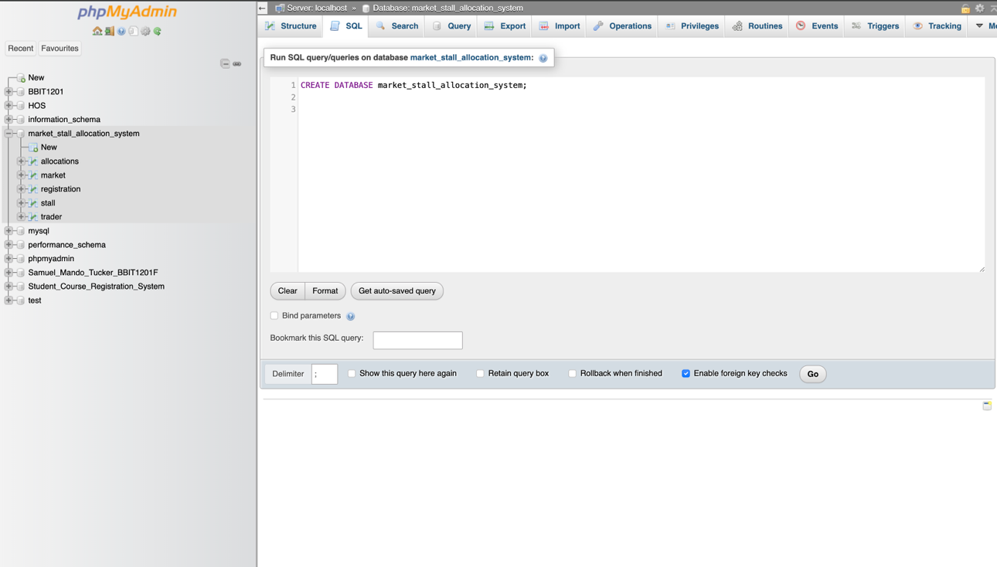

8.2 Table Creation
The market, trader, stall, allocation, and registration tables were created using SQL CREATE TABLE statements, with all primary keys, foreign keys, NOT NULL constraints, and default values defined as specified in Section 6 of our reports.

9. DATA MANIPULATION
Sample data manipulation operations were performed to demonstrate the functionality and correctness of the implemented database.

9.1 Insert Operation
INSERT INTO trader
(full_name, phone_number, business_type, gender, address )
VALUES
('Hawa S Bangura, '099238933', 'Fish Trader', 'Male', ' 23 New England');

This command inserts a new trader record into the trader table with an auto_increment for the ID NUMBER.
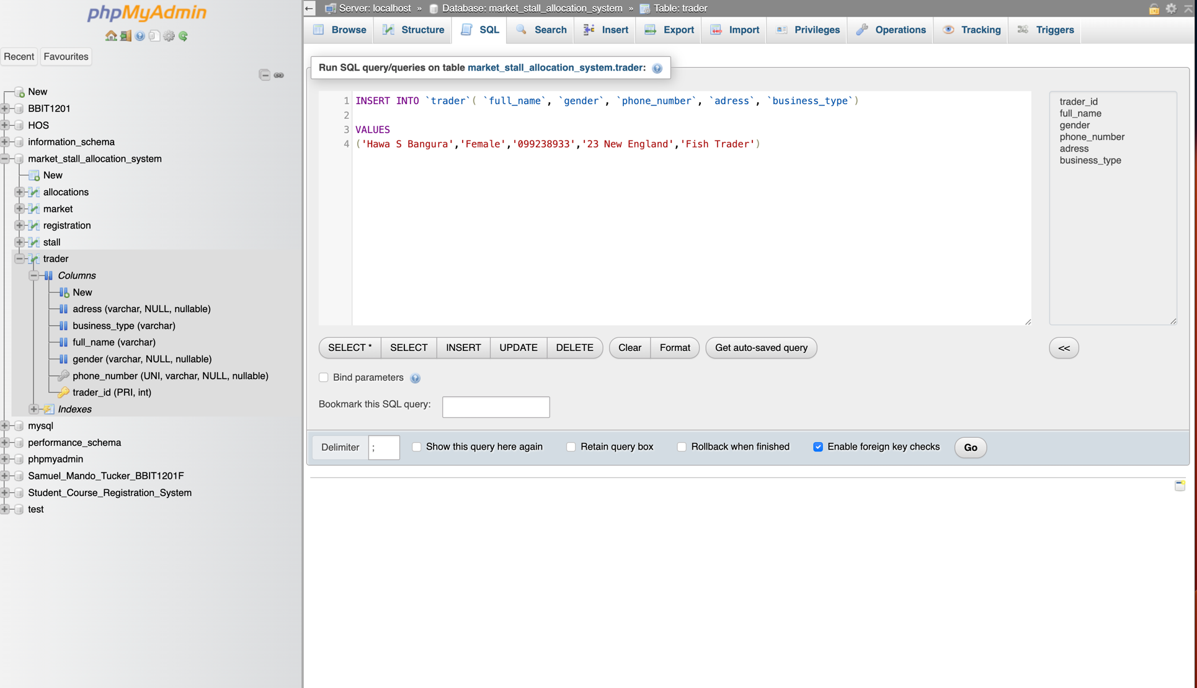

9.2 Update Operation
UPDATE trader
SET phone_number= ’073782211’
WHERE trader_id = 1;
This command updates the contact number of an existing trader record.
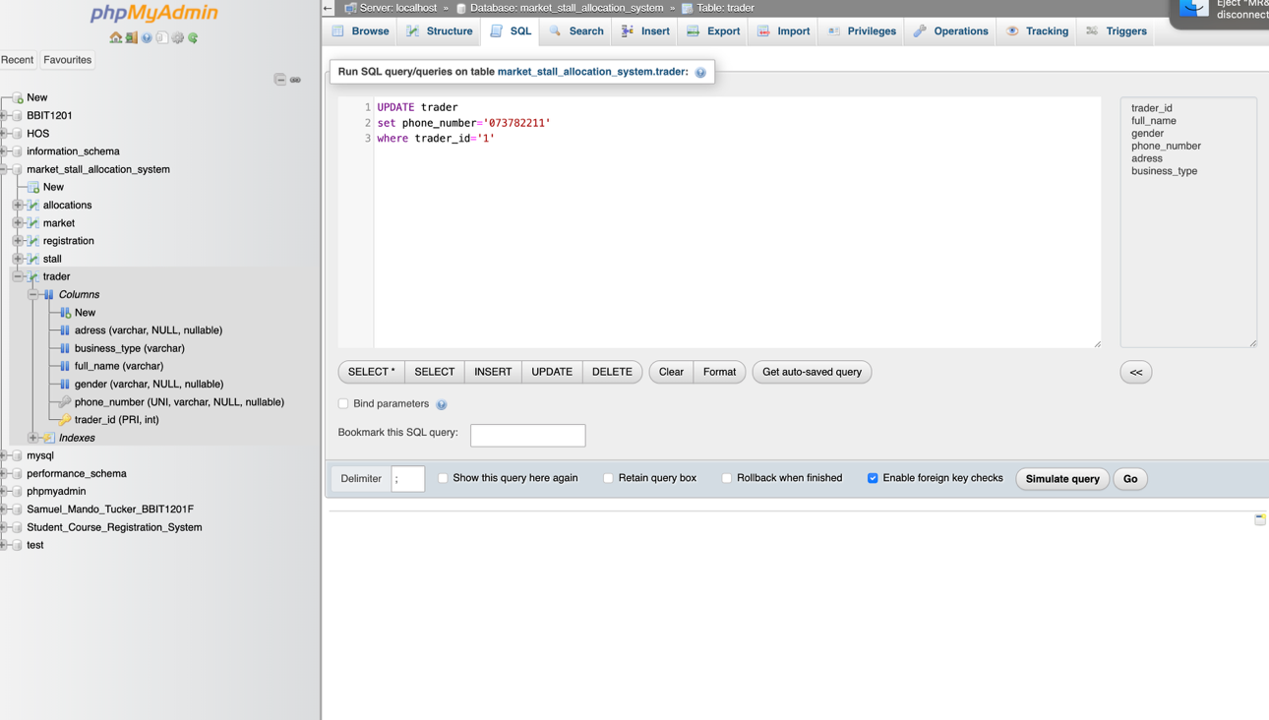

9.3 Delete Operation
DELETE FROM allocation
WHERE allocation_id = 17 AND allocation_status = 'Expired';

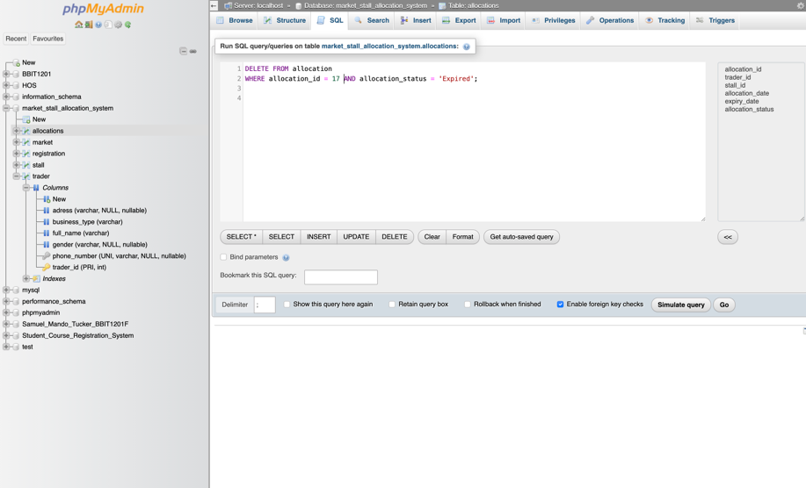
This command removes an expired allocation record that was entered in error.

10. SQL QUERIES AND OUTPUTS
The following SQL queries demonstrate the system's data accessibility and reporting capabilities, including filtering, sorting, aggregation, and the LIMIT clause, applied to realistic market-management scenarios.

10.1 SELECT Query
SELECT * FROM trader;
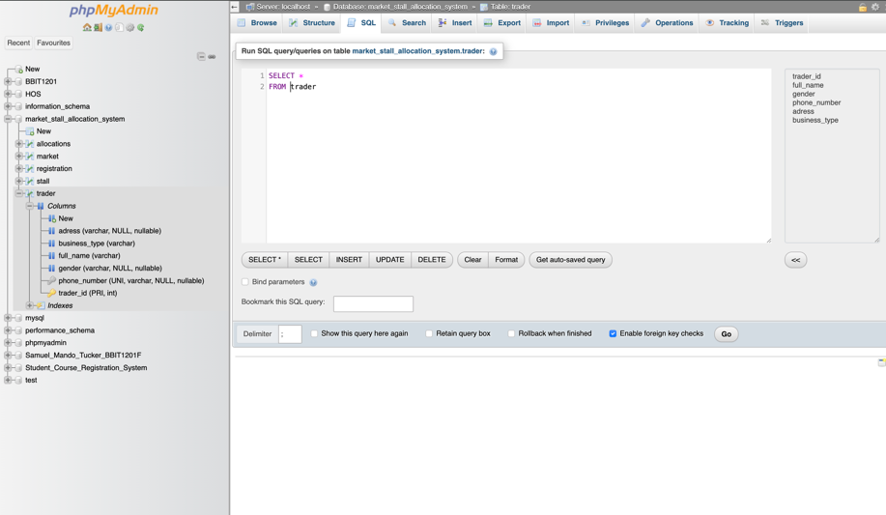
Retrieves all trader records currently stored in the system.

10.2 WHERE Clause
SELECT stall_id, stall_number, stall_size, location_description
FROM stall
WHERE stall_status = 'Available';

Displays only stalls that are currently available for allocation.
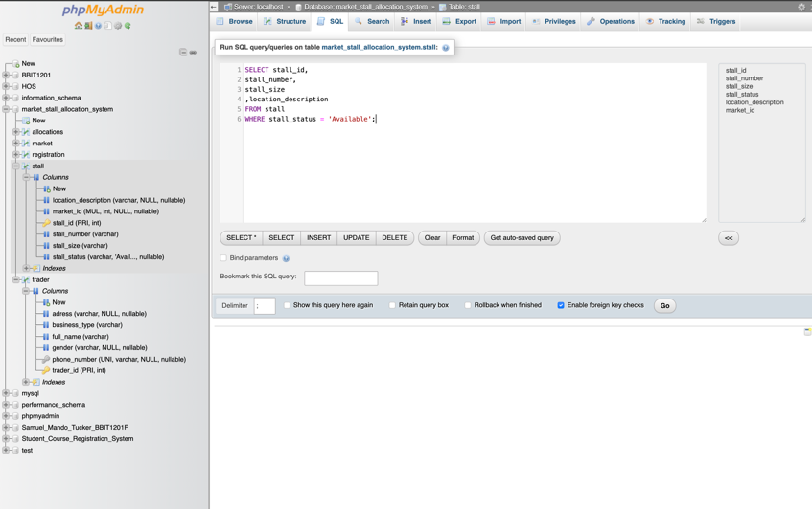

10.3 ORDER BY Query
SELECT trader_id, full_name, business_type
FROM trader
ORDER BY full_name ASC;

Sorts trader names alphabetically for easier administrative review.

10.4 COUNT Query
SELECT COUNT(*) AS total_traders
FROM trader;
Counts the total number of traders currently registered in the system.
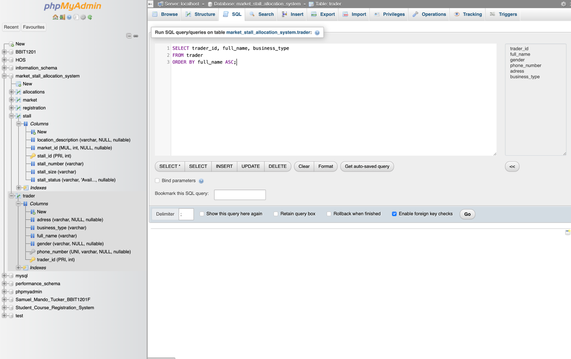

10.5 SUM Query
SELECT SUM(amount) AS total_registration_amount
FROM registration
WHERE status = 'Paid';

Calculates the total registration revenue collected to date — a key real-life reporting requirement for market administrators.
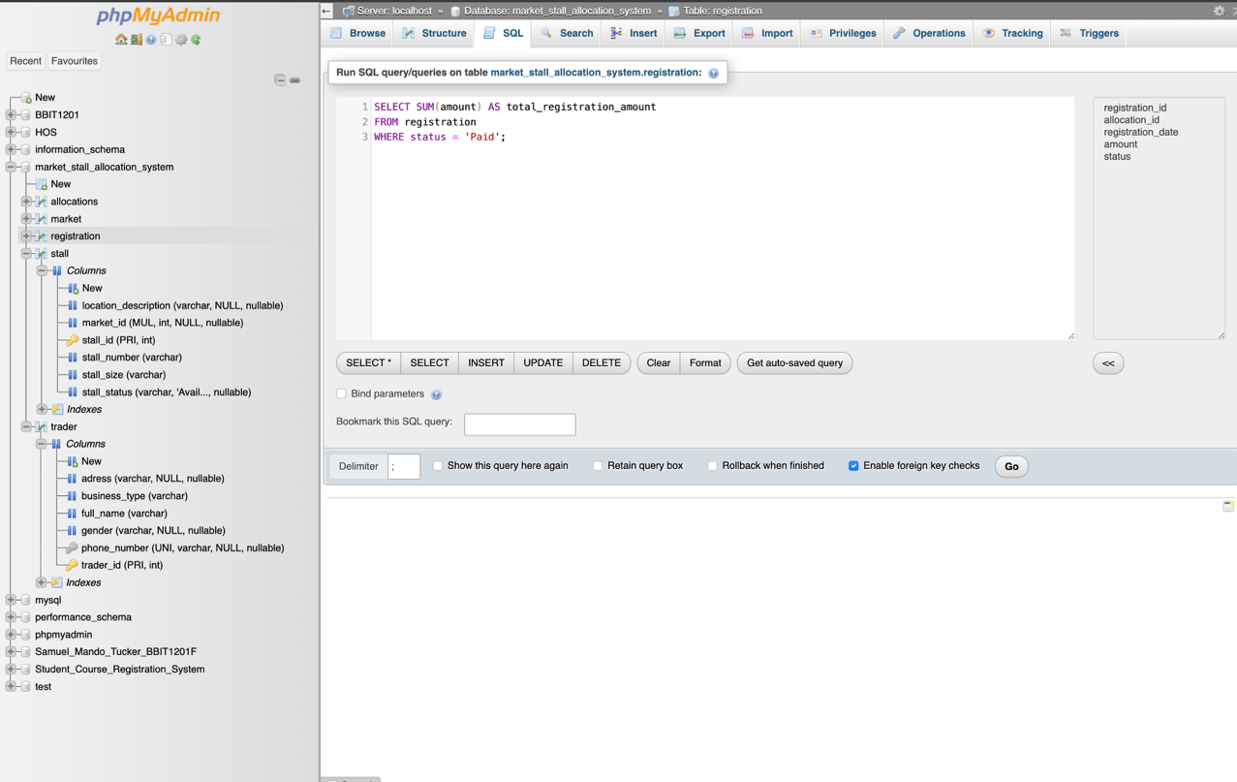

10.6 AVG Query

SELECT market_name,

AVG(amount)

AS average_rate_per_market_revenue

FROM registration

JOIN allocations

on registration.allocation_id=allocations.allocation_id

join stall on allocations.stall_id=stall.stall_id

JOIN market ON stall.market_id = market.market_id
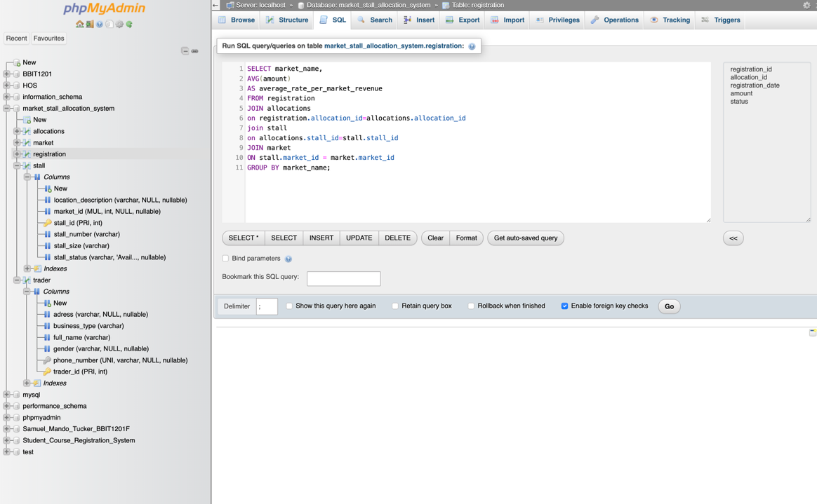
GROUP BY market_name;Calculates the average monthly registration rate for each market, to evaulate registration payment and enhance policy decisions on registrations.

10.7 LIMIT Query
SELECT trader_id, full_name, business_type,address
FROM trader
ORDER BY trader_id ASC
LIMIT 5;
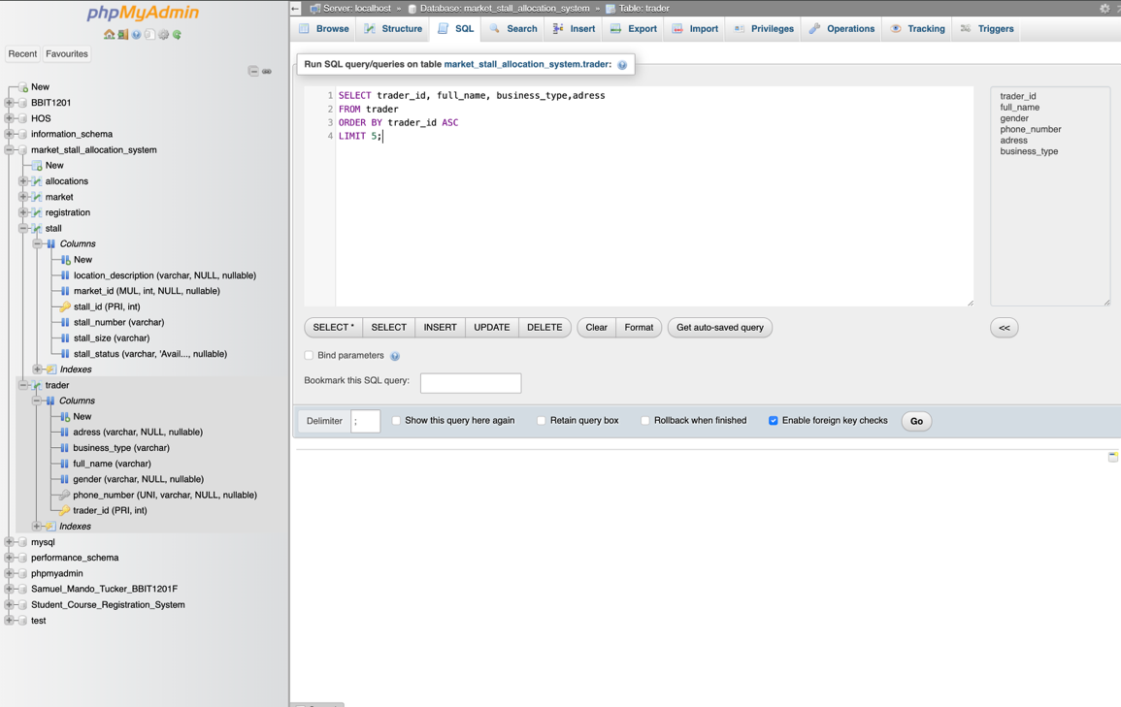
Displays the first five traders registered in the system with their selected attribute.

10.8 Outstanding Balances Query
SELECT trader.full_name,stall.stall_number,registration.amount,registration.status,market_name
FROM registration
JOIN allocations
on registration.allocation_id=allocations.allocation_id
JOIN trader
on allocations.trader_id=trader.trader_id
join stall on allocations.stall_id=stall.stall_id
JOIN market ON stall.market_id = market.market_id
where registration.status='pending';Identifies traders who currently have outstanding registration balances.
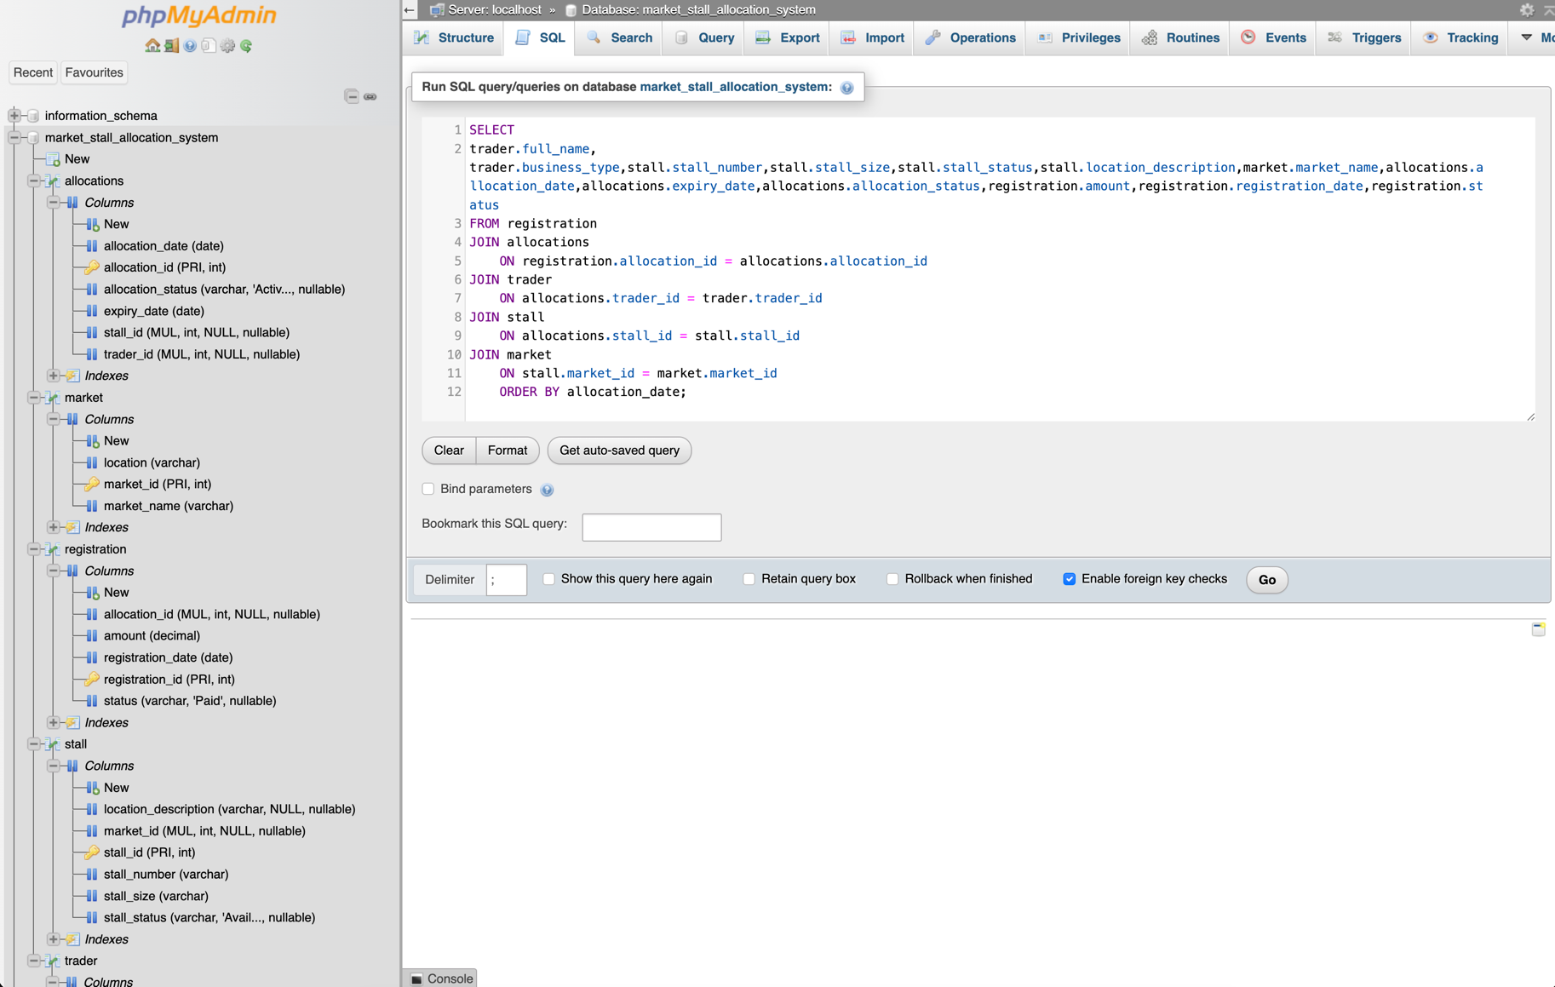

11. JOIN QUERY IMPLEMENTATION
The following query combines information from all related tables to produce a complete operational overview of stall allocations across the system:
SELECT
trader.full_name, trader.business_type,stall.stall_number,stall.stall_size,stall.stall_status,stall.location_description,market.market_name,allocations.allocation_date,allocations.expiry_date,allocations.allocation_status,registration.amount,registration.registration_date,registration.status
FROM registration
JOIN allocations
ON registration.allocation_id = allocations.allocation_id
JOIN trader
ON allocations.trader_id = trader.trader_id
JOIN stall
ON allocations.stall_id = stall.stall_id
JOIN market
ON stall.market_id = market.market_id
ORDER BY allocation_date;
This query demonstrates how relational databases combine related data from four separate tables into a single, meaningful result set, which is the foundation of practical reporting in any real-world database system.
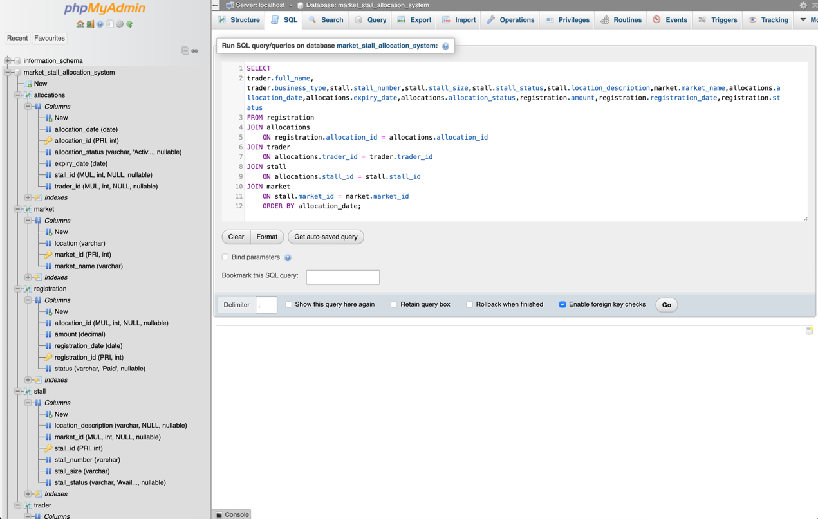

USER MANAGEMENT AND DATABASE SECURITY
Individual user accounts were created for each group member, with privileges assigned according to each member's role in managing the database, in line with the principle of least privilege.

12.1 User Creation
CREATE USER Samuel@'localhost' IDENTIFIED BY 'Samuel123';
CREATE USER Swaray@'localhost' IDENTIFIED BY 'Swaray123;
CREATE USER 'Rashid'@'localhost' IDENTIFIED BY 'Rahsid123';

12.2 Granting Privileges
GRANT ALL PRIVILEGES ON market_stall_allocation_system.* TO 'Samuel'@'localhost';
GRANT SELECT, INSERT, UPDATE ON market_stall_allocation_system.* TO 'Swaray'@'localhost';
GRANT SELECT ON market_stall_allocation_system.* TO 'Rashid'@'localhost';
FLUSH PRIVILEGES;

Privileges were deliberately differentiated across the three accounts: the project lead account holds full privileges for administrative purposes, a second account is restricted to data entry and editing (SELECT, INSERT, UPDATE), and a third, read-only account (SELECT) is reserved for members who only need to view records for reporting or presentation purposes.

12.3 Changing Passwords
ALTER USER 'Rashid'@'localhost' IDENTIFIED BY 'Rashid1234';

This command demonstrates how an account password can be changed without altering any of the account's existing privileges.

12.4 Importance of Database Security
Database security protects sensitive trader and financial information from unauthorised access, accidental modification, and malicious interference. Assigning each group member a distinct user account, rather than sharing a single set of credentials, ensures that any change made to the database can be traced back to the specific individual responsible. Restricting privileges according to each member's actual role — rather than granting full access to everyone — also limits the damage that could result from a mistake or a compromised account, which is a core principle of responsible database administration in any real-world public service system.
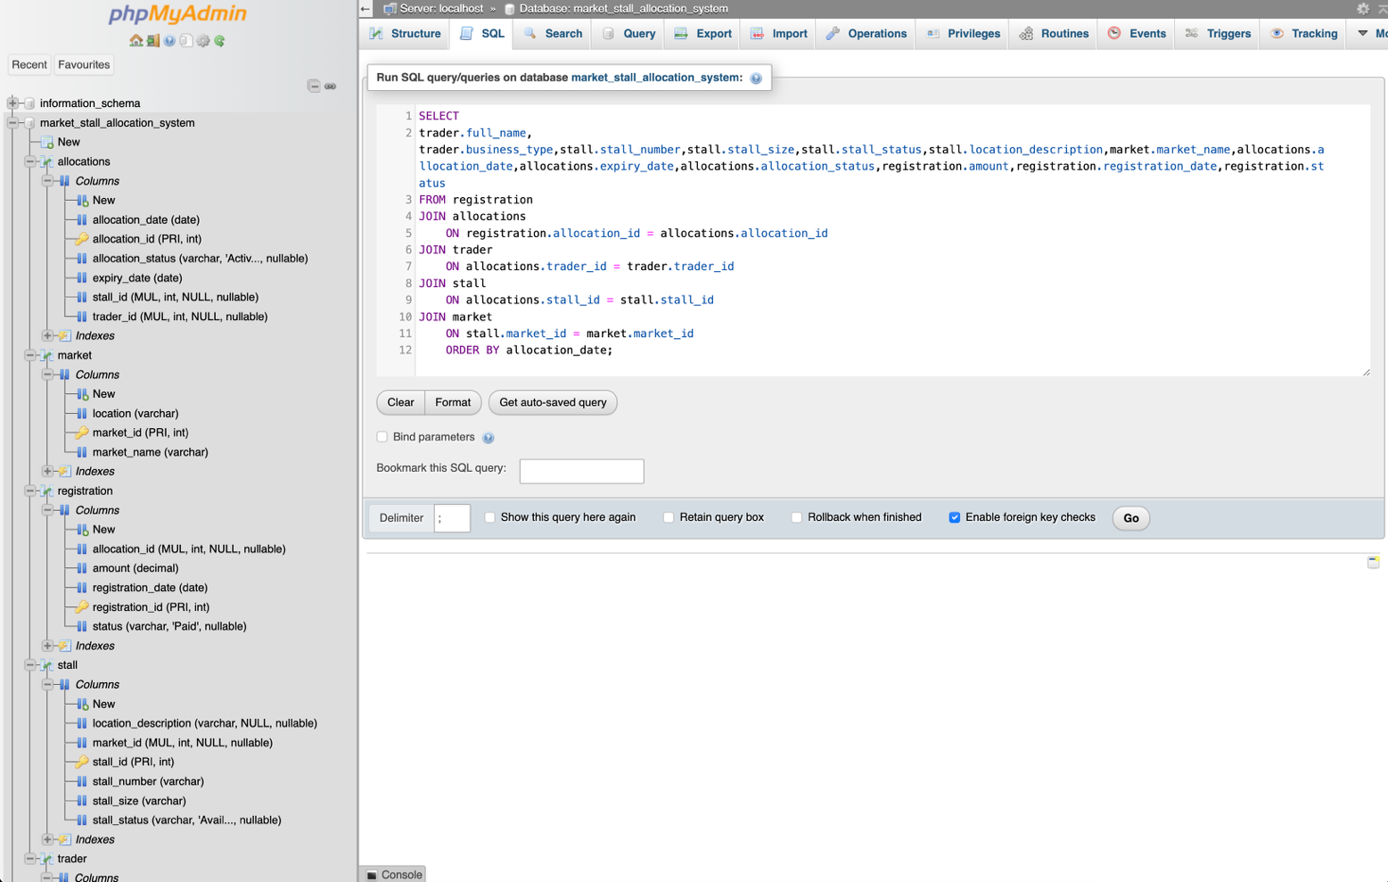

13. BENEFITS OF THE SYSTEM
The Market Stall Allocation System offers several measurable advantages over the manual processes it replaces:
- Faster and more reliable information retrieval for market administrators.
- Improved stall allocation management, with no risk of double-allocating a stall.
- Better organisation of trader and payment records in a single, centralised system.
- Reduced data redundancy through normalised table design.
- Improved reporting capabilities through structured SQL queries.
- Enhanced administrative efficiency, reducing time spent on routine record-keeping tasks.
- Greater data accuracy and integrity, enforced through primary keys, foreign keys, and constraints.
- Improved decision-making, supported by real-time revenue and occupancy reporting.

RECOMMENDATIONS
Based on our successful implementation of the Market Stall Allocation System, the following recommendations are proposed for future improvement and wider adoption and expansion:
- Develop a User-Friendly Interface
  - The current system is implemented through MySQL and phpMyAdmin. Future development should include a web-based or desktop application interface to make the system easier for market administrators to use without requiring SQL knowledge.
- Implement Automated Payment Management
  - The system should be enhanced to support automated payment tracking, receipt generation, and integration with Mobile Money services commonly used in Sierra Leone. This would improve revenue collection and reduce manual errors.
- Introduce Real-Time Reporting Dashboards
  - Management dashboards displaying key indicators such as stall occupancy rates, revenue collected, outstanding payments, and trader statistics would support faster decision-making and planning.
- Strengthen Data Security Measures
  - Additional security features such as password complexity requirements, data encryption, regular backups, audit logs, and multi-factor authentication should be implemented to better protect trader and financial information.
- Expand the System to Multiple Markets
  - The system should be deployed across multiple markets within municipalities and districts, enabling centralized management and standardized record-keeping practices nationwide.
- Implement Notification Features
  - SMS or email notifications can be added to remind traders about upcoming allocation expiry dates, outstanding registration payments, and important market announcements.
- Provide Training for Market Staff
  - Market administrators and staff should receive adequate training on database usage, data entry procedures, and system maintenance to ensure effective utilization of the system.
- Conduct Regular Data Audits
  - Periodic reviews of trader, stall, allocation, and registration records should be carried out to maintain data accuracy and identify inconsistencies early.
- Integrate Business Intelligence Tools
  - Future versions of the system could incorporate analytics tools to identify trends in market occupancy, revenue generation, and trader activities, supporting evidence-based policy decisions.

14. CONCLUSION
The Market Stall Allocation System successfully demonstrates the practical application of relational database concepts using MySQL. Building on the individual designs from Assignment 1, the group collaboratively refined a single Physical Data Model and used it to implement a fully functional database that achieves all of the project's stated objectives, providing a structured solution for managing traders, stalls, allocations, registrations, and market information.
The implementation of primary keys, foreign keys, data manipulation operations, structured SQL queries, and role-based user management collectively demonstrates the effectiveness of relational database systems in solving real-world administrative problems. Beyond satisfying the requirements of this module, the system illustrates how appropriately designed digital infrastructure can improve operational efficiency, enhance data accuracy, and support more sustainable and accountable market management practices within Sierra Leone, in direct alignment with SDG 11.

15. REFERENCES
- MySQL Official Documentation. Available at: https://dev.mysql.com/doc/
- MariaDB Official Documentation. Available at: https://mariadb.com/kb/en/documentation/
- Silberschatz, A., Korth, H. F., & Sudarshan, S. Database System Concepts. McGraw-Hill Education.
- COMP 102 — Introduction to Database, Lecture Notes. Limkokwing University of Creative Technology, Sierra Leone.
- Limkokwing University of Creative Technology, Sierra Leone. COMP 102 Final Project Assignment Brief, March 2026.
- United Nations. Sustainable Development Goal 11: Sustainable Cities and Communities. Available at: https://sdgs.un.org/goals/goal11

