# 資料庫概論　資圖系資圖（日）3B　各週作業

* 組別：04
* 組員：
  + 409440335　宋建章
  + 411006025　曾家悅
  + 412007204　陳宣瑋
  + 412657032　楊雅愉

## 目次

目次 2

2024-09-20：作業01 4

作業說明 4

資料庫主題 4

參考資料 4

資料表綱要（database table schema） 7

實體關係圖（entity relation diagram，ERD） 9

2024-09-27：作業02 10

作業說明 10

SQL指令 10

截圖 12

2024-10-04：作業03 13

作業說明 13

部分資料 13

SQL指令 16

截圖 19

2024-10-11：作業04 21

作業說明 21

作業04-01 SQL指令 21

作業04-01截圖 24

作業04-02 SQL指令 24

作業04-02截圖 25

作業04-03 SQL指令 25

作業04-03截圖 25

2024-10-18：作業05 26

作業說明 26

PHP程式 26

作業05-01近端截圖 26

作業05-02遠端截圖 26

## 2024-09-20：作業01

### 作業說明

各組選定資料庫主題，並寫出各個資料表綱要（schema），並繪製成個體關係圖（ERD）。

### 資料庫主題

金融服務統計資料庫。

### 參考資料

* <https://survey.banking.gov.tw/statis/webMain.aspx?sys=100&funid=allmenu>
* <https://hackmd.io/@investing/SkEbnGLwK>

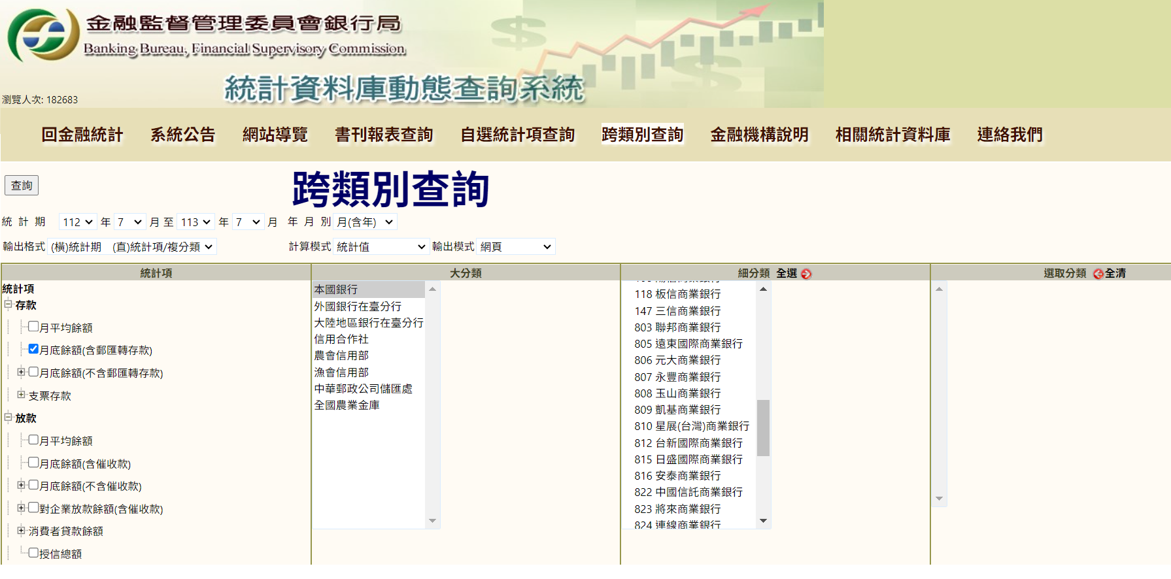

### 資料表綱要（database table schema）

圖片：

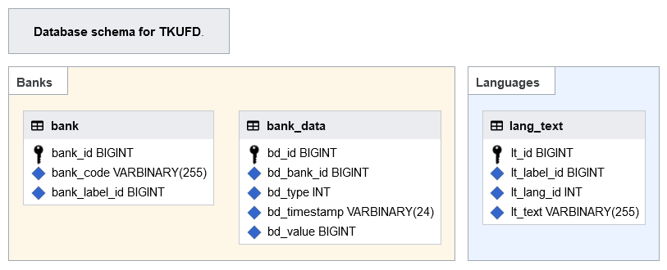

MySQL >= 8.0 / MariaDB >= 6.1：

|  |
| --- |
| **DATABASE** **DEFAULT** CHARACTER SET=utf8mb4 DEFAULT COLLATE=utf8mb4_unicode_ci;  **TABLE** bank (  bank_id BIGINT UNSIGNED AUTO_INCREMENT **NOT** **NULL**,  bank_code VARBINARY(255) **NOT** **NULL**,  bank_label_id BIGINT UNSIGNED **NOT** **NULL**,  **INDEX** bank_code (bank_code),  **PRIMARY** **KEY** (bank_id)  ) ENGINE=InnoDB, **DEFAULT** CHARSET=binary;  **TABLE** bank_data (  bd_id BIGINT UNSIGNED AUTO_INCREMENT **NOT** **NULL**,  bd_bank_id BIGINT UNSIGNED **NOT** **NULL**,  bd_type INT UNSIGNED **NOT** **NULL**,  bd_timestamp VARBINARY(24) **NOT** **NULL**,  bd_value BIGINT UNSIGNED **NOT** **NULL**,  **INDEX** bd_bid_type_timestamp (bd_bank_id, bd_type, bd_timestamp),  **PRIMARY** **KEY** (bd_id)  ) ENGINE=InnoDB, **DEFAULT** CHARSET=binary;  **TABLE** lang_text (  lt_id BIGINT UNSIGNED AUTO_INCREMENT **NOT** **NULL**,  lt_label_id BIGINT UNSIGNED **NOT** **NULL**,  lt_lang_id INT UNSIGNED **NOT** **NULL**,  lt_text VARBINARY(255) **NOT** **NULL**,  **INDEX** lt_label_lang (lt_label_id, lt_lang_id),  **PRIMARY** **KEY** (lt_id)  ) ENGINE=InnoDB, **DEFAULT** CHARSET=binary; |

MySQL < 8.0 / MariaDB < 6.1：

|  |
| --- |
| **DATABASE** **DEFAULT** CHARACTER SET=utf8 DEFAULT COLLATE=utf8_unicode_ci;  **TABLE** bank (  bank_id BIGINT UNSIGNED AUTO_INCREMENT **NOT** **NULL**,  bank_code VARBINARY(255) **NOT** **NULL**,  bank_label_id BIGINT UNSIGNED **NOT** **NULL**,  **INDEX** bank_code (bank_code),  **PRIMARY** **KEY** (bank_id)  ) ENGINE=InnoDB, **DEFAULT** CHARSET=binary;  **TABLE** bank_data (  bd_id BIGINT UNSIGNED AUTO_INCREMENT **NOT** **NULL**,  bd_bank_id BIGINT UNSIGNED **NOT** **NULL**,  bd_type INT UNSIGNED **NOT** **NULL**,  bd_timestamp VARBINARY(24) **NOT** **NULL**,  bd_value BIGINT UNSIGNED **NOT** **NULL**,  **INDEX** bd_bid_type_timestamp (bd_bank_id, bd_type, bd_timestamp),  **PRIMARY** **KEY** (bd_id)  ) ENGINE=InnoDB, **DEFAULT** CHARSET=binary;  **TABLE** lang_text (  lt_id BIGINT UNSIGNED AUTO_INCREMENT **NOT** **NULL**,  lt_label_id BIGINT UNSIGNED **NOT** **NULL**,  lt_lang_id INT UNSIGNED **NOT** **NULL**,  lt_text VARBINARY(255) **NOT** **NULL**,  **INDEX** lt_label_lang (lt_label_id, lt_lang_id),  **PRIMARY** **KEY** (lt_id)  ) ENGINE=InnoDB, **DEFAULT** CHARSET=binary; |

### 實體關係圖（entity relation diagram，ERD）

## 2024-09-27：作業02

### 作業說明

依據ER圖，以SQL語法建立資料庫與資料表。須附SQL指令及完成截圖。

### SQL指令

MySQL >= 8.0 / MariaDB >= 6.1：

|  |
| --- |
| **CREATE** **DATABASE** tkufd **DEFAULT** CHARACTER SET=utf8mb4 DEFAULT COLLATE=utf8mb4_unicode_ci;  **USE** tkufd;  **CREATE** **TABLE** bank (  bank_id BIGINT UNSIGNED AUTO_INCREMENT **NOT** **NULL**,  bank_code VARBINARY(255) **NOT** **NULL**,  bank_label_id BIGINT UNSIGNED **NOT** **NULL**,  **INDEX** bank_code (bank_code),  **PRIMARY** **KEY** (bank_id)  ) ENGINE=InnoDB, **DEFAULT** CHARSET=binary;  **CREATE** **TABLE** bank_data (  bd_id BIGINT UNSIGNED AUTO_INCREMENT **NOT** **NULL**,  bd_bank_id BIGINT UNSIGNED **NOT** **NULL**,  bd_type INT UNSIGNED **NOT** **NULL**,  bd_timestamp VARBINARY(24) **NOT** **NULL**,  bd_value BIGINT UNSIGNED **NOT** **NULL**,  **INDEX** bd_bid_type_timestamp (bd_bank_id, bd_type, bd_timestamp),  **PRIMARY** **KEY** (bd_id)  ) ENGINE=InnoDB, **DEFAULT** CHARSET=binary;  **CREATE** **TABLE** lang_text (  lt_id BIGINT UNSIGNED AUTO_INCREMENT **NOT** **NULL**,  lt_label_id BIGINT UNSIGNED **NOT** **NULL**,  lt_lang_id INT UNSIGNED **NOT** **NULL**,  lt_text VARBINARY(255) **NOT** **NULL**,  **INDEX** lt_label_lang (lt_label_id, lt_lang_id),  **PRIMARY** **KEY** (lt_id)  ) ENGINE=InnoDB, **DEFAULT** CHARSET=binary; |

MySQL < 8.0 / MariaDB < 6.1：

|  |
| --- |
| **CREATE** **DATABASE** tkufd **DEFAULT** CHARACTER SET=utf8 DEFAULT COLLATE=utf8_unicode_ci;  **USE** tkufd;  **CREATE** **TABLE** bank (  bank_id BIGINT UNSIGNED AUTO_INCREMENT **NOT** **NULL**,  bank_code VARBINARY(255) **NOT** **NULL**,  bank_label_id BIGINT UNSIGNED **NOT** **NULL**,  **INDEX** bank_code (bank_code),  **PRIMARY** **KEY** (bank_id)  ) ENGINE=InnoDB, **DEFAULT** CHARSET=binary;  **CREATE** **TABLE** bank_data (  bd_id BIGINT UNSIGNED AUTO_INCREMENT **NOT** **NULL**,  bd_bank_id BIGINT UNSIGNED **NOT** **NULL**,  bd_type INT UNSIGNED **NOT** **NULL**,  bd_timestamp VARBINARY(24) **NOT** **NULL**,  bd_value BIGINT UNSIGNED **NOT** **NULL**,  **INDEX** bd_bid_type_timestamp (bd_bank_id, bd_type, bd_timestamp),  **PRIMARY** **KEY** (bd_id)  ) ENGINE=InnoDB, **DEFAULT** CHARSET=binary;  **CREATE** **TABLE** lang_text (  lt_id BIGINT UNSIGNED AUTO_INCREMENT **NOT** **NULL**,  lt_label_id BIGINT UNSIGNED **NOT** **NULL**,  lt_lang_id INT UNSIGNED **NOT** **NULL**,  lt_text VARBINARY(255) **NOT** **NULL**,  **INDEX** lt_label_lang (lt_label_id, lt_lang_id),  **PRIMARY** **KEY** (lt_id)  ) ENGINE=InnoDB, **DEFAULT** CHARSET=binary; |

### 截圖

## 2024-10-04：作業03

### 作業說明

以SQL語法新增全部或部份資料。須交近端截圖。

### 部分資料

| **銀行 bank** | | |
| --- | --- | --- |
| **bank_id** | **bank_code** | **bank_label_id** |
| 1 | 004 | 1 |
| 2 | 012 | 2 |
| 3 | 013 | 3 |
| 4 | 017 | 4 |
| 5 | 021 | 5 |
| 6 | 048 | 6 |
| 7 | 052 | 7 |
| 8 | 806 | 8 |
| 9 | 807 | 9 |
| 10 | 808 | 10 |
| 11 | 809 | 11 |
| 12 | 810 | 12 |
| 13 | 810 | 13 |
| 14 | 822 | 14 |

| **銀行資料 bank_data** | | | | |
| --- | --- | --- | --- | --- |
| **bd_id** | **bd_bank_id** | **bd_type** | **bd_timestamp** | **bd_value** |
| 1 | 1 | 1 | 2023 | 1558889 |
| 2 | 2 | 1 | 2023 | 1189926 |
| 3 | 3 | 1 | 2023 | 1817179 |
| 4 | 4 | 1 | 2023 | 960135 |
| 5 | 5 | 1 | 2023 | 162491 |
| 6 | 6 | 1 | 2023 | 36045 |
| 7 | 7 | 1 | 2023 | 241939 |
| 8 | 8 | 1 | 2023 | 797925 |
| 9 | 9 | 1 | 2023 | 797143 |
| 10 | 10 | 1 | 2023 | 1144109 |
| 11 | 11 | 1 | 2023 | 160396 |
| 12 | 12 | 1 | 2023 | 148198 |
| 13 | 13 | 1 | 2023 | 921354 |
| 14 | 14 | 1 | 2023 | 1163282 |

| **多語言文字 lang_text** | | | |
| --- | --- | --- | --- |
| **lt_id** | **lt_label_id** | **lt_lang_id** | **lt_text** |
| 1 | 1 | 672 | 臺灣銀行 |
| 2 | 1 | 2 | Bank of Taiwan |
| 3 | 2 | 672 | 台北富邦商業銀行 |
| 4 | 2 | 2 | Taipei Fubon Commercial Bank |
| 5 | 3 | 672 | 國泰世華商業銀行 |
| 6 | 3 | 2 | Cathay United Bank |
| 7 | 4 | 672 | 兆豐國際商業銀行 |
| 8 | 4 | 2 | Mega International Commercial Bank |
| 9 | 5 | 672 | 花旗（台灣）商業銀行 |
| 10 | 5 | 2 | Citibank (Taiwan) |
| 11 | 6 | 672 | 王道商業銀行 |
| 12 | 6 | 2 | O-Bank |
| 13 | 7 | 672 | 渣打國際商業銀行 |
| 14 | 7 | 2 | Standard Chartered |
| 15 | 8 | 672 | 元大商業銀行 |
| 16 | 8 | 2 | Yuanta Commercial Bank |
| 17 | 9 | 672 | 永豐商業銀行 |
| 18 | 9 | 2 | Bank SinoPac |
| 19 | 10 | 672 | 玉山商業銀行 |
| 20 | 10 | 2 | E.SUN Commercial Bank |
| 21 | 11 | 672 | 凱基商業銀行 |
| 22 | 11 | 2 | KGI Bank |
| 23 | 12 | 672 | 星展（台灣）商業銀行 |
| 24 | 12 | 2 | DBS Bank (Taiwan) |
| 25 | 13 | 672 | 台新國際商業銀行 |
| 26 | 13 | 2 | Taishin International Bank |
| 27 | 14 | 672 | 中國信託商業銀行 |
| 28 | 14 | 2 | CTBC Bank |

### SQL指令

|  |
| --- |
| **INSERT INTO** bank (bank_id, bank_code, bank_label_id) **VALUES** (1, '004', 1);  **INSERT INTO** bank (bank_id, bank_code, bank_label_id) **VALUES** (2, '012', 2);  **INSERT INTO** bank (bank_id, bank_code, bank_label_id) **VALUES** (3, '013', 3);  **INSERT INTO** bank (bank_id, bank_code, bank_label_id) **VALUES** (4, '017', 4);  **INSERT INTO** bank (bank_id, bank_code, bank_label_id) **VALUES** (5, '021', 5);  **INSERT INTO** bank (bank_id, bank_code, bank_label_id) **VALUES** (6, '048', 6);  **INSERT INTO** bank (bank_id, bank_code, bank_label_id) **VALUES** (7, '052', 7);  **INSERT INTO** bank (bank_id, bank_code, bank_label_id) **VALUES** (8, '806', 8);  **INSERT INTO** bank (bank_id, bank_code, bank_label_id) **VALUES** (9, '807', 9);  **INSERT INTO** bank (bank_id, bank_code, bank_label_id) **VALUES** (10, '808', 10);  **INSERT INTO** bank (bank_id, bank_code, bank_label_id) **VALUES** (11, '809', 11);  **INSERT INTO** bank (bank_id, bank_code, bank_label_id) **VALUES** (12, '810', 12);  **INSERT INTO** bank (bank_id, bank_code, bank_label_id) **VALUES** (13, '810', 13);  **INSERT INTO** bank (bank_id, bank_code, bank_label_id) **VALUES** (14, '822', 14);  **INSERT INTO** bank_data (bd_id, bd_bank_id, bd_type, bd_timestamp, bd_value) **VALUES** (1, 1, 1, '2023', 1558889);  **INSERT INTO** bank_data (bd_id, bd_bank_id, bd_type, bd_timestamp, bd_value) **VALUES** (2, 2, 1, '2023', 1189926);  **INSERT INTO** bank_data (bd_id, bd_bank_id, bd_type, bd_timestamp, bd_value) **VALUES** (3, 3, 1, '2023', 1817179);  **INSERT INTO** bank_data (bd_id, bd_bank_id, bd_type, bd_timestamp, bd_value) **VALUES** (4, 4, 1, '2023', 960135);  **INSERT INTO** bank_data (bd_id, bd_bank_id, bd_type, bd_timestamp, bd_value) **VALUES** (5, 5, 1, '2023', 162491);  **INSERT INTO** bank_data (bd_id, bd_bank_id, bd_type, bd_timestamp, bd_value) **VALUES** (6, 6, 1, '2023', 36045);  **INSERT INTO** bank_data (bd_id, bd_bank_id, bd_type, bd_timestamp, bd_value) **VALUES** (7, 7, 1, '2023', 241939);  **INSERT INTO** bank_data (bd_id, bd_bank_id, bd_type, bd_timestamp, bd_value) **VALUES** (8, 8, 1, '2023', 797925);  **INSERT INTO** bank_data (bd_id, bd_bank_id, bd_type, bd_timestamp, bd_value) **VALUES** (9, 9, 1, '2023', 797143);  **INSERT INTO** bank_data (bd_id, bd_bank_id, bd_type, bd_timestamp, bd_value) **VALUES** (10, 10, 1, '2023', 1144109);  **INSERT INTO** bank_data (bd_id, bd_bank_id, bd_type, bd_timestamp, bd_value) **VALUES** (11, 11, 1, '2023', 160396);  **INSERT INTO** bank_data (bd_id, bd_bank_id, bd_type, bd_timestamp, bd_value) **VALUES** (12, 12, 1, '2023', 148198);  **INSERT INTO** bank_data (bd_id, bd_bank_id, bd_type, bd_timestamp, bd_value) **VALUES** (13, 13, 1, '2023', 921354);  **INSERT INTO** bank_data (bd_id, bd_bank_id, bd_type, bd_timestamp, bd_value) **VALUES** (14, 14, 1, '2023', 1163282);  **INSERT INTO** lang_text (lt_id, lt_label_id, lt_lang_id, lt_text) **VALUES** (1, 1, 672, '臺灣銀行');  **INSERT INTO** lang_text (lt_id, lt_label_id, lt_lang_id, lt_text) **VALUES** (2, 1, 2, 'Bank of Taiwan');  **INSERT INTO** lang_text (lt_id, lt_label_id, lt_lang_id, lt_text) **VALUES** (3, 2, 672, '台北富邦商業銀行');  **INSERT INTO** lang_text (lt_id, lt_label_id, lt_lang_id, lt_text) **VALUES** (4, 2, 2, 'Taipei Fubon Commercial Bank');  **INSERT INTO** lang_text (lt_id, lt_label_id, lt_lang_id, lt_text) **VALUES** (5, 3, 672, '國泰世華商業銀行');  **INSERT INTO** lang_text (lt_id, lt_label_id, lt_lang_id, lt_text) **VALUES** (6, 3, 2, 'Cathay United Bank');  **INSERT INTO** lang_text (lt_id, lt_label_id, lt_lang_id, lt_text) **VALUES** (7, 4, 672, '兆豐國際商業銀行');  **INSERT INTO** lang_text (lt_id, lt_label_id, lt_lang_id, lt_text) **VALUES** (8, 4, 2, 'Mega International Commercial Bank');  **INSERT INTO** lang_text (lt_id, lt_label_id, lt_lang_id, lt_text) **VALUES** (9, 5, 672, '花旗（台灣）商業銀行');  **INSERT INTO** lang_text (lt_id, lt_label_id, lt_lang_id, lt_text) **VALUES** (10, 5, 2, 'Citibank (Taiwan)');  **INSERT INTO** lang_text (lt_id, lt_label_id, lt_lang_id, lt_text) **VALUES** (11, 6, 672, '王道商業銀行');  **INSERT INTO** lang_text (lt_id, lt_label_id, lt_lang_id, lt_text) **VALUES** (12, 6, 2, 'O-Bank');  **INSERT INTO** lang_text (lt_id, lt_label_id, lt_lang_id, lt_text) **VALUES** (13, 7, 672, '渣打國際商業銀行');  **INSERT INTO** lang_text (lt_id, lt_label_id, lt_lang_id, lt_text) **VALUES** (14, 7, 2, 'Standard Chartered');  **INSERT INTO** lang_text (lt_id, lt_label_id, lt_lang_id, lt_text) **VALUES** (15, 8, 672, '元大商業銀行');  **INSERT INTO** lang_text (lt_id, lt_label_id, lt_lang_id, lt_text) **VALUES** (16, 8, 2, 'Yuanta Commercial Bank');  **INSERT INTO** lang_text (lt_id, lt_label_id, lt_lang_id, lt_text) **VALUES** (17, 9, 672, '永豐商業銀行');  **INSERT INTO** lang_text (lt_id, lt_label_id, lt_lang_id, lt_text) **VALUES** (18, 9, 2, 'Bank SinoPac');  **INSERT INTO** lang_text (lt_id, lt_label_id, lt_lang_id, lt_text) **VALUES** (19, 10, 672, '玉山商業銀行');  **INSERT INTO** lang_text (lt_id, lt_label_id, lt_lang_id, lt_text) **VALUES** (20, 10, 2, 'E.SUN Commercial Bank');  **INSERT INTO** lang_text (lt_id, lt_label_id, lt_lang_id, lt_text) **VALUES** (21, 11, 672, '凱基商業銀行');  **INSERT INTO** lang_text (lt_id, lt_label_id, lt_lang_id, lt_text) **VALUES** (22, 11, 2, 'KGI Bank');  **INSERT INTO** lang_text (lt_id, lt_label_id, lt_lang_id, lt_text) **VALUES** (23, 12, 672, '星展（台灣）商業銀行');  **INSERT INTO** lang_text (lt_id, lt_label_id, lt_lang_id, lt_text) **VALUES** (24, 12, 2, 'DBS Bank (Taiwan)');  **INSERT INTO** lang_text (lt_id, lt_label_id, lt_lang_id, lt_text) **VALUES** (25, 13, 672, '台新國際商業銀行');  **INSERT INTO** lang_text (lt_id, lt_label_id, lt_lang_id, lt_text) **VALUES** (26, 13, 2, 'Taishin International Bank');  **INSERT INTO** lang_text (lt_id, lt_label_id, lt_lang_id, lt_text) **VALUES** (27, 14, 672, '中國信託商業銀行');  **INSERT INTO** lang_text (lt_id, lt_label_id, lt_lang_id, lt_text) **VALUES** (28, 14, 2, 'CTBC Bank'); |

### 截圖

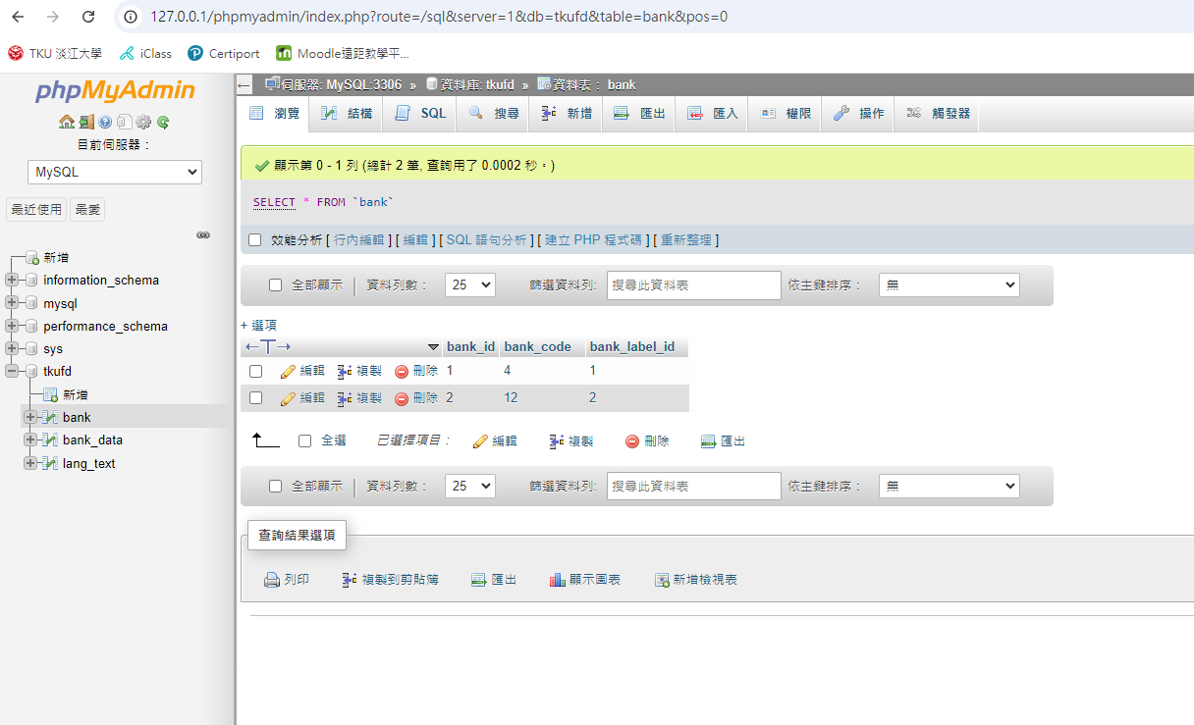

## 2024-10-11：作業04

### 作業說明

* 作業04-01：以SQL指令「在遠端」完成作業2、作業3。須附SQL及遠端截圖。
* 作業04-02：自行設定2~3個簡易查詢需求，並以SQL於近端查詢出來。須附SQL及近端截圖。
* 作業04-03：將資料庫和上述2~3個簡易查詢於遠端執行。須附SQL及遠端截圖。

### 作業04-01 SQL指令

遠端（MySQL < 8.0 / MariaDB < 6.1）：

|  |
| --- |
| **CREATE** **TABLE** bank (  bank_id BIGINT UNSIGNED AUTO_INCREMENT **NOT** **NULL**,  bank_code VARBINARY(255) **NOT** **NULL**,  bank_label_id BIGINT UNSIGNED **NOT** **NULL**,  **INDEX** bank_code (bank_code),  **PRIMARY** **KEY** (bank_id)  ) ENGINE=InnoDB, **DEFAULT** CHARSET=binary;  **CREATE** **TABLE** bank_data (  bd_id BIGINT UNSIGNED AUTO_INCREMENT **NOT** **NULL**,  bd_bank_id BIGINT UNSIGNED **NOT** **NULL**,  bd_type INT UNSIGNED **NOT** **NULL**,  bd_timestamp VARBINARY(24) **NOT** **NULL**,  bd_value BIGINT UNSIGNED **NOT** **NULL**,  **INDEX** bd_bid_type_timestamp (bd_bank_id, bd_type, bd_timestamp),  **PRIMARY** **KEY** (bd_id)  ) ENGINE=InnoDB, **DEFAULT** CHARSET=binary;  **CREATE** **TABLE** lang_text (  lt_id BIGINT UNSIGNED AUTO_INCREMENT **NOT** **NULL**,  lt_label_id BIGINT UNSIGNED **NOT** **NULL**,  lt_lang_id INT UNSIGNED **NOT** **NULL**,  lt_text VARBINARY(255) **NOT** **NULL**,  **INDEX** lt_label_lang (lt_label_id, lt_lang_id),  **PRIMARY** **KEY** (lt_id)  ) ENGINE=InnoDB, **DEFAULT** CHARSET=binary;  **INSERT INTO** bank (bank_id, bank_code, bank_label_id) **VALUES** (1, '004', 1);  **INSERT INTO** bank (bank_id, bank_code, bank_label_id) **VALUES** (2, '012', 2);  **INSERT INTO** bank (bank_id, bank_code, bank_label_id) **VALUES** (3, '013', 3);  **INSERT INTO** bank (bank_id, bank_code, bank_label_id) **VALUES** (4, '017', 4);  **INSERT INTO** bank (bank_id, bank_code, bank_label_id) **VALUES** (5, '021', 5);  **INSERT INTO** bank (bank_id, bank_code, bank_label_id) **VALUES** (6, '048', 6);  **INSERT INTO** bank (bank_id, bank_code, bank_label_id) **VALUES** (7, '052', 7);  **INSERT INTO** bank (bank_id, bank_code, bank_label_id) **VALUES** (8, '806', 8);  **INSERT INTO** bank (bank_id, bank_code, bank_label_id) **VALUES** (9, '807', 9);  **INSERT INTO** bank (bank_id, bank_code, bank_label_id) **VALUES** (10, '808', 10);  **INSERT INTO** bank (bank_id, bank_code, bank_label_id) **VALUES** (11, '809', 11);  **INSERT INTO** bank (bank_id, bank_code, bank_label_id) **VALUES** (12, '810', 12);  **INSERT INTO** bank (bank_id, bank_code, bank_label_id) **VALUES** (13, '810', 13);  **INSERT INTO** bank (bank_id, bank_code, bank_label_id) **VALUES** (14, '822', 14);  **INSERT INTO** bank_data (bd_id, bd_bank_id, bd_type, bd_timestamp, bd_value) **VALUES** (1, 1, 1, '2023', 1558889);  **INSERT INTO** bank_data (bd_id, bd_bank_id, bd_type, bd_timestamp, bd_value) **VALUES** (2, 2, 1, '2023', 1189926);  **INSERT INTO** bank_data (bd_id, bd_bank_id, bd_type, bd_timestamp, bd_value) **VALUES** (3, 3, 1, '2023', 1817179);  **INSERT INTO** bank_data (bd_id, bd_bank_id, bd_type, bd_timestamp, bd_value) **VALUES** (4, 4, 1, '2023', 960135);  **INSERT INTO** bank_data (bd_id, bd_bank_id, bd_type, bd_timestamp, bd_value) **VALUES** (5, 5, 1, '2023', 162491);  **INSERT INTO** bank_data (bd_id, bd_bank_id, bd_type, bd_timestamp, bd_value) **VALUES** (6, 6, 1, '2023', 36045);  **INSERT INTO** bank_data (bd_id, bd_bank_id, bd_type, bd_timestamp, bd_value) **VALUES** (7, 7, 1, '2023', 241939);  **INSERT INTO** bank_data (bd_id, bd_bank_id, bd_type, bd_timestamp, bd_value) **VALUES** (8, 8, 1, '2023', 797925);  **INSERT INTO** bank_data (bd_id, bd_bank_id, bd_type, bd_timestamp, bd_value) **VALUES** (9, 9, 1, '2023', 797143);  **INSERT INTO** bank_data (bd_id, bd_bank_id, bd_type, bd_timestamp, bd_value) **VALUES** (10, 10, 1, '2023', 1144109);  **INSERT INTO** bank_data (bd_id, bd_bank_id, bd_type, bd_timestamp, bd_value) **VALUES** (11, 11, 1, '2023', 160396);  **INSERT INTO** bank_data (bd_id, bd_bank_id, bd_type, bd_timestamp, bd_value) **VALUES** (12, 12, 1, '2023', 148198);  **INSERT INTO** bank_data (bd_id, bd_bank_id, bd_type, bd_timestamp, bd_value) **VALUES** (13, 13, 1, '2023', 921354);  **INSERT INTO** bank_data (bd_id, bd_bank_id, bd_type, bd_timestamp, bd_value) **VALUES** (14, 14, 1, '2023', 1163282);  **INSERT INTO** lang_text (lt_id, lt_label_id, lt_lang_id, lt_text) **VALUES** (1, 1, 672, '臺灣銀行');  **INSERT INTO** lang_text (lt_id, lt_label_id, lt_lang_id, lt_text) **VALUES** (2, 1, 2, 'Bank of Taiwan');  **INSERT INTO** lang_text (lt_id, lt_label_id, lt_lang_id, lt_text) **VALUES** (3, 2, 672, '台北富邦商業銀行');  **INSERT INTO** lang_text (lt_id, lt_label_id, lt_lang_id, lt_text) **VALUES** (4, 2, 2, 'Taipei Fubon Commercial Bank');  **INSERT INTO** lang_text (lt_id, lt_label_id, lt_lang_id, lt_text) **VALUES** (5, 3, 672, '國泰世華商業銀行');  **INSERT INTO** lang_text (lt_id, lt_label_id, lt_lang_id, lt_text) **VALUES** (6, 3, 2, 'Cathay United Bank');  **INSERT INTO** lang_text (lt_id, lt_label_id, lt_lang_id, lt_text) **VALUES** (7, 4, 672, '兆豐國際商業銀行');  **INSERT INTO** lang_text (lt_id, lt_label_id, lt_lang_id, lt_text) **VALUES** (8, 4, 2, 'Mega International Commercial Bank');  **INSERT INTO** lang_text (lt_id, lt_label_id, lt_lang_id, lt_text) **VALUES** (9, 5, 672, '花旗（台灣）商業銀行');  **INSERT INTO** lang_text (lt_id, lt_label_id, lt_lang_id, lt_text) **VALUES** (10, 5, 2, 'Citibank (Taiwan)');  **INSERT INTO** lang_text (lt_id, lt_label_id, lt_lang_id, lt_text) **VALUES** (11, 6, 672, '王道商業銀行');  **INSERT INTO** lang_text (lt_id, lt_label_id, lt_lang_id, lt_text) **VALUES** (12, 6, 2, 'O-Bank');  **INSERT INTO** lang_text (lt_id, lt_label_id, lt_lang_id, lt_text) **VALUES** (13, 7, 672, '渣打國際商業銀行');  **INSERT INTO** lang_text (lt_id, lt_label_id, lt_lang_id, lt_text) **VALUES** (14, 7, 2, 'Standard Chartered');  **INSERT INTO** lang_text (lt_id, lt_label_id, lt_lang_id, lt_text) **VALUES** (15, 8, 672, '元大商業銀行');  **INSERT INTO** lang_text (lt_id, lt_label_id, lt_lang_id, lt_text) **VALUES** (16, 8, 2, 'Yuanta Commercial Bank');  **INSERT INTO** lang_text (lt_id, lt_label_id, lt_lang_id, lt_text) **VALUES** (17, 9, 672, '永豐商業銀行');  **INSERT INTO** lang_text (lt_id, lt_label_id, lt_lang_id, lt_text) **VALUES** (18, 9, 2, 'Bank SinoPac');  **INSERT INTO** lang_text (lt_id, lt_label_id, lt_lang_id, lt_text) **VALUES** (19, 10, 672, '玉山商業銀行');  **INSERT INTO** lang_text (lt_id, lt_label_id, lt_lang_id, lt_text) **VALUES** (20, 10, 2, 'E.SUN Commercial Bank');  **INSERT INTO** lang_text (lt_id, lt_label_id, lt_lang_id, lt_text) **VALUES** (21, 11, 672, '凱基商業銀行');  **INSERT INTO** lang_text (lt_id, lt_label_id, lt_lang_id, lt_text) **VALUES** (22, 11, 2, 'KGI Bank');  **INSERT INTO** lang_text (lt_id, lt_label_id, lt_lang_id, lt_text) **VALUES** (23, 12, 672, '星展（台灣）商業銀行');  **INSERT INTO** lang_text (lt_id, lt_label_id, lt_lang_id, lt_text) **VALUES** (24, 12, 2, 'DBS Bank (Taiwan)');  **INSERT INTO** lang_text (lt_id, lt_label_id, lt_lang_id, lt_text) **VALUES** (25, 13, 672, '台新國際商業銀行');  **INSERT INTO** lang_text (lt_id, lt_label_id, lt_lang_id, lt_text) **VALUES** (26, 13, 2, 'Taishin International Bank');  **INSERT INTO** lang_text (lt_id, lt_label_id, lt_lang_id, lt_text) **VALUES** (27, 14, 672, '中國信託商業銀行');  **INSERT INTO** lang_text (lt_id, lt_label_id, lt_lang_id, lt_text) **VALUES** (28, 14, 2, 'CTBC Bank'); |

### 作業04-01截圖

### 作業04-02 SQL指令

|  |
| --- |
| ; |

### 作業04-02截圖

### 作業04-03 SQL指令

|  |
| --- |
| ; |

### 作業04-03截圖

## 2024-10-18：作業05

### 作業說明

* 作業05-01：設計網頁並以PHP程式查出「單一資料表」所有資料並輸出。須附PHP及近端截圖。
* 作業05-02：設計網頁並以PHP程式查出「單一資料表」所有資料並輸出。須附SQL及遠端截圖。

### PHP程式

|  |
| --- |
| <?php |

### 作業05-01近端截圖

### 作業05-02遠端截圖