2024-09-20

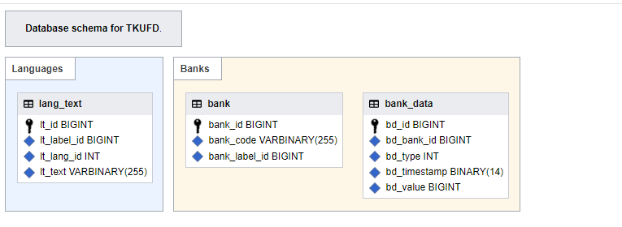

實體關係圖entity relation diagram

2024-09-27

**CREATE DATABASE tkufd DEFAULT CHARACTER SET=utf8mb4 DEFAULT COLLATE=utf8mb4_unicode_ci;**

**USE tkufd;**

**CREATE TABLE lang_text (**

**lt_id BIGINT UNSIGNED NOT NULL,**

**lt_label_id BIGINT UNSIGNED NOT NULL,**

**lt_lang_id INT UNSIGNED NOT NULL,**

**lt_text VARBINARY(255) NOT NULL,**

**INDEX lt_label_lang (lt_label_id, lt_lang_id),**

**PRIMARY KEY(lt_id)**

**) ENGINE=InnoDB, DEFAULT CHARSET=binary;**

**CREATE TABLE bank (**

**bank_id BIGINT UNSIGNED NOT NULL,**

**bank_code VARBINARY(255) NOT NULL,**

**bank_label_id BIGINT UNSIGNED NOT NULL,**

**INDEX bank_code (bank_code),**

**PRIMARY KEY(bank_id)**

**) ENGINE=InnoDB, DEFAULT CHARSET=binary;**

**CREATE TABLE bank_data (**

**bd_id BIGINT UNSIGNED NOT NULL,**

**bd_bank_id BIGINT UNSIGNED NOT NULL,**

**bd_type INT UNSIGNED NOT NULL,**

**bd_timestamp BINARY(14) NOT NULL,**

**bd_value BIGINT UNSIGNED NOT NULL,**

**INDEX bd_bid_type_timestamp (bd_bank_id, bd_type, bd_timestamp),**

**PRIMARY KEY(bd_id)**

**) ENGINE=InnoDB, DEFAULT CHARSET=binary;**

2024-10-04

多語言文字 lang_text

|  |  |  |  |
| --- | --- | --- | --- |
| lt_id | lt_label_id | lt_lang_id | lt_text |
| 1 | 1 | 672 | 臺灣銀行 |
| 2 | 1 | 2 | Bank of Taiwan |
| 3 | 2 | 672 | 台北富邦商業銀行 |
| 4 | 2 | 2 | Taipei Fubon Commercial Bank |
| 5 | 3 | 672 | 國泰世華商業銀行 |
| 6 | 3 | 2 | Cathay United Bank |
| 7 | 4 | 672 | 兆豐國際商業銀行 |
| 8 | 4 | 2 | Mega International Commercial Bank |
| 9 | 5 | 672 | 花旗（台灣）商業銀行 |
| 10 | 5 | 2 | Citibank (Taiwan) |
| 11 | 6 | 672 | 王道商業銀行 |
| 12 | 6 | 2 | O-Bank |
| 13 | 7 | 672 | 渣打國際商業銀行 |
| 14 | 7 | 2 | Standard Chartered |
| 15 | 8 | 672 | 元大商業銀行 |
| 16 | 8 | 2 | Yuanta Commercial Bank |
| 17 | 9 | 672 | 永豐商業銀行 |
| 18 | 9 | 2 | Bank SinoPac |
| 19 | 10 | 672 | 玉山商業銀行 |
| 20 | 10 | 2 | E.SUN Commercial Bank |
| 21 | 11 | 672 | 凱基商業銀行 |
| 22 | 11 | 2 | KGI Bank |
| 23 | 12 | 672 | 星展（台灣）商業銀行 |
| 24 | 12 | 2 | DBS Bank (Taiwan) |
| 25 | 13 | 672 | 台新國際商業銀行 |
| 26 | 13 | 2 | Taishin International Bank |
| 27 | 14 | 672 | 中國信託商業銀行 |
| 28 | 14 | 2 | CTBC Bank |

INSERT INTO `lang_text` VALUES (1,1,672,'台灣銀行');

INSERT INTO `lang_text` VALUES (1,1,2,' Bank of Taiwan ');

INSERT INTO `lang_text` VALUES (1,2,672,'台北富邦商業銀行');

INSERT INTO `lang_text` VALUES (1,2,2,' Taipei Fubon Commercial Bank ');

INSERT INTO `lang_text` VALUES (1,3,672,'國泰世華商業銀行');

INSERT INTO `lang_text` VALUES (1,3,2,' Cathay United Bank ');

INSERT INTO `lang_text` VALUES (1,4,672,'兆豐國際商業銀行');

INSERT INTO `lang_text` VALUES (1,4,2,' Mega International Commercial Bank ');

INSERT INTO `lang_text` VALUES (1,5,672,'花旗（台灣）商業銀行');

INSERT INTO `lang_text` VALUES (1,5,2,' Citibank (Taiwan)');

INSERT INTO `lang_text` VALUES (1,6,672,'王道商業銀行');

INSERT INTO `lang_text` VALUES (1,6,2,' O-Bank ');

INSERT INTO `lang_text` VALUES (1,7,672,'渣打國際商業銀行');

INSERT INTO `lang_text` VALUES (1,7,2,' Standard Chartered ');

INSERT INTO `lang_text` VALUES (1,8,672,'元大商業銀行');

INSERT INTO `lang_text` VALUES (1,8,2,' Yuanta Commercial Bank ');

INSERT INTO `lang_text` VALUES (1,9,672,'永豐商業銀行');

INSERT INTO `lang_text` VALUES (1,9,2,' Bank SinoPac ');

INSERT INTO `lang_text` VALUES (1,10,672,'玉山商業銀行');

INSERT INTO `lang_text` VALUES (1,10,2,' E.SUN Commercial Bank ');

INSERT INTO `lang_text` VALUES (1,11,672,'凱基商業銀行');

INSERT INTO `lang_text` VALUES (1,11,2,' KGI Bank ');

INSERT INTO `lang_text` VALUES (1,13,672,'星展（台灣）商業銀行');

INSERT INTO `lang_text` VALUES (1,13,2,' DBS Bank (Taiwan)');

INSERT INTO `lang_text` VALUES (1,14,672,'中國信託商業銀行');

INSERT INTO `lang_text` VALUES (1,14,2,' CTBC Bank ');

銀行 bank

|  |  |  |
| --- | --- | --- |
| bank_id | bank_code | bank_label_id |
| 1 | 004 | 1 |
| 2 | 012 | 2 |
| 3 | 013 | 3 |
| 4 | 017 | 4 |
| 5 | 021 | 5 |
| 6 | 048 | 6 |
| 7 | 052 | 7 |
| 8 | 806 | 8 |
| 9 | 807 | 9 |
| 10 | 808 | 10 |
| 11 | 809 | 11 |
| 12 | 810 | 12 |
| 13 | 812 | 13 |
| 14 | 822 | 14 |

INSERT INTO `bank` VALUES (1,’004’,1);

INSERT INTO `bank` VALUES (2,’012’,2);

INSERT INTO `bank` VALUES (3,’013’,3);

INSERT INTO `bank` VALUES (4,’017’,4);

INSERT INTO `bank` VALUES (5,’021’,5);

INSERT INTO `bank` VALUES (6,’048’,6);

INSERT INTO `bank` VALUES (7,’052’,7);

INSERT INTO `bank` VALUES (8,’806’,8);

INSERT INTO `bank` VALUES (9,’807’,9);

INSERT INTO `bank` VALUES (10,’808’,10);

INSERT INTO `bank` VALUES (11,’809’,11);

INSERT INTO `bank` VALUES (12,’810’,12);

INSERT INTO `bank` VALUES (13,’812’,13);

INSERT INTO `bank` VALUES (14,’822’,14);

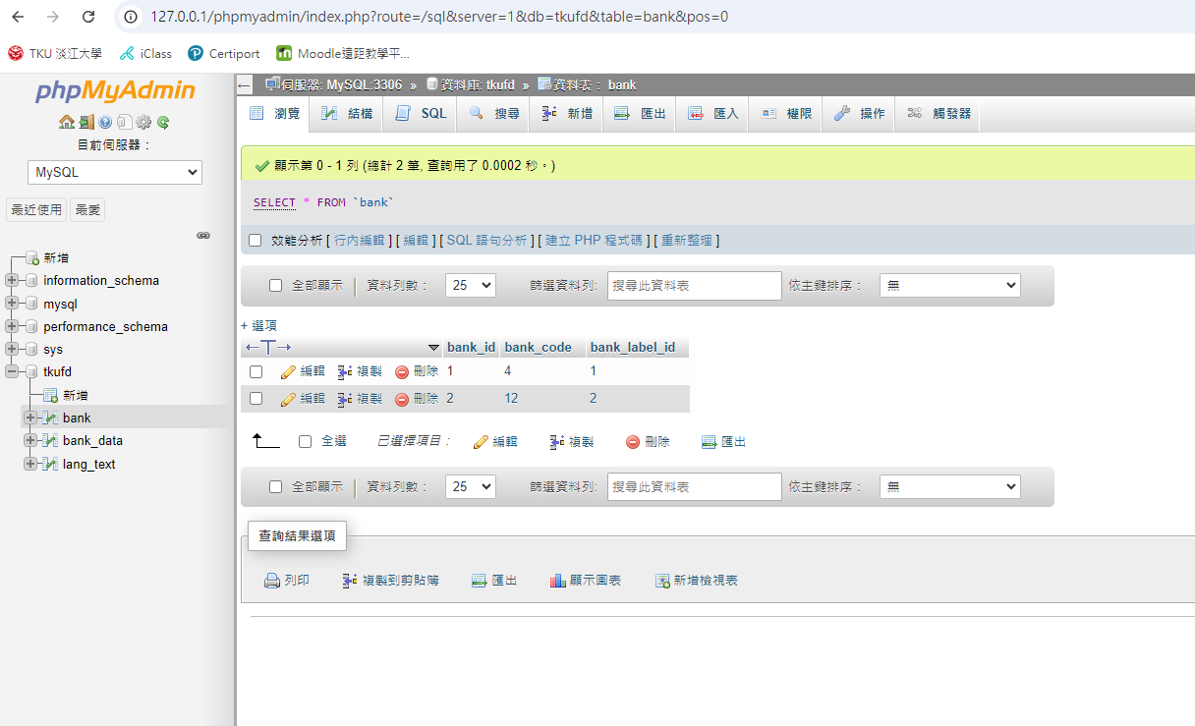

銀行資料 bank_data

|  |  |  |  |  |
| --- | --- | --- | --- | --- |
| bd_id | bd_bank_id | bd_type | bd_timestamp | bd_value |
| 1 | 1 | 1 | 202312 | 1558889 |
| 2 | 2 | 1 | 202312 | 1189926 |
| 3 | 3 | 1 | 202312 | 1817179 |
| 4 | 4 | 1 | 202312 | 960135 |
| 5 | 5 | 1 | 202312 | 162491 |
| 6 | 6 | 1 | 202312 | 36045 |
| 7 | 7 | 1 | 202312 | 241939 |
| 8 | 8 | 1 | 202312 | 797925 |
| 9 | 9 | 1 | 202312 | 797143 |
| 10 | 10 | 1 | 202312 | 1144109 |
| 11 | 11 | 1 | 202312 | 160396 |
| 12 | 12 | 1 | 202312 | 148198 |
| 13 | 13 | 1 | 202312 | 921354 |
| 14 | 14 | 1 | 202312 | 1163282 |

INSERT INTO `bank_data` VALUES (1,1,1,202312,1558889);

INSERT INTO `bank_data` VALUES (2,2,1,202312,118926);

INSERT INTO `bank_data` VALUES (3,3,1,202312,1817179);

INSERT INTO `bank_data` VALUES (4,4,1,202312,960135);

INSERT INTO `bank_data` VALUES (5,5,1,202312,162491);

INSERT INTO `bank_data` VALUES (6,6,1,202312,36045);

INSERT INTO `bank_data` VALUES (7,7,1,202312, 241939);

INSERT INTO `bank_data` VALUES (8,8,1,202312, 797925);

INSERT INTO `bank_data` VALUES (9,9,1,202312, 797143);

INSERT INTO `bank_data` VALUES (10,10,1,202312, 1144109);

INSERT INTO `bank_data` VALUES (11,11,1,202312, 160396);

INSERT INTO `bank_data` VALUES (12,12,1,202312, 148198);

INSERT INTO `bank_data` VALUES (13,13,1,202312, 921354);

INSERT INTO `bank_data` VALUES (14,14,1,202312, 1163282);

2024-10-11

SELECT * FROM `bank_data` WHERE 1