|  |  |  |  |  |  |  |  |  |
| --- | --- | --- | --- | --- | --- | --- | --- | --- |
| Id (編號) | bank code (銀行代碼) | Bank  (銀行) | Balance at the end of the month - demand deposit (月底餘額-活期性存款) | Loan-average monthly balance (放款-月平均餘額) | Derivative financial products-nominal principal balance (衍生性金融產品-名目本金餘額) | Margin item balance (保證金項餘額) | Automated service machine-number of financial cards issued (自動化服務機器-發行金融卡數) | Financial Structure - Assets (財務結構-資產) |
| 1 | 004 | 台灣銀行 | 1,558,889 | 3,126,354 | 36,165 | 94,601 | 10,077,904 | 6,160,215 |
| 2 | 012 | 台北富邦商業銀行 | 1,189,926 | 2,005,076 | 115,545 | 25,243 | 10,931,678 | 3,811,675 |
| 3 | 013 | 國泰世華商業銀行 | 1,817,179 | 2,224,879 | 191,261 | 18,836 | 11,517,599 | 4,091,073 |
| 4 | 017 | 兆豐國際商業銀行 | 960,135 | 2,131,583 | 31,767 | 137,869 | 6,003,930 | 3,964,527 |
| 5 | 021 | 花旗(台灣)商業銀行 | 162,491 | 69,243 | 37,605 | 11,008 | 1,479,961 | 495,421 |
| 6 | 048 | 王道商業銀行 | 36,045 | 204,976 | 5,306 | 26,010 | 665,310 | 390,571 |
| 7 | 052 | 渣打國際商業銀行 | 241,939 | 298,279 | 185,559 | 10,277 | 2,749,535 | 719,252 |
| 8 | 806 | 元大商業銀行 | 797,925 | 1,068,042 | 13,070 | 12,335 | 4,483,031 | 1,835,119 |
| 9 | 807 | 永豐商業銀行 | 797,143 | 1,418,709 | 124,042 | 29,714 | 6,875,193 | 2,476,216 |
| 10 | 808 | 玉山商業銀行 | 1,144,109 | 2,031,607 | 97,761 | 21,114 | 7,782,734 | 3,530,017 |
| 11 | 809 | 凱基商業銀行 | 160,396 | 404,648 | 83,601 | 15,452 | 4,391,225 | 790,198 |
| 12 | 810 | 星展(台灣)商業銀行 | 148,198 | 471,767 | 33,116 | 43,277 | 1,586,364 | 879,565 |
| 13 | 810 | 台新國際商業銀行 | 921,354 | 1,538,199 | 138,835 | 25,481 | 10,745,407 | 2,640,276 |
| 14 | 822 | 中國信託商業銀行 | 1,663,282 | 2,803,868 | 240,959 | 71,332 | 13,352,772 | 5,112,187 |
| 15 | 700 | 中華郵政 | - | - | - | - | - | 2,416,530 |
| 16 | 228 | 農會信用部 | - | - | - | - | 58,707,475 | 7,422,453 |

資料表綱要

112年

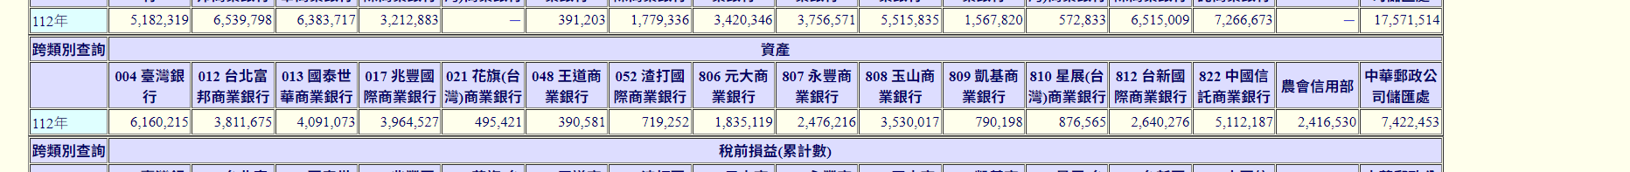

ERD圖: