

Website Specifications: Special Cakes for all Occasions

Contents

1. Client requirements 3

2. Website pages 3

2.1 Each page 3

2.2 Home 3

2.3 Cakes for sale 4

2.4 About 5

2.5 Contact us 6

3. Images 7

3.1 Additional images required 7

4. Style guide and layout 8

5. Guidelines and requirements 9

1. Client requirements

Special Cakes for All Occasions wants to use the website to promote their products, which will initially contain three pages. Their basic requirements are:

* the website needs to be completely functional and display correctly in common browsers
* the business owner does not want to update the website themselves and has asked ROI to maintain it.

1. Website pages
   1. Each page

Each page in the website must have a consistent background, with a suitable web banner image and the company logo. The logo image must have a link that takes you back to the Home page. See the **Images** section below for more detail.

* 1. Home

**Main page heading:** Welcome to Special Cakes for All Occasions

**Page sub heading (tag line):** We have the cakes for all your special events

Special Cakes for All Occasions is the answer to all your cake needs, serving a wide variety of sweets perfect for an office treat, birthday and other celebrations.

**Sub heading:** Come and visit us

23 Pacific Hwy, Sydney NSW

Phone: 8965 1234

Email: specialcakes@email.com

**Sub heading:** Bakery hours

Monday-Friday 8.30 am to 3 pm

Saturday and Sunday 8.30 am to 1 pm

**Images:** A suitable image needs to be sourced for this page. See the Images section below for more detail.

* 1. Cakes for sale

**Main page heading:** Cakes for Sale

**Images:** This page displays six product images and the product name (include a link on each image to display a larger image). Several images have been provided to use on this page, contained in the images folder – select six images from those provided for the following products:

* Speciality cakes
* Flavoured cakes
* Cheesecakes
* Brownies
* Cupcakes
* Macarons

**Sub heading:** Prices

**Developer instructions:** Include the following prices in a table:

Table 1 – Cakes for sale

| Cake Size | Suitable for | Price |
| --- | --- | --- |
| Small | 8-10 people | $50.00 |
| Medium | 10-12 people | $60.00 |
| Large | 16-10 people | $100.00 |

**Sub heading:** How to order

If you’re interested in ordering a cake for your special occasion, let us know!

Developer instructions: Include a form to be used by customers to enquire about ordering cakes. This must capture the following information, which will be emailed to the shop’s email address:

* Name
* Email address
* Phone number
* The type of cake required
* Date required.

For example:

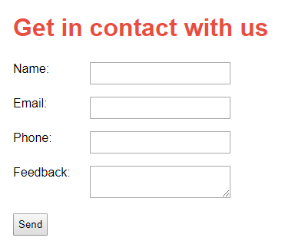

* 1. About

**Main page heading:** About Special Cakes for All Occasions

Special Cakes for All Occasions started a year ago by the store owner, Sam Rice, who wanted to share their love of baking with the world. Come and taste all the delightful cakes!

**Images:** A suitable image needs to be sourced for this page. See the Images section below for more detail.

**Sub heading:** Job opportunities

Come and work for us!

**Developer instructions:** Display the following in a table:

Table 2 – About

| Job title | Job description | Salary |
| --- | --- | --- |
| Pastry chef | Specialises in pastry desserts. Must have four years of experience. | $50,000 p.a. |
| Sales assistant | Serves customers in the shop and operates the cash register. | $25,000 p.a. |

* 1. Contact us

**Main page heading:** Get in touch with us

**Developer instructions:** Include a form to capture the following information, which will be emailed to the shop’s email address:

* Name
* Email address
* Phone number
* The person’s question or feedback.

For example:



1. Images

The company’s policy is to source images from places that do not have copyright restrictions or to use original photography.

The company takes its responsibility to adhere to copyright legislative requirements very seriously when sourcing, manipulating, saving and using images.

Images must follow industry standards and accessibility guidelines. For example, use a description on the image so that screen readers can identify that an image exists and what the image is.

The image filenames need to describe the content of the image and the pixel size of the longest edge of the image. Filenames should be descriptive and not longer than 32 characters. For example, an image of a brownie resized to 300 pixels wide would be named brownie300.jpg.

* 1. Additional images required

The company needs three images to be sourced, for a web banner (on each page) and for the Home and About pages. The images must promote the business in a professional and positive manner. They may include customers in a bakery, people eating cake, people baking and so on.

They would like to see your skills in image manipulation and want to see a range of appropriate effects on these images. They want the effects to be subtle so that they still look professional, for example, a monochrome effect or the addition of a slight texture.

The images need to be of at least web-quality resolution.

The web banner image should be saved with the following dimensions:

* Width 1200px, height 360px.

The two images for the Home and About pages should be saved with the following dimensions:

* Width 975px, height 750px.

1. Style guide and layout

The company logo has been provided and should appear at the top of each page. Clicking the logo will always take the user to the home page.

The company colours are:

* Burnt red: #E94D40
* Navy blue: #0C243C

The logo needs to appear on a white background

The font type to be used on each page is: Arial

The footer should contain the year the website was created and your full name.

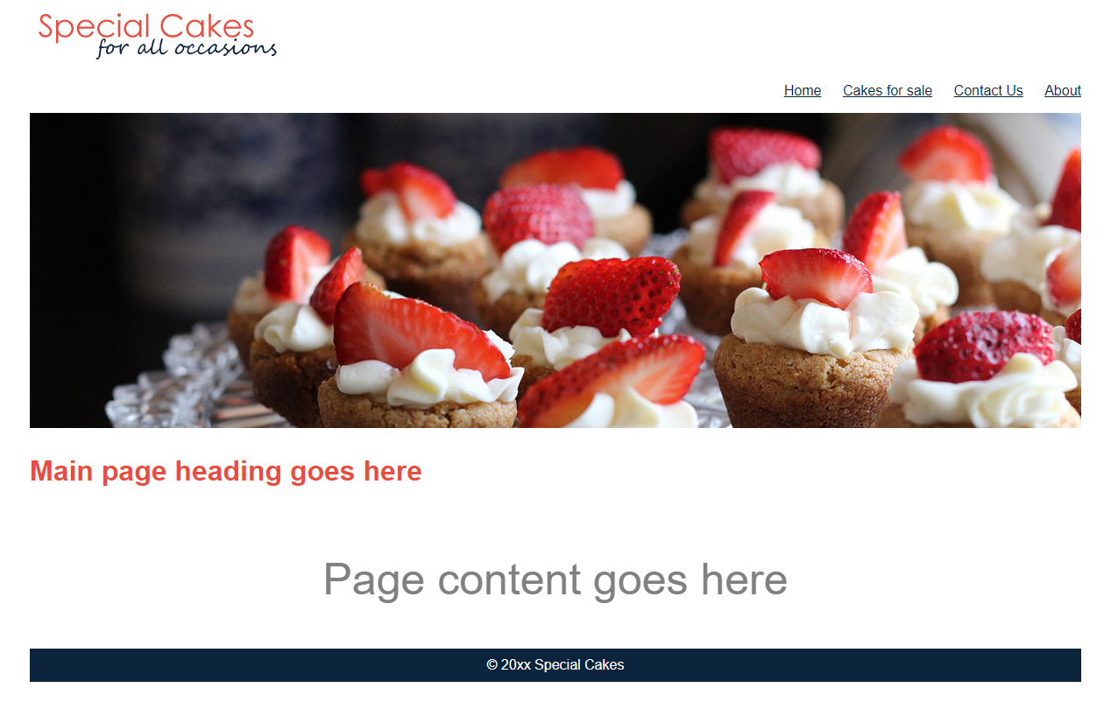Below is an example of a suitable layout: 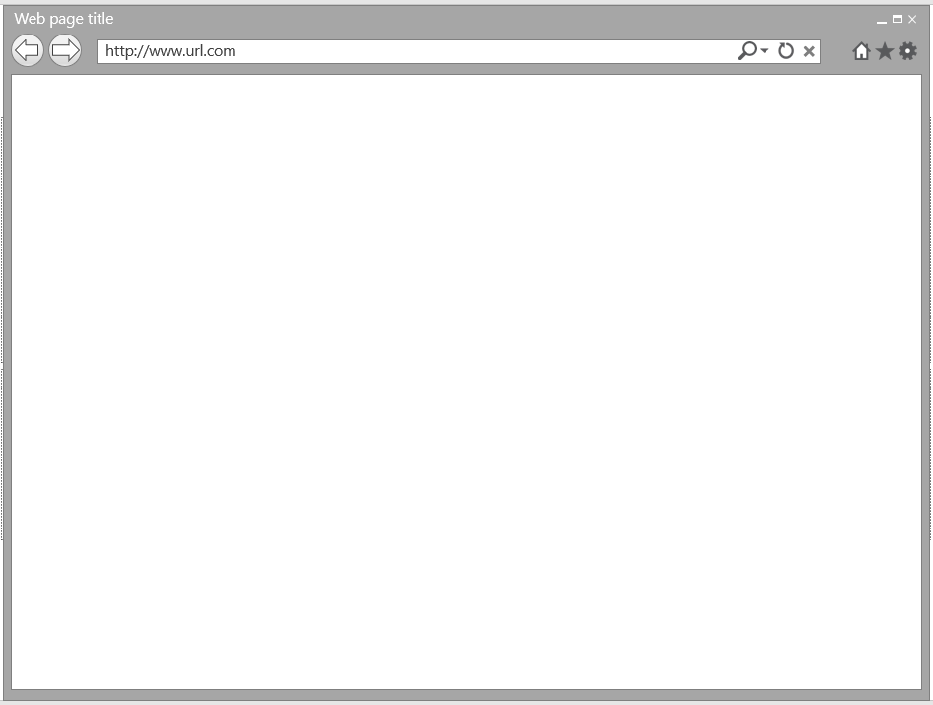

1. Guidelines and requirements

Special Cakes for all Occasions requirements for all websites it creates are that they must:

* display consistently in common browsers
* use valid markup
* meet the most current Web Content Accessibility Guidelines
* be tested for security issues.

A folder must be created for each website using the client name, or suitable abbreviation, with a subfolder called ‘images’ to store the website images. In this instance, a suitable folder name would be *specialcakes*.