Mean Compound Scores (570 participants)

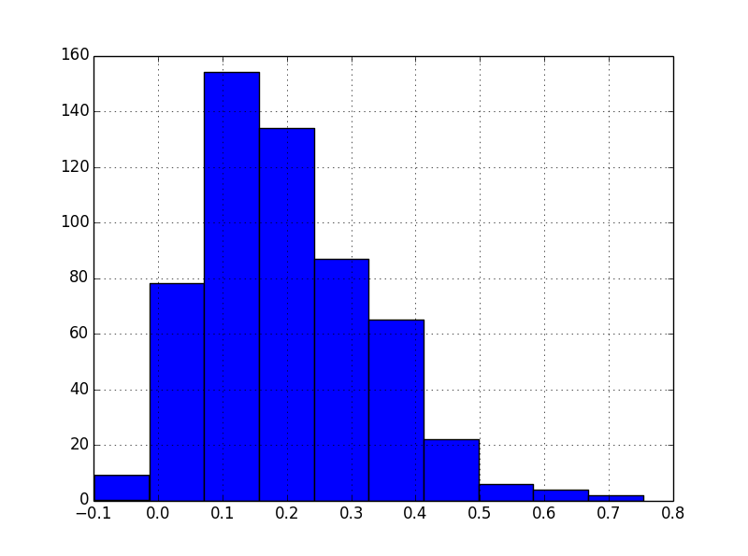

Mean Positivity Scores

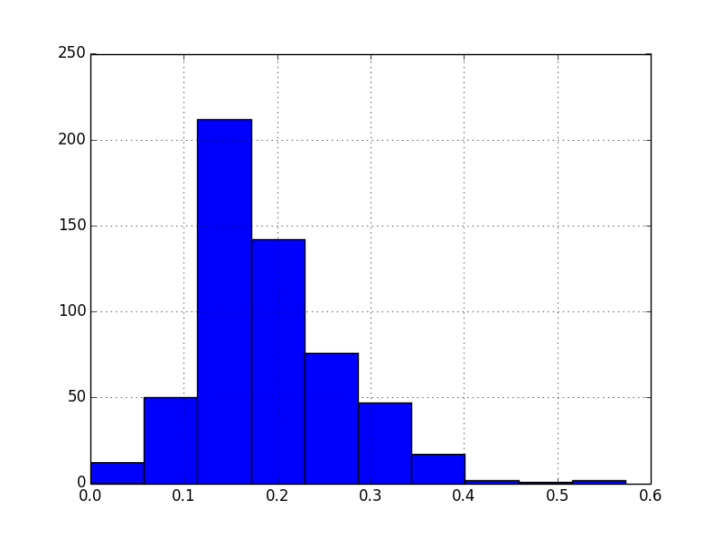

Mean Negativity Scores

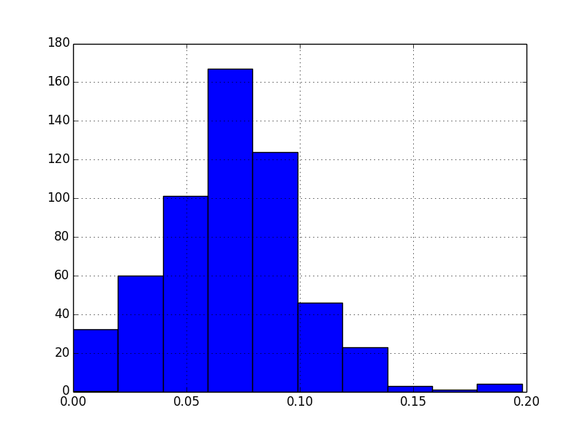

Mean Neutrality Scores

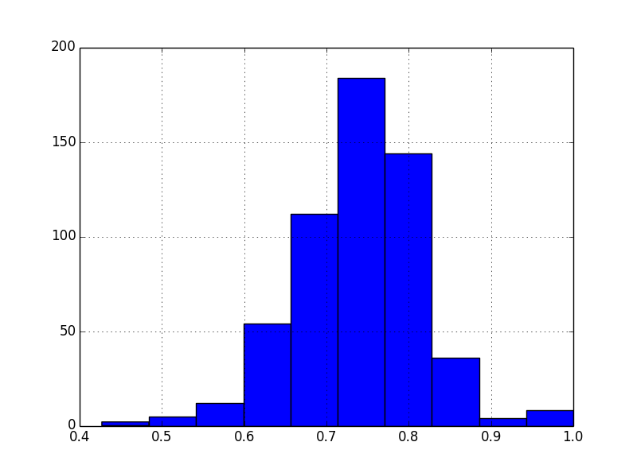

Compound Score for all Status updates for participants in our experiment. ~ 145,000 Statuses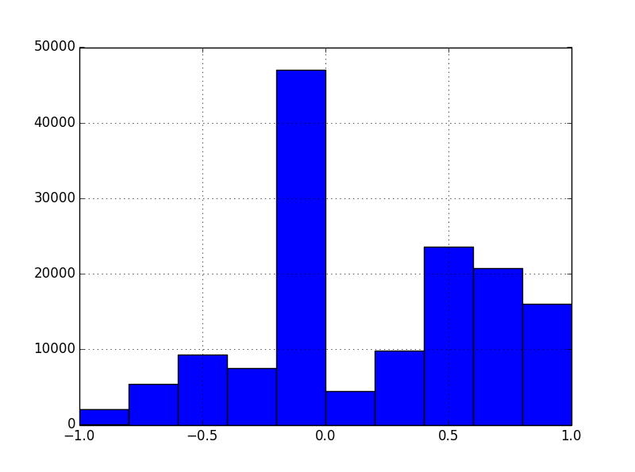

Neutral Scores for all Statuses

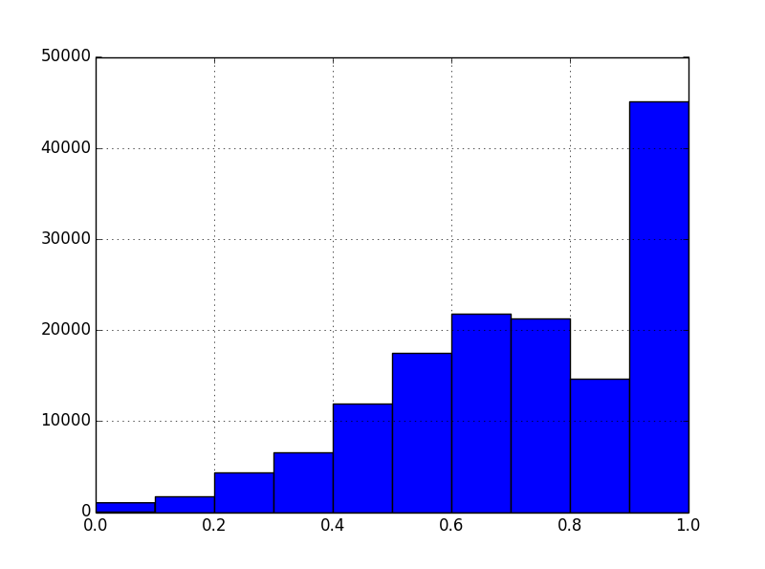

Positivity Scores for all Statuses

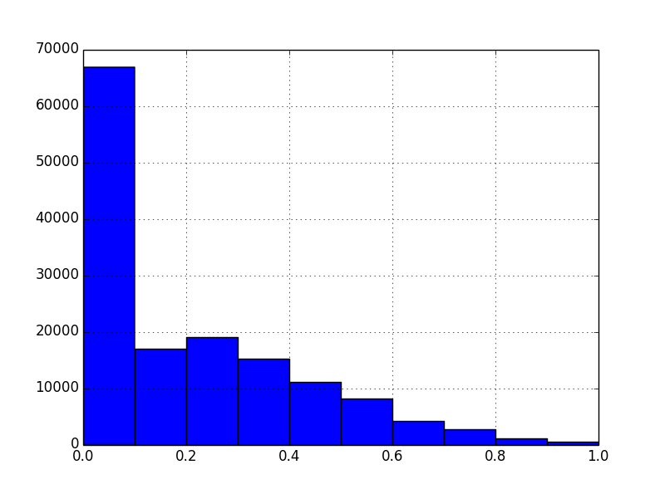

Negativity Scores for all Statuses

