Sample Materials

The survey can be found on the following link: <http://smallsocialsystems.com/asaf/IdentitySurvey.php>

Here are the material from that survey:

INSTRUCTIONS:

Welcome to the study! To start you will be asked a few demographic questions. You will then be presented a series of questions about what you identify with. The entire survey should take less than 15 minutes and could greatly help us understand how people express their identities in on-line social networks. Thanks in advance for your participation.

*Note: Though many questions will appear similar to each other, each question has unique features and is important for our analysis. We encourage you to answer them all.

DEMOGRAPHICS:

1. Gender

  Male   
  Female   
  Decline to answer

1. Year of Birth



1. Ethnicity. Check all that apply

  White   
  Black, African-American, or Negro   
  Hispanic or Latino   
  Asian Indian   
  Other Asian   
  Hawaiian, Pacific Islander   
  American Indian or Alaskan Native   
  Other



1. Highest education level attained

***Below are screen shots with questions and instructions from the remainder of the survey:





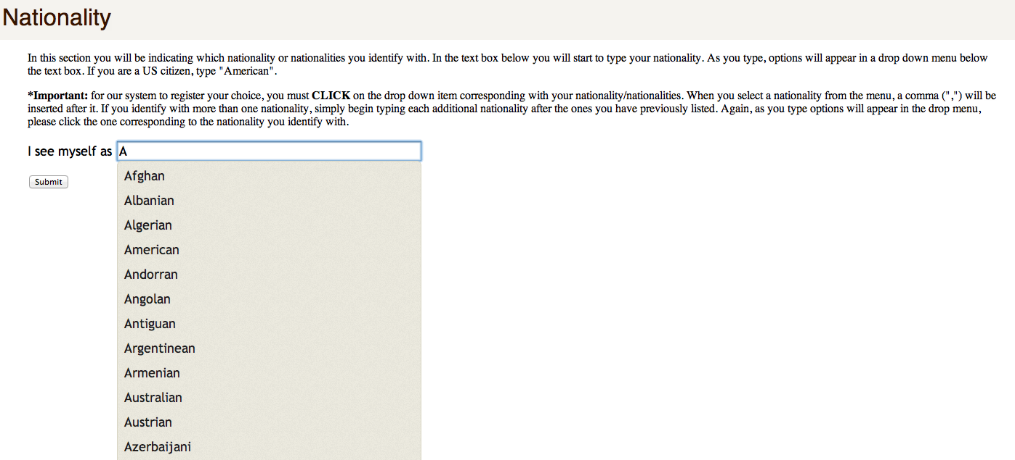

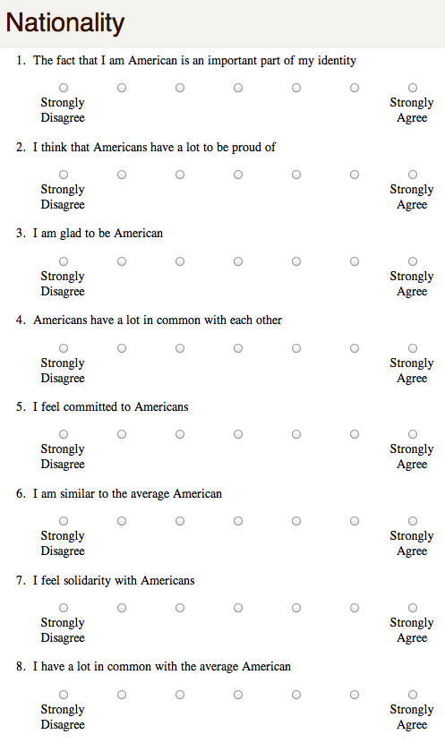

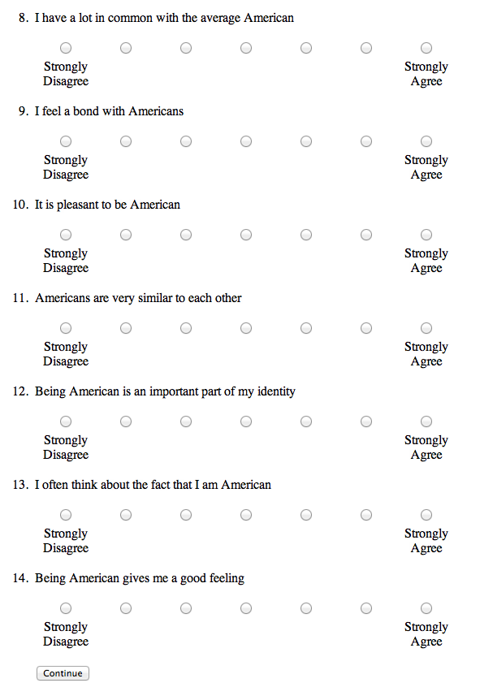

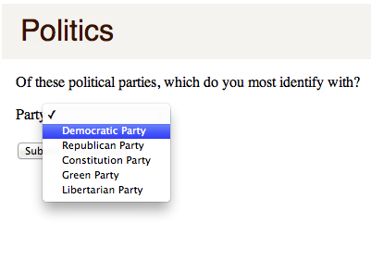

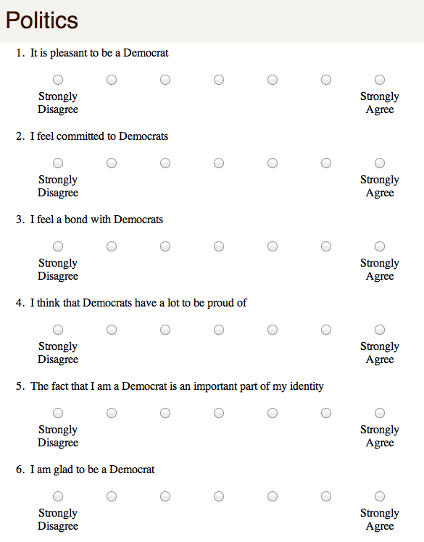

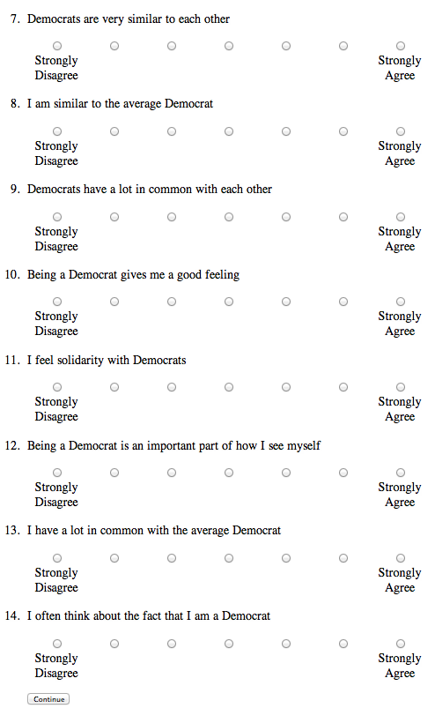

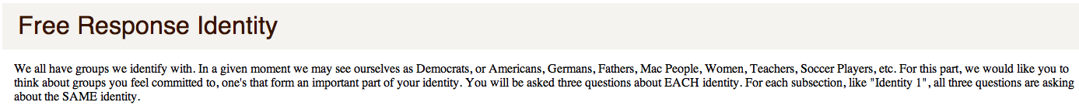

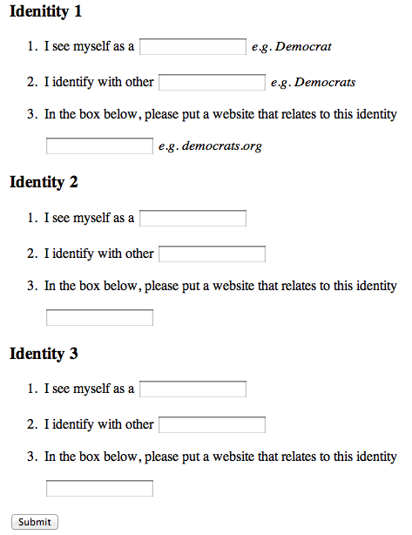

**CONTINGENCIES OF SELF-WORTH SCALE**

**\*Item is reverse-scored** such that 7=1, 6=2, 5=3, 4=4, 3=5, 2=6, 1=7.

**FAMILY** **SUPPORT**: items **7,** **10*, 16, 24,** and **29.**

**COMPETITION:** items **3, 12, 20, 25,** and **32**.

**APPEARANCE:** items **1,** **4*, 17, 21,** and **30*.**

**GOD’S LOVE:** items **2, 8, 18, 26,** and **31.**

**ACADEMIC COMPETENCE**: items **13*, 19, 22, 27,** and **33.**

**VIRTUE:** items **5, 11, 14, 28,** and **34.**

**APPROVAL FROM OTHERS:**  items: **6*,** **9,** **15*, 23*,** and **35.**

INSTRUCTIONS: Please respond to each of the following statements by circling your answer using the scale from "1 = Strongly disagree" to "7 = Strongly agree.” If you haven't experienced the situation described in a particular statement, please answer how you think you would feel if that situation occurred.

|  |  |  |  |  |  |  |  |  |
| --- | --- | --- | --- | --- | --- | --- | --- | --- |
|  |  | Strongly Disagree | Disagree | Disagree Somewhat | Neutral | Agree Somewhat | Agree | Strongly  Agree |
| 1. | When I think I look attractive, I feel good about myself. | 1 | 2 | 3 | 4 | 5 | 6 | 7 |
| 2. | My self-worth is based on God’s love. | 1 | 2 | 3 | 4 | 5 | 6 | 7 |
| 3. | I feel worthwhile when I perform better than others on a task or skill. | 1 | 2 | 3 | 4 | 5 | 6 | 7 |
| 4. | My self-esteem is unrelated to how I feel about the way my body looks. | 1 | 2 | 3 | 4 | 5 | 6 | 7 |
| 5. | Doing something I know is wrong makes me lose my self-respect. | 1 | 2 | 3 | 4 | 5 | 6 | 7 |
| 6. | I don’t care if other people have a negative opinion about me. | 1 | 2 | 3 | 4 | 5 | 6 | 7 |
| 7. | Knowing that my family members love me makes me feel good about myself. | 1 | 2 | 3 | 4 | 5 | 6 | 7 |
| 8. | I feel worthwhile when I have God’s love. | 1 | 2 | 3 | 4 | 5 | 6 | 7 |
| 9. | I can’t respect myself if others don’t respect me. | 1 | 2 | 3 | 4 | 5 | 6 | 7 |
| 10. | My self-worth is not influenced by the quality of my relationships with my family members. | 1 | 2 | 3 | 4 | 5 | 6 | 7 |
| 11. | Whenever I follow my moral principles, my sense of self-respect gets a boost. | 1 | 2 | 3 | 4 | 5 | 6 | 7 |
| 12. | Knowing that I am better than others on a task raises my self-esteem. | 1 | 2 | 3 | 4 | 5 | 6 | 7 |
| 13. | My opinion about myself isn’t tied to how well I do in school. | 1 | 2 | 3 | 4 | 5 | 6 | 7 |
| 14. | I couldn’t respect myself if I didn’t live up to a moral code. | 1 | 2 | 3 | 4 | 5 | 6 | 7 |
| 15. | I don’t care what other people think of me. | 1 | 2 | 3 | 4 | 5 | 6 | 7 |
| 16. | When my family members are proud of me, my sense of self-worth increases. | 1 | 2 | 3 | 4 | 5 | 6 | 7 |
| 17. | My self-esteem is influenced by how attractive I think my face or facial features are. | 1 | 2 | 3 | 4 | 5 | 6 | 7 |
| 18. | My self-esteem would suffer if I didn’t have God’s love. | 1 | 2 | 3 | 4 | 5 | 6 | 7 |

|  |  |  |  |  |  |  |  |  |
| --- | --- | --- | --- | --- | --- | --- | --- | --- |
|  |  | Strongly Disagree | Disagree | Disagree Somewhat | Neutral | Agree Somewhat | Agree | Strongly  Agree |
| 19. | Doing well in school gives me a sense of self-respect. | 1 | 2 | 3 | 4 | 5 | 6 | 7 |
| 20. | Doing better than others gives me a sense of self-respect. | 1 | 2 | 3 | 4 | 5 | 6 | 7 |
| 21. | My sense of self-worth suffers whenever I think I don’t look good. | 1 | 2 | 3 | 4 | 5 | 6 | 7 |
| 22. | I feel better about myself when I know I’m doing well academically. | 1 | 2 | 3 | 4 | 5 | 6 | 7 |
| 23. | What others think of me has no effect on what I think about myself. | 1 | 2 | 3 | 4 | 5 | 6 | 7 |
| 24. | When I don’t feel loved by my family, my self-esteem goes down. | 1 | 2 | 3 | 4 | 5 | 6 | 7 |
| 25. | My self-worth is affected by how well I do when I am competing with others. | 1 | 2 | 3 | 4 | 5 | 6 | 7 |
| 26. | My self-esteem goes up when I feel that God loves me. | 1 | 2 | 3 | 4 | 5 | 6 | 7 |
| 27. | My self-esteem is influenced by my academic performance. | 1 | 2 | 3 | 4 | 5 | 6 | 7 |
| 28. | My self-esteem would suffer if I did something unethical. | 1 | 2 | 3 | 4 | 5 | 6 | 7 |
| 29. | It is important to my self-respect that I have a family that cares about me. | 1 | 2 | 3 | 4 | 5 | 6 | 7 |
| 30. | My self-esteem does not depend on whether or not I feel attractive. | 1 | 2 | 3 | 4 | 5 | 6 | 7 |
| 31. | When I think that I’m disobeying God, I feel bad about myself. | 1 | 2 | 3 | 4 | 5 | 6 | 7 |
| 32. | My self-worth is influenced by how well I do on competitive tasks. | 1 | 2 | 3 | 4 | 5 | 6 | 7 |
| 33. | I feel bad about myself whenever my academic performance is lacking. | 1 | 2 | 3 | 4 | 5 | 6 | 7 |
| 34. | My self-esteem depends on whether or not I follow my moral/ethical principles. | 1 | 2 | 3 | 4 | 5 | 6 | 7 |
| 35. | My self-esteem depends on the opinions others hold of me. | 1 | 2 | 3 | 4 | 5 | 6 | 7 |