Intro

Welcome to the study! To start you will be asked a few demographic questions. After answering these, you will be presented with a series of questions about what you identify with. The entire survey should take less than 15 minutes and could greatly help us understand how people express their identities in on-line social networks. Thanks in advance for your participation.

Nationality Section

In this section you will be indicating which nationality or nationalities you identify with. In the text box below you will start to type your nationality. As you type, options will appear in a drop down menu below the text box. Example:

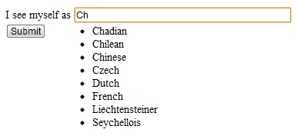

*Important: for our system to register your choice, you must **click** on the drop down item corresponding with your nationality/nationalities. When you select a nationality from the menu, a comma (",") will be inserted after it. If you identify with more than one nationality, simply begin typing each additional nationality after the ones you have previously listed. Again, as you type options will appear in the drop menu, please click the one corresponding to the nationality identify with. Example:

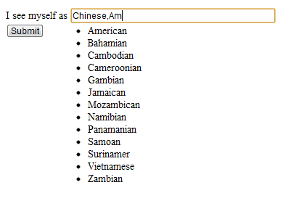

[note: I should add cursor icons on the selections to emphasize that people should be choosing and clicking]

Free Form

We all have groups we identify with. In a given moment we may see ourselves as Democrats, or Americans, Germans, Fathers, Mac People, Women, Teachers, Soccer Players, etc. In the next section we would like you to think about something you strongly identify with, something that you feel is important to understanding who you are. We realize you have many identities, but for the sake of this study, please type just one in the box below.