**Problem 1. Building an ER model for a hospital**

* Entities, key Attributes and related Attributes

Doctor: doctor code (key), doctor’s name, date of employment, specialty.

Patient: patient identification (key), patient name.

Treatment: date of treatment, duration of treatment, results.

* Relationships:

Doctor-Patient: Admit (one-to-many).

Doctor-Patient: Treated by (many-to-many).

Hospital-Treatment: Save (one-to-many).

* Weak Entites and Weak Relationship (if any)

Weak Entity: Treatment.

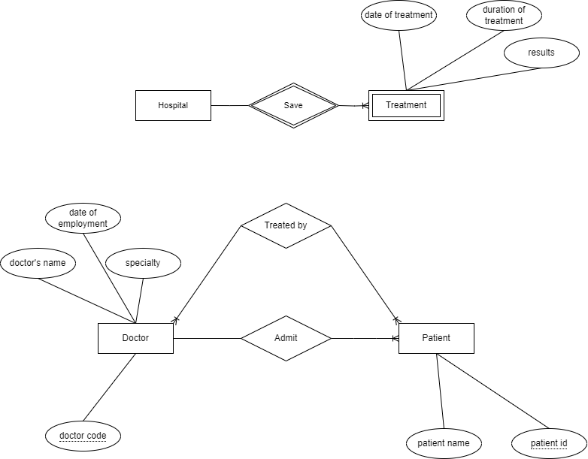

**Problem 2. Building an ER model for a University**

* Entities, key Attributes and related Attributes

Falcuty: faculty code (key), faculty name.

Class: class code (key), class name, wholesale number.

Student: student ID (key), full name, date of birth, gender, address, graduation point.

Subject: subject code (key), subject name, number of credits, exam score.

Library Card: card number (key), issue date, expiration date.

* Relationships:

Faculty-Class: Has (one-to-many).

Class-Student: Has (one-to-many).

Student-Subject: Study (many-to-many).

Student-Library Card: Belong (one-to-one).

* Weak Entities and Weak Relationships (if any)

Library Card.

Class.

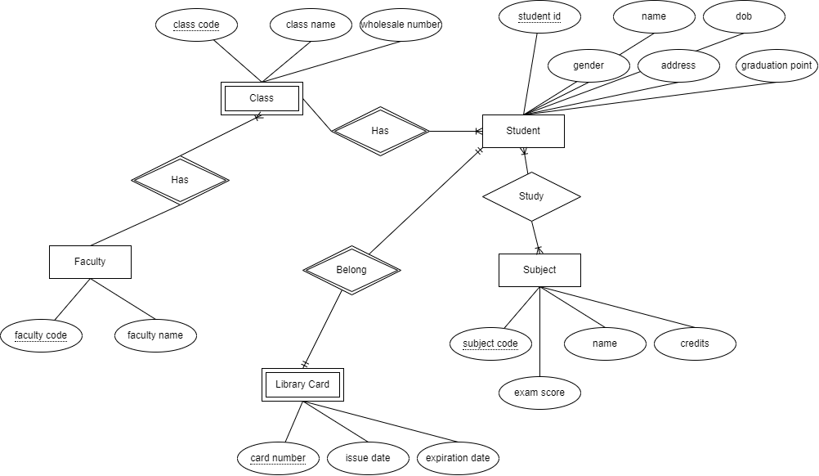

**Problem 3. Building an ER model and relational data model for 1 hotel needs to store information**

* Entities, key Attributes and related Attributes

Room: room code (key), room name.

Floor: floor code (key), floor name.

Guest: identity card number (key), full name, phone number.

Service: service code (key), service name, amount.

Invoice: invoice code (key), identity card code, name of customer, arrival dates, departure dates, number of days, room code, total room amount, service name, total service amount, total amount.

* Relationships:

Floor-Room: Has (one-to-many).

Guest-Room: Book (many-to-many).

Room-Service: Provide (many-to-many).

Invoice-Guest: Include (many-to-one).

Invoice-Room: For (many-to-one).

Invoice-Service: Contain (many-to-many).

* Weak Entities and Weak Relationships (if any)

Invoice.

