**Problem 1. Building an ER model from Database Schema**

* Entities, key Attributes and related Attributes

CUSTOMERS (**CUSTOMERID**, FULLNAME, ADDRESS, PHONE, BIRTHDAY, SALE, REGISTRATIONDATE)

STAFF (**STAFFID**, FULLNAME, DAYOFENTRY, PHONE)

PRODUCTS (**PRODUCTID**, PRODUCTNAME, UNIT, NATION, PRICE)

INVOICE (**INVOICEID**, PURCHASEDATE, CUSTOMERID, STAFFID, VALUE)

DETAILOFINVOICE (**INVOICEID**, **PRODUCTID**, QUANTITY)

* Relationships:

CUSTOMERS-INVOICE: Places (one-to-many)

STAFF-INVOICE: Handles (one-to-many)

INVOICE-DETAILOFINVOICE: Contains (one-to-many)

PRODUCTS-DETAILOFINVOICE: IncludedIn (one-to-many)

* Weak Entites and Weak Relationship (if any)

Weak Entities: DETAILOFINVOICE

Weak Relationships: INVOICE-DETAILOFINVOICE, PRODUCTS-DETAILOFINVOICE

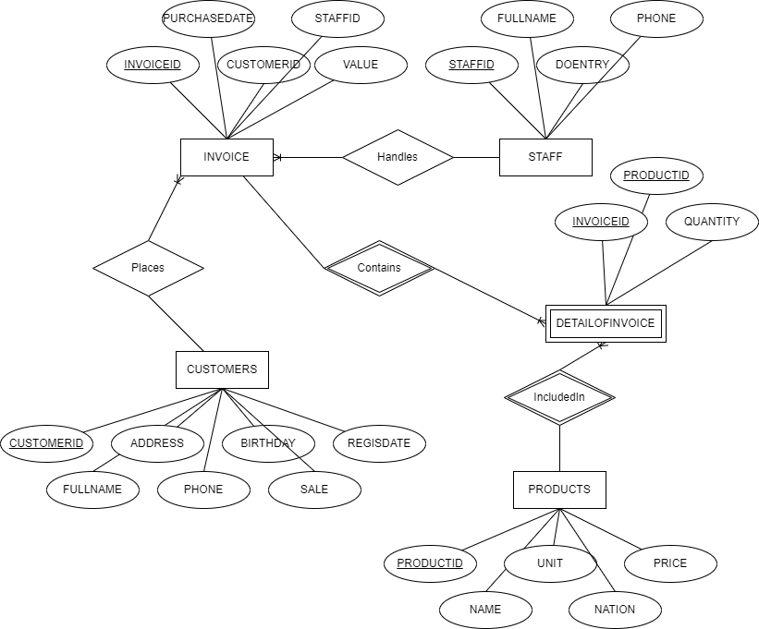

**Problem 2. Draw ER Diagram**

* Entities, key Attributes and related Attributes

Employee (**id**, fullname, dob, address, gender, mngCode, depCode, salType, workHours)

Department (**depCode**, name, startDate, proCode)

Location

Project (**proCode**, name, location, depCode)

Relative (name, dob, relationship)

* Relationships:

Employee-Department: Works (many-to-one)

Department-Location: Has (one-to-many)

Employee-Project: Participate (many-to-many)

Department-Project: Manages (one-to-many)

Employee-Relative: Has (one-to-many)

Employee-Employee: Manages (one-to-one)

* Weak Entities and Weak Relationships (if any)

Weak Entities: Relative

Weak Relationships: Employee-Relative

