Matthew

Coats / UI, UX Designer and Developer

# 843.793.7447

[mcoats@gmail.com](mailto:mcoats@gmail.com) [www.MatthewCoats.net](http://www.MatthewCoats.net/)

Atlanta College of Art

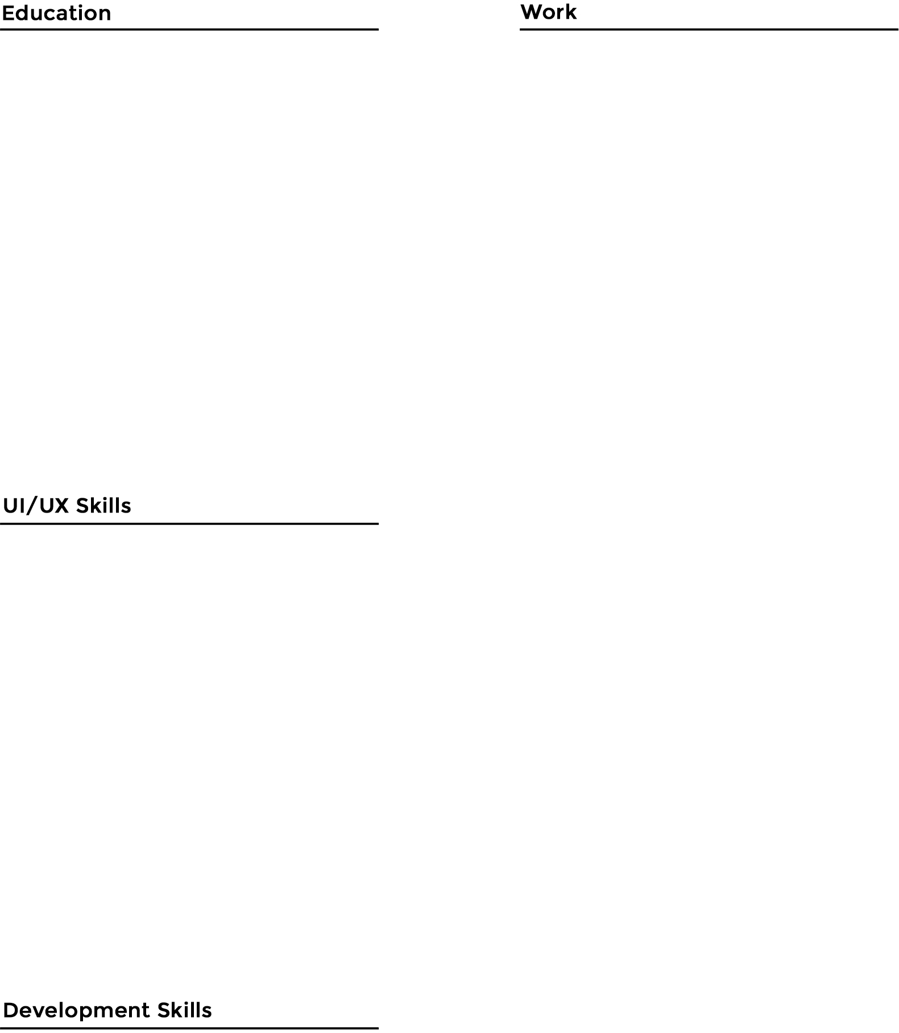

Studied Digital Multimedia and Web Design

# Kennesaw State University

Studied Information Systems

# CalArts

Certificate in Visual Elements of User Interface Design

# Stanford University

Certificate in Human Computer Interaction (HCI)

# Georgia Tech

Certificate in User Interface Personalization

# UI/UX Designer and Application Developer

* Designed user personas, user flows, and conducted user interviews to improve the UX of existing and future applications.
* Designed and developed industry leading user interfaces, from wireframes to high fidelity mockups, to HTML/CSS/JS.
* Lead efforts into transforming existing websites and web applications to be responsive across phones, tablets, and desktop/laptops computers.
* Lead the effort into transitioning our web applications to follow WCAG accessibility standards.
* Designed and developed user interfaces and user experiences in .NET, Java, and coldfusion based applications.

# Frontend Designer and Developer

A/B Testing

Adobe Creative Suite Axure

Brand Identity

Designing for Accessibility eCommerce Design Email Design

High Fidelity Mockups

Human Computer Interaction Journey Mapping

Mobile and Tablet Design Photography and Post Processing User Flows

User Interface Design User Personas

User Research Wireframing

CSS

eCommerce Development Email Development Expression Engine

Google Analytics HTML

Javascript jQuery MySQL

Responsive Frameworks (Bootstrap, Foundation.) Wordpress

* Responsible for every phase of the design and development process, from creating wireframes and high fidelity mockups to frontend web development with

HTML, CSS, and JS.

* Converted hotel booking engines to be responsive resulting in increase bookings.
* Built websites onto Wordpress or Expression Engine to improve SEO and content creation.
* Used analytic data to optimize websites and hotel booking engines to increase revenue and eliminate customer pain points.
* Created testing guidelines, go-live checklists, and post-go-live support documents which resulted in higher customer satisfaction and a 30% decrease in post-live bug fixes.

# Frontend Designer, Developer, and IT Support

* Responsible for every phase of the design and development process, from creating wireframes and high fidelity mockups to frontend web development in HTML and CSS.
* Designed internet based advertisements including banner ads and landing pages.
* Managed hosting, domains, and provided IT support including fixing/upgrading computers and managing the company email system.
* Designed brochures, flyers, and business cards for sales and marketing.
* Coordinated resources and assigned projects to teams and ensured their success.

# Art Teacher



* Taught advanced art classes to children in Kindergarten through 3rd Grade, class size ranged from 15 to 27.
* Structured lesson plans, developed assignments, and provided instruction and guidance.
* Managed supplies for a team of 4 teachers.

# Library Technical Assistant



* Staffed the front desk and handled customer support.
* Provided technology assistance and support to professors and staff.
* Mail and package sorting.