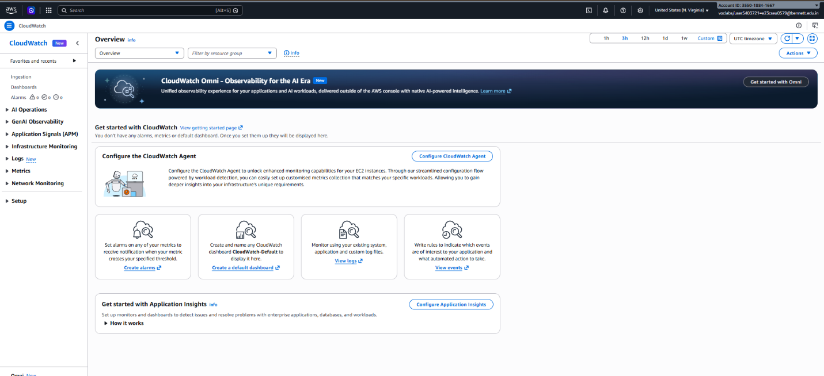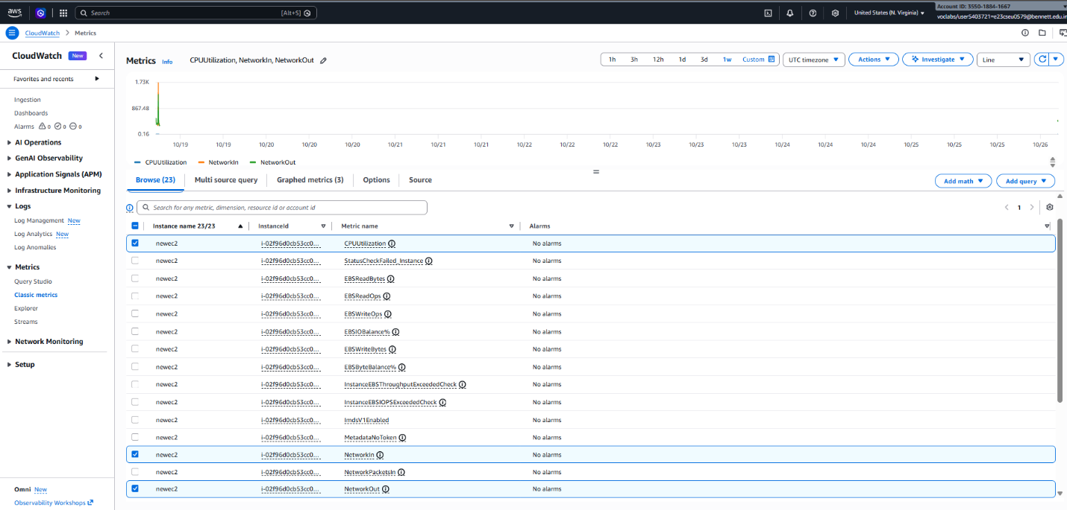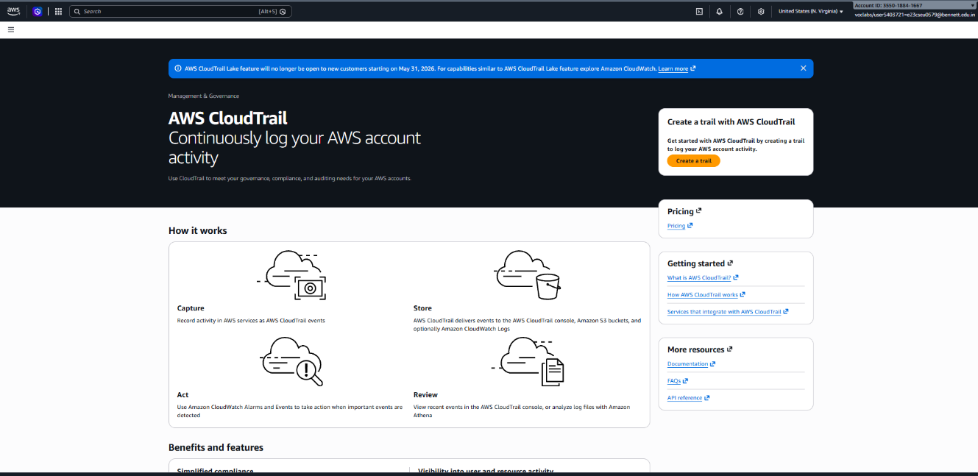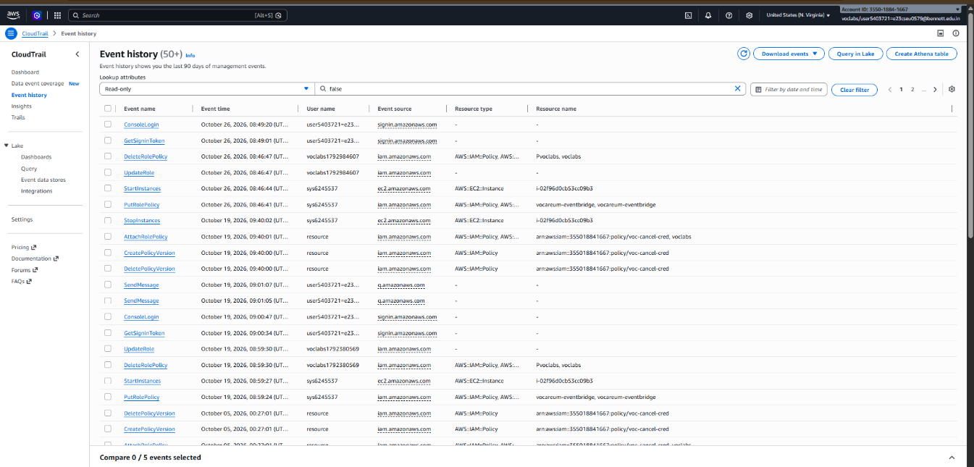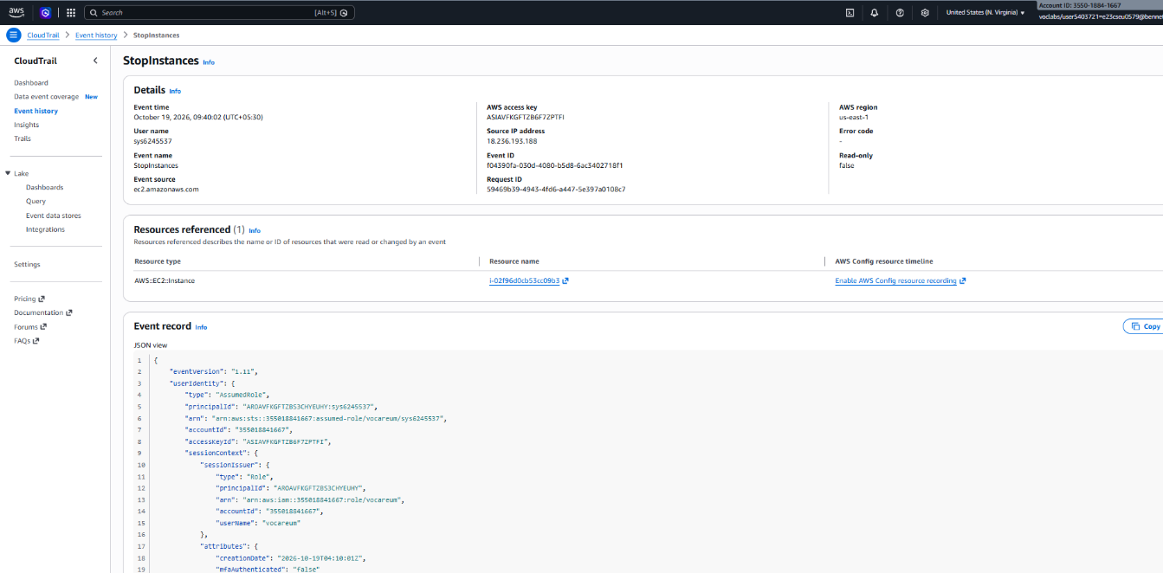
1. Strong passwords and MFA
- Use long, unique passwords for cloud accounts.
- Enable Multi-Factor Authentication (MFA) for the AWS root user and privileged IAM users.
- Never share passwords or access keys.
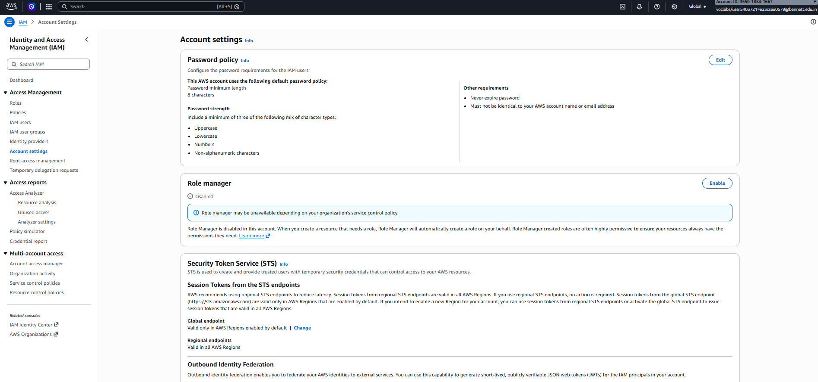
2. Least privilege access
- Grant users only the permissions required for their tasks.
- Use AWS IAM roles and policies to control access.
- Avoid giving unnecessary administrator permissions.
- Review permissions regularly.
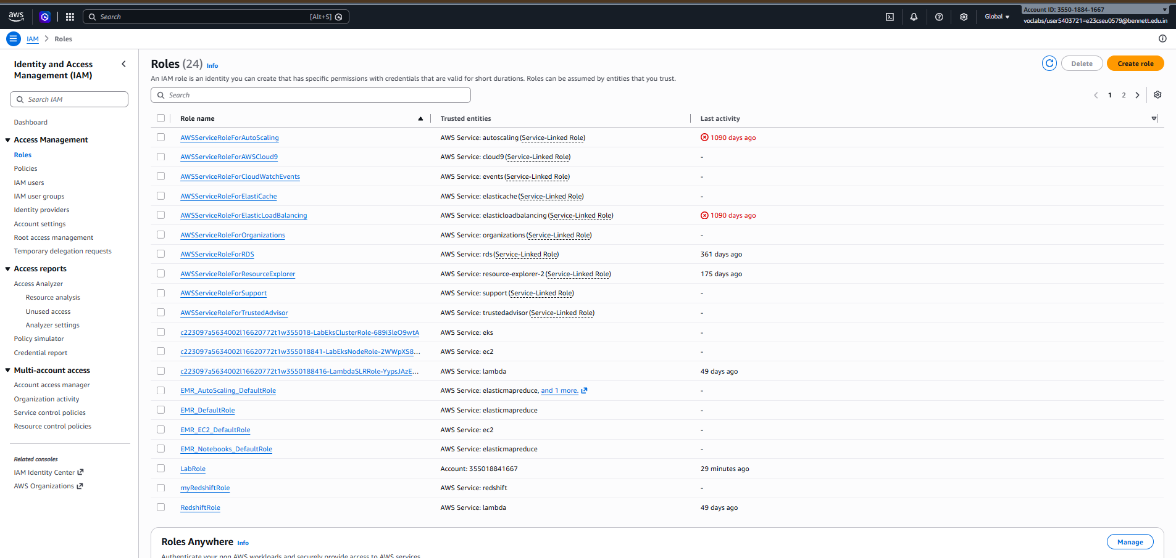
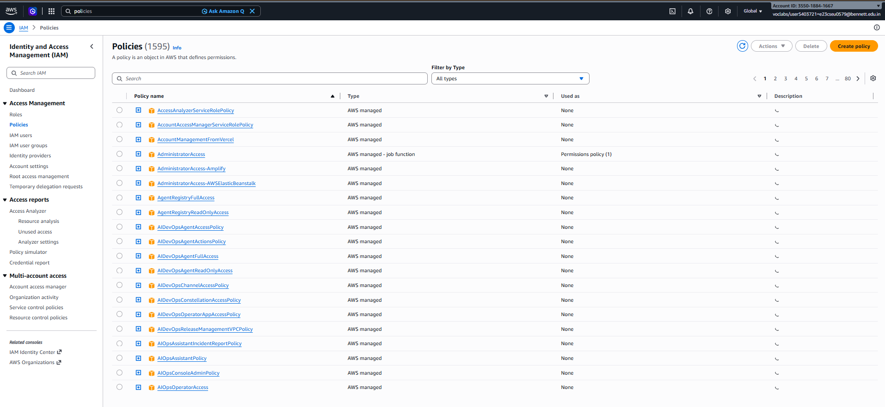
3. Data backup and recovery
- Back up important files and databases regularly.
- Use Amazon S3 versioning to recover previous versions of files.
- Test backups to ensure data can be restored.
- Protect backups against accidental deletion and unauthorized access.
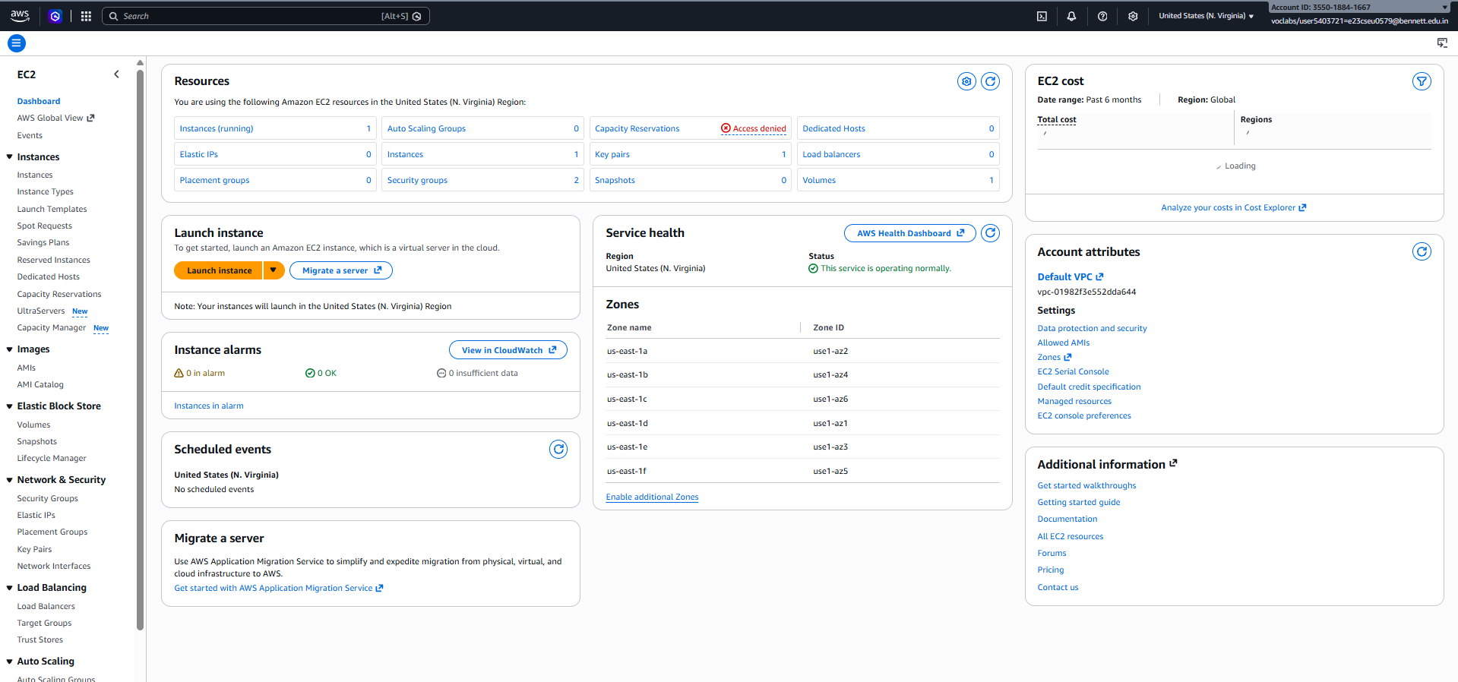
4. Regular updates and patching
- Install operating system and application security updates regularly.
- Patch vulnerabilities in EC2 instances.
- Use AWS Systems Manager Patch Manager where appropriate.
- Remove unused software and services.
