Project Socket Programming

Video Streaming with RTSP and RTP
- Describe
In this lab you will implement a streaming video server and client that communicate using the Real-Time Streaming Protocol (RTSP) and send data using the Real-time Transfer Protocol (RTP).
Your task is to implement the RTSP protocol in the client and implement the RTP packetization in the server. We will provide you code that implements the RTSP protocol in the server, the RTP de-packetization in the client, and takes care of displaying the transmitted video.
1. Control Channel (RTSP Commands) → TCP
- RTSP itself (the control protocol — e.g., SETUP, PLAY, PAUSE, TEARDOWN) almost always uses TCP.
- Default port: 554 (TCP)
- This ensures reliable delivery of control messages.
2. Media Stream (RTP Data) → UDP, TCP
- The actual media (audio/video) is typically transported using RTP (Real-time Transport Protocol).
- By default: RTP over UDP → faster, lower latency, but may lose packets.
- When using HD, change to use from UDP to TCP

Code:
Client, ClientLauncher:
The ClientLauncher starts the Client and the user interface which you use to send RTSP commands and which is used to display the video. In the Client class, you will need to implement the actions that are taken when the buttons are pressed. You do not need to modify the ClientLauncher module.
Server, ServerWorker:
These two modules implement the server which responds to the RTSP requests and streams back the video. The RTSP interaction is already implemented and the ServerWorker calls methods from the RtpPacket class to packetize the video data. You do not need to modify these modules.
RtpPacket:
This class is used to handle the RTP packets. It has separate methods for handling the received packets at the client side and you do not need to modify them. The Client also de-packetizes (decodes) the data and you do not need to modify this method. You will need to complete the implementation of video data RTP-packetization (which is used by the server).
VideoStream:
This class is used to read video data from the file on disk. You do not need to modify this class.
Running the code:
After completing the code, you can run it as follows:
First, start the server with the command
python Server.py <server_port>
where server_port is the port your server listens to for incoming RTSP connections. The standard RTSP port is 554, but you will need to choose a port number greater than 1024.
Then, start the client with the command
python ClientLauncher.py <server_host> <server_port> <RTP_port video_file>
where server_host is the name of the machine where the server is running, server_port is the port where the server is listening on, RTP_port is the port where the RTP packets are received, and video_file is the name of the video file you want to request (we have provided one example file movie.Mjpeg). The file format is described in Appendix section. The client opens a connection to the server and pops up a window like this:
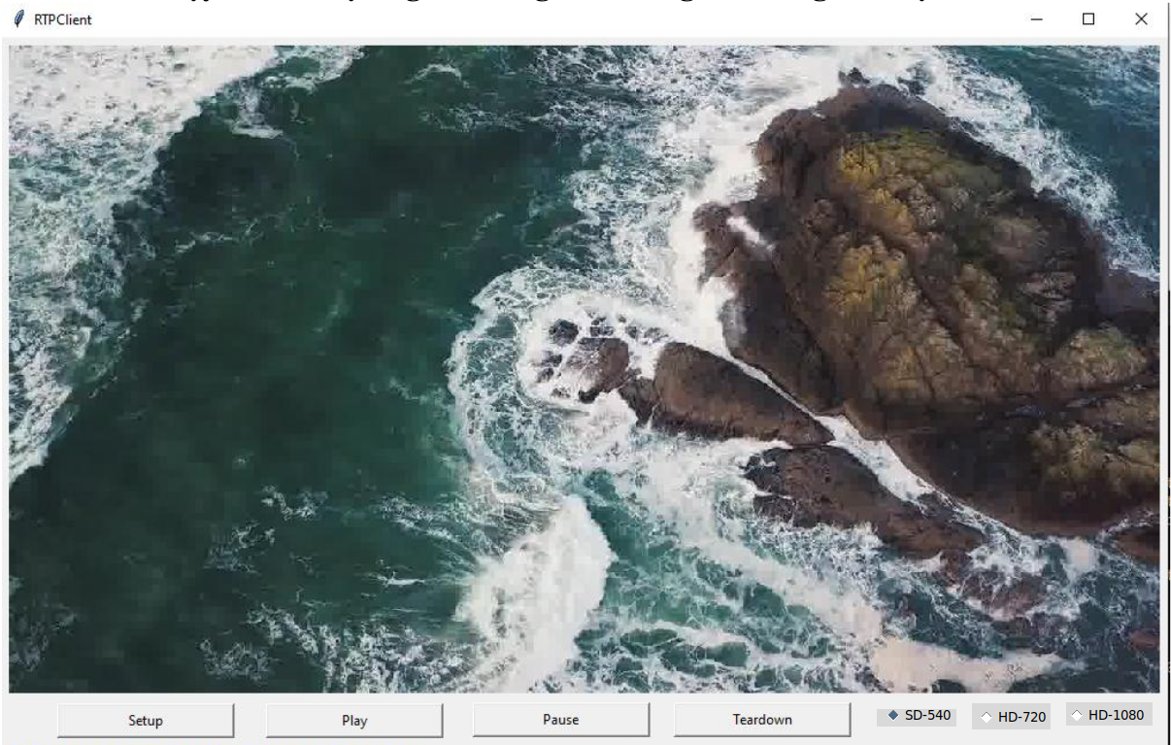
You can send RTSP commands to the server by pressing the buttons. A normal RTSP interaction goes as follows:
- The client sends SETUP. This command is used to set up the session and transport parameters.
- The client sends PLAY. This command starts the playback.
- The client may send PAUSE if it wants to pause during playback.
- The client sends TEARDOWN. This command terminates the session and closes the connection.
The server always replies to all the messages that the client sends. The code 200 means that the request was successful while the codes 404 and 500 represent FILE_NOT_FOUND error and connection error respectively. In this lab, you do not need to implement any other reply codes. For more information about RTSP, please see RFC 2326.

The Client
Your first task is to implement the RTSP protocol on the client side. To do this, you need to complete the functions that are called when the user clicks on the buttons on the user interface. You will need to implement the actions for the following request types. When the client starts, it also opens the RTSP socket to the server. Use this socket for sending all RTSP requests.

SETUP
- Send SETUP request to the server. You will need to insert the Transport header in which you specify the port for the RTP data socket you just created.
- Read the server’s response and parse the Session header (from the response) to get the RTSP session ID.
- Create a datagram socket for receiving RTP data and set the timeout on the socket to 0.5 seconds.
PLAY
- Send PLAY request. You must insert the Session header and use the session ID returned in the SETUP response. You must not put the Transport header in this request.
- Read the server's response.
PAUSE
- Send PAUSE request. You must insert the Session header and use the session ID returned in the SETUP response. You must not put the Transport header in this request.
- Read the server's response.
TEARDOWN
- Send TEARDOWN request. You must insert the Session header and use the session ID returned in the SETUP response. You must not put the Transport header in this request.
- Read the server's response.
Note: You must insert the CSeq header in every request you send. The value of the CSeq header is a number which starts at 1 and is incremented by one for each request you send.
Example:
Here is a sample interaction between the client and server. The client's requests are marked with C: and server's replies with S:. In this lab both the client and the server do not use sophisticated parsing methods, and they expect the header fields to be in the order you see below.
C: SETUP movie.Mjpeg RTSP/1.0
C: CSeq: 1
C: Transport: RTP/UDP; client_port=25000
S: RTSP/1.0 200 OK
S: CSeq: 1
S: Session: 123456
C: PLAY movie.Mjpeg RTSP/1.0
C: CSeq: 2
C: Session: 123456
S: RTSP/1.0 200 OK
S: CSeq: 2
S: Session: 123456
C: PAUSE movie.Mjpeg RTSP/1.0
C: CSeq: 3
C: Session: 123456
S: RTSP/1.0 200 OK
S: CSeq: 3
S: Session: 123456
C: TEARDOWN movie.Mjpeg RTSP/1.0
C: CSeq: 5
C: Session: 123456
S: RTSP/1.0 200 OK
S: CSeq: 5
S: Session: 123456
Client State
One of the key differences between HTTP and RTSP is that in RTSP each session has a state. In this lab you will need to keep the client's state up-to-date. Client changes state when it receives a reply from the server according to the following state diagram.
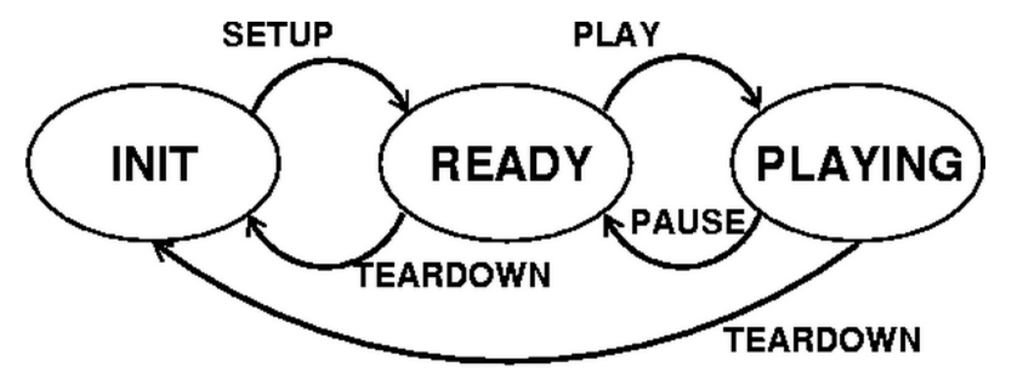
The Server
On the server side, you will need to implement the packetization of the video data into RTP packets. You will need to create the packet, set the fields in the packet header and copy the payload (i.e., one video frame) into the packet. When the server receives the PLAY-request from the client, the server reads one video frame from the file and creates an RtpPacket-object which is the RTP-encapsulation of the video frame. It then sends the frame to the client over UDP every 50 milliseconds.
For the encapsulation, the server calls the encode function of the RtpPacket class. Your task is to write this function. You will need to do the following: (the letters in parenthesis refer to the fields in the RTP packet format below).
- Set the RTP-version field (V). You must set this to 2.
- Set padding (P), extension (X), number of contributing sources (CC), and marker (M) fields. These are all set to zero in this lab.
- Set payload type field (PT). In this lab we use MJPEG and the type for that is 26.
- Set the sequence number. The server gives this the sequence number as the frameNbr argument to the encode function.
- Set the timestamp using Python's time module.
Set the source identifier (SSRC). This field identifies the server. You can pick any integer value you like.
- Because we have no other contributing sources (field CC == 0), the CSRC-field does not exist. The length of the packet header is therefore 12 bytes, or the first three lines from the diagram below.
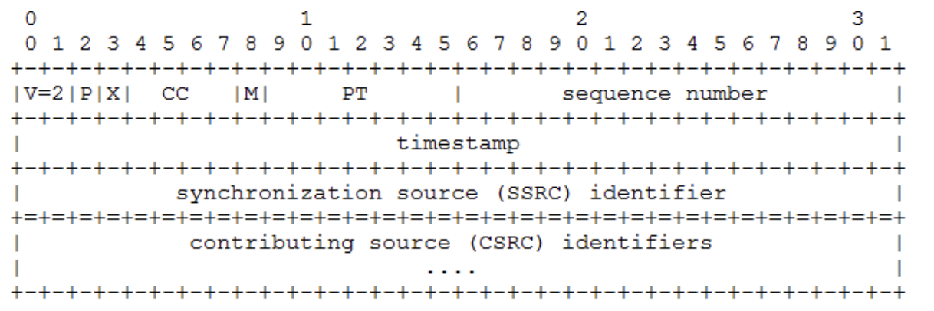
You must fill in the header fields in the header bytearray of the RtpPacket class. You will also need to copy the payload (given as argument data) to the RtpPacket’s payload data field.
The above diagram is in the network byte order (also known as big-endian). Python uses the same byte order, so you do not need to transform your packet header into the network byte order. For more details on RTP, please see RFC 1889.
Twiddling the Bits
Here are some examples on how to set and check individual bits or groups of bits. Note that in the RTP packet header format smaller bit-numbers refer to higher order bits, that is, bit number 0 of a byte is 2^7 and bit number 7 is 1 (or 2^0). In the examples below, the bit numbers refer to the numbers in the above diagram.
Because the header-field of the RtpPacket class is of type bytearray, you will need to set the header one byte at a time, that is, in groups of 8 bits. The first byte has bits 0-7, the second byte has bits 8-15, and so on.
To set bit number n in variable mybyte of type byte:
mybyte = mybyte | 1 << (7 - n)
To set bits n and n + 1 to the value of foo in variable mybyte:
mybyte = mybyte | foo << (7 - n)
Note that foo must have a value that can be expressed with 2 bits, that is, 0, 1, 2, or 3.
To copy a 16-bit integer foo into 2 bytes, b1 and b2:
b1 = (foo >> 8) & 0xFF
b2 = foo & 0xFF
After this, b1 will have the 8 high-order bits of foo and b2 will have the 8 low-order bits of foo. You can copy a 32-bit integer into 4 bytes in a similar way.
Bit Example
Suppose we want to fill in the first byte of the RTP packet header with the following values:
V = 2, P = 0, X = 0, CC = 3
In binary this would be represented as
1 0 | 0 | 0 | 0 0 1 1
V=2 P X CC = 3
2^7 . . . . . . . . 2^0
Advanced section
- HD Video Streaming: Extend the system to stream 720p or 1080p video with efficient packetization and adaptive control.
  - Change to use TCP to tranfer
- Client-Side Caching: Implement a frame buffer to reduce jitter when use click "SETUP", and "PLAY" will play in buffer
  - Pre-buffer N frames ahead of the client.
Appendix
MJPEG test to support HD and cached (don't use audio)
- Start and end image: '\xff\xd8', '\xff\xd9'
- Link download:
- https://filesamples.com/formats/mjpeg

B. Grading Rubric (Total 10 Points)

No. | Requirement | Points
1 | Implement the RTSP protocol in the client and implement the RTP packetization in the server.  - UDP and Implement fragmentation for frames exceeding MTU | 4pt.
2 | HD Video Streaming with TCP | 3pt.
3 | Client-Side Caching switch between SD and HD | 2.5pt.
4 | Report | 0.5pt.

C. Group Requirement & Submission Guidelines
- This exercise must be completed in a group of 3 students.
- Only one student from the group needs to submit the assignment.
- Submit all files in a ZIP file to the course platform before the deadline: MSSV1_MSSV2_MSSV3.zip

