CV
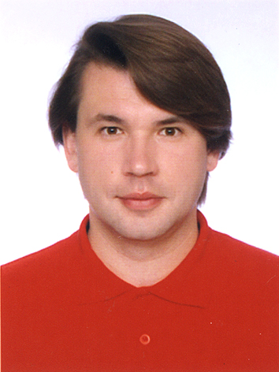

Name: Eduard Tkachuk

E-mail: wintermute2009@ukr.net

Objective: Design, development and maintenance Apps by React Native for IOS/Android and React/Redux for Web.

SPA projects: E-Commerce (React/Redux+React Native+NodeJS+MongoDB)
LocalStorage DB (React/Redux+React Native+Ionic)
Project Management (AngularJS+Cordova+NodeJS)

Technical Skills: React/Redux + React Native (IOS Development, Webpack)
Vue.js (Vue-cli, Vue-router, Vuex)
AngularJS (UI-Router, Ionic, Cordova)
NodeJS (Express, MongoDB, Bower, Gulp)

AppStore: https://itunes.apple.com/us/developer/eduard-tkachuk/id1154030317

Google Play Market: https://play.google.com/store/apps/developer?id=Eduard+Tkachuk

Experience: 2018-now – self-employed, software developer.

2016-2018 - Luxoft, software developer.

2015-2016 - SoftServe, software developer.

2015-2015 - EPAM-Systems, software developer.

Education: National Academy of Sciences of Ukraine, Institute for Nuclear Research, PhD student.

Kyiv National Taras Shevchenko University, Faculty of Mechanics and Mathematics.

Languages: Russian (native), English (advanced).

