**Front Garden Project**

Following receipt of your generous grant in support of our front garden project, this money has enabled us to transform our front garden from a plain space to something much more inviting. The children loved being able to get involved in the choosing of the planters and flowers, and the decorative items which they wanted to brighten up the whole area.

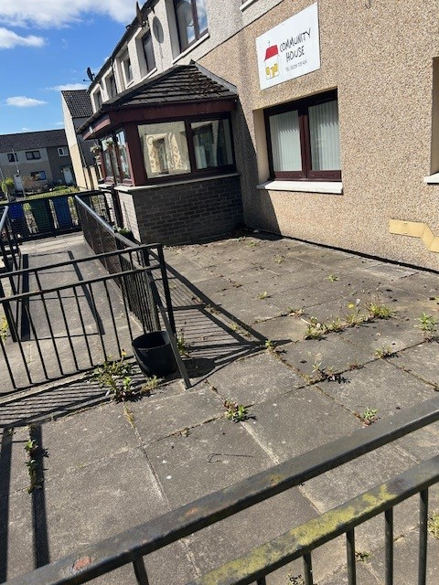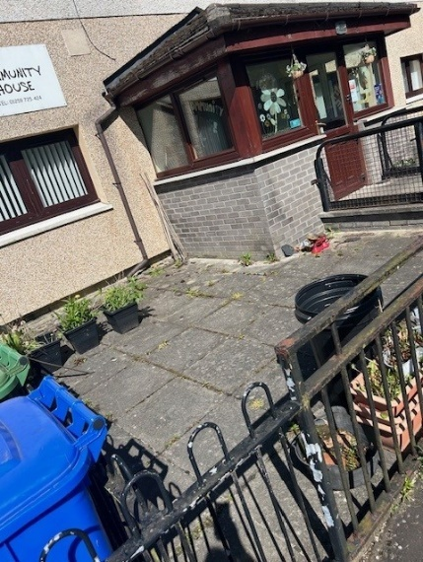The pictures below show the space prior to the start of any work being undertaken.

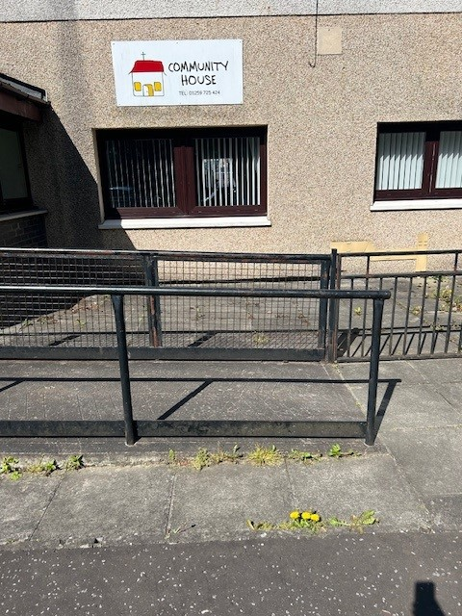

The first part of the project was to prepare the outside space ready for work to begin, this involved weeding the space and the clearing away of the rubbish and preparing small planter with flowers.

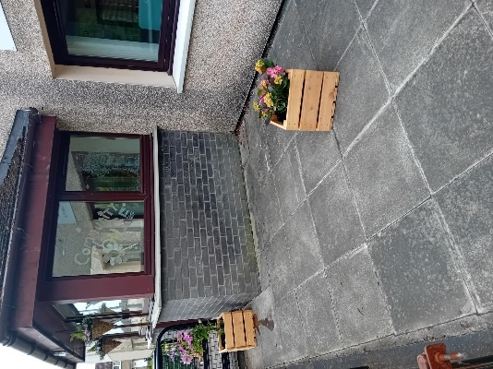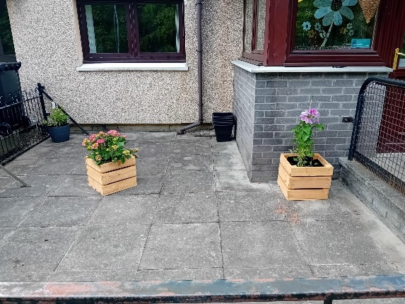

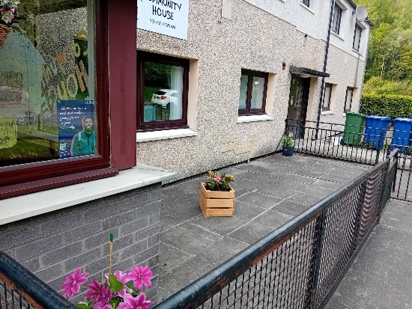

The children loved the second part of the project where they were able to get their hands dirty 😊. The children chose where they wanted the planters to go and enjoyed adding the decorative items to make the garden space their own.

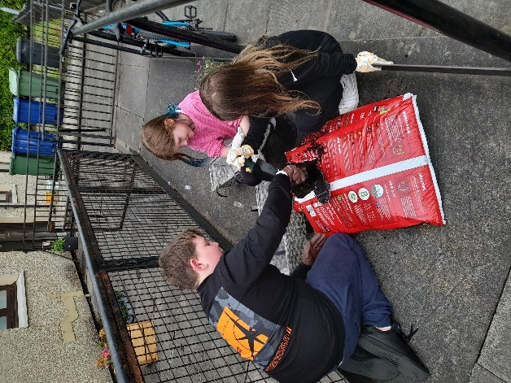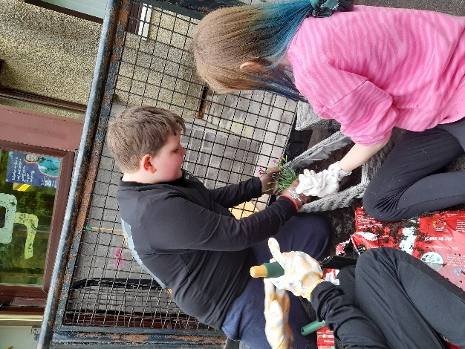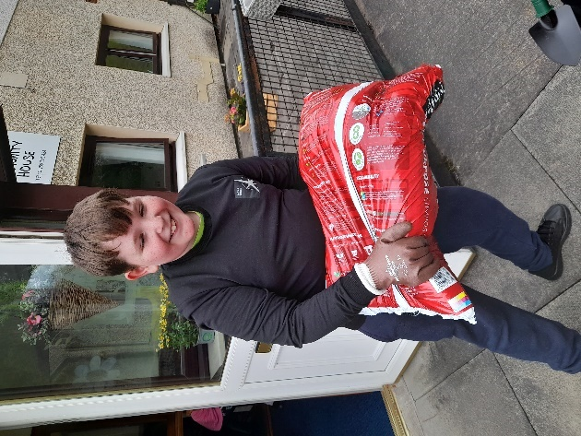

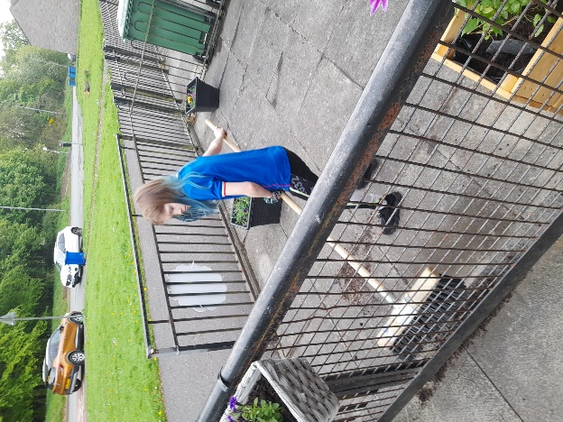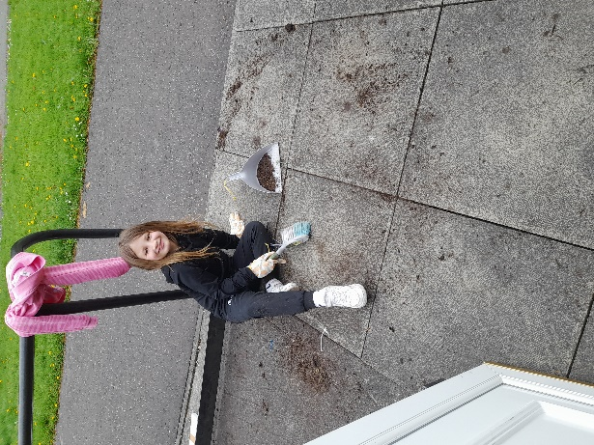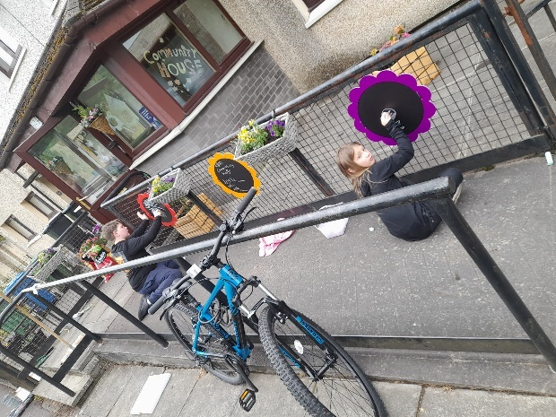

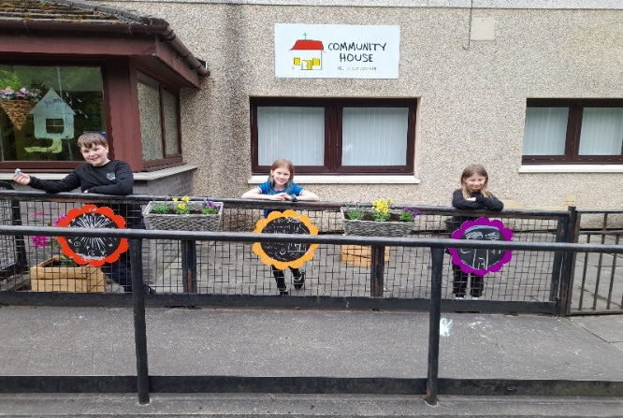

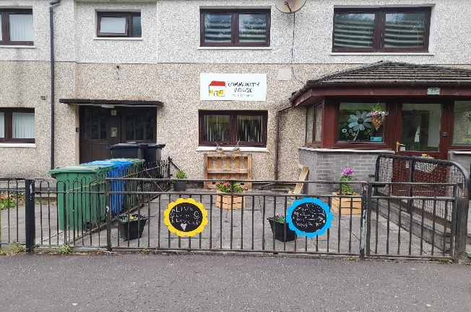

Time taken to upcycle old pallets and bring a little more colour to our space, this worked out well and they are a fantastic addition to the space, allowing more flowers to be planted.

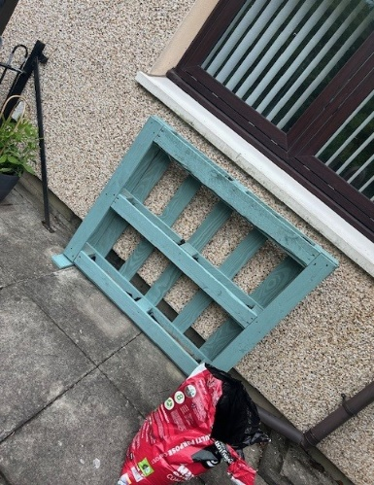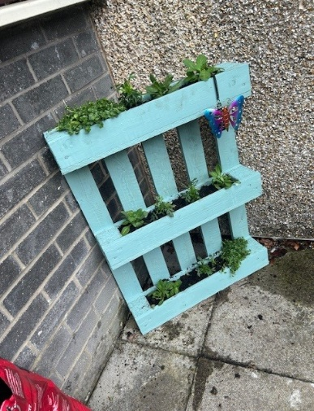The completion of the front garden project has brought lots of smiles, laughs and joy to the children using our services, it was a chance for them to get make decisions, design, get involved, and work in teams to transform this space. The children love this space now and with the seating area, it is used much more. The maintenance of the space is something that the children will continue to be involved in. They are all immensely proud of the work they have done, as are we!

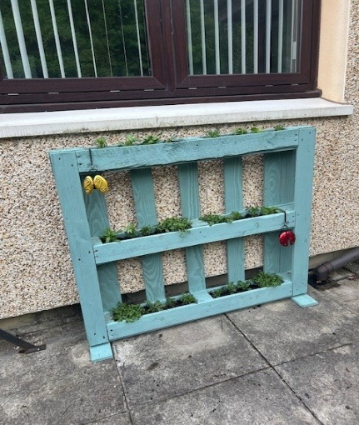

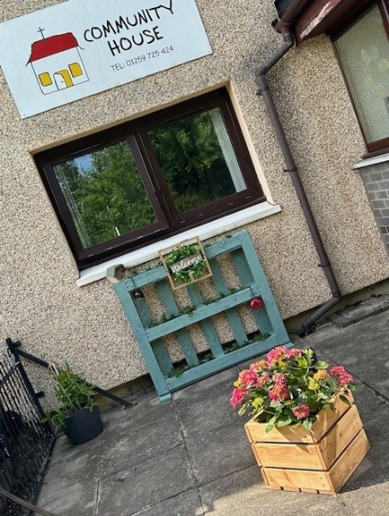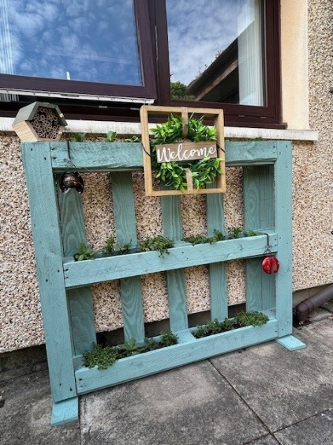

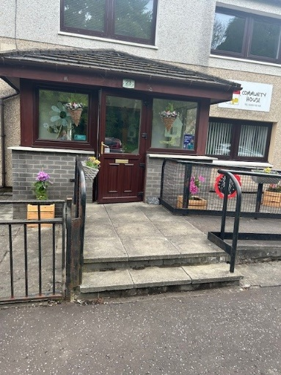

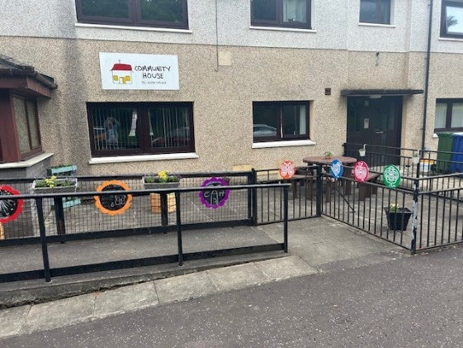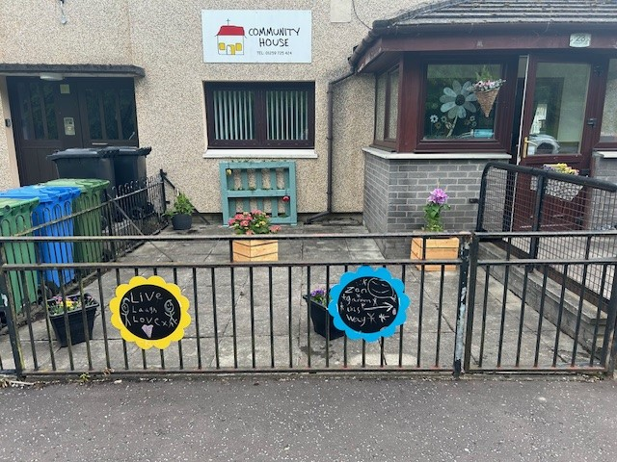

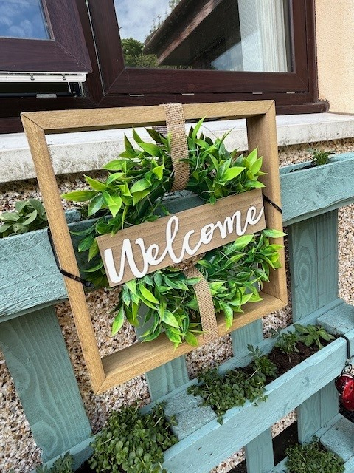

Thank you from everyone at Community House for your generosity 😊