Chaochen Wang

**Background:** Recent evidence suggested that there are three types of eaters (grazers, early eaters, and late eaters) according to the timing of energy consumption. This project aims at finding both timing and quantity eating patterns specifically for carbohydrate (carb) intake, and exploring their potential associations with hypertension and obesity.

**Methods:** Data are from the National Diet and Nutrition Survey (NDNS) Rolling Programme (2008/09-15/16) which included 6155 adults aged 19 or older in the UK. Time of the day was defined as: 6-9 am, 9-12 noon, 12-2 pm, 2-5 pm, 5-8 pm, 8-10 pm and 10 pm-6 am. Responses for carb intake within each time slot were categorised into: not eating any food, carb contributed 50% or 50% of total energy. Multilevel latent class analysis (MLCA) models were applied in finding the latent classes of carb consumption accounting for the hierarchical data structure. Survey-designed multivariable regression models were used to assess the associations between carb eating patterns and hypertension, body mass index (BMI), and waist circumferences (WC).

**Results:** Three carb eating day patterns (low/high percentage, and regular meal days) were found in 24483 observation days, based on which three types of carb eaters were defined: low (28.1%), moderate (28.8%), and high (43.1%) carb eaters. On average, low-carb eaters consumed the highest amount of total energy intake (7985.8 kJ), and they had higher percentages of energy contributed by fat and alcohol, especially after 8 pm. Moderate-carb eaters consumed the lowest amount of total energy (7341.8 kJ) while they had the tendency of eating carb later in time-of-day. High-carb eaters consumed most of their carb and energy within time slots of 6-9 am, 12-2 pm and 5-8 pm. In men, moderate-carb eaters may have lower odds of having hypertension compared with low-carb eaters (adjusted OR: 0.64, 95%CI: 0.41, 1.01). In women, high-carb eaters who lived with partners had both lower BMI (-1.76 kg/m2, -2.87, -0.73) and WC (-4.71 cm, -7.00, -2.43) compared with low-carb eaters, although these inverse associations were not observed in women who lived alone (*p* for interaction 0.014, and 0.009).

**Conclusions:** Contrary to the expectation, profiles of high-carb eaters seemed to be healthier among three types of carb eaters. Low-carb eaters probably followed the diet out of health purposes, but they may have chosen fat or alcohol as replacements of carb, which could possibly be a concern from a public health point of view. Whether these carb-eating patterns are associated with changes in blood pressure or obesity longitudinally should be further investigated.

image

MSc Project Report  
2017-2018

*Supervisor:*

**Submitted in partial fulfillment of the requirements**  
**for the degree of**

September 2018

I declare that this thesis titled, “” and the work presented in it are my own. I confirm that:

* This work was done wholly while in candidature for an MSc degree in Medical Statistics at London School of Hygiene and Tropical Medicine.
* No part of this thesis has previously been submitted for a degree or any other qualification at London School of Hygiene and Tropical Medicine or any other institution.
* Where I have consulted the published work of others, this is always clearly attributed.
* Where I have quoted from the work of others, the source is always given. With the exception of such quotations, this thesis is entirely my own work.
* I have acknowledged all main sources of help.
* Where the thesis is based on work done by myself jointly with others, I have made clear exactly what was done by others and what I have contributed myself.

I would like to thank my tutor and supervisor , for his guidance, patience, and help while working on this project and also to Dr. Suzana Almoosawi for her invaluable nutritional academic insight.  
Thanks to Raoul Mansukhani, for sharing his previous work and thoughts on the analyses, methodology in helpful discussions.  
I would like to thank the team of the National Diet and Nutrition Survey Rolling Programme (NDNS RP) who have made their data available to the public for academic study.  
I would like to thank all of the teachers, lecturers, staffs, and fellow course mates in the Department of Medical Statistics for providing their wonderful teaching techniques, and for sharing their excellent ideas that made this year such fruitful and enjoyable.  
Last but not the least, I want to express my gratitude to my family for their unconditional support, understanding, and encouragement throughout this year.

“*All models are wrong, but some are useful.*”

George E. P. Box

-0.6cm-0.3cm

openrightfalse

ll **AIC** & **A**kaike **I**nformation **C**riterion  
**HbA1C** & Haemoglobin **A1C**: Glycated haemoglobin  
**BMI** & **B**ody **M**ass **I**ndex  
**BIC** & **B**ayesian **I**nformation **C**riterion  
**CI** & **C**onfidence **I**nterval  
**DM** & **D**iabetes **M**ellitus  
**FSA** & **F**ood **S**tandards **A**gency  
**HDL** & **H**igh **D**ensity **L**ipoprotein cholesterol  
**LDL** & **L**ow **D**ensity **L**ipoprotein cholesterol  
**LCA** & **L**atent **C**lass **A**nalysis  
**LCGA** & **L**atent **C**lass **G**rowth **A**nalysis  
**LTA** & **L**atent **T**ransition **A**nalysis  
**MAFF** & **M**inistry of **A**griculture, **F**isheries and **F**ood  
**MLCA** & **M**ultilevel **L**atent **C**lass **A**nalysis  
**ML** & **M**aximum **L**ikelihood  
**NDNS** & the **N**ational **D**iet and **N**utrition **S**urvey  
**OR** & **O**dds **R**atio  
**PHE** & **P**ublic **H**ealth **E**ngland  
**PSUs** & **P**rimary **S**ampling **U**nits  
**RMLCA** & **R**epeated **M**easures **LCA**  
**TC** & **T**otal **C**holesterol  
**TG** & **T**ri**g**lycerides  
**WC** & **W**aist **C**ircumference

# Introduction

## Background

The widely accepted standard these days seems to be that we eat three main meals a day in addition to snacks. However, whether this is really an ideal temporal eating pattern for everyone has never been answered with scientific evidence. More importantly, how many temporal patterns of eating are there in the population, the proportions of people who actually manage/fail to follow this doctrine, and whether people are consistently following one specific temporal eating pattern or do they switch, have not been studied and described thoroughly either.

Although nutritional studies have extensively examined the influence of the quantity and quality of dietary and nutrients intake and their alteration on morbidity and mortality, investigations on temporal eating patterns and their effects are still scarce. The importance of the circadian rhythm in regulating physiological responses has been recognised for long, while its impact on nutrition and metabolism is still largely unknown [1–3]. Some recent evidence has found that meal timing is associated with a wide variety of health outcomes. Skipping breakfast is associated with a higher risk of developing type 2 diabetes [4]. Shift workers have a higher risk of developing metabolic syndrome [5] and type 2 diabetes [6]. Evening intake of energy is positively associated with overweight/obesity [7].

More recently, discernible temporal eating patterns that differed by sociodemographic and eating profiles were revealed by latent class analysis using nutrition survey data [8,9]. Based on total energy consumption, the presence of 3 groups of eaters: grazers, early eaters, and late eaters was identified [8,9]. So far, the temporal eating patterns were only based on averaging the total energy intake calculated from one or two 24-hour dietary recalls and therefore could not capture the day-to-day variation in temporal eating patterns. Thus, the question of how much variability within a person follows one or several specific temporal eating patterns in his/her everyday life remains unanswered. Many factors, such as day of the week or season, or culture may contribute to daily variation in dietary intake and temporal eating. However, most of the variation in an individual’s diet seems to be without an apparent pattern [10]. Intakes of macro-nutrients (carbohydrate, fat, and protein), due to the reason of their substantial contribution to the total energy intake, may have somewhat moderate degrees of day-to-day variation [11]. Thus, novel analytic methods that can account for this within-person day-to-day variation is needed.

In the present report, we focused on temporal eating patterns for carbohydrate consumption in a nationally representative sample of UK adults. Eating more carbohydrate in the morning has been found to be negatively associated with metabolic syndrome [12]. On the other hand, high total consumption of carbohydrate has been linked with higher risk of type 2 diabetes [13]. Whether the amount or the timing (or both) of carbohydrate consumption during the day matters is an important question to address for both individuals and the public as a whole.

## The National Diet and Nutrition Survey (NDNS)

The National Diet and Nutrition Survey (NDNS) programme [14] was initially established in 1992 and began as a joint initiative between the Ministry of Agriculture, Fisheries, and Food (MAFF) and the Department of Health. In 2008, a new continuous cross-sectional survey was started, the NDNS Rolling Programme (RP). The NDNS RP is funded by Public Health England (PHE), an executive agency of the Department of Health, and the UK Food Standards Agency (FSA). The survey recruits around 1000 people per year as a representative sample of the UK population. Fieldwork began in 2008 and is now starting its 11th year. NDNS provides essential evidence on the diet and nutrition of the UK population to enable PHE to identify and address nutritional issues in the population and monitor progress towards public health nutrition objectives.

The NDNS RP has now completed and analysed its eighth year. The sample was randomly drawn from a list of all addresses in the UK, clustered into postcode sectors. Overall, for years 1-8 combined, a sample of 39,300 addresses was selected from 799 (year 1-4), 323 (year 5-6), and 316 (year 7-8) postcode sectors. At each address, one household was selected at random in cases where there were two or more households. For each household, either an adult and a child, or a child only, was selected to participate.

These individuals were asked to keep a four-day diary on their food and drink consumption on consecutive days. An interview and a nurse visit were also conducted to collect information regarding height and weight, smoking and drinking habits, physical activity, blood pressure, prescribed medicines, dietary supplements, fasting blood sample, and 24-hour urine sample.

## Aims and objectives

Our goal is to explore and make use of the NDNS RP (2008/09-15/16) database to describe and identify the potential relationship between the timing of eating within the day and specific nutrient–carbohydrate intake. We aimed at finding patterns of both the amount of consumption and day-time of consumption for carbohydrate and defining latent groups in the UK adults. An additional aim is to investigate the association of carbohydrate eating patterns with hypertension and obesity.

# Methods

## Dietary diary collected in the NDNS RP

Participants were required to keep a diary that record everything eaten or drunk over four consecutive days. Interviewers undertook three visits with each participant. At the first visit, the interviewer explained the method followed a protocol, taking participants through the sections in the diary including how to describe details of food and drink and portion size and an example day. The second visit was a brief one to check for compliance, answer potential questions, and deal with problems. Interviewers also reviewed the diary to identify and edit possible omissions and missing detail in the food diary. The third visit was to collect the diary and again review and edit possible omissions.

In the diary, portion sizes of food or drink eaten were asked to be recorded in household measures (e.g. one tablespoon of beans, one Kit Kat finger-size), or for packaged foods to note the weight indicated on the packet. Homemade dishes were also described in the diary about their ingredients, quantities, along with a brief description of the cooking procedure and how much of the dish were consumed. For each eating occasion, in addition to the details of what and how much was eaten, participants were also asked to record: when was it, where they were, and who they were eating with. An example, used as guidance for participants, of a food diary for one day is shown in **Appendix [AppendixE]**.

### Definition of carbohydrate intake

Detailed dairy checking was performed to code and convert the food consumption into energy and nutrients intake. Intakes of nutrients were calculated from the food consumption records using a specially adapted Nutrient Databank [15], which was originally developed by the Ministry of Agriculture, Fisheries, and Food (MAFF) for the Dietary and Nutritional Survey of British Adults. Further details of data coding and editing are outlined in Appendix A of the NDNS official reports [16]. Specifically, the main variables that we adopted in the current analysis were defined as:

* Total energy intake = (protein 17) + (fat 37) + (carbohydrate 16) + (alcohol 29) kJ;
* Carbohydrate intake = total sugars + starch;
* All quantities above were measured as the mass in grams.

Time across a typical survey day was divided into 7 time slots in the dietary diary of NDNS RP: 6 am to 9 am, 9 am to 12 noon, 12 noon to 2 pm, 2 pm to 5 pm, 5 pm to 8 pm, 8 pm to 10 pm, and 10 pm to 6 am next morning. To produce a list of discrete responses for our variable of interest, the energy consumed within each time slot over the four days of survey for each participant were calculated. The percentages of total energy intake contributed by carbohydrate within each time slot were then calculated. Since we planned to apply latent class analysis (LCA) in the current study, in which the observed indicators for latent classes must be categorical, the responses were then dichotomised according to these percentages of the energy intake at a cut-off value of 50%, i.e. if within a time slot where any energy intake occurred, carbohydrate consumption was categorised by whether its energy contribution was lower or higher/equal to 50% of total energy intake within that time slot. Consequently, for each day of the recording, there were 7 data points generated by the diary. Each data point included one of the following responses:

* Not eating any food (energy intake = 0 kJ);
* Eating, and carbohydrate contributed less than 50% of the total energy intake;
* Eating, and carbohydrate contributed higher or equal to 50% of the total energy intake.

## Survey Data

### Survey selection method

The NDNS RP participants were drawn from the UK Postcode Address File, a list of all the addresses in the UK. The addresses were clustered into Primary Sampling Units (PSUs), small geographical areas, based on postcode sectors, randomly selected from across the UK. A list of 27 or 28 addresses was then randomly selected from each PSU.

Overall, for years 1 to 8 combined, a sample of 39,300 addresses was selected from 1,438 PSUs. The sampling selection process was:

* Randomly select PSUs from the Postcode Address File;
* Randomly select 27 or 28 addresses in that postcode area;
* Randomly select one household at that address for interviews;
* Selected addresses where children resided were randomly allocated to one of two groups to determine whether an adult (aged 19 years or older) and a child (aged 1.5 to 18 years) or a child only, were selected for interviews.

### Response rates

The response rates for completion of the dietary diary (three or four days) were 56%, 53%, 53%, for years 1 to 4, 5 to 6, and 7 to 8, respectively. A total of 6,155 adults aged 19 years and older were kept in the current study.

### Strata and weightings

It is necessary to apply weighting factors to the data collected in the NDNS RP for two reasons: to remove any bias in the observed results which may be due to differences in the probability of households and individuals being selected to take part; and to attempt to reduce differential non-response bias by age, sex, and geographical region.

The strata used to calibrate proportions in the sample include: age-group (1.5-3, 4-6, 7-10, 11-15, 16-18, 19-24, 25-29, 30-39, 40-49, 50-59, 60-64, 65-69, and over 70 years); sex (men or women); and regions (Northern Ireland, Scotland, Wales, and the nine regions of England).

Two steps of the weighting system were designed in the NDNS RP to assure that the combined sample would be representative of the UK population:

1. An overall selection weight, which is the product of the address, dwelling unit, catering (household) unit, and individual selection weights, was generated to correct for the unequal selection probabilities. These weights are the inverses of the selection probabilities at each level of the random sampling process, and they can be used to compensate for differences in the chance of selection of an individual.
2. An iterative procedure was used to adjust the selection weights until the distribution of the weighted sample matched that of the population for age-group, sex, and geographical region. Population distributions were taken from the mid-year population estimates [17].

Another two sets of weights were generated to correct for differential non-response (either due to refusal or inability) to 1) nurse visit and 2) giving a blood sample. Response rates to the nurse visit among those who completed a dietary diary was approximately 75%, to the blood sample in adults were 51%, 57%, and 50% for years 1 to 4, 5 to 6, and 7 to 8, respectively. In creating the nurse/blood sample weight, a logistic regression model was used by the NDNS RP study team to model the relationship between response to nurse visit/giving a blood sample and a set of predictor variables (socio-demographic, participant and catering/household unit characteristics). The model generated a predicted probability for each participant, which is the probability of agreeing to a nurse visit/providing a blood sample, given the characteristics of the individual and the household unit. Participants with characteristics associated with non-response were under-represented in the sample and therefore receive a low predicted probability. The inverses of these predicted probabilities were used as a set of non-response weights so that participants with a low predicted probability got a larger weight, increasing their representation in the sample. Then the nurse/blood sample weights were re-scaled so that the sum of which equalled the number of participants who had a nurse visit or who provided a blood sample. The final nurse/blood weights should, therefore, make the sample participants representative of all eligible persons in the population.

Further details of the weighting system developed by the NDNS RP are described in Appendix B of the reports published by Public Health England (PHE) [16,18,19].

### Socio-demographic status, lifestyle, physical activity, anthropometric measurements and biochemical analyses

Computer-assisted personal interviews were conducted for the selected individuals by trained interviewers to collect background information on smoking habits (current, ex-smokers, and never), ethnicity (white, non-white), education level (lower than degree/degree or above level), living with a partner or not, and other socio-demographic variables. Participants also had their height, weight, blood pressure, and waist circumferences (WC) measured by the nurses.

Specifically, blood pressure was measured in a sitting position using an automated, validated machine, the Omron HEM907, after a five-minute rest. The mean of the second and third readings, taken at one-minute intervals, were used in the current report. Hypertension was defined as with systolic blood pressure of 140 mmHg or above, or diastolic blood pressure of 90 mmHg or above, or taking any medication specifically to reduce blood pressure.

A self-completion questionnaire - the Recent Physical Activity Questionnaire [20] (RPAQ, developed by the MRC Epidemiology Unit Cambridge) was used to estimate physical activity from year 2 of the survey. The RPAQ was designed to assess usual physical activity in the last month in four domains: home, work, commuting to work, and leisure activities. Detailed descriptions of the assessment of adult physical activity in the NDNS RP and the processing of data are available in Appendices G and V of the published reports [16,18,19].

Blood samples were stored at 4 ${}^{∘}$ C, and sent directly by post to the Department of Haematology and Department of Clinical Biochemistry and Immunology, Addenbrooke’s Hospital, Cambridge within two hours of their collection. Serum samples were collected by centrifugation of the coagulated blood sample. Serum total, High-Density Lipoprotein (HDL) and Low-Density Lipoprotein (LDL) cholesterol, triglycerides (TG), fasting blood glucose, haemoglobin HbHbA1C were measured. HbA1C value of 6.5% was used as the cut off point for diagnosing diabetes.

Body mass index (BMI) was calculated as weight in kilograms divided by height in square meters. BMI was then categorised into less than 25 kg/m2 (normal weight), 25 to 30 kg/m2 (overweight), and higher or equal to 30 kg/m2 (obese).

### Ethical approval

Ethical approval for the survey was obtained from the Oxfordshire A Research Ethics Committee. The letters of approval for the original submission and subsequent substantial amendments, together with approved documents, were sent to all Local Research Ethics Committees covering areas where fieldwork was being conducted. Research governance approval was sought for all participating NHS laboratories and obtained where required by the Research and Development Committee for each laboratory. Ethical approval for the current project was obtained from the MSc Research Ethics Committee of the London School of Hygiene & Tropical Medicine (LSHTM MSc Ethics Ref: 15624).

## Statistical methods

### Latent Class Analysis (LCA)

Latent class analysis is a statistical technique that identifies categorical latent (unobserved) class variables on the basis of observed categorical variables [21]. It belongs to the family of latent variable models and is directly analogous to the factor analysis model. The major difference is that the latent variable in LCA is categorical, not continuous as in factor analysis. The basic assumptions in LCA are independent observations and local independence, the latter as shown in the fundamental expression of a typical LCA model:

$P\left(U_{i1}=s_{1},U_{i2}=s_{2},⋯,U_{ik}=s_{K}\right)=\sum_{t=t}^{T}{P}\left(C_{i}=t\right)\prod_{k=1}^{K}{P}\left(U_{ik}=s_{k}∨C_{i}=t\right)$

Where,

* $P\left(U_{i1}=s_{1},U_{i2}=s_{2},⋯,U_{ik}=s_{k}\right)$ is the probability of observing a particular vector of responses for th observation;
* is the probability that a randomly selected $i$ th observation will be in class $t$;
* $P\left(U_{ik}=s_{k}∨C_{i}=t\right)$ is the probability of a particular observed response pattern $U_{ik}=s_{k}$ conditional on membership in latent class $t$.

**Equation [LCA]** indicates that responses for an observation to the measuring variables are independent of one another given its membership in latent class $t$. However, in the NDNS RP data set, the assumption of independent observations is violated. Each individual completed their dietary diary for three/four consecutive days, and their diary recordings were later converted into three/four vectors of categorical responses reflecting the type of carbohydrate consumption at each time slot of the day. The observed sequences (observed days) are nested within the participants and therefore are not independent. This nested data structure requires multilevel techniques.

### Multilevel Latent Class Analysis (MLCA)

Multilevel latent class analysis accounts for the nested structure of the data by allowing latent class intercepts to vary across level 2 units, thereby examining if and how level 2 units influence the level 1 latent classes. These random intercepts allow the probability of membership in a particular level 1 (observation days) latent class to vary across level 2 units (e.g., here in the current context are the individuals). Essentially this allows the probability that an observation day will belong to a particular day-level latent class to vary across individual-levels.

#### Parametric approach

Proposed by Vermunt [22,23] and Asparouhov and Muthén [24], a traditional, parametric approach can be applied using a logistic regression model. For example, let’s assume that there are two types of observation days in the dietary survey–high and low carbohydrate eating days. In an unconditional logistic regression model, the probability of the outcome (i.e. an observed high carbohydrate eating day vs a low carbohydrate eating day) is constant within the individual-level, which means for each person throughout his/her survey there is some probability of following a high carbohydrate eating day. A random effect considers the individuals (level 2) to be drawn from the adult population in the UK, and the probability of the outcome (i.e. high carbohydrate eating days) across individuals is considered to be a random variable [25].

Thus, for a binary outcome $C_{ij}=0,1$ (low $0$ or high $1$ carbohydrate eating days), where $i$ denotes the observation days $\left(i=1,2,3,4\right)$, and $j$ denotes the individual , the 2-level random intercept logistic regression model can be expressed as:

$\begin{matrix}logit\left[P\left(C_{ij}=1\right)\right] & β_{0j}+β_{1}x_{ij}\left(daylevel\right) \\ β_{0j} & γ_{0}+γ_{1}w_{j}+u_{0j}\left(individuallevel\right) \\ ⇒P\left(C_{ij}=1\right) & \frac{exp\left(γ_{0}+β_{1}x_{ij}+γ_{1}w_{j}+u_{0j}\right)}{1+exp\left(γ_{0}+β_{1}x_{ij}+γ_{1}w_{j}+u_{0j}\right)}\end{matrix}$

Where we define:

* , where ;
* as the probability that the randomly selected $i$ th observation day of the th individual is a high carbohydrate eating day;
* $β_{0j}$ as the random intercept, for the outcome $C_{ij}=1$;
* the random deviation of the individuals $u_{0j}$ are assumed to be normally distributed (i.e. $u_{0j}∼N\left(0,σ_{u_{0}}^{2}\right)$), the magnitude of the $u_{0j}$ variance ($σ_{u_{0}}^{2}$) indicates the influence of the individuals (level 2);
* are the predictors for respectively day-level (weekdays or weekends) and individual-level, such as age, and sex.

The same framework can be used to consider random effects in an LCA model, but instead of saying that $C_{ij}$ is either low or high carbohydrate eating days as if we already know the set of latent classes, it is now replaced by a latent variable $G_{ij}$ which indicates the typologies of carbohydrate eating patterns. Then we can use the day-level data to assess the log-odds of belonging to the th type of carbohydrate eating pattern on a specific day of the survey and allow the log-odds to vary across individuals. Therefore, for some persons, the log-odds of having a $k$ th type of carbohydrate eating pattern during the survey can be high, but for the other persons, the log-odds of following the $k$ th type of carbohydrate eating pattern can be low.

If the day-level LCA model (carbohydrate eating temporal pattern typologies) is best defined by $T\left(T≥2\right)$ latent classes, then $T−1$ random intercept will be specified by a two-level multinomial logistic regression model. Similar to the typical LCA models, the latent class variable in an MLCA is defined by multiple observed indicators (here is defined by the responses of eating carbohydrate within each time slots, throughout three/four consecutive days of their survey period). Considering the latent class indicators as indicator variables ($U_{ijk}$), the MLCA model can be written as follows:

$P\left(U_{ij1}=s_{1},U_{ij2}=s_{2},⋯,U_{ijk}=s_{K}\right)=\sum_{t=1}^{T}{P}\left(G_{ij}=t\right)\prod_{k=1}^{K}{P}\left(U_{ijk}=s_{k}∨G_{ij}=t\right)$

Where,

* $U_{ijk}$ represents the response of carbohydrate eating (one of the following: not eating any food, $50\text{\%}$ of the energy, or $≥50\text{\%}$ of the energy) on the th day of the survey ($i∈\left(1,2,3,4\right)$) in $j$ th individual at the $k$ th time slot of the day ($k∈\left(1,2,3,⋯,7\right)$);
* $G_{ij}$ denotes the latent class membership for $j$ th individuals on the th day of the survey, the total number of day-level latent class is $T$;
* $P\left(U_{ijk}=s_{k}∨C_{ij}=t\right)$ is the probability of a specific response pattern, conditional on membership in latent class $t$.

The $P\left(G_{ij}=t\right)$ in equation [MLCA] is what we have already defined in equation [randomLCA]:

$P\left(G_{ij}=t\right)=\frac{exp\left(γ_{0}+β_{1}x_{ij}+γ_{1}w_{j}+u_{0j}\right)}{1+exp\left(γ_{0}+β_{1}x_{ij}+γ_{1}w_{j}+u_{0j}\right)}$

#### Non-Parametric approach

Since the parametric approach discussed above can be extremely computationally demanding [23,26], an alternative approach is using a non-parametric MLCA [27]. In this approach, separate latent class models are specified for level 1 (observation days) and level 2 (individuals). Similar with the parametric MLCA approach, there are $T−1$ random intercepts, where $T$ is the number of level 1 latent classes. However, rather than assuming the random intercepts following a normal distribution, the non-parametric MLCA assumes a multinomial (discrete) distribution of the level 2 latent classes. This approach is less computationally demanding compared with the parametric approach. These level 2 (individual) latent classes reflect differences in the probability of belonging to a specific day-level latent class so that individuals that have observation days with similar probabilities for the level 1 latent classes will be grouped together. The non-parametric MLCA model can be defined as follows:

$P\left(C_{ij}=t∨CB_{j}=m\right)=\frac{exp\left(γ_{tm}\right)}{\sum_{r=1}^{T}{exp}\left(γ_{tm}\right)}$

Where,

* is the individual-level latent class membership for the th individual;
* is the day-level and individual-level indicators.

According to Finch and French’s simulation study [28], the non-parametric approach generally resulted in a more accurate recovery of the underlying latent structure of the data at both levels and provided better latent class model compared with the parametric approach. In the current project, we are interested in exploring both meaningful individual (level 2) latent classes and the daily (level 1) carbohydrate consumption classification. Therefore, non-parametric MLCA was employed 1) to identify latent classes of observation days (level 1) based on the subjects’ responses to the 4-day food and drink diary and 2) to form distinct latent classes of individuals (level 2) based on the distribution of day-level carbohydrate eating temporal latent classes within individuals.

### Strategy of conducting MLCA

To identify the best-fitting model, we used the following sequential modelling strategy [29]:

* First, we ignored the multilevel structure of the data and estimated a series of traditional LC models to determine the number of classes at the observational day-level;
* Next, a series of MLCA models were fitted to account for the multilevel structure of the data. In these models, the number of day-level classes was based on the best fitting LCA model from the first step, and the LCA model at the individual-level was estimated to identify the number of individual-level latent classes;
* Last, once the number of individual-level latent classes was defined based on the previous stage, the number of day-level classes was modified (one class lower and one class higher than in the second step) to investigate the effect of changing level 1 classes and to confirm the best fitting model.

The number of classes in level 1 was determined by 1) the evaluation of model fit indices, including the Bayesian information criterion (BIC) and entropy, which is a statistic that summarizes latent class probabilities where values near 1 indicate better latent class separation; 2) the Lo-Mendell-Rubin Likelihood Ratio Test (LMR-LRT) [30,31] which compares $q$ vs classes models, where $q$ is the number of latent classes; most importantly, 3) pattern interpretability. In the steps of performing multilevel LCA, where LMR-LRT is not available, the same rules of model fit indices and pattern interpretability were used to determine the optimal combination of latent classes in observation day-level and individual-level. MLCA models were fitted in Mplus 7.4 [32], the Mplus syntax and outputs are shown in **Appendix [AppendixB]**.

### Characteristics of day-level latent classes and individual-level latent classes

Day-level latent classes identified by the first step of MLCA were tabulated according to the day of the week and also whether the diary was recorded during weekends or not. A contingency table giving the frequency of responses across the 7-time slots of the survey days was produced. Descriptive statistics for the dietary day-level recordings according to the latent class memberships were presented. Pearson $χ^{2}$ test was used to assess evidence fora difference in the distribution of categorical variables. One-way Analysis of Variance (ANOVA) was used to compare the means across the multiple groups for continuous variables.

Person-level point estimates and 95% confidence intervals (CIs) were determined by applying individual, nurse visiting, and blood sample weights and the clustered survey design. Descriptive statistics for sample characteristics were presented as weighted means (95% CI) or weighted percentages (95%CI). After examining the distribution of the data, the following variables were log-transformed to improve normality: fasting blood glucose, HbA1C, TC, LDL, HDL, TG, and average physical activity duration per day. Weighted geometric means (95% CI) were used for all log-transformed variables.

To see whether there is any temporal pattern for food intake at the individual-level, weighted estimates of nutrients consumption across the 7-time slots of the day were calculated for each individual-level latent class. Contributions (%) of the average energy intake within time slots were evaluated by determining the percentages of energy coming from carbohydrate, fat, protein, and alcohol intake.

For continuous variables, the *F* test was used to determine differences between latent classes with Bonferroni correction to account for multiple comparisons across 2 classes when applicable. For categorical variables, differences between latent classes were assessed using the adjusted Pearson $χ^{2}$ test for survey data.

### Association between individual-level latent classes and the prevalence of hypertension, and measurements of obesity

Associations between individual-level carbohydrate eating classes and hypertension (yes/no), body mass index (BMI, kg/m2), and waist circumference (WC, cm) were explored in men and women separately. Point estimates of weighted means and proportions and 95%CI of the characteristics were determined by applying either nurse visiting weights (for outcomes of hypertension, BMI, and WC) or blood sample weights (for diagnosis of DM) accordingly. Similarly, *F* tests (for continuous variables) and adjusted Pearson $χ^{2}$ tests (for categorical variables) were used to determine sex-specific differences by hypertension status and BMI categories.

Survey-designed logistic regression models (for hypertension), and linear regression models (for WC, BMI), were used to test for associations between latent classes of carbohydrate eating patterns and hypertension, BMI, and WC, in the NDNS RP sample, separately. Since diabetic participants might or might not modify their carbohydrate eating habits, we also fitted all the above-mentioned regression models restricted to those without diabetes.

For the multiple regression models, model fitting strategies are as follows:

1. The crude association between the carbohydrate eating groups and the outcomes was first examined.
2. Potential confounders of the association between carbohydrate eating groups (exposure) and the outcomes were selected depending on the descriptive statistical analyses conducted above, i.e. those associated with both the exposure and the outcome and also not on the causal pathway were selected as potential confounders. Covariates that are strongly related with the outcomes but not associate with carbohydrate eating groups may reduce the standard errors and improve the precisions, so they were also considered in the linear regression models.
3. Confounding or interaction effects from each of the potential factors were checked one by one. Interaction effects were tested using the adjusted Wald test for whether the regression coefficients of the interaction terms are simultaneously equal to zero.
4. A preliminary model that includes all of the variables suggested to be confounders in the previous step was established.
5. The remaining variables were added to the preliminary model one by one to see if any of them may be a confounder in the presence of the other covariates.
6. For logistic regression models (hypertension) under the survey data, goodness-of-fit was assessed using *F*-adjusted mean residual test [33,34] which is implemented in Stata using command svylogitgof [35]. Other diagnostics for regular logistic regression models, such as estimating the pseudo-R2, AIC or BIC, checking the standardised Pearson residuals, or covariate pattern residuals are currently not available for weighted survey data.
7. For linear regression models (WC, BMI), the assumption of independent observations is violated because of the clustered structure of the data. Therefore, inference from such models is based on design rather than the model. General checking such as QQ plots of the residuals (normality), plotting the residuals against fitted values (constant variance) are unneeded (also not available). Outliers, leverage, and Cook’s distance cannot be checked either. However, participants with extreme weightings (if any) were checked by removing them and refitting the models as a sensitivity analysis.
8. Since under complex survey designed data, the sampling-weighted least squares are not maximum likelihood, it would not be possible to compare models using likelihood ratio test. Instead, adjusted Wald tests with $p<0.05$ were used as criteria for variable inclusion in the final model. Another Stata command linktest was used to decide whether quadratic and cubic terms of continuous variables were necessary for improving the fitting of the model [36].

Data manipulation and preparation **(Appendix [AppendixA])** were done in R version 3.5.1 [37]. All statistical analyses, except for MLCA models, were performed with svyset command as implemented in Stata software version 15.1 [38]. The process of model fitting, covariate selection, and interaction effect testing for the association between carbohydrate eating patterns and hypertension is shown as an example in **Appendix [AppendixD]**. All *p* values were two-sided.

# Results

### Model selection, and interpretation

A series of traditional LCA of the responses to carbohydrate intake within the 7 time slots of the day was first examined. These initial analyses ignored the clustering of observation days within participants of the survey. **Table [tab:mixmodels]** shows the latent class solutions for one to five classes (see rows under the Fixed effects model section). The BIC declines as the number of day level classes increases. However, the improvement of BIC dropped to less than 1000 from 3 class to 4 class solutions (658.9) and from 4 class to 5 class solutions (361.7). Entropy index indicates that the 4 class model could explain about 51% of the data, while *p* values of Lo-Mendell-Rubun LRT suggest that the more classes we fit, the better model we will have until up to 6 classes (*p* = 0.06 and is not shown in the table). For the sake of parsimony, we only extended the model with random effects building on 2 class, 3 class, and 4 class solutions.

The results of the random effects models are presented in **Table [tab:mixmodels]** under the Random effects model section. It is evident that the BIC improves with the addition of random effects to account for the nested structure of the data. Entropy indicates that 2 classes in the day level and 4 classes in the individual level may be the best solution mathematically. However, after these solutions were checked in more details, the most substantively interpretable model was found to be the 3 $×$ 3 random effect model, which is the model with 3 latent classes in the day level and 3 latent classes in the individual level. We must emphasise that different researchers may have made decisions slightly different from ours, we have provided other solutions in **Appendix [AppendixC]** for reference.

In the 3 $×$ 3 random effect model solution we have chosen, there were 39.5%, 20.4%, and 40.1% observations classified into 3 latent groups at the day level. The overall counts and percentages for each response within each time slot and the distributions of the solution are presented in **Table [tab:daylevel]**. The trajectories illustrating the change of the probabilities of each response to carbohydrate eating during the hours of the day are shown separately by three types of days in **Figure [fig:level1]**.

lccccc &  
(l2ptr2pt)2-6 **Model** & **1 class** & **2 classes** & **3 classes** & **4 classes** & **5 classes**  
  
No. of free parameters & 14 & 29 & 44 & 59 & 74  
Log-likelihood & -173793.306 & -172669.771 & -172039.204 & -171633.941 & -171377.292  
BIC & 347728.092 & 345632.608 & 344523.060 & 343864.121 & 343502.409  
Lo-Mendell-Rubun LRT & – & 0.0001 & 0.0001 & 0.0001 & 0.0001  
Entropy & 1 & 0.310 & 0.392 & 0.510 & 0.481  
  
2 individual level classes & & & & &  
No. of free parameters & & 59 & 89 & 119 &  
Log-likelihood & & -169331.132 & -168700.96 & -168366.193 &  
BIC & & 339258.502 & 338301.338 & 337934.968 &  
Entropy & & 0.581 & 0.569 & 0.555 &  
3 individual level classes & & & & &  
No. of free parameters & & 89 & 134 & 179 &  
Log-likelihood & & -166936.279 & -166348.815 & -166062.761 &  
BIC & & 334771.968 & 334051.799 & 333934.448 &  
Entropy & & 0.677 & 0.630 & 0.644 &  
4 individual level classes & & & & &  
No. of free parameters & & 119 & 179 & &  
Log-likelihood & & -165441.731 & -164845.696 & &  
BIC & & 332086.045 & 331500.318 & &  
Entropy & & 0.729 & 0.659 & &

Class 1 days **(Figure [fig:level1]-A)** were given the name of “high percentage carbohydrate day” since in these days of the survey, the probabilities of carbohydrate contributed higher or equal to 50% of the energy consumed were always higher than that in the other two types of days. Specifically, high percentage carbohydrate days were characterised with probabilities of over 0.6 in time slots between 6 am to 9 am, 9 am to 12 noon, and also 2 pm to 5 pm, during which the time slots may be interpreted as breakfast, morning snack, and afternoon snack time periods for many participants. Moreover, even during late night time period, such as 8 pm to 10 pm, and 10 pm to 6 am time slots, the probabilities of having higher carbohydrate contained food were still as high as 0.412, and 0.246, respectively.

llccccc **Time slots of** & **Responses to** & & & & &   
(l2ptr2pt)5-5 (l2ptr2pt)6-6 (l2ptr2pt)7-7 **the day** & **carbohydrate intake** & & (%) & & &   
6 am – 9 am & & & & & &  
& Not eating any food & 7655 & 31.2 & 0.129 & 0.450 & 0.320  
& Carbohydrate 50%* & 4500 & 18.4 & 0.130 & 0.267 & 0.128  
& Carbohydrate 50% & 12328 & 50.4 & 0.741 & 0.283 & 0.552  
9 am – 12 noon & & & & & &  
& Not eating any food & 5447 & 22.2 & 0.237 & 0.079 & 0.401  
& Carbohydrate 50% & 7227 & 29.5 & 0.158 & 0.492 & 0.173  
& Carbohydrate 50% & 11809 & 48.2 & 0.605 & 0.429 & 0.426  
12 noon – 2 pm & & & & & &  
& Not eating any food & 4783 & 19.5 & 0.156 & 0.356 & 0.019  
& Carbohydrate 50% & 11112 & 45.4 & 0.405 & 0.413 & 0.560  
& Carbohydrate 50% & 8588 & 35.1 & 0.439 & 0.231 & 0.421  
2 pm – 5 pm & & & & & &  
& Not eating any food & 6926 & 28.3 & 0.130 & 0.123 & 0.659  
& Carbohydrate 50% & 8277 & 33.8 & 0.249 & 0.602 & 0.076  
& Carbohydrate 50% & 9280 & 37.9 & 0.621 & 0.276 & 0.266  
5 pm – 8 pm & & & & & &  
& Not eating any food & 3043 & 12.4 & 0.114 & 0.199 & 0.034  
& Carbohydrate 50% & 14240 & 58.2 & 0.516 & 0.590 & 0.639  
& Carbohydrate 50% & 7200 & 29.4 & 0.370 & 0.211 & 0.328  
8 pm – 10 pm & & & & & &  
& Not eating any food & 8722 & 35.6 & 0.322 & 0.291 & 0.480  
& Carbohydrate 50% & 8898 & 36.3 & 0.266 & 0.551 & 0.212  
& Carbohydrate 50% & 6863 & 28.0 & 0.412 & 0.158 & 0.308  
10 pm – 6 am & & & & & &  
& Not eating any food & 16295 & 66.6 & 0.680 & 0.590 & 0.751  
& Carbohydrate 50% & 4144 & 16.9 & 0.074 & 0.294 & 0.101  
& Carbohydrate 50% & 4044 & 16.5 & 0.246 & 0.115 & 0.148

Class 2 days **(Figure [fig:level1]-B)** were named as “low percentage carbohydrate day” because first of all, in these days the probability of participants skipping breakfast was 0.45. And after 9 am, within these days, the probability of having low carbohydrate contained food (carbohydrate contributed 50% of total energy intake), was always higher than having high carbohydrate contained food (carbohydrate contributed $≥$ 50% of total energy intake). In class 2 days, participants also turned to have morning snacks (with a probability of only 0.079 of **not** eating any food and similar probabilities of having either high or low carbohydrate contained food). This phenomenon may also be interpreted as having a long and late breakfast (brunch) in these mornings. The probability of **not** eating any food was the lowest for low carbohydrate days during the midnight time slot (10 pm to 6 am), with a probability of 0.590 compared with 0.680 and 0.751 in class 1 and class 3 days, respectively.

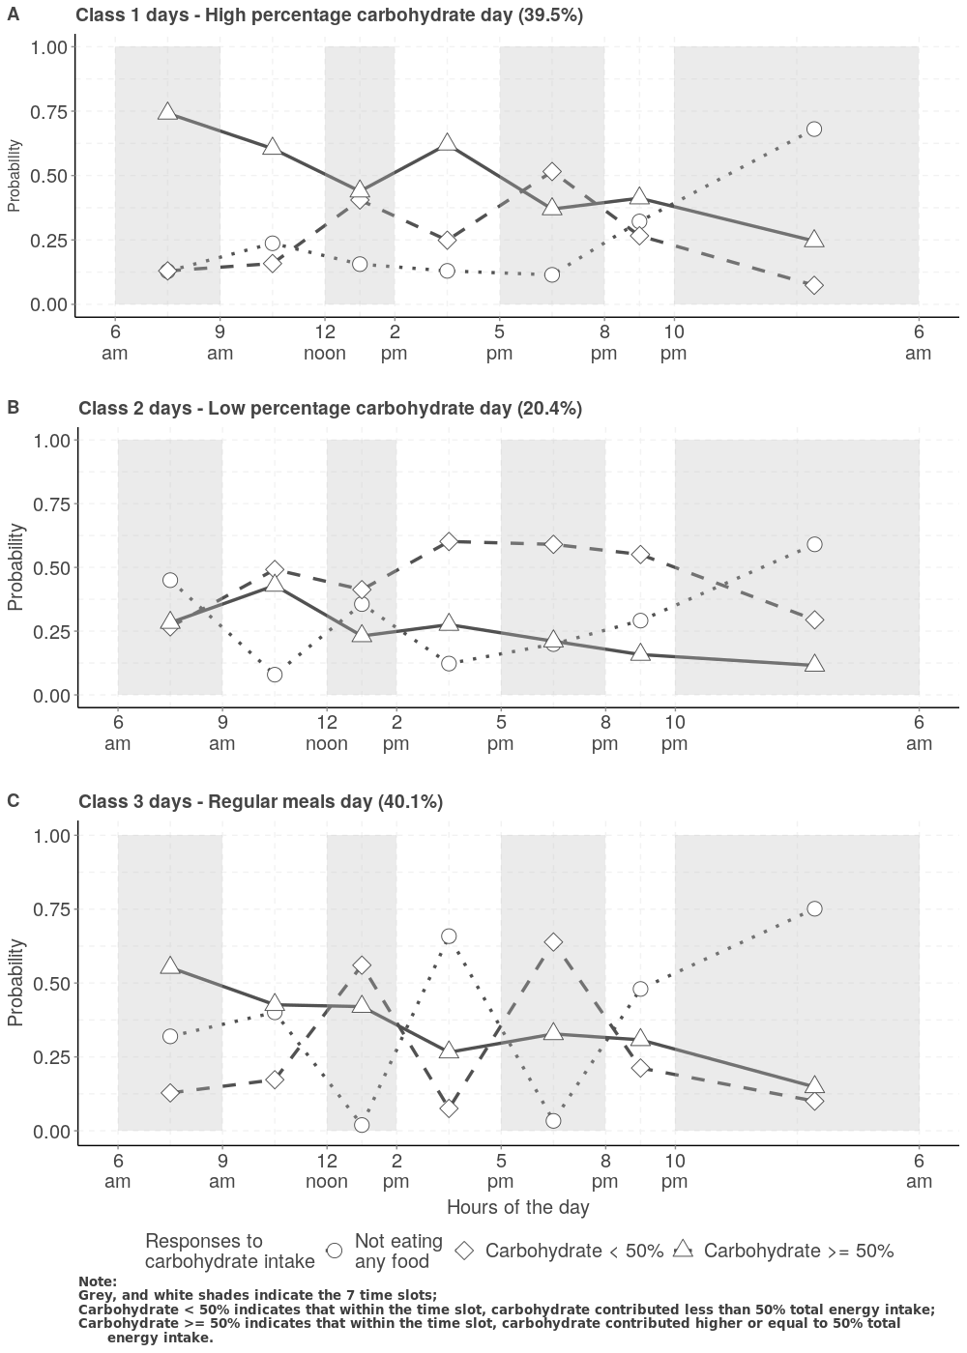

Day Level Latent Classes Solution.

Class 3 days **(Figure [fig:level1]-C)** were called “regular meals day” due to the following reasons: 1) participants’ dietary recordings showed that in these days there was almost 0 possibility of not eating any food at lunch (0.019 between 12 noon and 2 pm) and dinner (0.034 between 5 pm and 8 pm); 2) the probabilities of not eating during morning snack time (9 am to 12 noon) and afternoon snack time (2 pm to 5 pm) were also the highest among the three types of days (0.401 and 0.659). 3) during these days, participants may have some high carbohydrate contained food between 8 pm and 10 pm (probability = 0.308), but the probability of not eating any food during 10 pm to 6 am next morning was 0.751, the highest among the three types of days.

### Features of the three types of carbohydrate eating temporal patterns

lcccc & & & & ***P* value**\*  
Counts (% in row) & 9667 (39.5) & 5002 (20.4) & 9814 (40.1) &  
Country (%) & & & & < 0.001  
England & 5627 (58.2) & 2972 (59.4) & 5291 (53.9) &  
Northern Ireland & 1194 (12.4) & 527 (10.5) & 1400 (14.3) &  
Scotland & 1527 (15.8) & 813 (16.3) & 1774 (18.1) &  
Wales & 1318 (13.6) & 690 (13.8) & 1349 (13.7) &  
Day of Week (%) & & & & < 0.001  
Monday & 1303 (13.5) & 715 (14.3) & 1370 (14.0) &  
Tuesday & 1266 (13.1) & 674 (13.5) & 1290 (13.1) &  
Wednesday & 1225 (12.7) & 740 (14.8) & 1233 (12.6) &  
Thursday & 1272 (13.2) & 752 (15.0) & 1425 (14.5) &  
Friday & 1458 (15.1) & 797 (15.9) & 1479 (15.1) &  
Saturday & 1537 (15.9) & 703 (14.1) & 1495 (15.2) &  
Sunday & 1605 (16.6) & 621 (12.4) & 1522 (15.5) &  
Weekend, Yes (%) & 3142 (32.5) & 1324 (26.5) & 3017 (30.7) & < 0.001  
Total energy (kJ) & 7539.98 (2875.87) & 7160.22 (2922.15) & 7439.68 (2978.91) & < 0.001  
Carbohydrate (g) & 222.79 (89.84) & 209.70 (86.17) & 206.59 (84.42) & < 0.001  
Protein (g) & 71.36 (29.79) & 69.55 (30.20) & 73.29 (32.94) & < 0.001  
Fat (g) & 65.44 (33.27) & 63.94 (33.76) & 67.24 (34.73) & < 0.001  
Alcohol (g) & 11.76 (27.31) & 8.85 (24.25) & 13.80 (33.00) & < 0.001  
Total sugars (g) & 98.63 (56.03) & 88.03 (50.50) & 86.39 (50.96) & < 0.001  
Starch (g) & 124.07 (55.84) & 121.59 (56.13) & 120.11 (54.62) & < 0.001  
Non-milk extrinsic sugar & 59.45 (49.31) & 50.07 (43.41) & 50.41 (44.84) & < 0.001  
Fruit (g) & 107.40 (137.97) & 103.15 (129.08) & 92.76 (126.02) & < 0.001  
Yellow Red Green Vegetables (g) & 26.52 (46.44) & 26.84 (47.99) & 26.16 (45.99) & 0.681

The details of the characteristics of the three types of carbohydrate eating temporal patterns were listed in **Table [tab:day-level-features]**. Specifically, regular meals day turned to be recorded slightly more often in Northern Ireland, and Scotland. In terms of day of week distribution in the three types of days, there is strong evidence (*p* < 0.001) that high percentage carbohydrate days appeared more frequently in weekends (32.5%) compared with low carbohydrate day (26.5%) and regular meals day (30.7%).

As expected, consumption of total energy (7539.98 kJ), total carbohydrate (222.79 g), total sugar (98.63 g), starch (124.07 g), and non-milk extrinsic sugar (59.45 g) was the highest among high percentage carbohydrate days (all *p* < 0.001). On the other hand, the consumption of protein (73.29 g), total fat (67.24 g), and alcohol (13.80 g) were the highest in the regular meals days. Moreover, in the high percentage carbohydrate days, participants turned out to consume the highest amount of fruit (107.40 g). There was no evidence of any difference in the consumption of yellow, red, or green vegetables across the three types of days (*p* = 0.681).

### Individual-level LCA solution

In the random effect models, we utilised the non-parametric approach, in which we added a level 2 (individual level) latent classes based on the random means from the level 1 (day level) latent class solution. The results of the individual level LCA solution for 2 and 3 classes are presented in **Figure [fig:CB2level2]**, and **[fig:level2]**.

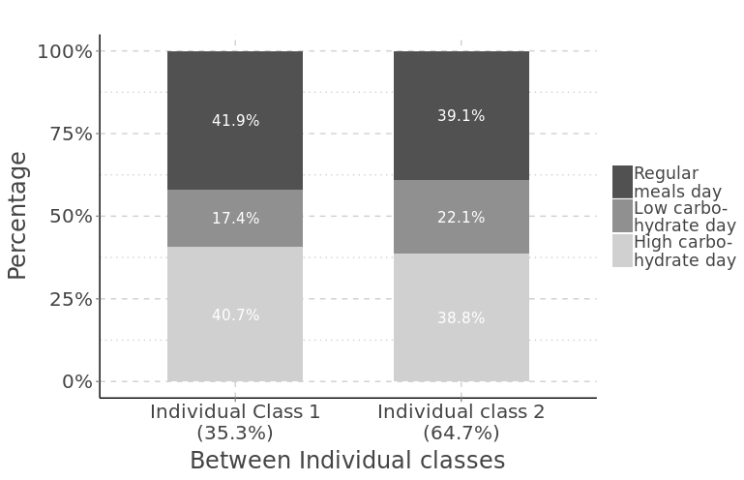

Multilevel Latent Class Solution, 3 classes in day level, 2 classes in individual level.

With two individual-level latent classes **(Figure [fig:CB2level2])**, one individual class comprises individuals with a relatively slightly higher proportion of having “low carbohydrate day” (22.1%) compared to the other (17.4%). This class represents nearly 65% of the individuals. However, we believe these individual classes are not very distinguishable from each other.

With three individual-level latent classes **(Figure [fig:level2])**, a low-carbohydrate eaters class, a moderate-carbohydrate eaters class, and a high-carbohydrate eaters class emerge. 43.1% participants were identified as high-carbohydrate eaters, in these individuals, about 50% of the days (2 out of 4 days) of their dietary diary could be classified as having high percentage carbohydrate days. Nearly 1 out of 4 days of their dietary diary were either “regular meals day” or “low carbohydrate day”. 28.1% participants fell into the low carbohydrate eaters class on the left-hand side of **Figure [fig:level2]**, their recordings of food intake showed that in more than 60% of their days, they were having “regular meals” which was characterised as with the highest amount of fat and alcohol consumptions as already described in **Table [tab:day-level-features]**. Moderate carbohydrate eaters have comparable proportions (42.0% vs 40.0%) of high carbohydrate days and regular meals days; 18.0% of their dietary diary was found to be low carbohydrate days.

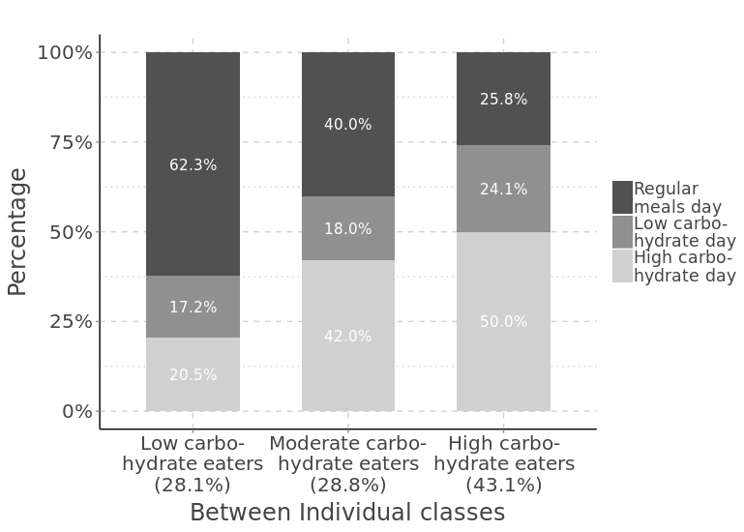

Multilevel Latent Class Solution, 3 classes in day level, 3 classes in individual level.

After recognising that there were three potential latent groups of carbohydrate eaters in the UK adults, whose food consumption patterns were also probably switching from one to another during the survey, their average carbohydrate contribution to total energy intake (as well as the subtypes of carbohydrate actually consumed) within the 7 pre-defined time slots of the day were still of interest. Survey-design-weighted mean energy intake within each time slot of the day and their composition of contribution is illustrated in **Figure [fig:energysourcesCB]**, weighted mean nutrients intakes are listed in **Table [tab:tab-nutri-indi]**.

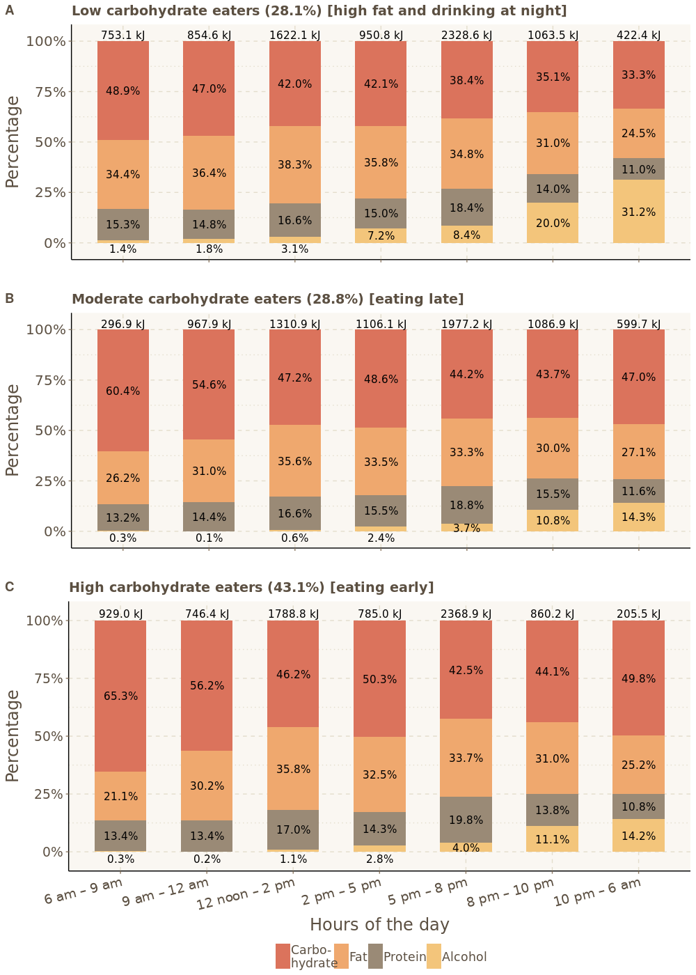

Sources of Energy Contribution at Each Time Slot by Individual Carbohydrate Eating Groups.

Among the three types of carbohydrate eaters, the mean of total energy intake over the 4 days of dietary survey was the highest (7985.8 kJ, 95%CI: 7283.3, 8146.3) in the low carbohydrate eaters group, and the lowest (7341.8 kJ, 95%CI: 7172.5, 7511.2) in the moderate eaters group **(Table [tab:tab-nutri-indi])**. Sources of energy for each type of carbohydrate eaters by the 7-time slots were also different. Low carbohydrate eaters **(Figure [fig:energysourcesCB]-A)** never had carbohydrate contributing more than 50% of their total energy throughout the day. Energy from fat was the highest for low carbohydrate eaters most of the time during the day (except for the time slot between 10 pm to 6 am next morning). Most impressively, energy contributed by alcohol was always the highest in low carbohydrate eaters, percentages for energy from alcohol for the 7-times slots were 1.4% (6-9 am), 1.8% (9-12 noon), 3.1% (12-2 pm), 7.2% (2-5 pm), 8.4% (5-8 pm), 20.0% (8-10 pm), and 31.2% (10-6 am), respectively. Contributions from different energy sources were quite similar for moderate and high carbohydrate eaters, but their absolute amount of energy consumption at each time slot was largely different. Moderate carbohydrate eaters **(Figure [fig:energysourcesCB]-B)** were characterised as consuming the lowest energy (296.9 kJ) before 9 am but having higher energy consumption (967.9 kJ) between 9 am and 12 noon time compared with low and high carbohydrate eaters. Moderate carbohydrate eaters may tend to have later breakfast, later lunch, and probably later dinner as well. They had the highest total energy consumption (599.7 kJ) at night (10 pm - 6 am) across all three types of eaters. High carbohydrate eaters **(Figure [fig:energysourcesCB]-C)** consumed the highest total energy (929.0 kJ) during 6 am to 9 am in the morning, and the lowest total energy between 10 pm to 6 am (205.5 kJ). Specifically, carbohydrate contributions to total energy intake were 65.3% (6-9 am), 56.2% (9-12 noon), 46.2% (12-2 pm), 50.3% (2-5 pm), 42.5% (5-8 pm), 44.1% (8-10 pm), and 49.9% (10-6 am). We also noticed that high carbohydrate eaters consumed their energy mainly from the following three time slots: 6-9 am, 12-2 pm, and 5-8 pm.

In total, the mean of total carbohydrate intake was 203.8 g, 218.3 g, and 233.4 g for low, moderate, and high carbohydrate eaters, respectively **(Table [tab:tab-nutri-indi])**. Total energy contributed by carbohydrate was close to 50% among the high carbohydrate eaters but was only 40.6% among the low carbohydrate eaters. In terms of the subtypes (components) of the carbohydrate consumed at each time slot, high carbohydrate eaters consumed more than 2 times (compared to low carbohydrate eaters) and nearly 4 times (against moderate carbohydrate eaters) the amount of sugar (37.9g 95% CI: 36.8, 39.2) and non-milk extrinsic sugar (i.e. free sugar, 11.1g 95%CI: 10.7, 11.6) between 6-9 am. Moderate carbohydrate eaters had carbohydrate intakes that were more spread out throughout the day. They consumed more sugar and starch during 9-12 noon, 2-5 pm, 8-10 pm, and 10-6 am. Low carbohydrate eaters turned to have a similar temporal pattern of consuming carbohydrates as the high carbohydrate eaters, but the absolute amount of fibre, sugar, free sugar, and starch consumed were usually lower than that in the high carbohydrate eaters except for time slots of 2-5 pm, and 10-6 am. Strong evidence (*p* < 0.001) suggested that the

lcccc **Variables** & & & & ***P* value** *  
Total energy (kJ) & 7985.8 (7823.3, 8146.3) & 7341.8 (7172.5, 7511.2) & 7677.8 (7555.8, 7799.8) & < 0.001  
Carbohydrate (g) & 203.8 (199.8, 207.8) & 218.3 (212.9, 223.7) & 233.4 (229.6, 237.2) & < 0.001  
**6 am – 9 am** & 23.0 (21.8, 24.3) & 11.2 (10.0, 12.3) & 37.9 (36.8, 39.2) &  
Fibre (g) & 1.4 (1.3, 1.5) & 0.6 (0.5, 0.7) & 2.0 (1.9, 2.2) &  
Sugar (g) & 10.2 (9.6, 10.9) & 5.3 (4.8, 5.8) & 19.7 (19.0, 20.4) &  
NMES (g) & 4.7 (4.3, 5.1) & 3.2 (2.9, 3.6) & 11.1 (10.7, 11.6) &  
Starch (g) & 12.8 (12.0, 13.5) & 5.9 (5.1, 6.6) & 18.3 (17.6, 19.1) &  
**9 am – 12 noon** & 25.1 (23.9, 26.3) & 33.0 (31.4, 34.6) & 26.2 (25.1, 27.2) &  
Fibre (g) & 1.5 (1.4, 1.6) & 1.6 (1.5, 1.7) & 1.3 (1.2, 1.3) &  
Sugar (g) & 11.6 (10.9, 12.3) & 15.7 (14.8, 16.6) & 14.2 (13.6, 14.8) &  
NMES (g) & 5.7 (5.2, 6.2) & 9.6 (8.9, 10.2) & 8.1 (7.7, 8.5) &  
Starch (g) & 13.5 (12.8, 14.3) & 17.3 (16.4, 18.3) & 11.9 (11.3, 12.6) &  
**12 noon – 2 pm** & 42.6 (40.9, 44.3) & 38.7 (37.0, 40.4) & 51.6 (50.2, 52.9) &  
Fibre (g) & 3.1 (2.9, 3.2) & 2.3 (2.2, 2.5) & 3.6 (3.5, 3.7) &  
Sugar (g) & 14.7 (14.0, 15.4) & 14.9 (14.0, 15.7) & 19.4 (18.7, 20.0) &  
NMES (g) & 7.3 (6.7, 7.8) & 9.1 (8.4, 9.8) & 10.3 (9.8, 10.8) &  
Starch (g) & 27.9 (26.6, 29.1) & 23,8 (22.6, 24.9) & 32.2 (31.2, 33.1) &  
**2 pm – 5 pm** & 25.0 (23.6, 26.4) & 33.6 (31.6, 35.6) & 24.7 (23.6, 25.7) &  
Fibre (g) & 1.6 (1.5, 1.7) & 1.9 (1.7, 2.0) & 1.3 (1.2, 1.4) &  
Sugar (g) & 11.9 (11.3, 12.7) & 14.5 (13.5, 15.5) & 13.4 (12.8, 13.9) &  
NMES (g) & 6.9 (6.4, 7.5) & 9.9 (9.0, 8.6) & 8.6 (8.2, 9.1) &  
Starch (g) & 13.1 (12.1, 13.9) & 19.1 (17.7, 20.4) & 11.3 (10.6, 11.9) &  
**5 pm – 8 pm** & 55.9 (54.1, 57.9) & 54.6 (52.1, 57.0) & 62.9 (61.3, 64.4) &  
Fibre (g) & 4.4 (4.2, 4.5) & 3.7 (3.5, 3.9) & 4.9 (4.7, 5.0) &  
Sugar (g) & 18.7 (17.9, 19.5) & 18.6 (17.6, 19.5) & 21.8 (20.9, 22.5) &  
NMES (g) & 10.2 (9.6, 10.8) & 11.8 (10.9, 12.6) & 12.1 (11.4, 12.7) &  
Starch (g) & 37.3 (35.8, 38.8) & 35.9 (34.1, 37.9) & 41.1 (39.9, 42.2) &  
**8 pm – 10 pm** & 23.3 (21.9, 24.6) & 29.7 (27.6, 31.7) & 23.7 (22.5, 24.9) &  
Fibre (g) & 1.4 (1.3, 1.6) & 1.6 (1.5, 1.8) & 1.3 (1.5, 1.8) &  
Sugar (g) & 10.9 (10.3, 11.5) & 13.2 (12.2, 14.2) & 12.4 (11.8, 13.0) &  
NMES (g) & 7.3 (6.8, 7.8) & 9.4 (8.5, 10.4) & 8.3 (7.8, 8.8) &  
Starch (g) & 12.3 (11.4, 13.3) & 16.4 (15.0, 17.8) & 11.3 (10.5, 12.1) &  
**10 pm – 6 am** & 8.8 (7.7, 9.8) & 17.6 (15.2, 19.9) & 6.4 (5.8, 7.1) &  
Fibre (g) & 0.34 (0.29, 0.39) & 0.74 (0.63, 0.85) & 0.24 (0.21, 0.27) &  
Sugar (g) & 5.3 (4.6, 6.1) & 10.0 (8.6, 11.5) & 4.1 (3.7, 4.5) &  
NMES (g) & 3.9 (3.3, 4.6) & 7.7 (6.4, 8.9) & 2.9 (2.6, 3.3) &  
Starch (g) & 3.5 (2.9, 3.9) & 7.5 (6.3, 8.8) & 2.3 (1.9, 2.7) &  
Carbohydrate (%) & 40.6 (40.2, 41.0) & 47.3 (46.8, 47.8) & 48.3 (47.9, 48.6) & < 0.001  
Fibre (g) & 13.7 (13.4, 14.0) & 12.5 (12.1, 12.9) & 14.7 (14.4, 14.9) & < 0.001  
Protein (g) & 79.9 (77.9, 81.8) & 69.3 (67.6, 71.0) & 73.7 (72.5, 74.8) & < 0.001  
Fat (g) & 74.7 (73.1, 76.4) & 63.8 (62.1, 65.5) & 65.7 (64.4, 67.0) & < 0.001  
Alcohol (g) & 20.8 (18.3, 23.2) & 10.7 (9.4, 11.9) & 8.9 (8.1, 9.8) & < 0.001

mean of total fibre consumption for low, moderate, and high carbohydrate eaters were different: 13.7g (95%CI: 13.4, 14.0), 12.5g (95%CI: 12.1, 12.9), and 14.7g (95%CI: 14.4, 14.9) with all 95% CI being non-overlapping. It is also noteworthy that low carbohydrate eaters consumed the highest average amount of protein (79.9 g, 17.2% of total energy), fat (74.7g, 35.4% of total energy), and alcohol (20.8 g, 6.8% of total energy) as we have described for **Figure [fig:energysourcesCB]**.

The social-demographic characteristics of the UK adults according to their individual level latent class membership are shown in **Table [tab:Level2tab1]**. Moderate carbohydrate eaters were relatively younger (*p* < 0.001). Gender distribution across the three types of carbohydrate eaters was reasonably even (*p* = 0.119). The distribution of the carbohydrate eater types appears to be changing with the year of survey. Low carbohydrate eaters represented 32.5% of the population in the first year of the survey but later dropped to lower than 30% (minimum in the third year at 22.6%) until the most recent year. The proportion of high carbohydrate eaters increased from 41.2% to the highest (50.6%) in the second year, but then started to decline to 38.4% in the 8th year of survey (*p* = 0.015). There was no evidence of any difference in employment status across three types of carbohydrate eaters. However, strong evidence suggested that high carbohydrate eaters had the highest proportion (61.3%) of living with partner (*p* < 0.001); moderate carbohydrate eaters had the lowest average income (27180.8 /year), the highest proportion of non-white population (20.5%), and a lower education level (23.3% with degree of higher education) compared with either low or high carbohydrate eaters.

Weighted means, percentages of anthropometric measurements, as well as biochemical characteristic profiles according to the latent carbohydrate eater groups are given in **Table [tab:tab2]**. Low carbohydrate eaters had higher mean BMI (27.8 kg/m2) and larger mean WC (98.9/89.9 cm in men/women) compared with 27.2, 27.3 kg/m2, and 95.9/88.7 (men/women), 98.1/87.2 (men/women) cm in moderate and high carbohydrate eaters. Moderate carbohydrate eaters had the highest prevalence of being a current smoker (27.8%), shortest time of daily physical activity (geometric mean: 0.87 hours/day), and lowest prevalence of hypertension (20.2%).

From the results of blood tests, 6.9% of low carbohydrate eaters were found to be diabetic (diagnosed by HbA1C > 6.5%), while the percentages of diabetes in the moderate and high carbohydrate eaters were 3.5%, and 4.1% (*p* < 0.011), respectively. Although there was some evidence (*p* = 0.027) that fasting blood glucose level may be slightly higher in non-diabetic low carbohydrate eaters, the geometric mean for HbA1C was probably lower (*p* = 0.010) in moderate carbohydrate eaters (5.43, 95%CI: 5.39, 5.47). Total cholesterol, HDL, and LDL were all lower in the moderate carbohydrate eaters, while no evidence of any difference of TG was found across three types of carbohydrate eaters.

lcccc **Variables** & & & & ***P* value** *  
Total (%) & 28.3 (26.9, 29.9) & 28.7 (27.1, 30.3) & 43.0 (41.3, 44.7) &  
Age (years) & 51.0 (49.9, 52.1) & 40.3 (39.1, 41.6) & 51.7 (50.7, 52.7) & < 0.001  
Sex (%) & & & & 0.119  
Men & 50.0 (46.9, 53.1) & 50.2 (47.0, 53.5) & 46.6 (44.0, 49.1) &  
Women & 50.0 (46.9, 53.1) & 49.8 (46.5, 53.0) & 53.4 (50.9, 56.0) &  
Survey years (% in rows) & & & & 0.015  
1 & 32.5 (28.4, 36.9) & 26.3 (21.9, 31.2) & 41.2 (36.6, 46.0) &  
2 & 26.8 (22.6, 31.3) & 22.6 (18.6, 27.3) & 50.6 (45.8, 55.4) &  
3 & 22.6 (18.8, 26.9) & 33.7 (28.6, 39.2) & 43.6 (38.7, 48.7) &  
4 & 27.9 (24.1, 32.2) & 27.6 (23.8, 31.8) & 44.4 (40.2, 48.7) &  
5 & 27.9 (24.2, 32.0) & 28.7 (24.4, 33.5) & 43.3 (38.2, 48.6) &  
6 & 28.0 (24.0, 32.4) & 31.5 (26.9, 36.6) & 40.5 (35.8, 45.3) &  
7 & 29.1 (25.2, 33.4) & 29.0 (24.5, 34.0) & 41.8 (37.1, 46.7) &  
8 & 31.1 (27.3, 35.3) & 30.5 (25.9, 35.5) & 38.4 (34.1, 42.8) &  
Paid employment (%) & & & & 0.907  
Yes & 40.3 (37.0, 43.6) & 40.8 (37.1, 44.5) & 39.8 (37.1, 42.6) &  
No & 59.7 (56.4, 63.0) & 59.2 (55.5, 62.9) & 60.2 (57.4, 62.9) &  
Live with partner (%) & & & & < 0.001  
Yes & 56.9 (53.6, 60.1) & 38.4 (35.2, 41.8) & 61.3 (58.7, 63.7) &  
No & 43.1 (39.9, 46.4) & 61.6 (58.2, 64.8)) & 38.7 (36.3, 41,3) &  
Household income, /year & & & & < 0.001  
Ethnicity (%) & & & &  
White & 94.2 (92.4, 95.6) & 79.5 (76.4, 82.3) & 91.9 (90.1, 93.4) & < 0.001  
Non-White & 5.8 (4.4, 7.6) & 20.5 (17.7, 23.6) & 8.1 (6.6, 9.9) &  
Education (%) & & & &  
Degree or higher & 29.0 (26.1, 32.1) & 23.3 (20.5, 26.3) & 26.2 (24.1, 28.5) & 0.019  
Lower than degree & 71.0 (67.9, 73.9) & 76.7 (73.7, 79.5) & 73.8 (71.5, 75.9) &

lcccc **Variables** & & & & ***P* value** *  
BMI (kg/m2) & 27.8 (27.4, 28.2) & 27.2 (26.7, 27.7) & 27.3 (26.9, 27.6) & 0.006  
WC (cm) &&&&  
Men & 98.9 (97.4, 100.5) & 95.9 (94.1, 97.8) & 98.1 (96.9, 99.2) & 0.056  
Women & 89.9 (88.7, 91.3) & 88.7 (87.1, 90.3) & 87.2 (86.1, 88.2) & 0.005  
Smoking status (%) & & & &  
Current & 20.4 (18.0, 23.0) & 27.8 (25.0, 30.9) & 17.1 (15.4, 19.0) & < 0.001  
Ex-smoker & 29.3 (26.5, 32.2) & 16.8 (14.6, 19.2) & 26.1 (24.9, 28.3) &  
Never & 50.3 (47.2, 32.2) & 55.4 (52.2, 58.6) & 56.8 (54.3, 59.3) &  
Physical activity (hours/day) ¶ & 1.08 (0.97, 1.19) & 0.87 (0.77, 0.97) & 1.07 (0.98, 1.16) & 0.005  
Hypertension, Yes (%) & 33.8 (30.2, 37.5) & 20.2 (17.0, 24.0) & 30.9 (26.9, 31.0) & < 0.001  
Total energy intake (kJ) & & & & < 0.001  
Glucose (mmol/l) & 5.17 (5.12, 5.23) & 5.05 (4.99, 5.13) & 5.10 (5.05, 5.15) & 0.027  
HbA1C (%) & 5.47 (5.44, 5.51) & 5.43 (5.39, 5.47) & 5.50 (5.48, 5.53) & 0.010  
DM § & 6.9 (5.0, 9.3) & 3.5 (2.3, 5.3) & 4.1 (2.9, 5.6) & 0.011  
TC (mmol/l) & 4.95 (4.84, 5.05) & 4.72 (4.62, 4.83) & 4.95 (4.87, 5.03) & 0.001  
HDL (mmol/l) & 1.39 (1.35, 1.43)& 1.32 (1.28, 1.35) & 1.39 (1.36, 1.42)& 0.003  
LDL (mmol/l) & 2.88 (2.79, 2.97) & 2.77 (2.68, 2.86) & 2.93 (2.86, 3.00)& 0.024  
TG (mmol/l) & 1.14 (1.08, 1.19) & 1.11 (1.05, 1.17) & 1.10 (1.06, 1.15) & 0.629

### Association between individual-level latent classes and hypertension, and obesity.

#### Hypertension

**Table [tab:tab1hypetension]** presents the characteristics of men and women participants in the NDNS RP 2008/09-15/16 by hypertension status. The weighted prevalences of hypertension were 30.4% in men and 27.5% in women. Among both sexes, there was strong evidence of differences by hypertension status for age, education level, living with a partner or not, smoking status, BMI, abdominal obesity (WC), and prevalence of diabetes (*p* < 0.01). No difference was found among either men or women for ethnicity. Strong evidence of difference was suggested in women for average household income (32741.5 /year in non-hypertensive vs 27862.0 /year in hypertensive, *p* < 0.001), and physical activity level (geometric mean: 0.81 hours/day in non-hypertensive compared with 0.53 hours/day in hypertensive, *p* < 0.001) but not in men. Interestingly, in both sexes, hypertensive participants had a higher proportion of being classified as low or high carbohydrate eaters; total energy and carbohydrate intake were higher in people without hypertension (*p* < 0.001).

The sex-specific associations of carbohydrate eating patterns with hypertension (both in total and in participants without diabetes) are shown in **Table [tab:tab2HYT]**. In the crude models, moderate carbohydrate eaters had statistically significant lower odds of having hypertension than low carbohydrate eaters in both men and women irrespective to diabetes status. Among men, after adjustment for selected confounders, which includes: age, live with partner or not, education level, BMI, smoking status, and total energy intake, the odds of having hypertension were 32% lower (OR: 0.68, 95% CI: 0.43, 1.07) in moderate carbohydrate eaters compared with low carbohydrate eaters, evidence for the OR different from 1 was borderline significant (*p* = 0.093). 95% CI of the adjusted OR became narrower (OR: 0.64, 95% CI: 0.41, 1.01, *p* = 0.054) when BMI was replaced with WC in model 2. When diabetic men were excluded in Model 2, the odds for moderate and high carbohydrate eaters compared with low carbohydrate eaters were 35% (OR: 0.65, 95%CI: 0.41, 1.03) and 27% (OR:0.73, 95%CI: 0.51, 1.06) lower, respectively. The negative associations between moderate carbohydrate eating pattern and hypertension were also observed in women, however, without any statistically significant evidence in the fully adjusted models. High carbohydrate eaters also had lower adjusted odds compared with low carbohydrate eaters, while the 95% CIs for the adjusted ORs were all wide and included the null value suggesting no evidence of any association in either men or women for high carbohydrate eating pattern and hypertension.

lcccccc & &  
(l2ptr2pt)2-4 (l2ptr2pt)5-7 & **Non-hypertensive** & **Hypertensive** & ***P* value\*** & **Non-hypertensive** & **Hypertensive** & ***P* value\***  
Weighted prevalence (%) & 69.6 (66.6, 72.5) & 30.4 (27.5, 33.4) & & 72.5 (69.8, 75.0) & 27.5 (25.0, 30.2) &  
Age (years) & 43.2 (41.7, 44.7) & 59.9 (58.0, 61.7) & < 0.001 & 43.9 (42.7, 45.1) & 64.9 (63.4, 66.5) & < 0.001  
Ethnicity (%) & & & 0.534 & & & 0.126  
White & 89.6 (86.5, 92.0) & 91.1 (86.2, 94.4) & & 85.7 (82.7, 88.3) & 90.2 (85.0, 93.7) &  
Non-white & 10.4 (8.0, 13.5) & 8.9 (5.6, 13.8) & & 14.3 (11.7, 17.3) & 9.8 (6.3, 15.0) &  
Education (%) & & & 0.006 & & & < 0.001  
Degree or higher & 30.3 (26.6, 34.2) & 21.5 (17.3, 26.5) & & 33.0 (29.9, 36.3) & 19.7 (15.8, 24.3) &  
Lower than Degree & 69.7 (65.8, 73.4) & 78.5 (73.5, 82.7) & & 67.0 (63.7, 70.1) & 80.3 (75.7, 84.2) &  
Household income,/year & 34006.5 (31972.9, 36040.1) & 32280.5 (29875.6, 34685.4) & 0.284 & 32741.5 (31009.9, 34473.1) & 27862.0 (25557.0, 30167.0) & < 0.001  
Live with partner, Yes, (%) & 56.1 (51.8, 61.4) & 66.6 (61.3, 71.5) & 0.002 & 48.7 (45.1, 52.3) & 58.9 (53.6, 63.9) & 0.002  
Smoking status & & & < 0.001 & & & < 0.001  
Current & 19.7 (16.6, 23.1) & 12.9 (9.5, 17.2) & & 15.2 (13.1, 17.6) & 8.5 (6.2, 11.6) &  
Ex-smoker & 24.2 (21.1, 27.6) & 38.8 (33.4, 44.5) & & 21.6 (19.1, 24.4) & 32.2 (27.3, 37.4) &  
Never & 56.2 (52.1, 60.1) & 48.3 (42.7, 54.0) & & 63.2 (60.1, 66.2) & 59.3 (54.0, 64.4) &  
Physical activity (hours/day) & 1.52 (1.33, 1.72) & 1.29 (1.08, 1.53) & 0.134 & 0.81 (0.73, 0.89) & 0.53 (0.42, 0.64) & < 0.001  
BMI (kg/m2) & 26.8 (26.4, 27.2) & 29.5 (28.9, 29.9) & < 0.001 & 26.4 (26.1, 26.8) & 29.8 (29.2, 30.5) & < 0.001  
WC (cm) & 95.0 (93.9, 96.2) & 104.6 (103.2, 106.1) & < 0.001 & 85.7 (84.8, 86.6) & 95.7 (94.2, 97.2) & < 0.001  
DM§ (%) & 3.7 (2.4, 5.7) & 12.6 (8.9, 17.5) & < 0.001 & 1.8 (1.0, 3.3) & 7.9 (5.1, 11.9) & < 0.001  
Carbohydrate eating patterns (%) & & & < 0.001 & & & < 0.001  
Low & 28.3 (24.8, 32.2) & 37.1 (32.0, 42.5) & & 26.9 (24.1, 29.9) & 32.0 (27.2, 37.2) &  
Moderate & 30.8 (26.9, 35.0) & 19.3 (15.3, 24.1) & & 29.6 (26.4, 33.0) & 18.4 (14.5, 22.9) &  
High & 40.8 (36.9, 44.9) & 43.6 (38.2, 49.2) & & 43.5 (40.3, 46.8) & 49.7 (44.1, 55.2) &  
Total energy intake (kJ) & 9021.4 (8791.9, 9251.0) & 8366.2 (8094.9, 8637.4) & < 0.001 & 6802.6 (6681.1, 6924.0) & 6396.7 (6217.1, 6576.2) & < 0.001  
Carbohydrate intake (g) & 259.2 (252.9, 265.3) & 235.3 (227.8, 242.8) & < 0.001 & 198.0 (194.2, 201.8) & 184.5 (178.8, 190.1) & < 0.001

lccccc &  
(l2ptr2pt)2-6 **Model** & **Low** & **Moderate** & ***P* value\*** & **High** & ***P* value\***  
  
  
Crude model & 1 & 0.48 (0.33, 0.70) & < 0.001 & 0.82 (0.59, 1.13) & 0.217  
Model 1 & 1 & 0.68 (0.43, 1.07) & 0.093 & 0.80 (0.56, 1.15) & 0.227  
Model 2 & 1 & 0.64 (0.41, 1.01) & 0.054 & 0.75 (0.53, 1.08) & 0.124  
  
Crude model & 1 & 0.49 (0.33, 0.73) & < 0.001 & 0.82 (0.59, 1.14) & 0.241  
Model 1 & 1 & 0.69 (0.43, 1.09) & 0.110 & 0.78 (0.54, 1.14) & 0.197  
Model 2 & 1 & 0.65 (0.41, 1.03) & 0.066 & 0.73 (0.51, 1.06) & 0.096  
  
  
Crude model & 1 & 0.52 (0.36, 0.75) & < 0.001 & 0.96 (0.72, 1.28) & 0.773  
Model 1 & 1 & 0.79 (0.45, 1.39) & 0.415 & 0.89 (0.61, 1.30) & 0.552  
Model 2 & 1 & 0.78 (0.45, 1.36) & 0.384 & 0.88 (0.62, 1.26) & 0.483  
  
Crude model & 1 & 0.51 (0.35, 0.74) & < 0.001 & 0.98 (0.73, 1.31) & 0.875  
Model 1 & 1 & 0.79 (0.44, 1.42) & 0.435 & 0.89 (0.61, 1.29) & 0.534  
Model 2 & 1 & 0.79 (0.45, 1.39) & 0.415 & 0.87 (0.61, 1.25) & 0.452

#### Obesity (BMI and WC)

**Table [tab:tab1BMI]** shows the characteristics of participants according to their obesity status stratified by sex. The survey design-weighted prevalences for being overweight and obese in the UK adults were estimated to be 43.4% and 25.7% in men, and 30.9% and 27.4% in women. Obviously, abdominal obesity (WC) increased significantly with the elevated BMI level in both men and women. Overweight or obese participants were older, having lower total energy intake and lower carbohydrate intake compared with normal weight men and women (*p* < 0.001). Moreover, education

lcccccccc & &  
(l2ptr2pt)2-5 (l2ptr2pt)6-9 & **Normal weight** & **Overweight** & **Obese** & ***P* value\*** & **Normal weight** & **Overweight** & **Obese** & ***P* value\***  
Weighted prevalence (%) & 30.9 (28.0, 33.9) & 43.4 (40.4, 46.4) & 25.7 (23.2, 28.4) & & 41.7 (39.0, 44.4) & 30.9 (28.4, 33.5) & 27.4 (25.1, 29.9) &  
BMI (kg/m2) & 22.6 (22.3, 22.8) & 27.3 (27.2, 27.5) & 33.7 (33.3, 34.2) & < 0.001 & 22.2 (22.0, 22.4) & 27.3 (27.2, 27.5) & 35.0 (34.6, 35.4) & < 0.001  
WC (cm) & 84.5 (83.6, 85.4) & 97.1 (96.4, 97.8) & 112.7 (111.6, 113.9) & < 0.001 & 76.9 (76.2, 77.5) & 89.0 (88.3, 89.7) & 103.7 (102.6, 104.7) & < 0.001  
Age (years) & 40.3 (38.2, 42.4) & 49.6 (47.9, 51.2) & 50.4 (48.5, 52.3) & < 0.001 & 45.0 (43.4, 46.7) & 50.4 (48.6, 52.3) & 50.9 (49.1, 52.7) & < 0.001  
Ethnicity (%) & & & & 0.466 & & & & 0.879  
White & 88.7 (83.9, 92.2) & 89.1 (85.6, 91.9) & 91.9 (87.3, 94.9) & & 88.4 (84.9, 91.19 & 88.6 (84.5, 91.7) & 87.3 (82.5, 90.9) &  
Non-white & 11.3 (7.8, 16.1) & 10.9 (8.1, 14.4) & 8.1 (5.1, 12.7) & & 11.6 (8.9, 15.1) & 11.4 (8.3, 15.5) & 12.7 (9.1, 17.5) &  
Education (%) & & & & 0.022 & & & & < 0.001  
Degree or higher & 29.5 (24.5, 35.0) & 28.3 (24.3, 32.7) & 20.1 (16.0, 25.0) & & 35.7 (31.8, 39.8) & 24.2 (20.4, 28.4) & 19.4 (16.1, 23.2) &  
Lower than Degree & 70.5 (65.0, 75.5) & 71.7 (67.3, 75.7) & 79.9 (75.0, 84.0) & & 64.3 (60.2, 68.2) & 75.8 (71.6, 79.6) & 80.6 (76.8, 83.9) &  
Household income, /year & & & & 0.011 & & & & < 0.001  
Live with partner, Yes, (%) & 40.3 (34.8, 46.1) & 65.3 (60.8, 69.6) & 65.6 (60.1, 70.8) & < 0.001 & 47.6 (43.2, 52.1) & 52.2 (47.5, 57.0) & 51.7 (46.7, 56.6) & 0.288  
Smoking status & & & & < 0.001 & & & & 0.042  
Current & 32.0 (26.8, 37.7) & 18.7 (15.5, 22.4) & 19.2 (15.0, 24.3) & & 19.5 (16.4, 22.9) & 17.8 (14.8, 21.4) & 16.4 (13.1, 20.3) &  
Ex-smoker & 17.3 (13.5, 22.0) & 28.6 (24.8, 32.7) & 32.9 (27.9, 38.4) & & 19.0 (15.9, 22.5) & 24.4 (20.8, 28.3) & 26.9 (22.8, 31.6) &  
Never & 50.6 (44.8, 56.4) & 52.7 (48.2, 57.1) & 47.9 (42.1, 53.7) & & 61.6 (57.4, 65.5) & 57.8 (53.3, 62.2) & 56.7 (51.8, 61.4) &  
Physical activity (hours/day) & 1.58 (1.33, 1.85) & 1.42 (1.24, 1.62) & 1.41 (1.15, 1.70) & 0.547 & 0.84 (0.74, 0.94) & 0.71 (0.62, 0.79) & 0.65 (0.53, 0.78) & 0.038  
Carbohydrate eating patterns (%) & & & & 0.072 & & & & 0.253  
Low & 25.9 (21.0, 31.5) & 30.6 (26.6, 35.0) & 31.4 (26.6, 36.6) & & 24.8 (21.5, 28.5) & 26.8 (22.8, 31.2) & 29.5 (25.3, 34.1) &  
Moderate & 34.2 (28.6, 40.4) & 25.5 (21.9, 29.6) & 25.5 (20.6, 31.0) & & 27.6 (23.8, 31.8) & 26.3 (22.3, 30.8) & 29.8 (25.4, 34.6) &  
High & 39.9 (34.2, 45.8) & 43.8 (39.6, 48.2) & 43.1 (37.7, 48.7) & & 47.6 (43.3, 51.9) & 46.9 (42.4, 51.4) & 40.7 (36.0, 45.6) &  
Total energy intake (kJ) & & & & 0.001 & & & & < 0.001  
Carbohydrate intake (g) & & & & < 0.001 & & & & < 0.001

level (*p* = 0.022 for men, < 0.001 for women), and average household income (*p* = 0.011 for men, < 0.001 for women) decreased with increases in BMI. Living with a partner was strongly positively associated with obesity for men but not for women. Men with obesity were also found to have the lowest proportion of never being a smoker (47.9%) and the highest proportion of being an ex-smoker (32.9%). Association between smoking status and obesity in women had only very weak evidence (*p* = 0.042), but a similar pattern as in men was observed (higher proportion of ex- and current smokers in overweight or obese women). No difference was found for length of physical activity across obesity levels in men, while in women, somewhat weak inverse association (*p*=0.038) was confirmed. Interestingly, predefined carbohydrate eating patterns lacked evidence for an association with BMI in men (*p* = 0.072) or in women (*p* = 0.253).

lccccc &  
(l2ptr2pt)2-6 **Model** & **Low** & **Moderate** & ***P* value\*** & **High** & ***P* value\***  
  
  
Crude model & – & -0.78 (-1.62, 0.06) & 0.068 & -0.28 (-0.96, 0.41) & 0.426  
Model 1 & – & -0.20 (-1.06, 0.66) & 0.654 & -0.43 (-1.13, 0.26) & 0.220  
  
Crude model & – & -0.65 (-1.49, 0.19) & 0.127 & -0.21 (-0.89, 0.48) & 0.557  
Model 1 & – & -0.10 (-0.97, 0.77) & 0.820 & -0.39 (-1.10, 0.31) & 0.269  
  
  
Crude model & – & -0.30 (-1.18, 0.57) & 0.496 & -0.76 (-1.44, -0.82) & 0.028  
Live with partner & – & -0.93 (-2.33, 0.46) & 0.188 & -1.76 (-2.78, -0.73) & 0.001  
Live alone & – & 1.17 (-0.35, 2.70) & 0.132 & 0.57 (-0.58, 1.71) & 0.332  
  
Crude model & – & -0.24 (-1.12, 0.65) & 0.601 & -0.71 (-1.39, -0.03) & 0.040  
Live with partner & – & -0.86 (-2.28, 0.55) & 0.232 & -1.62 (-2.65, -0.58) & 0.002  
Live alone & – & 1.22 (-0.34, 2.78) & 0.124 & 0.43 (-0.71, 1.56) & 0.462

Results of the multivariable linear regression analyses showed smaller BMI for moderate or high carbohydrate eaters compared with low carbohydrate eaters among men **(Table [tab:tab2BMI])**. However, the 95%CI of the regression coefficients were all wide and included the null value 0, indicating no statistically supported evidence for the inverse association. In women, evidence of an interaction effect was found between living with a partner or not and carbohydrate eating patterns for the outcome of BMI (*p* for interaction = 0.014 and 0.036 for women in total and without diabetes). For women who were living with partners, latent classes of carbohydrate eating patterns were negatively associated with BMI. Compared with women eating a low carbohydrate food pattern, women having a high carbohydrate eating pattern were associated with an average 1.76 kg/m2 lower BMI after adjustment of age, average household income, education level, smoking status, total energy intake and alcohol consumption. 95%CI for the adjusted BMI difference was 0.73 to 2.78 kg/m2, *p* = 0.001. After excluding diabetic women, BMI was still 1.62 kg/m2 (95%CI: 0.58, 2.65, *p* = 0.002) smaller in high carbohydrate eaters versus low carbohydrate eaters on average. On the contrary, latent classes of carbohydrate eating patterns were positively associated with BMI in women who were living by themselves, although there was no evidence that regression coefficients differed from 0 (*p* > 0.05).

Similarly, when looking at the association between carbohydrate eating pattern and abdominal obesity (WC), men who were classified as moderate carbohydrate eaters were found to have about 3 cm (95%CI: 0.52, 5.49 cm, *p* = 0.018) smaller WC compared to low carbohydrate eaters in the crude model **(Table [tab:tab2WC])**. However, after adjustment for age, living with partner or not, average household income, education level, hypertension, smoking status, total energy intake, and alcohol consumption, the association attenuated to no difference. The interaction effect of living with a partner or not on the association between carbohydrate eating patterns and WC was again found in women in total (*p* for interaction = 0.009) and without diabetes (*p* for interaction = 0.012). Among women who were living with their partners, high carbohydrate eaters had 4.71 cm (95%CI: 2.43, 7.00, *p* < 0.001) smaller WC on average compared with low carbohydrate eaters. The association remained after restricting the sample to non-diabetic women (-3.74 cm, 95% CI: -5.97, -1.51, *p* = 0.001). However, for women who were living alone, moderate carbohydrate eaters had 3.17 cm (95%CI: 0.05, 6.30, *p* = 0.047) larger WC on average compared with low carbohydrate eaters. The evidence for the positive association between moderate carbohydrate eaters and WC in women became weaker but still had borderline significance when excluding diabetic women (3.08 cm, 95%CI: -0.09, 6.25, *p* = 0.057).

lccccc &  
(l2ptr2pt)2-6 **Model** & **Low** & **Moderate** & ***P* value\*** & **High** & ***P* value\***  
  
  
Crude model & – & -3.00 (-5.49, -0.52) & 0.018 & -0.90 (-2.84, 1.04) & 0.364  
Model 1 & – & 1.06 (-1.50, 3.64) & 0.415 & -1.55 (-3.42, 0.31) & 0.103  
  
Crude model & – & -2.51 (-5.00, -0.21) & 0.048 & -0.51 (-2.47, 1.44) & 0.606  
Model 1 & – & 1.42 (-1.17, 4.01) & 0.283 & -1.29 (-3.18, 0.60) & 0.181  
  
  
Crude model & – & -1.28 (-3.26, 0.70) & 0.206 & -2.81 (-4.50, -1.12) & 0.001  
Live with partner & – & 0.28 (-2.85, 3.41) & 0.861 & -4.71 (-7.00, -2.43) & < 0.001  
Live alone & – & 3.17 (0.05, 6.30) & 0.047 & 0.73 (-1.84, 3.30) & 0.577  
  
Crude model & – & -0.91 (-2.88, 1.07) & 0.368 & -2.41 (-4.06, -0.76) & 0.004  
Live with partner & – & 1.11 (-2.02, 4.23) & 0.487 & -3.74 (-5.97, -1.51) & 0.001  
Live alone & – & 3.08 (-0.09, 6.25) & 0.057 & 0.16 (-2.36, 2.69) & 0.899

# Discussion and Conclusion

## Carbohydrate eating patterns

Using multilevel LCA as a novel technique, and data from the NDNS RP, this project examined carbohydrate temporal eating patterns firstly at the day level, based on which, individual level carbohydrate eating patterns were also defined subsequently.

Among the dietary diaries collected, there were three distinct latent classes specifically for carbohydrate intake: 1) high probabilities of having high carbohydrate contained food across the hours of day (high percentage carbohydrate day); 2) low carbohydrate food dominant throughout the hours of day (low percentage carbohydrate day); and 3) always having lunch and dinner day (regular meals day). From these day level classifications and their features, one might anticipate that individuals followed much of class 3) days, the regular meals day, might be eating a healthier diet because of regular eating habits. We might also speculate that those who followed either high or low carbohydrate percentage days would consume higher total energy than those who followed mostly regular meals days.

However, when the MLCA extended the model to an individual level, three types of persons were further defined depending on their 4-day-diary: 1) low carbohydrate eaters, who mostly followed “regular meals day”; 2) moderate carbohydrate eaters, who had similar probabilities of following either “regular meals day” or “high percentage carbohydrate day”; 3) high carbohydrate eaters, who followed “high percentage carbohydrate day” for half of their survey. For the first time, as far as we know, the day-to-day food intake pattern variation within individuals was successfully captured by MLCA models. Results from the MLCA models showed that from the perspective of carbohydrate consumption, people were indeed changing their diet from day to day even over the captured four days. The MLCA models allowed the probability of following a certain type of carbohydrate eating day to vary across individuals. This properly accounted for the fact that for some people, their probability of following a type of food eating pattern during the survey could be higher/lower than that in the others. This finding also suggested that assuming a person will always follow a certain type of eating pattern is not appropriate.

Surprisingly, low carbohydrate eaters whose dietary recordings suggested that they were mostly following a regular temporal meals pattern turned out to be consuming the highest amount of total energy among the three types of carbohydrate eaters. Detailed profiling of energy composition according to the time slots revealed that low carbohydrate eaters had a higher proportion of energy contributed by both alcohol and fat across the 7 time slots. A high percentage of fat consumption was shown in all 7-time slots, energy coming from alcohol exceeded more than one-fifth of the total energy after 8 pm. These findings explained why they were actually consuming the highest energy among the three types of carbohydrate eaters. In the meantime, we also found that participants consuming low carbohydrate food had a higher prevalence of diabetes, hypertension, and obesity. These health issues might lead them to replace carbohydrates in their diet with other energy sources such as fat, protein, or even alcohol. Therefore, there is a possibility that they chose to follow low carbohydrate diets for health purposes, but many of them were replacing carbohydrates with higher energy condensed food or even alcohol at night which might indeed be a public health concern.

Next, when looking into the details of the timing and composition of the energy intake among the moderate carbohydrate eaters, we realised that although these individuals did not consume as much alcohol as low carbohydrate eaters did at night, they consumed the highest amount of energy, especially during the time period as late as after 10 pm. People who fell into moderate carbohydrate eaters group seemed to have the tendency of having their food or meals later than high carbohydrate eaters. They consumed the highest amount of carbohydrates and also total energy among three types of carbohydrate eaters during the following time slots: 9-12 noon, 2-5 pm, 8-10 pm, and 10pm-6am. These individuals in the NDNS RP were younger, mostly single, with lower average income, and lower education level. They might correspond to the “late eaters” defined by previous studies [8,9].

Finally, the high carbohydrate eaters identified by our MLCA models had the highest absolute total amount of carbohydrate intake. Most (nearly 70%) of their total energy intake occurred during 6-9 am, 12-2 pm, and 5-8 pm time slots although their total energy consumption was not the highest (between low and moderate carbohydrate eaters). High carbohydrate eaters were also found to be the ones that consumed the least amount of energy after 8 pm. Therefore, contrary to what was anticipated at the beginning, people who followed high percentage carbohydrate days for most of their time were potentially eating a healthier diet compared with the other two eating patterns.

Our analyses looking for different temporal carbohydrate eating patterns also highlighted the complexity of eating behaviours in the population and the utility of exploratory, data-driven methods to objectively identify eating patterns that reflect both timing and quantities of food intake, which may not have been detected so far in the literature.

## Associations between carbohydrate eating patterns and health outcomes

Men who were classified as moderate carbohydrate eaters were estimated to have lower odds of having hypertension compared with low carbohydrate eaters, after adjustment for age, relationship status (living with a partner or not), educational level, BMI, smoking status and total energy intake. As discussed above, moderate carbohydrate eaters tended to have meals (or energy intake) later in time compared with high carbohydrate eaters. But, it is noteworthy that low carbohydrate eaters also obtained a large amount of energy from both fat and alcohol at night. Therefore, considering that moderate carbohydrate eaters were younger than low carbohydrate eaters (although age was adjusted in the full models), it is probable that reverse causality exists here (also due to the nature of cross-sectional study). That is, they were potentially both late eaters, however, with increased age (and so with increased health-related problems/concerns) some of the individuals modified their habits, replacing carbohydrate food with other energy sources (so that they became low carbohydrate eaters) leading to the phenomenon of lower odds of hypertension in moderate carbohydrate eaters. This phenomenon may be supported by some current trend in following low carbohydrate diets (ketogenic diets) which were found actually with limited weight losing effect and even associated with adverse events such as nonalcoholic fatty liver disease (NAFLD), and insulin resistance [39]. Although these hypotheses cannot be determined by the cross-sectional data from NDNS RP, if they are true, the energy sources individuals used to replace carbohydrate in their diet were apparently not wisely chosen.

Among women, relationship status acted as an interaction factor influencing the associations between carbohydrate eating patterns and BMI and abdominal obesity (WC). Directions of the associations were opposite to each other depending on whether women were living with a partner or not. This interaction effect was more noticeable when looking at abdominal obesity measurement. High carbohydrate eaters who lived with partners had lower BMI and WC than low carbohydrate eaters, while moderate carbohydrate eaters who lived alone had higher WC than their low carbohydrate eating counterparts, after adjustment of age, education level, smoking status, total energy intake, and alcohol consumption. High carbohydrate eaters who were characterised by high and early daily energy consumption and low fat and alcohol intake may reflect a healthier diet and lifestyle, but this might be different between women who lived alone and those who lived with their partners. It was often assumed that living alone may be associated with a lower diversity of food intake and a higher likelihood of having unhealthy dietary choices [40]. Therefore, there may be differences in the actual contents consumed in their high carbohydrates, or there may be other social, psychological or lifestyle-related factors related with living alone which were not measured or were not included in the models. Since the inverse association between high carbohydrate eating pattern and BMI or abdominal obesity were only observed among women who lived with partners, further investigation of this hypothesis is needed. In addition, the reason why moderate carbohydrate eaters’ WC was larger than low carbohydrate eaters only among women who lived alone is unknown. Given that the evidence of this association was weak and borderline significant, whether it was just a false positive finding should also be explored in other studies.

## Limitations and strengths

Several limitations in the current project merit consideration.

First, we ignored the order of observation days in the MLCA models. The food consumption diaries were accomplished by participants for at least 3 out of 4 consecutive days. In the multilevel analyses, these 3 or 4 days’ observations were treated as if they were exchangeable in the models. Since one’s diet might change according to the season, day of the week (weekdays or weekends), or sometimes depending on what one had consumed the day before, exchangeability of daily diaries is a strong assumption and cannot be overcome by the MLCA models adopted here. Other statistical techniques which could take the order or the longitudinal nature of the data into account, such as repeated measures latent class analysis (RMLCA), latent transition analysis (LTA)[21], or latent class growth analysis (LCGA) [27,41,42] are not applicable for the NDNS RP dataset. The NDNS RP participants were allowed to choose which days to begin their food diaries, but the alternative models above would require that the 3 or 4 repeated measurements of food diaries be recorded at the same time points longitudinally. Specifically, LCGA models (also called growth mixture model) will also need to model the change of the odds of the probability over time as a function (quadratic, or cubic) which is apparently not the objective in the current project.

Second, the classification of individuals to latent carbohydrate eating classes was defined by maximum posterior probability assignment rule. This approach assigns individuals to the class for which they have the highest posterior probability of membership [43]. The other approach is multiple pseudo-class draws [44], which was proposed in an attempt to account for uncertainty in class assignment. However, the maximum probability rule is still believed to be able to minimise the number of incorrect assignments [45]. A Monte Carlo simulation study [46] demonstrated that maximum probability assignment is less biased than multiple pseudo-class draws.

Moreover, the Monte Carlo simulation study [46] also found that an inclusive LCA (i.e. LCA with covariates) would probably perform better than non-inclusive LCA and has the potential to reduce bias of class assignment. However, whether this advantage can be extended to MLCA in the current project is unknown. Also, because the associations between the latent classes and distal outcomes (hypertension, and obesity) are still under exploration, appropriate covariates for an inclusive LCA model may not be known. Thus, as a first step, given the complexity of the NDNS RP dataset itself, we chose to fit the MLCA models without any covariate in either day level or individual level models. Future studies may be advised to consider incorporating other predictors in the MLCA models to see whether the classifications in both levels can be improved or not.

Third, detailed information on the occupations of the participants was not available, and thus we could not account for those who had a shift or night work. But considering that completing a 4-consecutive-day food diary may be a tremendous burden for all participants, those with shift or night work might be less able to comply and complete their diary for at 4 days. However, the latter hypothesis cannot be verified in the NDNS RP dataset. If people on shifts were included in the NDNS RP sample, the classification in both levels, as well as their associations with either hypertension or BMI would be biased.

Furthermore, under-reporting due to the burden of recording food and drink intake for 4 days for each occasion is also a concern in the current survey. To evaluate the influence of under-reporting in the NDNS RP sample, the study team conducted a doubly labelled water (DLW) sub-study within the survey. The details of this sub-study can be accessed from the Appendix X of the Official Reports provided by Public Health England [16,18,19]. In the sub-study, there is an assumption that in healthy adults, if energy consumed in food matches total energy expended over a given time period, the individuals are deemed to be in energy balance. Using the DLW technique, total energy expenditure (TEE) from a sub-sample of NDNS RP participants were measured and compared with the estimates of energy consumption from their 4 day diaries. Results of the sub-study showed reasonable agreement between energy consumed and TEE (overall ratio: 0.73), indicating some potential misreporting. Reasons such as misreporting of actual consumption, under-reporting or modified usual intake due to the burden of the survey/DLW sub-study may contribute to under-reporting of their energy consumed. We cannot extrapolate the estimated under-reporting to the whole sample since other individuals’ diet might be differentially affected by under-reporting. Moreover, within NDNS RP, it is not possible to differentiate between under-reporting due to ill health vs actual misreporting. Subsequently, most previous studies using data from the NDNS RP do not adjust for under-reporting of nutrients intake in the models.

Last, it should be noted that the findings from data-driven, exploratory methods may not be generalizable to populations in other countries, since the carbohydrate eating patterns in both day level and individual level may only reflect the dietary habits of the current population. The latter reflect the socio-cultural and lifestyle characteristics of the adult population in the UK. Further research is warranted to explore and better understand the eating patterns in other populations. In particular, the cross-sectional study design prevented us from deducing any causal effect between the carbohydrate eating patterns and respective health outcomes including hypertension, BMI or abdominal obesity.

Strengths of this study include the large, nationally representative sample of UK men and women. We applied a novel, objective approach using MLCA to examine the carbohydrate eating patterns while applying standardised criteria to determine the number of latent classes. The process of finding the classifications through model-based, data-driven procedure minimises reliance on researchers’ preconceived notions of eating patterns. Eating patterns were determined from 4 consecutive days of well-designed, fully-examined food diaries that provided detailed information of what and when food and drinks were eaten. MLCA correctly accounted for the multilevel structure of the data, where the 4-day diet diaries were nested within the participants. Our findings also captured the day-to-day variation of the respective carbohydrate eating patterns within individuals. Moreover, the examination of associations between the individual level carbohydrate eating patterns and hypertension, BMI, abdominal obesity took the complex and the clustered survey design into consideration, in addition to accounting for participant non-response to survey. Health outcomes such as weight, height, waist circumferences, and blood pressure, diabetes status were measured objectively by trained nurses in addition to lipid profile, glucose, and HbA1C being measured in blood. These approaches have an advantage over self-reported measurements as they may minimise bias caused by misclassification and under-reporting.

## Conclusions

We have successfully defined carbohydrate eating patterns in the general population in UK adults using the NDNS RP database in both observation day level and individual level. Low carbohydrate eaters tended to have higher energy intake from fat and alcohol compared to other types of carbohydrate eaters. Moderate carbohydrate eaters reported the lowest total daily energy intake and tended to have a higher energy intake later in the day. High carbohydrate eaters obtained most of their carbohydrate as well as energy earlier in the day. These eating patterns specifically for carbohydrate intake were found to differ by timing, quantity, and contributions to energy consumption. Compared with low carbohydrate eaters, men with a moderate carbohydrate eating pattern had a lower prevalence of hypertension. Women in moderate carbohydrate eating pattern and lived alone had a larger waist circumference compared with low carbohydrate eaters. Among women who lived with partners, a high carbohydrate eating pattern was associated with both lower BMI and smaller waist circumferences. Longitudinal studies are needed to investigate whether the identified eating patterns themselves are changing over time and to study how such circadian eating patterns may relate to the change of blood pressure, obesity, and other health outcomes (incidence of cancer, cardiovascular diseases, or mortality).

openrightfalse

# R code for importing and manipulating the data

%>% %>%

# #SurveyYear :   
 # Frequency Percent Cum. percent  
 # NDNS Year 1 801 13.01 13.01  
 # NDNS Year 2 812 13.19 26.21  
 # NDNS Year 3 782 12.71 38.91  
 # NDNS Year 4 1055 17.14 56.05  
 # NDNS Year 5 625 10.15 66.21  
 # NDNS Year 6 663 10.77 76.98  
 # NDNS Year 7 703 11.42 88.40  
 # NDNS Year 8 714 11.60 100.00  
 # Total 6155 100.00 100.00

# Sex :   
 # Frequency Percent Cum. percent  
 # 1 2537 41.22 41.22 Men  
 # 2 3618 58.78 100.00 Women  
 # Total 6155 100.00 100.00

%>%

%>%

%>% %>% %>%

“< 50%”“>= 50%”

%>% %>% %>%

%>% %>% %>%

%>% %>% %>%

%>% %>% %>% StringTok

%>% %>% %>% %>%

# Mplus syntax and output for Multilevel LCA models

Mplus VERSION 7.4  
MUTHEN & MUTHEN  
07/28/2018 9:55 AM  
  
INPUT INSTRUCTIONS  
  
TITLE: 3-class at level 1 (CW), 3-classes at level 2 (CB) random effects model   
ordered polytomous variables for carb intake at each time slot over four  
days of NDNS survey 2008/09 - 2015/16  
variable 0 = not eating  
1 = eating & carb provided < 50% calorie  
2 = eating & carb provided >= 50% calorie  
  
DATA: File is H:\summer_project\Mplus\TimeSlots\NDNS_Tslots.dat;  
  
  
VARIABLE: NAMES = id id_dy Age Sex H6_9 H9_12 H12_14 H14_17 H17_20  
H20_22 H22_6;  
  
USEVAR = H6_9 H9_12 H12_14 H14_17 H17_20  
H20_22 H22_6;  
  
auxiliary = Age Sex;  
  
CATEGORICAL = H6_9 H9_12 H12_14 H14_17 H17_20  
H20_22 H22_6;  
  
CLUSTER = id;  
  
IDVARIABLE = id_dy;  
  
BETWEEN = CB;  
  
WITHIN = H6_9 H9_12 H12_14 H14_17 H17_20  
H20_22 H22_6;  
  
CLASSES = CB(3) CW(3);  
  
MISSING are .;  
  
  
  
ANALYSIS:  
type = mixture twolevel;  
starts = 50 25;  
process = 8(starts);  
  
  
MODEL:  
%within%  
%overall%  
%between%  
%overall%  
CW ON CB;  
  
  
  
Savedata:  
file is H:\summer_project\Mplus\TimeSlots\Multilevel\NDNSslot_CW3CB3.txt;  
save is cprob;  
format is free;  
  
  
  
3-class at level 1 (CW), 3-classes at level 2 (CB) random effects model   
ordered polytomous variables for carb intake at each time slot over four  
days of NDNS survey 2008/09 - 2015/16  
variable 0 = not eating  
1 = eating & carb provided < 50% calorie  
2 = eating & carb provided >= 50% calorie  
  
SUMMARY OF ANALYSIS  
  
Number of groups 1  
Number of observations 24483  
  
Number of dependent variables 7  
Number of independent variables 0  
Number of continuous latent variables 0  
Number of categorical latent variables 2  
  
Observed dependent variables  
  
Binary and ordered categorical (ordinal)  
H6_9 H9_12 H12_14 H14_17 H17_20 H20_22  
H22_6  
  
Observed auxiliary variables  
AGE SEX  
  
Categorical latent variables  
CB CW  
  
Variables with special functions  
  
Cluster variable ID  
ID variable ID_DY  
  
Within variables  
H6_9 H9_12 H12_14 H14_17 H17_20 H20_22  
H22_6  
  
  
Estimator MLR  
Information matrix OBSERVED  
Optimization Specifications for the Quasi-Newton Algorithm for  
Continuous Outcomes  
Maximum number of iterations 100  
Convergence criterion 0.100D-05  
Optimization Specifications for the EM Algorithm  
Maximum number of iterations 500  
Convergence criteria  
Loglikelihood change 0.100D-02  
Relative loglikelihood change 0.100D-05  
Derivative 0.100D-02  
Optimization Specifications for the M step of the EM Algorithm for  
Categorical Latent variables  
Number of M step iterations 1  
M step convergence criterion 0.100D-02  
Basis for M step termination ITERATION  
Optimization Specifications for the M step of the EM Algorithm for  
Censored, Binary or Ordered Categorical (Ordinal), Unordered  
Categorical (Nominal) and Count Outcomes  
Number of M step iterations 1  
M step convergence criterion 0.100D-02  
Basis for M step termination ITERATION  
Maximum value for logit thresholds 15  
Minimum value for logit thresholds -15  
Minimum expected cell size for chi-square 0.100D-01  
Maximum number of iterations for H1 2000  
Convergence criterion for H1 0.100D-03  
Optimization algorithm EMA  
Integration Specifications  
Type STANDARD  
Number of integration points 15  
Dimensions of numerical integration 0  
Adaptive quadrature ON  
Random Starts Specifications  
Number of initial stage random starts 50  
Number of final stage optimizations 25  
Number of initial stage iterations 10  
Initial stage convergence criterion 0.100D+01  
Random starts scale 0.500D+01  
Random seed for generating random starts 0  
Parameterization LOGIT  
Link LOGIT  
Cholesky OFF  
  
Input data file(s)  
H:\summer_project\Mplus\TimeSlots\NDNS_Tslots.dat  
Input data format FREE  
  
  
SUMMARY OF DATA  
  
Number of missing data patterns 1  
Number of y missing data patterns 0  
Number of u missing data patterns 1  
Number of clusters 6155  
  
  
  
COVARIANCE COVERAGE OF DATA  
  
Minimum covariance coverage value 0.100  
  
  
UNIVARIATE PROPORTIONS AND COUNTS FOR CATEGORICAL VARIABLES  
  
H6_9  
Category 1 0.313 7655.000  
Category 2 0.184 4500.000  
Category 3 0.504 12328.000  
H9_12  
Category 1 0.222 5447.000  
Category 2 0.295 7227.000  
Category 3 0.482 11809.000  
H12_14  
Category 1 0.195 4783.000  
Category 2 0.454 11112.000  
Category 3 0.351 8588.000  
H14_17  
Category 1 0.283 6926.000  
Category 2 0.338 8277.000  
Category 3 0.379 9280.000  
H17_20  
Category 1 0.124 3043.000  
Category 2 0.582 14240.000  
Category 3 0.294 7200.000  
H20_22  
Category 1 0.356 8722.000  
Category 2 0.363 8898.000  
Category 3 0.280 6863.000  
H22_6  
Category 1 0.666 16295.000  
Category 2 0.169 4144.000  
Category 3 0.165 4044.000  
  
  
RANDOM STARTS RESULTS RANKED FROM THE BEST TO THE WORST LOGLIKELIHOOD VALUES  
  
Final stage loglikelihood values at local maxima, seeds, and initial stage   
start numbers:  
  
-166348.815 153942 31  
-166348.815 573096 20  
-166348.815 253358 2  
-166348.816 318230 46  
-166348.816 246261 38  
-166348.873 285380 1  
-166348.908 903420 5  
-166349.394 120506 45  
-166349.394 966014 37  
-166349.394 207896 25  
-166349.395 195873 6  
-166349.513 68985 17  
-166349.514 366706 29  
-166352.737 76974 16  
-166357.057 127215 9  
-166482.723 533738 11  
-166495.844 645664 39  
-166668.918 372176 23  
  
  
THE BEST LOGLIKELIHOOD VALUE HAS BEEN REPLICATED. RERUN WITH AT LEAST TWICE THE  
RANDOM STARTS TO CHECK THAT THE BEST LOGLIKELIHOOD IS STILL OBTAINED AND REPLICATED.  
  
  
THE MODEL ESTIMATION TERMINATED NORMALLY  
  
  
  
MODEL FIT INFORMATION  
  
Number of Free Parameters 134  
  
Loglikelihood  
  
H0 Value -166348.815  
H0 Scaling Correction Factor 1.8182  
for MLR  
  
Information Criteria  
  
Akaike (AIC) 332965.630  
Bayesian (BIC) 334051.799  
Sample-Size Adjusted BIC 333625.950  
(n* = (n + 2) / 24)  
  
  
  
MODEL RESULTS USE THE LATENT CLASS VARIABLE ORDER  
  
CB CW  
  
Latent Class Variable Patterns  
  
CB CW  
Class Class  
  
1 1  
1 2  
1 3  
2 1  
2 2  
2 3  
3 1  
3 2  
3 3  
  
  
FINAL CLASS COUNTS AND PROPORTIONS FOR THE LATENT CLASS PATTERNS  
BASED ON ESTIMATED POSTERIOR PROBABILITIES  
  
Latent Class  
Pattern  
  
1 1 4050.97975 0.16546  
1 2 1561.55249 0.06378  
1 3 1286.46696 0.05255  
2 1 2746.94031 0.11220  
2 2 3011.00217 0.12298  
2 3 1341.59686 0.05480  
3 1 2748.25320 0.11225  
3 2 4770.55950 0.19485  
3 3 2965.64876 0.12113  
  
  
FINAL CLASS COUNTS AND PROPORTIONS FOR EACH LATENT CLASS VARIABLE  
BASED ON ESTIMATED POSTERIOR PROBABILITIES  
  
Latent Class  
Variable Class  
  
CB 1 6898.99902 0.28179  
 2 7099.53906 0.28998  
 3 10484.46094 0.42823  
CW 1 9546.17285 0.38991  
 2 9343.11426 0.38162  
 3 5593.71240 0.22847  
  
  
FINAL CLASS COUNTS AND PROPORTIONS FOR THE LATENT CLASS PATTERNS  
BASED ON THEIR MOST LIKELY LATENT CLASS PATTERN  
  
Class Counts and Proportions  
  
Latent Class  
Pattern  
  
1 1 4262 0.17408  
1 2 1406 0.05743  
1 3 1178 0.04812  
2 1 2807 0.11465  
2 2 2946 0.12033  
2 3 1260 0.05146  
3 1 2745 0.11212  
3 2 5315 0.21709  
3 3 2564 0.10473  
  
  
FINAL CLASS COUNTS AND PROPORTIONS FOR EACH LATENT CLASS VARIABLE  
BASED ON THEIR MOST LIKELY LATENT CLASS PATTERN  
  
Latent Class  
Variable Class  
  
CB 1 6846 0.27962  
 2 7013 0.28644  
 3 10624 0.43393  
CW 1 9814 0.40085  
 2 9667 0.39485  
 3 5002 0.20431  
  
  
CLASSIFICATION QUALITY  
  
Entropy 0.630  
  
  
Average Latent Class Probabilities for Most Likely Latent Class Pattern (Row)  
by Latent Class Pattern (Column)  
  
Latent Class Variable Patterns  
  
Latent Class CB CW  
Pattern No. Class Class  
  
1 1 1  
2 1 2  
3 1 3  
4 2 1  
5 2 2  
6 2 3  
7 3 1  
8 3 2  
9 3 3  
  
1 2 3 4 5 6 7 8 9  
  
1 0.720 0.091 0.073 0.016 0.032 0.004 0.005 0.033 0.025  
2 0.183 0.609 0.098 0.005 0.002 0.030 0.040 0.005 0.027  
3 0.211 0.084 0.629 0.008 0.005 0.007 0.011 0.036 0.009  
4 0.019 0.004 0.002 0.692 0.184 0.051 0.011 0.034 0.003  
5 0.042 0.001 0.001 0.158 0.709 0.045 0.001 0.035 0.009  
6 0.012 0.037 0.013 0.065 0.084 0.702 0.042 0.003 0.042  
7 0.011 0.029 0.004 0.012 0.002 0.022 0.641 0.126 0.153  
8 0.026 0.003 0.009 0.025 0.024 0.001 0.115 0.675 0.123  
9 0.046 0.024 0.004 0.003 0.010 0.018 0.079 0.174 0.642  
  
  
  
MODEL RESULTS  
  
Two-Tailed  
Estimate S.E. Est./S.E. P-Value  
  
Within Level  
  
Latent Class Pattern 1 1  
  
Thresholds  
H6_9$1 -0.718 0.218 -3.294 0.001  
H6_9$2 0.973 0.299 3.258 0.001  
H9_12$1 -2.516 0.463 -5.433 0.000  
H9_12$2 0.675 0.132 5.118 0.000  
H12_14$1 -1.025 0.145 -7.057 0.000  
H12_14$2 1.240 0.116 10.725 0.000  
H14_17$1 -1.566 0.149 -10.520 0.000  
H14_17$2 1.090 0.100 10.909 0.000  
H17_20$1 -1.998 0.125 -16.000 0.000  
H17_20$2 1.549 0.100 15.556 0.000  
H20_22$1 -0.933 0.085 -10.914 0.000  
H20_22$2 1.829 0.103 17.770 0.000  
H22_6$1 0.253 0.083 3.046 0.002  
H22_6$2 2.308 0.117 19.691 0.000  
  
Latent Class Pattern 1 2  
  
Thresholds  
H6_9$1 -4.021 1.788 -2.249 0.025  
H6_9$2 -0.115 0.259 -0.445 0.656  
H9_12$1 0.167 0.373 0.448 0.654  
H9_12$2 2.142 0.586 3.657 0.000  
H12_14$1 -3.210 1.518 -2.115 0.034  
H12_14$2 0.858 0.167 5.124 0.000  
H14_17$1 0.044 0.384 0.114 0.909  
H14_17$2 1.617 0.293 5.509 0.000  
H17_20$1 -2.109 0.390 -5.409 0.000  
H17_20$2 1.399 0.196 7.126 0.000  
H20_22$1 -0.367 0.174 -2.109 0.035  
H20_22$2 2.347 0.382 6.151 0.000  
H22_6$1 0.754 0.259 2.912 0.004  
H22_6$2 2.542 0.264 9.646 0.000  
  
Latent Class Pattern 1 3  
  
Thresholds  
H6_9$1 -15.000 0.000 999.000 999.000  
H6_9$2 2.357 0.783 3.011 0.003  
H9_12$1 -1.433 0.372 -3.850 0.000  
H9_12$2 -0.604 0.279 -2.166 0.030  
H12_14$1 -1.988 0.257 -7.749 0.000  
H12_14$2 0.524 0.125 4.209 0.000  
H14_17$1 -1.027 0.232 -4.436 0.000  
H14_17$2 0.274 0.131 2.087 0.037  
H17_20$1 -2.665 0.310 -8.605 0.000  
H17_20$2 0.707 0.112 6.322 0.000  
H20_22$1 -0.527 0.152 -3.462 0.001  
H20_22$2 0.702 0.138 5.102 0.000  
H22_6$1 1.119 0.185 6.062 0.000  
H22_6$2 1.748 0.183 9.544 0.000  
  
Latent Class Pattern 2 1  
  
Thresholds  
H6_9$1 1.663 0.199 8.370 0.000  
H6_9$2 1.839 0.198 9.274 0.000  
H9_12$1 -2.150 0.281 -7.643 0.000  
H9_12$2 -0.869 0.140 -6.190 0.000  
H12_14$1 -1.978 0.191 -10.349 0.000  
H12_14$2 0.323 0.078 4.139 0.000  
H14_17$1 0.237 0.183 1.293 0.196  
H14_17$2 0.782 0.123 6.352 0.000  
H17_20$1 -2.936 0.428 -6.853 0.000  
H17_20$2 0.632 0.081 7.807 0.000  
H20_22$1 0.028 0.142 0.194 0.846  
H20_22$2 0.868 0.086 10.145 0.000  
H22_6$1 0.658 0.109 6.010 0.000  
H22_6$2 1.326 0.100 13.215 0.000  
  
Latent Class Pattern 2 2  
  
Thresholds  
H6_9$1 1.640 0.171 9.619 0.000  
H6_9$2 1.906 0.179 10.678 0.000  
H9_12$1 -1.954 0.347 -5.636 0.000  
H9_12$2 -0.360 0.127 -2.842 0.004  
H12_14$1 -0.016 0.189 -0.084 0.933  
H12_14$2 0.948 0.135 7.029 0.000  
H14_17$1 -1.906 0.301 -6.327 0.000  
H14_17$2 0.371 0.080 4.614 0.000  
H17_20$1 -0.812 0.116 -7.030 0.000  
H17_20$2 0.910 0.089 10.259 0.000  
H20_22$1 -0.742 0.089 -8.318 0.000  
H20_22$2 0.998 0.085 11.705 0.000  
H22_6$1 0.298 0.083 3.608 0.000  
H22_6$2 1.337 0.099 13.475 0.000  
  
Latent Class Pattern 2 3  
  
Thresholds  
H6_9$1 -1.072 0.500 -2.144 0.032  
H6_9$2 -0.309 0.346 -0.892 0.372  
H9_12$1 2.441 1.044 2.339 0.019  
H9_12$2 3.599 1.983 1.815 0.069  
H12_14$1 -1.029 0.211 -4.880 0.000  
H12_14$2 0.603 0.123 4.913 0.000  
H14_17$1 -0.010 0.243 -0.041 0.967  
H14_17$2 0.784 0.157 4.977 0.000  
H17_20$1 -0.953 0.203 -4.684 0.000  
H17_20$2 0.779 0.135 5.784 0.000  
H20_22$1 -0.105 0.210 -0.500 0.617  
H20_22$2 1.203 0.135 8.914 0.000  
H22_6$1 0.582 0.299 1.950 0.051  
H22_6$2 1.370 0.206 6.653 0.000  
  
Latent Class Pattern 3 1  
  
Thresholds  
H6_9$1 -4.593 1.699 -2.703 0.007  
H6_9$2 -2.975 0.428 -6.957 0.000  
H9_12$1 -0.322 0.207 -1.553 0.120  
H9_12$2 0.398 0.363 1.095 0.274  
H12_14$1 -5.060 3.668 -1.380 0.168  
H12_14$2 0.307 0.100 3.080 0.002  
H14_17$1 0.186 0.530 0.351 0.726  
H14_17$2 0.317 0.245 1.295 0.195  
H17_20$1 -4.019 0.957 -4.199 0.000  
H17_20$2 0.747 0.093 7.987 0.000  
H20_22$1 -0.233 0.132 -1.767 0.077  
H20_22$2 0.607 0.109 5.571 0.000  
H22_6$1 1.304 0.146 8.918 0.000  
H22_6$2 1.850 0.160 11.579 0.000  
  
Latent Class Pattern 3 2  
  
Thresholds  
H6_9$1 -1.232 0.195 -6.305 0.000  
H6_9$2 -0.858 0.169 -5.068 0.000  
H9_12$1 -4.377 1.937 -2.260 0.024  
H9_12$2 -1.488 0.316 -4.717 0.000  
H12_14$1 -1.727 0.227 -7.611 0.000  
H12_14$2 0.302 0.082 3.666 0.000  
H14_17$1 -1.834 0.237 -7.730 0.000  
H14_17$2 -0.294 0.186 -1.582 0.114  
H17_20$1 -2.588 0.487 -5.313 0.000  
H17_20$2 0.631 0.062 10.187 0.000  
H20_22$1 -0.920 0.078 -11.852 0.000  
H20_22$2 0.462 0.073 6.308 0.000  
H22_6$1 0.640 0.119 5.361 0.000  
H22_6$2 1.162 0.129 9.039 0.000  
  
Latent Class Pattern 3 3  
  
Thresholds  
H6_9$1 -4.941 5.813 -0.850 0.395  
H6_9$2 -2.680 0.887 -3.024 0.002  
H9_12$1 -0.765 0.640 -1.195 0.232  
H9_12$2 1.164 0.920 1.265 0.206  
H12_14$1 -1.415 0.439 -3.226 0.001  
H12_14$2 0.566 0.085 6.626 0.000  
H14_17$1 -2.052 0.650 -3.158 0.002  
H14_17$2 0.612 0.210 2.909 0.004  
H17_20$1 -1.627 0.427 -3.810 0.000  
H17_20$2 0.713 0.103 6.935 0.000  
H20_22$1 -0.850 0.329 -2.585 0.010  
H20_22$2 0.685 0.134 5.104 0.000  
H22_6$1 1.237 0.195 6.349 0.000  
H22_6$2 1.893 0.179 10.582 0.000  
  
Between Level  
  
Categorical Latent Variables  
  
Within Level  
  
Intercepts  
CW#1 -0.076 0.366 -0.208 0.835  
CW#2 0.475 0.309 1.539 0.124  
  
Between Level  
  
CW#1 ON  
CB#1 1.223 0.473 2.585 0.010  
CB#2 0.793 0.441 1.796 0.073  
  
CW#2 ON  
CB#1 -0.282 0.535 -0.526 0.599  
CB#2 0.333 0.455 0.733 0.464  
  
Means  
CB#1 -0.417 0.100 -4.178 0.000  
CB#2 -0.386 0.067 -5.770 0.000  
  
  
QUALITY OF NUMERICAL RESULTS  
  
Condition Number for the Information Matrix 0.428E-04  
(ratio of smallest to largest eigenvalue)  
  
  
SAVEDATA INFORMATION  
  
  
Save file  
H:\summer_project\Mplus\TimeSlots\Multilevel\NDNSslot_CW3CB3.txt  
  
Order of variables  
  
H6_9  
H9_12  
H12_14  
H14_17  
H17_20  
H20_22  
H22_6  
ID_DY  
AGE  
SEX  
CPROB1  
CPROB2  
CPROB3  
CPROB4  
CPROB5  
CPROB6  
CPROB7  
CPROB8  
CPROB9  
CB  
CW  
MLCJOINT  
ID  
  
Save file format Free  
  
Save file record length 10000  
  
  
DIAGRAM INFORMATION  
  
Mplus diagrams are currently not available for Mixture analysis.  
No diagram output was produced.  
  
  
Beginning Time: 09:55:10  
Ending Time: 10:02:01  
Elapsed Time: 00:06:51  
  
  
  
MUTHEN & MUTHEN  
3463 Stoner Ave.  
Los Angeles, CA 90066  
  
Tel: (310) 391-9971  
Fax: (310) 391-8971  
Web: www.StatModel.com  
Support: Support@StatModel.com  
  
Copyright (c) 1998-2015 Muthen & Muthen

# Other Solutions for MLCA

## 2 classes in day level

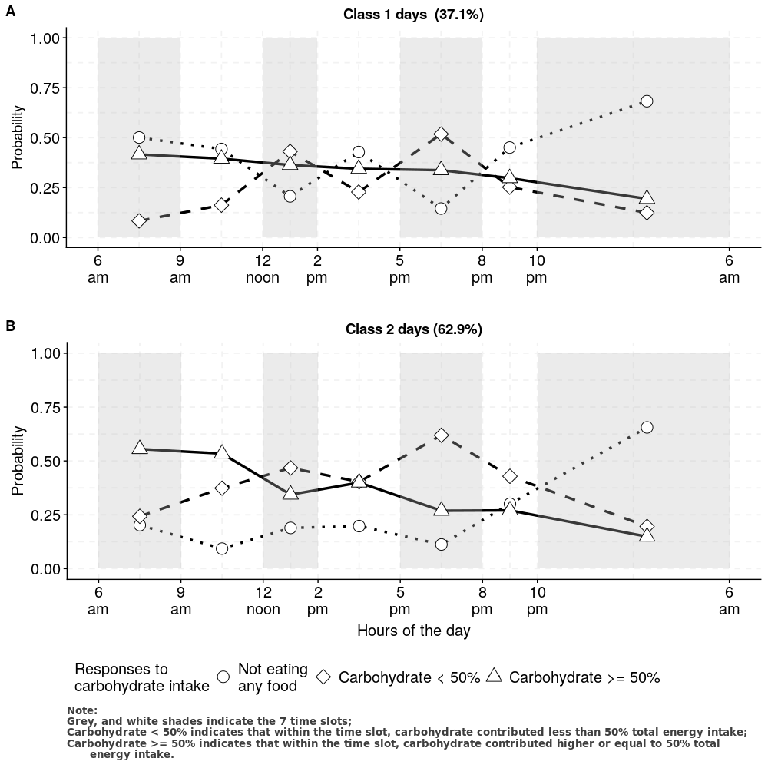

2 Classes solution in Day level.

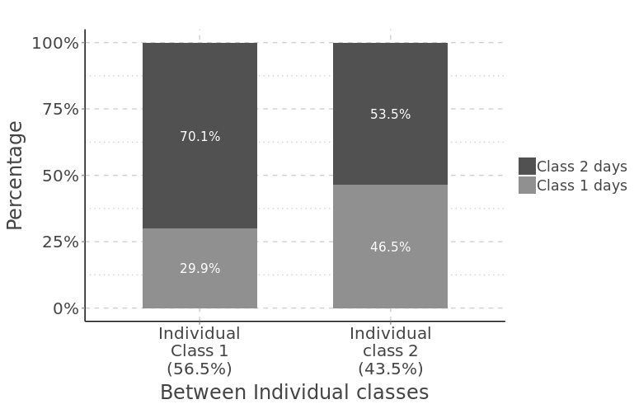

Multilevel Latent Class Solution, 2 classes in day level, 2 classes in individual level.

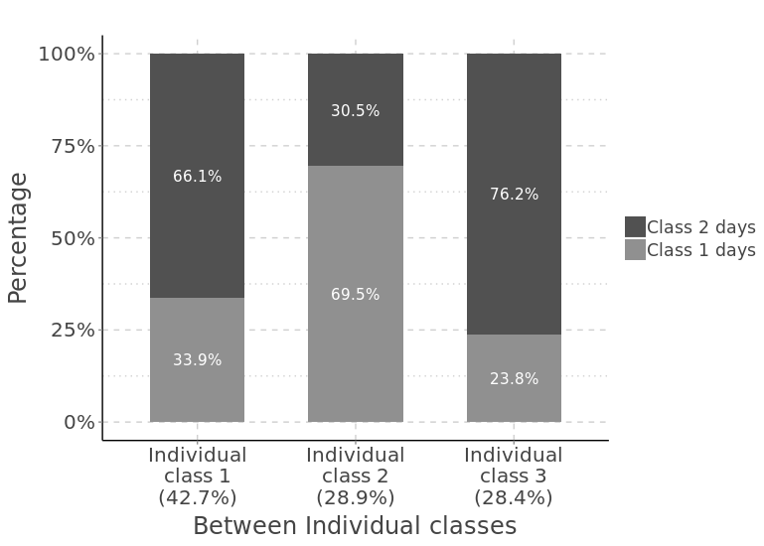

Multilevel Latent Class Solution, 2 classes in day level, 3 classes in individual level.

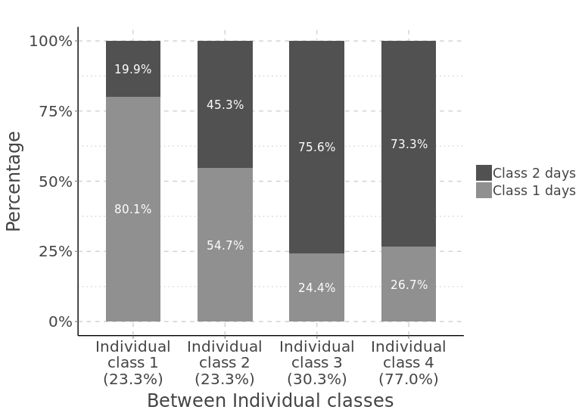

Multilevel Latent Class Solution, 2 classes in day level, 4 classes in individual level.

## 3 classes in day level, 4 classes in individual level

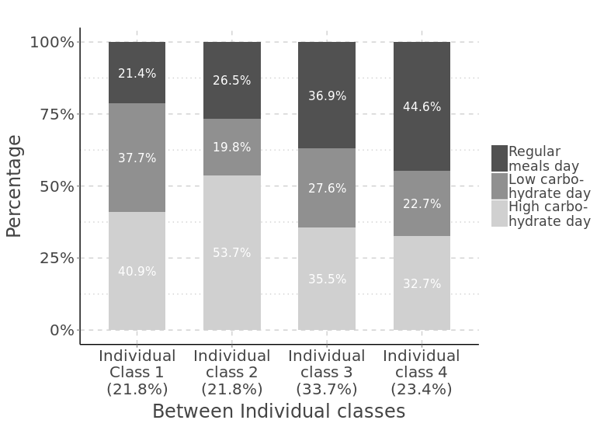

Multilevel Latent Class Solution, 3 classes in day level, 4 classes in individual level.

## 4 classes in day level

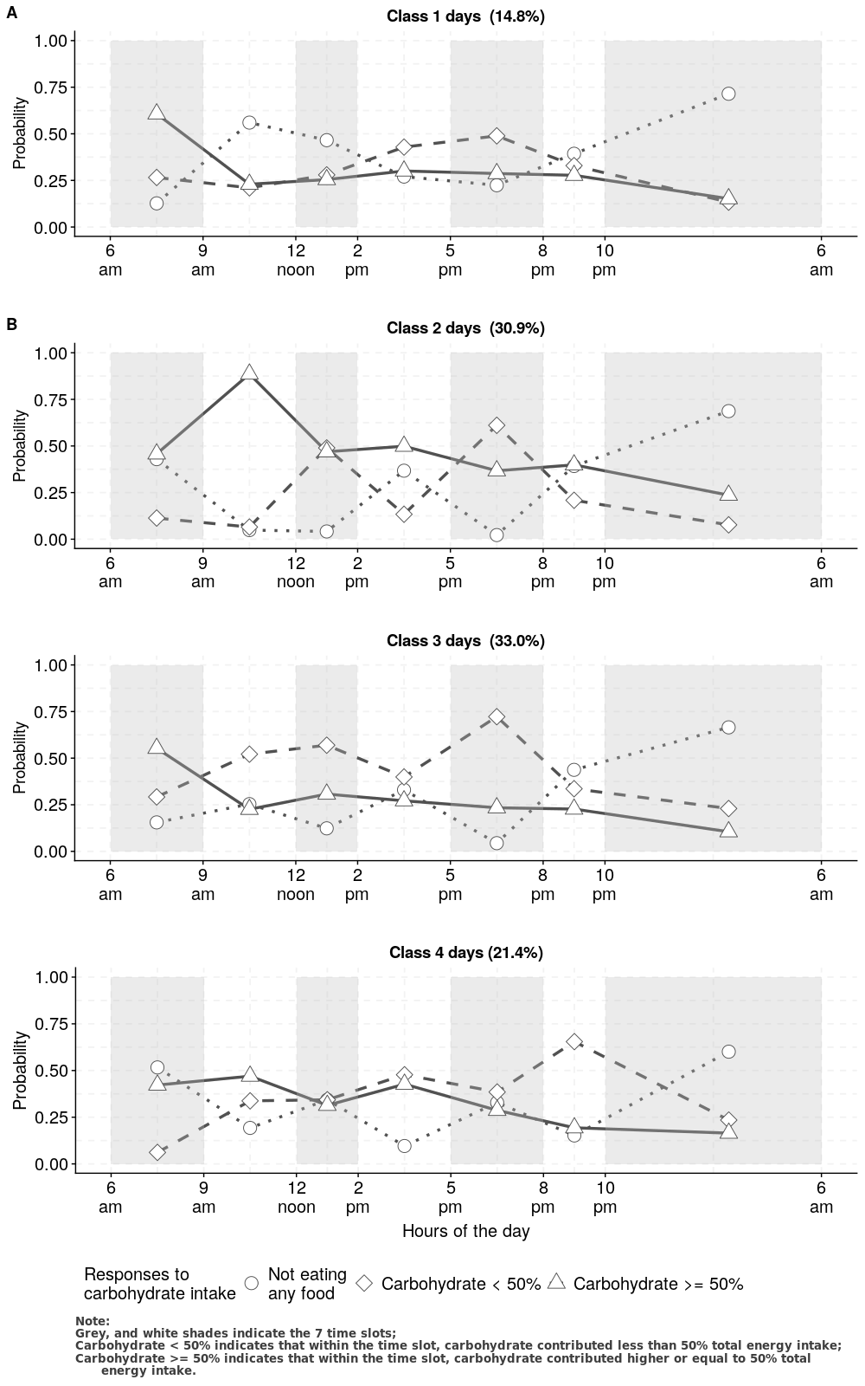

4 Classes Solution in Day level.

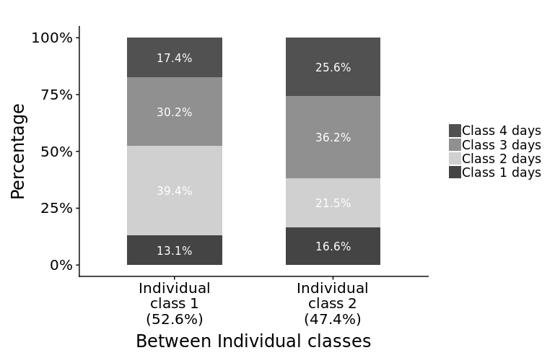

Multilevel Latent Class Solution, 4 classes in day level, 2 classes in individual level.

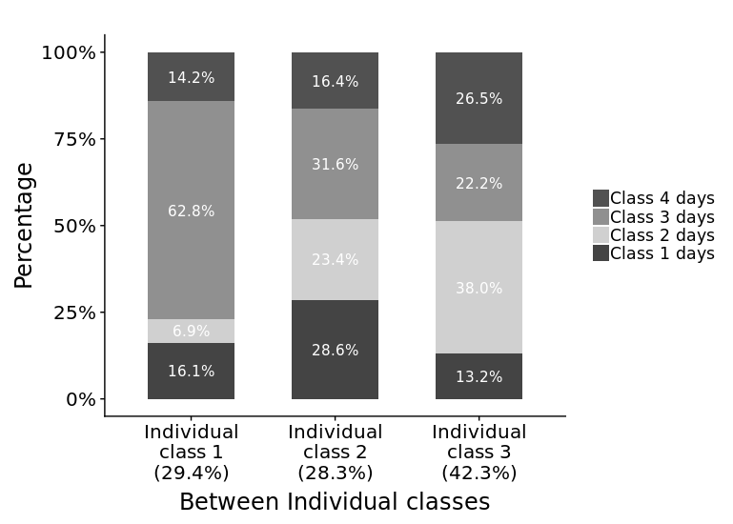

Multilevel Latent Class Solution, 4 classes in day level, 3 classes in individual level.

# R and STATA codes for processing individual level data analysis

%>%

%>%

%>%

%>% %>%

%>% %>%

%>% %>%

%>% %>%

%>% %>%

%>% %>%

%>% %>%

%>% %>%

%>% %>%

%>% %>%

%>%

%>%

%>% %>%

%>% %>% %>% %>% %>% %>% %>% %>% %>%

){

%>% %>% %>% %>% %>% %>% %>%

%>% %>% %>% %>% %>% %>%

%>% %>% %>% %>% %>% %>% %>%

%>%

%>% %>%

%>%

%>%

%>%

%>%

%>% %>%

%>%

%>%

************************************************  
// Analysing NDNS survey data in stata  
// for CW3CB3 survey data analysis   
// date created: 2018-08-01  
// manipulation of the data was done in R  
// import data from CW3CB3_7sregss.dta  
// change the path accordingly  
************************************************  
  
  
use "../CW3CB3_7regss.dta", clear  
  
label define smoking 1 "current" 2 "ex-smoker" 3 "Never"  
label values cigsta3 smoking  
label define gender 1 "Men" 2 "Women"  
label values Sex gender  
label define paid 1 "No" 2 "Yes"  
label values paidemployment paid  
label define ethnicity5 1 "White" 2 "Mixed" 3 "Black" 4 "Asian" 5 "Other"  
label values ethgrp5 ethnicity5  
label define ethnicity2 1 "White" 2 "non-White"  
label values ethgrp2 ethnicity2  
  
gen Married = 1 if MarStat == 2 | MarSt2 == 2   
replace Married = 1 if MarSt2 == 3  
replace Married = 0 if Married !=1  
tab Married  
tab MarSt2  
tab MarStat  
  
label define Partner 0 "No" 1 "Yes"  
label values Married Partner  
  
gen Education = qual7 == 1  
label define Ed 0 "lower than Degree" 1 "Degree or higher"  
label values Education Ed  
  
replace Education = . if qual7 >100  
tab Educ  
  
  
egen BMIcat = cut(bmival), at(10, 25, 30, 40, 60)  
tab BMIcat  
  
**********************************************************  
// variables need to be log transformed //  
**********************************************************  
  
gen logalc = ln(Alcoholg+1)  
summ logalc, detail  
gen logMVP = ln(MVPAtime+1)  
summ logMVP, detail  
gen logGlu = ln(Glucose)  
summ logGlu, detail  
gen logA1C = ln(A1C)  
summ logA1C, detail  
gen logChol = ln(Chol)  
summ logChol, detail  
gen logLDL = ln(LDL)  
gen logHDL = ln(HDL)  
gen logTG = ln(Trig)  
  
*********************************************************  
// weighting use wti to see the individual results //  
// //  
*********************************************************  
  
  
// weighting with individual weights, area is primary sampling unit,   
// gor is the cluster variable  
  
svyset area [pweight = wti1to8], strata(gor)  
  
svydescribe wti // describe the weighted data set  
  
svy: tabulate Sex CB, row se ci format(%7.3f)  
svy: tabulate Sex CB, col se ci format(%7.3f)  
svy: tabulate Country CB, col se ci format(%7.3f)  
svy: tabulate Country CB, row se ci format(%7.3f)  
svy: tabulate SurveyYear CB, col se ci format(%7.3f)  
svy: tabulate SurveyYear CB, row se ci format(%7.3f)  
svy: tabulate paid CB, col se ci format(%7.3f)  
  
svy: tabulate MarSt2 CB  
svy: tabulate MarStat CB  
svy: tabulate Married CB, row se ci format(%7.3f)  
svy: tabulate Married CB, col se ci format(%7.3f)  
svy: mean eqvinc, over(CB)  
test [eqvinc]1 = [eqvinc]2 = [eqvinc]3, mtest(b)   
// bonferroni-adjusted p-values for multiple groups using the mtest(b) option  
  
svy: tabulate ethgrp2 CB, row se ci format(%7.3f)  
svy: tabulate ethgrp2 CB, col se ci format(%7.3f)  
svy: tabulate Education CB, row se ci format(%7.3f)  
svy: tabulate Education CB, col se ci format(%7.3f)  
  
  
  
*********************************************************  
// nutritional distribution //  
// //  
*********************************************************  
  
svy: mean EnergykJ, over(CB)  
test [EnergykJ]1 = [EnergykJ]2 = [EnergykJ]3, mtest(b)   
  
svy: mean Energy6, over(CB)  
test [Energy6_9]1 = [Energy6_9]2 = [Energy6_9]3, mtest(b)   
  
svy: mean Energy9, over(CB)   
test [Energy9_12]1 = [Energy9_12]2 = [Energy9_12]3, mtest(b)   
  
svy: mean Energy12, over(CB)  
test [Energy12_14]1 = [Energy12_14]2 = [Energy12_14]3, mtest(b)   
  
svy: mean Energy14, over(CB)  
test [Energy14_17]1 = [Energy14_17]2 = [Energy14_17]3, mtest(b)   
  
svy: mean Energy17, over(CB)  
test [Energy17_20]1 = [Energy17_20]2 = [Energy17_20]3, mtest(b)   
  
svy: mean Energy20, over(CB)  
test [Energy20_22]1 = [Energy20_22]2 = [Energy20_22]3, mtest(b)   
  
svy: mean Energy22, over(CB)  
test [Energy22_6]1 = [Energy22_6]2 = [Energy22_6]3, mtest(b)   
  
  
svy: mean Carbohydrateg, over(CB)  
test [Carbohydrateg]1 = [Carbohydrateg]2 = [Carbohydrateg]3, mtest(b)   
  
svy: mean Carb6, over(CB)  
test [Carb6_9]1 = [Carb6_9]2 = [Carb6_9]3, mtest(b)   
  
svy: mean Carb9, over(CB)  
test [Carb9_12]1 = [Carb9_12]2 = [Carb9_12]3, mtest(b)   
  
svy: mean Carb12, over(CB)  
test [Carb12_14]1 = [Carb12_14]2 = [Carb12_14]3, mtest(b)   
  
svy: mean Carb14, over(CB)  
test [Carb14_17]1 = [Carb14_17]2 = [Carb14_17]3, mtest(b)   
  
svy: mean Carb17, over(CB)  
test [Carb17_20]1 = [Carb17_20]2 = [Carb17_20]3, mtest(b)   
  
  
svy: mean Carb20, over(CB)  
test [Carb20_22]1 = [Carb20_22]2 = [Carb20_22]3, mtest(b)   
  
svy: mean Carb22, over(CB)  
test [Carb22_6]1 = [Carb22_6]2 = [Carb22_6]3, mtest(b)   
  
svy: mean Sugar6, over(CB)  
test [Sugar6_9]1 = [Sugar6_9]2 = [Sugar6_9]3, mtest(b)   
  
  
  
svy: mean Sugar9, over(CB)  
test [Sugar9_12]1 = [Sugar9_12]2 = [Sugar9_12]3, mtest(b)   
  
svy: mean Sugar12, over(CB)  
test [Sugar9_12]1 = [Sugar9_12]2 = [Sugar9_12]3, mtest(b)   
  
svy: mean Sugar14, over(CB)  
test [Sugar14_17]1 = [Sugar14_17]2 = [Sugar14_17]3, mtest(b)   
  
svy: mean Sugar17, over(CB)  
test [Sugar17_20]1 = [Sugar17_20]2 = [Sugar17_20]3, mtest(b)   
  
svy: mean Sugar20, over(CB)  
test [Sugar20_22]1 = [Sugar20_22]2 = [Sugar20_22]3, mtest(b)   
  
svy: mean Sugar22, over(CB)  
test [Sugar22_6]1 = [Sugar22_6]2 = [Sugar22_6]3, mtest(b)   
  
svy: mean Starch6, over(CB)  
test [Starch6_9]1 = [Starch6_9]2 = [Starch6_9]3, mtest(b)   
  
svy: mean Starch9, over(CB)  
test [Sugar12_14]1 = [Sugar12_14]2 = [Sugar12_14]3, mtest(b)   
  
svy: mean Starch12, over(CB)  
test [Starch12_14]1 = [Starch12_14]2 = [Starch12_14]3, mtest(b)   
  
svy: mean Starch14, over(CB)  
test [Starch14_17]1 = [Starch14_17]2 = [Starch14_17]3, mtest(b)   
  
svy: mean Starch17, over(CB)  
test [Starch17_20]1 = [Starch17_20]2 = [Starch17_20]3, mtest(b)   
  
  
svy: mean Starch20, over(CB)  
test [Starch20_22]1 = [Starch20_22]2 = [Starch20_22]3, mtest(b)   
  
svy: mean Starch22, over(CB)  
test [Starch20_22]1 = [Starch20_22]2 = [Starch20_22]3, mtest(b)   
  
svy: mean Fibre6, over(CB)  
test [Starch22_6]1 = [Starch22_6]2 = [Starch22_6]3, mtest(b)   
  
gen Fibreg = Fibre6 + Fibre9 + Fibre12 + Fibre14 + Fibre17 + Fibre20 + Fibre22  
svy: mean Fibreg, over(CB)  
test [Fibreg]1 = [Fibreg]2 = [Fibreg]3, mtest(b)   
  
  
svy: mean Fibre9, over(CB)  
test [Fibre9_12]1 = [Fibre9_12]2 = [Fibre9_12]3, mtest(b)   
  
  
svy: mean Fibre12, over(CB)  
test [Fibre12_14]1 = [Fibre12_14]2 = [Fibre12_14]3, mtest(b)   
  
svy: mean Fibre14, over(CB)  
test [Fibre14_17]1 = [Fibre14_17]2 = [Fibre14_17]3, mtest(b)   
  
svy: mean Fibre17, over(CB)  
test [Fibre17_20]1 = [Fibre17_20]2 = [Fibre17_20]3, mtest(b)   
  
svy: mean Fibre20, over(CB)  
test [Fibre20_22]1 = [Fibre20_22]2 = [Fibre20_22]3, mtest(b)   
  
svy: mean Fibre22, over(CB)  
test [Fibre22_6]1 = [Fibre22_6]2 = [Fibre22_6]3, mtest(b)   
  
svy: mean NMES6, over(CB)  
test [NMES6_9]1 = [NMES6_9]2 = [NMES6_9]3, mtest(b)   
  
svy: mean NMES9, over(CB)  
test [NMES9_12]1 = [NMES9_12]2 = [NMES9_12]3, mtest(b)   
  
  
svy: mean NMES12, over(CB)  
test [NMES12_14]1 = [NMES12_14]2 = [NMES12_14]3, mtest(b)   
  
svy: mean NMES14, over(CB)  
test [NMES14_17]1 = [NMES14_17]2 = [NMES14_17]3, mtest(b)   
  
svy: mean NMES17, over(CB)  
test [NMES17_20]1 = [NMES17_20]2 = [NMES17_20]3, mtest(b)   
  
  
svy: mean NMES20, over(CB)  
test [NMES20_22]1 = [NMES20_22]2 = [NMES20_22]3, mtest(b)   
  
svy: mean NMES22, over(CB)  
  
  
svy: mean CHO, over(CB)  
test [CHOpctotE]1 = [CHOpctotE]2 = [CHOpctotE]3, mtest(b)   
  
  
svy: mean Proteing, over(CB)  
test [Proteing]1 = [Proteing]2 = [Proteing]3, mtest(b)   
  
svy: mean Prot6, over(CB)  
test [Prot6_9]1 = [Prot6_9]2 = [Prot6_9]3, mtest(b)   
  
svy: mean Prot9, over(CB)  
test [Prot9_12]1 = [Prot9_12]2 = [Prot9_12]3, mtest(b)   
  
svy: mean Prot12, over(CB)  
test [Prot12_14]1 = [Prot12_14]2 = [Prot12_14]3, mtest(b)   
  
svy: mean Prot14, over(CB)  
test [Prot14_17]1 = [Prot14_17]2 = [Prot14_17]3, mtest(b)   
  
svy: mean Prot17, over(CB)  
test [Prot17_20]1 = [Prot17_20]2 = [Prot17_20]3, mtest(b)   
  
svy: mean Prot20, over(CB)  
test [Prot20_22]1 = [Prot20_22]2 = [Prot20_22]3, mtest(b)   
  
svy: mean Prot22, over(CB)  
test [Prot22_6]1 = [Prot22_6]2 = [Prot22_6]3, mtest(b)   
  
  
svy: mean Proteinp, over(CB)  
test [ProteinpctotE]1 = [ProteinpctotE]2 = [ProteinpctotE]3, mtest(b)   
  
svy: mean Fatg, over(CB)  
test [Fatg]1 = [Fatg]2 = [Fatg]3, mtest(b)   
  
  
svy: mean Fat6, over(CB)  
test [Fat6_9]1 = [Fat6_9]2 = [Fat6_9]3, mtest(b)   
  
svy: mean Fat9, over(CB)  
test [Fat9_12]1 = [Fat9_12]2 = [Fat9_12]3, mtest(b)   
  
  
svy: mean Fat12, over(CB)  
test [Fat12_14]1 = [Fat12_14]2 = [Fat12_14]3, mtest(b)   
  
svy: mean Fat14, over(CB)  
test [Fat14_17]1 = [Fat14_17]2 = [Fat14_17]3, mtest(b)   
  
svy: mean Fat17, over(CB)  
test [Fat17_20]1 = [Fat17_20]2 = [Fat17_20]3, mtest(b)   
  
svy: mean Fat20, over(CB)  
test [Fat20_22]1 = [Fat20_22]2 = [Fat20_22]3, mtest(b)   
  
svy: mean Fat22, over(CB)  
test [Fat22_6]1 = [Fat22_6]2 = [Fat22_6]3, mtest(b)   
  
svy: mean Fatp, over(CB)  
test [FatpctotE]1 = [FatpctotE]2 = [FatpctotE]3, mtest(b)   
  
svy: mean Alcoholg, over(CB)  
test [Alcoholg]1 = [Alcoholg]2 = [Alcoholg]3, mtest(b)   
  
svy: mean Alc6, over(CB)  
test [Alc6_9]1 = [Alc6_9]2 = [Alc6_9]3, mtest(b)   
  
svy: mean Alc9, over(CB)  
test [Alc9_12]1 = [Alc9_12]2 = [Alc9_12]3, mtest(b)   
  
svy: mean Alc12, over(CB)  
test [Alc12_14]1 = [Alc12_14]2 = [Alc12_14]3, mtest(b)   
  
svy: mean Alc14, over(CB)  
test [Alc14_17]1 = [Alc14_17]2 = [Alc14_17]3, mtest(b)   
  
svy: mean Alc17, over(CB)  
test [Alc14_17]1 = [Alc14_17]2 = [Alc14_17]3, mtest(b)   
  
svy: mean Alc20, over(CB)  
test [Alc14_17]1 = [Alc14_17]2 = [Alc14_17]3, mtest(b)   
  
svy: mean Alcoholp, over(CB)  
test [AlcoholpctotE]1 = [AlcoholpctotE]2 = [AlcoholpctotE]3, mtest(b)   
  
svy: tabulate cigsta3 CB, col se ci format(%7.3f)  
svy: tabulate dnnow CB, col se ci format(%7.3f)  
svy: tabulate hibp CB, col se ci format(%7.3f)  
  
sum MVP [weight=wti1to8] if CB ==1 , det  
sum MVP [weight=wti1to8] if CB ==2 , det  
sum MVP [weight=wti1to8] if CB ==3 , det  
svy: mean MVP, over(CB)  
  
svy: mean logMVP, over(CB) eform  
test [logMVP]1 = [logMVP]2 = [logMVP]3, mtest(b)   
  
disp exp(.731059) - 1   
dis exp(.6768489) -1   
dis exp(.7852691) -1  
  
disp exp(.6239265) - 1   
dis exp(.571165) -1   
dis exp( .6766879) -1  
  
disp exp(.7273621) - 1   
dis exp(.684545) -1   
dis exp(.7701791) -1  
  
svy: mean logalc, over(CB)  
  
  
disp exp( 2.035795) - 1   
dis exp(1.933326) -1   
dis exp(2.138264) -1  
  
  
*********************************************************  
// re-weighting use wtn to see the BMI,wc measurements //  
// //  
*********************************************************  
  
svyset area [pweight = wtn1to8], strata(gor)  
svy: mean wst, over(CB)  
test [wstval]1 = [wstval]2 = [wstval]3, mtest(b)   
  
gen Men = Sex == 1   
svy, subpop(Men): mean wst, over(CB)  
test [wstval]1 = [wstval]2 = [wstval]3, mtest(b)   
  
gen Women = Sex == 2  
svy, subpop(Women): mean wst, over(CB)  
test [wstval]1 = [wstval]2 = [wstval]3, mtest(b)   
  
svy: mean bmi, over(CB)  
  
test [bmival]1 = [bmival]2 = [bmival]3, mtest(b)   
  
*********************************************************  
// re-weighting use wtb to see the blood test results //  
// //  
*********************************************************  
  
svyset area [pweight = wtb1to8], strata(gor)  
  
svy: mean HDL, over(CB)  
test [HDL]1 = [HDL]2 = [HDL]3, mtest(b)   
  
svy: mean Chol, over(CB)  
test [Chol]1 = [Chol]2 = [Chol]3, mtest(b)   
  
svy: mean LDL, over(CB)  
test [LDL]1 = [LDL]2 = [LDL]3, mtest(b)   
  
svy: mean Trig, over(CB)  
test [Trig]1 = [Trig]2 = [Trig]3, mtest(b)   
  
gen DM = A1C <= 6.5 if !missing(A1C)  
  
svy, subpop(DM): mean Glucose, over(CB)  
test [Glucose]1 = [Glucose]2  
test [Glucose]1 = [Glucose]2 = [Glucose]3, mtest(b)  
  
svy, subpop(DM): mean A1C, over(CB)  
test [A1C]1 = [A1C]2  
test [A1C]1 = [A1C]2 = [A1C]3, mtest(b)  
  
svy: tabulate DM CB, col se ci format(%7.3f)  
  
svy, subpop(DM): mean Glucose, over(CB)  
test [Glucose]1 = [Glucose]2  
test [Glucose]1 = [Glucose]2 = [Glucose]3, mtest(b)  
svy, subpop(DM): mean A1C, over(C)  
test [A1C]1 = [A1C]2  
test [A1C]1 = [A1C]2 = [A1C]3, mtest(b)  
  
svy: tabulate DM C, col se ci format(%7.3f)  
  
svy, subpop(DM): mean logGlu, over(CB)  
test [logGlu]1 = [logGlu]2 = [logGlu]3, mtest(b)  
  
dis exp(1.642848)  
dis exp(1.632226)  
dis exp(1.653471)  
  
dis exp(1.620347)  
dis exp(1.606447)  
dis exp(1.634246)  
  
dis exp(1.629356)  
dis exp(1.620271)  
dis exp(1.63844)  
  
svy, subpop(DM): mean logA1C, over(CB)  
test [logA1C]1 = [logA1C]2 = [logA1C]3, mtest(b)  
  
dis exp(1.699581)  
dis exp(1.69296)  
dis exp(1.706203)  
  
dis exp(1.691608)  
dis exp(1.683897)  
dis exp(1.699318)  
  
dis exp(1.705623)  
dis exp(1.700665)  
dis exp(1.710581)  
  
svy: mean logChol, over(CB)  
dis exp(1.598818)  
dis exp(1.577698)  
dis exp(1.619939)  
  
dis exp(1.55251)   
dis exp(1.530408)  
dis exp(1.574613)  
  
dis exp(1.599389)  
dis exp(1.583391)  
dis exp(1.615388)  
  
test [logChol]1 = [logChol]2 = [logChol]3, mtest(b)  
  
svy: mean logHDL, over(CB)  
dis exp(.3293169)  
dis exp(.3026793)  
dis exp(.3559545)  
  
dis exp(.2749379)   
dis exp(.2476816)  
dis exp(.3021941)  
  
dis exp(.3269002)  
dis exp(.3062623)  
dis exp(.3475381)  
  
test [logHDL]1 = [logHDL]2 = [logHDL]3, mtest(b)  
  
svy: mean logLDL, over(CB)  
dis exp(1.058635)  
dis exp(1.028391)  
dis exp(1.08888)  
  
dis exp(1.018181)   
dis exp(.984431)  
dis exp(1.051931)  
  
dis exp(1.075229)  
dis exp(1.051369)  
dis exp(1.09909)  
  
test [logLDL]1 = [logLDL]2 = [logLDL]3, mtest(b)  
  
svy: mean logTG, over(CB)  
dis exp(.1273876)  
dis exp(.0777152)  
dis exp(.17706)  
  
dis exp(.1012169)   
dis exp(.0460972)  
dis exp(.1563366)  
  
dis exp(.0983298)  
dis exp(.0607423)  
dis exp(.1359172)  
  
  
test [logTG]1 = [logTG]2 = [logTG]3, mtest(b)  
  
***************************************************  
// Analysing NDNS survey data in stata  
// for CW3CB3 survey data analysis on hypertension  
// date created: 2018-08-06  
// manipulation of the data was done in R  
// import data from CW3CB3_7sregss.dta  
// change the path accordingly  
**************************************************  
  
use "../CW3CB3_7regss.dta", clear  
  
label define smoking 1 "current" 2 "ex-smoker" 3 "Never"  
label values cigsta3 smoking  
label define gender 1 "Men" 2 "Women"  
label values Sex gender  
label define paid 1 "No" 2 "Yes"  
label values paidemployment paid  
label define ethnicity5 1 "White" 2 "Mixed" 3 "Black" 4 "Asian" 5 "Other"  
label values ethgrp5 ethnicity5  
label define ethnicity2 1 "White" 2 "non-White"  
label values ethgrp2 ethnicity2  
  
gen Married = 1 if MarStat == 2 | MarSt2 == 2   
replace Married = 1 if MarSt2 == 3  
replace Married = 0 if Married !=1  
tab Married  
tab MarSt2  
tab MarStat  
  
label define Partner 0 "No" 1 "Yes"  
label values Married Partner  
  
gen Education = qual7 == 1  
label define Ed 0 "lower than Degree" 1 "Degree or higher"  
label values Education Ed  
  
replace Education = . if qual7 >100  
tab Educ  
  
egen BMIcat = cut(bmival), at(10, 25, 30, 40, 60)  
tab BMIcat  
  
**********************************************************  
// variables need to be log transformed //  
**********************************************************  
  
gen logalc = ln(Alcoholg+1)  
summ logalc, detail  
gen logMVP = ln(MVPAtime+1)  
summ logMVP, detail  
gen logGlu = ln(Glucose)  
summ logGlu, detail  
gen logA1C = ln(A1C)  
summ logA1C, detail  
gen logChol = ln(Chol)  
summ logChol, detail  
gen logLDL = ln(LDL)  
gen logHDL = ln(HDL)  
gen logTG = ln(Trig)  
  
  
*********************************************************  
// weighting use wti to see the individual results //  
*********************************************************  
  
  
// weighting with individual weights, area is primary sampling unit,   
// gor is the cluster variable  
svyset area [pweight = wti1to8], strata(gor)  
  
svydescribe wti // describe the weighted data set  
  
  
*********************************************************  
// re-weighting use wtn to see the BMI,wc measurements //  
*********************************************************  
svyset area [pweight = wtn1to8], strata(gor)  
  
  
gen Men = Sex == 1 // n of men = 2537  
gen Women = Sex == 2 // n of women = 3618  
  
svy, subpop(Men): tab hibp, se ci format(%7.3f)  
svy, subpop(Women): tab hibp, se ci format(%7.3f)  
  
svy, subpop(Men): mean age, over(hibp)  
test [age]1 = [age]0  
svy, subpop(Women): mean age, over(hibp)  
test [age]1 = [age]0  
  
svy, subpop(Men): mean wst, over(hibp)  
test [wstval]1 = [wstval]0  
svy, subpop(Women): mean wst, over(hibp)  
test [wstval]1 = [wstval]0  
  
svy, subpop(Men): tabulate CB hibp, col se ci format(%7.3f)  
  
svy, subpop(Women): tabulate CB hibp, col se ci format(%7.3f)  
  
svy, subpop(Men): tabulate Country hibp, col se ci format(%7.3f)  
  
svy, subpop(Women): tabulate Country hibp, col se ci format(%7.3f)  
  
svy, subpop(Men): tabulate SurveyYear hibp, col se ci format(%7.3f)  
  
svy, subpop(Women): tabulate SurveyYear hibp, col se ci format(%7.3f)  
  
svy, subpop(Men): tabulate ethgrp2 hibp, col se ci format(%7.3f)  
  
svy, subpop(Women): tabulate ethgrp2 hibp, col se ci format(%7.3f)  
  
svy, subpop(Men): tabulate Edu hibp, col se ci format(%7.3f)  
  
svy, subpop(Women): tabulate Edu hibp, col se ci format(%7.3f)  
  
svy, subpop(Men): tabulate cigsta3 hibp, col se ci format(%7.3f)  
  
svy, subpop(Women): tabulate cigsta3 hibp, col se ci format(%7.3f)  
  
svy, subpop(Men): tabulate Married hibp, col se ci format(%7.3f)  
  
svy, subpop(Men): mean logMVP, over(hibp)  
test [logMVP]1 = [logMVP]0  
  
disp exp(.9234363 ) - 1   
dis exp(.8457101) -1   
dis exp(1.001163) -1  
  
disp exp(.828635) - 1   
dis exp(.730244) -1   
dis exp( .9270261) -1  
  
svy, subpop(Women): mean logMVP, over(hibp)   
test [logMVP]1 = [logMVP]0  
  
disp exp(.5916676) - 1   
dis exp(.5473043) -1   
dis exp(.6360309) -1  
  
disp exp(.4231103) - 1   
dis exp(.3536885) -1   
dis exp(.4925322) -1  
  
svy: mean logalc, over(CB)  
  
disp exp( 2.035795) - 1   
dis exp(1.933326) -1   
dis exp(2.138264) -1  
  
svy, subpop(Men): mean bmi, over(hibp)  
test [bmival]1 = [bmival]0  
svy, subpop(Women): mean bmi, over(hibp)  
test [bmival]1 = [bmival]0  
  
svy, subpop(Men): mean EnergykJ, over(hibp)  
test [EnergykJkJ]1 = [EnergykJkJ]0  
svy, subpop(Women): mean EnergykJ, over(hibp)  
test [EnergykJkJ]1 = [EnergykJkJ]0  
  
svy, subpop(Men): mean Carbo, over(hibp)  
test [Carbohydrateg]1 = [Carbohydrateg]0  
  
svy, subpop(Women): mean Carbohydrateg, over(hibp)  
test [Carbohydrateg]1 = [Carbohydrateg]0  
  
svy, subpop(Men): mean Proteing, over(hibp)  
test [Proteing]1 = [Proteing]0  
  
svy, subpop(Women): mean Carbohydrateg, over(hibp)  
test [Carbohydrateg]1 = [Carbohydrateg]0  
  
svy: tabulate Sex hibp, col se ci format(%7.3f)  
  
svy: tabulate paid hibp, col se ci format(%7.3f)  
  
gen DM = A1C > 6.5 if !missing(A1C)  
  
svy, subpop(Men): tabulate Married hibp, col se ci format(%7.3f)  
svy, subpop(Women): tabulate Married hibp, col se ci format(%7.3f)  
  
svy, subpop(Men): mean eqvinc, over(hibp)  
test [eqvinc]1 = [eqvinc]0  
  
svy, subpop(Women): mean eqvinc, over(hibp)  
test [eqvinc]1 = [eqvinc]0  
  
********************************************************  
** Building the GLM model   
** date: 07/08/2018  
********************************************************  
  
svyset area [pweight = wtn1to8], strata(gor)  
  
// crude association between CB and hypertension   
  
svy, subpop(Men): logistic hibp i.CB  
  
svy, subpop(Women): logistic hibp i.CB  
  
// in non DM   
svy, subpop(Men if DM != 1): logistic hibp i.CB  
svy, subpop(Women if DM != 1): logistic hibp i.CB  
  
// looking for confounders one by one  
// Age: -> confounder  
svy, subpop(Men): logistic hibp i.CB age  
test age  
svy, subpop(Women): logistic hibp i.CB age  
test age  
  
svy, subpop(Men): logistic hibp i.CB##c.age  
svy, subpop(Women): logistic hibp i.CB##c.age  
test 2.CB#c.age 3.CB#c.age // no interaction  
  
// Partner -> confounder  
svy, subpop(Men): logistic hibp i.CB i.Married  
test 1.Married  
svy, subpop(Women): logistic hibp i.CB i.Married  
test 1.Married  
  
svy, subpop(Men): logistic hibp i.CB##i.Married  
svy, subpop(Women): logistic hibp i.CB##i.Married  
  
test 2.CB#1.Married 3.CB#1.Married // -> no interaction  
  
// Income -> not confounder for men but confounder for women  
svy, subpop(Men): logistic hibp i.CB eqvinc   
test eqvinc  
svy, subpop(Women): logistic hibp i.CB eqvinc   
test eqvinc  
  
svy, subpop(Men): logistic hibp i.CB##c.eqvinc   
svy, subpop(Women): logistic hibp i.CB##c.eqvinc   
  
test 2.CB#c.eqvinc 3.CB#c.eqvinc // -> (probably) no interaction  
  
// Education -> confounder  
svy, subpop(Men): logistic hibp i.CB i.Edu   
test 1.Edu  
svy, subpop(Women): logistic hibp i.CB i.Edu   
test 1.Edu  
  
svy, subpop(Men): logistic hibp i.CB##i.Edu   
svy, subpop(Women): logistic hibp i.CB##i.Edu   
  
test 2.CB#1.Edu 3.CB#1.Edu // no interaction  
  
// BMI -> confounder  
svy, subpop(Men): logistic hibp i.CB bmi  
test bmi  
svy, subpop(Women): logistic hibp i.CB bmi  
test bmi  
  
svy, subpop(Men): logistic hibp i.CB##c.bmi  
svy, subpop(Women): logistic hibp i.CB##c.bmi  
  
test 2.CB#c.bmival 3.CB#c.bmival // no ineraction  
  
// paid employment -> not confounder  
svy, subpop(Men): logistic hibp i.CB i.paid  
test 2.paid  
svy, subpop(Women): logistic hibp i.CB i.paid  
test 2.paid  
  
svy, subpop(Men): logistic hibp i.CB##i.paid  
svy, subpop(Women): logistic hibp i.CB##i.paid  
  
test 2.CB#2.paid 3.CB#2.paid  
  
// Smoking -> confounder  
svy, subpop(Men): logistic hibp i.CB i.cigsta3  
test 2.cigsta3 3.cigsta3  
svy, subpop(Women): logistic hibp i.CB i.cigsta3  
test 2.cigsta3 3.cigsta3  
  
svy, subpop(Men): logistic hibp i.CB##i.cigsta3  
svy, subpop(Women): logistic hibp i.CB##i.cigsta3  
  
test 2.CB#2.cigsta3 2.CB#3.cigsta3 3.CB#2.cigsta3 3.CB#3.cigsta3 // no interaction  
  
// Total energy intake -> confounder  
svy, subpop(Men): logistic hibp i.CB EnergykJ  
test EnergykJ  
svy, subpop(Women): logistic hibp i.CB EnergykJ  
test EnergykJ  
  
svy, subpop(Men): logistic hibp i.CB##c.EnergykJ  
svy, subpop(Women): logistic hibp i.CB##c.EnergykJ  
test 2.CB#c.EnergykJkJ 3.CB#c.EnergykJkJ // no interaction  
  
// ethnicity -> not confounder  
svy, subpop(Men): logistic hibp i.CB i.ethgrp2  
test 2.eth  
svy, subpop(Women): logistic hibp i.CB i.ethgrp2  
test 2.eth  
  
svy, subpop(Men): logistic hibp i.CB##i.ethgrp2  
svy, subpop(Women): logistic hibp i.CB##i.ethgrp2  
test 2.CB#2.ethgrp2 // no interaction  
  
// Alcohol -> not confounder for men but confounder for women  
svy, subpop(Men): logistic hibp i.CB Alcoholg  
test Alcoholg  
svy, subpop(Women): logistic hibp i.CB Alcoholg  
test Alcoholg  
  
svy, subpop(Men): logistic hibp i.CB##c.Alcoholg  
svy, subpop(Women): logistic hibp i.CB##c.Alcoholg  
test 2.CB#c.Alcoholg 3.CB#c.Alcoholg // no interaction  
  
// logMVP -> not confounder   
svy, subpop(Men): logistic hibp i.CB logMVP  
test logMVP  
svy, subpop(Women): logistic hibp i.CB logMVP  
test logMVP  
  
svy, subpop(Men): logistic hibp i.CB##c.logMVP  
svy, subpop(Women): logistic hibp i.CB##c.logMVP  
test 2.CB#c.logMVP 3.CB#c.logMVP // no interaction  
  
// Model includes all possible confounders in Men  
svy, subpop(Men): logistic hibp i.CB age i.Married i.Edu bmi i.cig EnergykJ   
linktest  
svy, subpop(Men): logistic hibp i.CB age i.Married i.Edu wst i.cig EnergykJ   
linktest  
svy, subpop(if Men & DM != 1): logistic hibp i.CB age i.Married ///  
 i.Edu bmi i.cig EnergykJ   
linktest  
svy, subpop(if Men & DM != 1): logistic hibp i.CB age i.Married ///  
 i.Edu wst i.cig EnergykJ   
linktest  
  
// use the model above to see whether any other factors are confounders   
// conditional on the other variables   
  
// income -> not confounder  
svy, subpop(Men): logistic hibp i.CB age i.Married i.Edu bmi i.cig ///   
 EnergykJ eqvinc  
test eqvinc  
  
// ethnicity -> not confounder  
svy, subpop(Men): logistic hibp i.CB age i.Married i.Edu bmi i.cig ///   
 EnergykJ i.ethgrp2  
test 2.ethgrp2  
  
// alcohol -> not confounder  
svy, subpop(Men): logistic hibp i.CB age i.Married i.Edu bmi i.cig ///   
 EnergykJ Alcoholg  
test Alcoholg  
  
// MVP(physical activity) -> not confounder  
svy, subpop(Men): logistic hibp i.CB age i.Married i.Edu bmi i.cig ///   
 EnergykJ logMVP  
test logMVP  
  
// Model includes all possible confounders in Women  
svy, subpop(Women): logistic hibp i.CB age i.Married eqvinc i.Edu ///  
 bmi i.cig EnergykJ Alcoholg   
linktest  
svy, subpop(Women): logistic hibp i.CB age i.Married eqvinc i.Edu ///  
 wst i.cig EnergykJ Alcoholg   
linktest  
  
  
// use the model above to see whether any other factors are confounders   
// conditional on the other variables   
  
// ethnicity -> not confounder  
svy, subpop(Women): logistic hibp i.CB age i.Married eqvinc i.Edu ///   
 bmi i.cig EnergykJ Alcoholg i.ethgrp2  
test 2.ethgrp2  
  
// MVP (physical activity) -> not confounder  
svy, subpop(Women): logistic hibp i.CB age i.Married eqvinc i.Edu ///   
 bmi i.cig EnergykJ Alcoholg logMVP  
test logMVP  
  
  
svy, subpop(if Women & DM != 1): logistic hibp i.CB age i.Married ///   
 eqvinc i.Edu bmi i.cig EnergykJ Alcoholg  
linktest  
  
svy, subpop(if Women & DM != 1): logistic hibp i.CB age i.Married ///   
 eqvinc i.Edu wst i.cig EnergykJ Alcoholg  
linktest

# Example of a food diary for one day



NATIONAL DIET AND NUTRITION SURVEY – Food and Drink Diary Example, from 6 am to 12 noon.

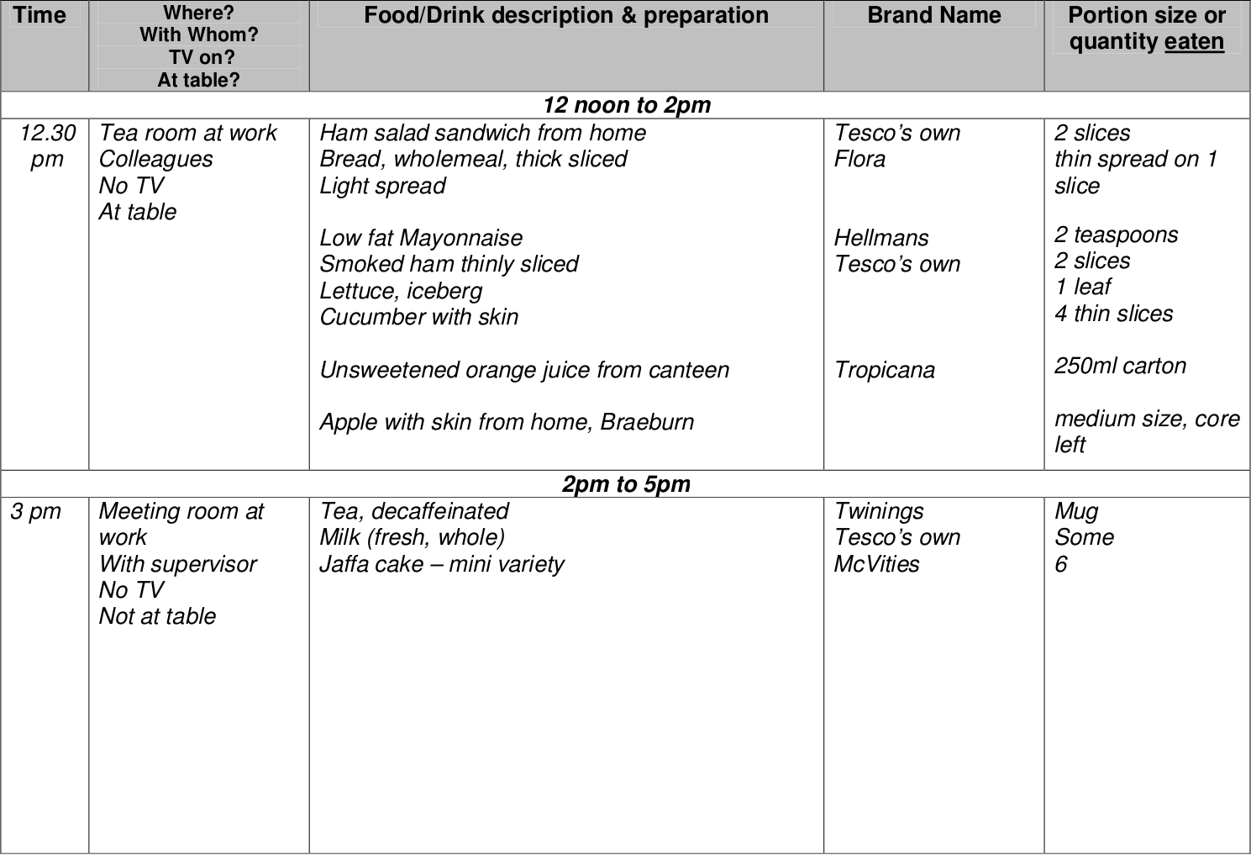

NATIONAL DIET AND NUTRITION SURVEY – Food and Drink Diary Example, from 12 noon to 5 pm.

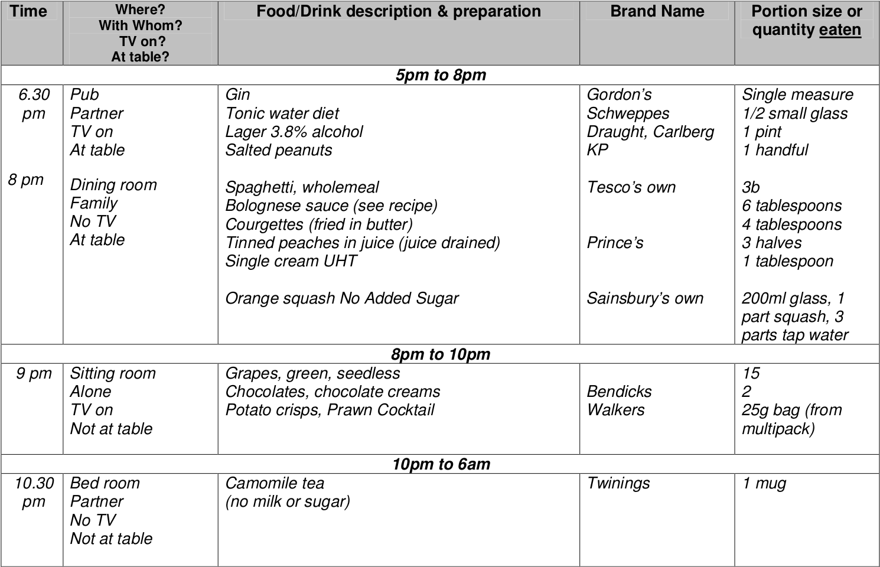

NATIONAL DIET AND NUTRITION SURVEY – Food and Drink Diary Example, from 5 pm to 6 am.



NATIONAL DIET AND NUTRITION SURVEY – Food and Drink Diary Example, home made food recipes.

1. Johnston JD. Physiological responses to food intake throughout the day. Nutrition Research Reviews. Cambridge University Press; 2014;27:107–18.

2. Garaulet M, Gómez-Abellán P. Timing of food intake and obesity: A novel association. Physiology & Behavior. Elsevier; 2014;134:44–50.

3. Asher G, Sassone-Corsi P. Time for food: The intimate interplay between nutrition, metabolism, and the circadian clock. Cell. Elsevier; 2015;161:84–92.

4. Uemura M, Yatsuya H, Hilawe EH, Li Y, Wang C, Chiang C, et al. Breakfast skipping is positively associated with incidence of type 2 diabetes mellitus: Evidence from the aichi workers’ cohort study. Journal of Epidemiology. Japan Epidemiological Association; 2015;25:351–8.

5. De Bacquer D, Van Risseghem M, Clays E, Kittel F, De Backer G, Braeckman L. Rotating shift work and the metabolic syndrome: A prospective study. International Journal of Epidemiology. Oxford University Press; 2009;38:848–54.

6. Pan A, Schernhammer ES, Sun Q, Hu FB. Rotating night shift work and risk of type 2 diabetes: Two prospective cohort studies in women. PLoS Medicine. Public Library of Science; 2011;8:e1001141.

7. Almoosawi S, Vingeliene S, Karagounis L, Pot G. Chrono-nutrition: A review of current evidence from observational studies on global trends in time-of-day of energy intake and its association with obesity. Proceedings of the Nutrition Society. Cambridge University Press; 2016;75:487–500.

8. Leech RM, Worsley A, Timperio A, McNaughton SA. Temporal eating patterns: A latent class analysis approach. International Journal of Behavioral Nutrition and Physical Activity. BioMed Central; 2017;14:3.

9. Mansukhani R, Palla L. Investigating eating time patterns in uk adults from the 2008–2012 national diet and nutrition survey. Proceedings of the Nutrition Society. Cambridge University Press; 2018;77.

10. Schulze MB, Martínez-González MA, Fung TT, Lichtenstein AH, Forouhi NG. Food based dietary patterns and chronic disease prevention. BMJ. British Medical Journal Publishing Group; 2018;361:k2396.

11. Willett W. Nature of variation in diet. Nutritional epidemiology. Oxford University Press; 2012. pp. 34–48.

12. Almoosawi S, Prynne C, Hardy R, Stephen A. Time-of-day and nutrient composition of eating occasions: Prospective association with the metabolic syndrome in the 1946 british birth cohort. International Journal of Obesity. Nature Publishing Group; 2013;37:725.

13. Alhazmi A, Stojanovski E, McEvoy M, Garg ML. Macronutrient intakes and development of type 2 diabetes: A systematic review and meta-analysis of cohort studies. Journal of the American College of Nutrition. Taylor & Francis; 2012;31:243–58.

14.. National diet and nutrition survey years 1-8, 2008/09-2015/16. 9th Edition. 2018.

15. Smithers G. MAFF’s nutrient databank. Nutrition & Food Science. MCB UP Ltd; 1993;93:16–9.

16.. National diet and nutrition survey rolling programme. 2018.

17.. Mid 2008, 2009, 2010, 2011, 2012, 2013, 2014, 2015, and 2016 population estimates. 2018.

18. Bates B, Lennox A, Prentice A, Bates CJ, Page P, Nicholson S, et al. National diet and nutrition survey: Results from years 1, 2, 3 and 4 (combined) of the rolling programme (2008/2009-2011/2012): A survey carried out on behalf of public health england and the food standards agency. Public Health England; 2014.

19. Roberts C, Steer T, Maplethorpe N, Cox L, Meadows S, Nicholson S, et al. National diet and nutrition survey: Results from years 7 and 8 (combined) of the rolling programme (2014/2015–2015/2016). Public Health England; 2018;

20. Besson H, Brage S, Jakes RW, Ekelund U, Wareham NJ. Estimating physical activity energy expenditure, sedentary time, and physical activity intensity by self-report in adults. The American Journal of Clinical Nutrition. Oxford University Press; 2009;91:106–14.

21. Collins L, Lanza S. Latent class and latent transition analysis: With applications in the social, behavioral, and health sciences. Wiley; 2010.

22. Vermunt JK. Multilevel latent class models. Sociological Methodology. 2003. pp. 213–39.

23. Vermunt JK. Latent class and finite mixture models for multilevel data sets. Statistical Methods in Medical Research. Sage Publications Sage UK: London, England; 2008;17:33–51.

24. Muthén B, Asparouhov T. Multilevel regression mixture analysis. Journal of the Royal Statistical Society: Series A (Statistics in Society). Wiley Online Library; 2009;172:639–57.

25. Snijders T, Bosker R. Multilevel analysis: An introduction to basic and advanced multilevel modeling. SAGE Publications; 2011.

26. Van Horn ML, Fagan AA, Jaki T, Brown EC, Hawkins JD, Arthur MW, et al. Using multilevel mixtures to evaluate intervention effects in group randomized trials. Multivariate Behavioral Research. Taylor & Francis; 2008;43:289–326.

27. Davidian M, Fitzmaurice G, Molenberghs G, Verbeke G. Growth mixture modeling: Analysis with non-gaussian random effects. Longitudinal data analysis. Chapman; Hall/CRC; 2008. pp. 157–80.

28. Finch WH, French BF. Multilevel latent class analysis: Parametric and nonparametric models. The Journal of Experimental Education. Taylor & Francis; 2014;82:307–33.

29. Henry KL, Muthén B. Multilevel latent class analysis: An application of adolescent smoking typologies with individual and contextual predictors. Structural Equation Modeling. Taylor & Francis; 2010;17:193–215.

30. Lo Y, Mendell NR, Rubin DB. Testing the number of components in a normal mixture. Biometrika. Oxford University Press; 2001;88:767–78.

31. Nylund KL, Asparouhov T, Muthén BO. Deciding on the number of classes in latent class analysis and growth mixture modeling: A monte carlo simulation study. Structural Equation Modeling. Taylor & Francis; 2007;14:535–69.

32. Muthén LK, Muthén BO. Mplus: Statistical analysis with latent variables: User’s guide. Muthén & Muthén Los Angeles; 2017.

33. Archer K. Goodness-of-fit tests for logistic regression models developed using data collected from a complex sampling design. Unpubl Ph Diss Ohio State Univ Columb OH. 2001;

34. Archer KJ, Lemeshow S, Hosmer DW. Goodness-of-fit tests for logistic regression models when data are collected using a complex sampling design. Computational Statistics & Data Analysis. Elsevier; 2007;51:4450–64.

35. Archer KJ, Lemeshow S, others. Goodness-of-fit test for a logistic regression model fitted using survey sample data. Stata Journal. StataCorp LP; 2006;6:97–105.

36. Pregibon D. Goodness of link tests for generalized linear models. Applied Statistics. JSTOR; 1980;15–4.

37.. R: A language and environment for statistical computing [Internet]. Vienna, Austria: R Foundation for Statistical Computing; 2018. Available from: <https://www.R-project.org/>

38. StataCorp LLC. Stata statistical software: Release 15 [Internet]. 2017. Available from: <https://www.stata.com/>

39. Kosinski C, Jornayvaz FR. Effects of ketogenic diets on cardiovascular risk factors: Evidence from animal and human studies. Nutrients. Multidisciplinary Digital Publishing Institute; 2017;9:517.

40. Hanna KL, Collins PF. Relationship between living alone and food and nutrient intake. Nutrition Reviews. Oxford University Press; 2015;73:594–611.

41. Jung T, Wickrama K. An introduction to latent class growth analysis and growth mixture modeling. Social and Personality Psychology Compass. Wiley Online Library; 2008;2:302–17.

42. Andruff H, Carraro N, Thompson A, Gaudreau P, Louvet B. Latent class growth modelling: A tutorial. Tutorials in Quantitative Methods for Psychology. 2009;5:11–24.

43. Nagin DS. Group-based modeling of development. Harvard University Press; 2005.

44. Wang C-P, Hendricks Brown C, Bandeen-Roche K. Residual diagnostics for growth mixture models: Examining the impact of a preventive intervention on multiple trajectories of aggressive behavior. Journal of the American Statistical Association. American Statistical Association; 2005;100:1054–76.

45. Goodman LA. On the assignment of individuals to latent classes. Sociological Methodology. SAGE Publications Sage CA: Los Angeles, CA; 2007;37:1–22.

46. Bray BC, Lanza ST, Tan X. Eliminating bias in classify-analyze approaches for latent class analysis. Structural Equation Modeling. Taylor & Francis; 2015;22:1–11.