**The time and quantity patterns of carbohydrate intake in the UK adults – results from the National Diet and Nutrition Survey Rolling Programme (2008-16)** By C. Wang1,2, S. Almoosawi3, L.Palla1,  *1Dept Medical Statistics, LSHTM, London, UK and  2Dept Public Health, Aichi Medical University, Aichi, Japan and 3Brain, Performance and Nutrition Research Centre Northumbria University, Newcastle, UK*

Recent evidence suggested that there are three types of eaters (grazers, early eaters, and late eaters) according to the timing of energy consumption (1,2). This study aims at finding both timing and quantity eating patterns specifically for carbohydrate (carb) intake in UK adults.

Data are from the National Diet and Nutrition Survey (NDNS) Rolling Programme (2008/09-15/16) which included 6155 adults aged 19 or older in the UK. Time of the day was defined as: 6-9 am, 9-12 noon, 12-2 pm, 2-5 pm, 5-8 pm, 8-10 pm and 10 pm-6 am. Responses for carb intake within each time slot were categorised into: not eating any food, carb contributed $<$ 50% or $≥$ 50% of total energy. Multilevel latent class analysis (MLCA) (3) models were applied in finding the latent classes of carb consumption accounting for the hierarchical data structure. Survey-designed multivariable regression models were used to assess the associations between carb eating patterns and hypertension, and BMI.

Three carb eating day patterns (low/high percentage, and regular meal days) were found in 24483 observation days, based on which three types of carb eaters were defined: low (28.1%), moderate (28.8%), and high (43.1%) carb eaters. On average, low-carb eaters (Fig.1.) consumed the highest amount of total energy intake (7985.8 kJ), and they had higher percentages of energy contributed by fat and alcohol, especially after 8 pm. Moderate-carb eaters (Fig.2.) consumed the lowest amount of total energy (7341.8 kJ) while they had the tendency of eating carb later in time-of-day. High-carb eaters (Fig.3.) consumed most of their carb and energy within time slots of 6-9 am, 12-2 pm and 5-8 pm.

Contrary to the expectation, profiles of high-carb eaters seemed to be healthier among three types of carb eaters. Low-carb eaters probably followed the diet out of health purposes, but they may have chosen fat or alcohol as replacements of carb, which could possibly be a concern from a public health point of view. Whether these carb-eating patterns are associated with changes in blood pressure or obesity longitudinally should be further investigated.

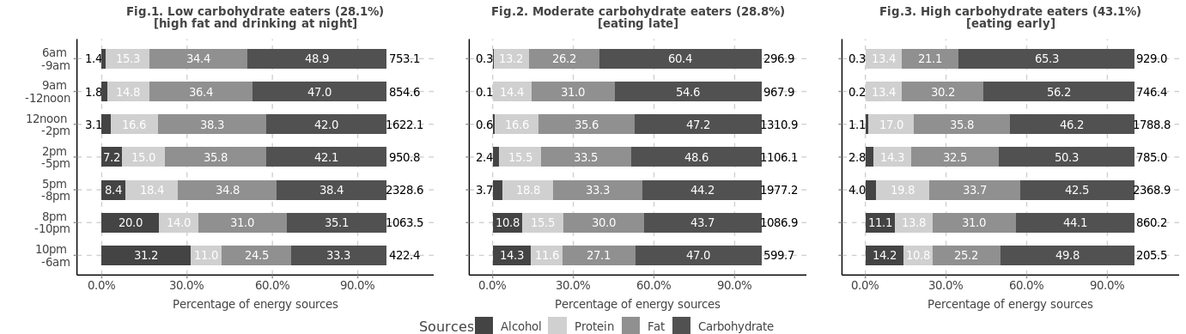

kJ

kJ

kJ

1. Mansukhani R, Palla L. *Proc Nutr Soc.* 2018 **77**(OCE1).

2. Leech RM, Worsley A, Timperio A, McNaughton SA.  *Int J Behav Nutr Phys Act.* 2017 **14**(1):3.

3. Finch H, Bolin J, Bolin J. Multilevel Modeling Using *Mplus*. *Chapman and Hall/CRC*; 2017