Relationships between food groups, eating time slots and diabetes status in adults from the UK National Diet and Nutrition Survey (2008–2017)

Chaochen Wang1, Suzana Almoosawi2, Luigi Palla3,4,5

1. Department of Public Health, Aichi Medical University, Nagakute, Aichi, JAPAN (C.W.);
2. Imperial College London
3. Department of Public Health and Infectious Diseases, University of Rome La Sapienza, Rome, Italy (L.P.)
4. Department of Medical Statistics, London School of Hygiene & Tropical Medicine, London, UK
5. Department of Global Health, School of Tropical Medicine and Global Health, University of Nagasaki, Nagasaki, Japan

Corresponding Author: Luigi Palla

Present address for L.P.: Department of Public Health and Infectious Diseaes, University of Rome La Sapienza, Piazzale Aldo Moro 5, Rome, 00185, Italy. (email: Luigi.Palla<at>uniroma1.it)

Sources of Support: This work was supported by Grants-in-Aid for Young Scientists (grant number 19K20199 to C.W.) from the Japan Society for the Promotion of Science (JSPS).

Short running head: Food groups and time of consumption.

##### 

## ABSTRACT

**Background:** Time of eating has been shown to be associated with diabetes and obesity.

**Objective:** To identify potential relationships between foods and eating time, and see whether these associations may vary by diabetes status.

**Design:** The National Diet and Nutrition Survey (NDNS) including 6802 adults (age 19) collected 749026 food recordings by a 4-day-diary. The contingency table cross-classifying 60 food groups with 7 pre-defined eating time slots (6-9am, 9am-12pm, 12-2pm, 2-5pm, 5-8pm, 8-10pm, 10pm-6am) were analyzed by Correspondence Analysis (CA). Biplots displaying the associations were generated for all adults and separately by diabetes status (self-reported, pre-diabetes, undiagnosed diabetes, and non-diabetics) to explore the associations between food groups and time of eating across diabetes strata. For selected food groups odds ratios (OR, 99% confidence intervals, CI) were derived of consuming unhealthy foods at evening/night (8 pm - 6 am) vs. earlier in the day, by logistic regression models with generalized estimating equations.

**Results:** The biplots suggested positive associations between evening/night and puddings, regular soft drinks, sugar confectioneries, chocolates, spirits, beers, ice cream, biscuits, and crisps. The OR (99% CIs) of consuming these foods at evening/night were respectively 1.38 (1.03, 1.86), 1.74 (1.47, 2.06), 1.92 (1.38, 2.69), 3.19 (2.69, 3.79), 11.13 (8.37, 14.80), 7.19 (5.87, 8.82), 2.38 (1.79, 3.15), 1.91 (1.67, 2.16), 1.55 (1.27, 1.88) vs. earlier time. Stratified biplots found that sweetened beverages, sugar-confectioneries appeared more strongly associated with evening/night consumption among undiagnosed diabetics.

**Conclusions:** Foods consumed in the evening/night time tend to be highly processed, easily accessible, and rich in added sugar or saturated fat. Individuals with undiagnosed diabetes are more likely to consume unhealthy foods at night. Further longitudinal studies are required to ascertain the causal direction of the association between late-eating and diabetes status.

##### 

## INTRODUCTION

The timing of energy intake has been shown to be associated with obesity and diabetes. (1) Specifically, eating late at night or having a late dinner was found to be related to higher risk of obesity (2,3), hyperglycemia (4), metabolic syndrome (5), diabetes (6), and poorer glycemic control among diabetics (7). However, the relationship between food choice and the time of food consumption during the day is left largely unknown. Shiftworkers have an increased risk of obesity (8,9), and diabetes (10), probably due to limited availability of healthy food choice during their night shifts (8,11). Identifying those unhealthy foods that might be chosen during late night time would be helpful when guiding people to change their eating habit for the purpose of either weight losing or maintaining glycemic control. Dietary diary recordings from national surveys can provide detailed food choice data for exploration of the relationships between food groups and their time of consumption in general population.

In this study, we aimed to describe the relationship between food groups and the time of day when they were consumed, and how such relationships may vary by status of type 2 diabetes, using the data published by the Rolling Programme of the UK National Diet and Nutrition Survey from 2008 to 2017 as this survey includes diet diaries providing detailed information on the time of day of food intake

## METHODS

6802 adults (2810 men and 3992 women) and 749026 food recordings collected by the UK National Diet and Nutrition Survey Rolling Programme (NDNS RP 2008-17) were analyzed in the current study (12). The sample was randomly drawn from a list of all addresses in the UK, clustered into postcode sectors. Details of the rationale, design and methods of the survey can be found in the previous published reports (13,14). Time of the day was categorized in 7 slots: 6-9 am, 9-12 noon, 12-2 pm, 2-5 pm, 5-8 pm, and 10 pm - 6 am. Foods recorded were classified into 60 standard food groups with 1 to 10 subgroups each: the details are given in Appendix R of the NDNS offical report (15). We focused on the 60 standard food groups in the current analysis. Diabetes status was defined as: 1) healthy if fasting glucose was lower than 6.10 (mmol/L), hemoglobin A1c (HbA1c) were less than 6.5 (%), and without self-reported diabetes or under treatment of diabetes (n = 2626); 2) pre-diabetic if fasting glucose was between 6.10 and 6.99 (inclusive) but without self-reported diabetes or under treatment of diabetes (n = 133); 3) undiagnosed diabetic if either fasting glucose was higher or equal to 7.00 (mmol/L) or HbA1c higher or equal to 6.5 (%) but without self-reported diabetes or under treatment of diabetes (n = 99); 4) diabetic if participant had self-reported diabetes or under treatment of diabetes (n = 227). Consequently, the number of adults whose diabetes status could not be confirmed was 3717 (1519 men, 2198 women) which were kept only in the whole sample (unstratified) analyses. In addition, the National Statistics Socio-economic Classification (16) were applied in the survey and therefore accordingly, the socio-economic classification for the individuals’ household were defined with 8 categories.

Correspondence analysis (CA) (17,18) was used as a tool for data mining, visualisation and hypotheses generation using half of the randomly selected NDNS diary entries data. Specifically, the contingency table generated by cross-tabulating 60 food groups and 7 time slots were analyzed by CA. Through CA, the 60 categories of standard food and the 7 time-slots were projected on two dimensions that could jointly contain large percentage of the deviation (or inertia) of the table. Biplots that graphically show the association between time of day and food groups were derived for all adults and separately according to their diabetes status. To account for the hierarchical structure of the data (food recorded by the same individuals who lived within the same area/sampling units) and calculate population average odds ratios (OR), logistic regression models with generalized estimating equations (GEE) were subsequently used to test associations that were first suggested by visual inspection of biplots generated by CA, using the remaining half of the diary entries data. The marginal ORs and their 99% confidence intervals (CI) were derived of consuming unhealthy food groups selected by CA, later in the day (8 pm - 6 am, i.e. in the evening and night) compared to earlier in the day (morning and afternoon). CA and biplots were conducted and generated by the following packages under R environment (19): FactoMineR, factoextra, ggplot2, ggrepel (20–23). Logistic regression models with GEE were performed with SAS procedure GENMOD (24) adjusted for age, sex, and socio-economic status, which were deemed the main potential confounders of the associations

## RESULTS

The dataset consisted of 2810 (41.3%) men and 3992 (58.7%) women older than or equal to 19 years old with the mean age of 49.9 years (SD = 17.6). Of these 22.6 % were current smokers, 24.3 % were past smokers. The average body mass index (BMI) was 27.7 kg/m (SD = 5.41). Among the food recordings collected (n=749026), 56.9% were recorded during traditional breakfast (6 am - 9 am: 14.3%), lunch (12 noon - 2 pm: 18.5%), or dinner (5 pm - 8 pm: 24.1%) time slots. Table 1. shows the top 37 food groups that contributed to 90% of the total calories consumed by adults in NDNS RP. These food groups accounted for 478028 of the total diary entries (63.8 %). The random process split the whole set of food recordings into a hypothesis generating dataset of 374682 and a testing dataset of 374344.

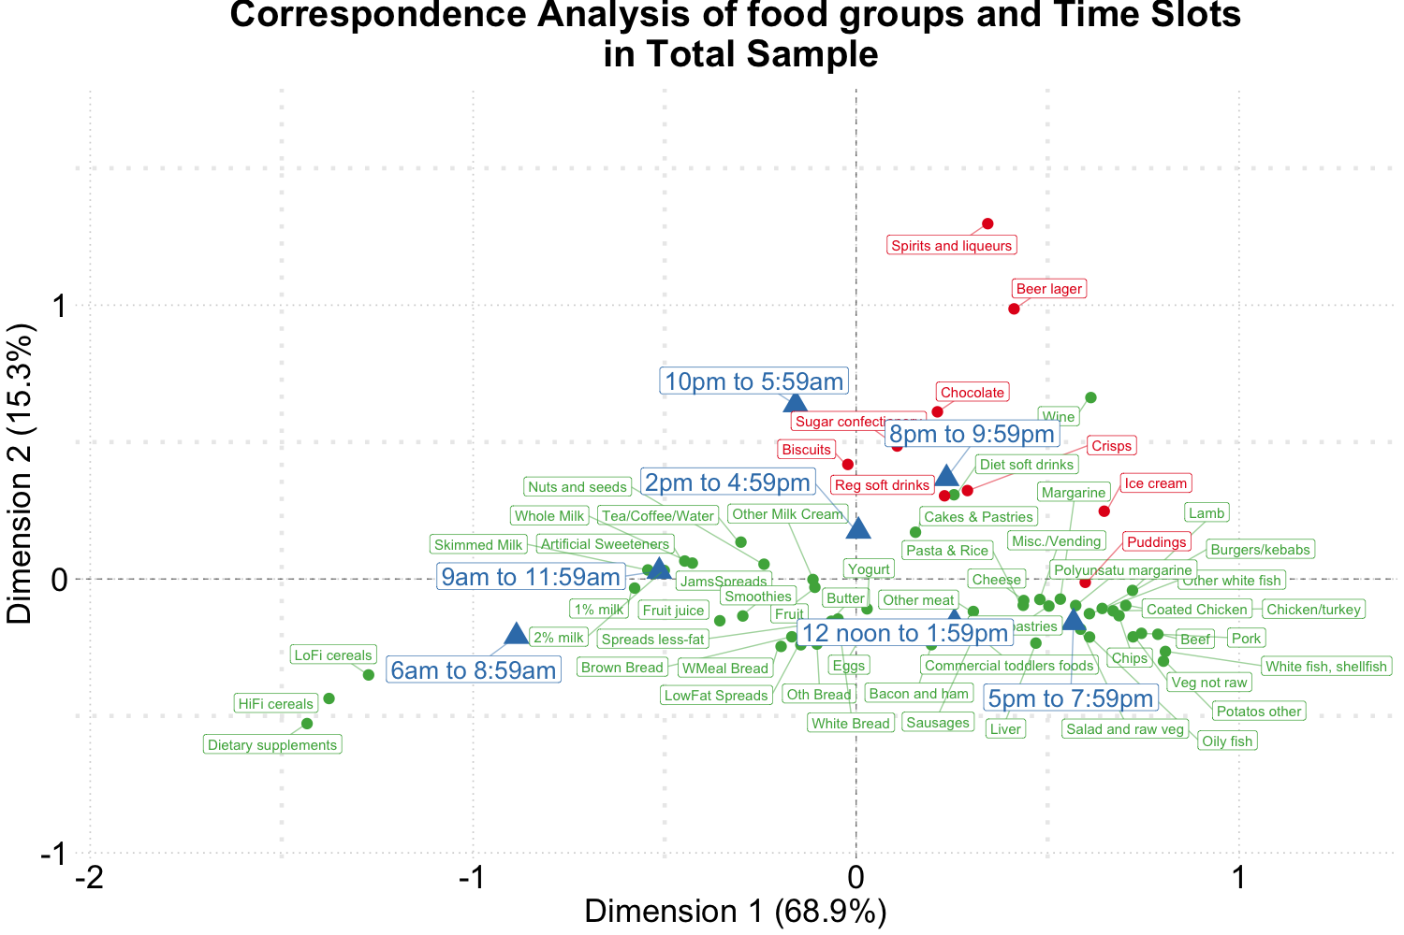

Figure 1. Biplot of food groups and eating time slots among total sample of NDNS RP.

Figure 1-5 present the CA biplots that visually summarize the associations between 60 food groups and the time of their consumption in the entire sample and then stratifying by their diabetes status. In Figure 1, the horizontal axis explains 68.9 % the association (inertia) between food and time while the verticle axis reflects 15.3 % of the same relationship. Therefore, a total of 84.2 % of the inertia between food and time were captured in this figure which shows a visual summary of how those two categorical variables are related. Specifically, time slots later than 8 pm are shown in the upper side of the plot closer to alcoholic products (beers and spirits) or highly processed/energy-dense foods (sugar confectioneries, chocolates, biscuits, regular softdrinks, ice cream, crisps); time earlier than noon appear in the left hand side together with typical breakfast foods (cereals, milk, bread, etc.).

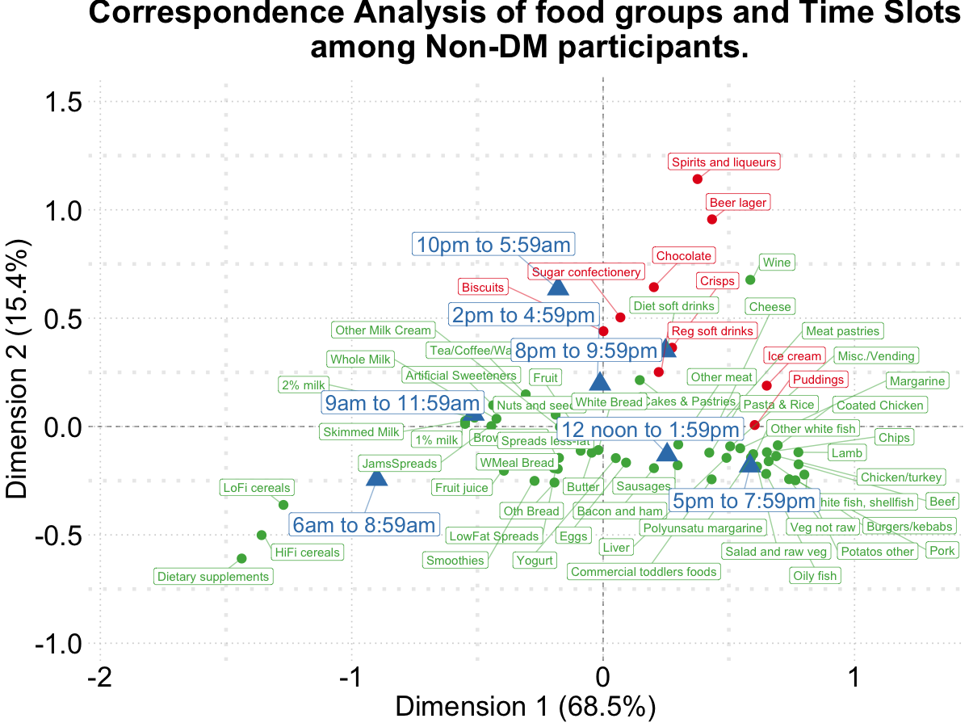

Figure 2. Biplot of food groups and eating time slots among **non-diabetics**.

To visualize the potentially different associational patterns between food groups and time slots according to diabetes status, Figure 2-5 display the CA plots in subsets of the data. Depending on diabetes status, these biplots explained 76.3% to 84.1% of the inertia in the data. Similarly to the biplot created from the total sample (Figure 1), later time in the day (8 pm and later) are shown in the upper side of each figure and suggested an association with the alcoholic beverages and highly processed or energy dense food groups. Additionally, some food groups and time slots also flagged up associations potentially different by diabetes status. For example, puddings seemed to be closer to later time in the day among undiagnosed diabetics (Figure 4) while for diagnosed diabetic patients (Figure 3) they were close to traditional dinner time (5 pm to 8 pm) or earlier in the day. Furthermore, sugar confectioneries/chocolates/biscuits/regular soft drinks appeared to be associated with later time in the day (8 pm or later) more strongly among undiagnosed diabetics (Figure 4) than the others.

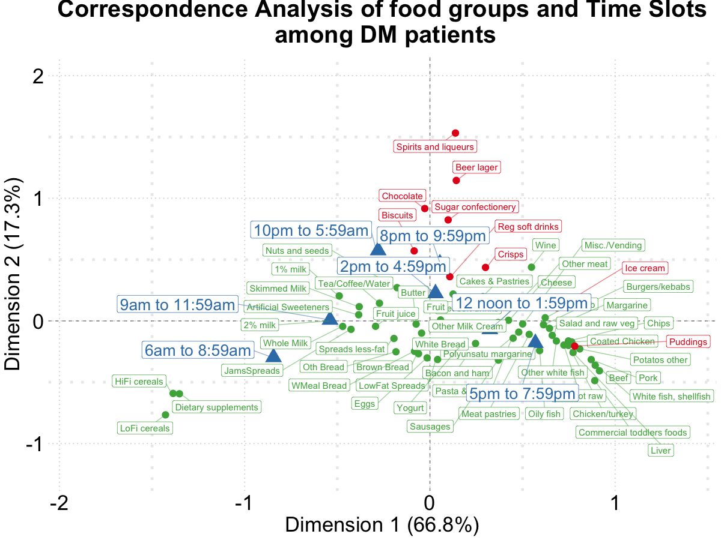

Figure 3. Biplot of food groups and eating time slots among **diabetics**.

Based on the findings suggested from Figure 1-5, we decided to focus on puddings, regular soft drinks, sugar confectioneries, chocolates, spirits, beers, ice cream, biscuits, crisps as these foods either showed a particularly strong association with time of the day or a different pattern of association across different strata of the survey sample; hence we tested the following hypotheses using logistic regression models (adjusted for age, sex, and socio-economic levels) with GEE: that the odds of consuming each selected food at later time of the day (8 pm - 6 am) is the same compared to earlier in the day; and the associations of the above-mentioned food groups and time slots are the same among participants with different diabetes status (i.e. no interaction between time of the time of food intake and diabetes status). The results are summarized in Table 2.

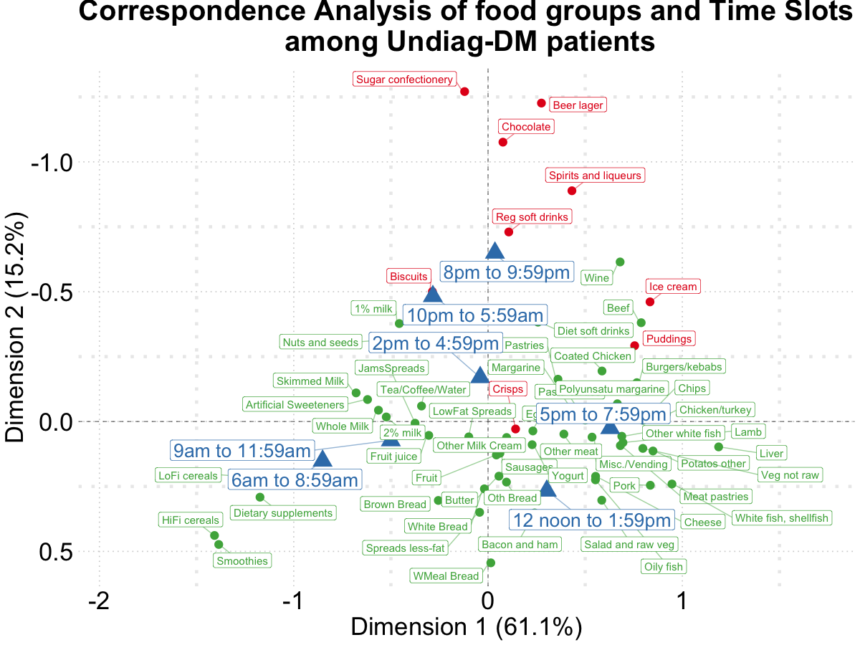

Figure 4. Biplot of food groups and eating time slots among **undiagnosed diabetics**.

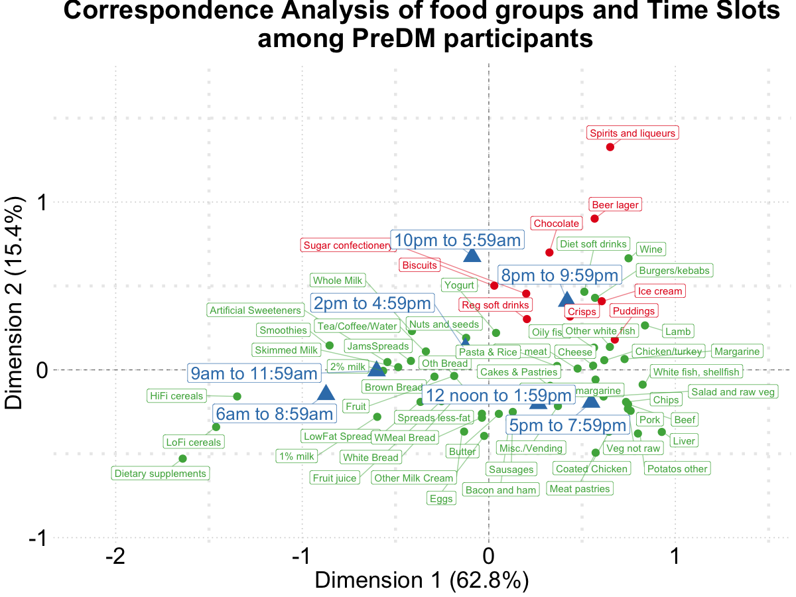

Figure 5. Biplot of food groups and eating time slots among **pre-diabetics**.

The listed food groups were found to be consumed during time between 8 pm and 6 am with higher odds compared to earlier time. The OR (99% CIs) main effects of consuming these foods at evening/night were for puddings 1.38 (1.03, 1.86), for regular soft drinks 1.74 (1.47, 2.06), for sugar confectioneries 1.92 (1.38, 2.69), for chocolates 3.19 (2.69, 3.79), for spirits 11.13 (8.37, 14.80), for beers 7.19 (5.87, 8.82), for ice-cream 2.38 (1.79, 3.15), for biscuits 1.91 (1.67, 2.16), for crisps 1.55 (1.27, 1.88) vs. earlier time. Opposite directions of the association for puddings were detected across diabetes status:the ORs (99% CIs) for consuming puddings at night time (8 pm or later) compared to earlier time were 1.50 (1.10, 2.07), 0.89 (0.16, 4.87), 1.81 (0.41, 7.98), and 0.58 (0.14, 2.43) for healthy, prediabetic, undiagnosed diabetic, and diabetic paticipants, respectively. Furthermore, undiagnosed diabetic patients were found to have particularly high odds of consuming regular soft drinks (OR: 2.72; 99% CI: 1.44, 5.14), and sugar cofectioneries (OR: 13.07; 99%CI: 4.59, 37.24) during night time periods than earlier time in the day.

## DISCUSSION

The present study described the potential relationships between food groups and time of their consumption in a representative sample from the NDNS RP. All unhealthy foods emerged from CA were found to be more likely to be consumed after 8 pm. These included alcoholic/sweetened beverages, chocolates and other foods rich in added sugars and saturated fats such as biscuits and ice cream. Foods chosen in the evening/night time slots tend to be highly processed and easily accessible. Specifically, undiagnosed patients might be at a higher risk of worsening their condition as they were found to have higher odds to choose a number of less healthy foods after 8 pm (sugar confectioneries, regular soft drinks) compared to earlier time than diabetics and non-diabetics. These findings are concerning considering previous research that have indicated that quality of macronutrient intake in the evening is likely to influence fasting glucose levels and glycaemic response to subsequent meals in the morning (<https://doi.org/10.1093/ajcn/48.4.1041>). More recently, a randomized controlled trial indicated that consuming carbohydrates at dinner irrespective of glycaemic index raised postprandial glucose response to breakfast producing what is known as a second meal effect ([http://dx.doi.org/10.1136/bmjdrc-2019-001099](http://dx.doi.org/10.1136/bmjdrc-2019-001099" \t "_new)). Similar observation have been made by Nitta and colleagues who observed that eating sweet snacks post-dinner worsened glycaemic excursions in the evening and at subsequent breakfast [https://doi.org/10.1016/j.diabet.2018.10.004](https://doi.org/10.1016/j.diabet.2018.10.004" \o "Persistent link using digital object identifier" \t "_blank)

. Added to this is evidence that suggests that the late-night dinners induce post-prandial hyperglycaemia in patients with type 2 diabetes and that interventions at this eating occasions can result in a profound impact on postprandial glycaemic [https://doi.org/10.1016/j.diabres.2017.05.010](https://doi.org/10.1016/j.diabres.2017.05.010" \o "Persistent link using digital object identifier" \t "_blank). On the balance of this evidence, tageting and improving the timing and quality of foods in evening eating occasions provides a unique opportunity to design intervention to those who might be at risk of being diabetics,.

A compelling finding of our study is the observation that diabetes patients were found to be potentially controlling their choice of food groups such as avoiding puddings at night. However, higher odds of consuming alcoholic beverages and energy condensed foods such as chocolates and sugar confectioneries at night among individuals with diabetes suggestes that their food choice might need further modifications.

Assessing the relationships between food groups and timing of eating by diabetes status can be considered as a first step towards identifying specific public health targets for behavior change/intervention. This is important as most current public health strategies and dietary recommendations do not provide targeted advice that takes into considerations specific eating occasions. This is important considering that targeted advice is more likely to result in sustainable behavioural change. Our findings are consistent with previous evidence that has found that both sweetened and alcoholic beverages are responsible for large portion of energy consumption at night in other populations (25)….

An important limitation in this study is the cross-sectional design of the study. The inability to assess the temporal relationship between timing of food intake and diabetes status means that a cause-effect relationship between time of unhealthy food intake and diabetes status cannot be established. Hence further prospective studies are warranted to investigate the temporal relationship between diabetes and other disease incidences in relation to both quality and timing of eating. Moreover, the current study assumes that mis-reporting occurred equally amongst all eating occasions. This limitation has been reported by previous research and is a limitation of chrono-nutrition {ADD THIS REF PLEASE PMC5490587}.

### Conclusions

In conclusion, our study indicates that…

## ACKNOWLEDGEMENT

## CONFLIT OF INTEREST (COI) STATEMENT

The authors declared no conflicts of interest.

## AUTHOR’S CONTRIBUTIONS

CW, SA, and LP: designed research and had primary responsibility for final content; CW and LP performed statistical analysis; and all authors: wrote the manuscript, read and approved the final manuscript.

##### 

## REFERENCES

1. Almoosawi S, Vingeliene S, Karagounis L, Pot G. Chrono-nutrition: A review of current evidence from observational studies on global trends in time-of-day of energy intake and its association with obesity. Proc Nutr Soc. Cambridge University Press; 2016;75:487–500.

2. Xiao Q, Garaulet M, Scheer FA. Meal timing and obesity: Interactions with macronutrient intake and chronotype. International Journal of Obesity. Nature Publishing Group; 2019;43:1701–11.

3. Yoshida J, Eguchi E, Nagaoka K, Ito T, Ogino K. Association of night eating habits with metabolic syndrome and its components: A longitudinal study. BMC public health. Springer; 2018;18:1366.

4. Nakajima K, Suwa K. Association of hyperglycemia in a general japanese population with late-night-dinner eating alone, but not breakfast skipping alone. Journal of Diabetes & Metabolic Disorders. BioMed Central; 2015;14:16.

5. Kutsuma A, Nakajima K, Suwa K. Potential association between breakfast skipping and concomitant late-night-dinner eating with metabolic syndrome and proteinuria in the japanese population. Scientifica. Hindawi; 2014;2014.

6. Mattson MP, Allison DB, Fontana L, Harvie M, Longo VD, Malaisse WJ, Mosley M, Notterpek L, Ravussin E, Scheer FA, et al. Meal frequency and timing in health and disease. Proceedings of the National Academy of Sciences. National Acad Sciences; 2014;111:16647–53.

7. Sakai R, Hashimoto Y, Ushigome E, Miki A, Okamura T, Matsugasumi M, Fukuda T, Majima S, Matsumoto S, Senmaru T, et al. Late-night-dinner is associated with poor glycemic control in people with type 2 diabetes: The kamogawa-dm cohort study. Endocrine journal. The Japan Endocrine Society; 2017;EJ17–0414.

8. Balieiro LCT, Rossato LT, Waterhouse J, Paim SL, Mota MC, Crispim CA. Nutritional status and eating habits of bus drivers during the day and night. Chronobiology international. Taylor & Francis; 2014;31:1123–9.

9. Barbadoro P, Santarelli L, Croce N, Bracci M, Vincitorio D, Prospero E, Minelli A. Rotating shift-work as an independent risk factor for overweight italian workers: A cross-sectional study. PLoS One. Public Library of Science; 2013;8.

10. Pan A, Schernhammer ES, Sun Q, Hu FB. Rotating night shift work and risk of type 2 diabetes: Two prospective cohort studies in women. PLoS Med. Public Library of Science; 2011;8:e1001141.

11. Bonnell EK, Huggins CE, Huggins CT, McCaffrey TA, Palermo C, Bonham MP. Influences on dietary choices during day versus night shift in shift workers: A mixed methods study. Nutrients. Multidisciplinary Digital Publishing Institute; 2017;9:193.

12. MRC Elsie Widdowson Laboratory and NatCen Social Research. National diet and nutrition survey years 1-8, 2008/09-2015/16 [data collection]. 11th Edition. UK Data Service. SN: 6533; 2018.

13. Bates B, Lennox A, Prentice A, Bates CJ, Page P, Nicholson S, Swan G. National Diet and Nutrition Survey: Results from years 1, 2, 3 and 4 (combined) of the Rolling Programme (2008/2009-2011/2012): A survey carried out on behalf of Public Health England and the Food Standards Agency. Public Health England; 2014.

14. Roberts C, Steer T, Maplethorpe N, Cox L, Meadows S, Nicholson S, Page P, Swan G. National Diet and Nutrition Survey: Results from years 7 and 8 (combined) of the Rolling Programme (2014/2015–2015/2016). Public Health England; 2018;

15.. National diet and nutrition survey years 1-8, 2008/09-2015/16. 9th Edition. 2018.

16. Rose D, Pevalin DJ. The national statistics socio-economic classification: Origins, development and use. 2005.

17. Greenacre M. Correspondence analysis in practice. Chapman; Hall/CRC; 2017.

18. Chapman AN, Beh EJ, Palla L. Application of correspondence analysis to graphically investigate associations between foods and eating locations. 2017;

19. R Core Team. R: A language and environment for statistical computing [Internet]. Vienna, Austria: R Foundation for Statistical Computing; 2019. Available from: <https://www.R-project.org/>

20. Lê S, Josse J, Husson F. FactoMineR: A package for multivariate analysis. Journal of Statistical Software. Foundation for Open Access Statistic; 2008;25:1–18.

21. Kassambara A, Mundt F. Factoextra: Extract and visualize the results of multivariate data analyses [Internet]. 2019. Available from: <https://CRAN.R-project.org/package=factoextra>

22. Wickham H. Ggplot2: Elegant graphics for data analysis [Internet]. Springer-Verlag New York; 2016. Available from: <https://ggplot2.tidyverse.org>

23. Slowikowski K. Ggrepel: Automatically position non-overlapping text labels with ’ggplot2’ [Internet]. 2019. Available from: <https://CRAN.R-project.org/package=ggrepel>

24. Institute S. SAS 9.4 language reference: Concepts. USA: SAS Institute Inc. 2013.

25. Hassen WS, Castetbon K, Tichit C, Péneau S, Nechba A, Ducrot P, Lampuré A, Bellisle F, Hercberg S, Méjean C. Energy, nutrient and food content of snacks in french adults. Nutrition journal. BioMed Central; 2018;17:33.