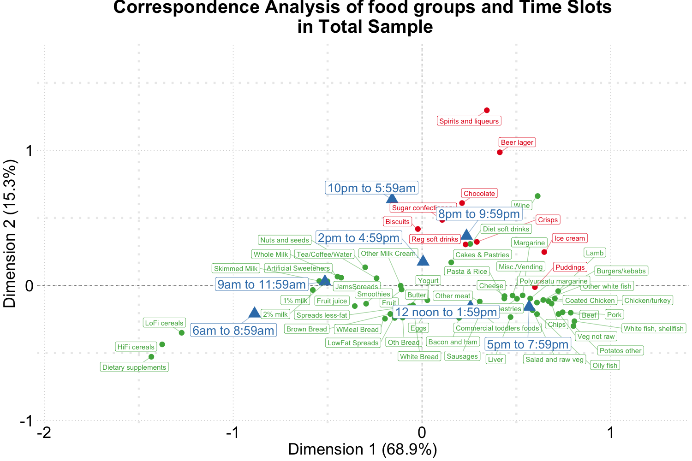

Figure 1: Biplot of food groups and eating time slots among total sample of NDNS RP.

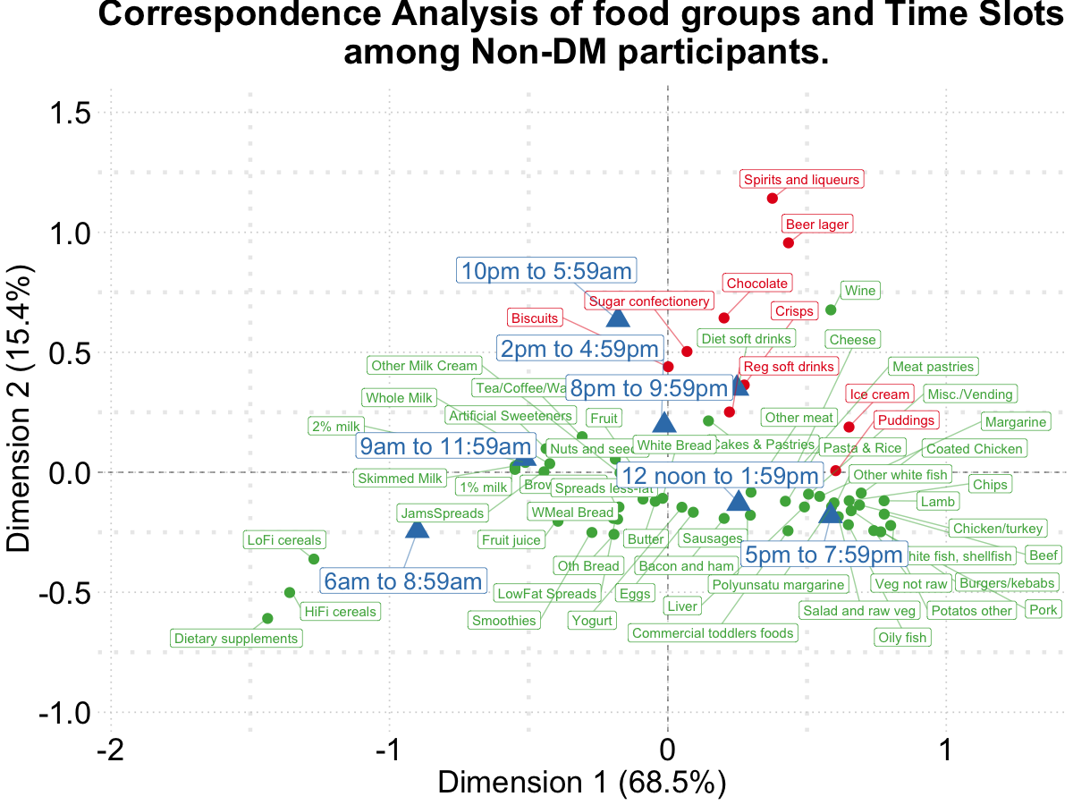

Figure 2: Biplot of food groups and eating time slots among **non-diabetics**.

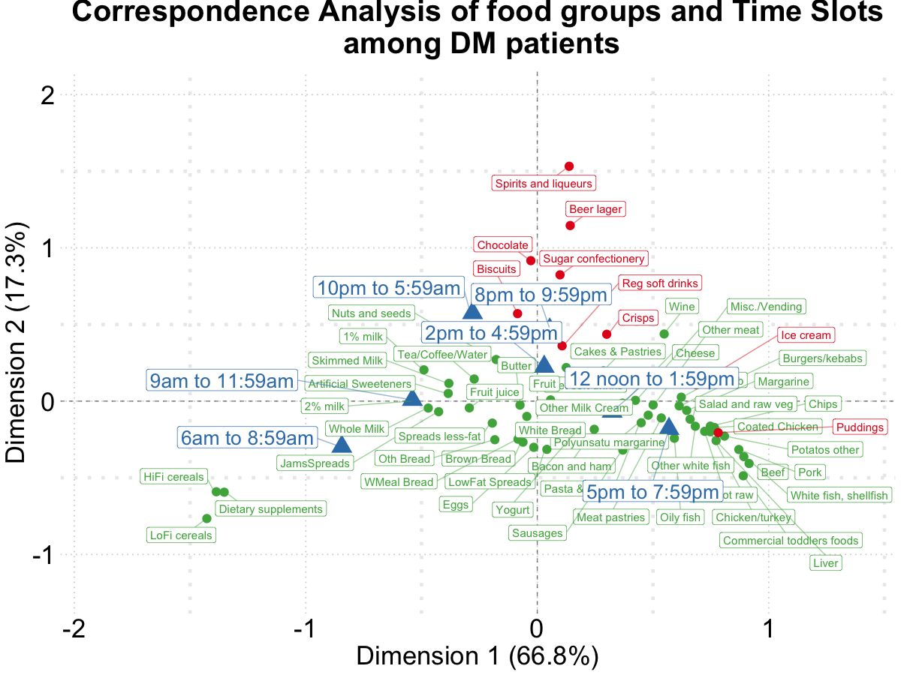

Figure 3: Biplot of food groups and eating time slots among **diabetics**.

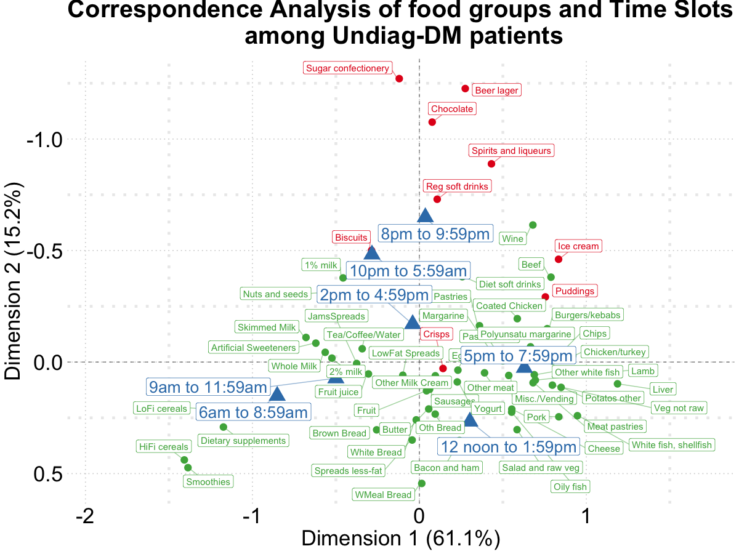

Figure 4: Biplot of food groups and eating time slots among **undiagnosed diabetics**.

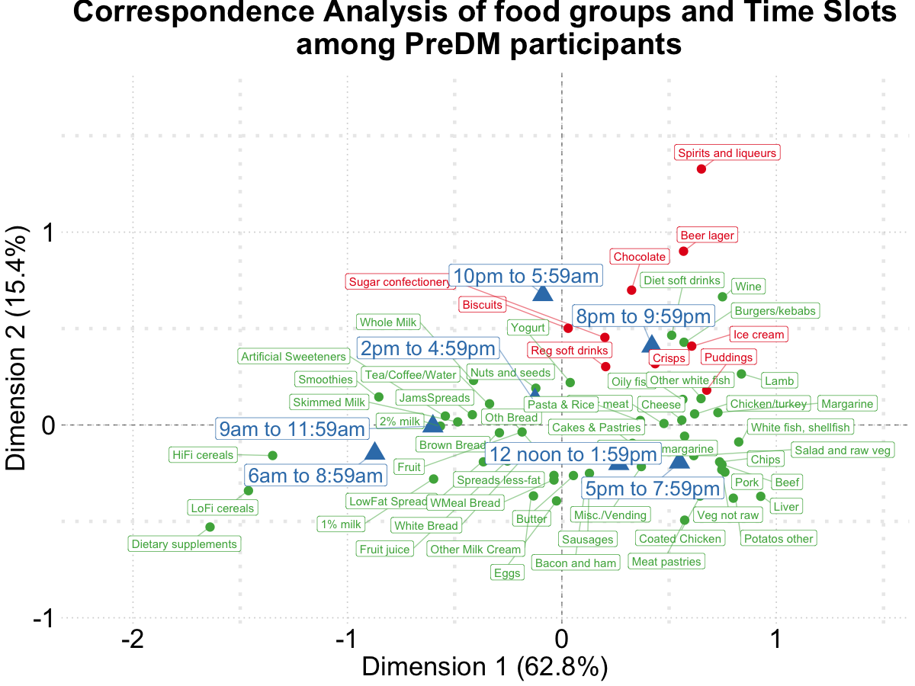

Figure 5: Biplot of food groups and eating time slots among **pre-diabetics**.

Table 1. The numbers of food recordings contributed to the total calories consumed by adults in the UK adults. (NDNS RP 2008-2017).

| **Food group names** | **n** | **Calories** | **Relative Prop** | **Cal Prop** | **Cal Cum Prop** |
| --- | --- | --- | --- | --- | --- |
| Pasta & Rice and other cereals | 18353 | 3512069.99 | 2.45% | 7.36% | 7.36% |
| White Bread | 18434 | 3245641.19 | 2.46% | 6.80% | 14.17% |
| Chips, fried and roast potatoes and potato products | 6749 | 1884058.68 | 0.90% | 3.95% | 18.12% |
| Cakes, buns, sweet pastries, fruit pies | 7806 | 1710594.27 | 1.04% | 3.59% | 21.70% |
| Vegetable (not raw) | 51317 | 1665474.02 | 6.85% | 3.49% | 25.19% |
| Biscuits | 13200 | 1662598.06 | 1.76% | 3.49% | 28.68% |
| Fruit | 33903 | 1641675.02 | 4.53% | 3.44% | 32.12% |
| Miscellaneous unclassified foods | 48597 | 1639024.81 | 6.49% | 3.44% | 35.56% |
| Chicken/turkey | 8863 | 1617820.30 | 1.18% | 3.39% | 38.95% |
| Cheese | 10983 | 1492015.32 | 1.47% | 3.13% | 42.07% |
| Beer lager | 8199 | 1484001.20 | 1.09% | 3.11% | 45.19% |
| Semi-skimmed milk | 57611 | 1302649.72 | 7.69% | 2.73% | 47.92% |
| Potatos other (in salads and dishes) | 10113 | 1291447.61 | 1.35% | 2.71% | 50.62% |
| Fat spreads | 37960 | 1215278.60 | 5.07% | 2.55% | 53.17% |
| Beef | 4987 | 1124560.42 | 0.67% | 2.36% | 55.53% |
| High fiber breakfast cereals | 8215 | 1072813.73 | 1.10% | 2.25% | 57.78% |
| Whole meal bread | 7193 | 1070695.89 | 0.96% | 2.24% | 60.02% |
| Chocolate | 6495 | 1046112.65 | 0.87% | 2.19% | 62.22% |
| Wine | 6967 | 1027792.96 | 0.93% | 2.15% | 64.37% |
| Brown, granary and wheatgerm bread | 6183 | 1009074.95 | 0.83% | 2.12% | 66.48% |
| Butter | 10203 | 965901.11 | 1.36% | 2.02% | 68.51% |
| Eggs | 7554 | 964769.19 | 1.01% | 2.02% | 70.53% |
| Soft drinks not diet | 11387 | 940516.516 | 1.52% | 1.97% | 72.50% |
| Reduced fat spreads | 12620 | 848834.89 | 1.68% | 1.78% | 74.28% |
| Crisps and savoury snacks | 5664 | 835671.58 | 0.76% | 1.75% | 76.04% |
| Sausages | 3025 | 775004.13 | 0.40% | 1.62% | 77.66% |
| Meat pastries | 1979 | 744639.89 | 0.26% | 1.56% | 79.22% |
| Bacon and ham | 8467 | 738727.49 | 1.13% | 1.55% | 80.77% |
| Yogurt | 6776 | 665484.55 | 0.90% | 1.40% | 82.16% |
| Low-fiber breakfast cereals | 4303 | 560296.32 | 0.57% | 1.17% | 83.34% |
| Nuts and seeds | 6259 | 559873.88 | 0.84% | 1.17% | 84.51% |
| Oily fish | 2610 | 550425.36 | 0.35% | 1.15% | 85.67% |
| Whole Milk | 13628 | 530449.07 | 1.82% | 1.11% | 86.78% |
| White fish, shellfish | 1597 | 498928.82 | 0.21% | 1.05% | 87.82% |
| Puddings | 2291 | 459784.62 | 0.31% | 0.96% | 88.79% |
| Other Milk Cream | 6605 | 434239.37 | 0.88% | 0.91% | 89.70% |
| Pork | 1832 | 420503.76 | 0.24% | 0.88% | 90.58% |

Table 2. Odds ratio (99% confidence intervals) for food groups eaten at night (8 pm - 6 am) vs. earlier time in the day, among total and according to different diabetes status, NDNS RP 2008-2017.

| **Selected food groups** | **Overall** | **Healthy** | **Pre-diabetics** | **Undiagnosed diabetes** | **Diabetes** |
| --- | --- | --- | --- | --- | --- |
| Pudding | 1.38 (1.03, 1.86) | 1.50 (1.10, 2.07) | 0.89 (0.16, 4.87) | 1.81 (0.41, 7.98) | 0.58 (0.14, 2.43) |
| Regular soft drink | 1.74 (1.47, 2.06) | 1.72 (1.43, 2.06) | 1.87 (0.97, 3.57) | 2.72 (1.44, 5.14) | 1.38 (0.65, 2.96) |
| Sugar Confectionery | 1.92 (1.38, 2.69) | 1.63 (1.14, 2.32) | 2.10 (0.52, 8.46) | 13.07 (4.59, 37.24) | 5.10 (2.15, 12.09) |
| Chocolate | 3.19 (2.69. 3.79) | 3.10 (2.57, 3.73) | 4.07 (2.58, 3.73) | 2.52 (0.95, 6.66) | 5.13 (2.55, 10.30) |
| Spirit | 11.13 (8.37, 14.80) | 10.86 (8.01, 14.73) | 8.48 (2.26, 31.79) | 7.51 (1.99, 5.21) | 36.8 (7.36, 183.66) |
| Beer | 7.19 (5.87, 8.82) | 7.49 (6.02, 9.34) | 4.05 (2.00, 8.20) | 7.87 (3.51, 17.63) | 6.32 (2.29, 17.47) |
| Ice Cream | 2.38 (1.79, 3.15) | 2.45 (1.82, 3.31) | 3.32 (0.75, 14.62) | 0.98 (0.14, 7.00) | 1.65 (0.54, 5.07) |
| Biscuit | 1.91 (1.67, 2.16) | 1.78 (1.55, 2.03) | 3.51 (2.16, 5.71) | 2.75 (1.35, 5.59) | 2.44 (1.54, 3.88) |
| Crisp | 1.55 (1.27, 1.88) | 1.56 (1.27, 1.92) | 1.95 (0.79, 4.78) | 1.37 (0.37, 5.12) | 1.16 (0.49, 2.75) |
| Logistic regression models with GEE were adjusted for age, sex, and social-economic levels. | | | | | |