Dear Editor Yehuda Ben-Zion,

We would like to thank you, Dr. Blandine Gardonio, Prof. Peter Shearer for their constructive comments on our manuscript #2019JB019076R entitled “**Detailed Investigation of the Foreshock Sequence of the 2010 Mw 7.2 El Mayor-Cucapah Earthquake**”. We are submitting a revised manuscript that includes the response to all the reviewer’s comments and suggestions. Following are point-to-point responses to the comments and implementation. We marked the original comments as **bold**, our reply as regular font, and new text inserted/revised in the paper as *italic*.

We thank you and the reviewers again and hope that the newly revised version will be accepted for publication.

Best regards,

Dongdong Yao (dongdony@umich.edu), Yihe Huang, Zhigang Peng and Raul R. Castro

**Reviewer #1: Blandine Gardonio, Ecole Normale Suprieure, Paris France.**

**I think that the answers given by the authors were very clear and that they correctly argued and I would like to thank the authors for this great work. I have read carefully the paper and Supp. Mat. and I think that there is no further corrections needed, at least for my part.**

We thank Dr. Blandine Gardonio for taking time to revise our paper. We really benefit a lot from her constructive comments and make it more readable.

**Reviewer #2: Peter Shearer**

**I am generally happy with the changes that the authors made in response to the reviews. However, before publication I would like two figures added to the supplement, which should help clarify some issues that I raised in my review.**

1. **A log-log plot of fc1 vs. fc2 from Table S3 should be included.**

**This shows a clear correlation between fc1 and fc2 and highlights the problem with allowing fc2 to be unconstrained within a wide range. It also shows the large number of measurements for which fc2 is set to its (probably unrealistic) maximum value. I believe this plot shows that it’s better to fix the smaller event corner frequency (the paper now also includes this approach) and the paper therefore should highlight the fixed smaller event stress drop results more than their original approach. However, I’ll leave that up to the authors, provided they include this figure so that the reader can make their own assessment of the varying fc2 approach.**

We thank Peter for this great suggestion, and we add the following Figure R1 as now the new supplementary Figure S11. We also refer to this figure in Line 422 in the main text. 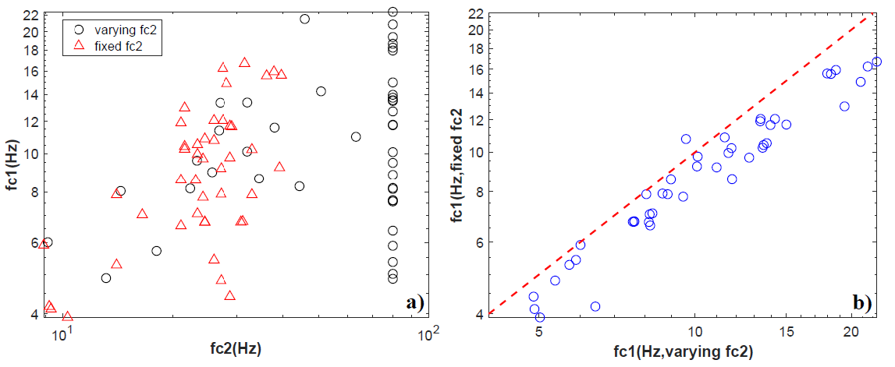

Figure R1. a) Estimated fc1 versus fc2 from both varying fc2(black open circles) and fixed fc2(red triangles). b) Comparison between estimated fc1 from varying fc2 (X axis) and fixed fc2 (Y axis). The red dashed line show a slope of 1.0.

1. **Figures R6 to R8 in the author’s response letter should be combined into a single plot and shown in the Supplement. As separate plots, it’s too hard to see the differences in slope. For simplicity, only the cumulative FMD need be plotted.**

We merged those plots together and it is shown as Figure R2 (also replace original Figure S7). We also refer to this figure by adding the following sentence in L283 of the main text: “*The cumulative frequency-magnitude distribution for catalog foreshocks, detected foreshocks and catalog aftershocks are shown in Figure S7* “. We also modify L286-288 from original text “*We obtained Mc=0.5 and b=0.67 (Figure S7). The 287 measured b value is lower than the value (0.96) of the aftershocks [Hauksson et al., 288 2010]*” to “*The measured b value for foreshocks is lower than the value (0.96) of the aftershocks [Hauksson et al., 2010], which is also consistent with what we observed for catalog aftershocks with first 120 days (Figure S7)*”.

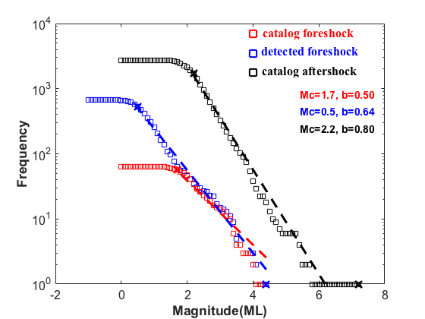

Figure R2. Frequency-magnitude distribution for catalog foreshock (red squares), detected foreshocks (blue squares) and catalog aftershock (black squares). Corresponding magnitude of completeness (Mc) and b value are labeled with the same color.