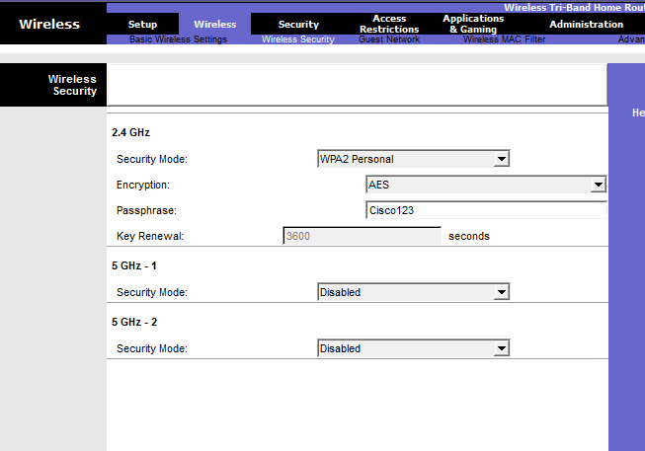
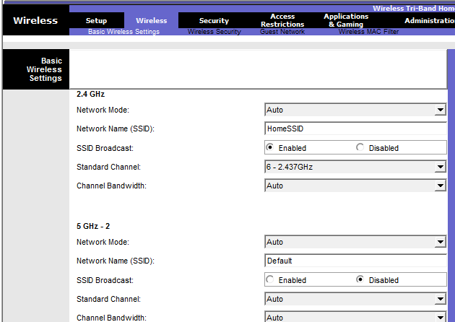

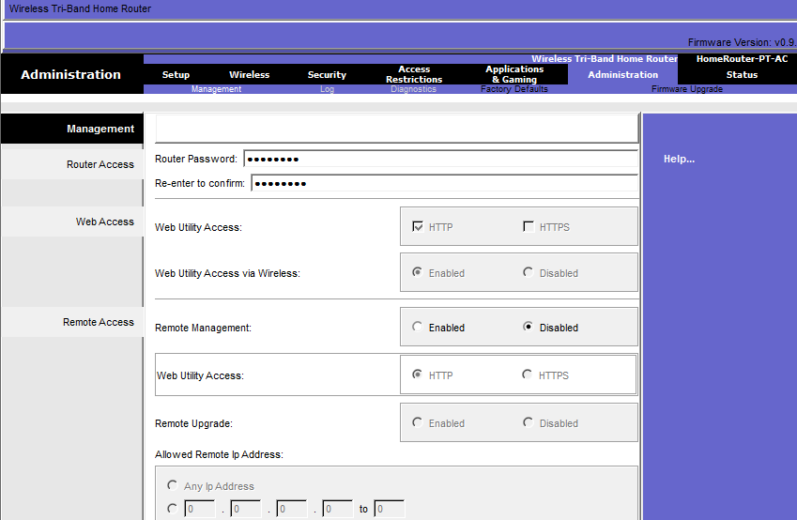
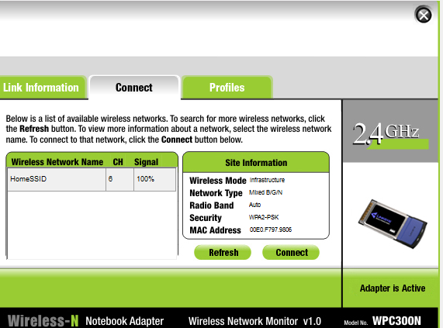

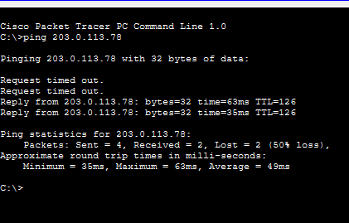

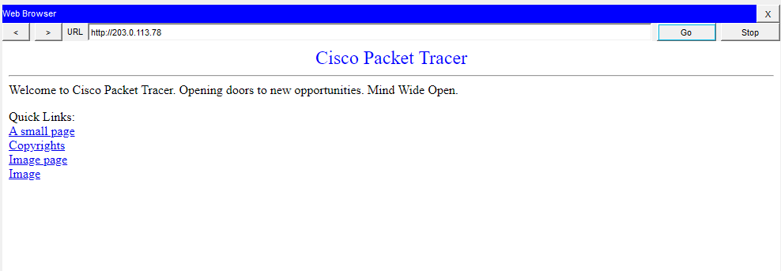

Part 1 Configure a Home Wireless Router

Step 1 DHCP
- Router LAN IP : 192.168.6.1
- Subnet Mask : 255.255.255.224
- DHCP Server : Enable
- Starting IP : 192.168.6.3
- Maximum Users : 20
- Internet Connection : Automatic Configuration (DHCP)
- Static DNS : 10.100.100.252

Step 2 Wireless
- Network Mode : Auto
- SSID : HomeSSID
- Channel : 6
- SSID Broadcast : Enable

Step 3 Security
- Security Mode : WPA2-Personal
- Passphrase : Cisco123
- Router Password : Cisco123

Step 4 Client
Laptop, Tablet และ Smartphone
- SSID : HomeSSID
- Authentication : WPA2-Personal
- Password : Cisco123

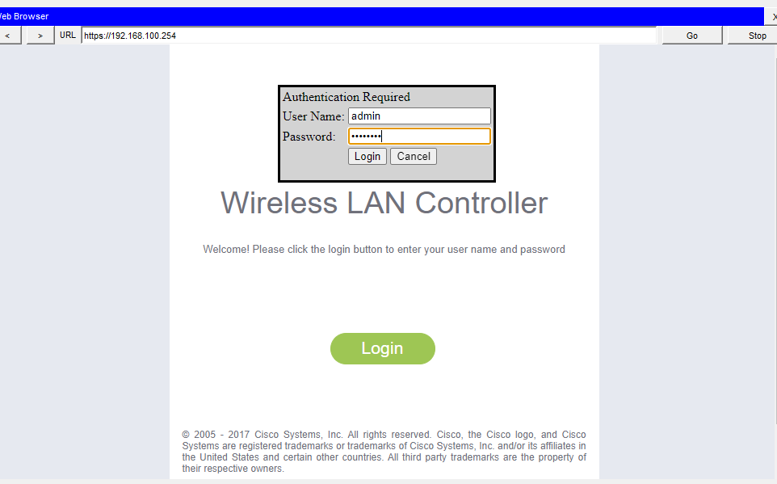
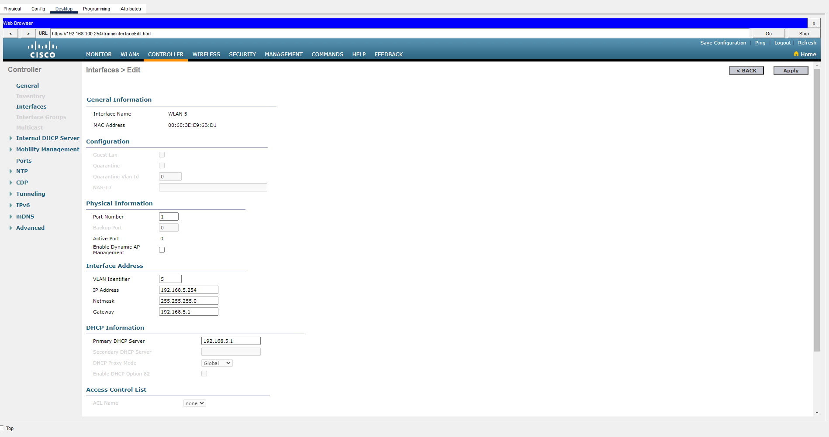

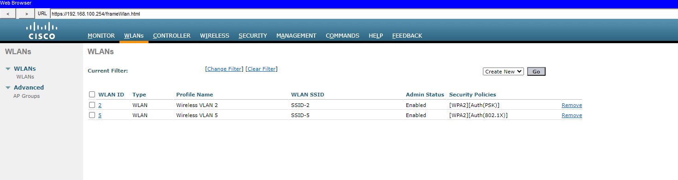

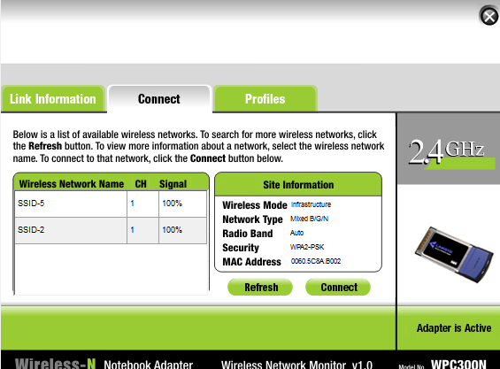

Part 2 Configure WLC

VLAN Interface 2
- Name : WLAN 2
- VLAN : 2
- Port : 1
- IP Address : 192.168.2.254
- Mask : 255.255.255.0
- Gateway : 192.168.2.1
- DHCP Server : 192.168.2.1

VLAN Interface 5
- Name : WLAN 5
- VLAN : 5
- Port : 1
- IP Address : 192.168.5.254
- Mask : 255.255.255.0
- Gateway : 192.168.5.1
- DHCP Server : 192.168.5.1

DHCP Scope
- Scope Name : management
- Start Address : 192.168.100.235
- End Address : 192.168.100.245
- Network : 192.168.100.0
- Netmask : 255.255.255.0
- Default Router : 192.168.100.1

RADIUS
- Server Index : 1
- Server Address : 10.6.0.254
- Shared Secret : RadiusPW

SNMP
- Community : WLAN
- IP Address : 10.6.0.254

WLAN 2
- Profile Name : Wireless VLAN 2
- SSID : SSID-2
- ID : 2
- Interface : WLAN 2
- Security : WPA2-PSK
- Passphrase : Cisco123
- FlexConnect Local Switching : Enable
- FlexConnect Local Authentication : Enable

WLAN 5
- Profile Name : Wireless VLAN 5
- SSID : SSID-5
- ID : 5
- Interface : WLAN 5
- Security : WPA2-Enterprise (802.1X)
- Authentication Server : 10.6.0.254
- FlexConnect Local Switching : Enable
- FlexConnect Local Authentication : Enable

Wireless Host 1
- SSID : SSID-2
- Security : WPA2-PSK
- Password : Cisco123

Wireless Host 2
- SSID : SSID-5
- Security : WPA2-Enterprise
- Username : userWLAN5
- Password : userW5pass

การทดสอบ
ทดสอบด้วยคำสั่ง
ping 203.0.113.78
จาก Wireless Host ทั้งสอง
จากนั้นเปิด Web Browser
http://203.0.113.78

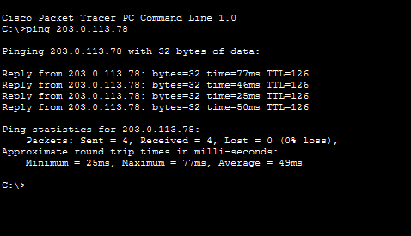

Question
Verify the address. What address did it receive?
Answer
The Internet interface received an IP address automatically from the DHCP server. The exact IP address depends on the Packet Tracer simulation and may vary for each activity.

ผลลัพธ์จากการตั้งค่า

