CP3402 Prac 04
Trivia Quiz Dynamic Website with PHP + MySQL
For my local development environment, I configured a local Apache and MySQL stack using XAMPP. The site is dynamic on localhost powered by PHP 8 and a MySQL database managed by phpMyAdmin. Server-side backend logic handles SQL queries, user authentication, and randomized questions. The frontend is built using HTML, CSS, Bootstrap, and JavaScript to deliver an interactive user interface.
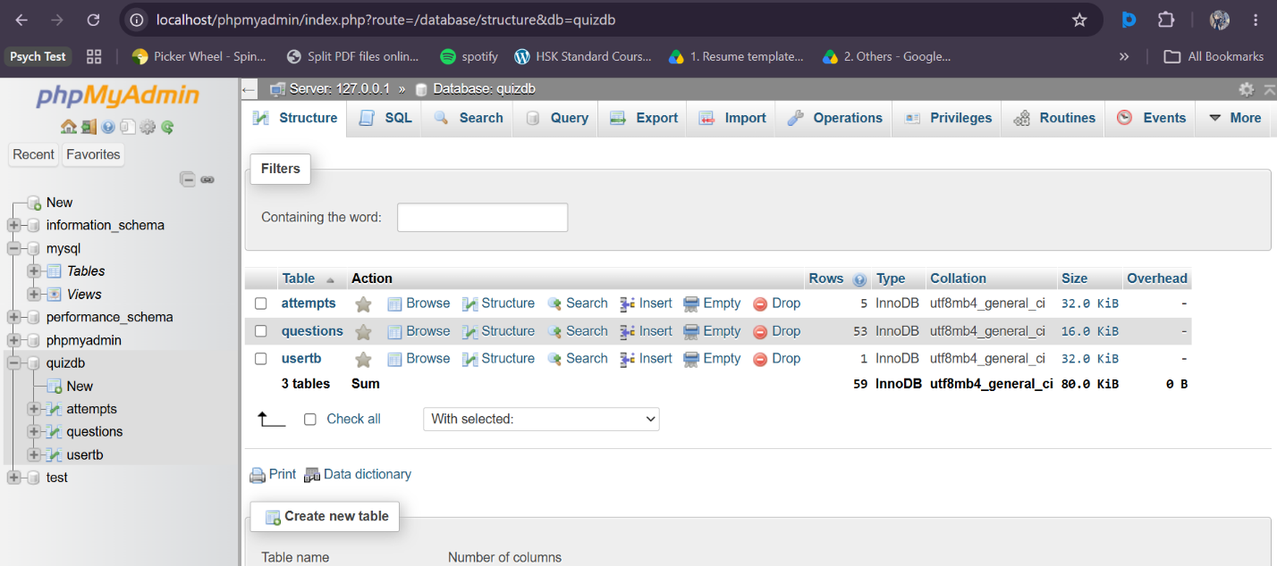
MySQL Database:

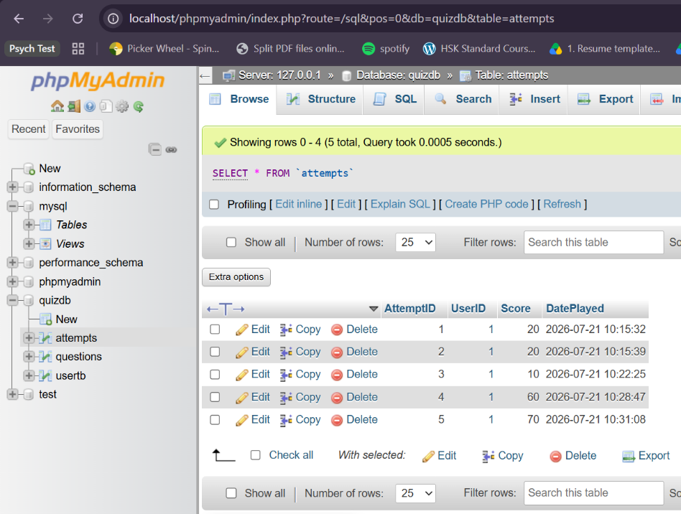
Tables:
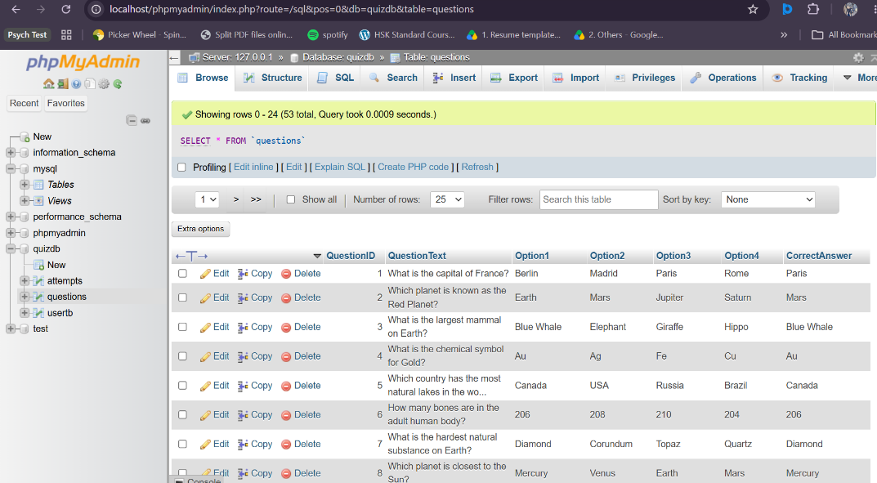
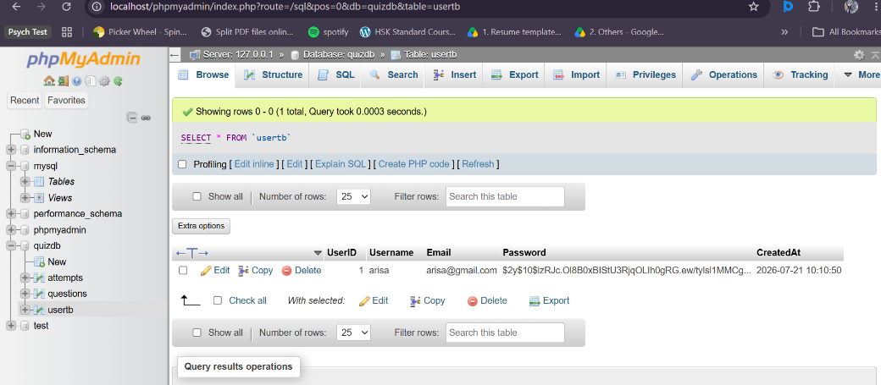

Dynamic website:
Index.php
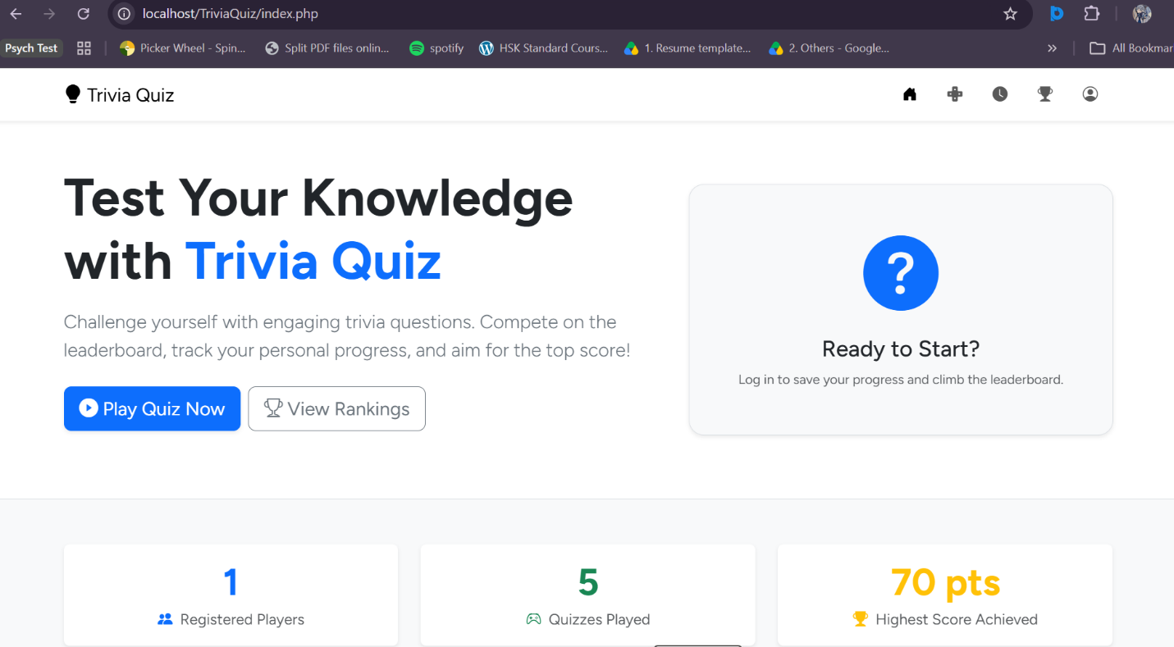
Quiz.php
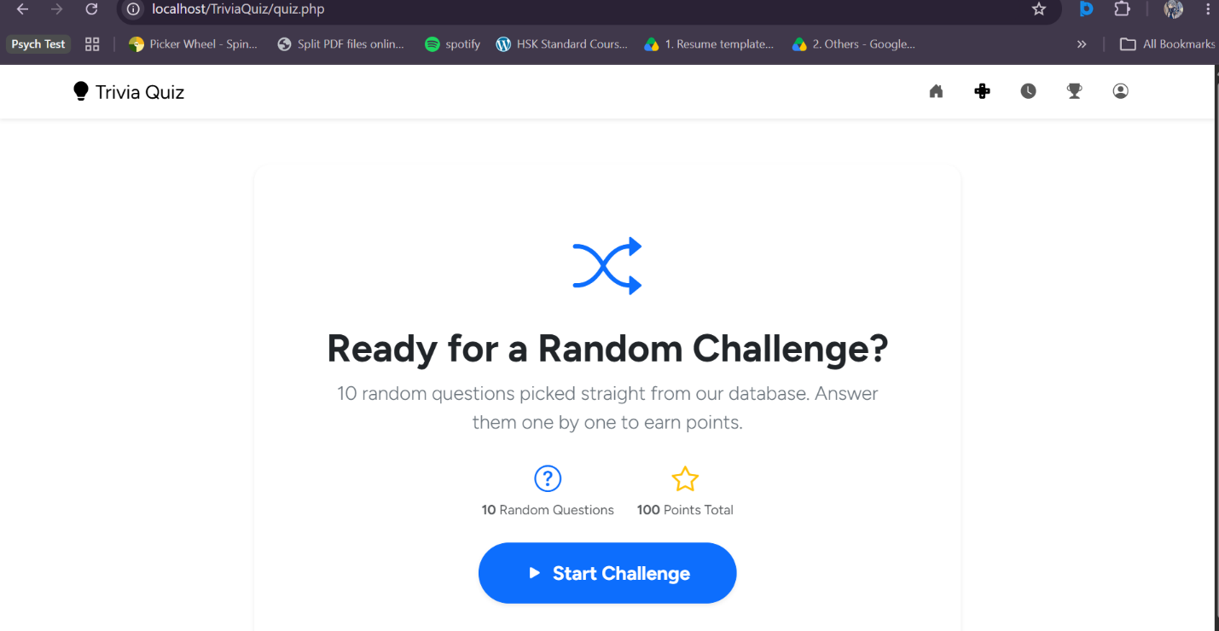
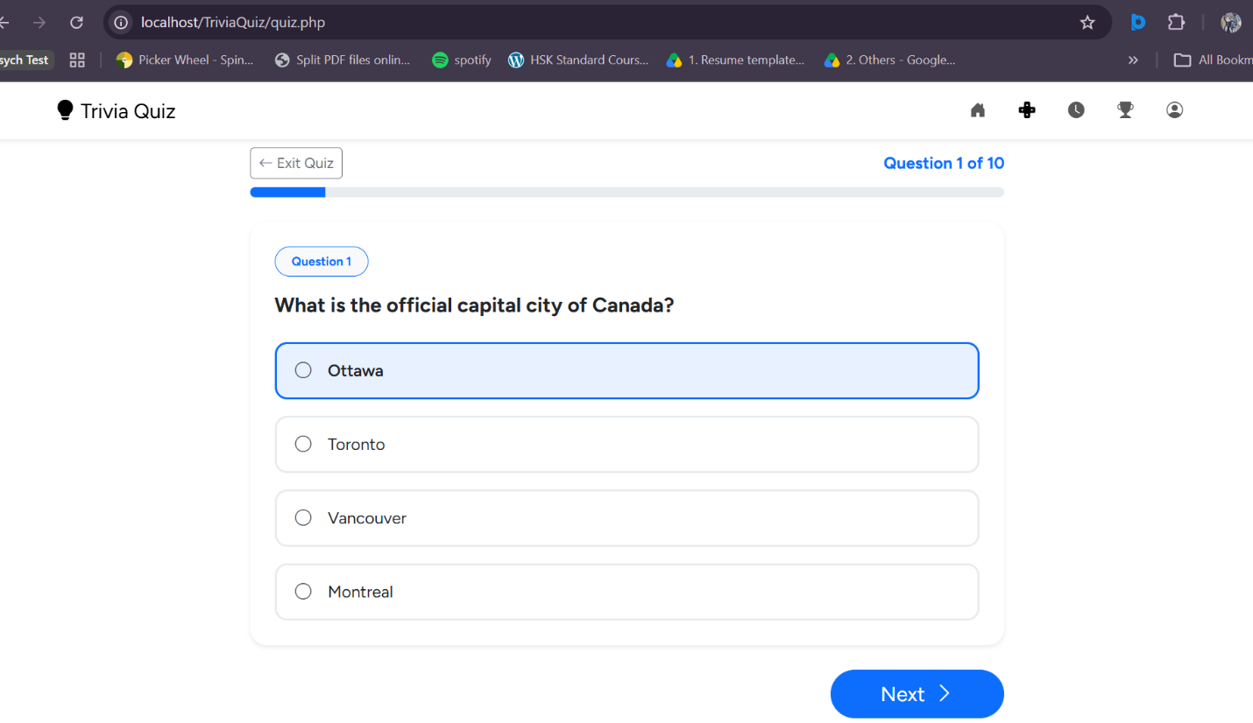
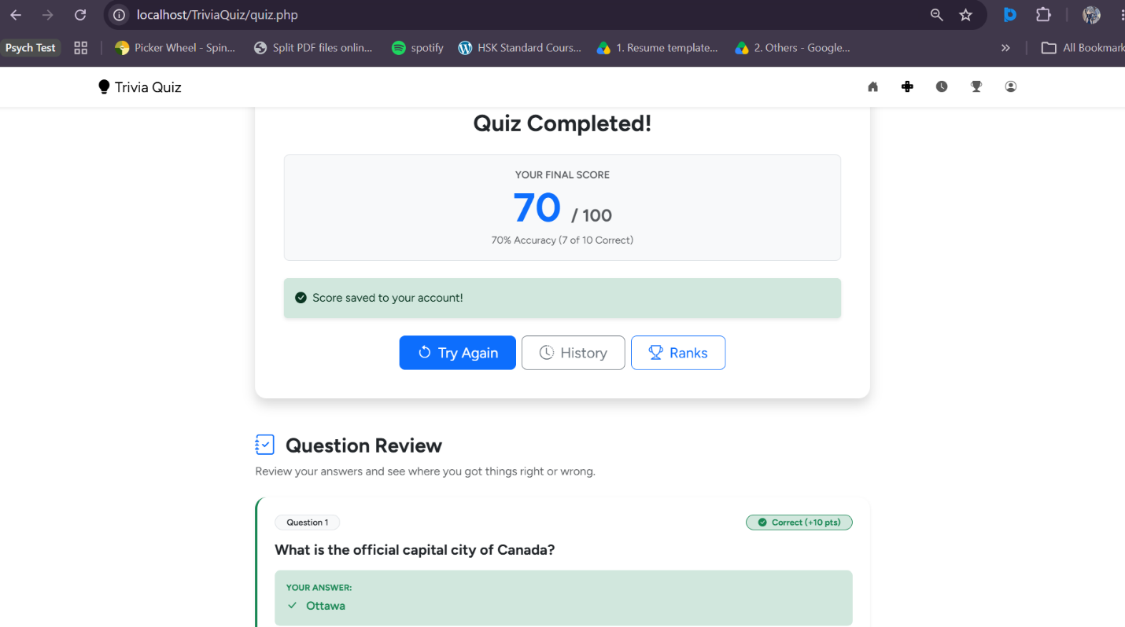

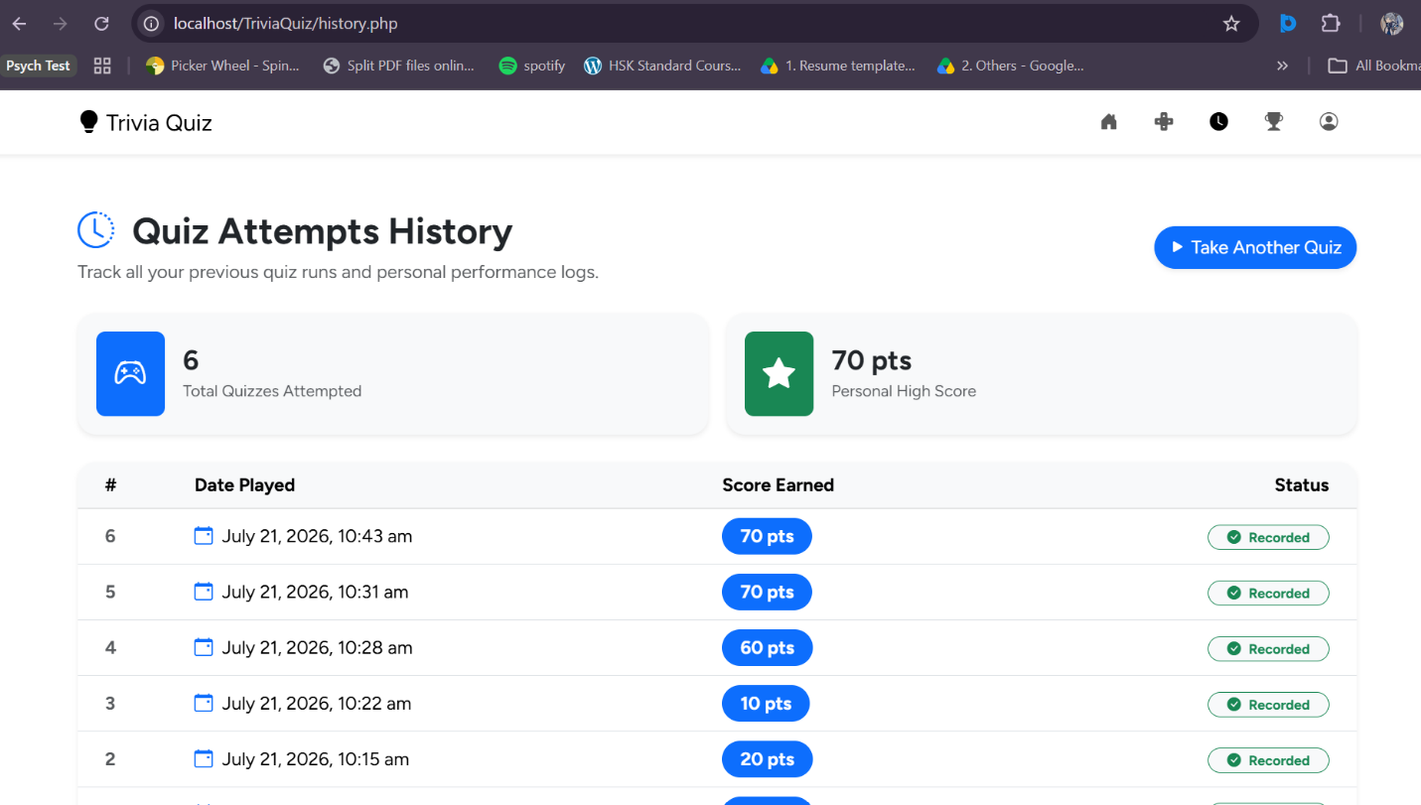
History.php

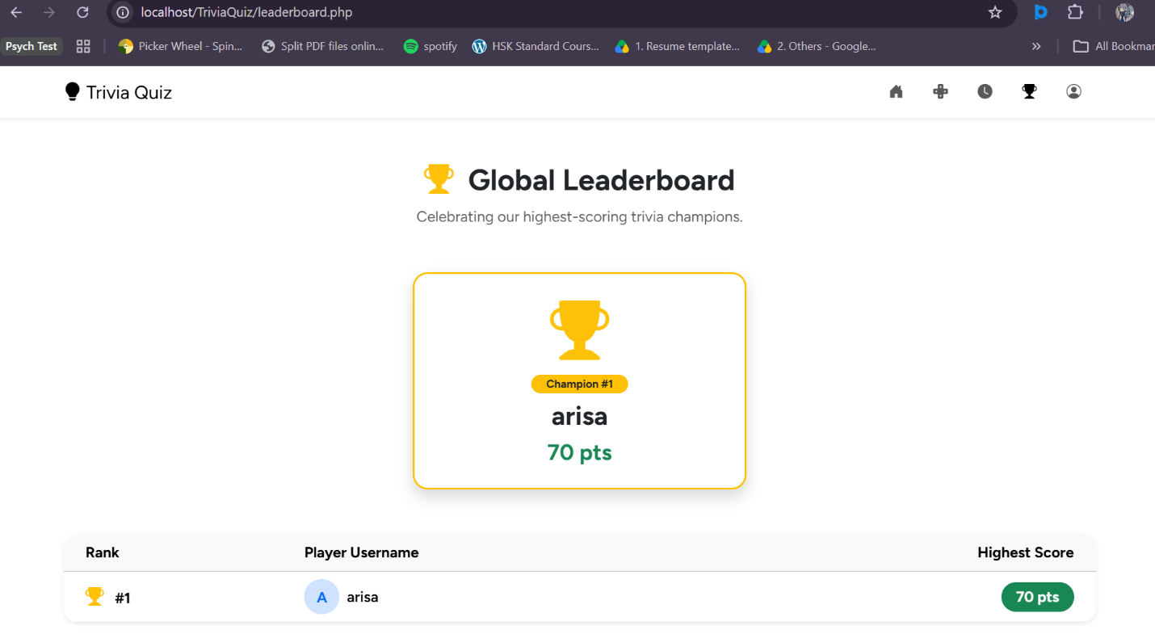
Leaderboard.php

Profile.php
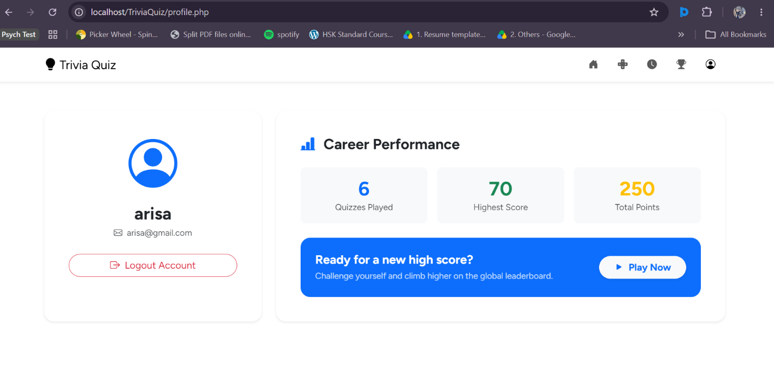
Logged in View

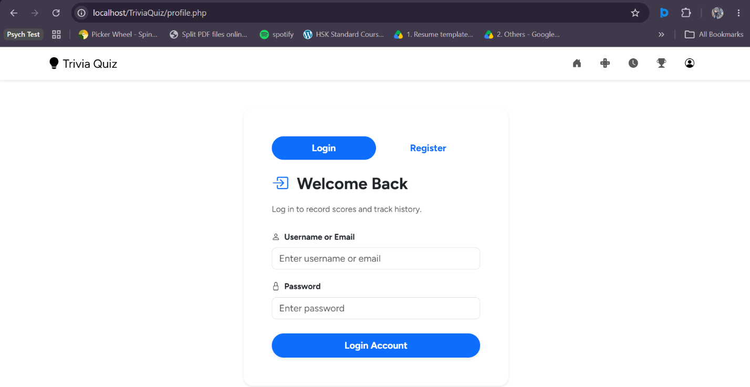
Logged out View

