SentinelOne and horizon-client.exe: Startup Analysis
Procmon capture of 2026-10-08, 08:49 to 08:50 | Host 1H86243478 | SentinelOne Agent 26.1.2.177 | Omnissa Horizon Client on .NET 8.0.31
Bottom line
SentinelOne is hooked into horizon-client.exe within the first 20 ms of the process, but that hook-in costs about 0.1 second. It does not explain the slow start.
63.1 of the 67.7 seconds (93%) the client runs in this capture are three identical 21-second TCP connection timeouts to the machine's own address. Nothing the SentinelOne agent does in user mode lines up with them. Whatever drops those connections works below what Procmon can see.
SentinelOne's kernel network callouts are the leading suspect, but this capture cannot prove it. The same three-stall pattern appeared on an earlier capture from what appears to be a different machine, which points to fleet policy rather than one bad endpoint.

1. What was captured
Item | Detail
Processes | horizon-client.exe (PID 14524, 44,892 events) and SentinelAgent.exe (PID 9204, 17,189 events)
Window | 08:49:19.387 to 08:50:33.092 (73.7 s). The client was active 08:49:22.736 to 08:50:30.473 (67.7 s).
Host and user | 1H86243478, user Vz7zh0. The earlier capture was from 1H8624348Q, so this appears to be a second machine.
Not captured | horizon-protocol.exe (the child process), the SentinelOne kernel drivers, svchost, System. The export has no Duration column, so per-operation latency cannot be measured.

2. Timeline
At | Event
-0.009 s | SentinelAgent.exe inspects horizon-client.exe (name query, open-by-ID with oplock, size and security queries). It finishes in 3.7 ms.
+0.020 s | SentinelOne's InProcessClient64.dll is opened inside the client, before ntdll.dll appears in the image-load log.
+0.067 s | InProcessClient64.dll is mapped as the fifth module, ahead of advapi32, user32 and shell32.
+0.089 to +0.119 s | It reads SentinelMonitor\Config\OnExecuteOff (not found) and InProcessClientsDir, then file-maps IdrApiMon64.dll. No image-load event is logged for that second DLL.
+0.145 s | Symantec DLP prntm64.dll loads (print-monitor hook).
+1.618 s | SentinelAgent.exe inspects horizon-protocol.exe, the child process. It finishes in 2.0 ms.
+2.23 s | Stall 1 begins. A connection to the machine's own address gets no answer.
+23.14 s | Agent sends 1,672 bytes to gk-east.srvs.usps.gov:8080 and receives about 9 KB back.
+23.18 s | Agent sets agentConnected=1, then re-reads its driver configuration (about 1,650 events over the next 1.7 s) and rewrites its logging-session registry values.
+23.26 s | Stall 1 ends after 21.0 s. The client immediately opens a loopback connection that succeeds.
+31.3 s | Agent runs a software-inventory scan (5,795 registry events in 2 s).
+44.31 s, +65.33 s | Stalls 2 and 3 end after 21.0 s each, each followed by a successful loopback connection.
+65.87 s | Eracent EPM hook DLL loads, 0.54 s after the last stall.
+67.74 s | Capture ends while WPF libraries are still loading.
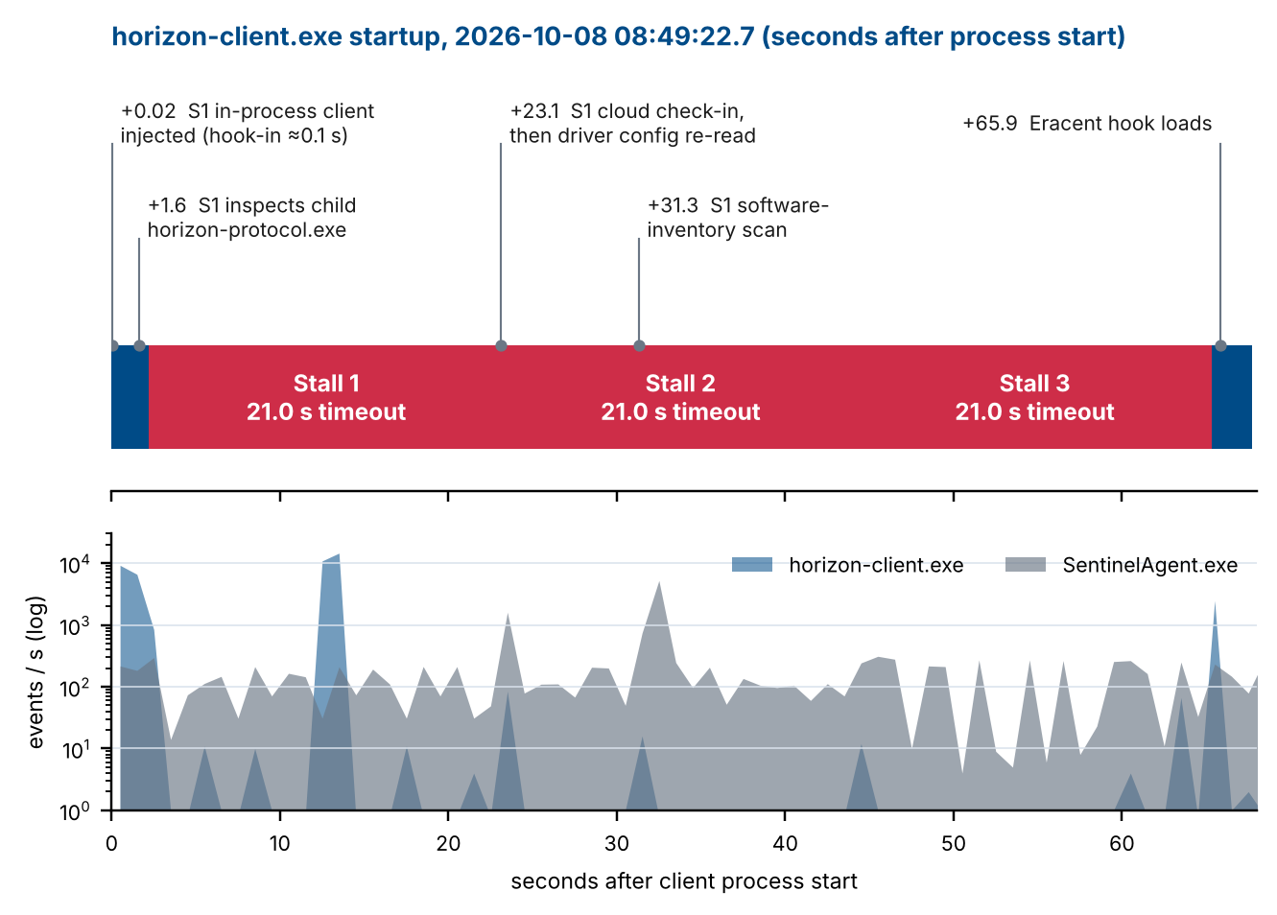
Times are seconds after the client process started (08:49:22.7356). The blue bars are normal startup work: 2.2 s before the first stall and 2.4 s after the last one.

3. Where SentinelOne hooks into the client
- Pre-launch inspection. The agent inspects the executable 9 ms before the process-start event and the child horizon-protocol.exe the same way when it launches. The inspections take 3.7 ms and 2.0 ms.
- In-process client. InProcessClient64.dll is loaded into the client at +0.020 s to +0.067 s. Its position ahead of the normal Windows DLLs is consistent with kernel-assisted early injection, though Procmon cannot show the injection mechanism itself.
- API monitor. After reading its driver configuration, it maps IdrApiMon64.dll (+0.114 s). The logged mapping calls and the absence of a load event suggest the in-process client maps it itself. That is an inference.
- Total cost. Everything SentinelOne does inside the client lasts from +0.020 s to +0.119 s, about 0.1 s (0.15% of the run). The client has 31 early SentinelOne-related events in total.
Two things SentinelOne does not do in this capture. It never touches the client's own files: there are zero agent events on horizon-client.profile or the client's logs, even though the client writes 25,451 times to the profile in 1.67 s. And no agent event references the stalled ports (57895 to 57917).

4. SentinelOne's network settings, as read by the agent
At +23.2 s the agent re-read its kernel driver configuration. These are the values that bear on network behavior:
Setting | Value | What it means (my reading)
NetMon\NetworkConnectionInterceptorEnabled | 1 | SentinelOne's connection-interception callout is on.
NetMon\NetworkConnectionTrackerEnabled, ...IdAssignerEnabled | 1, 1 | Every TCP connection is tracked and tagged.
NetMon\NetworkDnsInterceptorEnabled, DnsSnifferEnabled | 1, 1 | DNS traffic is inspected.
NetMon\WfpNetworkInspectionFeaturesEnabled | 1 | Network features built on the Windows Filtering Platform are active.
NetMon\NetworkInspectionEnabled | 0 | Deep content inspection is off.
Sentinel Labs\State\networkQuarantined | 0 | The agent is not in network quarantine. That rules out the "disconnect from network" action.
ReportFirewallBlockedPackets, ...PermittedPackets | 0, 0 | The agent is not reporting firewall decisions, so its console may show nothing even if a firewall control dropped packets.
ProcessBlockTimeout, IdrProcessBlockTimeout | 500, 500 | The agent can hold a process launch for at most 0.5 s.
PropagateInjectionExclusionToDescendants | 0 | An injection exclusion on a parent process would not automatically cover its child processes.
These are common agent defaults, so they show that SentinelOne has network callouts in the path. They do not show that those callouts dropped anything.

5. The stalls
Stall | SYN sent | Gave up | Wait | What followed
1 | +2.23 s | +23.26 s | 21.0 s | Loopback view-localhost 57904 to 57903 connected in under 1 ms.
2 | +23.27 s | +44.31 s | 21.0 s | Loopback 57915 to 57914 connected; a 1-byte message was exchanged.
3 | +44.32 s | +65.33 s | 21.0 s | Loopback 57922 to 57921 connected; a 1-byte message was exchanged.

All three attempts follow the same schedule: the SYN is retransmitted at +1, +3, +7 and +15 seconds, and the connection is abandoned at +21. That matches the usual Windows connect timeout, so nobody has tuned it. Each attempt goes from the machine's own FQDN address to itself (1H86243478.usa.dce.usps.gov), never to 127.0.0.1. Procmon logs only the retransmits and the final disconnect, so the SYN times in the table are inferred from that schedule.
The 21-second wait is a timeout, not a refusal. A missing listener would produce an instant reset, and a Windows Filtering Platform block at the outbound connect layer normally fails immediately too. A silent timeout usually means the SYN was discarded on the inbound side or lower in the stack. SentinelOne's agent process cannot show you that, because the drop happens in kernel drivers.
Correction to my earlier reading: this capture covers only two processes, so a TCP accept in another process would not appear. "No accept was logged" is therefore weaker evidence than I stated. The consecutive port numbers (57893 to 57896 allocated within a millisecond) suggest the listener is in the client itself, but I cannot confirm that.

6. Is SentinelOne's agent activity delaying anything?
Agent activity during the stalls falls into three groups. None of it lines up with a stall starting or ending.
- Constant background. About 15 probes a second for a file named c (never found) and 1,486 touches of devcon.exe under drivers\UMDF\WWAN\IntelFlashService. The rate is the same before the client launched and while it ran.
- Cloud check-in at +23.1 s. Stall 1 ended 74 ms after the exchange finished, which looks suspicious. But stalls 2 and 3 ended without any agent activity, and all three lasted the same 21.0 s. A fixed duration points to a timer expiring, not to the agent releasing the connection.
- Software inventory at +31.3 s. It happened in the middle of stall 2 while the client was idle, so it cannot have delayed it.

7. Where the time went and what could be dropping the traffic
Component | Time | Basis
Three self-address connection timeouts | 63.1 s (93%) | Measured, SYN schedule in the trace
Normal startup and UI loading, before and after the stalls | 4.6 s (7%) | Measured
SentinelOne in-process hook-in (inside the figure above) | 0.1 s (0.15%) | Measured, +0.020 to +0.119 s
Profile file writes, concurrent with stall 1 | 1.67 s (off the critical path) | Measured

Likely candidates for whatever drops the connections. These percentages are my judgment, not measurements:
Candidate | Estimate | Reason
SentinelOne kernel network callouts | 35% | Present and enabled in the connection path; the only product whose settings we saw
Another third-party WFP driver (VPN or ZTNA client, NAC, packet filter) | 15% | Any callout can discard traffic silently
Explicit Windows Firewall block rule or policy | 15% | Windows normally treats a machine's traffic to its own address as loopback and passes it, so an explicit rule fits better than a default-deny
Symantec DLP network filter | 10% | Only its print hook was seen in the process
Odd address or routing for the machine's own name | 10% | Source and destination show the same host name, so the address looks local
Unknown | 15% | Not visible in this capture

8. How to confirm, in order
- Read the client's own log for this run. C:\Users\Vz7zh0\AppData\Local\Omnissa\Horizon\logs\omnissa-horizon-client-2026-10-08-084923-14524.txt was being written at +2.2 s, just before the first stall. Lines around that time should name the address and purpose of the connection. The horizon-crtbora-14524.log file in %TEMP%\omnissa-VZ7ZH0\ may help too.
- Test whether the drop is machine-wide: run Resolve-HorizonClientLoopbackStall.ps1 -Diagnose. Its self-address probe shows whether PowerShell, which is not the client, also times out when connecting to this machine's own address. A timeout means the drop is machine-wide. Success points to a per-process rule, such as a SentinelOne process policy.
- Name the dropping filter: run Trace-HorizonClientPorts.ps1 elevated. It records Filtering Platform drop events during a launch and names the filter and provider that dropped each packet. If it reports blocked attempts with no logged drop, the drop happened below what Windows can log.
- Ask the SOC for a pilot exclusion. Request a process-scoped interoperability exclusion for both horizon-client.exe and horizon-protocol.exe. The setting PropagateInjectionExclusionToDescendants=0 suggests a parent exclusion will not cover the child. Also ask them to check the console for network or firewall-control events on this host between 08:49:25 and 08:50:28 on 2026-10-08. Retime the launch afterwards.
- Re-capture Procmon unfiltered. Add the Duration column and include horizon-protocol.exe, svchost and System. That shows whether any process accepts on the stalled ports and where the time goes in drivers.
- Open an Omnissa case. Ask why the client connects to the machine's own FQDN address at startup, why it waits the full 21 seconds on each of three attempts before falling back, and whether that is configurable.

9. Limits of this analysis
- The capture is filtered to two user-mode processes. Kernel drivers (SentinelMonitor, WFP callouts, Symantec and Eracent filters) are invisible, so no component is proven to be the dropper.
- Registry values are read from agent requests in the trace. I interpret their names; I have not checked them against SentinelOne documentation, and the console policy is the authority.
- One capture on one machine, plus an earlier capture on another. Both show the same three-stall pattern, but neither included drop-level data.

