Why horizon-client.exe Is Slow to Open: Client Log Analysis
Omnissa Horizon Client 8.14.0 (build 12437220870, .NET runtime 8.0.31) | Client logs from 2026-10-06 14:17 (PID 4460) and 2026-10-08 08:49 (PID 14524)
Bottom line
Both client logs show the same thing. Between the last SDK setup line (Set local language as en-us) and UDPProxy_Initialize, the client's main thread writes nothing for 63.2 s on 2026-10-06 and 63.1 s on 2026-10-08.
The main window object loads in about 1 second, but the server list does not appear until about 65 seconds. During the gap the client has not contacted any Connection Server, so the delay is local to the endpoint, not a server or network login problem.
On 2026-10-08 the log lines up with the Procmon capture to within 32 ms: the gap is the three 21-second timeouts of the client's connections to its own address. The log adds where it happens, inside the SDK's Platform::Init startup, before the UDP proxy starts.
The log cannot say what drops those connections. That is still a kernel-level filter on the endpoint.

1. What the logs show
Event | 2026-10-06 (PID 4460) | 2026-10-08 (PID 14524)
Process start | 14:17:04.062 | 08:49:22.725
Main window loaded | +0.9 s | +1.3 s
Last SDK setup line (Set local language) | +1.34 s | +2.23 s
UDPProxy_Initialize logged | +64.51 s | +65.38 s
Gap between those two lines | 63.17 s | 63.14 s
StartServices, then ServersView shown | +64.5 s, then +64.65 s | +65.4 s, then +65.64 s
Decoder probe finished (worker thread) | +13.5 s | +31.6 s
Decoders found | H264, AV1 | H264, HEVC (4:4:4, 4:2:0, HDR), AV1
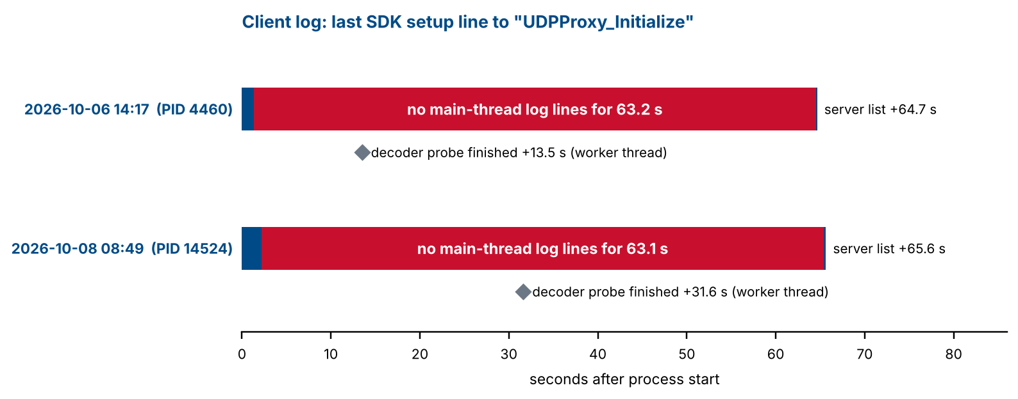
Every log line in the gap region comes from other threads (decoder probing on thread 03). Thread 01, the main thread, is silent. The 10-second logging-policy task is scheduled only after the gap, and the auto-update service is not logged at all during startup, so neither is involved.

2. How the log fits the Procmon capture
Log line, 2026-10-08 | Procmon, same run | Match
08:49:24.959 Set local language as en-us (last setup line) | First self-address connection attempt begins at about 24.97 (inferred) | Gap starts here
08:50:28.102 UDPProxy_Initialize and CdkConnection_SetLoopbackPort: 57905 | Third 21-second timeout ends at 08:50:28.070 | Log line follows by 32 ms
63.14 s between the two lines | 3 x 21.0 s = 63.1 s of TCP timeouts | Same length
08:49:24.897 Failed to retrieve the list of queues (error) | 0.50 s with no client file activity before the same line is written | Same moment

The log therefore places the stall in the client's startup code, after SDK setup and before the UDP proxy and its loopback port are published. The three stalled TCP connections in the Procmon trace are what the client is doing during those 63 seconds.

3. What the log rules out
- Connection Server, login and network path. The client has no server connection yet. The 2026-10-06 log says so directly at shutdown, and OnServerLoggedOut appears only after the gap.
- Decoder probing. It runs on a worker thread and finishes at +13.5 s and +31.6 s, long before the main thread resumes. It is slower on the second machine (29.4 s versus 12.1 s from the last setup line), probably because it tests more codecs, but it is not on the critical path.
- Logging policy and auto-update. The logging policy is applied after the gap, and the auto-update service is not logged during startup.
- The profile file and registry. The Procmon capture already showed these are short (about 1.7 s of profile writes) and run while the main thread is blocked.

4. Other things in the logs
- `Init HznProtect failed` (error) in both runs, logged within 1 ms of UDPProxy_Initialize, so after the delay. I found no public documentation for HznProtect, so I cannot say what it protects or whether its failure is harmless. It appears on both machines, so it is probably environmental rather than a one-off.
- A 0.5-second extra wait on 2026-10-08 only. The client appears to launch horizon-protocol.exe (the log calls it the PartnerAppMgr service) and then waits 0.51 s before logging Failed to retrieve the list of queues. On 2026-10-06 the same step took 13 ms and reported 0 queues. SentinelOne's agent settings include a 500 ms process-block timeout, which is a coincidence worth testing but not evidence. This wait adds about half a second, not a minute.
- `DriveWatcherImpl::Cleanup: Hidden window thread not started` appears at shutdown in the 2026-10-06 log (the other log ends before shutdown). It is unrelated to startup.

5. What to do next
- Name the component dropping the connections. On an affected machine, run Resolve-HorizonClientLoopbackStall.ps1 -Diagnose and then Trace-HorizonClientPorts.ps1 elevated. The second names the filter and provider that dropped each packet.
- Ask the SOC for a pilot exclusion for both executables. Request a process-scoped interoperability exclusion for horizon-client.exe and horizon-protocol.exe, and a check of the SentinelOne console for network events on the affected host during the window. Retime the launch afterwards.
- Get a log from a machine that starts quickly. If its gap between Set local language and UDPProxy_Initialize is a second or two, compare its security agent policy and firewall configuration with the slow machines.
- Open an Omnissa case with both logs and the Procmon capture. Ask why startup makes three 21-second connection attempts to the machine's own address before the UDP proxy initializes, whether a setting avoids it, and what the Init HznProtect failed error means.

6. Limits
- The logs are at INFO level and do not say what the client is connecting to. A debug-level client log or a vendor build with extra tracing would.
- Only the 2026-10-08 run has a matching Procmon capture. For 2026-10-06 the link rests on the identical 63-second gap, not on direct evidence.
- I do not know which machine produced the 2026-10-06 log. The decoder results suggest different hardware from the 2026-10-08 machine.

