- Install the package
- Put gmcs.rsp and smcs.rsp in root
- Put „InputSettings.xml“ in root StreamingAssets folder from package StreamingAssets folder if you want to hit play on test demo
- Connect your devices
- Open Window-InputMapper editor
- Drag AnimatorController or create custom states
- Map your input into combination by clicking buttons or moving joysticks.(single,double,long action)
- Save your settings as .xml (States.cs would be generated for you so you can access your states as States.MyState)
- Load your .xml
InputManager.loadSettings(Path.Combine(Application.streamingAssetsPath,"InputSettings.xml"));
- Add manual mappings(optional)

InputManager.MapStateToInput("Click_W+C_State", KeyCodeExtension.W.DOUBLE,KeyCodeExtension.C.LONG);

- Check if the state is triggered
if (InputManager.GetInputDown((int)States.Wave))
{
Debug.Log("Wave Down");
animator.Play((int)States.Wave);
}

if (InputManager.GetInputUp((int)States.MyCustomState))
{
Debug.Log(States.MyCustomState + "-Up");
// animator.Play((int)States.Wave);
}

Use InputManager.GetInput for combo inputs:

bool atOnce = false;

//atOnce (default=false)
//Function returns true when combination pressed in row If set to true function return true
//when all keys/buttons in combination are pressed.
bool bCombo = (InputManager.GetInput((int)States.Click_W+C_State, atOnce
));

//using input as digital (similar to Input.GetKey)
bool bHold = (InputManager.GetInput((int)States.Walk_Forward, false));

//using same input as analog value (similar to Input.GetAxis)
float analogValue = InputManager.GetInput((int)States.Walk_Forward, false, 0.3f, 0.1f, 0f);

- Or register event handler and wait event to happen

ev.INPUT += new EventHandler(Handle1);
ev.INPUT += new EventHandler(Handle2);
ev.UP += new EventHandler(onUp);//this wouldn't fire for combo inputs(single only)
ev.DOWN += new EventHandler(onDown);//this wouldn't fire for combo inputs(single only)

void onUp(object o, EventArgs args)
{
Debug.Log("Up");
}

void onDown(object o, EventArgs args)
{
Debug.Log("Down");
}

void Handle1(object o, EventArgs args)
{
Debug.Log("Handle1");
}

void Handle2(object o, EventArgs args)
{
Debug.Log("Handle2");
}

- Write custom device driver on high level (see XinputDriver.cs,WiimoteDriver.cs,ThrustMasterDriver.cs in source) and add it to the manger.

InputManager.AddDriver(new XInputDriver());

Still hard to understand? Go watch and read on bellow links.
https://www.youtube.com/watch?v=kX0j69ZgeCw

GITHUB: https://github.com/winalex/Unity3d-InputMapper

WiiDriver Demo
https://www.youtube.com/watch?v=tEwMcA2ZaMk

ThrustMasterDriver Demo (Win+Droid+Osx)
https://www.youtube.com/watch?v=uoH-RfopGzk

Web Player demo(thru Gamepad API):
https://www.youtube.com/watch?v=sXMWmn4Kc9c
MORE:
http://unity3de.blogspot.com/2014/06/unity-input-manger-pain-is-spreading.html

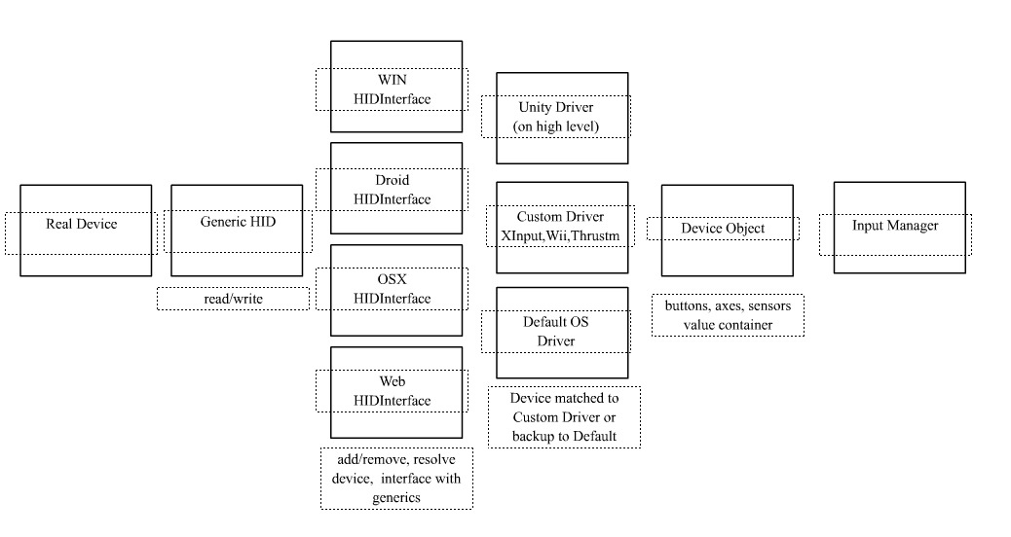

Feel free to contact me with your contribution, bugs reports, idea....
winxalex@gmail.com

