### 电子制作初学者工具合集

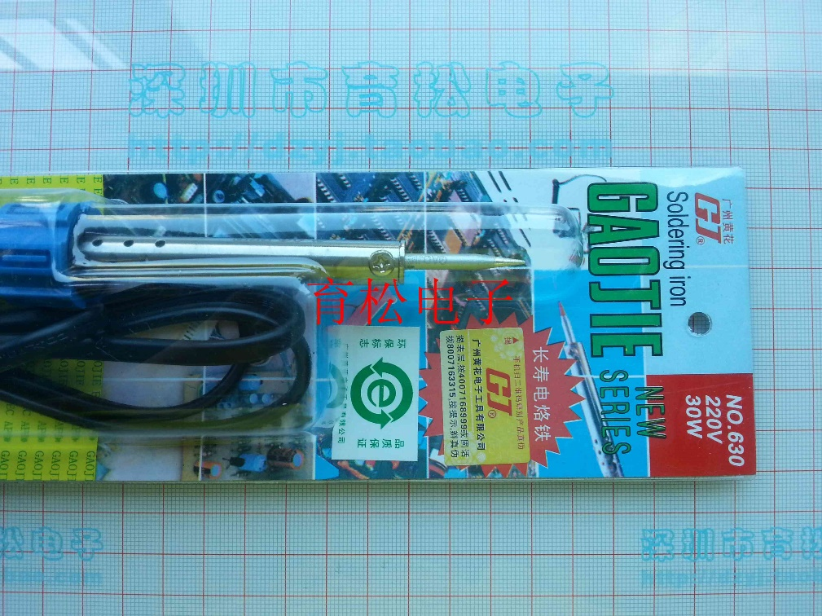

电烙铁套件

<http://meal.taobao.com/mealDetail.htm?spm=2013.1.1000371.d9.V1GuJ2&meal_id=362505211&item_num_id=1927831389&seller_id=44390641>

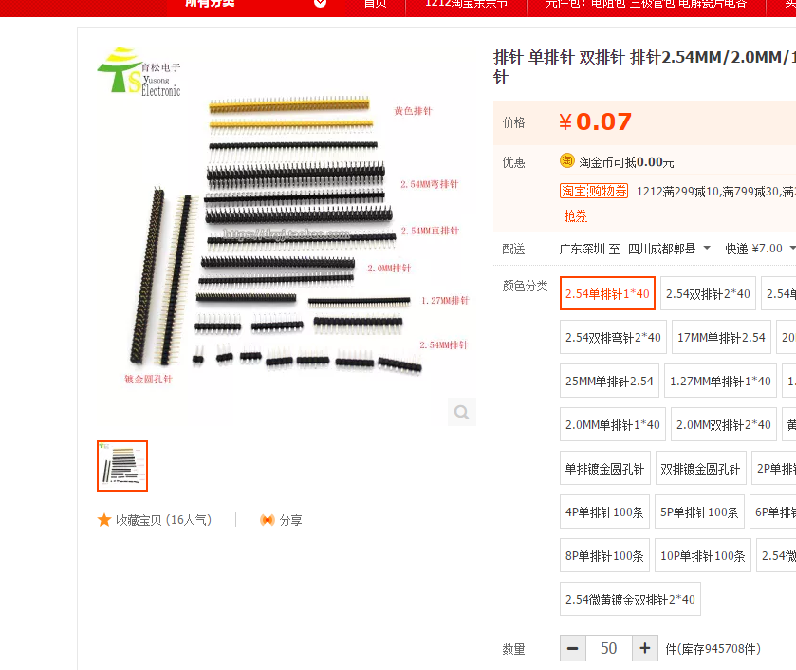

2.54 单排插针 50份

<https://item.taobao.com/item.htm?spm=a1z10.3-c-s.w4002-14787471870.10.PXMJFP&id=542264693806>

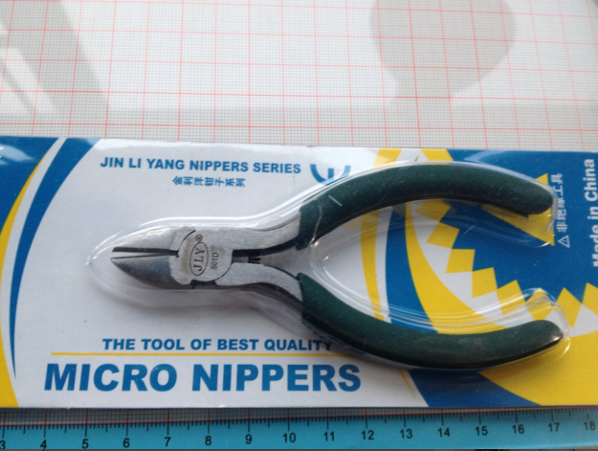

斜口钳

<https://item.taobao.com/item.htm?spm=a1z10.3-c-s.w4002-14787471870.10.SsPs7M&id=178522467>

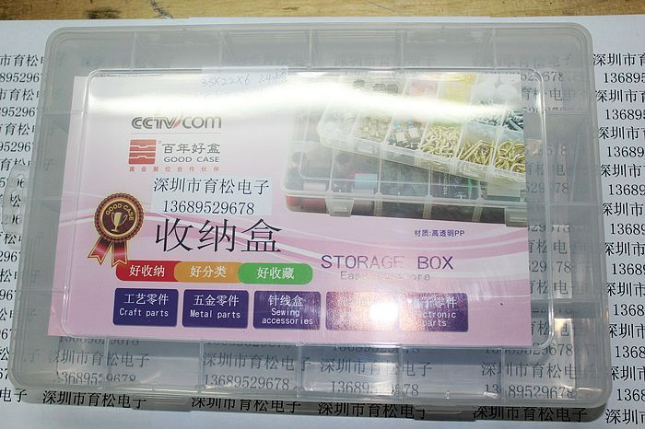

元件盒

<https://item.taobao.com/item.htm?spm=a1z10.5-c-s.w4002-14787471864.14.W1eRSO&id=13908437965>

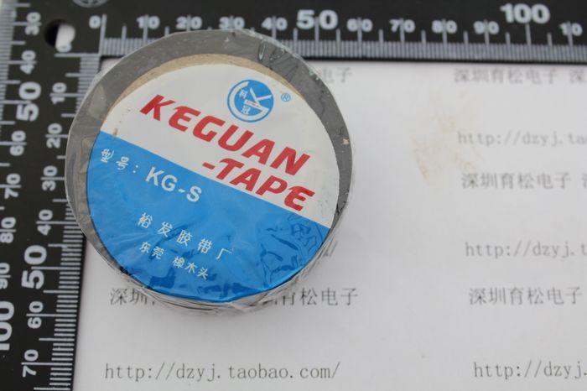

电工胶布

<https://item.taobao.com/item.htm?spm=a1z10.5-c-s.w4002-14787471864.12.RspSri&id=178523141>

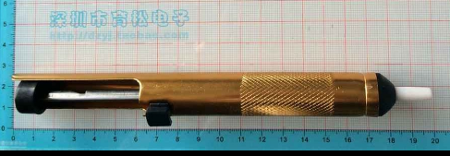

吸锡器

<https://item.taobao.com/item.htm?spm=a1z10.5-c-s.w4002-14787471864.14.sjT5ib&id=9950699849>

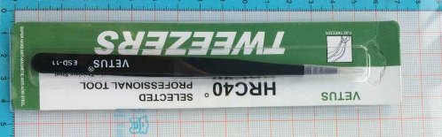

镊子

https://item.taobao.com/item.htm?spm=a1z10.5-c-s.w4002-14787471864.16.kf14Yg&id=521869900427