Sprint 4
UML DIAGRAMS

1. Logical View: Class diagram

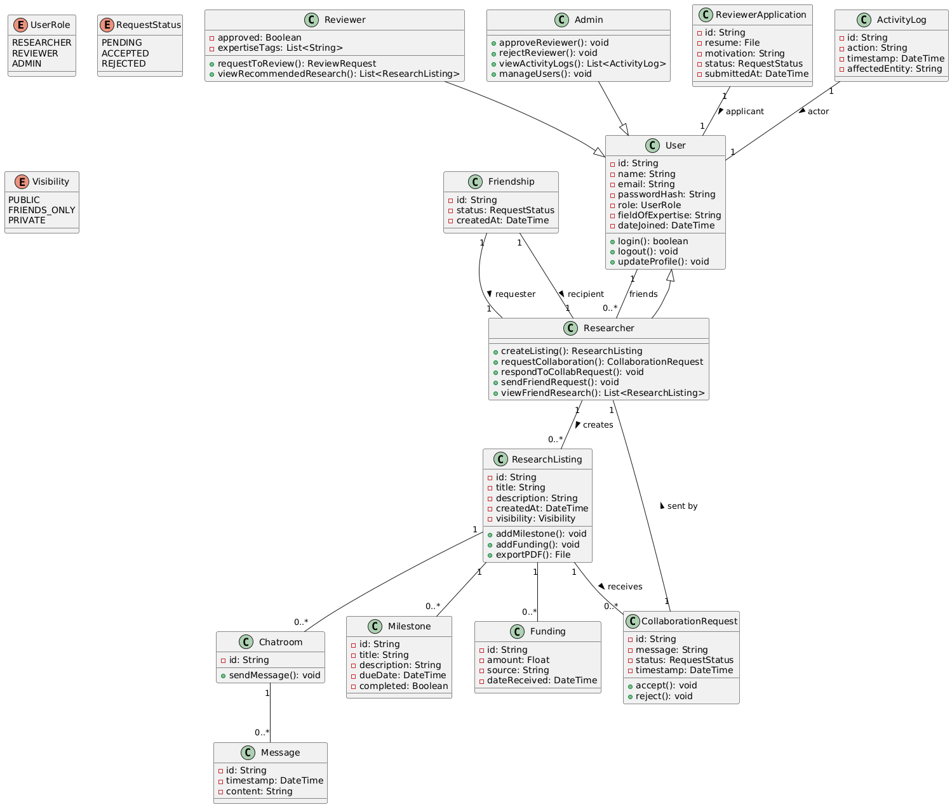

2. Implementation View: component diagram

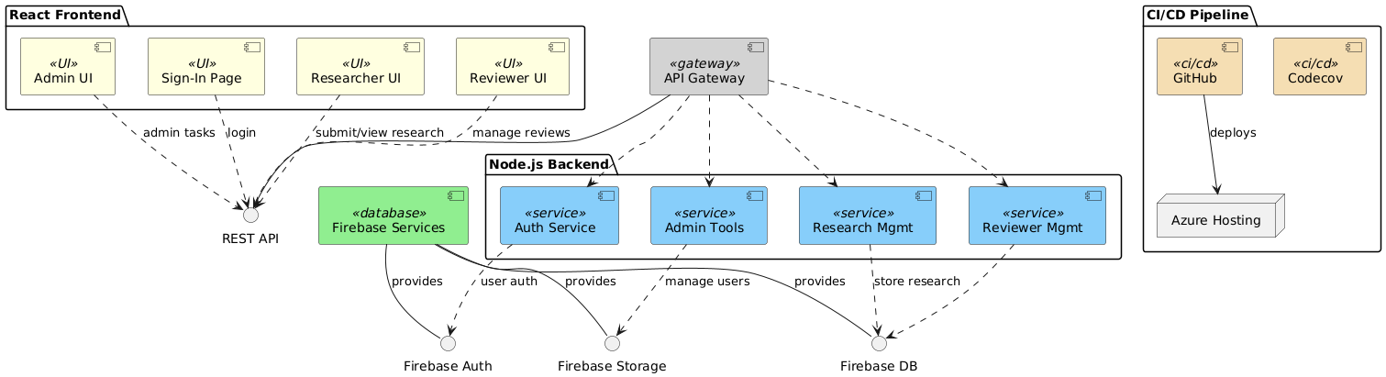
3. Use Case View: use case diagram
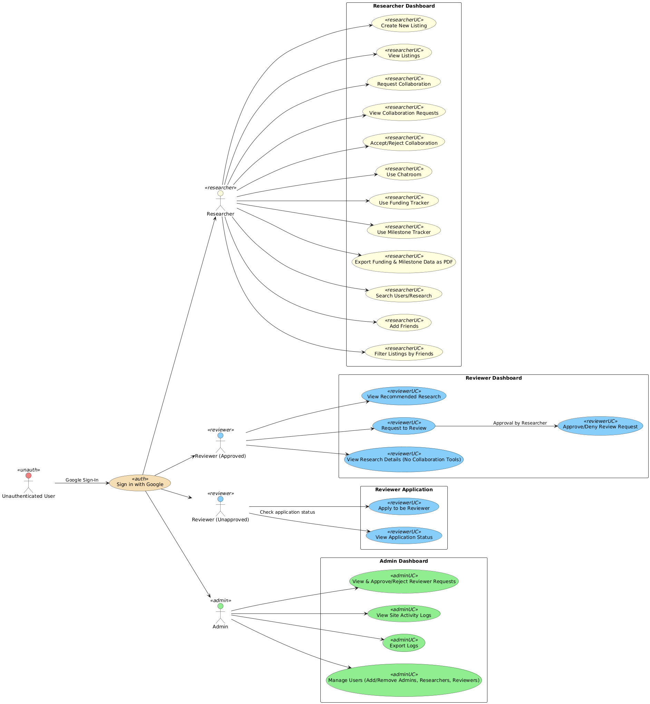
4. Process View: sequence diagrams for researcher, reviewer and admin

Researcher
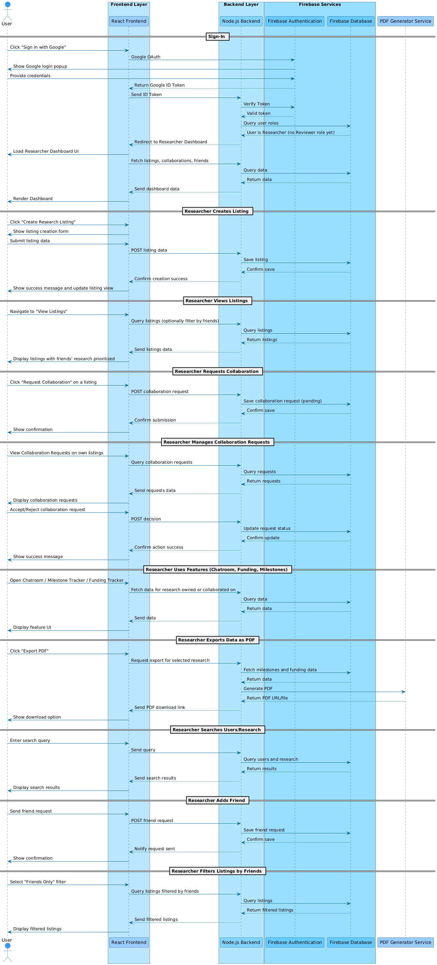

Reviewer(unapproved)
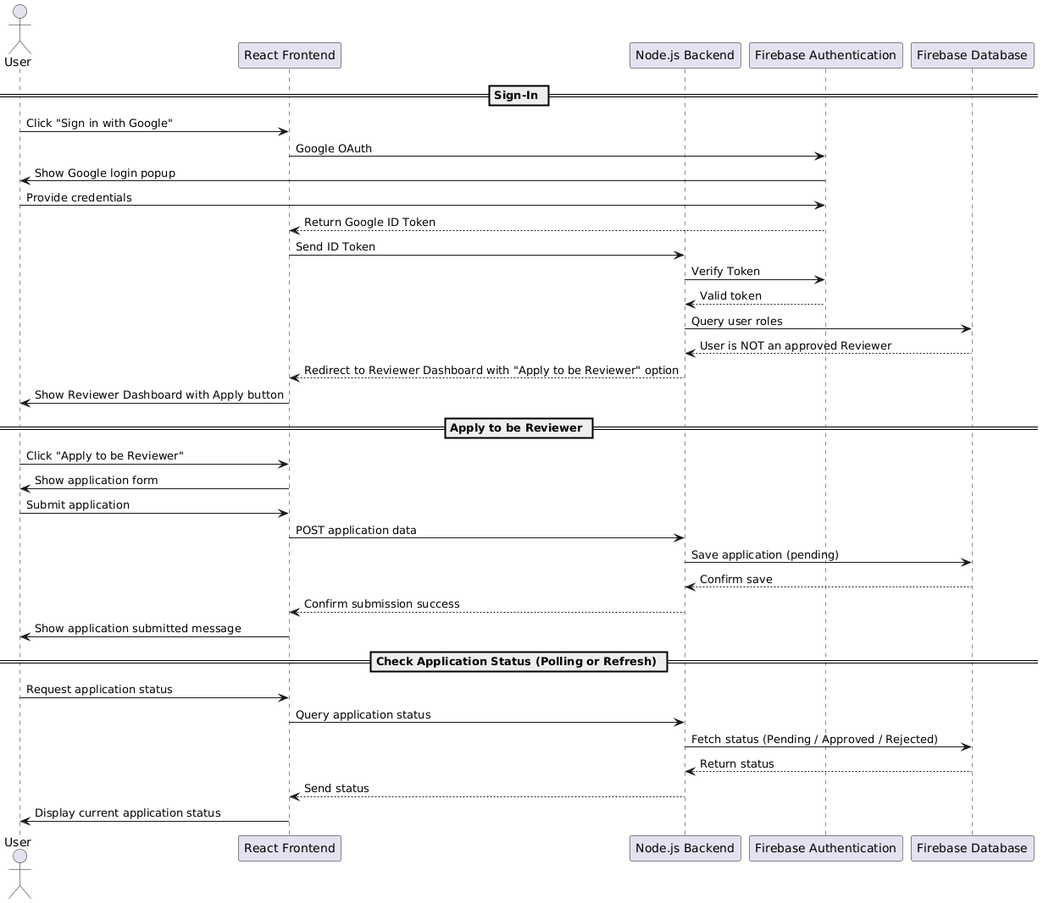

Reviewer(approved)
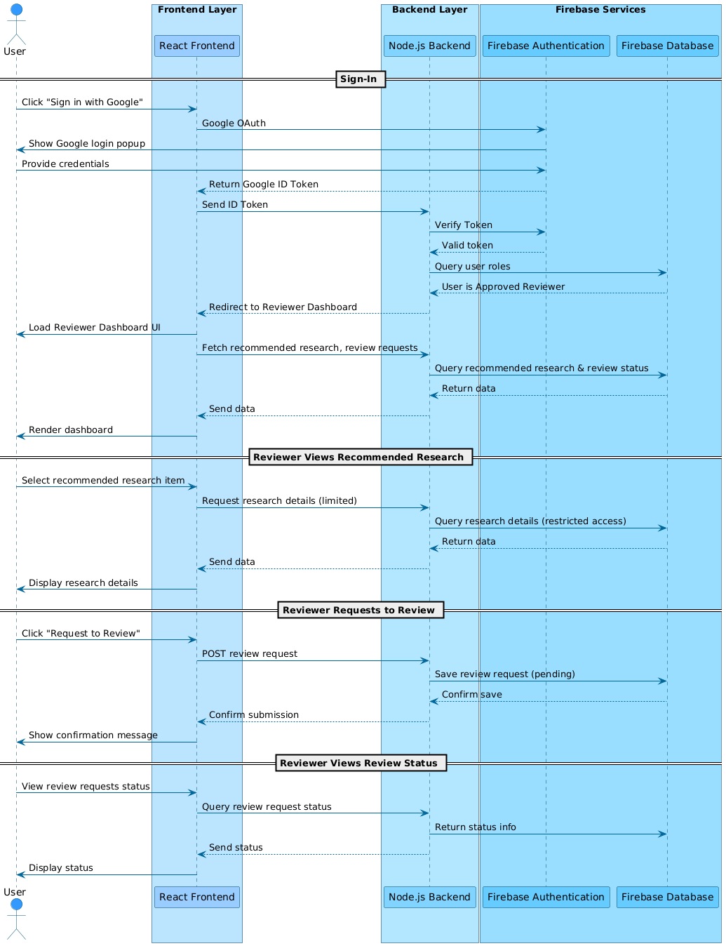

Admin

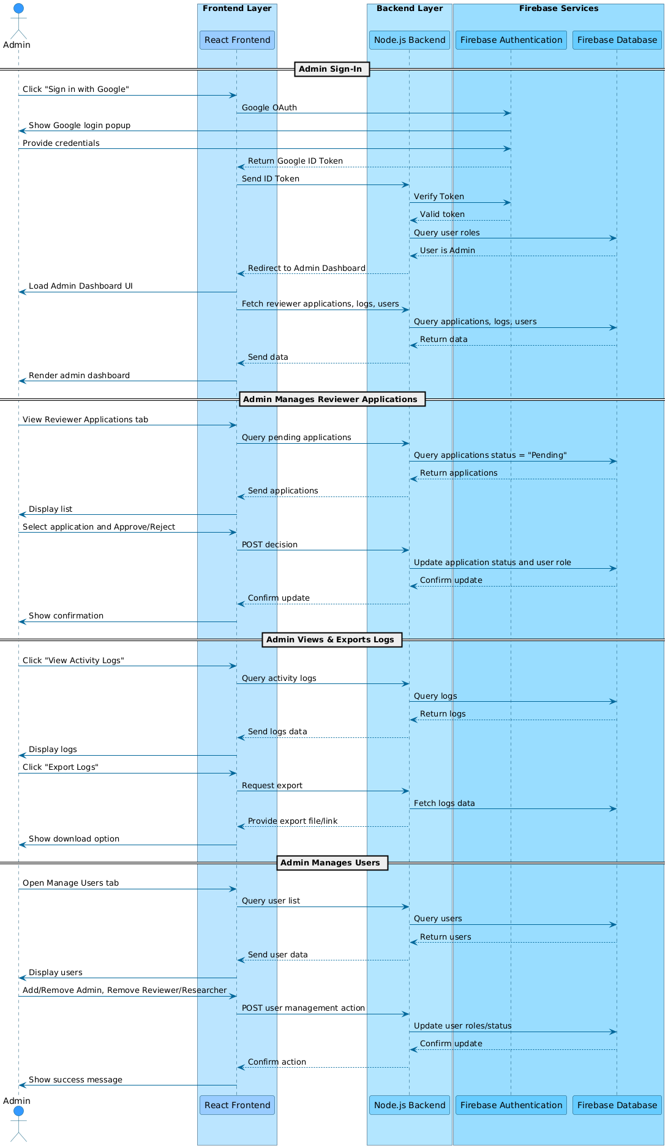
5. Deployment View: deployment diagram
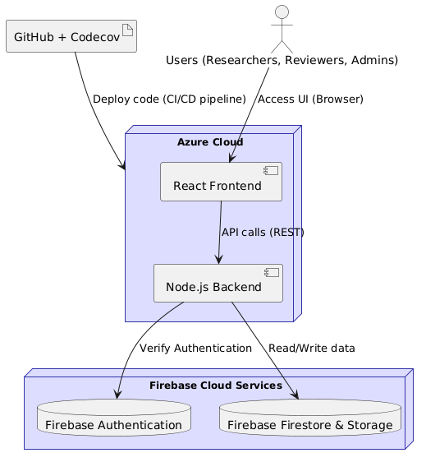

USER STORIES

