XXI. volume. .

, 9 2s. Wideroc, A new Prinz1p to production higher tensions, 387

=====-========---- ··- ·--- -

**Above a new principle to production higher tensions** 1st

From

**Rolf forest,** Berlin.

1. Introduction.
2. The equations of motion des electron.
3. kinetics voltage transformation with potential fields.
   1. The Principle.
4. theory the resulting tensions.
5. The experimental Investigation.
6. details the experimental setup.
7. prospects des procedure.
8. The beam transformer.
9. The Principle.
10. The basic equations.
11. Experimental investigations.
12. Summary.

# Introduction.

Sch wi erigkei ten in the Behcrrs chung hohc r Spann u ngc'n.

As is well known lay all difficulties at the production higher Tensions in the control of electrostatic fields. All technical insulating materials have cinema limited insulating ability, at one conscience field strength hit they pass through and become leaders. The level of the generated voltage is therefore mainly determined through the strong increasing dimensions the insulation limited.

However, it is now possible to significantly reduce this limit of the generated voltages to increase, by man electrostatic fields largely avoids and the up-transformation is carried out with the help of fast-moving electrons and ions .

potential and kinetic tensions.

If itself electric loads <lurch a electric Field move, save them a Tei! the field energy as kinetic energy on. For the kinetic Energy is <las general Law, daB she always with the potential energy is linked, in the Arise and in the Disappear.

Accordingly this fact appears cs because of this also z.wcckmaBig, to talk about the voltage of a moving charge. The load then receives (in Analogic to the energy concepts) this kinetic tension, if it is potential Tension fallen is.

Two \Vege_ the voltage generation.

When producing high potential voltages, there are mainly two ways gone.

1 dissertation furnished on 29th 10th 1027 at the technical university Aachen.

388

Wideroe, A neucs principle to production higher Voltage Archive for

In conventional transformers, an electric vortex field with the high-voltage winding creates an electric potential field, Since the electric vortex field extends to infinity, this method allows theoretically unlimited high tensions to generate; the Tensions would only be isolation difficulties limited.

Elektrotechnik.

The second way to produce high voltages uses a series connection of several smaller voltages. Well-known examples of such voltage generation are the impulse voltage circuits of Marx and Topler 1 (circuit by means of sparks), the Schenkel circuit by means of glow valves 2 and the mechanical parallel series switch (capacitor voltage booster from Rossing) 3 •

In this process, the energy is supplied to the dielectric at a lower voltage than electrostatic field energy is stored and after switching as height Tension used.

production kinetic tensions.

The same methods can be used to produce high kinetic tensions become.

In one arrangement, electrons are forced to rotate in an electric vortex field, the energy of the vortex field is called kinetic tension of rotating electrons won.

Such an arrangement, which works with electron beams, we will refer to in the following (because of the analogy to the ordinary transformer) as a beam transformer. name.

1'ach the In another method, the electrons (or ions) are accelerated one after the other in several potential fields. They store the voltage in each field as kinetic energy on and achieve in this way high kinetics tensions.

Zic **1st**

The aim of this work is to investigate to what extent these two methods are applicable for the production of high kinetic stresses and which difficulties itself included result.

# The equations of motion des electron.

### Tension and Speed.

For small velocities of electrons and ions, the change the Neglect mass during movement. The kinetic energy of the charge is in this trap:

*W=e·U=* ***ni*** - ***v2***

2 '

from which itself the both equations of motion result:

###### (I)

1 .E. :VI a r x, ETZ S. 652, 1924 and :\1. Top I he, ETZ S. 1045, 1924.

2 M. Leg, ETZ S. 333, **1919.**

3 B. L. Rossing, Trans. Leningrad Electric Res. Lab. r. 4, S. 77, 1926.

rg28. W1der6e, rn new nnzip to manufacturer ung high tensions. 389

XXI. Band. • E' p · I

For Higher speeds and voltages (above **30** kV) still need the :Mass crowding taken into account become. Xach the theory of relativity he gives itself for the kinetic energy the Load 1 :

*0* **1)**

*W* = *m c 2 (--==-I=--:* - = *e* · Ukin; **(2)**

v1- 2

###### where:

*c* = 0 speed of light = **3** • **10 10** _cm = **1** Lim.

*fl* = speed the charge in Lim.

sec

The exact equations of motion result itself from it to:

*U* = *S* (; l ;;c **-1)** *"'S* • {2

*V* = *cvl';\ }!ir--.,c• v C!.*

(3)

(4)

The constant

*m* c 2

*s* == - - ,

the "specific" mass energy", is one character-

ristischec GroDc for the dynamics electric loads. For electrons result the last :Measurements 2

_.Jl....._ = - - - -- -- --- = **009** kV.

*e* **1,768** KWE

*s* = *m c2* **(3** • **1010** cm scc-1)2

For cin simply loaded ion with dem atomic weight *A* is:

-=A !,'!... 68 - '. *=A* 933l\1Volt 3

!2 •*c*

"' 9680 " •

Because of the large :Mass (s groH) can man at ions for all trap the at approximate formulas (l) use.

The mass the charge at the kinetic Tension *U* is:

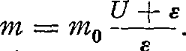(5)

## P) electrons in changeable electrical fields.

In the following can the temporal .Changes to the electric field during the passage the electrons not always neglected become.

\iWe therefore want to solve the equation of electron motion in a spatial constant field, <read field strength itself after the function *E (t)* temporally, derive. For a _path element is:

##### *dU=E·ds,*

with the equation (4) for the speed results itself:

Integrated:

*d u* =

v'U 2 +2 *U* ***E***

*C* - *[J-- E* • •

*E d t.*

Approximately:

*ftJ42DZ* = *c• jE (t) dt* + *C .* (6)

##### *y'i--Oe=c•fE(t)dt+C.* (6a)

The boundary conditions (U 0 and t 0 ) determine the constant of integration *C.*

1 See e.g. B. A. Summer f e Id, atomic structure and spectral lines. **8th** Chapter. -· Braunschweig

2 F. Where If, Ann. d. Physics, S. 849, 1927.

3 **1** MVolt = 10 6 Volt.

archive for

390 Widcroe, A new principle to production higher tensions.

Elektrotechnik.

## The effects of gas molecules on electron beams in high vacuum.

In weak accelerating fields, the electrons must travel long distances to reach high voltages (see Section IV). The gas molecules can therefore still have significant effects even in extremely high vacuum. on the electron beams to run away.

The middle free length of the path the molecules is at **10- 8** mm Hg (a Pressure, cter

itself with one glass apparatus to reach la:Bt) for different Gases:

Tabcllc I.

|  |  |  |  |  |  |  |  |
| --- | --- | --- | --- | --- | --- | --- | --- |
|  | | I |  | | | | |
| gas | H2 |  | 02 | N2 | CO 2 | H 2 0 |  |
| :Medium free length of the path in km= 105 cm | 14.6 |  | 8.1 | 7.6 | 5.1 | 4.75 |  |

Pressure: **10- 8** mm Hg= **1.3** • **10- 5** Dyn cm-- 2 Temperature: t = **25°** C = **298°** K.

The middle free length of the path the electrons is after Maxwell 4 • y'lf so large; the measured electron path lengths seem to be somewhat larger1, so that one can consider Value: **10 7** cm for the free length of the path the electrons at **10-8** mm**​** Hg

assume can. In elem electrical vortex fields one transformer is the Field·

strength of the Grand Order **0, 1**  :t. So we would already in the extraction of **10 6** Volt= **1** :MVolt in the Area the middle free Weglangen come. There but the effects the gas molecules also very from the Tension the Elek

trons are dependent, the free vVeglange only an indicative value for the assessment this gas effects.

A more detailed investigation of the effects of gas molecules on accelerated electrons (essentially based on Lenard's work on this areas) have so following Results shown:

The gas molecules cause Absorption, voltage loss uncl distractions of electrons out of the trajectory. At the in Ask upcoming \Verten from Field-

strong (ctwa **0.1** 1 ) and maximum to reaching Tension (approximately **10** MV) plays

now the absorption and the voltage loss during printing below **10- 6** mm Hg kcine Role. The diffusion of electrons is not on the other hand to neglect. Sic conditional a lower limit for the initial voltage *U* 0 . This limit would be our case approximately between 0.5 and 10 kV lie.

The diffusion because of should the gas pressure not high as 10- 7 mm Hg sem.

# Kinetic voltage transformation with potential fields.

## 1st The Principle.

How already crwahnt, let itself in electric potential fields the principle of kinetic voltage transformation use. The electrical Charges (in this case ions, see later) pass through several potential fields and store in everyone Field <read Tension as kinetic energy on.

A.l's first G. Is nig such a arrangement for the production from High voltage ion beams proposed 2 • Isnig wants to measure the electric fields using travelling waves produce. This traveling waves should so led would, daB she the

1 Partzsch, Ann. d. Phys. 44, 556, 1914.

2 G. Isnig, Ark. f. Mathematics Astronomy och physics 18, No. 30, Notebook 4, S. 45, 1925.

XXI. Band.

r 9 2s. Wideroe, A ncues principle to production higher tensions. 391

reach the accelerating electrodes at the same time as the ions. The implementation of this idea would pose great difficulties (e.g. avoiding reflections and unwanted coupling of the traveling waves); any results are until now not published wordcn.

In Picture I is one cheaper arrangement dcr transformation shown.

The electric fields are transmitted by means of the alternating voltage *Ub* over four acceleration sections I-- IV generated (the Number the Stretch is in the principle of course not limited). The ion beams to reach the first acceleration section with the initial tension ng *u 0 .* While one half period would the ions in I

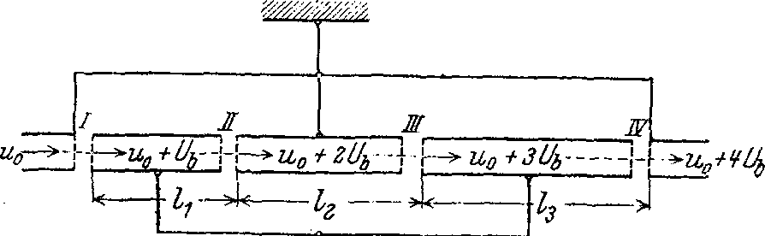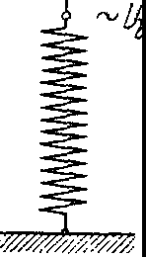

Picture l. principle dcr voltage transformation with potential fields.

and III accelerated, in II and IV become she braked. Becomes so the Distance 1 of two acceleration sections is chosen so that the ions cover this distance in half a period, they will be accelerated in all sections with the voltage *Ub* .

Between two acceleration tracks are the ions (in the interior one cylinder

ibid.) any electrostatic protected from influence. During this time will be the ions and the cylinder from dem potential - *Ub* on the potential + *Ub* elevated;

The resulting kinetic energy of the ions is therefore transferred to the AC source as an increased charging DC current withdrawn.

Man sees now also, Why for such orders ions chosen been

are. The slower the electrical charges move at the relevant voltage ( *s* rough), um so smaller become the distances l and the frequencies of the \N'exchange voltage *Ub.* The transformation by means of electron beams wilderness frequencies of ctca **10 8** sec- 1 and require large dimensions of the acceleration tubes ("-' I m). The ions have a 100-1000 times lower speed at the same voltage and offer because of this no such technical difficulties.

## 2nd theory the resulting kinetic tensions.

* 1. The basic equation.

We will in the following, In order to get an overview of the phenomena occurring, examine the simplest arrangement with 2 acceleration sections. Adding more acceleration sections offers nothing fundamentally new, the examination methods remain the same.

For the speed between the both Stretch applies the approximate

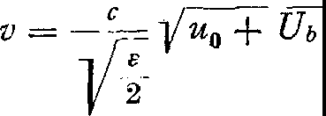formula (5)

392 Wideroe, A neucs principle to production higher tensions. Arcbiv for

Elektrotechnik,

For

u 0 = initial tension,

*Vb=* :Maximum value the acceleration voltage.

the Wavelength *A* the alternating current results itself thus

*l l* I *A v* **"1-; *v'*** Uo *+u-;;* 2 *c*

*t--··=--·* -· ------- --

*V z*

the Condition:

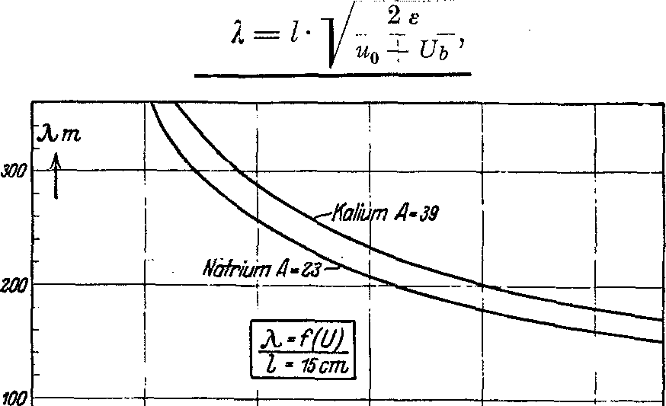from it follows:

(7)

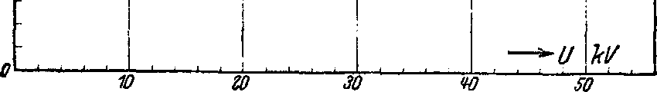

Picture **2nd** wave length in dependence the acceleration voltage.

Picture **2** shows the Wavelength in dependence the Tension *V* = *u 0* + *V1,* for Sodium and potassium ions at a fixed distance *l* = **15** cm between the two acceleration sections.

/J) The Voltage- time curves.

In most cases, the alternating voltage *Vb will* have a sinusoidal curve (a rectangular curve would of course be the most favorable in this case). Many ions are therefore not accelerated with the maximum voltage, and the resulting phenomena will be examined in more detail below. will be.

For the total kinetic Tension the ions receive we:

*U* = Uo + *U1* + *Uz* = Uo + *Vb* sin 0Jf1- *Vb* sin OJ ([ 1 +-,- ---,_ *,3=_* .·- .:::.) ,

+ 2

*c* 2 (u 0 *Ub* s1 w t 1

***e***

wobci

*u* = u 0 + *V b* - sm OJ t 1 -

*V b* s m •

Uo •

OJ ( t *n* ·-+ 1 -· + .-'-- - ·· ) ,

* ***(,I,*** Sill *W f1*

1 +

vVir fi.ihren die Bedingung **(7)** ein und erhalten:

*v-·*

(8)

*fl= Ub* !St.

The last member gives the tension to, wclchc the ions, the to Zcit *t;* the first stretch go through, in the second Route receive. Um the resulting voltage-time curve to find, is but the observation from the two acceleration distance out of cheaper. Out of equation (8) can we bercchncn, to which Time *t 2* the ions (which to Time *t 1* the first stretch happen) the zwcitc Streekc reach. It is:

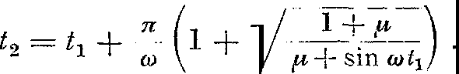

XXI. volume. .

1 9 28. W1dcroe, A new principle to production higher tensions. 393

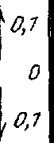

*+1,0*

*0,9*

*0,8* ,

i L- --J -- ,

......

I

*0,7* ---

LJ_I. /***v;1***

I • I **/ I**

\,

**i\."'**

*=0*

*0,6* ,-

*0,8* -tt-\1 *-)* 11}0. k'

'"'**'0**

1

"

--. ·-f-.

1\ 'I"'\..'

*,cv*

*2 1* ***V[\***

)

\

*N_O*

*0,3*

*+0,2* A-f+r-+---;c1v

**I----** -- ··---- - I ,.

***Hi***

:·-- !

***i..-*** ..-,, , , I..);\.

,/'

i

'\

'

**l\.**

I

--;--

I I

-

\,

i

I

k

***v*** I

·-

·-- i--

*\i*

i

""\

*-0,Z*

*O,J* f--

*0,¥*

L+-*VJ*

***V***"

I

·-

/

-

-

i

*y4(l}*

i

*0,5*

*0,6*

*0,7*

*0,8*

*!*

.-....+-- -1,

,-

I

**P"**

kt

I

:

i I

I

'

I

I

:

'

*0,9* ***r--***

*-1,oo· 10*

*20 so*

-

'

-

*¥O 50 oO*

*10 80 .90• 100 110 130 130 1'IO 1so 1110 110 1ru*

I

I

!

f---- **t--1·-**i -f-

***- wt [/rod***

Picture 3. *y* / *(t).* voltage-time curve before dcr second acceleration section

*- u1l*

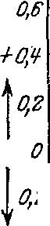

*+z,o*

*_l/_1.8*

0/ 1-- l.-f rr··

:

I I i I

*1,6*

*1,'I*

*1,2*

*1,0*

*0,8*

***-***I ***+; iy***I ***:****1* ***'***

I

-

*w* '-

**11fTt**

*i ..>. <*

:

I

'

·-

;_ <i -::

-

L--' --

*>(*

,--,--

f----: */e?' {/*

I

*-¼*

*V* /

***V*** 1 "-1'....

!><I">/\

.,,,r

!

I\ *:*

*v,*

*1--···,wo,sV* \

,,

-- ·

,,,,.. l

I

I

' \

*I* /

*z-*

*-O,'I*

***t*** /

*Y"'*

\

\

/

,'/

IJ

I

I

\ 00

-

*v..,.*

--

-

--

*0,67*

*0,87'*

/

/

-·

--·

*tJ=f(l}*

*1,0*

l--••-5t-·

*1,*

*1,*

;_:_,--t 1±_

*1,6* . --

*1,8*

-Z, *o· 10 ZO 30 '10 SO /JO 70 80 .90v 100 110 1ZO 130 1'10 150 160 170 180°*

,-+

_tJ -- t--

:

I

I

Picture 4th Resulticrende voltage-time curve directly behind dcr two acceleration track

394 W ideroe, A new principle to production higher Tensions. Archive for

Elektrotechnik.

The voltage of these ions (of section I) is known, so we know the voltage-time curve u 1 = / (t 2 ) short before the second acceleration section (we see here from the initial tension u 0 away).

Picture 3 shows this Function, *y* = ;: = *j (wt),* for different Values from *µ.*

*wt* increases, the voltage gradually increases until we reach a point where ions with higher voltage suddenly appear. From this point until *wt=* 90° is the ion beam inhomogeneous and contains ions with three different voltages; of these, the ions with the highest voltage are of particular interest .

The resulting *U* (t) curve, immediately after the second acceleration stretch, is shown in Figure 4; this Curve will naturally change, if we the rays to other position regard.

*y)* The circumstances in the acceleration section.

The previous considerations all apply under the assumption of infinitely short acceleration distances. We want to examine the admissibility of this assumption and the expected changes investigate.

The ions pass through a time-varying electric field in the acceleration section. The kinetic tension can then (because *e is* large) be determined using the simplified equation (6 a) calculate:

t+ T

*-y'2 ue* - *-y'2* u 0 *e =cf E* (t) *dt,*

*t*

from it results itself:

t+T

*j*

*u* = -} *[v 0* + *E* (t) *dt* ]2,

t

(9)

Um the Time *T* for <las running through the acceleration section to find, mlissen

we the Away des Ions as function the Time calculate. After equation **(1)** is:

*!*

t+T

*v* = --- **,/2** *u e* = *c*- *E* (t) *dt* + *v*

*2*

*C* -

*c V c 0*

and:

t

*J J* (/

T T t+T

*s* = *v d t* = : *E* (t) *dt] d T* + *v 0 T*

0 0 t

###### (10)

If we one sinusoidal alternating current *Uh* presuppose and for sin co *T*

and cos co *T* die first limbs the series expansions insert *(w T* < 10°),

receive we for *T* the approximate determining equation:

_ *T* + *c 2 Em* sin *w t* . *y 2 c 2 Em* • *w* [2 T 3 cos *w t* - *w T 4* • sin *w t]*

7 +7 ---

*s* - *Vo* 2 12 '

ds

(11)

The last member ,1 *s* the equation is in the general very small, it determines the deviation <lurch the Change in voltage during acceleration of the ions. To get an overview of the To obtain deviations in time *T* , this Time for a special case calculated. It were:

Long the acceleration distance: *s* = 0.5 cm.

Maximum Field strength: *Em=* 40 kV, *ub* = **20** kV, Uo = **10** kV, *Vo* = **2.23** • **10 7** cm ,

cm sec

*w* = 6.5 • 10 6 sec- 1 , *w T* = 7.6° until 6.0°, *e* = 3.62 • 10 10 V (Potassium).

XXI. Volume. p .

1 9 28. Wideroe, A new rinz1p to production higher tensions. 395

The percentage changes the Time *T* are in the Table 2 plotted, the run through time is extended by a very small amount due to the voltage change. For the reached kinetic Tension results itself:

*f*

t+T

**Ukin={-[vo+- ;** *Emsinwtdt]2=;* [v 0 +'/;'·sinw} sinw(t+ ;)]2. **(12)**

**t**

Fiir the relative voltage loss (d. h. Loss measured to the voltage at the the ions the acceleration section leave) results itself thus **to:**

*U b* S • ill *w* ( + *t T)* - ***e*** - [ Vo + - *c•* - *Em* S • ill **(I)** *T* ·-. S • ill *w* ( + *t* - *T* -- *)* **]2**

*Au* Upot- Ukin 2 *ew* 2 2 (13)

*u·* +

= *Upot* = *Ub* sin (I) *(t T)*

If we enter the values of the previous example, we get the values in Table **2** specified percentage Values the voltage reduction. At For phase angles up to about **30°** the reduction is considerable, when approaching the maximum voltage (and this area is of particular interest) the voltage reduction becomes negligible small.

table **2nd**

|  |  |  |  |  |  |  |  |
| --- | --- | --- | --- | --- | --- | --- | --- |
| ***wt=100*** | **20°** | **30°** | **40°** | **50°** | **60°** | **70°** | 900 |
|  | **0.707** | **0.508** | **0.352** | **0.251** | **0.177** | **0.106 0.025** | **0** |
| **100** *u* **- =-2** , **06** | **10.6** | **7.0** | **4.8** | **2.8** | **1.90** | **1.40 0.60** | **- 0.15** |

Finally, if we want to take into account the increased speed in the second acceleration section, we must determine the length *l* between the acceleration tracks something correct. If we the already Using the example mentioned above, yourself (how to easy out the average speed

in the second Route calculate can) one shortening the Long *l* um 0.64 mm. This .Change amounts around ½ °lo and is so negligible small.

## The experimental Investigation.

The experimental investigations should before everything the accuracy the principle prove and the difficulties des procedure closer clarify. Out of

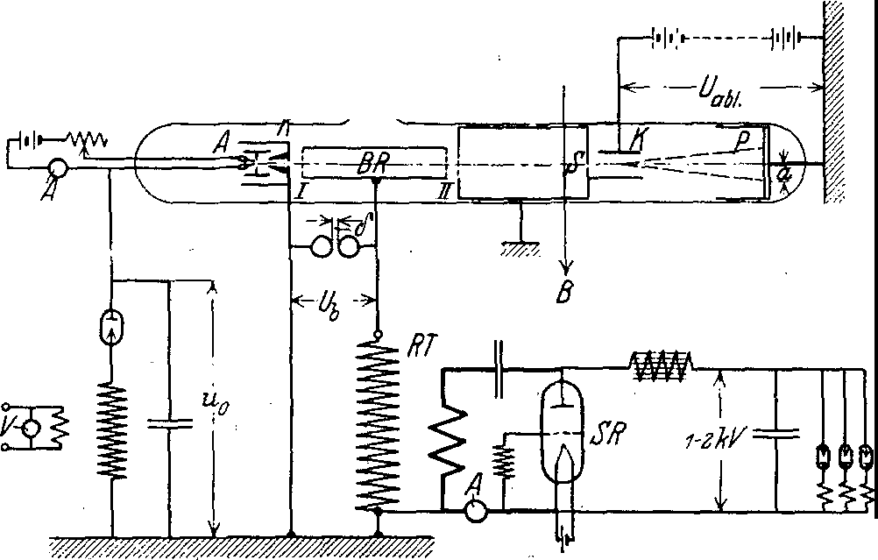

*ZurPumpe*

t

m

Picture 5th The used Circuit.

archive f. electrical engineering. XXI. Band, 4th Issue *26*

396 Wideroc, A new principle to production higher tensions.

Atchiv for

J >electronics.



For these reasons, the simplest arrangement with two acceleration sections was investigated. The acceleration voltage became also relative low chosen and fraud in the mcistcn traps ctwa **20 kVoltma:i:•**

Figure 5 shows a schematic view of the apparatus used, Figure 6 a photograph of the test tubes. The ions are absorbed by the Gli.ih anode *A* produced in high vacuum; she are with the initial tension *u 0* accelerate and leave the cathode *K* The ion beam passes through the acceleration path I,

I

*I*

*I*

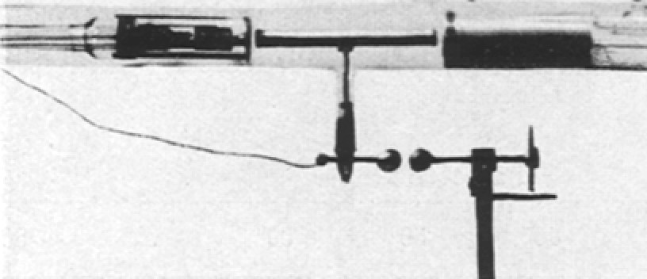

Picture 6th The test tubes.

the acceleration tube *BR* and the section II, then passes an electrostatically protected route and is by means of the gap *S* on cinen about 0, I mm wide line is blanked out. In the condenser *K,* the rays are deflected electrostatically and finally reach the photographic plate *P.* From the deflection *a* the rays la.Bt itself the Tension the ion beams calculate.

1. **details the experimental setup.**

*a)* D ic manufacturer ung the ion beams.

By far the greatest difficulty in the experiments was the production of the ion beams. Since the entire apparatus must be in high vacuum, the use of a glass anode seems to be the most advantageous. It was first attempted to use ion beams according to the method of Gehrke and Reichenheim 1 to produce. However, this path was abandoned due to the many difficulties 2 , where this method sick, leave.

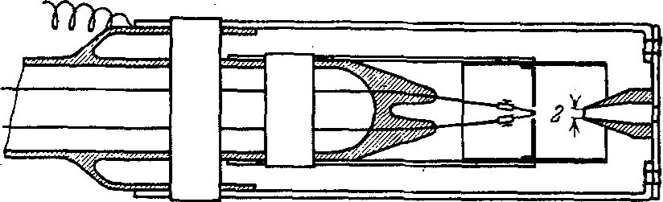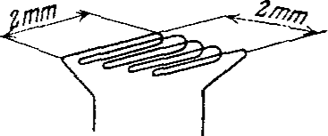

Picture 7th a) The electrode set. b) The glow wire.

Useful results were only obtained with the Kunsmann 3 specified ionizer reached. If possible pure iron oxide Fe 3 0 4 became with I °lo KN'O 3 and 0.50/o

1 Gehrke and Rcichenhcim, negotiation d. German. Phys. Gcs., Vol. 8, S. 559, 1906; Vol. 9, S. 76, 200, 376, 1907, Vol. 10, p. 217, 1908.

2 Aston, isotopes, Braunschweig, S. 90, 1923.

3 Kunsmann, Science 62, S. 269, 1925. - Larson u. Richardson, I. of Ind. Chemic, Vol. 17, p. 971, 1925.

XXI. Band.

**397**

xg28. Wideroc, A new principle to production higher tensions.

Mg 2 O 3 and melted in vacuum. The ionizer was designed as fine powder using paraffin on the platinum anode cemented and finally <lurch Gli.ihen in one illuminating gas atmosphere reduced.

For the generating electrodes envies itself the in Picture **7** shown Construction is very affordable. The electrode set allowed tensions up to 40 kV **max** between anode and cathode to create. As material filr the electrodes became molybdenum and aluminum (for some parts that do not get warm) chosen. The platinum glow wire was as a double grid trained and became quite with dem ionizer filled out.

The ion beams had one divergence from approximately 1 : 50, the current varied with dem heating current the anode and fraud (at Red heat) about 0.05-0.15 milliamps. To determine the nature of the ion beams, preliminary tests (without deceleration voltage *Vb)* driven out, where the electric Diversion <lurch one magnetic replaced was. It showed itself, daB the rays only positive Potassium- and sodium ions contained 1 . The ratio of the two ion types was not constant; in many cases published only the potassium ions 2 : The life des ionizer fraud at the relative strengthen emission only approximately 5-10 Hours (in the contrast to others He

experiences 3 ). This was allowed probably therefore ri.ihren, daB while this Time the Main•

part the in the ionizer existing ions emitted became.

The initial voltage u 0 was in the usual way by rectifying an alternating voltage manufactured; the Tension became primary side measured.

The vacuum of the tubes was measured with an ionization vacuum meter; a coherent ion emission was only at good vacuum **(10- 6** until **10- 7** mm Hg). With good degassing and cooling with liquid air of the tubes, a vacuum from approximately 10- 7 mm Hg erected. \Vahrcnd des operation rose dcr pressure in the ring on around 4 • 10- 7 mm Hg.

*(3)* The acceleration span Hungarian

The method offers the great advantage that the acceleration voltage can be determined by means of ice-free resonant transformers (Tesla transformers) produce In the present case, it envies is most effective, the oscillation circuit of the Transmitter tube to be designed directly as a transformer. The voltage *Vb* could be easily regulated by changing the anode voltage and heating the transmitter tube. The tension was primarily <lurch the Performance the Tube (Telefunken *RS* **21** IV) and the dielectric losses in the resonance transformer limited.

A spherical spark gap proved to be the most suitable for measuring the acceleration voltage. The ball diameter was 2 cm (around to keep the capacitance as small as possible), the spark gap was calibrated with direct voltages 5 . Irradiation of the radio link with a mercury quartz lamp had no detectable influence on the measurements. The curve shape of the deceleration voltage became with one western Electric pipes 6 oscillographed; she crwies themselves as very Exactly sinusoidal.

*y)* The measurement the kinetic Tension

gcschah <lurch electrostatic deflection. In Picture 8 is one dcrartige distraction shown been; as track curve results itself one parabolic tangent, the Diversion *a* becomes:

1 The Diversion gcniigtc not, um the potassium isotopes **A= 39** and **41** from each other to separate.

2 The sodium ions stir probably from regulations des ionizer here. Much-

light stem sic from dem ;.'lfagnesittiegcl des melting furnace.

3 Kunsman n, Phys. Rev., Vol. **27,** S. **739, 1926.**

*4* S. Dushmann u. C. G. Found, Phys. Rev., Vol. **17,** S. **7, 1921** and Vol. **23,** S. **734, 1924,**

5 The Wcrtc fall quite with the from Schumann indicated together. Schumann. Berlin **1923,** electric trike breakthrough field strength the Gases. S. **10,** table II and S. **21st**

8 Johnson, JOSA, Vol. **6,** S. **701, 1922.**

**26\***

398 objections, A new principle to manufacturing higher Spanmingen; Archive flir

Elektrotechnik.

*a* = *l* • *!!!_* = • *_:* E.ibl *h_* = ***l1*** *l2* • *Eabl* - +

2 *2* +

*V/ Vt m/ Vi U* **2** *U* e .

and for ion beams *(s* » U):

*a* = l 1 l 2 • Eabl *2U* = *0 - .*

**1** CEabl

**(14)**

**(14a)**

We see that the electrostatic deflection 1=1 depends on the ion mass is and only from the Tension *U* (and the deflection voltage) depends. A precision measurement the Tension *U* became at the Attempt not strives and was also with the simple apparatus barely possible. As main

*,t*

*ll*

*u-- '.... ====----- ----- -*

* I
* . . *f*

*lz p.1*

Picture 8th electrostatic Diversion.

The source of error is small changes in the direction of the ion beams ( caused by changes in the emission) in connection with small inhomogeneities of the two Deceleration fields in consideration. Through magnification des distance between the gap and the acceleration sections, the errors mentioned above (fuzzy 1:1 change of the zero position) can be eliminated. The accuracy of the voltage measurements was 4-,-50fo, and the calibration of the deflection capacitor reached the accuracy 1-20/o.

To increase the sensitivity, the photographic plates were sprinkled with calcium tungstate; she became through a magnetic activated Shutter protected from outside light. A strong magnetic field *B* ensured that no electrons through the gap get there could. The exposure time lag between **10** sec and **3** min.

* 1. The test results.

Da the stray fields the deflection capacitor difficult to calculate were, was the deflection constant *C* in equation (14a) <lurch calibrations with known Span-

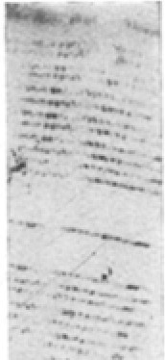

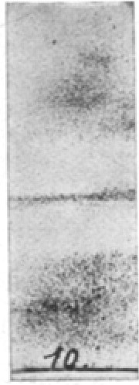***za.***

**a calibration,** b) _ ,t **290 m,**

***J.*** = **290 m,**

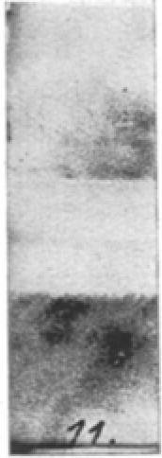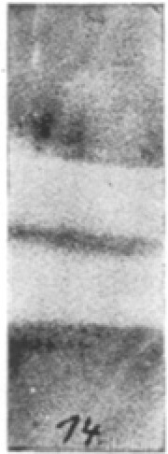**d) ,t** = **23- m,**

***...,U* =42.5 k\',**

***Z U--:* 51 , 9 kV,**

***TO*** = **56.0 k\' .**

picture 9th recordings at different tensions and wavelengths.

tions. Figure **9** a shows a calibration plate. In order to reduce the sources of emissions as much as possible, became the rays alternately after both directions distracted. As mean from approximately 20· measurements crgab itself cinema deflection constant from:

*C* = (50.8+ 0.4) cm.

**xx! 92 nd •** Wideroe, A new principle to production higher tensions; 399

The Try with acceleration phases showed immediately, da:13 the ions that e escalated double kinetic Tension received:

Um the calculated stresses, became the Wavelength the Voltage *Ub* changed; the Deviations from the <lurch die Condition **(7)** given value were up to to **30%,** The resulting change in the The achieved voltage is shown in Figure **10** , where the measured values are also plotted. The drawn curve presents the theoretically to expecting Change des stress effect

grades *ryu* '= ***.S*** -;;,, *uo* represents. The curve became found, by the in Picture **3** shown *U* (t) curve (fi.ir *µ* = 0.4 - 0.6) to phase-shifted sine curves was added. The maximum values of the resulting curves then result in the curve shown in Figure 10. Curve.

*- f* ***- +Y***



*µ=0,'I*

*0*

*0,9*

/

*V*

*V*

-

*=0,i*

0

*kaium*

*Wlllri11m*

'

.......

*0,.u*

/

'-'

I',..........

*0,*

*71*

*ium*

*l1v=ff: \JI*

*0,6*

*ll5go*

*Bo 10 60 .so l/0 so zo 10*

*0.1*

-

*,6'.*

*0.9*

*ilR*

*.A,*

*o 10 zo 80 l/0 so 60 10 90+80*

*10*

*1.1 f!'Z 1,8 1.'f 1.5 1.G 7.t81,l 2/J*

Picture 10th Comparison the measured with the calculated values for the voltage efficiency at different wavelengths.

\As you can see from Figure **10** he sees, confirm the values measured from the recordings in each respect the calculated curve. The Deviations from the calculated values lay all within the accuracy limit.

The lines the Potassium- and sodium ions love itself only at the Measurements with ***A=* 175** m apart separate. In all other traps mu:13 the Distance the lines only 0.1-0.2 mm be, what a separation not enough. In Picture 9 b--'-d are recordings at different wavelengths reproduced.

The experimental investigations Tests have shown that the voltage efficiency changes little with the wavelength. Da but the intensity (carried charge) the rays decrease significantly at too short a wavelength, it is recommended the Wavelength after the Condition **(7)** to choose.

## prospects des procedure.

The applications des procedure hanging closely with the production possibility of ion beams. With the methods known today it should hardly be possible to increase the emission current higher than **1-10** milliamps. Under these circumstances, the process is hardly suitable as a technical high-voltage source for direct voltages (the short life of the ionizer).

**400** Wideroe, A new principle to production higher Tensions. Archive for

Elektrotecbnik.

ion beams higher Tension claim but to itself a high physical Interest, and out of diesel reason was allowed the developed Proceedings not without value be. •

The generated voltages are limited mainly by two conditions. Firstly, the quality of the vacuum limits the usable voltage *Ub;* secondly limited the Capacity the acceleration tubes and the dimensions of apparatus the Number the acceleration sections. Out of dem last reason is it

advantageous, as possible heavy ions to use. cesium ions *(s* = **125** • **10 10** Volt)

should be favorable in this regard. If we assume an acceleration voltage from *Ub* = **170 kVmas** 'out of, would man with 5 acceleration tubes one

Tension from around **1** MVolt generate can. The gauze apparatus became at a Wavelength from *A=* 175 m approximately 1.20 m long become. With still Heavier ions (such as thorium *s* = **213** • 10 10 volts) would be subjected to similar conditions. from approximately 2 MVolt to reach can.

* 1. **The beam transformer.**

## The Principle.

Figure **11** shows a schematic of how the beam transformer works. The primary winding W 1 drives an alternating current ***</J*** through the iron core of the transformer. The high vacuum tubes *R serve as secondary winding.* The electron beam is done by means of the luminous cathode *K* generates and into the circular pipes *R* driven.

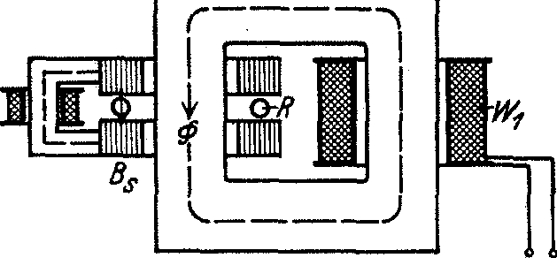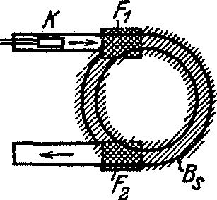

Picture IL mode of action des beam transformer.

For the control of the electrons in the transformer tubes you could use electrostatic or magnetic fields. However, a rough calculation shows daB the control of high voltages electrostatic fields of the size

order l M - - Volt he f or d ern w u .. r d . en.

cm

Since the corresponding magnetic control is easier to manufacture (the field strength lay in the magnitude 5000 GauB), becomes in the following only this type of steering examined.

. The electrons rotate in the electric vortex field des alternating flow ***(I>,*** up to she the desired kinetic Tension reached have. The Centrifugal force, which arises during rotation, is cancelled by the control field *Bs* ; the two indicated fields F 1 and F 2 ensure the introduction and deflection of the electrons out of the circular orbit.

In the following investigation of the beam transformer we will first examine the achievable voltage of the electrons. We will then discuss the most important constructive Condition des transformer, the right training of the control panel *Bs* determine.

## The basic equations.

* 1. The Tension.

We take in following to, daB the alternating current *<J'J* itself evenly her one circular area distributed. The alternating current forms then a symmetrical electric

xx! 92 and Wideroe, A new principle to production higher tensions. 401

vortex field, whose lines of force concentric circles are, out of. Da the field strength spatially constant is, can we the equation **(6)** use:

*Vu•* + **2** *U e* = *cf E* (t) *d t* + *C* .

Moved itself a electron au£ one circular path with dem radius *r,* becomes the field strong (positive calculated):

from which:

*E(t)*

I *d* ***(J_j***

=- ·-

*2n:r dt'*

*V U 2* + 2 *U e* = 2 : *r* • *<1>* + *C* . (15)

We driving the boundary conditions a, da.f3 the Tension from U 0 au£ *U,* the Flu.f3

* from **<1> 0** au£ ***<1>*** grow should, and receive:

(15a)

With hindsight on simple steering the electrons choose we the initial values U 0 and **</J 0 ,** so da.f3 she the following equation gentigen:

*yU 0 2 +2U 0 e= 2 :r•< .D 0 •* (16)

For the Tension *U* the electrons results itself then:

*V u2* + 2 *u* I! = 2: *r.* ***<l>*** I

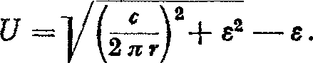from which:

**(17)**

The Tension *U* is in this trap independent from the initial values, corresponds so one transformation from U 0 = **</J 0** = **0** out of. Um the achievable Estimate voltage to can, want we assume da.f3 the surface of the alternating flow ten Part of the area limited by the electron current (=iron filling factor). We receive then:

*_c_* • *<l>* = *_c_.* . *nr• B* = *C.* s • *B. r* = *ui.*

*2n:r 2nr* 2

The introduced GroDe *Ui* corresponds the accessible Tension for the Ideally, the electrons had no mass *(e* = 0) and were constantly moving at almost the speed of light *v* = *c* = konsta11-t were running. For the achieved maximum Tension results itself also: • •

(for *U.;* > > e) ,

WHERE

*U .* _ **l** 5 , *i:,* Bmax l\I volt

(18)

(18 a)

- • ' " *r* IO 000 Gaufi • cm •

Out of equation **(18)** goes out, daB man at one iron fill factor = 0.5 and a maximum induction from *B* = 15 000 GauB already with a pipe radius from approximately 9 cm the Tension 10 millions volt produce can.

The calculations !assen it so possible appear, that you with the radiation transformer very height tensions to reach can. Out of this reason it appeared justified, the principle des transformer and <read difficulties more precisely investigate.

/J) The control panel.

Au£ one moving charge works in one magnetic field the electrodynamic Power:

402 Wideroe, A new principle to production high Tensions. Archive for

Elcktrotcchnik.

The radial effective deceleration force the rotating electronic is:

* **2**

=

*Pb= b·m 3!.- ·m.*

***r***

The magnetic Stcuerfeld becomes then <lurch the equation certainly:

#### *e•v·Bs = r - · m* ,

v2

*V* I *ci/U 2 +2Ue m* 0 *(U+e)* **I,/·-** *2* **-- -**

#### *Bs=;-.-;;m=er-lJ+ ·- ···' e =c=rv U -t- 2Ue.* **(19)**

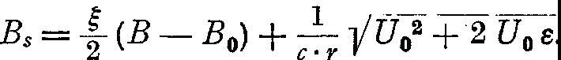um To investigate the relationship between the control field and the dcm inducing field, we introduce in the last equation the value of the voltage according to equation (15a) a:

**(20)**

We seen out of this Equation, daf3, if the earlier mentioned Condition **(16)**

fulfilled is (and only then), the control panel dem inducing field proportional becomes:

*Bs* = { · *B.* **(21)**

It is also easy to see that the two fields have the same direction miss. We receive so the most important Result:

control panel and inducing cs Field are• proportional and phase-equal and can therefore be generated by means of the same excitation and the same change1£1uf3 ***<P*** become.

The Result runs to one essential simplification the construction of the transformer.

It is also advisable to direct the inducing flux across an air gap i to lead; man has then the both air gaps so to dimensioning, daf3

*"s* = *t i,* **(22)**

Da the induction within des electronic circuit never quite constant will is for *i* in above equation the middle inducing air gap to use.

### Experimental Investigation n

* 1. The experimental setup.

The cxpcrimentellen investigations should in first line the Ask clarify whether it is It is possible to move electrons several times on a circular path using magnetic fields around to lead. If itself this should prove possible, The acceleration in vortex fields should be investigated. To enable these investigations, A beam transformer of the simplest possible construction was designed; Figures **12** and **13** show schematic views of this transformer. The entire arrangement can be broken down into the following construction details :

The Glow cathode tubes. The arrangement the Pole.

The Construction des transformer.

The Glow cathode tubes were in close reference to the one from Rogowski and Grosser developed glow cathode oscillograph 1 was built. A Tungsten filament emits electrons that the electrical cathode-anode field go through and in the circular transformer tubes *R* get there. Mittcls the two coils cross *SI* and *Sll* ( the horizontal coils are not shown) earth fields and transformer struc- tures are compensated. The electron beam can be this Wash any liber the pipe cross-section move.

1 W. Rogowski and W. Grosser, Arch. f. Elcktrot., Ed. XV, S. **377, 1925.**

rg28. Wideroc, A new principle to production higher tensions. 403

XXI. Band.

The concentration coil *KS* collects the rays in front of the circular tubes, the collection point can be moved (by changing the coil current) up to about **10** cm into the circular tubes move in.

The access to circular pipes song itself <lurch the by means of one grease-ground closure *V* lock out; the front the locking plate was with luminous material (Zn S 2 ) coated. In order to better follow the beam path, the glass walls the circular pipes also with one thin layer of zinc sulfide The entire glass apparatus was constantly exposed to a gas filled with solid **CO 2** cooled diffusion pump, the vacuum_ reached in everyone traps **10- 6** mm Hg.

*ZvrPvmpll*

i:

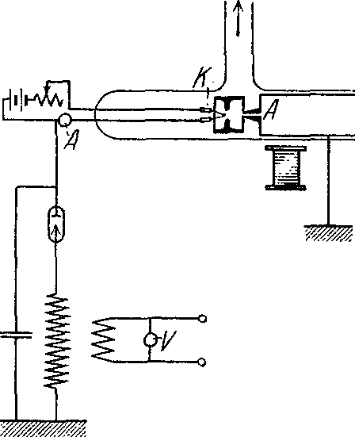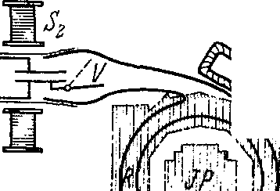

*]is1*

Jj

a

!f

b

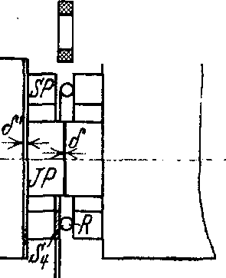

,ls -

Picture **12th** arrangement the glow cathode tubes and the transformer poles.

Due to the relatively long length of the tubes, the rays were often disturbed, before she to circular pipes arrived. At further Attempt It was therefore recommended to use the electrode shape shown in Figure 7. This electrodes !assen itself also quite in the Kahe the circular pipes attach.

The arrangement the Pole is out Picture 12a and **b** to recognize; the Pole are intended to induce flux3 and develop the control induction with the right strength. To ensure rapid river changes to make possible, became the Pole out of **0.2** mm thick Trans

former sheets assembled, the outline dear itself the circular shape .good adjust. The both air gaps *O* and ***O'*** serve in addition, the Relationship the both In

productions *B;* and *Bs* each other to set. One .Change the air gaps be effective large .changes from *B;,* while itself the tax induction few changes.

**2)**

Um the right Relationship the both inductions *(B;;* = **to** receive, became

two test coils between the poles and excited with **50** Percent alternating current. One test coil was used to measure of the entire from the circular pipes to grasp inducing river;s, while one small test coil <las control panel <through the circular tubes. The (very small) alternating voltages of the two coils were by means of induction-free \Viderstande matched and out of dem Relationship

*tram* calculated. As zero instrument served a vibration galvanometer.

*-Bs*

The iron filling factor was at the present execution ; = **0.43.**

The magnetization curve of the transformer was measured ballistically, an induction *B;* max = 14 000 Gauss was still easily accessible. Da the middle radius dcr circular pipes *r* = 7.25 cm was, wilderness this an increase in voltage are equivalent to on:

*U* = [1.5 • 0.43 • 7.25 • 1.4) - *s* = 6.0 MVolt.

404 Wideroe, A new principle to production higher tensions. **Arcbiv** for

Elektrotechnik.

Construction des transformer.

The magnetic circle of transformer became out of dem core of a 200 kV A, 3-phase transformer formed 1 . The lqse yoke was cut between two cores, in between were the transformer poles installed.

The primary winding stock out of 16 Wash, **1** mm diameter copper wire

with 480 turns each. The coils were designed to achieve the fastest possible flow parallel switched on. The time constant fraud approximately *T* = **0.2** sec.

Since the experiments only aimed to determine the acceleration of the electrons, became the primary winding on one direct current switched on.

The river in iron of the transformer increases, then after a I - *e-* x-curve, and we receive cinema one-time Transformation. Kach approximately the Time​ became the

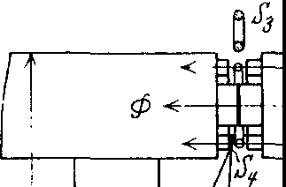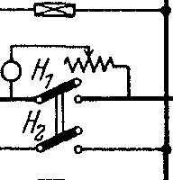

*MW.*

J'

*J'*

Picture 13th The test circuit des transformer.

flat coil IV (the one quite small time constant owned) turned on. This coil spins all electrons, the itself still in the Tube move (and this mittissen in this case away des strengthen control panel one height Tension own) against the pipe wall, where they are <lurch luminous phenomena noticeable make The used circuit goes out of Picture 13 out. The initial flow </J 0 is done by of the resistance *R* adjusted. The switch H 1 closes short-circuits this resistance and connects the magnetizing winding directly to a 500-volt network. The switch H 2 (which flat coil turns on) was with dem first Switch mechanically so connected, daB the both circuits with approximately 0, **1** sec interim period took place. The

emerging streams became with the fuses *S* switched off.

{J) The Results.

In the experiments, the cathode rays on the shutter screen were first collected and on cin maximum set. War one sufficient Constancy of rays reached, became the closure open, so that the rays into the circular pipes. The starting field *It* O was then regulated so that the rays were as the circuit railway dcr Tube followed.

As first appearance zcigte itself included, daB the entire circular pipes itself to a fairly constant counter voltage. During the experiments, the anode voltage mostly **30** kV, the counter voltage fraud approximately **10** kV. Has the pipes these counter voltage reached, flow ebcnso many electrons out of the circular pipes



1 single-phase core with loose yoke stood not to disposal. The iron core was from the city E.-\V. Aachen most willingly for the experiments to disposal placed.

**xx! 9 nd •** Wideroe, A new principle to production higher tensions. 405

out of here (primarily as sliding discharges the glass walls along), How by means of the rays are brought in become. The counter-voltage continued the from the cathode voltage calculated Values the starting field strength very down, brings but otherwise none large Disadvantages.

The further Experiences concerned the Behave the on the glass walls the Tube itself located electrons. It stock the Hope, daJ3 this electrons itself How a electrostatic grid (see later) behave would be 1, the other electrons from the glass walls push away could. This appears but not the case to be; the charges to the Wanden were uneven and did not practice the expected effects out of.

It proved itself as very difficult, the electrons in the right to guide in a circular path. Only by means of the coil *SI I I* and a suitable shape of the pipes succeeded it, the rays approximately I½ times in the circular pipes to show around. It However, it did not seem possible to keep the rays permanently in the circular orbit; shortly after one orbit, the rays usually fell on the walls. For this reason, it was also clear why the acceleration tests did not show any results. The transformer was excited several times, but no electrons of higher voltage were observed.

*y)* Sta training the electrons nbahne n.

Although the results of the studies were negative, they did provide some experience which may provide guidelines for further studies.

The main difficulty of the transformer is to constantly on the circular path to receive. The trajectories the electrons become very light

<lurch inhomogene magnetic fields and additional fields the wall charges disturbed. It must therefore an arrangement must be created which the electrons after center of the pipe urged, the so stabilizing on the trajectory works.

But it now seems very difficult to find such an arrangement. The usual gas concentration of the usual Braun tubes is due to the large absorption losses at low vacuum not usable.

More orders with axis-parallel electrodes or Current conductors (grids inside or outside the pipes) also offer no possibility of stabilization. A grid will repel electrons from the walls in certain areas, but in other areas the electrons will be driven against the walls (the line integral *Js Ks ds* is over the circumference of the pipe is **zero).** It It is easy to show that electrostatic and electrodynamic lattices in this trap complete similar works.

A axial magnetic field (concentration coil) would probably the electrons to form a spiral path within the pipes. However, this spiral path would be Disturbance against the Wande driven become.

The only possibility of stabilization seems to be an electrode in the pipe axis in connection with one axial magnetic fields to be. The inner electrode would secure the remaining spiral path against drifting, while the magnetic field would keep the electrons from the inner electrode keep away wilderness.

Whether this will lead to stabilization is possible, has yet to be investigated. In any case, all further investigations on beam transformers should focus on the stabilization problem dedicated be. First if one stabilization achieved is, will the acceleration from electrons in electrical vortex fields possible be.

1 M. We 11au he, Arch. f. electrot., Vol. 16, S. 13, 1926.

406 Wideroe, A new principle to production higher Tensions. Archive for

Elektrotechnik.

## Summary.

In this work, the possibilities of generating high voltages using kinetic voltages (fast moving electrons and ions) are investigated. In analogy to the usual transformers and parallel-series circuits, two processes result: acceleration in vortex fields and in potential fields.

*Acceleration* in vortex fields could generate very high voltages. The process fails because there are no possibilities to transfer the electrons to one circular path to bind. The Solution this Ask appears to Time large difficulties to prepare.

The acceleration in potential fields became at middle tensions (20 to 50 kV) examined. The theoretical considerations became complete <Confirmed by the investigations. The process allows voltages of about 2 million volt to produce.

Since the performance is currently small, the process is mainly used for physical investigations in Ask come.

Lord Prof. Dr.-Ing. W. Rogowski am I for willing Support with this Work and fi.ir multiple suggestions sincere Thanks to guilty.