# Problem 3 – Sprint Board

**Working with Remote Data**

For the solution of some of the following tasks, you will need to use an up-to-date version of the **local REST service** provided in the lesson’s resources archive. You can [read the documentation here](https://github.com/softuni-practice-server/softuni-practice-server).

**Environment Specifics**

Please be aware that every JS environment may **behave differently** when executing code. Certain things that work in the browser are not supported in **Node.js**, which is the environment used by **Judge**.

The following actions are **NOT** supported:

* **.forEach()** with **NodeList** (returned by **querySelector()** and **querySelectorAll()**)
* **.forEach()** with **HTMLCollection** (returned by **getElementsByClassName()** and **element.children**)
* using the **spread-operator** (**...**) to convert a **NodeList** into an array
* **append()** (use only **appendChild()**)
* **prepend()**
* **replaceWith()**
* **replaceAll()**
* **closest()**
* **replaceChildren()**

If you want to perform these operations, you may use **Array.from()** to first convert the collection into an array.

## Requirements

Write a JS program that can load, create, remove, and edit a list of tasks. You will be given an HTML template to which you must bind the needed functionality.

First, you need to install all dependencies using the npm install command.

Then, you can start the front-end application with the npm start command.

You also must start the ***server.js*** file in the ***server*** folder using the node server.js command in another console **(BOTH THE CLIENT AND THE SERVER MUST RUN AT THE SAME TIME)**.

At any point, you can open up another console and run npm test to test the **current state** of your application. It’s preferable for **all of your tests to pass locally** before you submit to the Judge platform, like this:

Картина, която съдържа текст

Описанието е генерирано автоматично

## Endpoints

* [**http://localhost:3030/jsonstore/tasks/**](http://localhost:3030/jsonstore/tasks/)
* [**http://localhost:3030/jsonstore/tasks/**](http://localhost:3030/jsonstore/tasks/)**:id**

## Load the Board

Clicking the **[Load Board]** button on the **top left** should send a **GET** request to the server to fetch **all sprint tasks** in your local database. You have to add each task to its **specified column list** (ToDo, In Progress, Code Review, or Done). The tasks should have **different text contents** inside their respective **buttons** depending on which column they are in:

* ToDo – **“Move to In Progress”**
* In Progress – **“Move to Code Review”**
* Code Review – **“Move to Done”**
* Done – **“Close”**

Each Sprint task has the following **HTML** **structure**:

<li class="task">

<h3>Fix Bug</h3>

<p>We have a new bug to fix</p>

<button>Move to In Progress/Move to Code Review/Move to Done/Close</button>

</li>

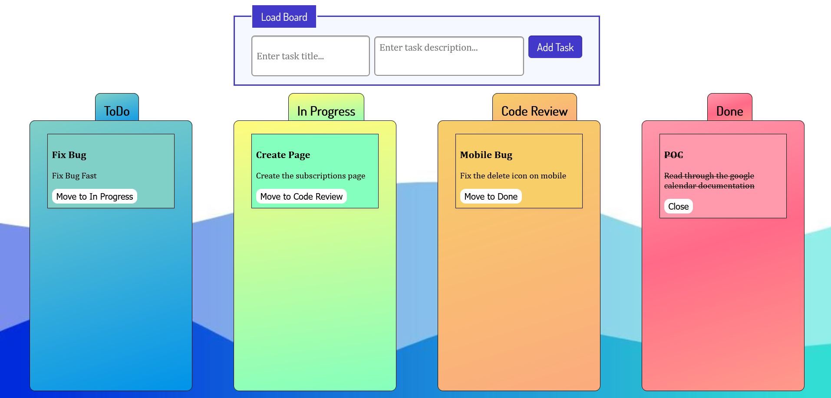

## Add a Task

Clicking the **[Add Task]** button should send a **POST** request to the server creating a new task with a **title** and **description** from the input values (the **status** should have an initial value of **'ToDo'**). After a successful creation, you should send another **GET** request to fetch all the tasks, including the **newly added one** into the **ToDo** column. You should also **clear all input fields** after the creation!

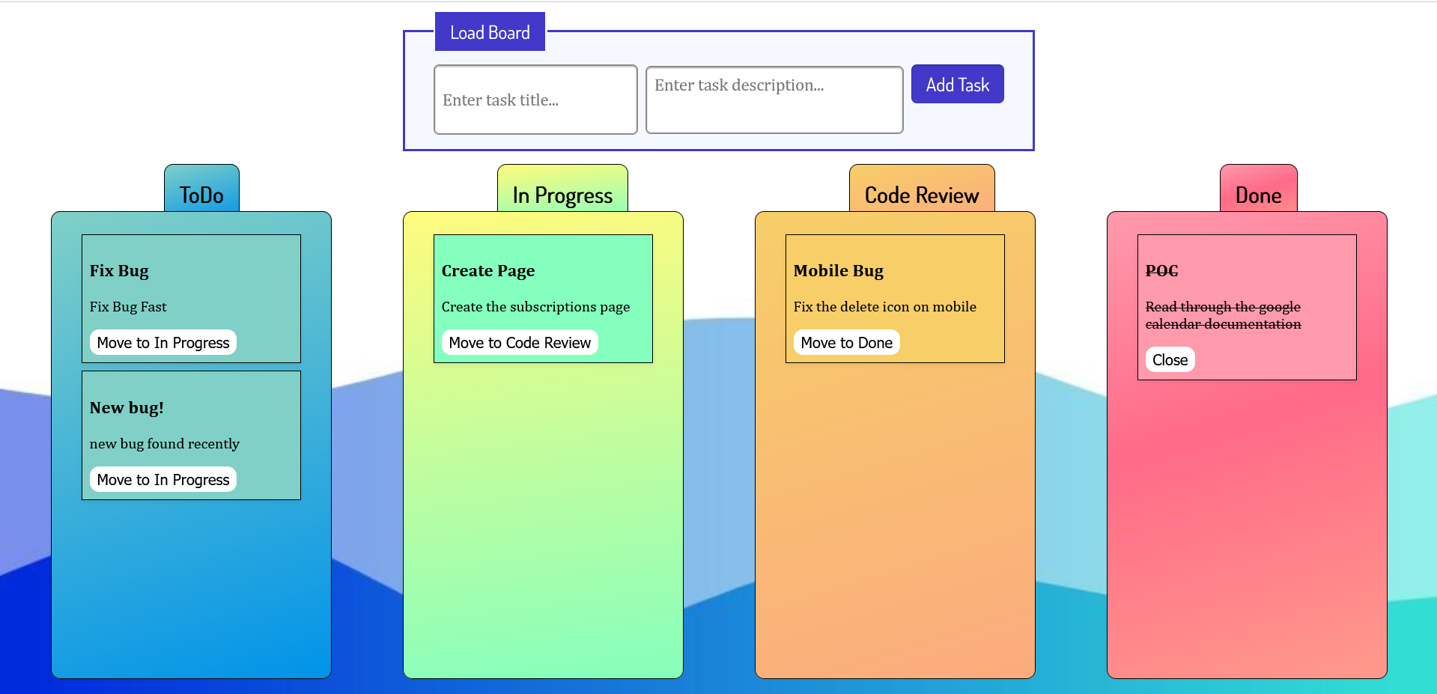

## Move a Task

Clicking the **[Move]** button on the individual tasks from the **first 3 columns** should move the task from one column to the next – from **ToDo** to **In Progress** to **Code Review** and finally to **Done**.

After clicking the **[Move]** button, you should send a **PATCH** request to the server to **modify the status** of the changed item. After the successful request, you should **fetch the items again** and see that the change has been made.

## Close a Task

Clicking the **[Close]** button on the tasks in the **Done section** should send a **DELETE** request to the server and remove the item from your local database. After you’ve removed it successfully, **fetch** the items **again**.

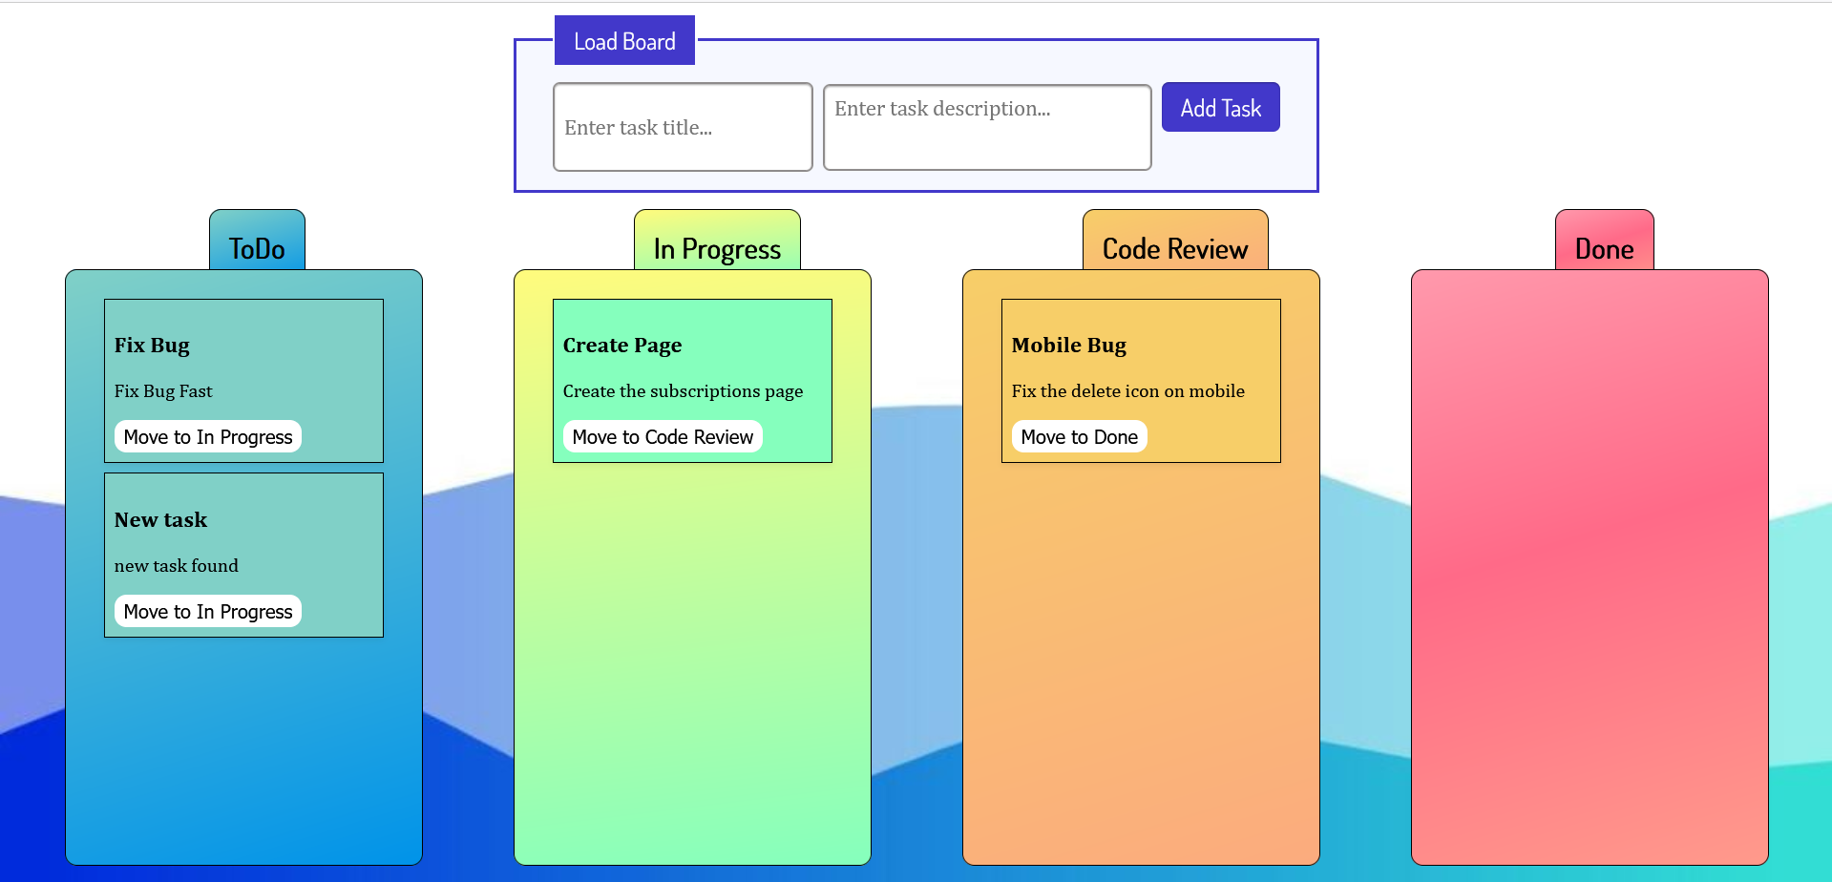

## Submitting Your Solution

Select the content of your working folder (the given resources). Exclude the *node_modules* & *tests* folders. Archive the rest into a **ZIP** file and upload the archive to Judge.

Картина, която съдържа текст

Описанието е генерирано автоматично

Картина, която съдържа текст

Описанието е генерирано автоматично