LifeBudget Micro
User Guide
Final Submission Version - Assignment 3 Project Build
Educational personal finance and investment scenario-planning prototype
Purpose of this guide
This guide explains how to access, run, test, and use LifeBudget Micro. It describes the main modules, expected inputs, user actions, outputs, interpretation points, and known limitations so that the submitted software artefact can be assessed as a working end-to-end prototype.
Important educational notice
LifeBudget Micro is not financial advice, investment advice, or a personal suitability assessment. Investment outputs are historical backtests, educational proxies, or scenario projections and do not guarantee future outcomes.
How this guide is organised
The guide combines a quick-start flow for assessors with a module-by-module user manual. It focuses on the main user-relevant setup routes, controls, outputs, and interpretation points, rather than listing every possible interface state.

1. Project Overview
LifeBudget Micro is an educational decision-support Streamlit prototype for personal finance planning and investment scenario exploration. It helps users connect weekly budget choices with estimated savings capacity, compare savings-only outcomes with investment/proxy scenarios, and understand the risks and limitations behind those comparisons.
Unlike a simple savings calculator, LifeBudget Micro links estimated contribution capacity with a tested investment-style return path or clearly labelled educational proxy, then translates those assumptions into probabilistic long-term scenario ranges. The prototype demonstrates an end-to-end workflow: financial inputs produce budget feasibility outputs, feed an educational Strategy Engine, and support long-term scenario projections and final insights.

1.1 Audience and Scope
This tool is intended for general users who want to build financial understanding around saving, surplus income, and long-term planning choices. It helps users explore questions such as: how much could I save, what happens if I only save in cash, what changes if I test an investment-style strategy, and what risks or limitations should I consider?
This guide is also intended for assessors and technical reviewers who need to run the prototype, follow the main workflow, and understand how it demonstrates a working software artefact.
All outputs should be interpreted as educational planning, backtesting, and scenario-comparison outputs only. They are not financial advice, investment advice, a regulated suitability assessment, or a production investment-planning service.

2. Core Features Implemented
Core end-to-end workflow features:
- Personal finance planning: weekly income and spending inputs, savings capacity estimation, and short-term target feasibility checks.
- Risk profile and asset universe setup: user-selected risk profile, asset universe selection, and market panel preparation.
- Strategy Engine: walk-forward historical backtesting with risk/return metrics and benchmark context.
- Long-term scenario projection: Monte Carlo-style comparison of savings-only and savings-plus-investing outcomes.
- Final report / insights: a summary view that connects personal finance inputs, investment strategy outputs, projections, and limitations.
Optional analysis and transparency features:
- Strategy improvement checks: optional post-run suggestions that compare alternative presets, tuning choices, universe mixes, or universe sizes.
- Reliability and robustness checks: educational diagnostics that help users understand whether a strategy result appears stable or sensitive to assumptions.

3. Setup, Access, and Test Inputs

3.1 Access and Run Options
Recommended option: hosted online app
The quickest way to test LifeBudget Micro is through the hosted Streamlit deployment:
https://lifebudget-micro.streamlit.app/
This is the recommended route for assessment and quick testing. The hosted version may take longer during market-panel preparation or Strategy Engine backtesting because it runs on Streamlit Community Cloud resources.
Optional local run
The app can also be run locally from the GitHub repository.
Clone the repository and install the required dependencies:
git clone https://github.com/wirstyle/lifebudget-micro.git
cd lifebudget-micro
pip install -r requirements.txt
Run the Streamlit app:
streamlit run app.py
The app should then open in the browser. If it does not open automatically, copy the local Streamlit URL shown in the terminal into the browser.

3.2 Recommended Test Environment and Sample Inputs
LifeBudget Micro is a web-based Streamlit app. It can be opened in a browser on desktop, laptop, tablet, or mobile devices.
For assessment and full testing, a desktop or laptop browser is recommended. The app includes charts, tables, expandable diagnostics, and sidebar navigation, which are easier to inspect on a larger screen.
Mobile browser access may work for quick inspection, but the prototype has primarily been tested and optimised for desktop/laptop use.
No login credentials are required. The app does not require users to upload private financial data. Users can enter sample budget values directly in the interface. In the hosted version, market data is prepared through the built-in asset panel workflow using the deployment market-data panel.
Suggested Personal Finance sample values:
Take-home income: £460/week | Fixed essentials: £185/week | Variable essentials: £80/week | Discretionary spending: £35/week | Approximate free margin: £160/week | Example savings target: £48/week | Example horizon: 12 weeks

3.3 Code Repository and Final Version
GitHub repository: https://github.com/wirstyle/lifebudget-micro
Hosted app: https://lifebudget-micro.streamlit.app/
Deployed branch: deploy-lifebudget-demo
Final assessment tag: assignment-3-final
The final assessment tag identifies the submitted code snapshot and should match the commit used by the hosted Streamlit deployment.

4. Quick Start: Recommended End-to-End Test Flow
1. Open the app online or run it locally.
2. Accept the educational notice on the home screen.
3. Open Personal Finance Planner.
4. Enter or keep sample weekly income, spending, and savings target values.
5. Review the cash-flow summary, free margin, savings target, feasibility check, and short-term path chart.
6. Continue to Investment Strategy Lab.
7. Select a risk profile, keep or adjust the recommended asset universe, and confirm that the market-data panel is ready.
8. Run the Strategy Engine and wait for the results-ready confirmation.
9. Review historical risk/return metrics, benchmark context, reliability diagnostics, and optional improvement checks.
10. Continue to Long-Term Scenario Explorer.
11. Generate a long-term projection using the monthly contribution produced by the finance setup.
12. Open the final report / insights summary and review the connected explanation.
This flow demonstrates the main idea of the project: a user can move from personal finance inputs to investment strategy testing and then to long-term educational scenario comparison.

4.1 What This Test Flow Demonstrates
This test flow demonstrates the full input-action-output chain expected from the prototype: the user enters budget values, the app calculates planning outputs, the investment setup prepares a market panel, the Strategy Engine produces historical metrics, and the Long-Term Scenario Explorer generates scenario outputs. The results should be interpreted as educational backtests, proxies, and projections rather than advice, forecasts, or guarantees.

5. Common Interface Elements
LifeBudget Micro uses a consistent interface pattern across the app. This section explains the elements that appear repeatedly so the user understands how to navigate the prototype before reading the individual module sections.

5.1 Sidebar Navigation
The sidebar remains visible throughout the system. It is used as a navigation and guidance area rather than only as a menu.
- Home button: returns the user to the main module selection screen. On the home screen itself, this button is disabled because the user is already there.
- Current module context: shows the active module name and a short description of what the user is doing.
- Current state summary: displays relevant saved information, such as the finance plan, risk profile, prepared asset universe, or latest strategy result.
- Contextual guidance: explains what the user should check before continuing to the next module.
- Help expanders: provide Q&A, terms, assumptions, limitations, or diagnostics depending on the module.

5.2 Expanders and Progressive Disclosure
Expandable sections are used to keep the interface readable. Main actions are shown directly on the page, while supporting explanations and technical details are placed inside expanders.
Expander type | Purpose
Q&A sections | Answer common user questions in plain language, such as why weekly values are used or what a feasibility check means.
Terms sections | Define important terms used in the current module, such as free margin, drawdown, volatility, Sharpe ratio, or Monte Carlo projection.
Diagnostics sections | Show technical or audit-style information, such as market panel status, timing information, reliability checks, or engine details.
Assumptions and limitations | Explain caveats behind educational simulations, backtests, projections, and non-advice disclaimers.
Detailed controls | Allow users to make more precise edits only when needed, without making the main workflow too complex.

5.3 Status and Information Messages
The app uses colour-coded messages as part of the user guidance system. These messages should be read as contextual help rather than financial recommendations.
- Blue information boxes explain the purpose of a section, the recommended next action, or how a result should be interpreted.
- Green confirmation boxes indicate that an action has been completed successfully, such as accepting the educational notice, saving a plan, or preparing a panel.
- Yellow warning boxes highlight assumptions, educational caveats, limitations, or non-advice disclaimers.

5.4 Module Cards and Recommended Flow
The app is organised around three main modules: Personal Finance Planner, Investment Strategy Lab, and Long-Term Scenario Explorer. Users can inspect modules directly, but the recommended workflow gives the clearest end-to-end demonstration because later modules reuse outputs created earlier in the process.
Recommended full workflow
Finance Planner -> Investment Lab -> Scenario Explorer -> Insights Summary

6. Home and Module Selection
When the app first opens, the user is shown the main home screen. This page introduces the prototype as an educational planning and scenario-comparison tool and gives access to the three main modules.

Before using the modules, the user must accept the educational notice. Figure 1a shows the initial notice and confirmation checkbox. Until this is accepted, the module cards remain disabled. Figure 1b shows the home screen after acceptance, where the module cards become available and the recommended full workflow is visible.
A
Figure 1a. Initial educational notice before acceptance. The module cards remain disabled until the user confirms the notice.
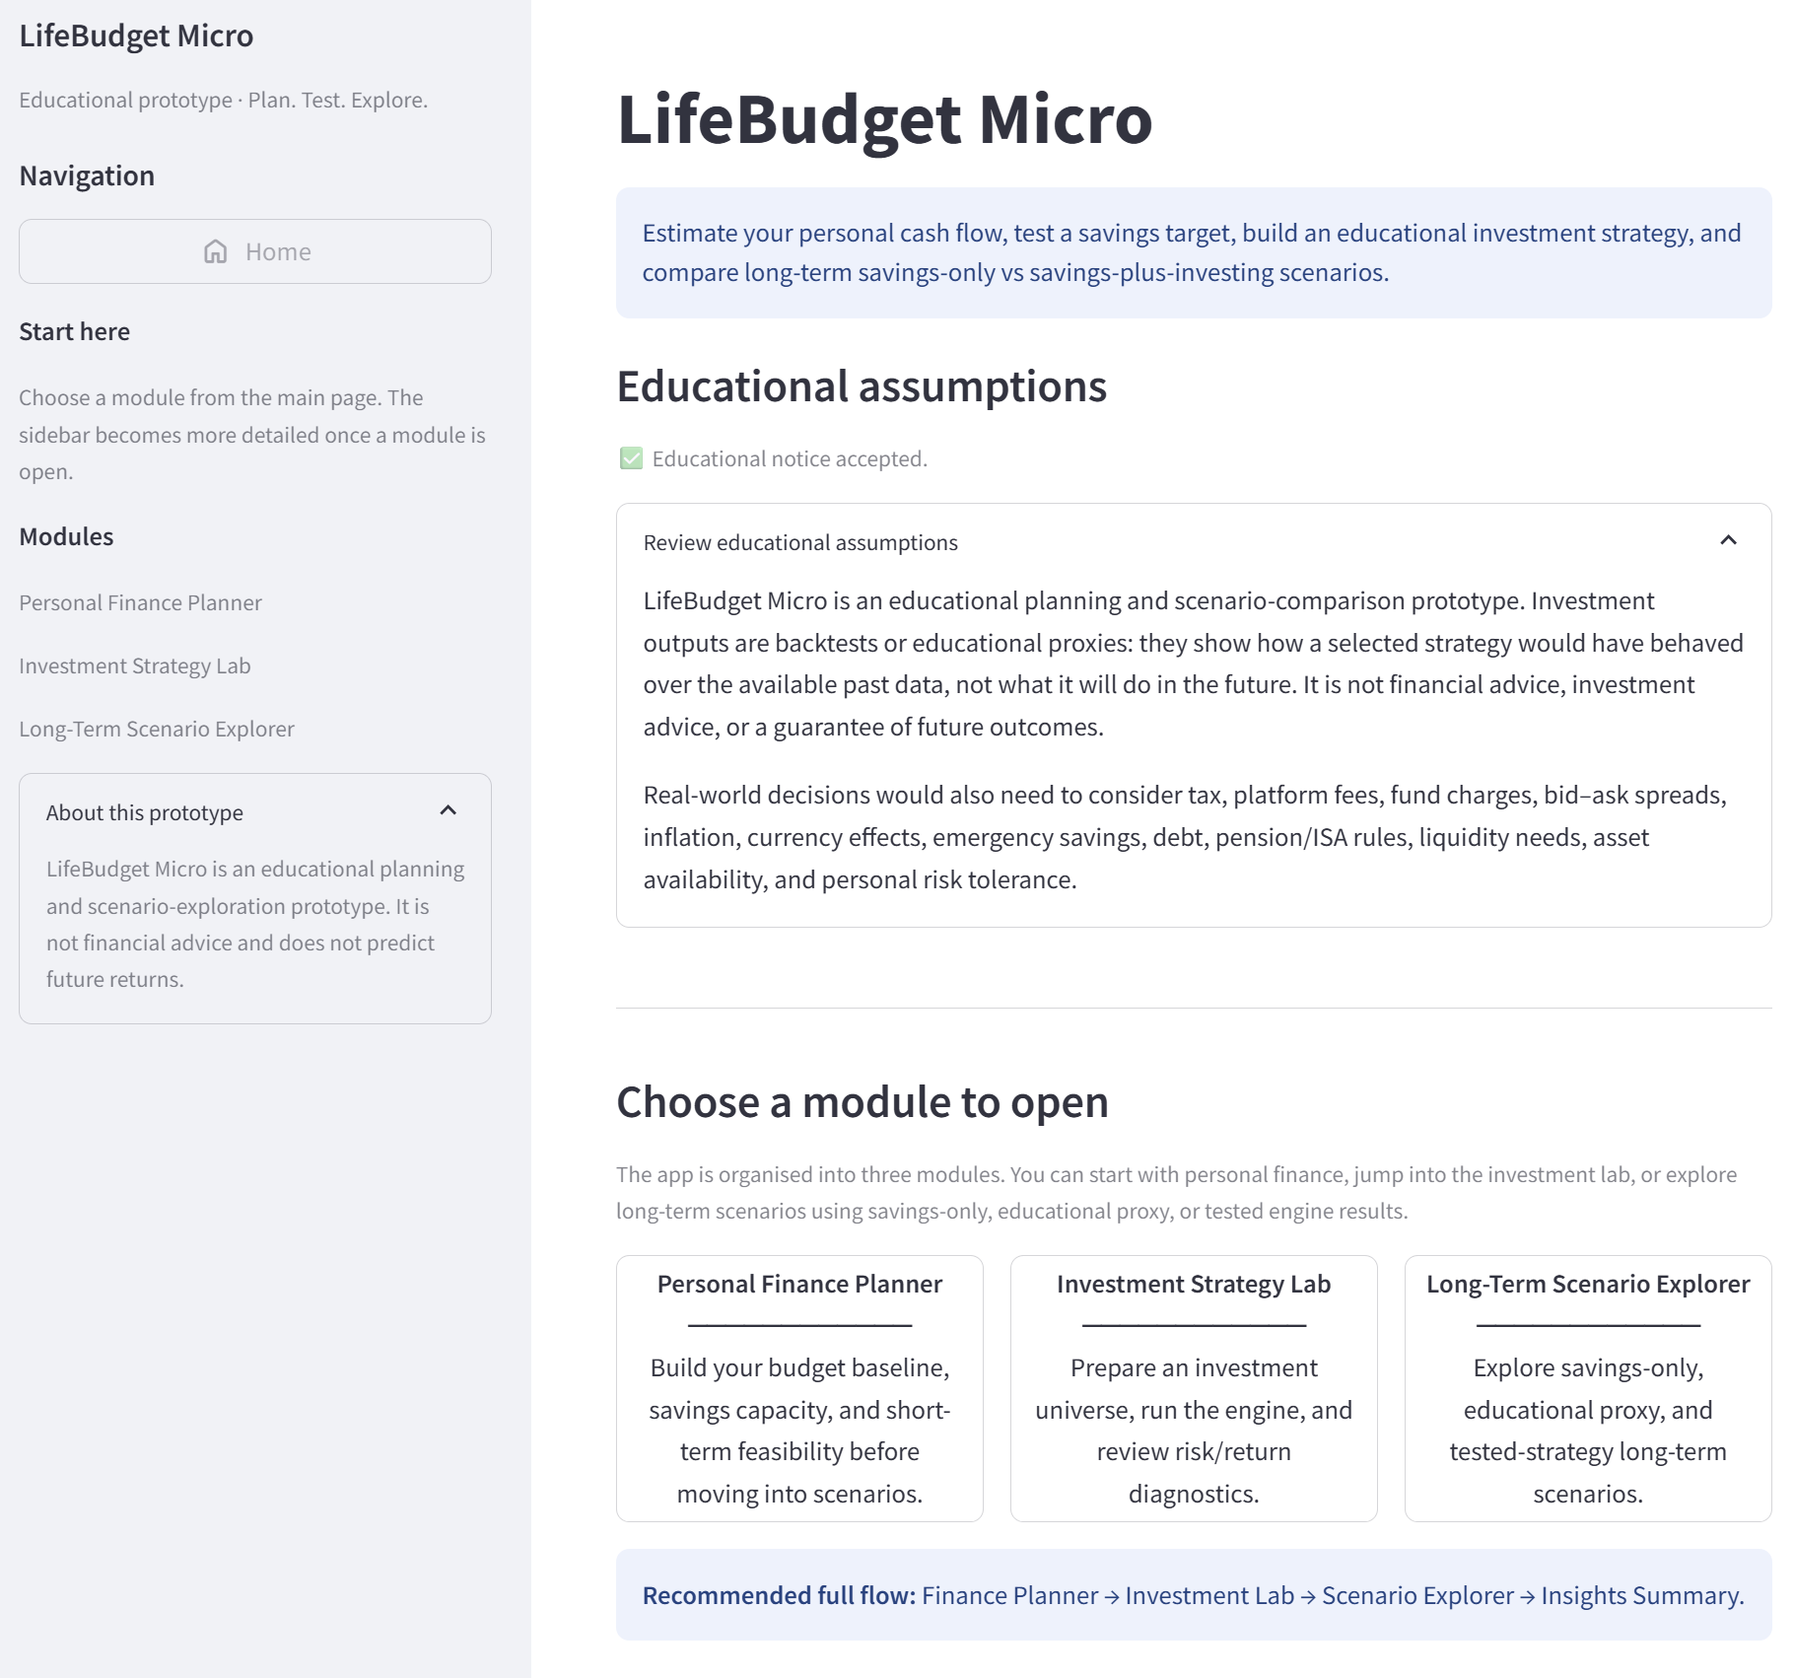
Figure 1b highlights the main elements of the home screen: the sidebar navigation and Home button (1), the educational assumptions area (2), the review assumptions expander (3), the module cards (4), and the recommended full workflow banner (5).
1
2
3
4
5
Figure 1b. Home screen after accepting the educational notice, with the main navigation and module-selection elements highlighted.

6.1 User Choices on This Screen
- Review the educational assumptions and limitations.
- Accept the educational notice to enable the module cards.
- Open one of the three main modules: Personal Finance Planner, Investment Strategy Lab, or Long-Term Scenario Explorer.
- Use the sidebar Home button later to return to this screen. On the home screen itself, this button is visible but disabled because the user is already there.

6.2 Module Cards
- Personal Finance Planner: builds the budget baseline, estimates savings capacity, and tests short-term target feasibility.
- Investment Strategy Lab: prepares an investment universe, runs the Strategy Engine, and reviews risk/return diagnostics.
- Long-Term Scenario Explorer: compares savings-only, educational proxy, and tested-strategy long-term scenarios.

7. Personal Finance Planner
The Personal Finance Planner is the first recommended module in the full workflow. It creates a simple budget baseline, estimates the user's free margin, and turns that surplus into a savings target that can later be used by the investment and long-term scenario modules.
The module uses weekly values as the common planning baseline, while also summarising the plan in weekly, monthly, and yearly terms. Its purpose is to estimate income, spending, free margin, savings capacity, and short-term target feasibility without trying to recreate a complete bank statement.
The key output is the savings/contribution bridge: a planning estimate that connects the Personal Finance Planner to the Investment Strategy Lab and Long-Term Scenario Explorer.
Figure 2a highlights the main setup screen: the current-plan sidebar (1), the guidance message explaining why the module matters (2), the budget estimate and quick presets (3), the detailed controls expander (4), and the weekly/monthly/yearly summary table (5).

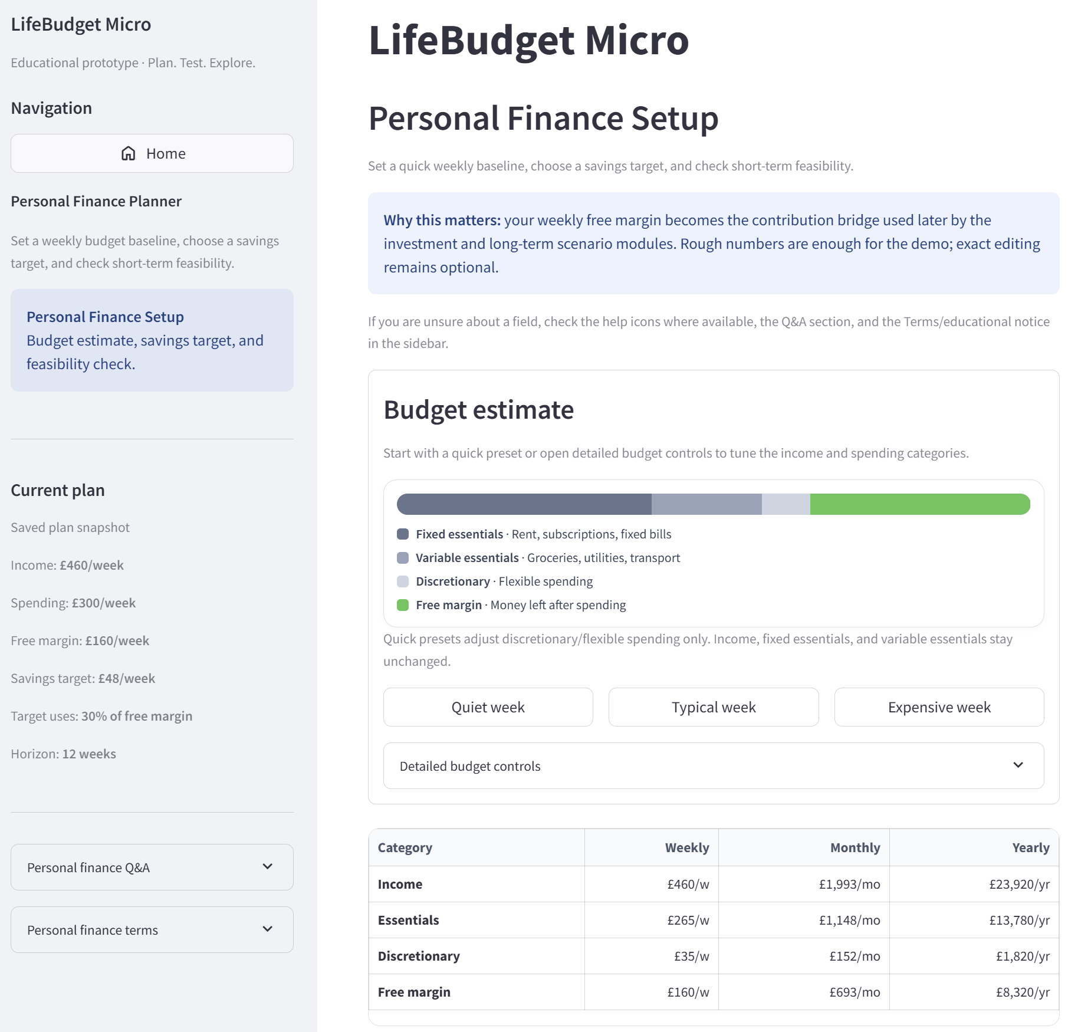
1
2
3
4
5
Figure 2a. Personal Finance Planner setup area with the main setup elements highlighted.

7.1 Budget Setup, Inputs, and Example Values
The user can start with a quick preset, adjust the main budget sliders, or open detailed budget controls for more precise estimates. These routes all update the same underlying budget baseline, so the basic demo flow does not require every optional control to be used.
Route | What the user does | When it is useful
Quick presets | Choose Quiet week, Typical week, or Expensive week. These presets adjust discretionary / flexible spending while keeping income, fixed essentials, and variable essentials unchanged. | Fastest route for a demo or rough planning baseline.
Budget sliders | Adjust take-home income, fixed essentials, variable essentials, and discretionary spending. | Best route for simple manual tuning.
Gross-pay estimate | Estimate take-home income from gross income, income period, and deduction rate. | Useful when the user knows gross income but not take-home pay.
Fixed essentials breakdown | Itemise rent/housing, utilities, council tax, internet/phone, transport pass, insurance, and subscriptions. | Useful when fixed commitments need to be transparent.
Variable essentials breakdown | Estimate groceries, utilities, household basics, and commute costs. | Useful when variable needs should be broken down.
Exact totals editor | Enter income and spending totals directly with weekly, monthly, or yearly periods. | Useful when the user already knows the exact totals they want to test.

The core budget inputs are take-home income, fixed essentials, variable essentials, discretionary spending, savings target, and short-term horizon. Detailed budget controls can estimate take-home pay, itemise fixed or variable essentials, or enter exact income and spending totals. Optional stress-test settings control the horizon, spending variability, and one-off life-event assumptions used in the feasibility check.
The detailed controls are included for transparency and flexibility, but a user can complete the main test flow by using the quick presets, budget sliders, and savings-target card only.
Example test values used in the guide:
Income: £460/week | Spending: £300/week | Free margin: £160/week | Savings target: £48/week | Target uses about 30% of free margin | Horizon: 12 weeks
Figure 2b shows the detailed budget controls: the main budget sliders (1) and the optional setup tools (2).

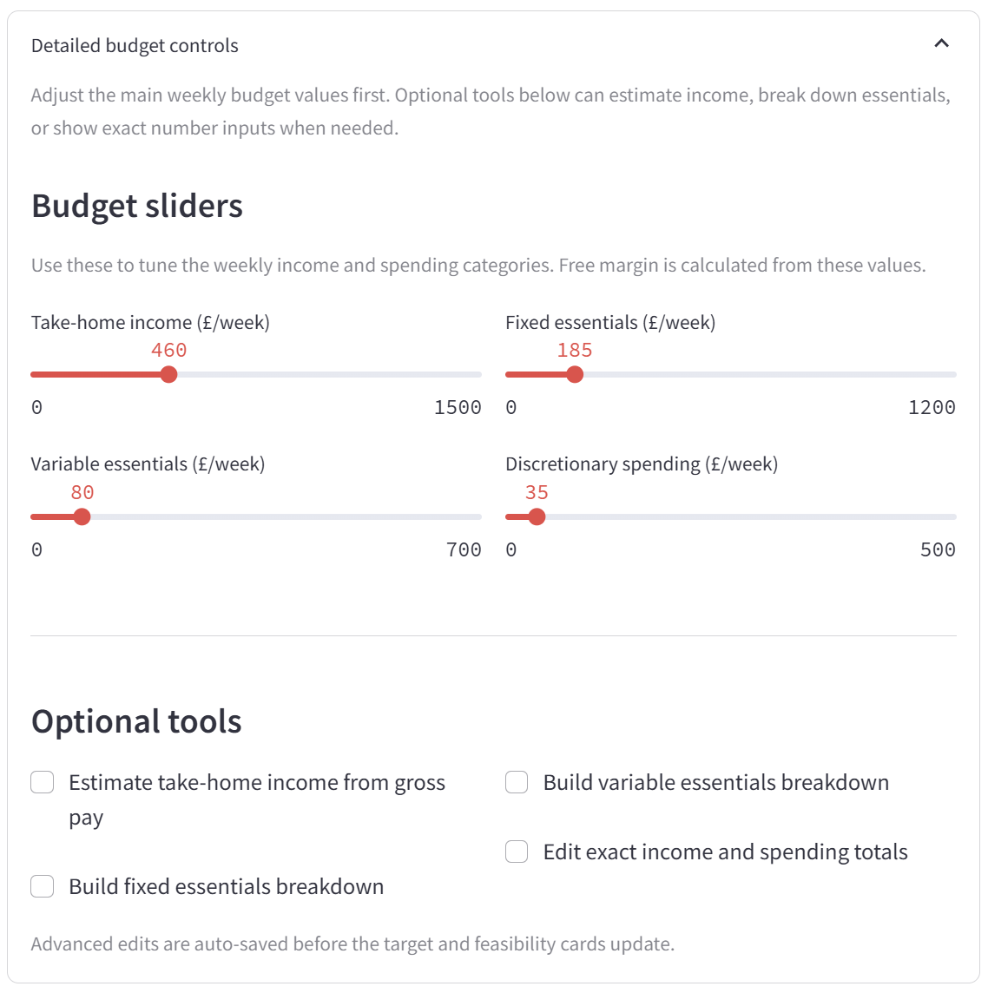
1
2
Figure 2b. Detailed budget controls, including budget sliders and optional setup tools.

7.2 Outputs and Interpretation
The module produces a budget summary, cash-flow summary, savings target, feasibility check, short-term path chart, uncertainty band, and sidebar current-plan summary.
- Budget summary: weekly, monthly, and yearly view of income, essentials, discretionary spending, and free margin.
- Cash-flow summary: compact view of income, spending, and free margin.
- Savings target card: lets the user test cautious, balanced, or stretch savings habits.
- Feasibility check: shows conservative, expected, and high-case outcomes for the short-term plan.
- Short-term path chart and uncertainty band: compare the baseline path with the target plan and show the 10-90% range when short-term variability is applied.
- Sidebar current plan: keeps the key values visible while the user edits the module.
Figure 2c highlights the main outputs: the cash-flow summary (1), savings target (2), feasibility check card (3), short-term path chart (4), and optional stress-test settings (5).

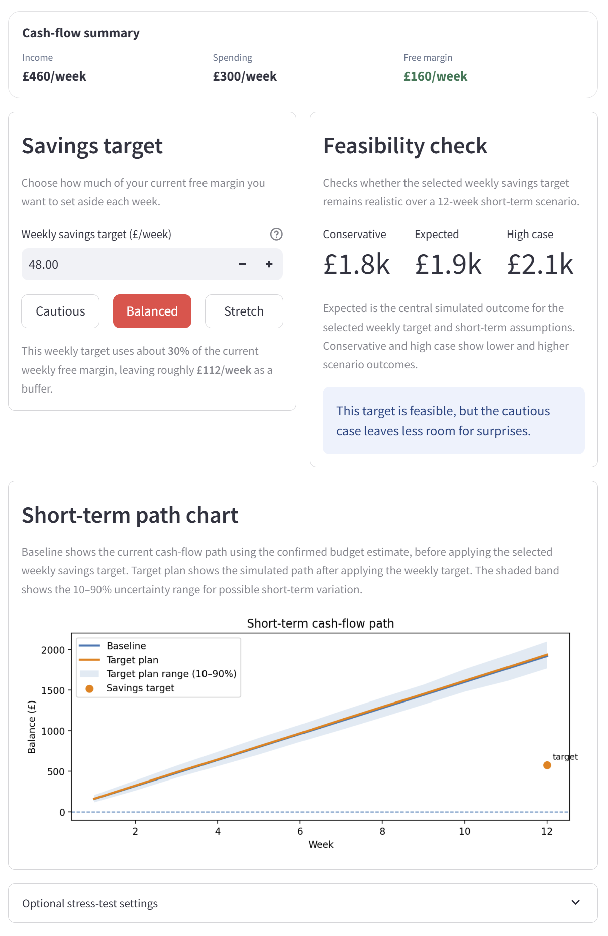
1
2
3
4
5
Figure 2c. Main Personal Finance Planner outputs and stress-test settings.
A positive free margin suggests that the entered assumptions leave potential savings capacity. A negative or very small free margin suggests that the plan may need adjustment before testing longer-term scenarios.
The feasibility check is not a guarantee; it is a short-term planning stress check based on the values entered. Its purpose is to show whether the selected savings target still appears workable under uncertainty.
The savings/contribution bridge is the key value carried into the Investment Strategy Lab and Long-Term Scenario Explorer.

7.3 Caveats for This Module
- The figures are planning estimates, not verified bank data.
- The module does not assess whether the user's real financial situation is suitable.
- Weekly values are used as a common baseline, while the app also displays monthly and yearly equivalents.
- Stress-test controls affect only the short-term planning check, not investment results.

8. Risk Profile and Asset Universe
This module prepares the educational investment setup used by the Strategy Engine. The user chooses a risk profile, selects or customises an asset universe, confirms the funding bridge from the Personal Finance Planner, and checks that the market-data panel is ready.
This screen should be interpreted as a setup and data-preparation step. It decides what risk profile, asset basket, contribution bridge, and market data the later Strategy Engine can use. No portfolio optimisation, walk-forward testing, or performance evaluation happens here; those steps happen later in the Strategy Engine.
Once the setup and market-data status look correct, the user can continue to the Strategy Engine.
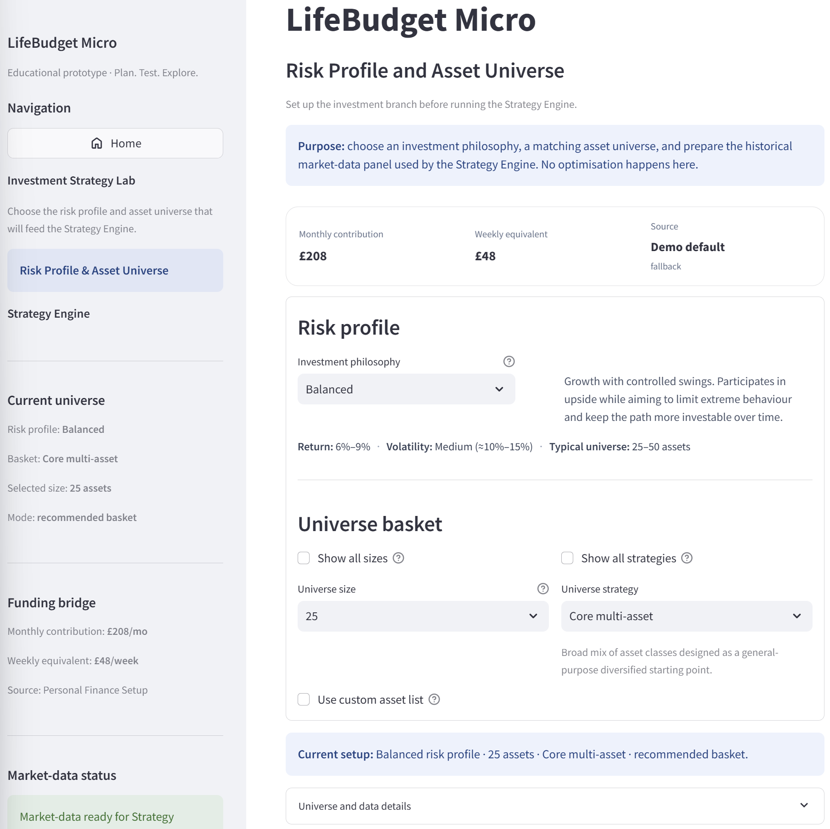
Figure 3a highlights the main setup screen: the sidebar summary and funding context (1), the purpose/no-optimisation guidance (2), the contribution bridge inherited from the finance setup (3), the risk-profile selector (4), and the universe-basket controls with the current setup summary (5).
1
2
3
4
5

Figure 3a. Risk Profile and Asset Universe setup screen with the main setup areas highlighted.

8.1 Main Setup Controls
The main setup controls define the investment posture and the basket of assets that the later Strategy Engine can test. These controls are educational setup choices, not personal recommendations.
Control | What it changes | How to read it
Risk profile | Selects Growth, Balanced, or Defensive. | Changes the broad educational posture of the scenario. Balanced is a middle-ground example; Growth accepts larger swings; Defensive prioritises stability.
Universe size | Sets the intended number of selected assets. | Smaller universes are easier to inspect; larger universes can provide broader coverage but add complexity.
Universe strategy | Sets the type of basket, such as Core multi-asset, Diversified global beta, Equity heavy, Defensive income, or Long-history / projection-friendly. | Defines which kind of asset mix is available to the Strategy Engine.
Show all sizes / strategies | Reveals additional setup options. | Useful for deliberate testing, but not required for the normal flow.
Use custom asset list | Allows the generated basket to be replaced with manually selected assets. | Useful for custom testing, but still educational rather than personalised advice.

8.2 Main Outputs
- Current setup summary: risk profile, number of selected assets, universe strategy, and whether the basket is recommended or custom.
- Funding bridge: monthly contribution and weekly equivalent inherited from the Personal Finance Planner.
- Market-data panel status: confirmation that the panel is ready for the Strategy Engine, including asset count, row count, return frequency, and data source.
- Universe mix and full asset list: transparent view of the selected asset basket.
- Optional diagnostics and CSV exports: technical preview and audit information for users or reviewers who want more detail.
- Continue to Strategy Engine: used once the setup and market-data status look correct.

8.3 Universe Details, Market Data, and Optional Diagnostics
The Universe and data details expander provides transparency about the selected basket and the data that will feed the Strategy Engine. Figure 3b shows the universe mix (1), the full asset list with ticker/name/group/subgroup labels (2), the cached deployment panel notice (3), and the market-data setup fields used by the hosted deployment (4).

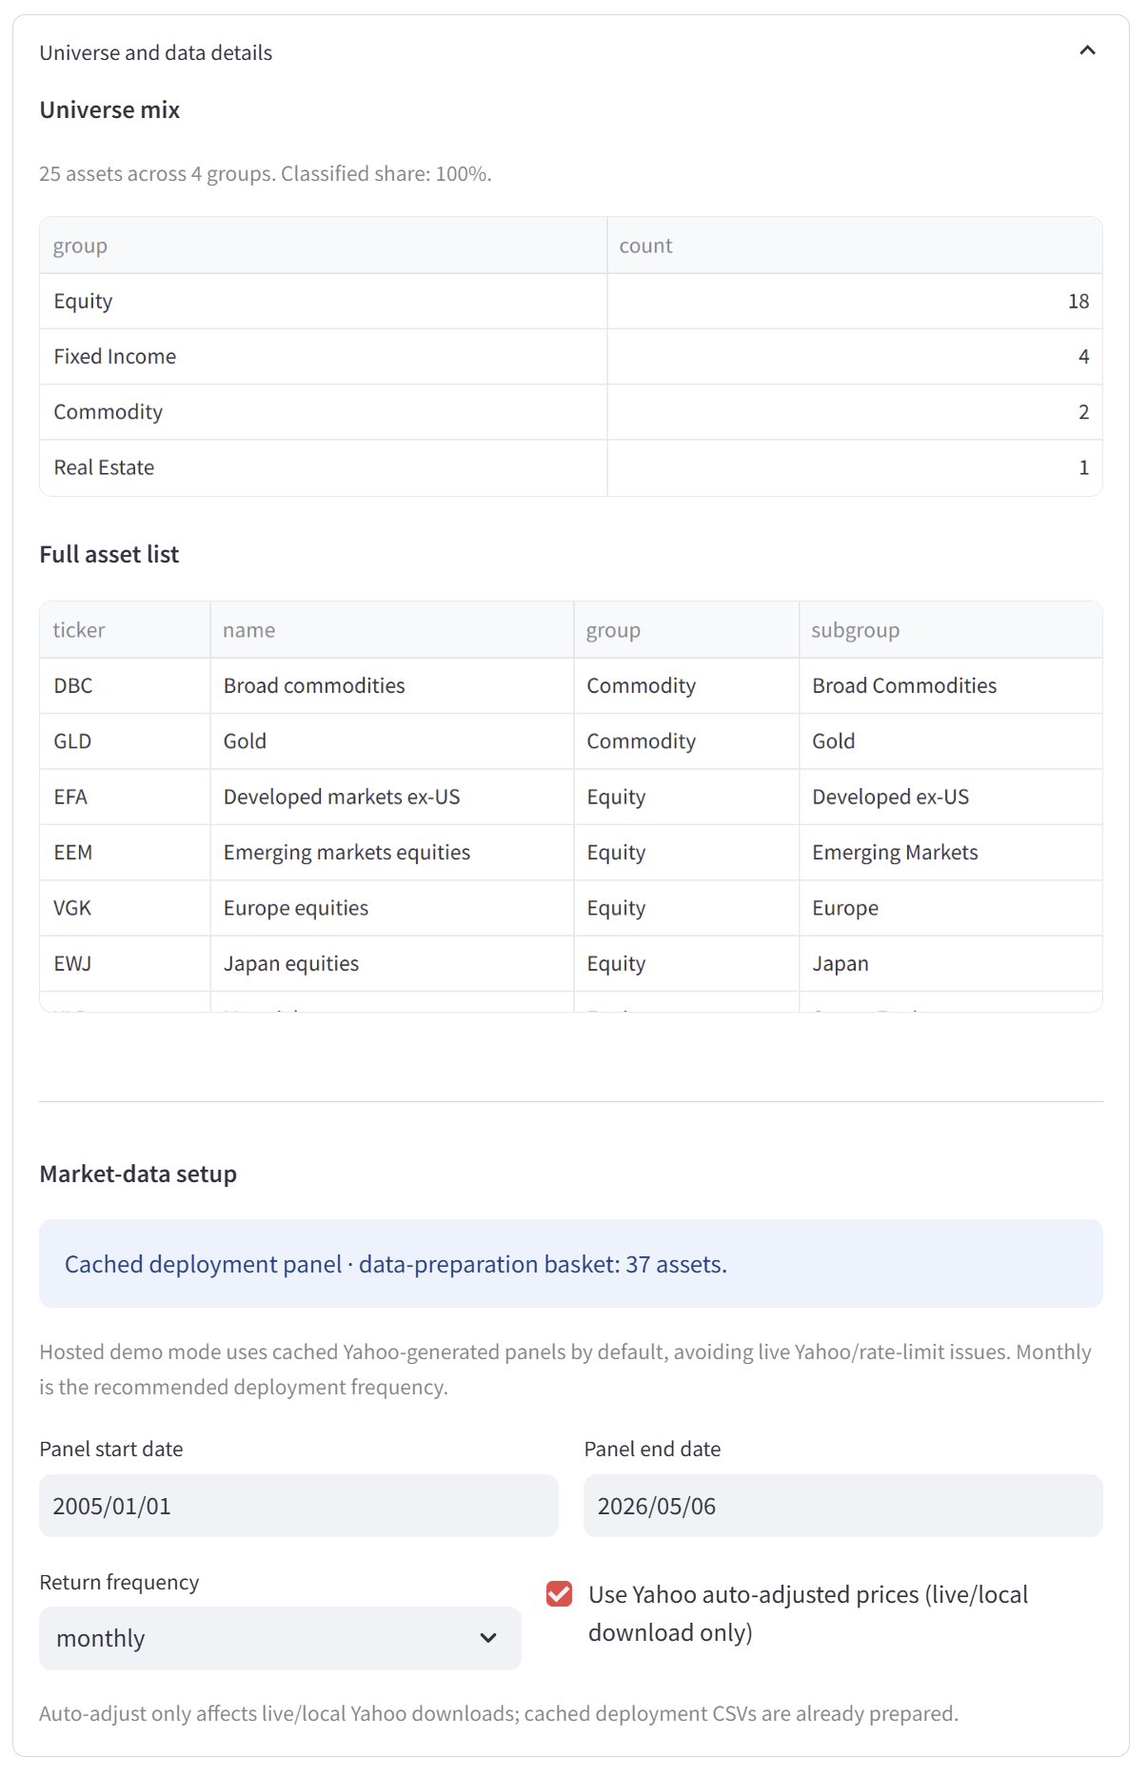
1
2
3
4
Figure 3b. Universe and market-data details, including asset mix, full asset list, and cached deployment panel setup.
- Universe mix: summarises the selected assets across groups such as Equity, Fixed Income, Commodity, and Real Estate.
- Full asset list: shows the tickers and labels included in the selected basket.
- Market-data setup: shows the historical coverage, return frequency, and cached deployment panel used by the hosted app.
In the example screenshots, the Balanced / Core multi-asset setup uses a 25-asset recommended basket. The prepared market-data panel may contain a broader cached data-preparation basket, which is why the panel asset count can be higher than the selected universe size.

Custom asset selection and diagnostics are optional. They support transparency and deliberate testing, but they are not required for the normal setup flow.
- Custom asset list: lets the user manually override the generated preset basket. Turning the override off returns to the generated preset while keeping the previous custom selection available if the user turns it back on.
- Diagnostics and downloads: can show prepared panel previews, timing breakdowns, ticker audits, and CSV export controls. These tools help with auditability and debugging, but they do not refresh data or run the engine by themselves.
Figure 3c shows part of the diagnostics area: the ticker audit (1), CSV download controls (2), and Back/Continue navigation buttons (3).
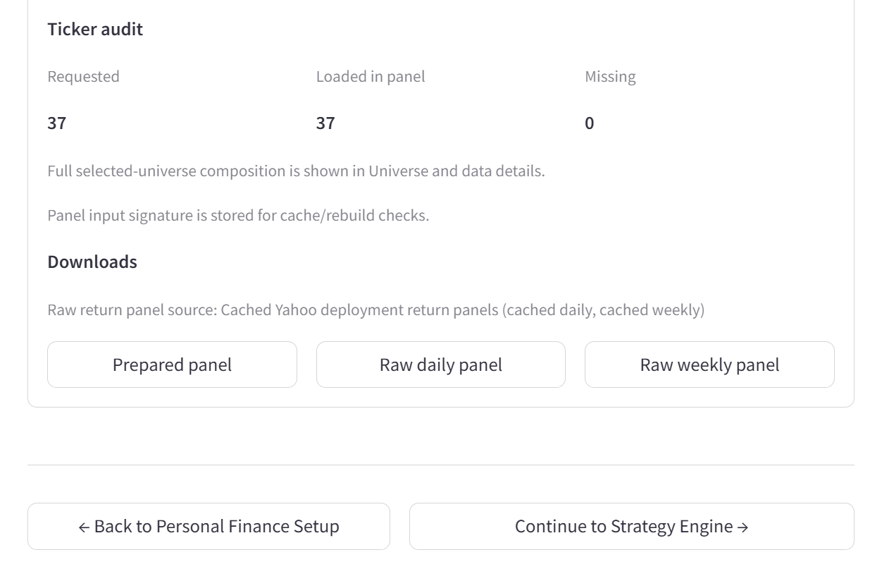
1
2
3
Figure 3c. Diagnostics, ticker audit, download controls, and navigation after the market-data panel is prepared.

8.4 Caveats for This Module
- Risk profiles and universe baskets are educational setup options, not investment recommendations.
- No optimisation or backtest result is produced on this screen.
- Cached market data improves hosted-demo reliability but may not always match a live Yahoo download at a later date.
- Asset availability depends on the prepared market-data source.
- The funding bridge is inherited from the finance setup and remains an estimate rather than verified bank data.

9. Strategy Engine
The Strategy Engine turns the selected risk profile, asset universe, and market-data panel into a tested historical strategy return path. The portfolio path is created first; headline metrics such as CAGR, volatility, Sharpe ratio, and maximum drawdown are calculated afterwards.
This module is the historical test layer of the prototype. It shows how one selected setup behaved over the available tested period, including risk and drawdown. It is not a forecast, guarantee, or live fund track record.
The normal workflow is to choose a strategy template and style preset, optionally fine-tune the setup, run the portfolio, review the results, and then continue to the Long-Term Scenario Explorer once a tested result is stored.
Before the run, the screen shows whether the selected universe and market-data panel are ready. The Long-Term Scenario button remains disabled until a tested Strategy Engine result has been created.
The most important practical output is the stored tested result. This result allows the Long-Term Scenario Explorer to use an actual tested strategy path rather than only a generic educational proxy.
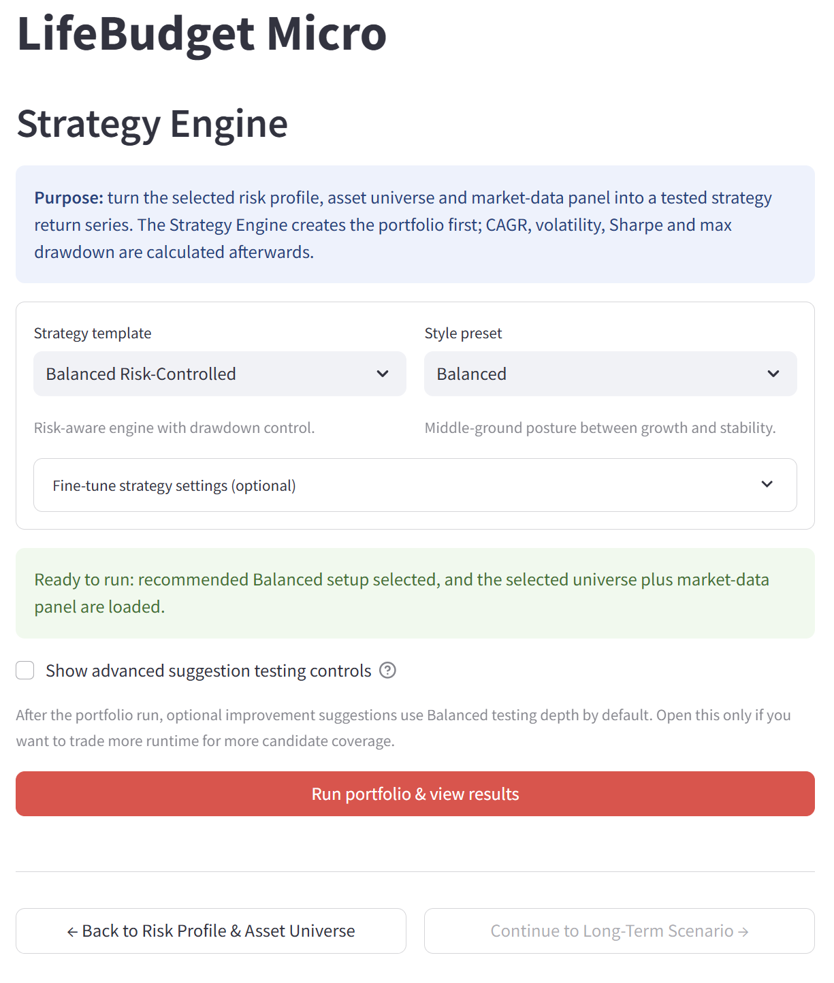
Figure 4a highlights the pre-run Strategy Engine screen: the strategy template and style preset (1), the fine-tune settings expander (2), the ready-to-run confirmation (3), the advanced suggestion-testing toggle (4), the Run portfolio button (5), and the disabled Long-Term Scenario button before a run exists (6).
1
2
3
4
5
6

Figure 4a. Strategy Engine pre-run setup screen with the main run controls highlighted.

9.1 Pre-Run Setup and Controls
Before running the portfolio, the user chooses a high-level engine setup. These controls are educational setup choices, not personal recommendations. The sidebar acts as a pre-run checklist: it shows the selected template, style preset, risk profile, panel size, row count, and funding bridge inherited from the Personal Finance Planner.
Control | What it changes | Normal use
Strategy template | Selects the broad engine method, such as Balanced Risk-Controlled, Core Ranking, or Hybrid Research. | Use the recommended template for the basic demo; change it only to compare construction styles.
Style preset | Applies a risk posture such as Defensive, Balanced, or Growth. | Use it as the main user-facing strategy posture control.
Fine-tune strategy settings | Plain-English posture sliders for risk appetite, drawdown protection, diversification, responsiveness, turnover, and signal confidence. | Optional. Leave at preset values for the normal demo; open only to test a deliberate posture change.
Advanced technical engine overrides | Low-level parameters such as top_k, lookbacks, signal mode, temperature, inertia, weight shrink, and feature-mu options. | Technical only. Leave unchanged unless testing a clear hypothesis.
Advanced suggestion testing controls | Sets how many optional improvement candidates are tested after the portfolio run. | Leave closed for the fastest normal run; open only if broader post-run suggestion testing is needed.
Run portfolio & view results | Runs the selected setup and creates the tested historical result. | Main action once the green ready-to-run confirmation is visible.

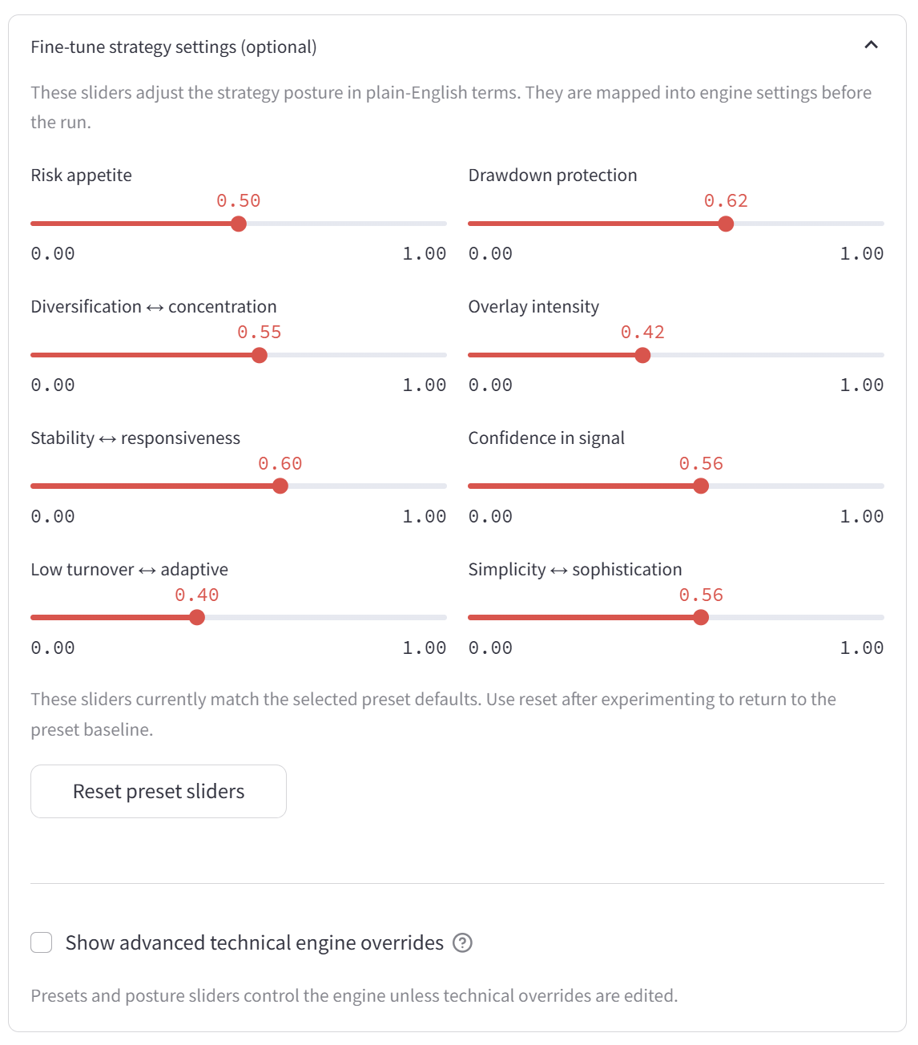
Figure 4b shows the optional fine-tune controls: posture sliders (1), the reset preset sliders button (2), and the advanced technical override toggle (3).
1
2
3

Figure 4b. Optional fine-tune settings and technical override entry point.
The Technical improvement guide supports deliberate experiments by explaining which controls may affect CAGR, volatility, MaxDD, or Sharpe. It should be treated as experiment guidance, not as a promise of improvement.
The safest demo route is to run the recommended setup first, then open advanced controls only when there is a clear reason to test alternatives.

9.2 Run Action, Results, and Benchmark Context
The main action is Run portfolio & view results. Once selected, the app runs the historical strategy test using the selected engine setup, asset universe, market-data panel, and funding context. The user should wait for the results-ready confirmation before reviewing post-run outputs.
After the run completes, the Strategy Engine Results screen shows a green completion message, the headline metrics, a collapsed setup/rerun area, and a “How to read this result” expander. The optional improvement checks appear below the main metrics. These outputs should be read together rather than as isolated scores.
The main metrics are:
- CAGR: annualised growth over the evaluated historical window; not a guaranteed future return.
- Volatility: how bumpy or variable the tested return path was.
- Max drawdown: worst historical fall from a previous high to a later low; the main pain-test metric.
- Sharpe: risk-adjusted return measure that depends on the tested period and assumptions.
Benchmark context compares the tested strategy with simple same-period references such as the S&P 500, Nasdaq-100, and Gold. This helps frame whether the strategy behaved more like a growth benchmark, defensive diversifier, or risk-controlled profile.
Main result outputs include:
- Tested strategy return path and headline metrics.
- CAGR, volatility, maximum drawdown, and Sharpe ratio.
- Plain-English metric interpretation for the selected risk profile.
- Same-period benchmark context.
- Stored result that can be used by the Long-Term Scenario Explorer.
In the guide example, the baseline run produced CAGR 9.73%, volatility 11.71%, maximum drawdown -19.43%, and Sharpe 0.85. If the user applies an improvement suggestion, the active displayed result can update; the screenshots show early improvement phases moving the result to approximately CAGR 9.93% and then 10.00%, with slightly lower volatility and drawdown. These are historical test outputs for comparison inside the app, not forecasts.

Figure 4c shows the post-run results screen: the results-ready confirmation (1), the headline metrics (2), the How to read this result expander (3), the optional improvement phase cards (4), the active recommendation metrics (5), and the Apply / Keep decision buttons (6).
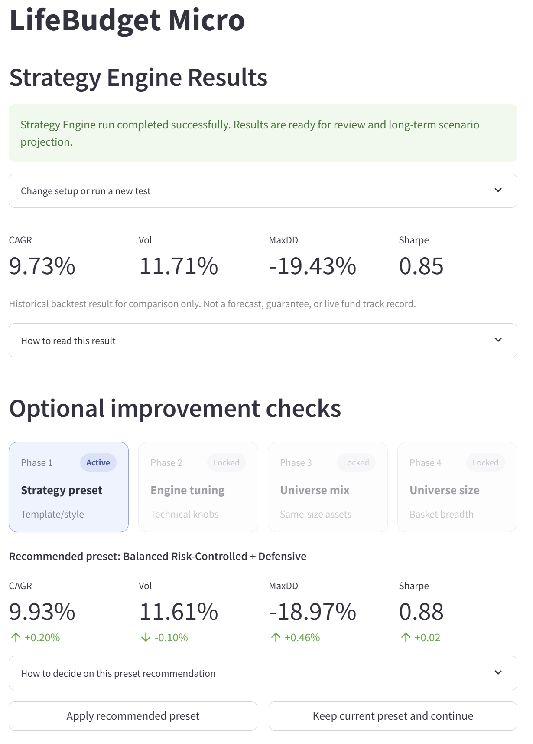
1

2

3

4

5

6

Figure 4c. Strategy Engine Results screen showing the completed run, headline metrics, and an active optional improvement phase.

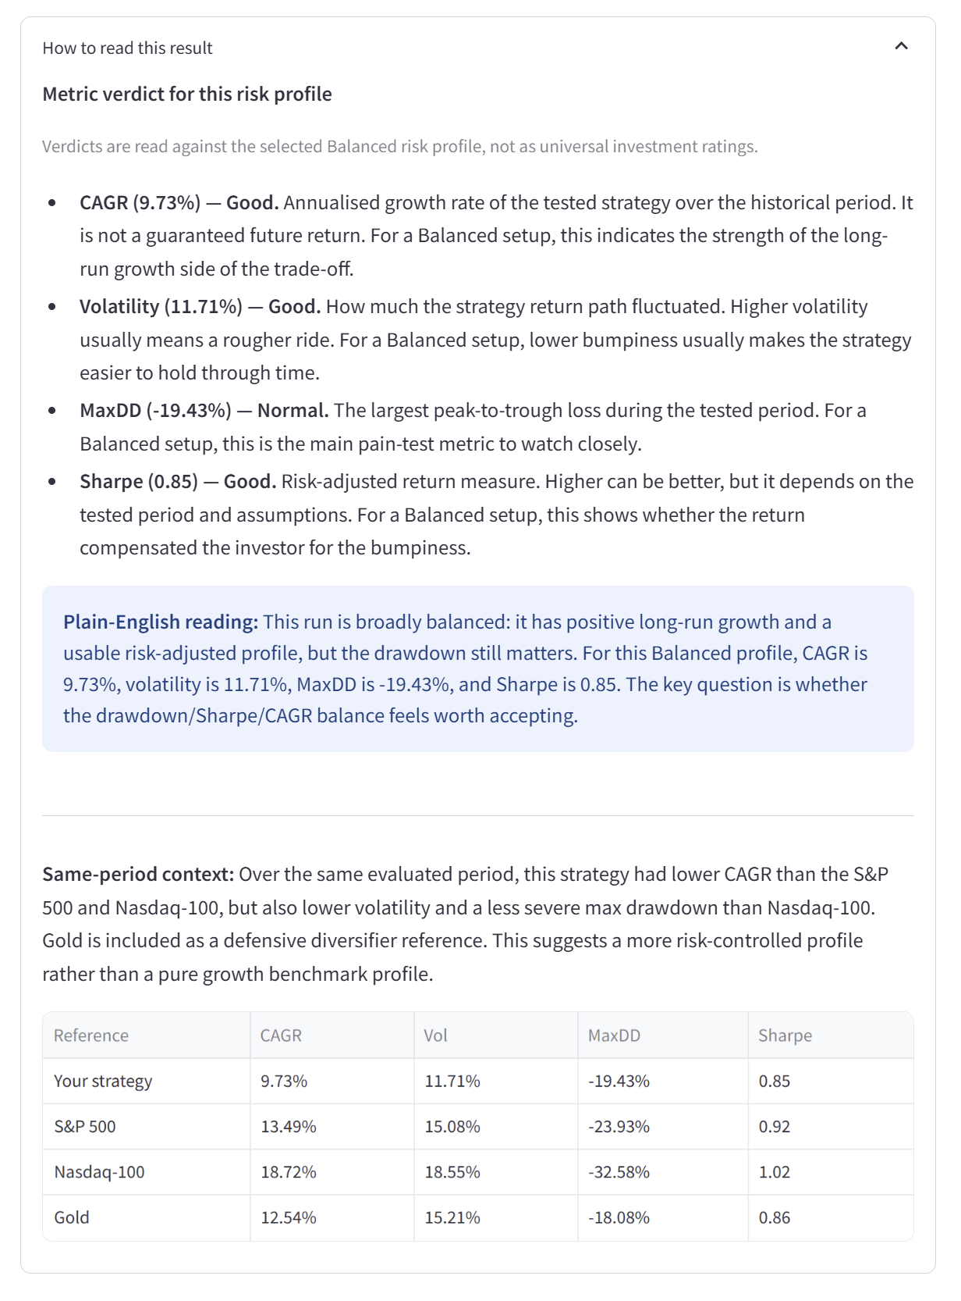
Figure 4f shows the result interpretation panel: metric verdicts for the selected risk profile (1), the plain-English reading (2), same-period benchmark context (3), and the benchmark comparison table (4).
1

2

3

4

Figure 4f. Result interpretation panel showing metric verdicts, plain-English explanation, and same-period benchmark context.

9.3 Optional Improvement Checks
The advanced suggestion testing toggle is configured before the portfolio run, but the checks themselves appear after the run. Higher testing depth checks more candidates and can add several minutes of real engine runtime.
After a run, the app can compare controlled alternatives before the user moves into long-term projection. Suggestions preserve user control: the app can recommend a change, but the user decides whether to apply it, keep the current setup, or continue without changing that phase.
The phase cards show the current improvement state. Active means the user can decide on that phase now. Applied means a rerun-tested candidate was accepted. Locked means later phases are waiting for earlier decisions. Skipped means the current setup was kept because no tested candidate passed the acceptance gate, or because the user chose to continue without applying a change.
Each active recommendation includes a “How to decide…” expander. This gives a plain-English decision guide, shows whether the candidate passed the acceptance gate, displays a compact candidate table, and keeps the Apply / Keep decision under user control.
Phase | Focus | User decision
Phase 1 - Strategy preset | Tests an alternative template/style combination. | Apply the recommended preset or keep the current preset and continue.
Phase 2 - Engine tuning | Tests small parameter changes within the current strategy family. | Apply the recommended tuning or keep the current tuning and continue.
Phase 3 - Universe mix | Tests same-size changes to the asset mix. | Apply the recommended universe composition or keep the current mix.
Phase 4 - Universe size | Tests whether a broader or narrower basket improves the trade-off. | Apply a size change if it passes the gate, or keep the current size.
Apply means the rerun-tested candidate is accepted and carried forward. Keep or skip means the current setup is retained. A skipped phase is not a failure; for example, the universe mix or universe size phase may be skipped when no tested alternative materially improves the overall trade-off enough to pass the acceptance gate.
The decision guide is to compare the whole result profile, not only one number. A slightly higher CAGR may not be attractive if it creates a much larger drawdown, higher volatility, or weaker Sharpe profile.
In the guide example, early improvement phases can improve the displayed trade-off, while later universe-mix or universe-size phases may be skipped if no tested alternative materially improves the result.
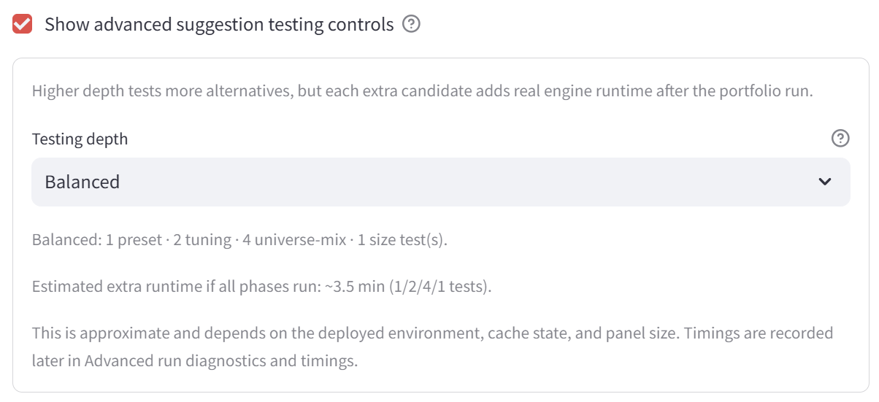
Figure 4d shows the optional suggestion testing control: the toggle for advanced suggestion checks (1), the selected testing depth (2), and the approximate extra runtime message (3).
1

2

3

Figure 4d. Optional suggestion testing depth before the portfolio run.
Figure 4g shows a post-run improvement decision area: the decision guide (1), the acceptance gate message (2), the candidate comparison table (3), the recommended technical settings and explanation (4), and the Apply / Keep buttons (5).
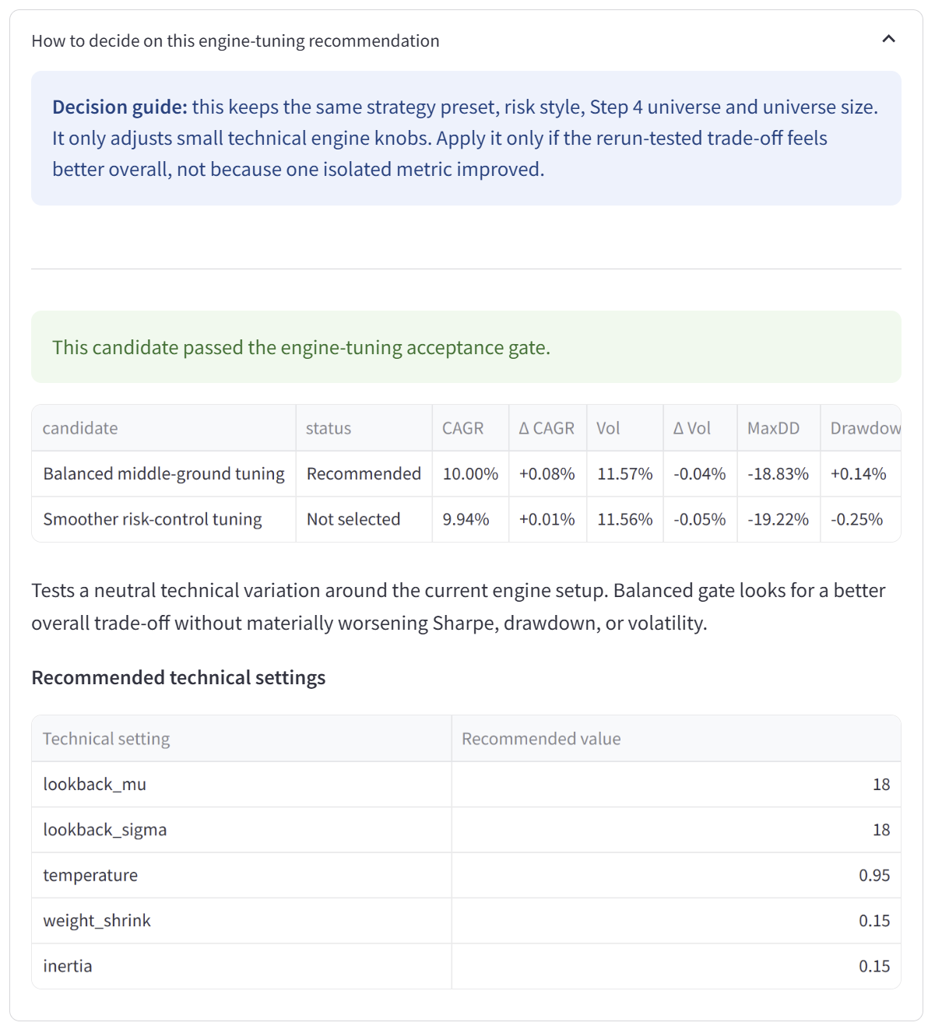
1

2

3

4

5

Figure 4g. Optional improvement decision area showing the decision guide, acceptance gate, candidate comparison, recommended settings, and Apply / Keep controls.

9.4 Diagnostics, Reliability, and Robustness
Diagnostics, reliability, and robustness tools are optional transparency layers. They are useful for technical review and interpretation, but they are not recommendations and do not make the result predictive.
After a run, the sidebar can show a latest-result summary and timing snapshot. The timing panel can show the engine runtime, walk-forward time, probabilistic layer time, OOS months, panel shape, suggestion overhead, phase-level suggestion timings, and component-level engine timings.
Reliability and robustness are best reviewed after optional improvement checks are completed, because accepted suggestions can change the setup being assessed.
- Run timings and metadata: explain runtime, panel shape, run signature, config fingerprint, timestamp, and major engine components.
- Suggestion timing: shows how long optional improvement checks took and how many candidates were tested or passed.
- Reliability assessment: summarises the evidence supporting the result and the main method caveats.
- Benchmark validation: recomputes benchmark metrics from the same selected market-data panel and evaluated period.
- Start-date robustness: reruns the same configuration from different historical start windows to test sensitivity to the chosen start date.
In the guide example, the reliability panel reports Moderate-to-Strong overall reliability and Strong start-date robustness after the robustness check has been run. These labels mean the result looked more stable across the checks performed inside the app; they do not make the result a forecast.
Start-date robustness may initially show “Not run yet”. When run, it reuses the selected market-data panel and reruns the same configuration across alternative historical start windows. Timing varies by deployed environment, cache state, panel size, selected testing depth, and whether robustness checks are run.

Figure 4h shows the reliability and robustness panel: the overall reliability label (1), the start-date robustness label (2), the confidence explanation (3), the robustness status and action area (4), and the detailed evidence / validation area (5).
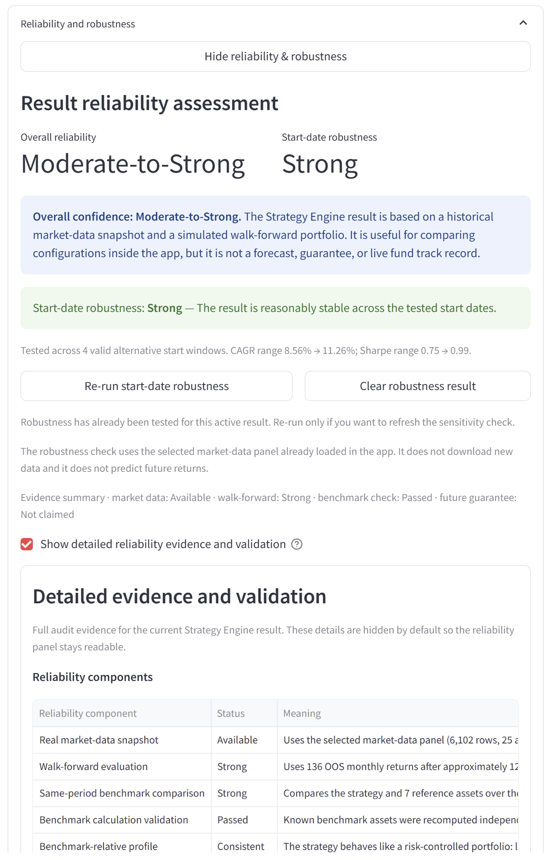
1

2

3

4

5

Figure 4h. Reliability and robustness panel showing overall reliability, start-date robustness, detailed evidence, benchmark validation, and method limits.

9.5 Caveats for This Module
- Historical backtest results are not forecasts or guarantees.
- The engine can improve one metric while worsening another, so the whole trade-off should be considered.
- Optional improvement checks and applied suggestions are educational scenario choices, not advice.
- Advanced technical overrides can make results harder to interpret if changed without a clear hypothesis.
- Reliability, timing, and start-date diagnostics support transparency, but they do not predict future regimes.
- The tested result can support long-term scenario comparison, but it still remains a historical educational output.

10. Long-Term Scenario Explorer
The Long-Term Scenario Explorer converts the contribution bridge from the Personal Finance Planner into long-term scenario ranges. It compares a savings-only baseline with either a completed Strategy Engine return path or a clearly labelled educational investment proxy.
This module asks a different question from the Strategy Engine. The Strategy Engine shows how a selected setup behaved on the historical market-data panel. The Long-Term Scenario Explorer asks what range of contribution outcomes could occur if future returns behaved similarly to the selected return path or proxy.
It should not be read as a forecast. It does not predict an exact future amount; it shows possible low, middle, and high outcome ranges under the selected contribution, horizon, return-path, and simulation assumptions.
The user should normally:
- check the monthly contribution carried forward from the Personal Finance Planner;
- confirm whether the scenario uses a tested Strategy Engine path or an educational proxy;
- set the starting investment pot, optional wealth goal, and comparison horizons;
- review or refresh the projection as settings change;
- compare the savings-only baseline with the P10, median, and P90 scenario range;
- continue to the Final Report once the scenario has been generated.
In the guide example, the module uses a contribution of about £208/month, equivalent to about £48/week, and a Balanced projection profile. The example screen also uses a £0 starting pot, an optional £3,000 wealth goal, and horizon comparisons including the current one-year view plus 20, 30, and 50 years.

Figure 5a shows the Long-Term Scenario Explorer main screen, including the scenario status sidebar, contribution bridge, projection summary metrics, horizon comparison chart, and scenario help expanders.
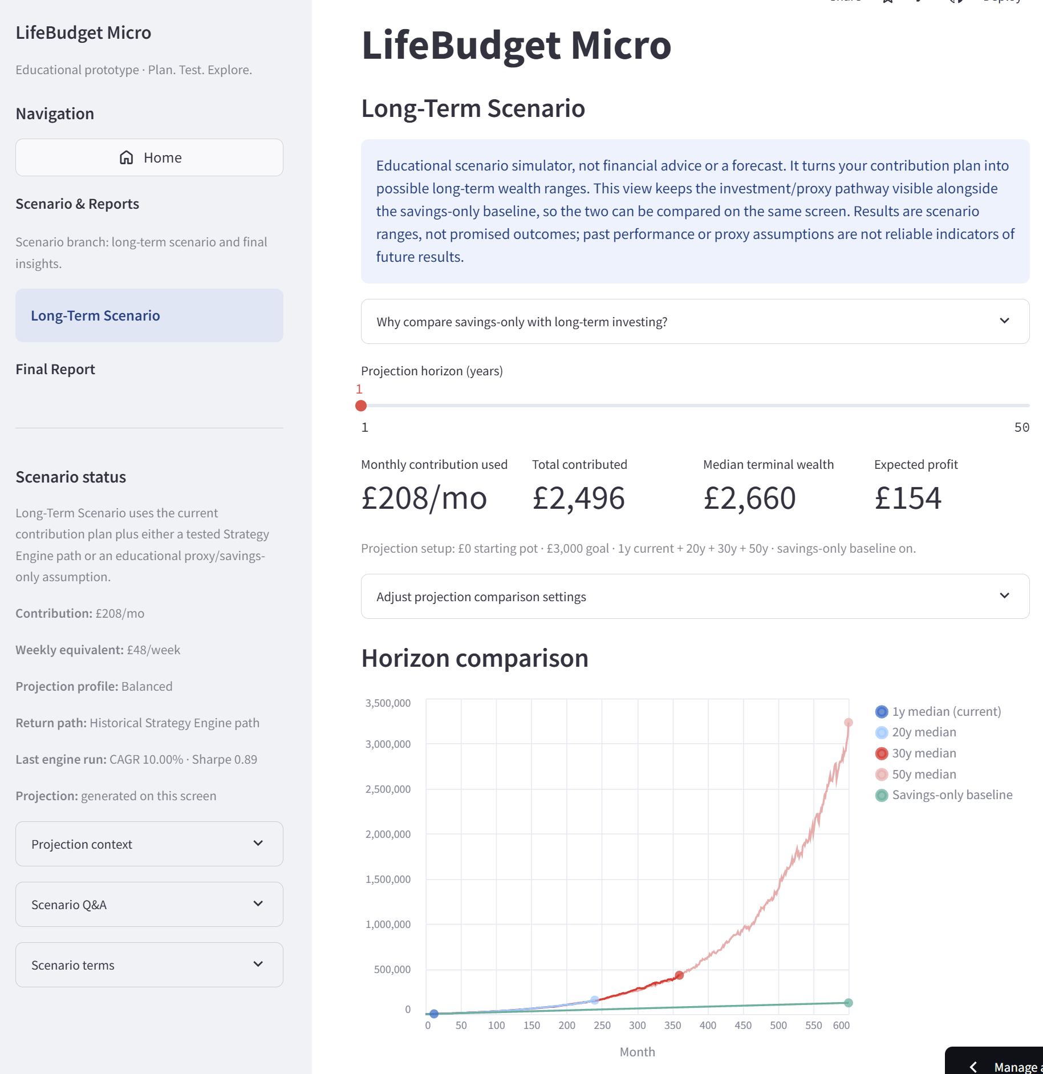
Figure 5a. Long-Term Scenario Explorer main screen showing the contribution bridge, scenario status, projection summary, and horizon comparison chart.

10.1 Projection Inputs and Scenario Settings
The projection inputs define the contribution, starting amount, goal, horizons, and scenario-generation settings. These controls are educational scenario assumptions, not personal financial recommendations. The projection comparison updates automatically when these inputs change.
Setting | Meaning | Normal use
Starting investment pot | Amount already available at the start of the long-term scenario. It is separate from future monthly contributions. | Leave at 0 for a simple contribution-only test, or enter a starting amount if the scenario should include an existing pot.
Optional wealth goal | Target amount used to calculate goal probability. In the guide screenshot, this is set to £3,000 for the current one-year scenario. | Optional. Use only when the user wants to test a specific long-term target.
Compare across horizons | Runs the same contribution and return-path assumptions across selected horizons such as 20, 30, and 50 years. | Keep enabled for the clearest long-term comparison.
Show savings-only baseline | Adds a cash/savings-only comparison path using the same starting pot and contribution but no investment return or market volatility. | Keep enabled because it is the main comparison baseline.
Horizon list | Controls which horizons appear in the comparison table and chart. | Use values such as 20, 30, and 50 years for the main demo.
Advanced scenario settings | Optional Monte Carlo and path controls. | Keep current or suggested settings unless deliberately testing assumptions.
The advanced Monte Carlo and path settings are optional and secondary. They include the number of simulated paths, the projection path mode, hybrid daily simulation, synthetic trading days per month, and daily path variation. These settings change how the scenario range is generated and displayed, but they do not make future outcomes more predictable.
In the guide example, the advanced controls show 100 Monte Carlo paths and hybrid daily simulation. The app also displays a Balanced projection coherence suggestion recommending 21 synthetic trading days per month and 0.18 daily path variation. This is an optional adjustment; users can keep the current settings unless deliberately testing projection-path assumptions.
The sidebar keeps the scenario context visible while the user reviews the projection. It normally shows the contribution bridge, weekly equivalent, projection profile, return-path source, latest Strategy Engine result, and whether the projection has been generated on the current screen. It also includes Q&A, terms, and diagnostic expanders for checking assumptions.

10.2 Savings-Only vs Investment / Proxy Comparison
The savings-only baseline is the stability comparison. It uses the same starting pot and monthly contribution but does not apply investment return, market volatility, drawdown, or strategy risk.
The investment/proxy path is not presented as a guaranteed better choice. It shows how the outcome range could change if returns behaved similarly to the tested Strategy Engine path or educational proxy. A higher median result may still involve uncertainty, temporary losses, and model risk.

The safest way to read this comparison is:
- savings-only shows the simple contribution baseline;
- the investment/proxy path shows a wider and more uncertain scenario range;
- P10 and P90 show lower and higher modelled ranges;
- the median is only the middle scenario, not a promise;
- the comparison is useful only if the user understands the assumptions behind both paths.

10.3 Main Outputs and Example Projection Values
After the projection is generated, the module shows a horizon comparison table and summary metrics. The key idea is to compare ranges and trade-offs rather than focus on one headline number.
Output | Meaning
Horizon comparison table | Compares terminal outcomes at each selected horizon, including median final wealth, savings-only baseline, P10, P90, and loss vs contributions.
Median final wealth | The middle scenario outcome across simulated paths.
P10 / P90 | Lower and higher range markers under the model assumptions. They are not promised outcomes.
Savings-only baseline | The amount produced by the same starting pot and contributions without investment return or market volatility.
Loss vs contributions | The share of simulated outcomes where the final value ends below total contributions. It is a scenario diagnostic, not a prediction.
Goal probability | The share of simulated outcomes that reach the optional wealth goal. It should be treated as secondary unless the goal is meaningful.
The screenshots show an example horizon comparison using the current contribution and selected Strategy Engine return path. The current one-year projection has a median final wealth of about £2,660, a savings-only baseline of £2,496, a P10 value of about £2,413, a P90 value of about £2,880, a loss-vs-contributions diagnostic of about 25%, and a goal probability of about 3%.
Horizon | Median final wealth | Savings-only baseline | P10 | P90 | Loss vs contrib.
1 year (current) | £2,660 | £2,496 | £2,413 | £2,880 | 25.00%
20 years | £154,777 | £49,920 | £97,858 | £273,669 | 0.00%
30 years | £430,953 | £74,880 | £234,907 | £926,909 | 0.00%
50 years | £3,234,437 | £124,800 | £1,328,866 | £7,776,863 | 0.00%
These figures are example scenario outputs from the screenshots. They depend on the selected contribution, Strategy Engine path or proxy, horizon, simulation settings, and historical data period. They should not be interpreted as expected real-world future wealth. Small differences can also appear if the user changes the projection settings before reviewing the results.

Figure 5b shows the projection results view used for the example values, including the horizon comparison table, detailed projection metrics, loss-vs-contributions diagnostic, goal probability, and navigation to the final insights summary.
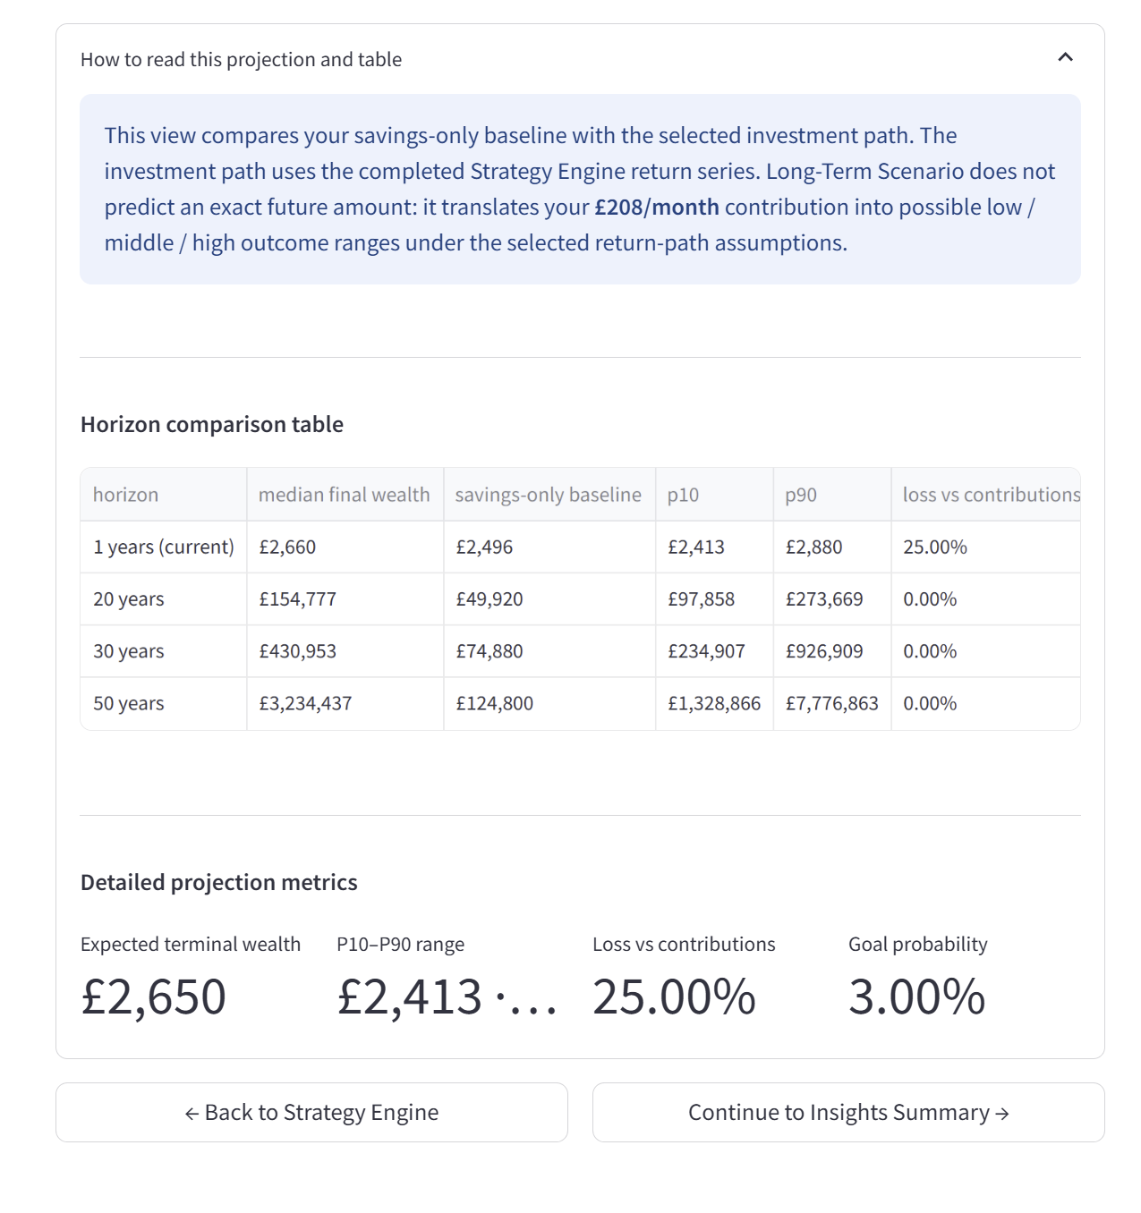
Figure 5b. Projection results view showing the horizon comparison table, P10-P90 range, loss-vs-contributions diagnostic, goal probability, and navigation to the final insights summary.

10.4 Caveats for This Module
- Monte Carlo outputs are scenario simulations, not predictions.
- The projection range depends on the selected contribution, return path, data window, horizon, and simulation settings.
- The savings-only baseline is not fully risk-free in real life because inflation and purchasing-power risk are not fully modelled.
- The investment/proxy path is not a recommendation to invest and is not guaranteed to outperform savings-only.
- More Monte Carlo paths can make the displayed range smoother, but they do not make future outcomes more certain.
- The module works at strategy-return level and does not yet show month-by-month asset-level purchase percentages.
- Essential spending is treated as fixed in the model; discretionary contribution behaviour can be adjusted by the prototype.

11. Final Report and Insights Summary
The Final Report is the closing screen of the recommended workflow. It summarises the selected personal finance plan, investment setup, tested Strategy Engine result, Long-Term Scenario comparison, and decision-support interpretation in one place.
In the guide example, the report uses a tested Strategy Engine result interpreted through the Long-Term Scenario. This is stronger than a generic educational proxy, but it is still historical scenario evidence rather than a forecast or recommendation.
The purpose of the report is to show how the earlier modules connect: the Personal Finance Planner provides the contribution bridge, the Investment Strategy Lab defines the setup, the Strategy Engine creates a historical tested return path, and the Long-Term Scenario translates those assumptions into long-term scenario ranges.
The report should be used as a final comparison and reflection screen. It helps the user compare savings-only simplicity with investment/proxy upside and uncertainty, but it does not decide what the user should do.
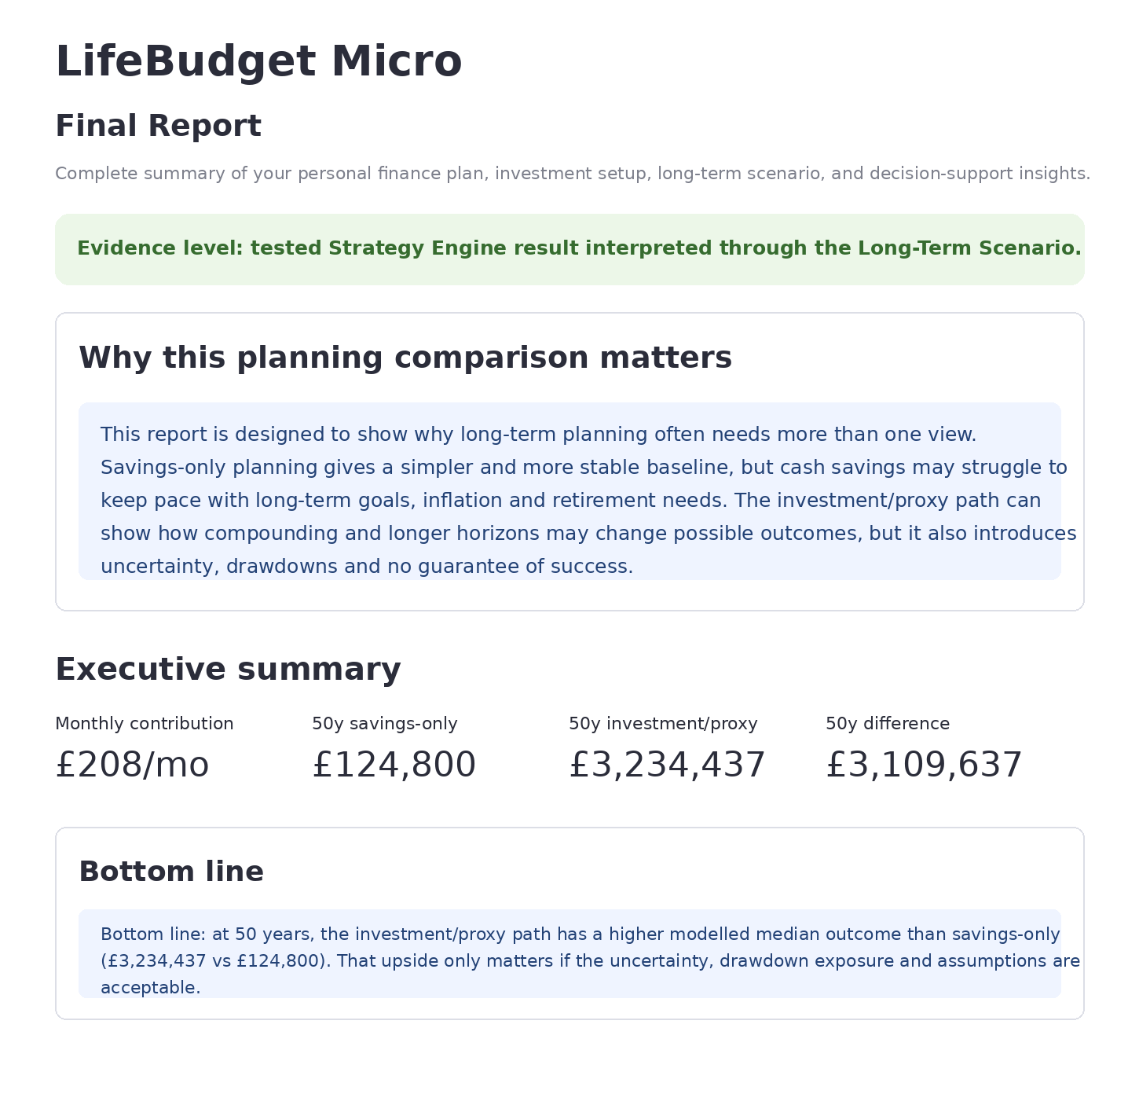
Figure 6a. Final Report overview showing the evidence level, why the planning comparison matters, executive summary, and bottom-line comparison.

11.1 Executive Summary and Setup Snapshot
The executive summary highlights the main cross-module values. In the example screenshots, the report shows a monthly contribution of about £208/month, a 50-year savings-only baseline of £124,800, a 50-year investment/proxy median of £3,234,437, and a 50-year modelled difference of £3,109,637.
Bottom line: at 50 years, the investment/proxy path has a higher modelled median outcome than savings-only in the example. That upside only matters if the uncertainty, drawdown exposure, model assumptions, and user tolerance are acceptable.
Executive metric | Example value | Meaning
Monthly contribution | £208/month | Contribution bridge inherited from the Personal Finance Planner.
50-year savings-only | £124,800 | Same contribution path without investment return or market volatility.
50-year investment/proxy median | £3,234,437 | Median modelled outcome under the selected return-path assumptions.
50-year difference | £3,109,637 | Difference between the investment/proxy median and savings-only baseline.
The setup snapshot confirms which inputs created the report. In the screenshots, the Strategy Engine snapshot shows Sharpe 0.89, CAGR 10.0%, and drawdown severity 18.8%. The setup snapshot also confirms a Balanced risk profile, a tested Strategy Engine return path, and horizon comparison across the current one-year view plus 20, 30, and 50 years.
Snapshot area | What it shows
Personal finance plan | Contribution capacity used in the scenario, such as £208/month.
Investment setup | Return path source, risk profile, and whether the Strategy Engine has been tested.
Strategy Engine snapshot | Key historical metrics such as Sharpe, CAGR, and drawdown severity.
Long-Term Scenario | Which horizons were compared, such as current 1 year, 20 years, 30 years, and 50 years.
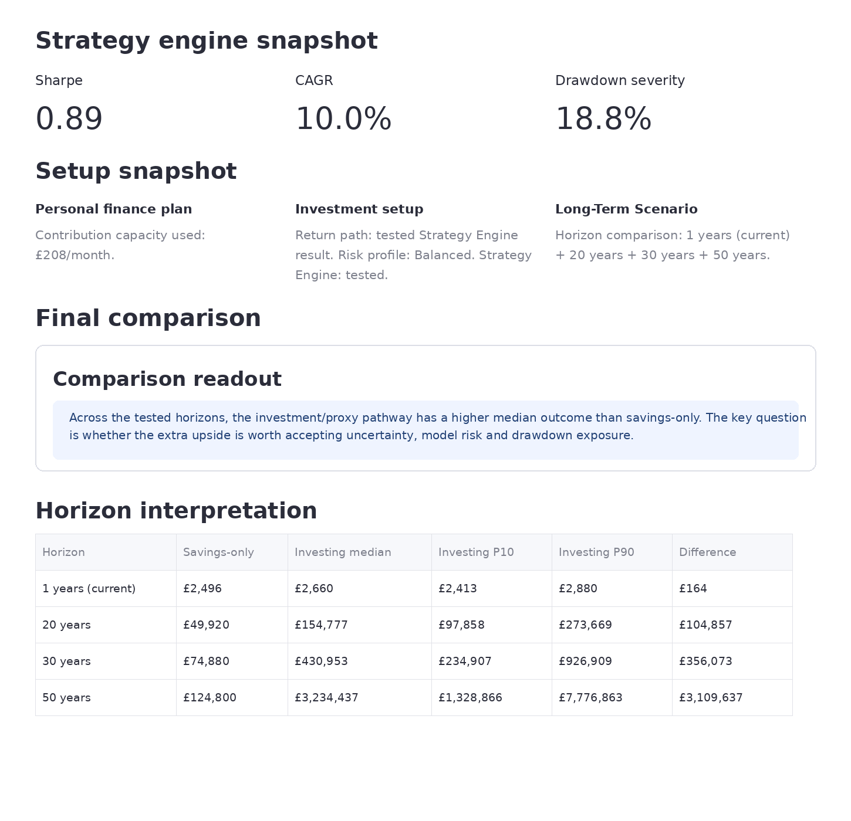
Figure 6b. Final Report comparison view showing the Strategy Engine snapshot, setup snapshot, final comparison readout, and cross-horizon interpretation table.

11.2 Final Comparison and Selected-Horizon Details
The final comparison readout explains whether the investment/proxy pathway produced a higher median outcome than savings-only across the tested horizons. It does not say that investing is automatically better; it frames the result as a trade-off between upside, uncertainty, model risk, and drawdown exposure.
Horizon | Savings-only | Investing median | Investing P10 | Investing P90 | Difference
1 year (current) | £2,496 | £2,660 | £2,413 | £2,880 | £164
20 years | £49,920 | £154,777 | £97,858 | £273,669 | £104,857
30 years | £74,880 | £430,953 | £234,907 | £926,909 | £356,073
50 years | £124,800 | £3,234,437 | £1,328,866 | £7,776,863 | £3,109,637

The Selected-horizon projection details expander keeps the main report focused while still showing the detailed values for the currently selected horizon. In the screenshots, the selected-horizon values include expected terminal wealth £2,650, median terminal wealth £2,660, P10 downside case £2,413, P90 upside case £2,880, and modelled growth £154.

Selected-horizon metric | Example value | Meaning
Expected terminal wealth | £2,650 | Average-style model output for the selected horizon.
Median terminal wealth | £2,660 | Middle scenario outcome.
P10 downside case | £2,413 | Lower scenario range marker.
P90 upside case | £2,880 | Higher scenario range marker.
Modelled growth | £154 | Modelled increase above the contribution baseline for the selected horizon.

11.3 Decision Interpretation and Safe Use
The decision interpretation section turns the numbers into plain-language planning guidance. It separates upside versus simplicity, risk trade-off, decision status, and a recommended next step.
Block | Meaning
Upside vs simplicity | Savings-only is simpler and avoids market volatility, but has limited upside. The investment/proxy path may improve the central outcome but introduces uncertainty.
Risk trade-off | A higher central scenario is not automatically a better decision; it must be judged against drawdown exposure, model risk, evidence quality, and whether the user could stay invested through bad periods.
Decision status | The report encourages continuing to test assumptions rather than treating the result as a final answer.
Recommended next step | Stress-test the Long-Term Scenario with different contributions, goals, and horizons. Return to Strategy Engine only if the investment branch needs lower drawdown, a different universe, or a cleaner risk profile.
The safe-use area reinforces that the page is for comparison and decision support only. It should not be read as financial advice, an investment recommendation, or a promise of future results.
- The Strategy Engine created a historical return path from the selected universe and engine configuration.
- The Long-Term Scenario translates contribution assumptions into projected ranges; it does not predict future wealth.
- P10, median, and P90 are scenario percentiles under the model assumptions, not guaranteed outcomes.
- The comparison is fair only when both branches use the same contribution, starting pot, goal, and horizons.
- Historical returns and educational proxies are not reliable indicators of future results.

11.4 Sidebar, Report Inputs, and Diagnostics
The final-report sidebar confirms that the report is available and lists the main state inputs used to generate it. It normally shows the source module, return-path source, monthly contribution, weekly equivalent, and horizon view. It also provides report inputs, technical diagnostics, Q&A, and terms expanders for users or reviewers who want to inspect the report state.
Sidebar diagnostic caveat: the final-report sidebar reads app state only. It does not rerun projections, refresh data, or launch diagnostics.

11.5 Caveats for This Module
- The final report summarises previous module outputs; it does not independently validate the user's real financial situation.
- A higher modelled median is not automatically a better decision because drawdown, uncertainty, model risk, and risk tolerance matter.
- The report is only as reliable as the assumptions, market-data panel, Strategy Engine result, and Long-Term Scenario settings used to create it.
- The report should support evaluation and reflection, not replace professional financial advice.
- The safest interpretation is comparative: how do different pathways behave under the same contribution and horizon assumptions?

12. Known Limitations and Future Work
LifeBudget Micro is a working educational prototype, not a production financial planning platform. The submitted version demonstrates the core end-to-end workflow while leaving several production, regulatory, data, and research extensions outside the current scope.

12.1 Current Limitations
- LifeBudget Micro is an educational prototype, not financial advice, investment advice, or a personal suitability assessment.
- The app is a historical backtesting and scenario-comparison prototype. It shows how selected strategies would have behaved over available historical data; it does not predict future market outcomes.
- Investment outputs are based on historical backtests, educational proxies, and scenario assumptions. Historical performance does not guarantee future performance.
- The prototype does not fully model tax, ISA or pension rules, platform fees, fund charges, bid-ask spreads, inflation, currency effects, debt, liquidity needs, asset availability, or individual risk tolerance.
- The hosted Streamlit version uses prepared or cached market-data panels to keep the online deployment reliable. Market data availability may vary depending on the source and data preparation pipeline.
- Hosted execution may be slower than local execution because market-panel preparation, backtesting, optional suggestion checks, and robustness diagnostics run on hosted Streamlit resources.
- The long-term projection works at strategy-return level and does not yet show month-by-month asset-level contribution allocation.
- Mobile browser access may work for quick inspection, but the prototype is primarily tested and optimised for desktop or laptop use.
- The system focuses on demonstrating core project logic and behaviour rather than production-grade financial planning, security, persistence, compliance, or large-scale deployment.

12.2 Not Implemented Yet / Future Development
- A production frontend could be rebuilt with a dedicated web framework to improve responsiveness across desktop and mobile devices.
- A production data layer should replace cached CSV panels with robust API-based market-data pipelines, multiple data sources, fallback handling, and validation checks.
- Persistent user accounts and a database layer could allow users to save, reload, compare, and export plans, strategy setups, and scenario results.
- The current strategy controls could be expanded with richer parameter governance while keeping the default user interface simple and understandable.
- Additional governance layers, such as coherence checks, stability checks, recommendation diversity checks, and guided apply/reset controls, could be extended further in a future version.
- The current historical model could be extended into a forward-looking research mode using scenario variables such as inflation assumptions, interest-rate environments, central-bank policy regimes, and geopolitical stress scenarios.
- The Long-Term Scenario engine could be improved with more realistic contribution allocation, rebalancing, fees, inflation, alternative market regimes, and asset-level contribution modelling.
- Future work could include multiple functional datasets from different providers rather than relying on one prepared cached market-data source for the hosted demo.

13. Troubleshooting
- If the app appears slow during market panel generation or strategy backtesting, wait for the relevant confirmation message before clicking additional buttons.
- If optional suggestion checks or robustness diagnostics take several minutes, wait for the next confirmation message before interacting with the controls again.
- If market data preparation fails temporarily, rerun the market panel generation step.
- If running locally, ensure that dependencies have been installed from the requirements file.
- If the hosted version becomes unresponsive, refresh the page and rerun the relevant section.
- If a chart or table is difficult to read on mobile, switch to a desktop or laptop browser.

14. Demo Recording Guide
1. Briefly introduce LifeBudget Micro and the educational notice.
2. Show the home screen and accept the educational assumptions.
3. Open Personal Finance Planner, set sample values, and show the cash-flow, feasibility, and contribution-bridge outputs.
4. Prepare the risk profile and asset universe.
5. Run the Strategy Engine and show historical metrics, benchmark context, reliability context, and optional improvement checks.
6. Open the Long-Term Scenario Explorer and generate a projection.
7. Finish with the final report, safe-use notes, and known limitations.
The demo should focus on showing the full end-to-end workflow: user input, setup preparation, historical strategy result, long-term scenario output, and final report interpretation.

