Supervisor Ready PhD Research Brief
When Should Adaptive Network Recovery Be Triggered
Wisam Makki Salim | MSc Computer Engineering | ORCID 0009-0000-6998-3912

Research context
Fast routing control can shorten disruption, but periodic HELLO and topology messages consume wireless capacity and may destabilize service. Prior work already establishes adaptive MANET routing and adaptive HELLO messaging. The practical question here is narrower: when should faster control be active, and at what cost?

Research question
Under stable, progressive, abrupt, and repeated disturbances, when does state-triggered OLSR timer adaptation improve packet delivery relative to static OLSR and always-on fast control, and what control and harmful-tail costs accompany any improvement?

Existing implementation
The ns-3.47 implementation uses a 16-node wireless ad hoc topology and two UDP flows. B0 uses standard OLSR timers. B1 keeps HELLO at 0.5 s and TC at 1.0 s. B2 applies the same fast timers after a signal or transmission-failure trigger. The v2 study added a repeated-disturbance condition and fixed the disturbed node across mechanisms for each seed.
Condition | Meaning | Runs per mechanism
A | Stable negative control | 30
B | Progressive mobility disturbance | 30
C | Abrupt next-hop radio failure | 30
D | Repeated out-and-back mobility | 30

Evidence produced
The package contains 360 fresh paired runs, per-run logs, raw and processed tables, deterministic bootstrap intervals, three regenerated figures, and explicit checks for missing rows and disturbance-target mismatches.

Verified findings
Condition | Always-on PDR effect | Triggered PDR effect | Always-on cost | Triggered cost
Stable | +0.571 [-0.630, +2.312] | +0.432 [+0.000, +1.296] | +0.05410 | +0.00004
Progressive | +1.591 [+1.214, +1.971] | +0.108 [-0.069, +0.320] | +0.05305 | +0.00307
Failure | +1.453 [+1.055, +1.796] | -0.117 [-0.279, +0.010] | +0.05043 | +0.00111
Repeated | +3.392 [+2.736, +4.049] | +0.404 [-0.261, +1.055] | +0.05357 | +0.00378
Reading the table. PDR effects are paired mean percentage-point differences from static OLSR with 95% percentile-bootstrap intervals. Cost is normalized OLSR control bytes per delivered payload byte.
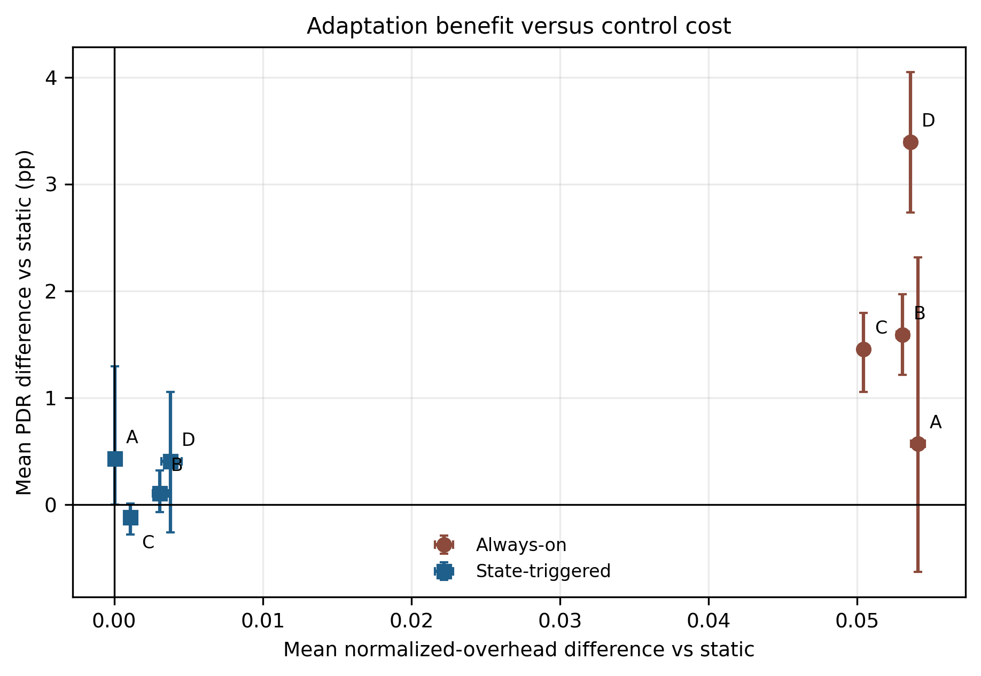
Figure 1 Mean delivery effect and normalized control cost relative to static OLSR. Error bars show 95% paired bootstrap intervals.

Interpretation and limitations
Always-on fast control improves mean delivery in all three disturbance conditions, but adds a large and consistent control cost and raises p95 delay in most runs. The locked triggered rule does not reproduce that benefit reliably. It also triggers in 3 of 30 stable runs, so the 20-event threshold is not validated. One topology family, two flows, deterministic path loss, and an aggregate recovery definition limit generalization.

Proposed doctoral extension
The next step is a guarded trigger and exit policy that combines route state with channel-load evidence, caps reactive duration, and treats worst-flow harm as a constraint. Confirmation requires fresh development and evaluation seeds, several topology and mobility families, heterogeneous traffic, and selected testbed checks.

Repository and feasibility
Repository: https://github.com/wisam-makki-salim/adaptive-routing-resilience-ns3-pilot. The work is suitable for an externally conducted doctorate because simulation, analysis, and documentation can be performed remotely; short visits could support design review and physical validation. Any formal arrangement remains subject to the supervisor and university regulations.

