Pilot Study v2 Technical Report
Resilience and Control Cost Tradeoffs in Adaptive OLSR
Wisam Makki Salim | MSc Computer Engineering | ORCID 0009-0000-6998-3912

Abstract
This study asks whether state-triggered OLSR timer adaptation provides a better resilience-cost balance than static operation and permanent fast control. A fresh ns-3.47 experiment executed 360 paired runs across stable, progressive, abrupt-failure, and repeated-disturbance conditions. Always-on fast control improved mean packet delivery in the three disturbance conditions but increased normalized control overhead by about 0.050 to 0.054 and usually increased p95 delay. The pre-specified state-triggered rule did not produce a repeatable delivery gain and activated in 3 of 30 stable runs. The evidence therefore rejects the tested trigger as a validated solution while identifying a specific doctoral problem: guarded activation and exit control under explicit overhead and worst-flow constraints.

Research question and contribution boundary
The primary question is when state-triggered fast control improves delivery relative to static and always-on operation, and what costs accompany any gain. The contribution is a reproducible three-way comparison with a fixed disturbance target, fresh paired seeds, and retained negative results. Timer adaptation is established prior work; this report does not claim a new routing protocol or state-of-the-art performance.

Related work position
RFC 3626 defines periodic OLSR HELLO and TC messaging. Qin and Kunz studied adaptive MANET routing, Hoebeke and colleagues examined context-dependent routing modes, and Han and Lee studied adaptive HELLO messaging. These studies establish the broader direction. The pilot addresses a narrower design question through an explicit static, always-on, and state-triggered comparison.
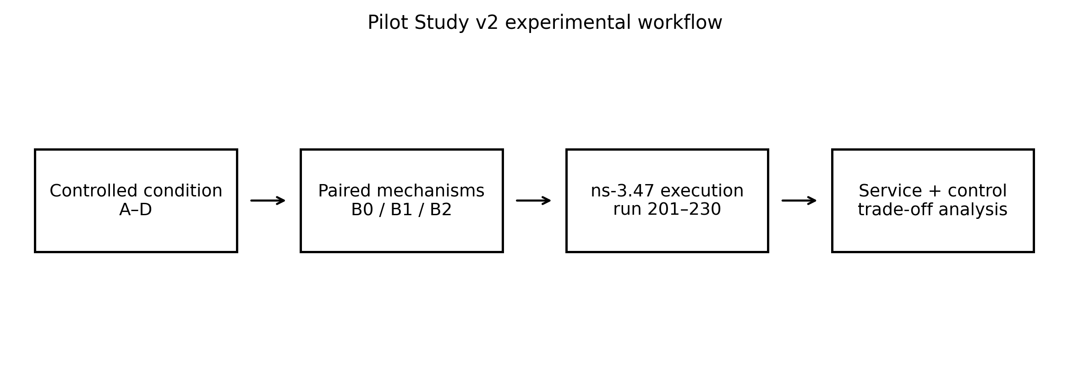
Figure 1 Executed v2 workflow. Every condition uses the same 30 run numbers across B0, B1, and B2.

Methods
Sixteen nodes form a jittered four-by-four IEEE 802.11g ad hoc topology. Two UDP flows transmit 512-byte packets every 20 ms during a 120 s simulation. B0 uses HELLO 2.0 s and TC 5.0 s. B1 uses HELLO 0.5 s and TC 1.0 s throughout. B2 enters the same fast mode at -81 dBm after three weak samples or after 20 final transmission failures within the implemented burst rule.
Item | Locked value
Simulator | ns-3.47, optimized build
Fresh runs | 201–230, paired across mechanisms
Conditions | A stable; B progressive; C failure; D repeated
Primary outcome | Packet delivery ratio
Guardrails | Worst-flow PDR, p95 delay, overhead, recovery, route availability
Uncertainty | 50,000 deterministic paired bootstrap resamples
For each fresh run, a static B0 probe identifies the active next-hop target. That node is then fixed for B0, B1, and B2. This correction prevents the mechanism from changing the disturbance it receives. Every simulator process writes a separate log and a 22-field result row. The analysis rejects incomplete matrices or target mismatches.

Results
Condition | B1 PDR difference | B2 PDR difference | B1 overhead | B2 overhead
A | +0.571 [-0.629, +2.304] | +0.432 [0.000, +1.296] | +0.05410 | +0.00004
B | +1.591 [+1.214, +1.969] | +0.108 [-0.069, +0.320] | +0.05305 | +0.00307
C | +1.453 [+1.054, +1.796] | -0.117 [-0.279, +0.010] | +0.05043 | +0.00111
D | +3.392 [+2.738, +4.044] | +0.404 [-0.260, +1.050] | +0.05357 | +0.00378
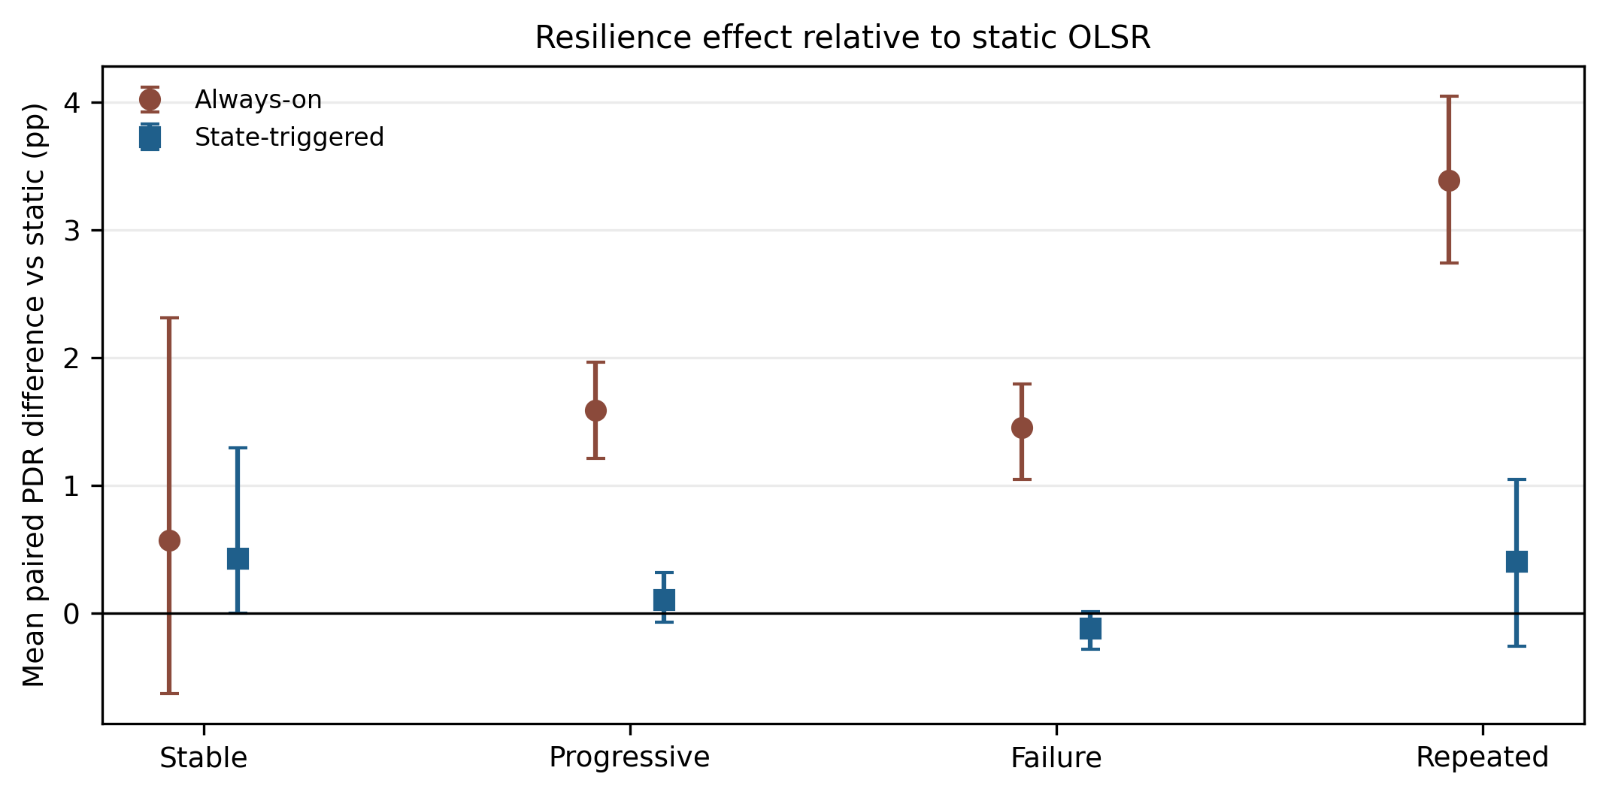
Figure 2 Mean paired PDR difference from static OLSR with 95% bootstrap intervals.
B1 increased PDR in 28/30 B runs, 28/30 C runs, and 29/30 D runs. B2 effects were mixed: 14/30 B runs improved, 8/30 C runs improved, and 17/30 D runs improved. Relative to B1, B2 PDR was lower by 1.483 points in B, 1.570 in C, and 2.988 in D. The corresponding intervals were wholly below zero.
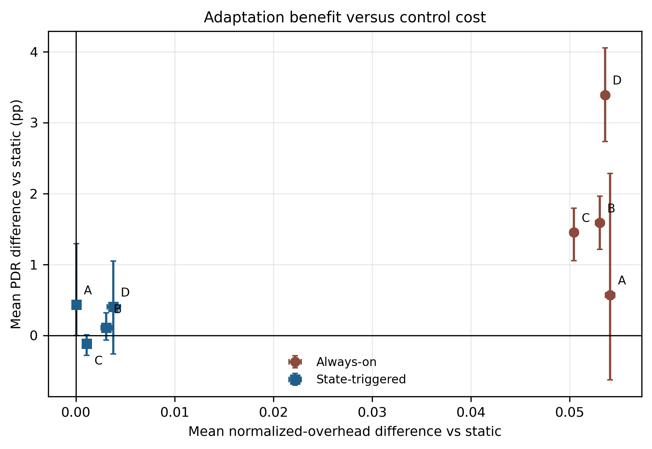
Figure 3 Mean resilience effect and normalized control cost. Labels A–D denote the four conditions.

Stable control and trigger behavior
B2 produced four failure-trigger transitions across three stable runs and no recovery transition. Twenty-nine of 30 stable PDR pairs matched B0 exactly; one outlier produced the positive mean. This violates H1 and shows that the pre-specified 20-event threshold is too sensitive for the intended negative-control behavior. B2 triggered in all B and D runs and in 27/30 C runs.

Worst flow and recovery
B1 increased mean minimum-flow PDR by 3.697 points in B, 3.349 in C, and 7.229 in D. B2 changes were +0.217, -0.220, and +0.475, with intervals crossing zero. The recovery field uses -2 for non-recovery and was not averaged as a duration. All B and C runs met the operational definition. In D, B1 did not recover in 6/30 runs; B0 and B2 did so in all 30. The zero-second median in D also shows that the aggregate recovery definition is too coarse for repeated events.

Threats to validity
- One topology family and deterministic log-distance path loss limit external validity.
- Two constant-rate flows do not represent heterogeneous IoT traffic.
- The disturbed relay is anchored fairly but still comes from one source route.
- The controller's recovery depends on renewed signal evidence and may remain reactive after route change.
- Bootstrap intervals describe variation across these 30 runs; they do not prove generality.
- No energy claim is made because no energy model is part of the v2 experiment.

Independent review
The comparisons are suitable for supervisor review after the target-selection confound and recovery sentinel were corrected. The tested B2 controller is not suitable for a superiority claim. The project is strongest as proof of execution: it exposes a failed trigger, shows the attainable benefit and cost of fast control, and leaves a precise research problem for doctoral work.

Doctoral research path
- Design a guarded trigger and exit policy with a finite reactive budget, route-state confirmation, and channel-load safeguards.
- Validate across topology, density, mobility, fading, traffic, and failure-location blocks using fresh seeds.
- Select policies under explicit worst-flow, tail-loss, delay, and control-cost constraints, then test selected cases on a small physical platform.

Reproducibility statement
The repository retains the locked YAML protocol, C++ source, execution and analysis scripts, raw 360-run table, target anchors, per-run logs, processed comparisons, recovery and trigger summaries, and figure sources. The exact command is documented in the README. The main result table and PNG figures regenerate deterministically from the stored raw CSV.

References
Clausen T, Jacquet P. Optimized Link State Routing Protocol. RFC 3626. 2003. doi:10.17487/RFC3626.
Qin L, Kunz T. Adaptive MANET Routing: A Case Study. ADHOC-NOW 2008:43–57. doi:10.1007/978-3-540-85209-4_4.
Hoebeke J et al. Adaptive routing for mobile ad hoc networks. EURASIP Journal on Wireless Communications and Networking. 2012;2012:126. doi:10.1186/1687-1499-2012-126.
Han SY, Lee D. An Adaptive Hello Messaging Scheme for Neighbor Discovery in On-Demand MANET Routing Protocols. IEEE Communications Letters. 2013;17(5):1040–1043. doi:10.1109/LCOMM.2013.040213.130076.

