EarthScape Climate Agency
Big-data climate and air-quality monitoring for Karachi, Lahore, Islamabad, Peshawar and Quetta
Final project report (Aptech eProject, Big Data). Prepared 08 October 2026. Student name, roll number and centre: to be completed by the student.
Honesty statement. Everything reported as working was run and verified; items that could not be completed are listed in Section 14 and in the requirement table (Section 4). No data, metric or test result in this report is invented. The demonstration video has not been recorded by this document's author.

1. Problem definition and objectives
The EarthScape Climate Agency monitors climate change. It needs a solution that collects climate data from several kinds of source, stores it scalably, processes it in parallel, applies machine learning, visualises it interactively for authenticated users and alerts stakeholders when thresholds are crossed. The SRS requires HDFS storage and Hadoop MapReduce processing.
- Integrate approved sources: 25 years of NASA POWER hourly reanalysis, Open-Meteo current weather and air quality (modelled), OpenAQ PM2.5 (observed) and MODIS land-surface temperature (planned).
- Store the data in HDFS (RAW, INTERIM, PROCESSED) with partitioning, manifests and checksums.
- Process the historical data with Hadoop MapReduce on YARN (daily, monthly and yearly aggregates).
- Provide near-real-time monitoring by REST polling and threshold alerts.
- Provide trend analysis, anomaly detection, correlation analysis and forecasting that can be re-trained.
- Provide role-protected interactive dashboards, a feedback system, monitoring, backups and documentation.

2. Scope, assumptions and technologies
Item | Decision
Geographic scope | Pakistan: Karachi, Lahore, Islamabad, Peshawar, Quetta (coordinates in config/cities.json)
Historical data | NASA POWER hourly, 2001-01-01 to 2025-12-31: T2M, RH2M, PRECTOTCORR, WS2M, PS, ALLSKY_SFC_SW_DWN (gridded reanalysis, not station data)
Current data | Open-Meteo weather and air quality (model output, REST polling); OpenAQ PM2.5 (observed by third-party monitors)
Satellite data | MODIS MOD11A2 v061 LST, tiles h24v06/h24v05/h23v05 (not ingested: no NASA Earthdata credentials)
Big data stack | Hadoop 3.4.3 (HDFS, YARN, MapReduce via Hadoop Streaming in Python) in WSL2 Ubuntu 24.04
Application | Python 3.13, FastAPI, Jinja2, Bootstrap, Chart.js, MongoDB 8.2, Argon2id, scikit-learn, SciPy, pandas
Real-time | Near-real-time REST polling thread (15 min; OpenAQ hourly). No Kafka or Spark.
Notifications | In-app alerts only (no email or SMS)
Deployment | Local laptop, bound to 127.0.0.1; not public

3. Requirement sources
The requirements come from the Aptech SRS 'Big Data - EarthScape Climate Agency' (Functional Requirements, Non-Functional Requirements, Hardware/Software Requirements, Project Deliverables). The SRS file itself is not redistributed in the submission package. Software named by the SRS without a stated function (Apache server, Tableau, Impala server, RStudio, Anaconda) was not treated as optional: each has its own line in Section 4.

4. Requirement traceability (40 items)
Status summary: 22 Complete, 8 Partial, 4 Not implemented, 1 Blocked, 1 Not available, 1 Not active, 1 Prepared, not active, 1 Not demonstrated, 1 Not done (total 40). Complete means the code or data exists and was run and verified.
ID | SRS wording / section | Status | Evidence | Missing / limits | User action
AUTH-1 | Functional > User Authentication and Authorization: "Implement a secure authentication system for users with different roles (e.g., administrators, analysts)." | Complete | Argon2id, server-side sessions, CSRF, lockout: services.py, security.py; AuthTest/PasswordTest; real-browser login for both roles | TLS not active (SEC-1) | none
AUTH-2 | same: "Define access controls to restrict data access based on user roles and responsibilities." | Complete | need_admin, last-admin protection; RbacUserTest; browser test: Analyst gets 403 on /admin/ and cannot poll | role set is the SRS example list; no further roles required | none
ING-1 | Functional > Data Ingestion: "Implement mechanisms to handle both historical and real-time data sources." | Complete | HDFS RAW 125 files / 1,095,720 rows, INTERIM 5 files, manifests with sha256 | none | none
ING-2 | same (real-time source) | Complete | live_sources.py, live.py; real polls stored; duplicates not stored | model output, not station data | none
ING-3 | Data Ingestion: "...environmental sensor data." | Complete | real poll: 89 readings from active monitors in all 5 cities; browser test shows them | PM2.5 only; mostly low-cost sensors | none
ING-4 | Data Ingestion: "diverse climate-related datasets" | Complete | labelled MODELLED everywhere; never mixed with OpenAQ | no backfill | none
ING-5 | Data Ingestion: "...including satellite imagery..." | Blocked | downloader, CMR plan (1,515 granules, 11.2 GB), check command, tile math, pyhdf reader with scale/fill/QC/geolocation checks verified on a synthetic HDF4 file (ModisReaderTest) | no NASA Earthdata credentials; no real granule downloaded; HDF4 reader untested on real MODIS | Add Earthdata credentials to .env, run the pilot
ING-6 | Data Ingestion: "...weather station records..." | Not available | no station dataset was approved; POWER/Open-Meteo are gridded/model data and are labelled so | needs a user decision on a station source | Decide on / supply a station dataset, or accept as a documented deviation
ING-7 | Data Ingestion: "Ensure compatibility with common data formats used in climate science." | Partial | CSV, JSON and HDF4-EOS (reader tested only on a synthetic file); NetCDF not used | real HDF4 pending | none (real HDF4 needs credentials)
HDFS-1 | Functional > Data Storage: "Utilize HDFS ... Implement data partitioning and organization strategies to optimize retrieval and processing." | Complete | POWER layers (raw/interim/processed, city/year partitions, manifests); live RAW partitioned by source and UTC day | first real live day seals after 05:00 PKT on 2026-10-09 (see testing report) | Run seal-raw after 05:00 PKT 2026-10-09
MR-1 | Functional > Data Processing: "Implement Hadoop MapReduce jobs for parallel processing of climate data across distributed nodes." | Complete | three Streaming jobs on YARN, each independently verified (daily 45,655, monthly 1,500, yearly 125 rows) | single node | none
PROC-1 | Data Processing: "algorithms for the identification of climate patterns, anomalies, and correlations ... handle missing or incomplete data gracefully." | Complete | climate_ml.py; missing -999 -> null + flag; skipped, never filled | unsupervised, no labels | none
RT-1 | Functional > Real-time Data Processing: "Integrate real-time data streaming capabilities. Ensure seamless integration with batch processing." | Partial | 15-min REST polling (approved) -> MongoDB -> alerts; new current-vs-historical comparison joins live readings with the batch climatology | not event streaming (no Kafka/Spark, by decision) | Confirm that approved REST polling is acceptable for "streaming"
ML-1 | Functional > Machine Learning Models: "algorithms for anomaly detection" | Complete | robust z + Isolation Forest, tested with an injected spike | unsupervised | none
ML-2 | same: "...trend prediction..." | Complete | Theil-Sen/Mann-Kendall, chronological split, baselines, real metrics | modest skill for precipitation (stated) | none
ML-3 | same: "...and correlation analysis." | Complete | deseasonalised Pearson/Spearman | air quality excluded (short record) | none
ML-4 | same: "Regularly update and refine models based on the latest available data." | Complete | manage.py train-ml, admin button, versioned ml_runs | retraining is manual | Run train-ml periodically (manual)
DASH-1 | Functional > Data Visualization: "Create interactive dashboards ... customizable and user-friendly interfaces" | Complete | 15 pages; browser test: all charts painted, no console errors, no overflow at 390 px | charts need CDN internet | none
DASH-2 | Real-time Data Processing: "seamless integration with batch processing" (current vs historical) | Complete | /current comparison card + /api/current/comparison; reference verified against an independent recomputation; ReferenceTest/ComparisonApiTest | temperature and humidity only; labelled as two different models | none
ALERT-1 | Functional > Notifications and Alerts: "automated notifications and alerts ... based on predefined thresholds ... configurable alerting mechanisms to notify users in real-time." | Complete (in-app) | rules, evaluator, history, acknowledgement, badge; browser-verified acknowledge | email/SMS not configured (needs credentials and a decision) | Decide whether email/SMS is required (needs credentials)
FB-1 | Functional > Feedback and Support: "A support system for users to contact for assistance, report issues, and provide feedback." | Complete | submission, admin review, XSS-safe; browser-verified | none | none
PERF-1 | Non-Functional > Performance / Performance Monitoring: "Implement monitoring tools to track system performance, resource utilization, and data processing times." | Partial | health-check every 15 min (Task Scheduler) records application, MongoDB, HDFS, polling freshness, backup, disk and CPU/memory (system, app and mongod) to logs/health.jsonl (MonitorTest); poll-cycle duration stored in ingest_status and logged; YARN application ids and manifests for MapReduce | MapReduce run times are not captured by the app (only in YARN history); no dashboard | none
SEC-1 | Non-Functional > Data Security: "Implement encryption mechanisms to secure sensitive climate data during storage and transmission." | Not active | BitLocker state could not be read without admin rights (see security doc) | needs your approval and an Administrator step | Approve and run BitLocker (elevated)
SEC-2 | same (transmission) | Prepared, not active | config/apache/earthscape.conf reviewed and corrected; certificate steps documented; app stays on 127.0.0.1 | Apache not installed; not tested | Approve Apache install + certificate
SEC-3 | Data Security: "Ensure compliance with relevant data protection regulations and standards." / Compliance and Standards | Partial | provenance, labels, least-privilege design documented | no formal compliance assessment | Confirm what the examiner expects
REL-1 | Non-Functional > Reliability > Uptime: "minimum of 99% uptime, with scheduled maintenance communicated in advance." | Not demonstrated | health history started; single laptop; WSL stops with its session | needs supervision and a measured window | Keep the laptop/WSL running if uptime is to be shown
REL-2 | Reliability > Data Backup: "Regular automated data backups must be performed." | Complete | Task Scheduler EarthScape backup daily 02:00 (confirmed Ready; one run result 0); backup + restore into an isolated DB verified; retention 7; recheck in the final phase: both tasks Ready, last results 0 | Windows laptop must be on; HDFS data not in the scheduled job (--hdfs is manual) | Keep the laptop on at 02:00 (or it runs at next start)
SCAL-1 | Non-Functional > Scalability: "horizontal scaling ... Implement load balancing mechanisms." | Partial (design) | HDFS/YARN design; reducers=1 here | no load balancer; scaling not demonstrated | Accept as documented design limit, or decide on a load balancer
DOC-1 | Documentation > User Documentation: "user guides, FAQs, and tutorials" | Complete | user-guide.md with FAQ and walkthrough | no tutorial video | none
DOC-2 | Documentation > Developer Documentation: "system architecture, data processing workflows, and machine learning models" | Complete | architecture.md (diagrams), data-architecture.md, ml-methodology.md | none | none
DOC-3 | Project Deliverables: problem definition, design specifications, flowcharts/DFDs, source code, test data, installation instructions, ReadMe.doc listing assumptions | Partial | all as Markdown; Mermaid flowchart in architecture.md; ZIP contains source, tests, notebook, docs | SRS asks for ReadMe.doc / a written report: convert README.md/report-material.md yourself | Convert the .docx files to .doc (WPS/Word Save As) if .doc is mandatory
DOC-4 | Documentation > Video: "Provide video displaying complete working of the application." | Not done | script in demo-script.md | you must record it | Record the video
SW-1 | Hardware/Software Requirements: "Hadoop, HDFS and Apache server" | Complete | running; jobs above | none | none
SW-2 | Hardware/Software Requirements: "Mongo Db Compass, and Shell" | Partial | MongoDB 8.2 and Compass installed and used; mongosh not installed | mongosh not installed: winget has no user-scope installer, so it needs an elevated install | Install mongosh (elevated winget) if the shell is required
SW-3 | Hardware/Software Requirements: "Jupiter Anaconda Notebook 3" | Partial | JupyterLab + EarthScape kernel; notebook executed | Anaconda itself not installed | Decide whether Anaconda itself is required
SW-4 | Hardware/Software Requirements: "RStudio" | Not implemented | not installed; analytics in Python | needs your decision | Decide: install R + RStudio?
SW-5 | Hardware/Software Requirements: "Hadoop, HDFS and Apache server" | Not implemented | TLS reverse-proxy config prepared | needs your decision to install | Decide: install Apache (for TLS reverse proxy)?
SW-6 | Hardware/Software Requirements: "Tableau" | Not implemented | cache CSVs in data/processed/app_cache/ are Tableau-readable | licensed desktop tool, your side | Decide / use your licence
SW-7 | Hardware/Software Requirements: "Impala server" | Not implemented | not installed | heavy Hadoop-side install; needs your decision | Decide: install Impala?
SW-8 | Hardware/Software Requirements: "Visual Code Studio / PyCharm" | Complete | VS Code used | none | none

5. System architecture
Single-machine academic system: Windows 11 with WSL2 for Hadoop. There are no microservices, containers or queues. The figure shows the batch layer, the near-real-time layer and the application and operations components.
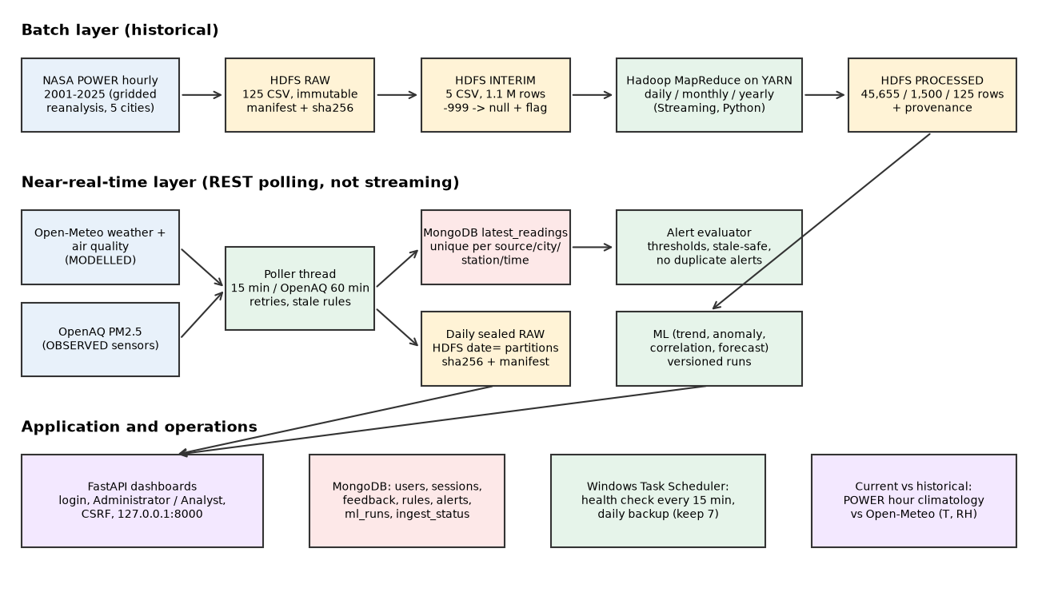
Figure 1. EarthScape architecture and data flow
Component | Technology | Role
Web app | FastAPI + Jinja2, Bootstrap, Chart.js, uvicorn on 127.0.0.1:8000 | dashboards, JSON APIs, authentication, administration
Application database | MongoDB (database earthscape) | users, sessions, feedback, alert rules and alerts, current readings, ingest status, ML runs
Big-data storage | HDFS /earthscape | RAW, INTERIM, PROCESSED layers and provenance manifests
Batch processing | Hadoop MapReduce (Streaming) on YARN | hourly to daily, monthly and yearly aggregation
Analytics | pandas, scikit-learn, SciPy | trends, anomalies, correlation, forecasts
Collection | Python urllib polling thread | Open-Meteo weather/air quality, OpenAQ
Monitoring and backup | manage.py health-check / backup, Windows Task Scheduler | 15-minute health check, daily backup with retention

6. Data sources and provenance
Source | Class | Notes
NASA POWER hourly | Gridded reanalysis (MERRA-2) + satellite-derived radiation (CERES); not station data | 125 city-year CSV files, 1,095,720 rows; fill value -999 never present in the download
Open-Meteo weather | MODELLED, near-real-time | temperature, humidity, precipitation, 10 m wind (km/h), pressure (hPa); UTC; 15-minute interval
Open-Meteo air quality | MODELLED (CAMS) | PM2.5, PM10, CO, NO2, SO2, O3, US AQI; never shown as observed
OpenAQ | OBSERVED (mostly low-cost sensors, sparse) | PM2.5 only; active monitors within 25 km; location, sensor class, provider and distance kept; API key only from the environment
MODIS MOD11A2 v061 | Satellite-derived | measured plan: 1,515 granules, 11.2 GB (tiles h24v06 2.9 GB, h24v05 4.2 GB, h23v05 4.1 GB); not downloaded

Provenance is recorded in append-only manifest files in HDFS (source, request, size, SHA-256, record counts, times, version, YARN application id). Raw data stays provider-native and immutable; corrections happen downstream. Missing values stay visible (POWER -999 becomes null plus a flag in INTERIM, never an invented value). Modelled and observed environmental data are labelled on every page and never merged.

7. HDFS design
/earthscape
_manifest/<source>.jsonl append-only provenance (last line per object_key wins)
raw/power_hourly_gridded/city=<c>/year=<y>/*.csv 125 objects
raw/openmeteo_weather_model/date=YYYY-MM-DD/polls.jsonl sealed daily
raw/openmeteo_airquality_model/date=YYYY-MM-DD/polls.jsonl
raw/openaq_observed/current/date=YYYY-MM-DD/latest.jsonl
interim/power_hourly/city=<c>/power_hourly_<c>.csv 5 objects
processed/power_daily | power_monthly | power_yearly/part-00000
Partitioning is by city and year (historical) and by source and UTC day (live). Ingestion is idempotent: an identical object is adopted, a different one is refused, uploads go to a temporary path, are verified by size and SHA-256 read-back and are then moved into place. The live RAW rollover (sealing a finished UTC day) was verified with an in-memory HDFS (eight tests: provenance, counts, hash, duplicates, interruption recovery, no overwrite). No real daily object exists yet: polling began on 2026-10-08, so the first UTC day ends at 05:00 PKT on 2026-10-09.

8. MapReduce processing
Three Hadoop Streaming jobs (Python mapper and reducer, one reducer, exact decimal arithmetic, deterministic output) are submitted to YARN by run_power_job.py. The driver verifies inputs by manifest, checks the YARN final state, verifies the output with an independent recomputation from INTERIM, publishes without overwriting and writes provenance.
Job | Input | Output | Rows | YARN application
daily | 5 INTERIM files | processed/power_daily | 45,655 | application_1791451740685_0004
monthly | daily output | processed/power_monthly | 1,500 | application_1791451740685_0005
yearly extremes | daily output | processed/power_yearly | 125 | application_1791451740685_0006

Daily solar irradiance is the mean in the provider unit MJ/hr (no daily total); the daily precipitation total is empty unless all 24 hourly values are valid. The INTERIM data (67 MB) is smaller than one HDFS block, so the jobs demonstrate the architecture; they do not claim big-data scale, and scaling was not demonstrated on this single node.

9. Machine-learning methodology
Code: src/ml/climate_ml.py (version climate_ml_v1, seed 42). The data are POWER aggregates produced by MapReduce; all statements concern this model-based product, not station observations.
- Trends: Theil-Sen slope with a 95% interval and Mann-Kendall test on annual values (n = 25 years).
- Anomalies: day-of-year median climatology fitted on 2001-2015 only; robust z-score (|z| > 3.5) and an Isolation Forest (200 trees, contamination 0.01) fitted on 2001-2015 and applied to 2016-2025. No labels exist, so precision and recall cannot be computed; a unit test confirms an injected +15 C spike is detected.
- Correlation: Pearson and Spearman on deseasonalised daily anomalies; association only, not causation.
- Forecast: monthly values; chronological split (train 2001-2020, test 2021-2025); seasonal climatology and last-year baselines versus a harmonic-trend Ridge model; model chosen by rolling-origin validation inside the training years only; the band is forecast +/- 1.96 x test RMSE (approximate, not a calibrated interval).
- Updating: manage.py train-ml or the Administrator button stores a new versioned run in MongoDB; training is reproducible.
City | Temperature trend C/decade [95% interval] | p | Precipitation mm/decade [95% interval] | p
Karachi | 0.127 [-0.053, 0.261] | 0.1557 | 107.3 [8.6, 230.2] | 0.0223
Lahore | -0.672 [-1.019, -0.264] | 0.0007 | 207.5 [124.2, 324.5] | 0.0000
Islamabad | -0.613 [-1.120, -0.269] | 0.0024 | 401.2 [239.0, 598.3] | 0.0001
Peshawar | -0.722 [-1.165, -0.428] | 0.0004 | 353.8 [234.3, 465.6] | 0.0000
Quetta | -0.028 [-0.398, 0.346] | 0.9447 | 124.5 [40.6, 225.9] | 0.0039

Forecast result: the selected model had a test MAE no worse than the seasonal-climatology baseline in 18 of 20 city-variable forecasts; high R2 for temperature mostly reflects the seasonal cycle and precipitation skill is limited. Reanalysis trends can include artefacts of changing assimilated observations; this is a description of the dataset, not a physical attribution. Full tables: docs/ml-methodology.md.

10. Dashboard, authentication and authorisation
The application has 15 pages. Authentication uses Argon2id password hashes, generic error messages, a 15-minute lockout after five failures, server-side sessions with random tokens in HttpOnly SameSite cookies (only the SHA-256 is stored) and a CSRF token on every state-changing request. Roles: Administrator (everything, plus user management, feedback review, data refresh, manual polling and retraining) and Analyst (dashboards, alert rules, acknowledgements, feedback). The last Administrator cannot be demoted or disabled.
Page | Content
Overview, Historical Climate, City Comparison | KPIs, temperature/precipitation/humidity/wind charts, five-city comparison (NASA POWER, labelled as gridded reanalysis)
Trends & Extremes, Correlation, Forecast | Theil-Sen trends, anomaly counts, hot/frost/heavy-rain days from the yearly MapReduce job, correlation matrices, 12-month forecasts with held-out test results
Current Data | freshness and STALE flags, latest modelled weather and air quality, observed OpenAQ monitors, recent history, current-vs-historical comparison
Alert Rules, Alert History | threshold rules, raised alerts, acknowledgement, navigation badge
Data Sources | provider classes, provenance (YARN ids, checksums), Administrator data refresh
Feedback, Feedback Review, User Management | support requests; Administrator review and account administration

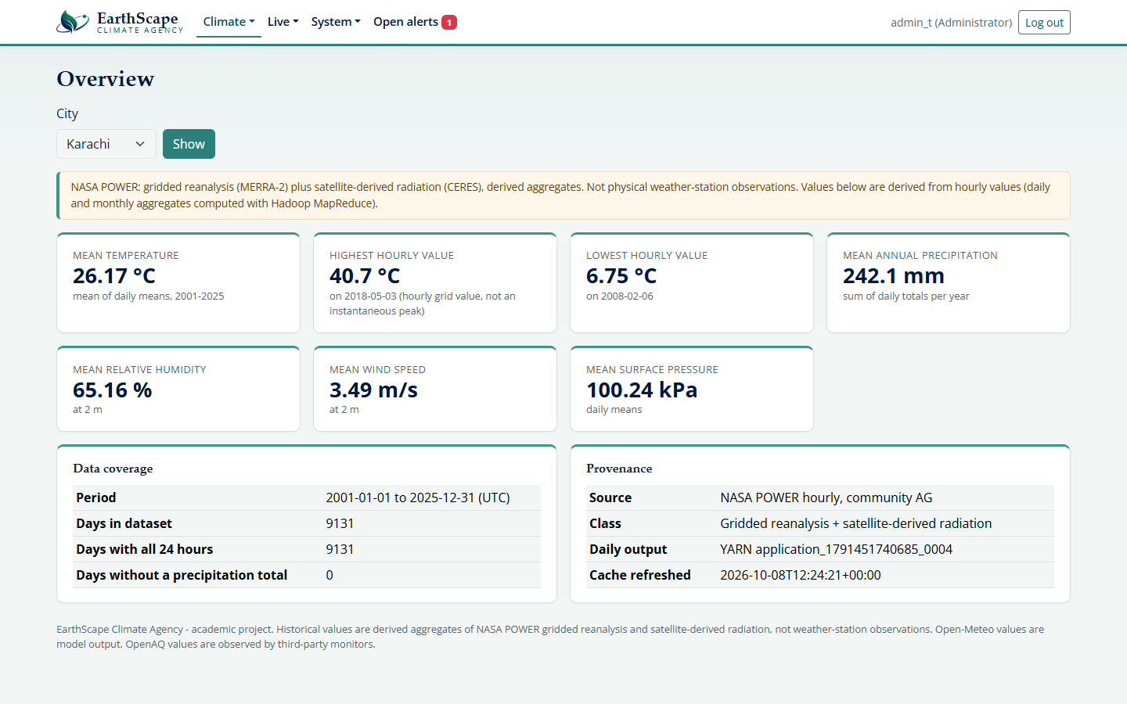
Figure 2. Overview
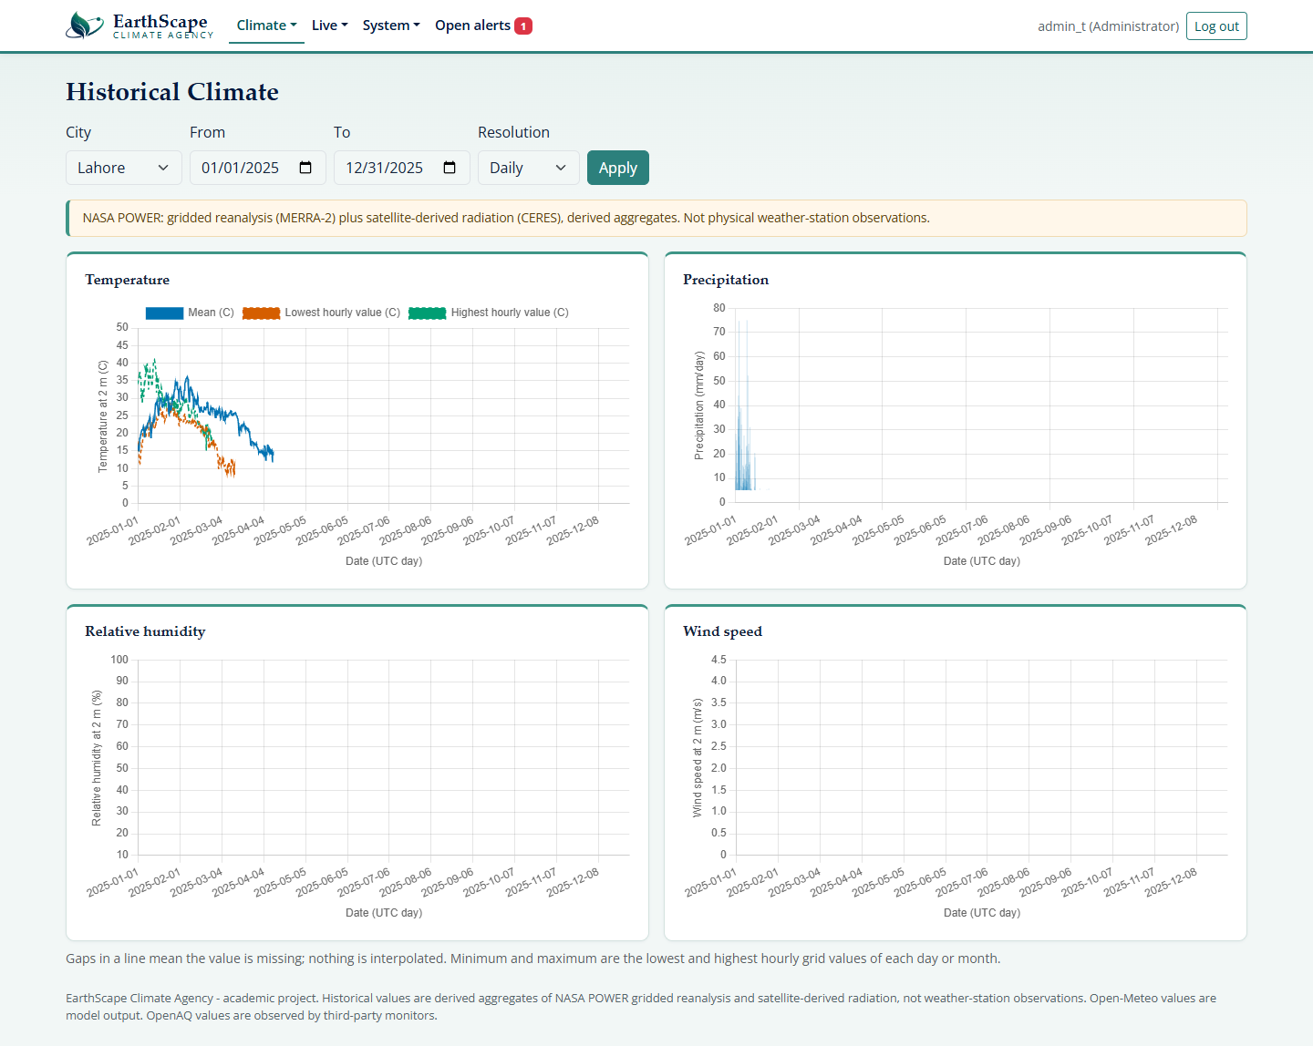
Figure 3. Historical Climate
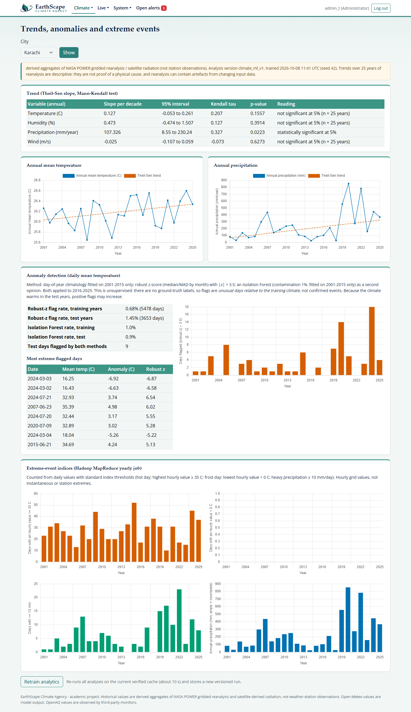
Figure 4. Trends and Extremes
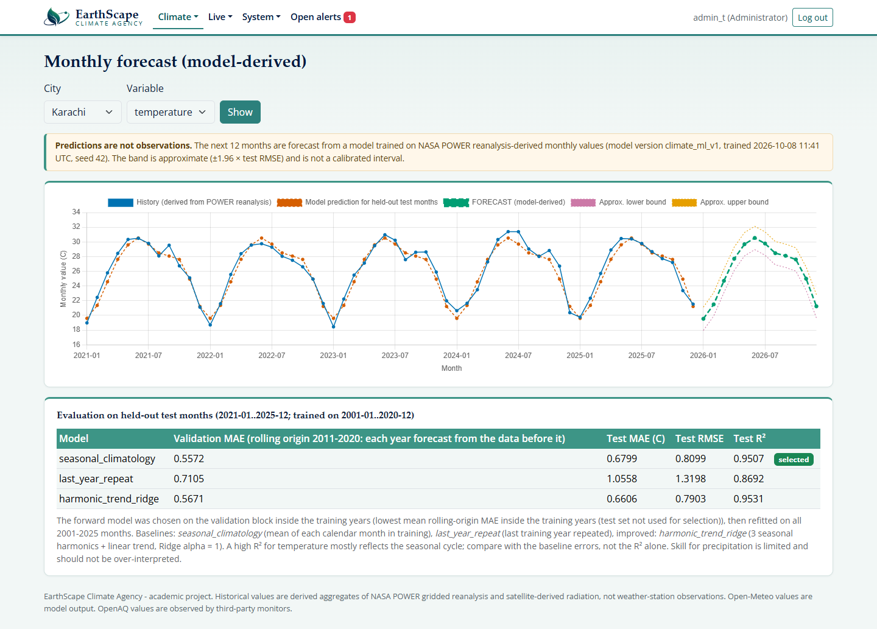
Figure 5. Forecast (model-derived, labelled as predicted)
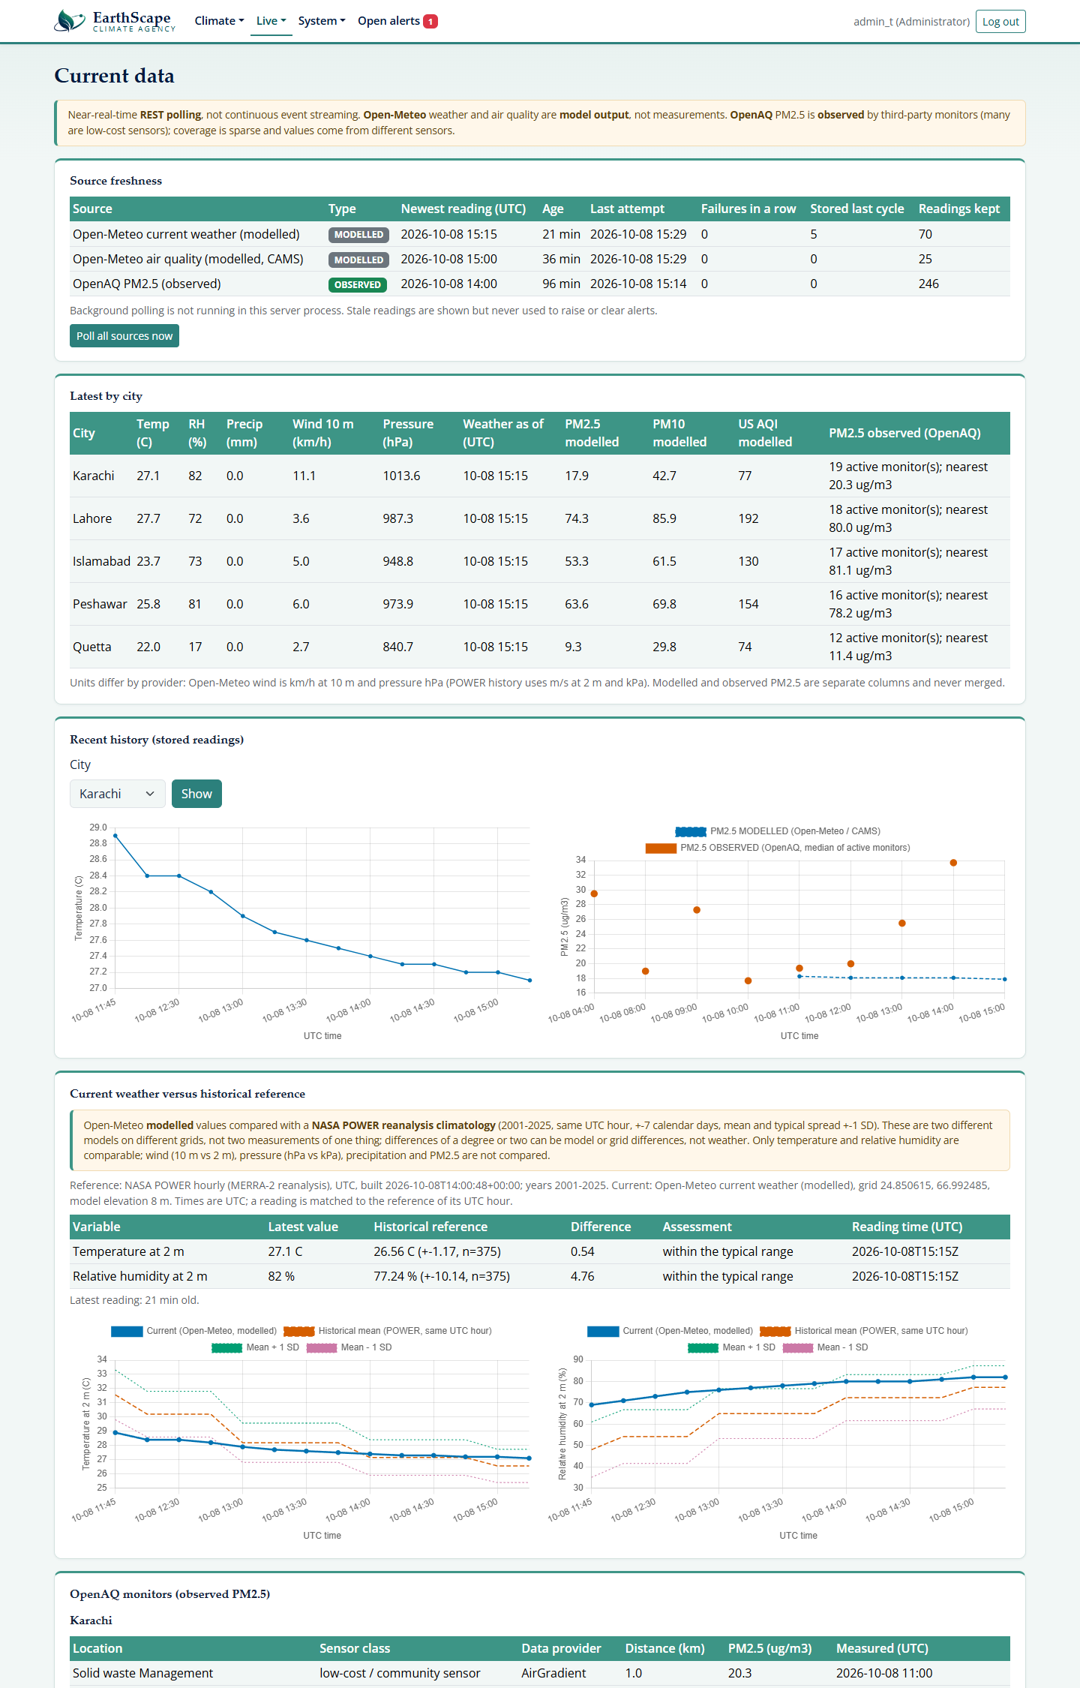
Figure 6. Current Data with the current-vs-historical comparison
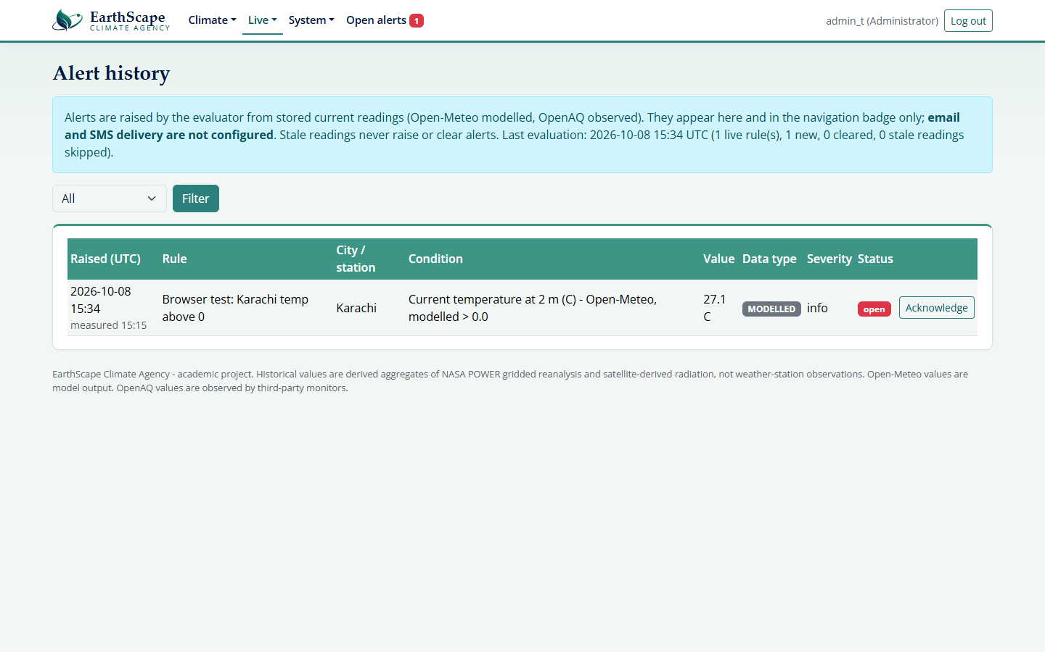
Figure 7. Alert History
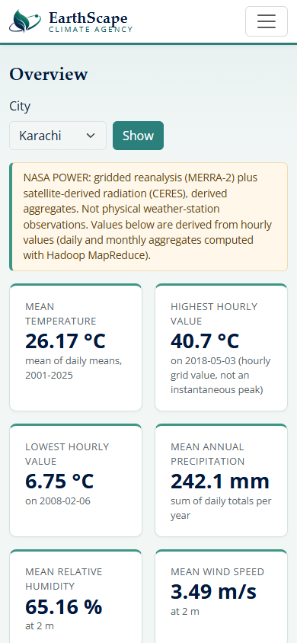
Figure 8. Overview at 390 px mobile width

11. Near-real-time processing, alerts, comparison and feedback
A polling thread collects Open-Meteo every 15 minutes and OpenAQ hourly, with bounded retries and backoff. Readings are stored in MongoDB without duplicates (unique per source, city, station and time). Raw provider responses are staged and sealed into HDFS after each UTC day. Failures are recorded and shown, and never stop other sources. This is near-real-time REST polling, not continuous event streaming.
Alerts: rules name a city (or all), a live variable, operator, threshold and severity. After every poll the newest non-stale reading per city (OpenAQ: per monitoring location) is evaluated; one alert is raised per episode, updated while the condition holds, cleared when it ends; users acknowledge alerts. Stale readings (weather > 60 min, air quality > 3 h, OpenAQ > 24 h) never raise or clear alerts. Email and SMS are not configured.
Current vs historical: Open-Meteo temperature and humidity of the last 24 hours are compared with the NASA POWER climatology for the same UTC hour (mean and standard deviation over +-7 calendar days across 2001-2025, 375 samples per hour for a typical date). The two sources are different models on different grids, so differences can be model or grid differences; wind (10 m vs 2 m), pressure (hPa vs kPa), precipitation and PM2.5 are deliberately not compared. A stored reference value was recomputed independently from the HDFS INTERIM data and matched exactly.
Feedback: any user submits a category, subject and message; Administrators review and set the status. Messages containing HTML are shown escaped.

12. Security, monitoring and reliability
- Active: Argon2id, server-side sessions, CSRF, role checks on every route, input validation, parameterised/whitelisted MongoDB access, CSP and security headers, safe error pages, secrets only in the environment or a git-ignored .env.
- Monitoring (active): a Windows scheduled task runs manage.py health-check every 15 minutes and records application, MongoDB, HDFS, live-polling freshness, newest backup, disk space, CPU and memory with UTC timestamps in logs/health.jsonl. It records only; it does not notify or restart anything.
- Backups (active): a scheduled task runs a daily backup (MongoDB application data, SHA-256 checksums, newest 7 kept). A real backup was restored into an isolated database with identical document counts and users; the scratch database was then dropped. Backups hold password hashes, never plaintext secrets.
- TLS (prepared, not active): an Apache reverse-proxy configuration was reviewed and corrected (TLS 1.2/1.3, loopback only); Apache is not installed.
- Encryption at rest (not active): BitLocker status could not be read without Administrator rights; nothing was enabled.
- Uptime: 99% was not demonstrated; the system runs on one laptop and WSL daemons stop with their session.

13. Testing results
Automated suite: 149 tests, all passing (stdlib unittest, about two minutes, needs only the local MongoDB; app tests use throw-away databases). Areas: NASA POWER ingestion and validation, RAW to INTERIM, MapReduce mappers/reducers, authentication, RBAC, CSRF, MongoDB, feedback, alerts, data cache, dashboards and APIs, provider parsing, live storage, raw sealing, ML, historical reference and comparison, health monitor, backup retention and restore, MODIS reader on a synthetic HDF4 file.
- Hadoop on the real cluster: three YARN jobs SUCCEEDED; each output was recomputed independently from INTERIM (means within the documented 0.0001 bound); repeat runs were skipped.
- Real browser (Chrome): 52 page views across both roles at 1280 px and 390 px: all charts painted, no failed requests, no horizontal overflow, role restrictions enforced (403 for the Analyst on admin pages), alert acknowledgement, feedback and error states worked. A defect (unknown URLs returned raw JSON) was found and fixed.
- Live providers: real polls stored weather, air-quality and 89 OpenAQ readings; repeat polls stored no duplicates.
- Operations: graceful startup/shutdown of the server verified; scheduled health-check and backup runs finished with result 0.

14. Limitations and requirements not met
- MODIS satellite data not ingested (no NASA Earthdata credentials). The downloader, plan, HDF4 reader (scale factor, fill value, QC flags, geolocation check) and tests exist; the reader has only been run on a synthetic HDF4 file.
- Weather-station records (named by the SRS) were not part of the approved datasets.
- Streaming: near-real-time polling replaces event streaming by decision.
- TLS and encryption at rest are not active; 99% uptime and load balancing are not demonstrated or implemented; scaling is by design only (single node).
- SRS software list: Apache server, Tableau, Impala server and RStudio are not installed; Anaconda is replaced by JupyterLab; MongoDB Compass is installed but mongosh is not.
- POWER is gridded reanalysis; Open-Meteo is modelled; OpenAQ is sparse and mostly low-cost; forecasts are modest beyond the seasonal baseline; anomaly detection has no ground truth.
- The demo video has not been recorded.

15. Installation and execution
Full steps are in the ReadMe. In short (Windows 11, PowerShell, project root): create the venv and install requirements.txt; start MongoDB; start HDFS (and YARN for new jobs) in WSL; run manage.py init-db, create-admin, refresh-data, build-reference and train-ml; start the server with uvicorn on 127.0.0.1:8000.
.venv\Scripts\python.exe -m uvicorn app.main:create_app --factory --app-dir src --host 127.0.0.1 --port 8000
.venv\Scripts\python.exe -m unittest discover -s tests

16. References
- NASA Langley Research Center POWER Project, power.larc.nasa.gov (MERRA-2 and CERES SYN1deg based parameters).
- Open-Meteo weather and air-quality APIs (open-meteo.com); Copernicus Atmosphere Monitoring Service (CAMS).
- OpenAQ API v3 (openaq.org).
- NASA LP DAAC, MOD11A2 v061 MODIS/Terra Land Surface Temperature/Emissivity 8-Day L3 Global 1 km SIN Grid.
- Apache Hadoop 3.4.3 documentation: HDFS, YARN, MapReduce, Hadoop Streaming.
- Sen, P. K. (1968). Estimates of the regression coefficient based on Kendall's tau. JASA 63. Mann, H. B. (1945). Nonparametric tests against trend. Econometrica 13. Kendall, M. G. (1975). Rank Correlation Methods.
- Iglewicz, B. and Hoaglin, D. (1993). How to Detect and Handle Outliers. ASQC Quality Press.
- Liu, F. T., Ting, K. M. and Zhou, Z.-H. (2008). Isolation Forest. IEEE ICDM.
- ETCCDI climate change indices (Zhang et al., 2011, WIREs Climate Change 2).

