What conclusions do people remember from last week?(can’t talk about own team’s results)

*E.g., slightly less than half of car accidents happen in intersections in Madison.*

**Data Density**

* Counting numbers represented
* Pie vs. line
* Why more context (in the form of data) provides credibility

**Goal:** a few data-dense plots that are highly polished

**Approach 1**: many plots like the following

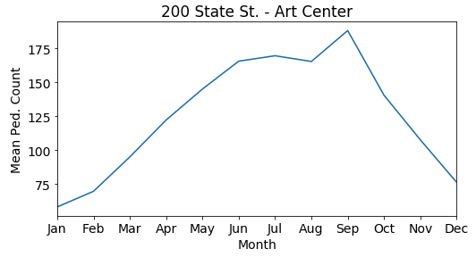

**Approach 2:** one plot makes comparisons easier, but it’s not as polished as the others

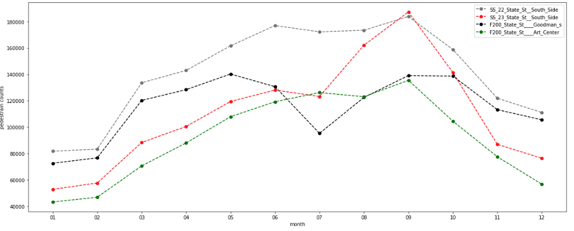

**Examples of good conclusions:**

* Each intersection gets ___ to ___ thousand pedestrians per hour at the peak of summer
* Foot traffic is ___ to ___ times greater at the peak than in January
* Intersections farther from the capital receive more/less traffic…

Map Examples:

* Friends: <https://www.facebook.com/notes/facebook-engineering/visualizing-friendships/469716398919/>
* Airports: <https://trailsofwind.figures.cc/>
* Rivers: <https://johnroscoe.files.wordpress.com/2013/10/edward-tufte-envisioning-information-1990-pg74.jpg>