Heatwave mortality in France from 1990 to 2025 in high spatiotemporal resolution
Hans-Aloys Wischmann, Institute for Public Health, Charité - Universitätsmedizin Berlin
Rewritten: 2026-05-16 to 2026-10-09 / Executed: 2026-10-09

Setup

Load: Model Fits
Proportion of observed deaths for which te(tmpc,hump) was significant (p < 0.05), by age group and lag [days]
Lag | 90+ | 80-89 | 60-79 | 40-59 | 20-39 | 00-19 | Total
0 | 57.0% | 51.3% | 62.4% | 31.8% | 17.8% | 19.2% | 52.6%
1 | 37.1% | 38.3% | 19.9% | 16.5% | 4.7% | 7.6% | 28.1%
2 | 15.0% | 26.7% | 11.4% | 11.2% | 6.0% | 3.6% | 16.8%
3 | 7.4% | 11.9% | 22.5% | 17.5% | 6.5% | 2.5% | 15.0%
4 | 11.8% | 9.1% | 11.8% | 13.0% | 6.7% | 2.8% | 10.8%
5 | 3.0% | 6.6% | 15.8% | 5.4% | 6.1% | 7.4% | 8.9%
6 | 6.6% | 10.2% | 12.5% | 10.9% | 4.8% | 8.5% | 10.2%
7 | 1.5% | 13.8% | 16.5% | 6.0% | 4.2% | 2.2% | 11.2%
8 | 5.0% | 13.4% | 16.1% | 12.5% | 5.6% | 2.3% | 12.3%
9 | 7.2% | 5.5% | 17.2% | 12.8% | 2.3% | 4.6% | 10.5%
10 | 3.6% | 5.3% | 12.3% | 6.7% | 3.6% | 3.1% | 7.4%
11 | 4.6% | 9.2% | 20.8% | 8.1% | 7.6% | 2.0% | 12.0%
12 | 7.9% | 9.7% | 19.4% | 7.3% | 6.1% | 1.7% | 12.2%
13 | 2.4% | 16.7% | 26.8% | 9.2% | 3.2% | 9.3% | 16.2%
14 | 19.0% | 48.9% | 45.6% | 27.8% | 10.5% | 3.2% | 38.3%
Summer deaths in France (6272 summer days across 33 years)
Urbanity | Observed  Deaths | GAM  T*RH  (Counts) | DLNM  T*LAG  (Counts) | GAM  Avg.Exp  (Counts) | GAM  Avg.Exp  (Rates) | GAM  Weekly  (Rates)
Rural | 1,757,127 | 1,752,719 | 1,752,727 | 1,752,744 | 1,754,844 | 1,757,126
Urbain dense | 3,776,282 | 3,735,414 | 3,733,396 | 3,733,938 | 3,776,246 | 3,776,281
Urbain intermédiaire | 3,180,891 | 3,138,637 | 3,138,247 | 3,138,291 | 3,180,480 | 3,180,891
Total | 8,714,300 | 8,626,770 | 8,624,370 | 8,624,973 | 8,711,570 | 8,714,298

Check: Model Quality
The mean absolute error (MAE) between the predicted and the observed total number of deaths across France is computed by analysis day (year and day of year), sex, and age group. Scatter plots depict the residuals, i.e., the observed minus the predicted number of deaths across France by mean daily temperature (lag = 0), for each analysis day, by sex and age group, comparing the DLNM on the x-axis to either the Weekly GAM or the Sensitivity GAM on the y-axis.
Mean absolute error (MAE) for daily death rates [1/100k] across all analysis days
Sex | Age | Observed  Rate | Best  MAE | GAM  T*RH  (Counts) | DLNM  T*LAG  (Counts) | GAM  Avg.Exp  (Counts) | GAM  Avg.Exp  (Rates) | GAM  Weekly  (Rates)
Female | 90+ | 44.6136 | 3.1550 | . | +0.0577 | +0.3311 | +0.3339 | +0.4051
Female | 80-89 | 15.5590 | 0.9493 | . | +0.0117 | +0.0832 | +0.0807 | +0.1231
Female | 60-79 | 2.9209 | 0.2046 | . | +0.0010 | +0.0043 | +0.0015 | +0.0081
Female | 40-59 | 0.6130 | 0.0722 | . | +0.0001 | +0.0002 | +0.0001 | +0.0007
Female | 20-39 | 0.1291 | 0.0313 | . | +0.0006 | +0.0006 | +0.0006 | +0.0006
Female | 00-19 | 0.0873 | 0.0267 | . | +0.0005 | +0.0005 | +0.0006 | +0.0005
Male | 90+ | 54.3534 | 5.8483 | . | +0.0587 | +0.2682 | +0.2622 | +0.2964
Male | 80-89 | 23.0852 | 1.5848 | +0.0111 | . | +0.0947 | +0.0847 | +0.1261
Male | 60-79 | 5.9013 | 0.3516 | +0.0201 | +0.0138 | +0.0215 | . | +0.0206
Male | 40-59 | 1.3553 | 0.1175 | +0.0016 | +0.0017 | +0.0011 | . | +0.0026
Male | 20-39 | 0.3375 | 0.0543 | . | +0.0006 | +0.0008 | +0.0009 | +0.0010
Male | 00-19 | 0.1309 | 0.0321 | . | +0.0004 | +0.0004 | +0.0005 | +0.0005
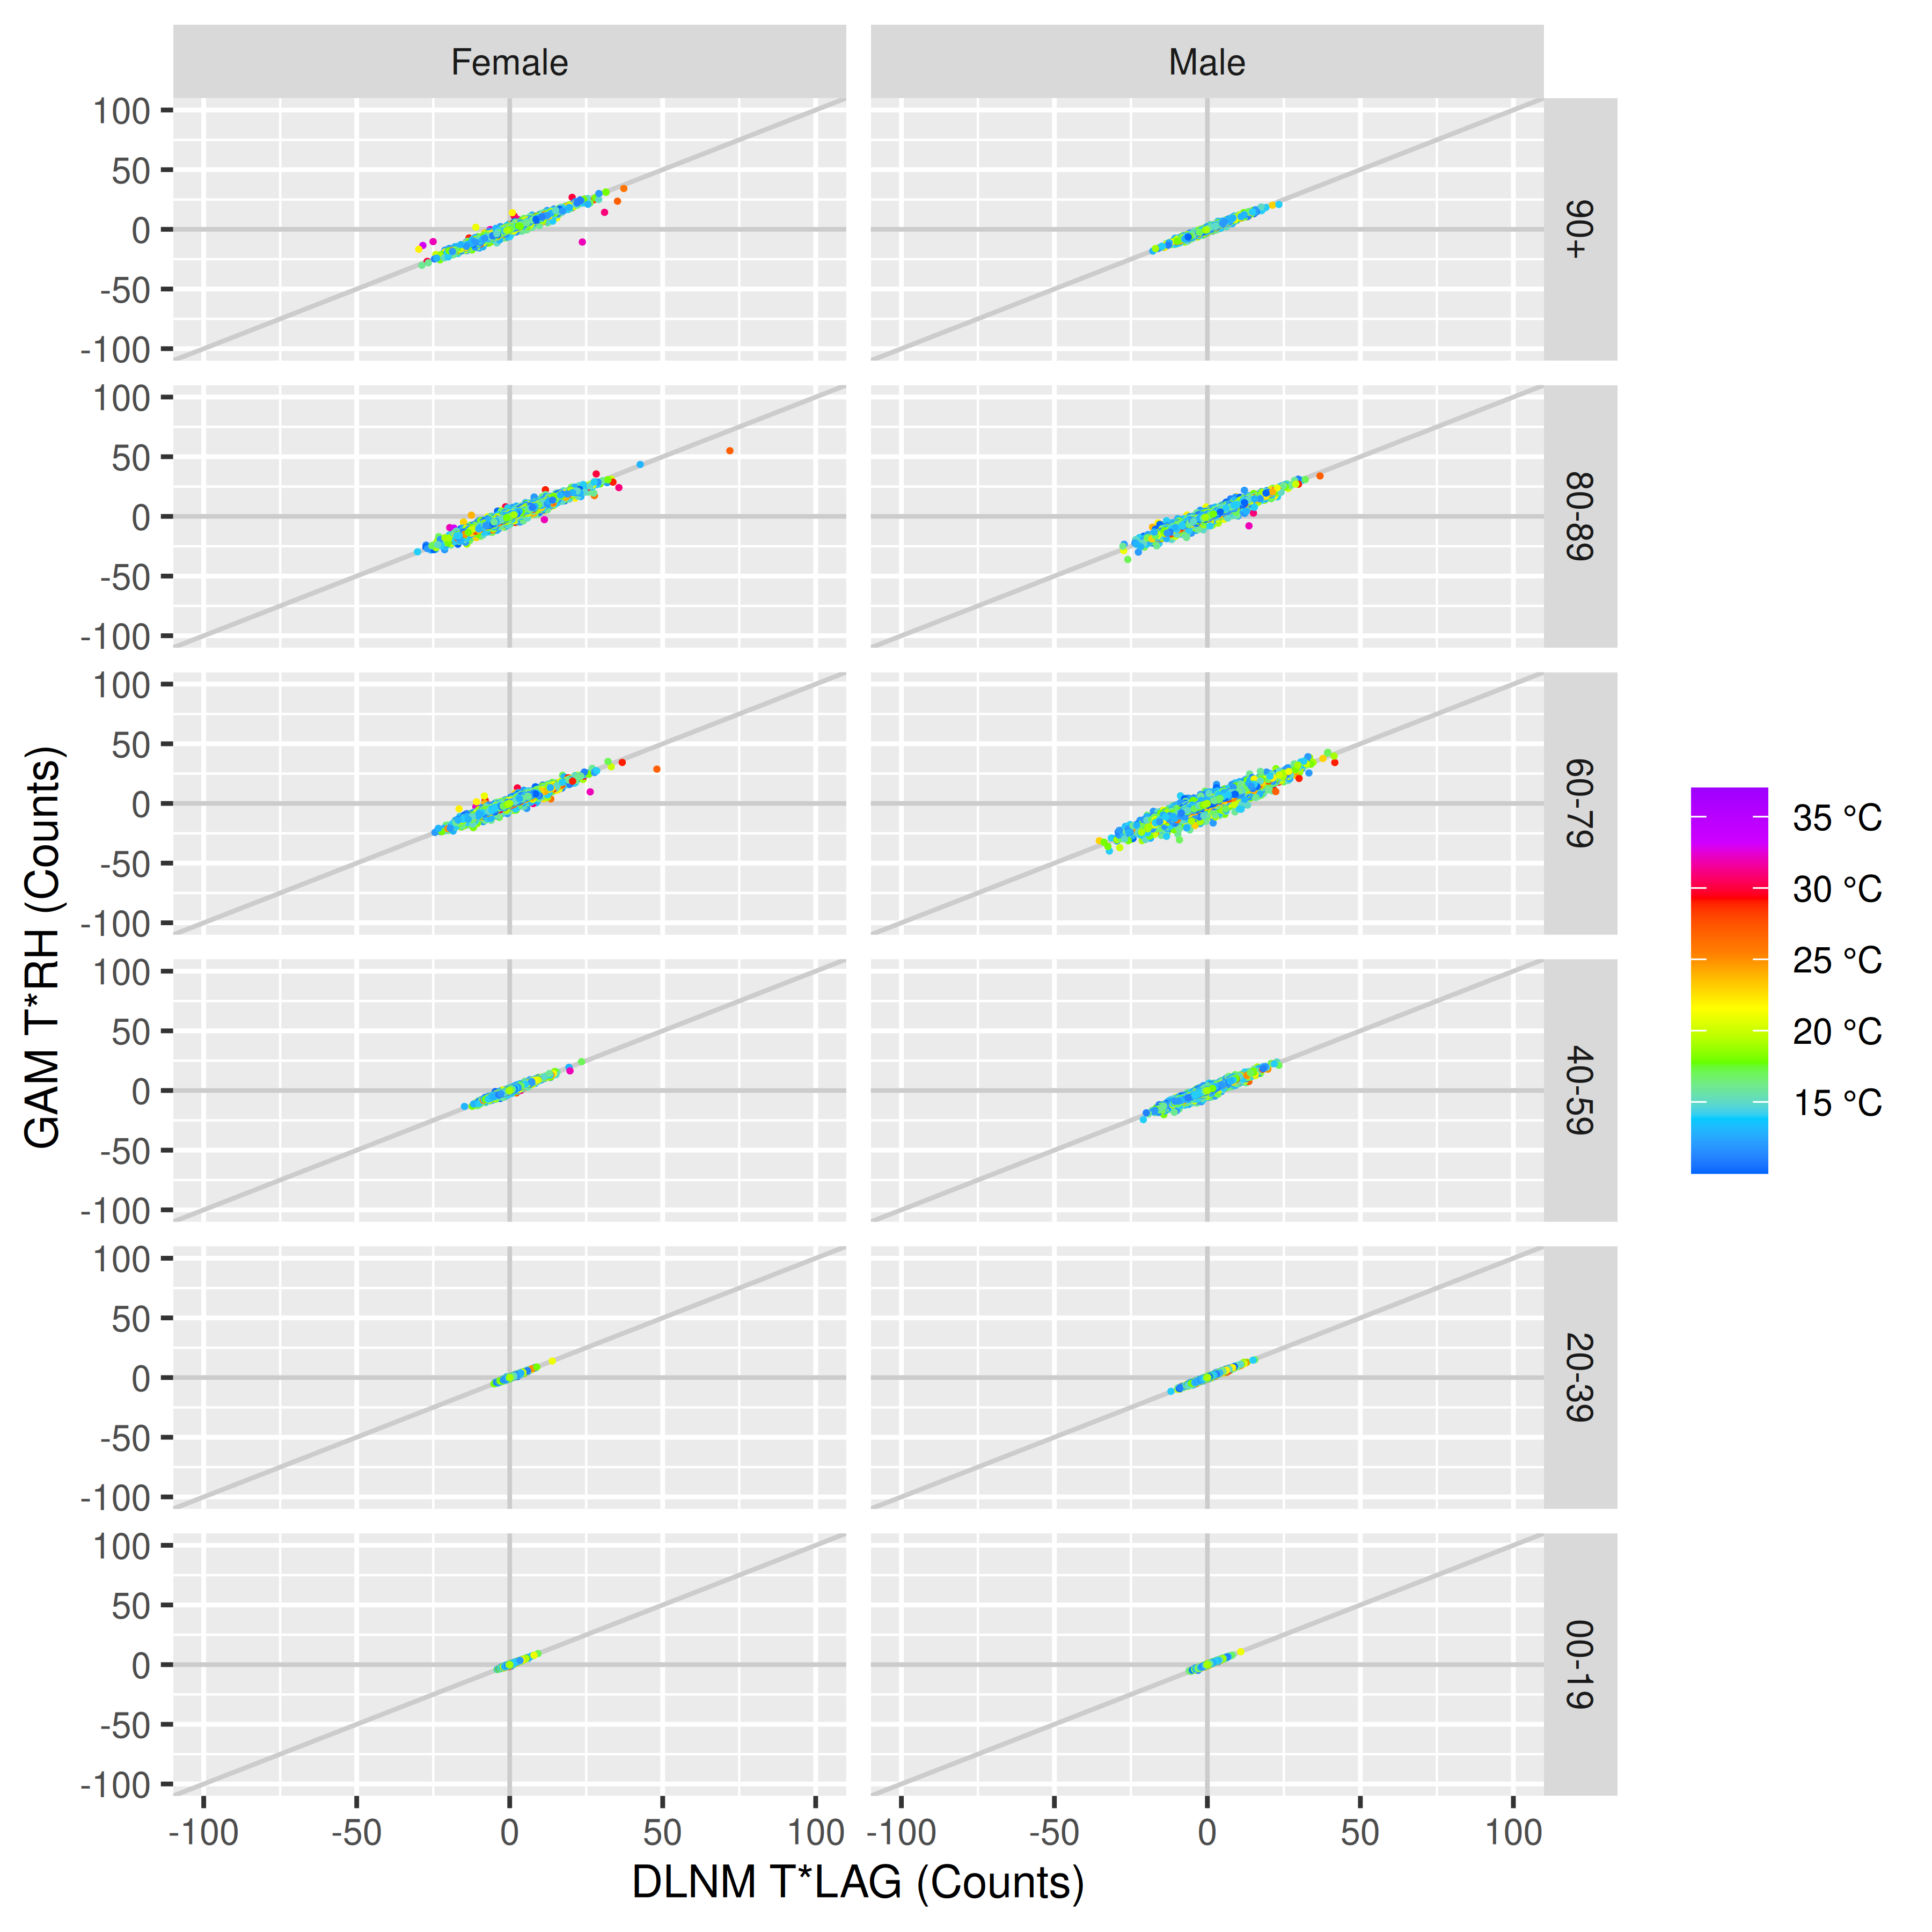
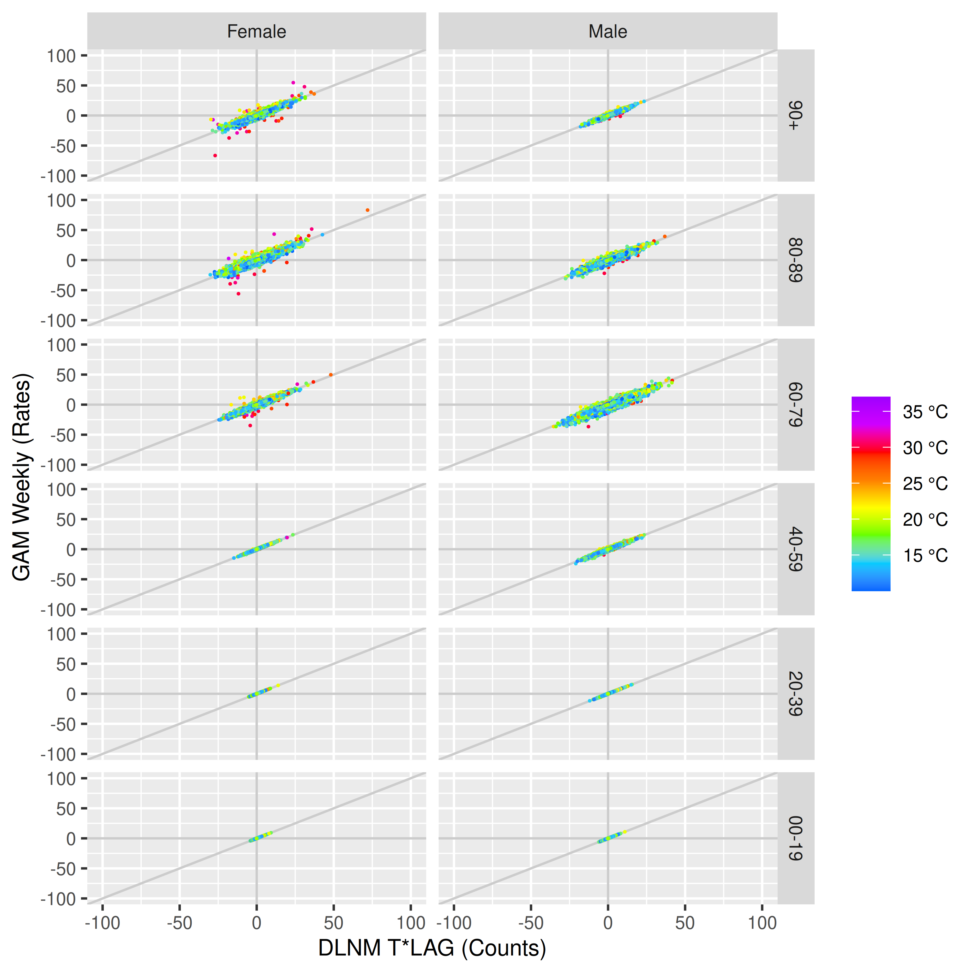
The final checks show the mean absolute error (MAE) and the mean error (BIAS) as well as their respective 99% confidence intervals (ribbon edges), for each of the models, by sex, age, and daily mean temperature, across all analysis days.
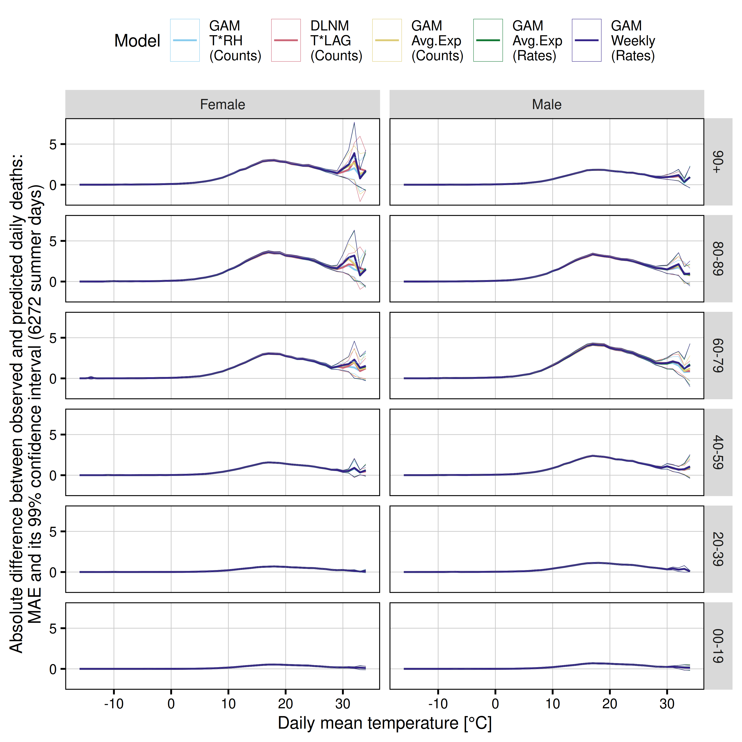
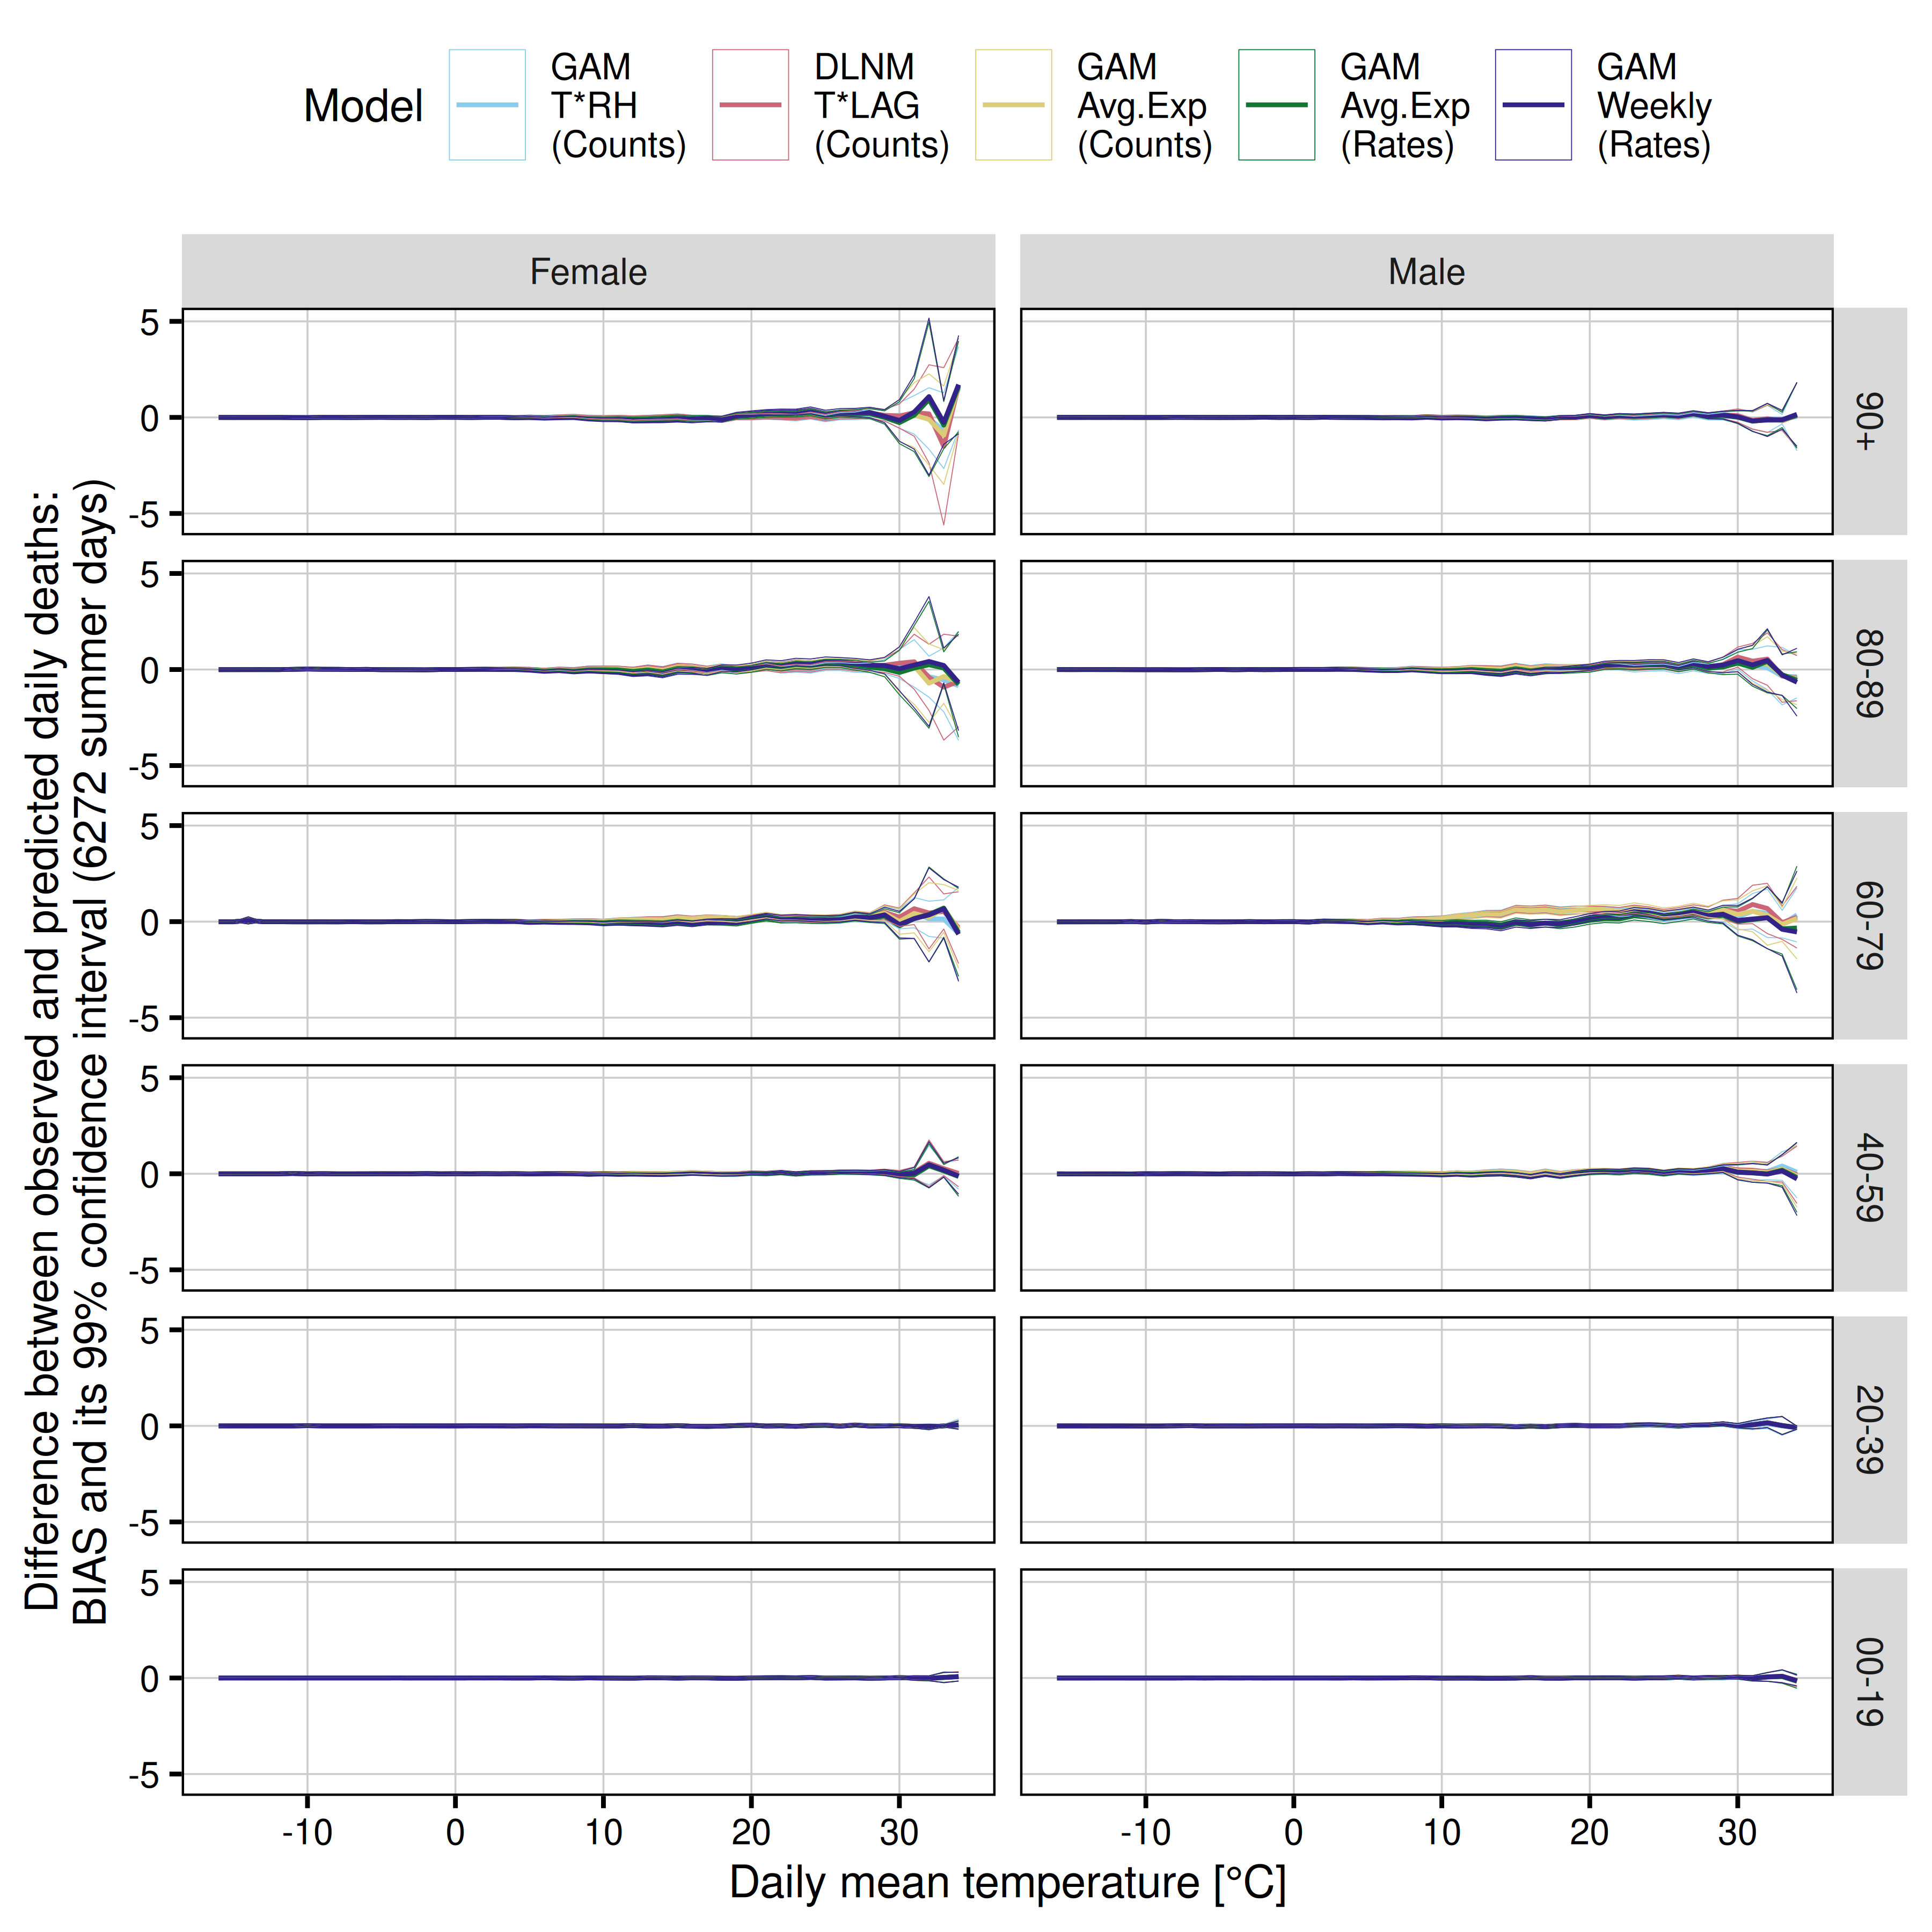

Plot: Mortality
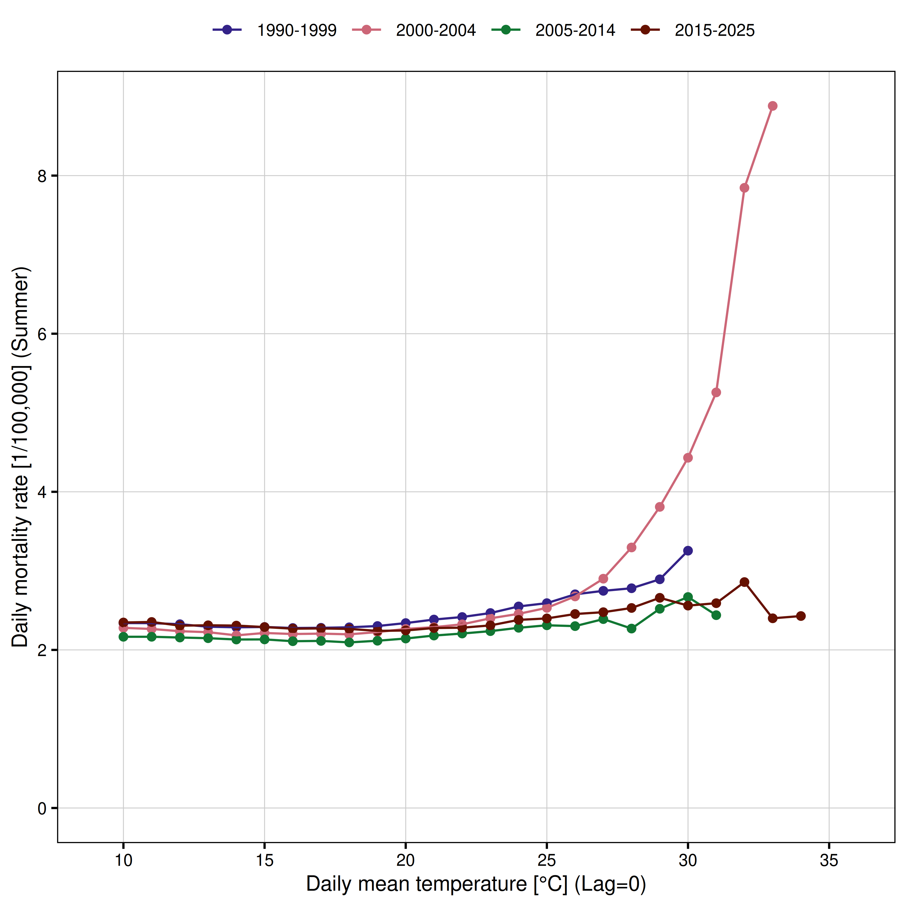
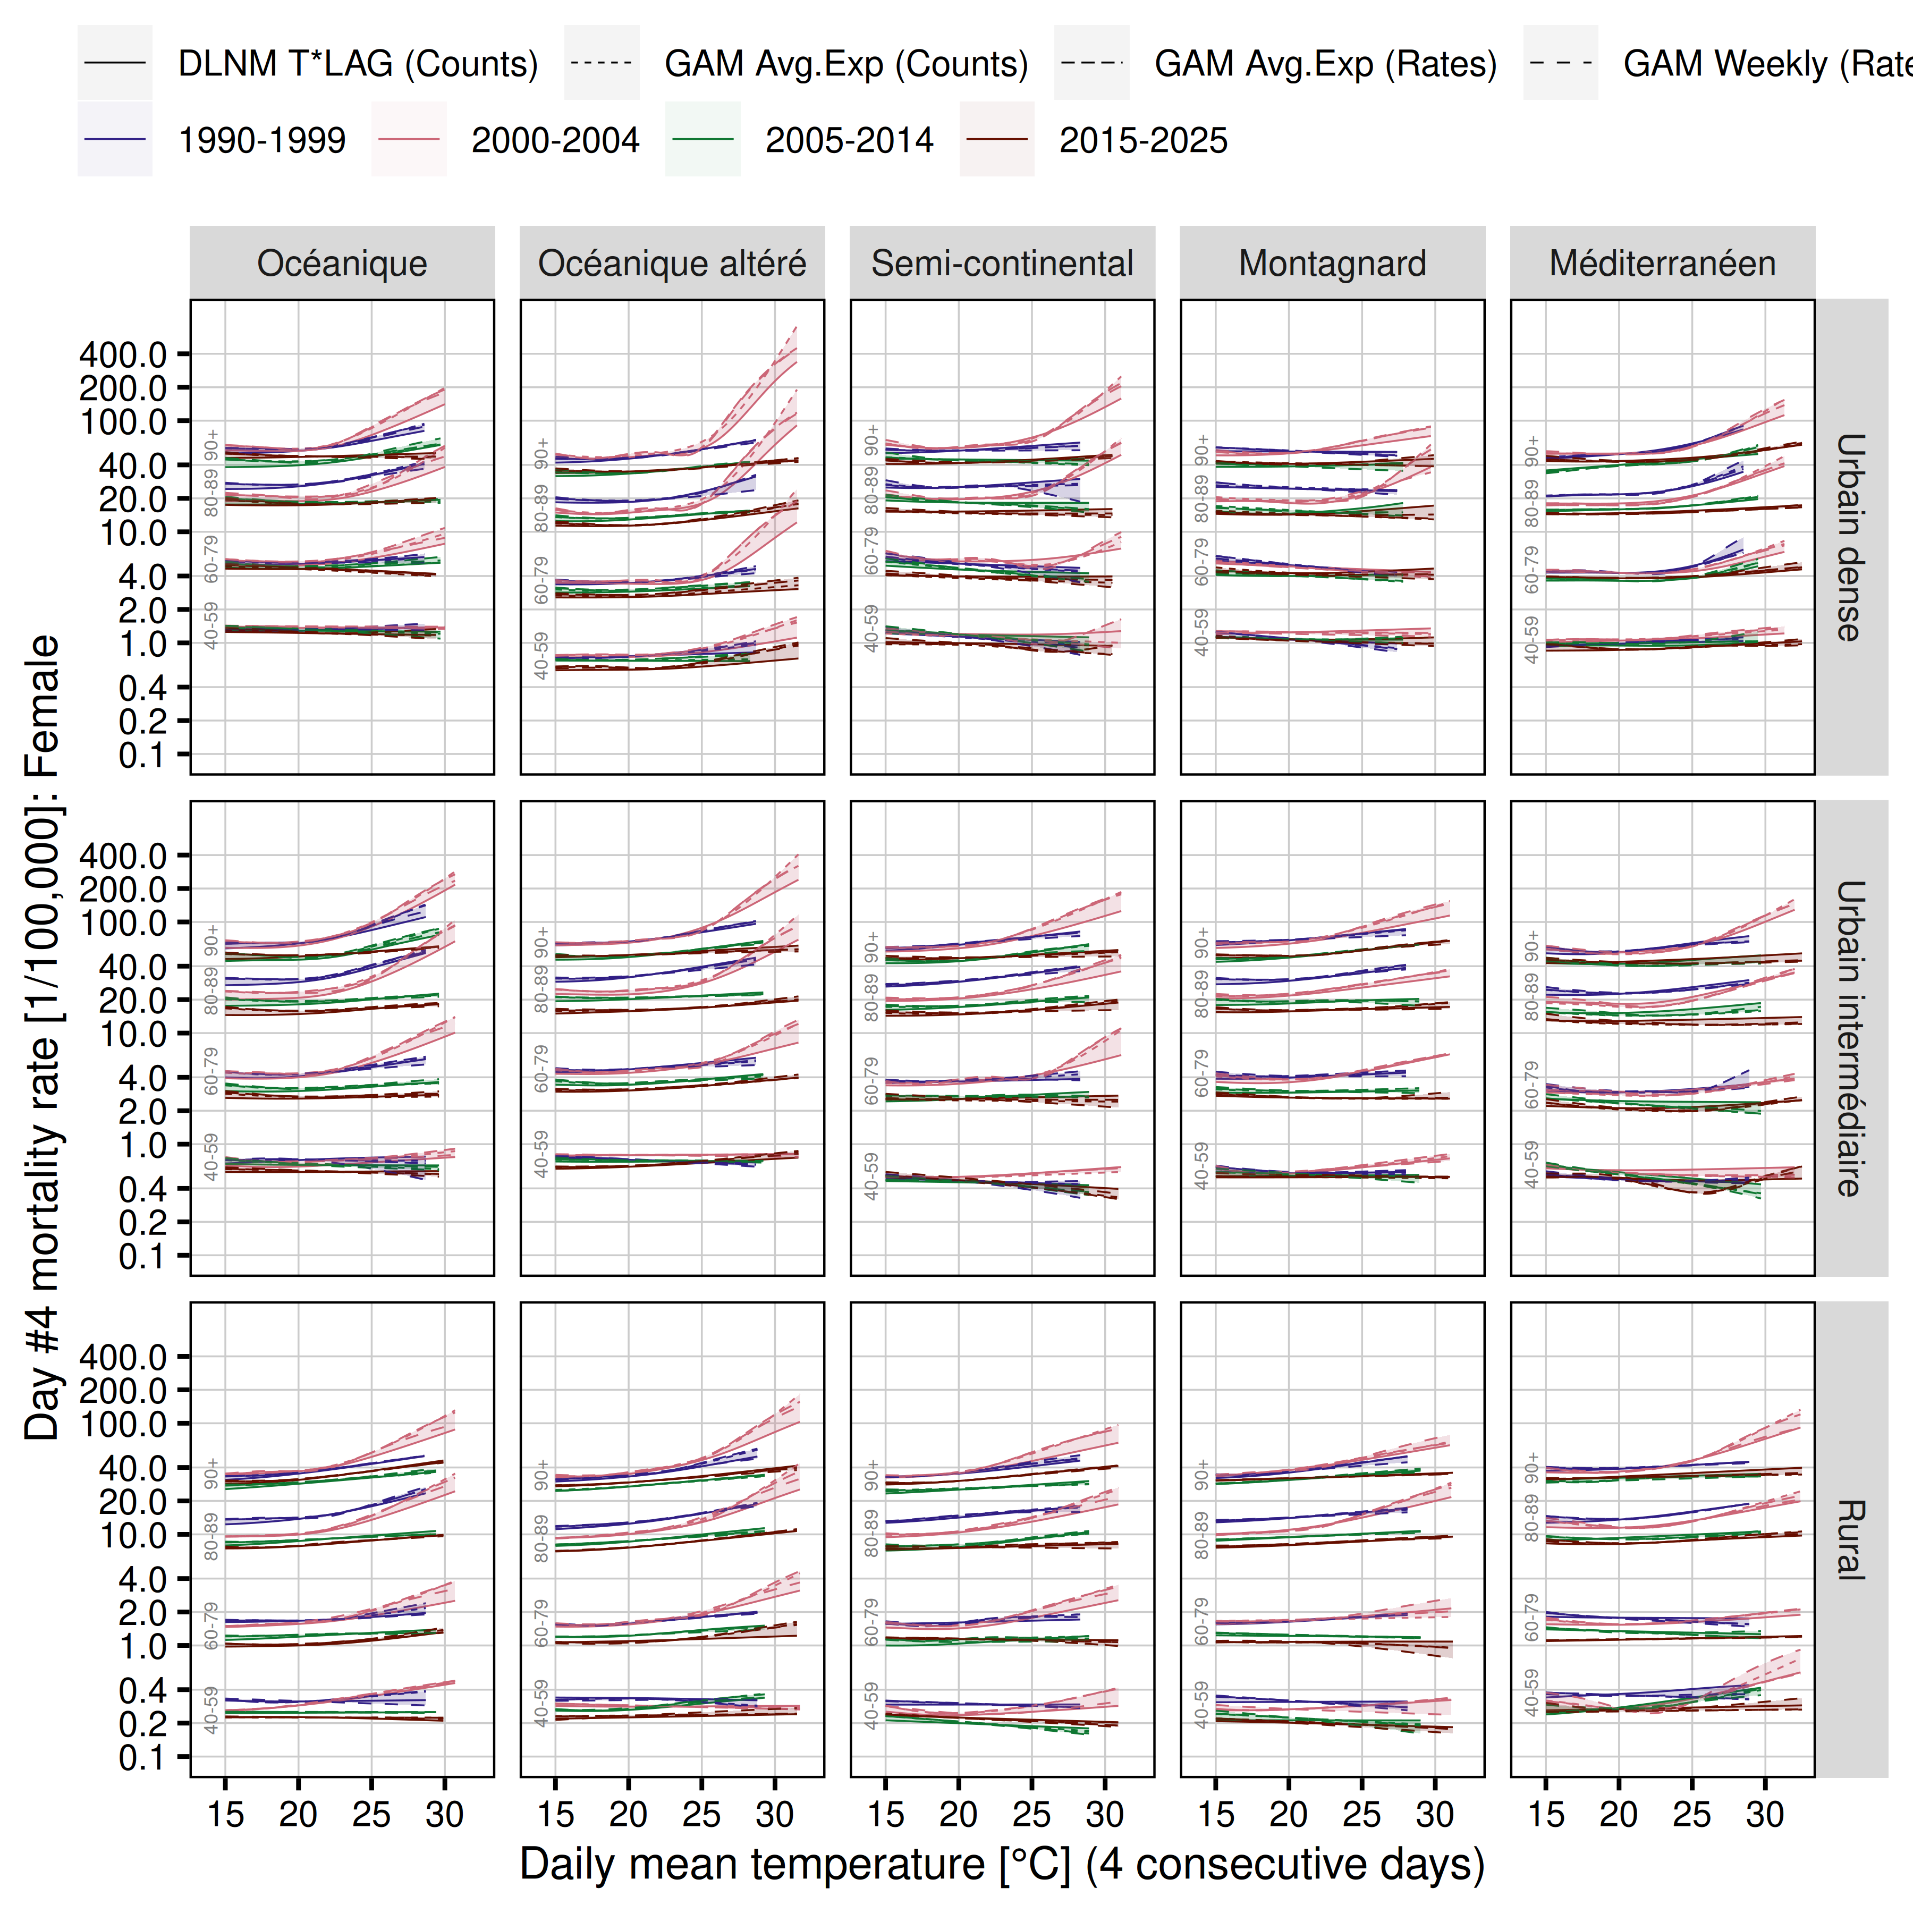
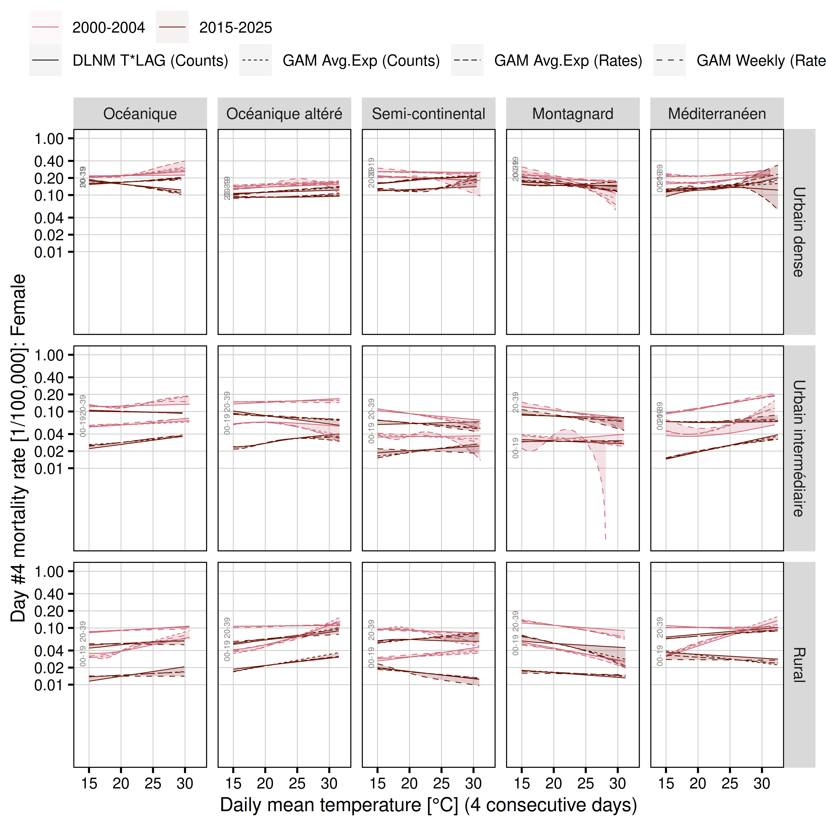
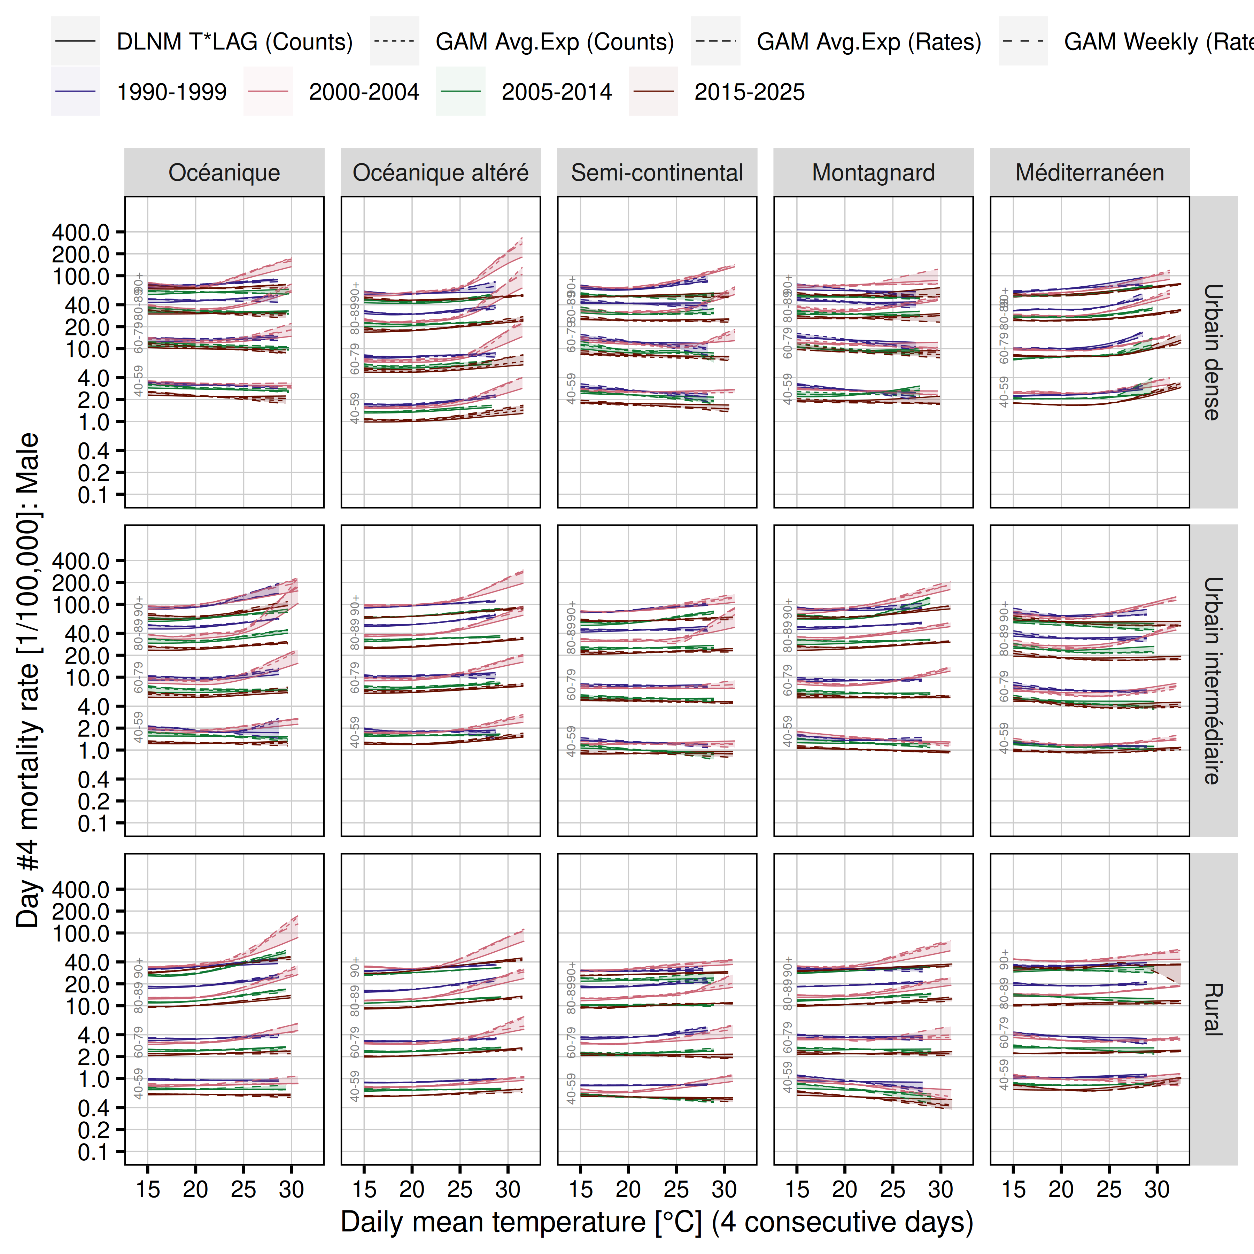
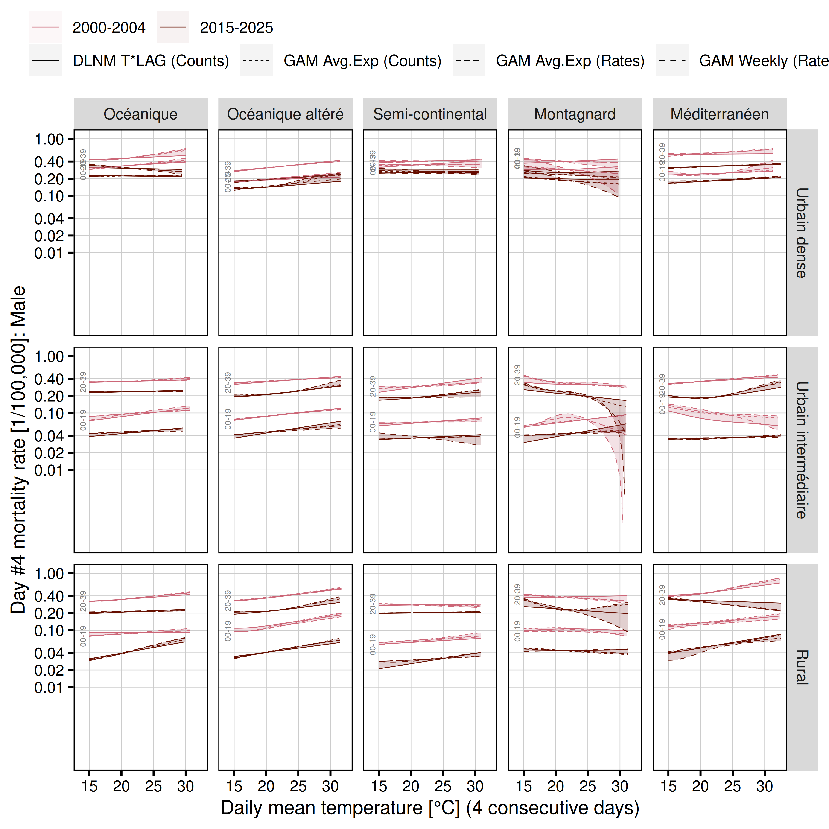
tag | elapsed | user | sys
Processing completed | 864.3 | 4,745.7 | 494.2
$citation
To cite RStudio in publications use:
Posit team (2026). RStudio: Integrated Development Environment for R.
Posit Software, PBC, Boston, MA. URL http://www.posit.co/.
A BibTeX entry for LaTeX users is
@Manual{,
title = {RStudio: Integrated Development Environment for R},
author = {{Posit team}},
organization = {Posit Software, PBC},
address = {Boston, MA},
year = {2026},
url = {http://www.posit.co/},
}
$mode
[1] "desktop"
$version
[1] '2026.9.0.174'
$long_version
[1] "2026.09.0+174"
$release_name
[1] "Autumn Hawkbit"
R version 4.6.1 (2026-06-24)
Platform: x86_64-pc-linux-gnu
Running under: Ubuntu 26.04.1 LTS
Matrix products: default
BLAS: /usr/lib/x86_64-linux-gnu/openblas-pthread/libblas.so.3
LAPACK: /usr/lib/x86_64-linux-gnu/openblas-pthread/libopenblasp-r0.3.32.so; LAPACK version 3.12.0
locale:
[1] LC_CTYPE=en_US.UTF-8 LC_NUMERIC=C
[3] LC_TIME=en_US.UTF-8 LC_COLLATE=en_US.UTF-8
[5] LC_MONETARY=en_US.UTF-8 LC_MESSAGES=en_US.UTF-8
[7] LC_PAPER=de_DE.UTF-8 LC_NAME=C
[9] LC_ADDRESS=C LC_TELEPHONE=C
[11] LC_MEASUREMENT=de_DE.UTF-8 LC_IDENTIFICATION=C
time zone: Europe/Berlin
tzcode source: system (glibc)
attached base packages:
[1] parallel stats graphics grDevices datasets utils methods
[8] base
other attached packages:
[1] scales_1.4.0 sf_1.1-3 RhpcBLASctl_0.23-42
[4] doParallel_1.0.17 iterators_1.0.14 foreach_1.5.2
[7] flextable_0.10.1 lubridate_1.9.5 forcats_1.0.1
[10] stringr_1.6.0 dplyr_1.2.1 purrr_1.2.2
[13] readr_2.2.0 tidyr_1.3.2 tibble_3.3.1
[16] ggplot2_4.0.3 tidyverse_2.0.0
loaded via a namespace (and not attached):
[1] gtable_0.3.6 xfun_0.61 bspm_0.5.8
[4] tzdb_0.5.0 vctrs_0.7.3 tools_4.6.1
[7] generics_0.1.4 proxy_0.4-29 pkgconfig_2.0.3
[10] KernSmooth_2.23-27 data.table_1.18.6.1 RColorBrewer_1.1-3
[13] S7_0.2.2 rvg_0.4.2 uuid_1.2-2
[16] lifecycle_1.0.5 compiler_4.6.1 farver_2.1.2
[19] textshaping_1.0.5 officedown_0.4.1 codetools_0.2-20
[22] fontquiver_0.2.1 fontLiberation_0.1.0 class_7.3-24
[25] htmltools_0.5.9 yaml_2.3.12 pillar_1.11.1
[28] classInt_0.4-11 openssl_2.4.2 cachem_1.1.0
[31] fontBitstreamVera_0.1.1 tidyselect_1.2.1 zip_3.0.2
[34] digest_0.6.39 stringi_1.8.9 fastmap_1.2.0
[37] grid_4.6.1 cli_3.6.6 magrittr_2.0.5
[40] patchwork_1.3.2 e1071_1.7-17 withr_3.0.3
[43] gdtools_0.5.1 timechange_0.4.0 rmarkdown_2.32
[46] officer_0.7.6 otel_0.2.0 askpass_1.2.1
[49] ragg_1.5.2 hms_1.1.4 memoise_2.0.1
[52] evaluate_1.0.5 knitr_1.52 viridisLite_0.4.3
[55] rlang_1.3.0 Rcpp_1.1.2 DBI_1.3.0
[58] glue_1.8.1 xml2_1.6.0 rstudioapi_0.19.0
[61] R6_2.6.1 units_1.0-1 systemfonts_1.3.2

