Latent Gender Score

Process Data: Causal Discovery

Charité - Universitätsmedizin Berlin, Institut für Public Health  
Hans-Aloys Wischmann, Mascha Kern

Revised: March 27, 2025  
Executed: March 28, 2025

## Load: DAGs and Layouts

## Plot: Domain Knowledge DAG, Causal Discovery DAG

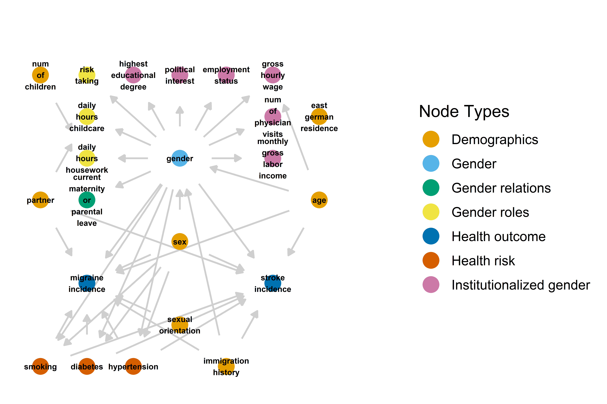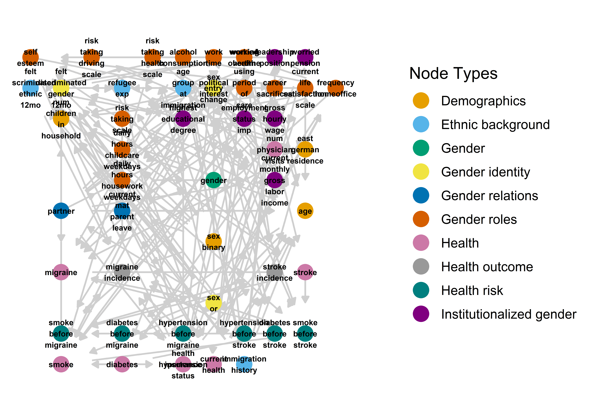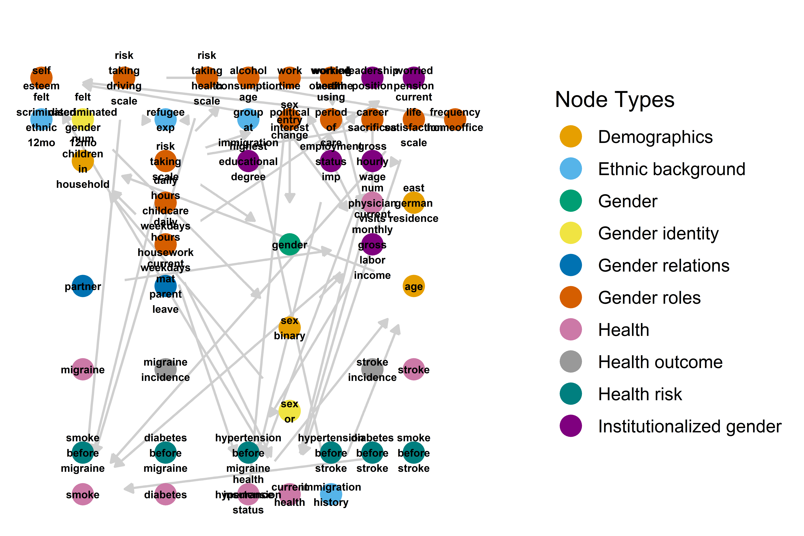

## Done

Time difference of 20.40548 secs