Quantification of Practice Effects in
Self-Administered Online
Cognitive Pre-Screening Tests
  - Structural Equation Modeling (SEM) followed by
Gaussian Mixture Modeling (GMM)
Charité - Universitätsmedizin Berlin
Institute of Public Health
Hans-Aloys Wischmann
July 2nd, 2026

Setup

Population
The study population has been described in detail elsewhere [Huijbers, 2025, https://www.nature.com/articles/s41598-026-35640-0]: It consisted of persons who self-enrolled online between 2024-01-13 and 2025-03-31, and who subsequently took the XpressO test, either in a web browser, or in an application that they downloaded and installed onto a personal device. All participants consented electronically to the use of their anonymized data for research and development purposes. Neither (clinical) diagnoses regarding the cognitive status nor scores from (supervised) cognitive screening tests were available for the participants.
Exclusions(sex): 0, exclusions(edu): 0, exclusions(age > 85): 351, exclusions(missing_1st): 33, exclusions(differing_edu): 36, exclusions(incomplete): 0. Years of education were categorized into Primary, LowerSecondary, UpperSecondary, PostSecondary, Tertiary using cutoffs of 6, 10, 13, 15 years.

Odds Ratios (ORs) for same-day and multi-week retest
Table S1: Logistic regression: same_day_return ~ sex + age_10y + edu_level + xpresso_score_level + platform + language_code / multi_week_return ~ sex + age_10y + edu_level + xpresso_score_level + platform + language_code
Covariate | OR [95%-CI], Same day | OR [95%-CI], 2-6 Weeks | p, Same day | p, 2-6 Weeks
sexFemale | 0.90 [0.86, 0.95] | 1.09 [0.97, 1.22] | <0.001 | 0.17
age_10y | 0.98 [0.96, 1.00] | 1.22 [1.17, 1.28] | 0.014 | <0.001
edu_levelLowerSecondary | 1.00 [0.84, 1.18] | 1.25 [0.77, 2.08] | 0.98 | 0.37
edu_levelUpperSecondary | 0.98 [0.85, 1.15] | 1.33 [0.88, 2.10] | 0.84 | 0.19
edu_levelPostSecondary | 1.09 [0.94, 1.28] | 1.48 [0.98, 2.33] | 0.27 | 0.079
edu_levelTertiary | 1.09 [0.94, 1.26] | 1.43 [0.96, 2.22] | 0.28 | 0.096
xpresso_score_levelIntermediate | 0.94 [0.88, 1.00] | 1.00 [0.83, 1.20] | 0.050 | 0.99
xpresso_score_levelHigh | 0.26 [0.24, 0.28] | 0.90 [0.77, 1.06] | <0.001 | 0.21
platformWeb Browser | 0.49 [0.46, 0.52] | 0.10 [0.08, 0.12] | <0.001 | <0.001
language_codeFrench | 0.67 [0.63, 0.72] | 0.55 [0.47, 0.64] | <0.001 | <0.001
[1] "Checking IPW: Variance Inflation Factors (VIFs), should all be <5 as a rule-of-thumb, glm_0d and glm_2w"
GVIF Df GVIF^(1/(2*Df))
sex 1.016821 1 1.008375
age_10y 1.248051 1 1.117162
edu_level 1.166174 4 1.019402
xpresso_score_level 1.172097 2 1.040497
platform 1.561676 1 1.249670
language_code 1.690797 1 1.300306
GVIF Df GVIF^(1/(2*Df))
sex 1.016034 1 1.007985
age_10y 1.143454 1 1.069324
edu_level 1.089245 4 1.010743
xpresso_score_level 1.107699 2 1.025901
platform 1.328541 1 1.152624
language_code 1.388794 1 1.178471
[1] "Checking IPW: Deciles (QQ), glm_0d and glm_2w"
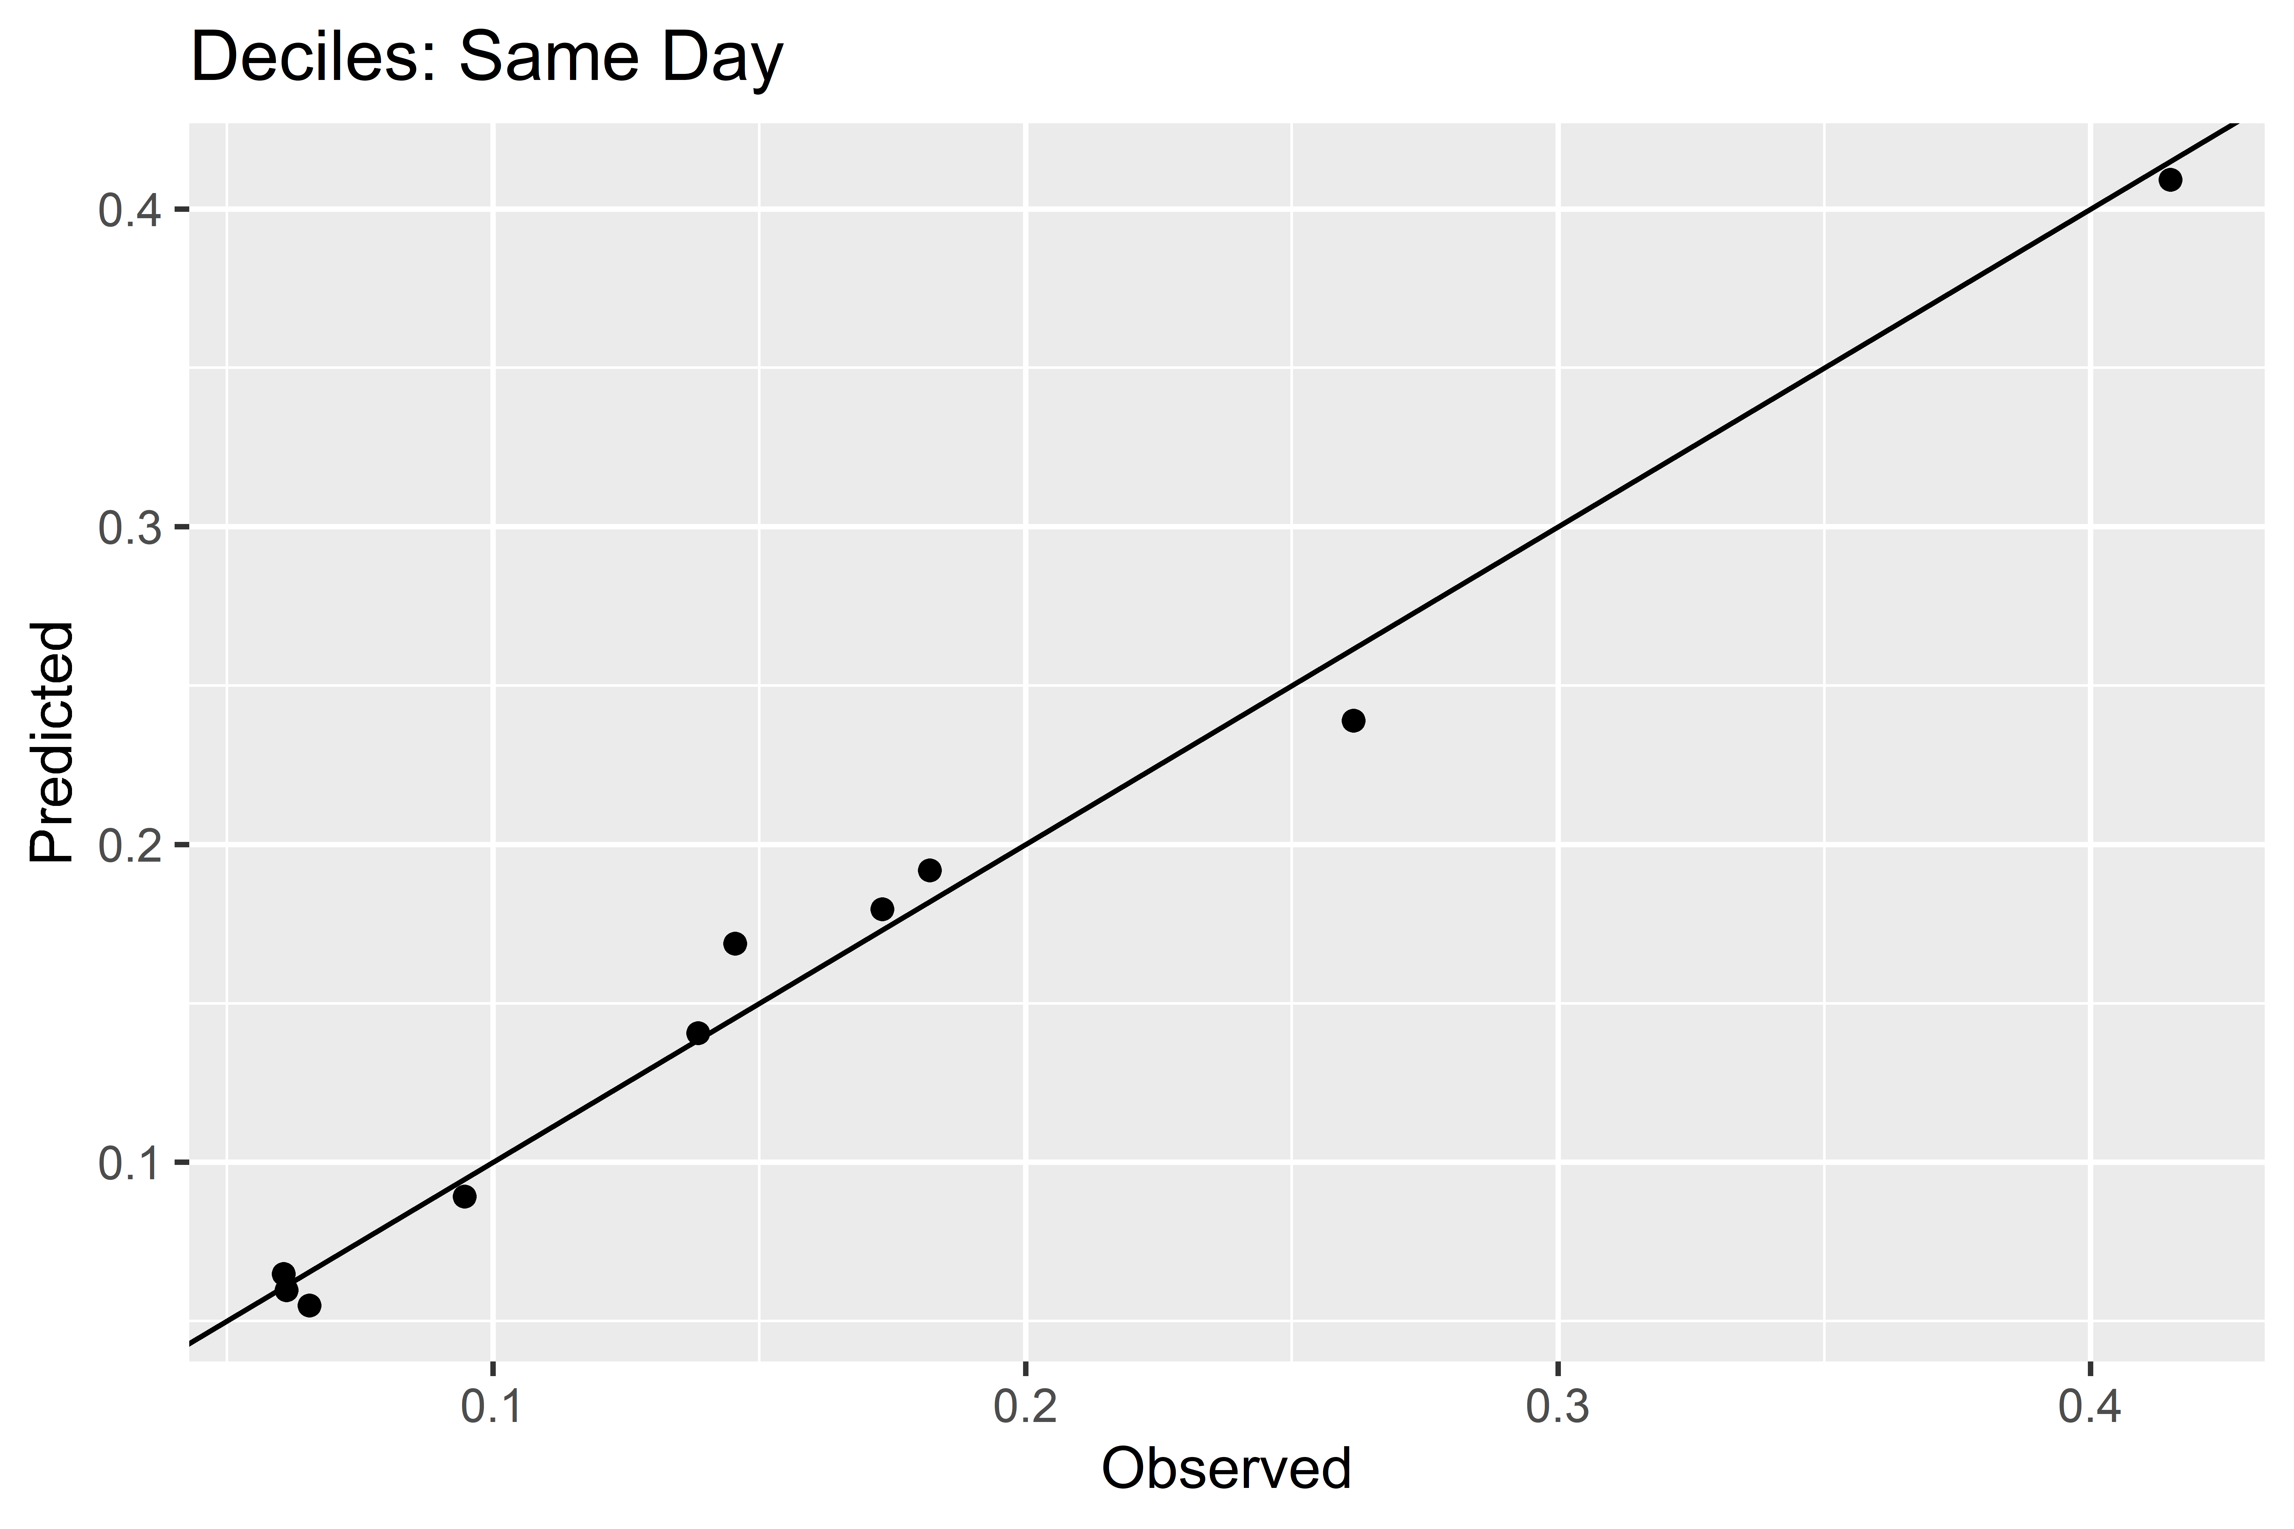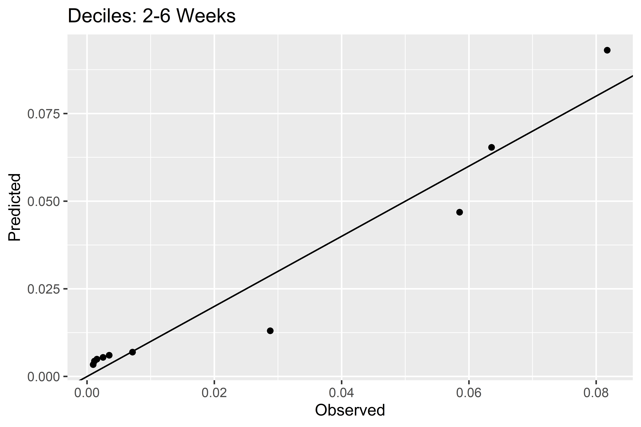
[1] "Checking IPW: Area Under the Curve (AUC), should all be as close to 1 as possible, glm_0d and glm_2w"
Area under the curve: 0.7032
Area under the curve: 0.8178
Overall, the probability to return for at least one additional test on the day of the initial test was 16.0%, but only 2.5% for at least one additional test after a gap of 14 to 42 days.

Structural Equation Modeling (SEM) of cognitive domains
First, cognitive status for the overall study population are estimated on a continuous scale in a Structural Equation Model (SEM), based on observed item counts and question time metrics from the XpressO test, separately for the memory tasks and the logical tasks. Baseline status is estimated as two distinct but potentially correlated, unobserved, latent continuous variables, using data from the initial session only. Regressions are added for all metrics as a function of sex (dichotomous, converted to integer), age (continuous), and education level (ordinal, i.e., ordered categorical, converted to integer), and for the number of correct items and the question times, as a function of the number of items placed. Weighting (IPW) is not performed, as the initial session of all participants is analyzed.

Gaussian Mixture Modeling (GMM) for cognitive status
Subsequently, cognitive status for the overall study population is estimated as a latent categorical variable in a Gaussian Mixture Model (GMM), based on the observed metrics from the XpressO test plus the two latent continuous cognitive status variables computed in the first step, using the SEM. Using the R package MoEclust, influences of the covariates sex, age, and education level on the indicator variables and on the probability density are included. Models with 3 classes are computed, to separate a presumably cognitively normal sub-population from a probably cognitively impaired sub-population, while allowing for a third class, e.g., with intermediate or vastly superior cognitive performance.
Participants are tentatively classified as cognitively impaired (ML_CI), by this SEM-GMM unsupervised machine learning approach, when they are categorized into the lowest memory performance class or into the lowest logical performance class, and otherwise as cognitively normal (ML_CN).
Warning: Optimal model contains positive log-densities; consider setting 'posidens' to FALSE
Warning: Solution contains positive log-densities and may be spurious
------------------------------------------------------
Gaussian Parsimonious Clustering Model with Covariates
Data: metrics_covariates %>% select(-age, -sex, -edu, -xid)
------------------------------------------------------
MoEClust: VVV (ellipsoidal, varying volume, shape, and orientation), with 3 components
Gating Network Covariates: ~age + sex + edu
Expert Network Covariates: ~age + sex + edu
Noise Component: FALSE
log.likelihood n d df iters BIC ICL AIC Algo
1114770 51760 5 164 3 2227760 2215679 2229212 EM
Clustering table :
1 2 3
17380 1547 32833
Bayesian Information Criterion (BIC):
EII VII EEI VEI EVI VVI EEE VEE EVE
3 -1053300 -955977.8 -1008214 1339401 -316379.4 1725006 -609260.9 -1332220 -Inf
VVE EEV VEV EVV VVV
3 -Inf -267566.5 -Inf -Inf 2227760
Top 3 models based on the BIC criterion:
VVV,3 VVI,3 VEI,3
2227760 1725006 1339401
Warning: Optimal model contains positive log-densities; consider setting 'posidens' to FALSE
Warning: Solution contains positive log-densities and may be spurious
------------------------------------------------------
Gaussian Parsimonious Clustering Model with Covariates
Data: metrics_covariates %>% select(-age, -sex, -edu, -xid)
------------------------------------------------------
MoEClust: VVI (diagonal, varying volume and shape), with 3 components
Gating Network Covariates: ~age + sex + edu
Expert Network Covariates: ~age + sex + edu
Noise Component: FALSE
log.likelihood n d df iters BIC ICL AIC Algo
2404874 51760 5 134 5 4808294 4808270 4809480 EM
Clustering table :
1 2 3
27268 1775 22717
Bayesian Information Criterion (BIC):
EII VII EEI VEI EVI VVI EEE VEE
3 -672803.3 -216783.8 -565810.3 2187388 -217292.8 4808294 -257446.4 -Inf
EVE VVE EEV VEV EVV VVV
3 -158196.5 -Inf 10162.86 -Inf -Inf 4341318
Top 3 models based on the BIC criterion:
VVI,3 VVV,3 VEI,3
4808294 4341318 2187388

Demographics including Imputed Cognitive Status
Table 1: Study population and sub-populations with a repeat session on the day of their initial session or after a gap of 2 to 6 weeks
Population | Education | N | Age  Mean [Min; Max] | Female | XpressO  Mean (SD) | ML_CI
Total | Primary | 1,371 | 61.4 [18; 85] | 57.0% | 55.4 (32.8) | 10.9%
Total | LowerSecondary | 3,742 | 64.8 [18; 85] | 56.7% | 56.1 (32.6) | 8.9%
Total | UpperSecondary | 13,121 | 62.9 [18; 85] | 63.1% | 65.1 (30.1) | 7.3%
Total | PostSecondary | 9,385 | 59.9 [20; 85] | 62.0% | 71.0 (28.1) | 5.8%
Total | Tertiary | 24,141 | 56.8 [22; 85] | 58.9% | 75.9 (25.9) | 4.7%
Total | All | 51,760 | 59.6 [18; 85] | 60.3% | 70.3 (28.8) | 6.0%
Same-Day | Primary | 250 | 59.5 [20; 84] | 53.2% | 66.9 (30.7) | 16.8%
Same-Day | LowerSecondary | 591 | 64.0 [18; 85] | 53.1% | 65.4 (31.2) | 12.7%
Same-Day | UpperSecondary | 1,927 | 61.8 [18; 85] | 59.8% | 72.1 (28.1) | 11.7%
Same-Day | PostSecondary | 1,436 | 59.5 [20; 85] | 60.0% | 76.1 (25.8) | 10.2%
Same-Day | Tertiary | 4,066 | 57.6 [22; 85] | 55.6% | 79.1 (24.3) | 9.1%
Same-Day | All | 8,270 | 59.4 [18; 85] | 57.1% | 75.6 (26.6) | 10.4%
Fortnight+ | Primary | 24 | 56.9 [22; 79] | 75.0% | 73.7 (24.9) | 4.2%
Fortnight+ | LowerSecondary | 54 | 62.0 [32; 82] | 64.8% | 77.4 (22.8) | 5.6%
Fortnight+ | UpperSecondary | 230 | 60.3 [18; 85] | 69.1% | 72.6 (27.2) | 6.1%
Fortnight+ | PostSecondary | 207 | 59.1 [20; 80] | 68.6% | 75.8 (26.8) | 8.2%
Fortnight+ | Tertiary | 776 | 58.1 [22; 85] | 61.2% | 79.6 (25.2) | 4.6%
Fortnight+ | All | 1,291 | 58.8 [18; 85] | 64.2% | 77.5 (25.8) | 5.5%

Prevalence of cognitive impairment, by age, sex, and education level
The prevalence of presumed cognitive impairment is assessed in the overall study population based on the imputed classification, using a generalized additive logistic regression model (GAM) from the R package mgcv, to create prevalence estimates stratified by sex and education level, with a smooth dependency on age, by sex and education level.


GAMs for XpressO scores
The imputed cognitive classification is subsequently leveraged to analyze the XpressO scores across all participants as a function of age, sex, education level, and tentative cognitive status, both to inspect the relationship between the imputed classification and the XpressO scores, and to create insights into the dependency of the XpressO scores on the demographic covariates. Here, we use another GAM to create a quantitative synopsis of the XpressO scores, for the initial session, again allowing for a smooth dependency on age, by sex, education level, and cognitive status. The parametric coefficients are used to quantify baseline XpressO score differences in the study population, i.e., offsets, for all education levels compared to primary education and for women compared to men.
Warning: Removed 6 rows containing missing values or values outside the scale range
(`geom_ribbon()`).
Removed 6 rows containing missing values or values outside the scale range
(`geom_ribbon()`).

Table S2: Baseline differences in XpressO scores, compared to primary education, male, cognitively impaired (ML_CI), from GAM regression
Covariate | Difference [95%-CI] | p.value
Female | 4.9 [4.5, 5.4] | <0.001
LowerSecondary | 2.5 [0.9, 4.1] | 0.002
UpperSecondary | 8.2 [6.7, 9.6] | <0.001
PostSecondary | 11.6 [10.2, 13.1] | <0.001
Tertiary | 15.0 [13.6, 16.4] | <0.001
ML_CN | 39.7 [38.6, 40.8] | <0.001

Practice Effects
Practice effects are defined as the difference in observed metrics between the first completed retest session and the initial session, for each participant. Inverse probability weighting (IPW) is applied to adjust for self-selection bias in the participants’ decisions to retake the test, so as to estimate mean practice effects and standard deviations (SDs) that would have been observed if all participants had returned for both retests. Consequently, a weighted paired two-sample t-test is used to check each metric for significant differences, stratified by the imputed, tentative classification into cognitively normal versus cognitively impaired.
Table 2: Practice effects showing IPW-weighted mean difference, (IPW-weighted SD), and p-value from IPW-weighted two-sample paired t.test
 | Impaired (ML_CI) |  | Normal (ML_CN)
Metric | Same-Day | Fortnight+ | Same-Day | Fortnight+
total question time [min] | -2.4 / <0.001 | -2.0 / <0.001 | -0.9 / <0.001 | -0.6 / <0.001
logical question time [min] | -1.4 / <0.001 | -1.6 / <0.001 | -0.4 / <0.001 | -0.3 / <0.001
memory question time [min] | -0.3 / <0.001 | -0.2 / 0.14 | -0.2 / <0.001 | -0.1 / <0.001
logical number of items placed | 2.0 / <0.001 | 2.3 / <0.001 | -0.1 / <0.001 | -0.1 / <0.001
logical number of 100correct items | 2.8 / <0.001 | 4.3 / <0.001 | 1.2 / <0.001 | 0.3 / 0.11
logical number of correct colors | 2.4 / <0.001 | 2.7 / <0.001 | 0.6 / <0.001 | 0.1 / 0.22
memory number of items placed | 1.7 / <0.001 | 0.8 / 0.001 | -0.1 / <0.001 | -0.1 / <0.001
memory number of correct items | 2.0 / <0.001 | 0.8 / 0.20 | -0.1 / 0.002 | -0.2 / <0.001
memory number of correct items and positions | 2.4 / <0.001 | 1.2 / 0.13 | 0.1 / 0.001 | -0.1 / 0.36
number of prior sessions | 1.0 / <0.001 | 3.9 / <0.001 | 1.0 / <0.001 | 2.9 / <0.001
Table S3: Practice effects as in Table 2, but excluding subjects with primary education
 | Impaired (ML_CI) |  | Normal (ML_CN)
Metric | Same-Day | Fortnight+ | Same-Day | Fortnight+
total question time [min] | -2.4 / <0.001 | -2.0 / <0.001 | -0.9 / <0.001 | -0.6 / <0.001
logical question time [min] | -1.4 / <0.001 | -1.6 / <0.001 | -0.4 / <0.001 | -0.3 / <0.001
memory question time [min] | -0.3 / <0.001 | -0.2 / 0.15 | -0.2 / <0.001 | -0.1 / <0.001
logical number of items placed | 2.0 / <0.001 | 2.3 / <0.001 | -0.1 / <0.001 | -0.1 / <0.001
logical number of 100correct items | 2.8 / <0.001 | 4.3 / <0.001 | 1.2 / <0.001 | 0.3 / 0.075
logical number of correct colors | 2.5 / <0.001 | 2.7 / <0.001 | 0.6 / <0.001 | 0.1 / 0.36
memory number of items placed | 1.7 / <0.001 | 0.8 / 0.001 | -0.1 / <0.001 | -0.1 / <0.001
memory number of correct items | 2.0 / <0.001 | 0.7 / 0.23 | -0.1 / 0.001 | -0.2 / <0.001
memory number of correct items and positions | 2.5 / <0.001 | 1.1 / 0.17 | 0.1 / 0.001 | -0.1 / 0.26
number of prior sessions | 1.0 / <0.001 | 3.9 / <0.001 | 1.0 / <0.001 | 2.9 / <0.001

Discrimination Power (XpressO)
Two working points on ROC for new, adapted XpressO score, after a gap of more than 1 week
Sensitivity | Specificity | point
0.84 | 0.87 | Sensitivity >= 84%
0.89 | 0.84 | Youden index
Scale for x is already present.
Adding another scale for x, which will replace the existing scale.

DeLong's test for two ROC curves
data: roc_1w and roc_1
D = 12.568, df = 17305, p-value < 2.2e-16
alternative hypothesis: true difference in AUC is greater than 0
sample estimates:
AUC of roc1 AUC of roc2
0.9227314 0.8421238
AUC(initial): 0.842, AUC(same-day retests): 0.589, AUC(retests after gap): 0.631, AUC(with practice effects): 0.923.

Supplementary Materials

Figure S1: Mean performance metrics stratified by session number

Figure S2: SEM-imputed continuous cognitive performance status for logical and memory tasks.

Figure S3: Age and selected memory performancemetrics, by GMM-imputed categorical logical status, initial session.

Figure S4: Age and selected logical performance metrics, by GMM-imputed categorical memory status, initial session.
SEM - Imputation of latent continuous cognitive performance status from memory and logical performance metrics.
SEM - The latent variable can only be estimated up to an arbitraty, irrelevant factor (and sign).
SEM - Direction of the imputed status is fixed by setting the regression factor to 1 for the number of fully correct items.
mem =~ 1.0 * sum_memory_number_of_correct_items_and_positions +
sum_memory_number_of_correct_items +
sum_memory_number_of_items_placed +
sum_memory_question_time
log =~ 1.0 * sum_logical_number_of_100correct_items +
sum_logical_number_of_correct_colors +
sum_logical_number_of_items_placed +
sum_logical_question_time
sum_memory_number_of_correct_items_and_positions +
sum_memory_number_of_correct_items +
sum_memory_number_of_items_placed +
sum_memory_question_time +
sum_logical_number_of_100correct_items +
sum_logical_number_of_correct_colors +
sum_logical_number_of_items_placed +
sum_logical_question_time ~ sex + age + edu_level
sum_memory_number_of_correct_items_and_positions + sum_memory_number_of_correct_items + sum_memory_question_time ~ sum_memory_number_of_items_placed
sum_logical_number_of_100correct_items + sum_logical_number_of_correct_colors + sum_logical_question_time ~ sum_logical_number_of_items_placed
mem ~~ log
lavaan 0.6-21 ended normally after 221 iterations
Estimator ML
Optimization method NLMINB
Number of model parameters 47
Number of observations 51760
Model Test User Model:
Test statistic 12966.318
Degrees of freedom 13
P-value (Chi-square) 0.000
Model Test Baseline Model:
Test statistic 219713.475
Degrees of freedom 52
P-value 0.000
User Model versus Baseline Model:
Comparative Fit Index (CFI) 0.941
Tucker-Lewis Index (TLI) 0.764
Loglikelihood and Information Criteria:
Loglikelihood user model (H0) -642683.442
Loglikelihood unrestricted model (H1) -636200.283
Akaike (AIC) 1285460.884
Bayesian (BIC) 1285877.040
Sample-size adjusted Bayesian (SABIC) 1285727.673
Root Mean Square Error of Approximation:
RMSEA 0.139
90 Percent confidence interval - lower 0.137
90 Percent confidence interval - upper 0.141
P-value H_0: RMSEA <= 0.050 0.000
P-value H_0: RMSEA >= 0.080 1.000
Standardized Root Mean Square Residual:
SRMR 0.050
Latent Variables:
Estimate
mem =~
sm_mmry_n_____ 1.000
sm_mmry_nmb___ 0.374
sm_mmry_nmb___ 0.080
sm_mmry_qstn_t -0.082
log =~
sm_lgcl___100_ 1.000
sm_lgcl_nmb___ 0.556
sm_lgcl_nmb___ 0.061
sm_lgcl_qstn_t -0.013
Regressions:
Estimate
sum_memory_number_of_correct_items_and_positions ~
sex 0.327
age -0.022
edu_level 0.248
sum_memory_number_of_correct_items ~
sex 0.124
age -0.008
edu_level 0.092
sum_memory_number_of_items_placed ~
sex 0.022
age -0.004
edu_level 0.023
sum_memory_question_time ~
sex -0.126
age 0.013
edu_level -0.027
sum_logical_number_of_100correct_items ~
sex 0.883
age -0.091
edu_level 0.831
sum_logical_number_of_correct_colors ~
sex 0.435
age -0.053
edu_level 0.502
sum_logical_number_of_items_placed ~
sex 0.031
age -0.007
edu_level 0.016
sum_logical_question_time ~
sex -0.184
age 0.027
edu_level 0.005
sum_memory_number_of_correct_items_and_positions ~
sm_mmry_nmb___ 0.598
sum_memory_number_of_correct_items ~
sm_mmry_nmb___ 0.863
sum_memory_question_time ~
sm_mmry_nmb___ 0.034
sum_logical_number_of_100correct_items ~
sm_lgcl_nmb___ -0.745
sum_logical_number_of_correct_colors ~
sm_lgcl_nmb___ -0.002
sum_logical_question_time ~
sm_lgcl_nmb___ -0.461
Covariances:
Estimate
mem ~~
log 3.054
Variances:
Estimate
.sm_mmry_n_____ 0.670
.sm_mmry_nmb___ 0.323
.sm_mmry_nmb___ 0.657
.sm_mmry_qstn_t 0.152
.sm_lgcl___100_ 1.100
.sm_lgcl_nmb___ 2.259
.sm_lgcl_nmb___ 0.824
.sm_lgcl_qstn_t 0.912
mem 3.722
log 24.967

Version and Citations
[1] "R version 4.6.0 (2026-04-24 ucrt)"
To cite the 'MoEClust' package in publications, please use:
Keefe Murphy and T. Brendan Murphy (2020). Gaussian Parsimonious
Clustering Models with Covariates and a Noise Component. Advances in
Data Analysis and Classification, 14(2): 293-325. URL:
https://doi.org/10.1007/s11634-019-00373-8.
A BibTeX entry for LaTeX users is
@Article{,
author = {Keefe Murphy and Thomas Brendan Murphy},
title = {Gaussian Parsimonious Clustering Models with Covariates and a Noise Component},
year = {2020},
journal = {Advances in Data Analysis and Classification},
volume = {14},
number = {2},
doi = {10.1007/s11634-019-00373-8},
pages = {293--325},
url = {https://doi.org/10.1007/s11634-019-00373-8},
}
Keefe Murphy and T. Brendan Murphy (2025). MoEClust: Gaussian
Parsimonious Clustering Models with Covariates and a Noise Component.
R package version 1.6.0. URL:
https://cran.r-project.org/package=MoEClust.
A BibTeX entry for LaTeX users is
@Manual{,
author = {Keefe Murphy and Thomas Brendan Murphy},
title = {\texttt{\textup{MoEClust}}: {G}aussian Parsimonious Clustering Models with Covariates and a Noise Component},
year = {2025},
note = {\textsf{R} package version 1.6.0},
url = {https://cran.r-project.org/package=MoEClust},
}
To cite lavaan in publications please use:
Rosseel Y., Jorgensen T. D., De Wilde L. (2025). lavaan: Latent
Variable Analysis. R package version 0.6-20.
https://doi.org/10.32614/CRAN.package.lavaan
A BibTeX entry for LaTeX users is
@Manual{,
title = {{lavaan}: Latent Variable Analysis},
author = {Yves Rosseel and Terrence D. Jorgensen and Luc {De Wilde}},
year = {2025},
note = {R package version 0.6-20},
doi = {10.32614/CRAN.package.lavaan},
url = {https://CRAN.R-project.org/package=lavaan},
}
Rosseel, Y. (2012). lavaan: An R Package for Structural Equation
Modeling. Journal of Statistical Software, 48(2), 1-36.
https://doi.org/10.18637/jss.v048.i02
A BibTeX entry for LaTeX users is
@Article{,
title = {{lavaan}: An {R} Package for Structural Equation Modeling},
author = {Yves Rosseel},
journal = {Journal of Statistical Software},
year = {2012},
volume = {48},
number = {2},
pages = {1--36},
doi = {10.18637/jss.v048.i02},
}
2011 for generalized additive model method; 2016 for beyond exponential
family; 2004 for strictly additive GCV based model method and basics of
gamm; 2017 for overview; 2003 for thin plate regression splines.
Wood, S.N. (2011) Fast stable restricted maximum likelihood and
marginal likelihood estimation of semiparametric generalized linear
models. Journal of the Royal Statistical Society (B) 73(1):3-36
A BibTeX entry for LaTeX users is
@Article{,
title = {Fast stable restricted maximum likelihood and marginal
likelihood estimation of semiparametric generalized linear models},
journal = {Journal of the Royal Statistical Society (B)},
volume = {73},
number = {1},
pages = {3--36},
year = {2011},
author = {S. N. Wood},
doi = {10.1111/j.1467-9868.2010.00749.x},
}
Wood S.N., N. Pya and B. Saefken (2016) Smoothing parameter and model
selection for general smooth models (with discussion). Journal of the
American Statistical Association 111:1548-1575.
A BibTeX entry for LaTeX users is
@Article{,
title = {Smoothing parameter and model selection for general smooth models (with discussion)},
author = {S. N. Wood and N. Pya and B. S{\"a}fken},
journal = {Journal of the American Statistical Association},
year = {2016},
pages = {1548--1575},
volume = {111},
doi = {10.1080/01621459.2016.1180986},
}
Wood, S.N. (2004) Stable and efficient multiple smoothing parameter
estimation for generalized additive models. Journal of the American
Statistical Association. 99:673-686.
A BibTeX entry for LaTeX users is
@Article{,
title = {Stable and efficient multiple smoothing parameter estimation for
generalized additive models},
journal = {Journal of the American Statistical Association},
volume = {99},
number = {467},
pages = {673--686},
year = {2004},
author = {S. N. Wood},
doi = {10.1198/016214504000000980},
}
Wood, S.N. (2017) Generalized Additive Models: An Introduction with R
(2nd edition). Chapman and Hall/CRC.
A BibTeX entry for LaTeX users is
@Book{,
title = {Generalized {A}dditive {M}odels: An Introduction with {R}},
year = {2017},
author = {S. N. Wood},
edition = {2},
publisher = {Chapman and Hall/CRC},
}
Wood, S.N. (2003) Thin-plate regression splines. Journal of the Royal
Statistical Society (B) 65(1):95-114.
A BibTeX entry for LaTeX users is
@Article{,
title = {Thin-plate regression splines},
journal = {Journal of the Royal Statistical Society (B)},
volume = {65},
number = {1},
pages = {95--114},
year = {2003},
author = {S. N. Wood},
doi = {10.1111/1467-9868.00374},
}

