Patient-level simulation and model comparison for robust incremental cost estimation
  - Online Resource 4: Data Postprocessing
Charité - Universitätsmedizin Berlin
Institute of Public Health
Hans-Aloys Wischmann, Toivo Glatz
Edited: 2026-11-01, Executed: 2026-11-01

Libraries and Utility Functions

Data Postprocessing
Warning: Removed 24 rows containing missing values or values outside the scale range
(`geom_bar()`).
Removed 24 rows containing missing values or values outside the scale range
(`geom_bar()`).
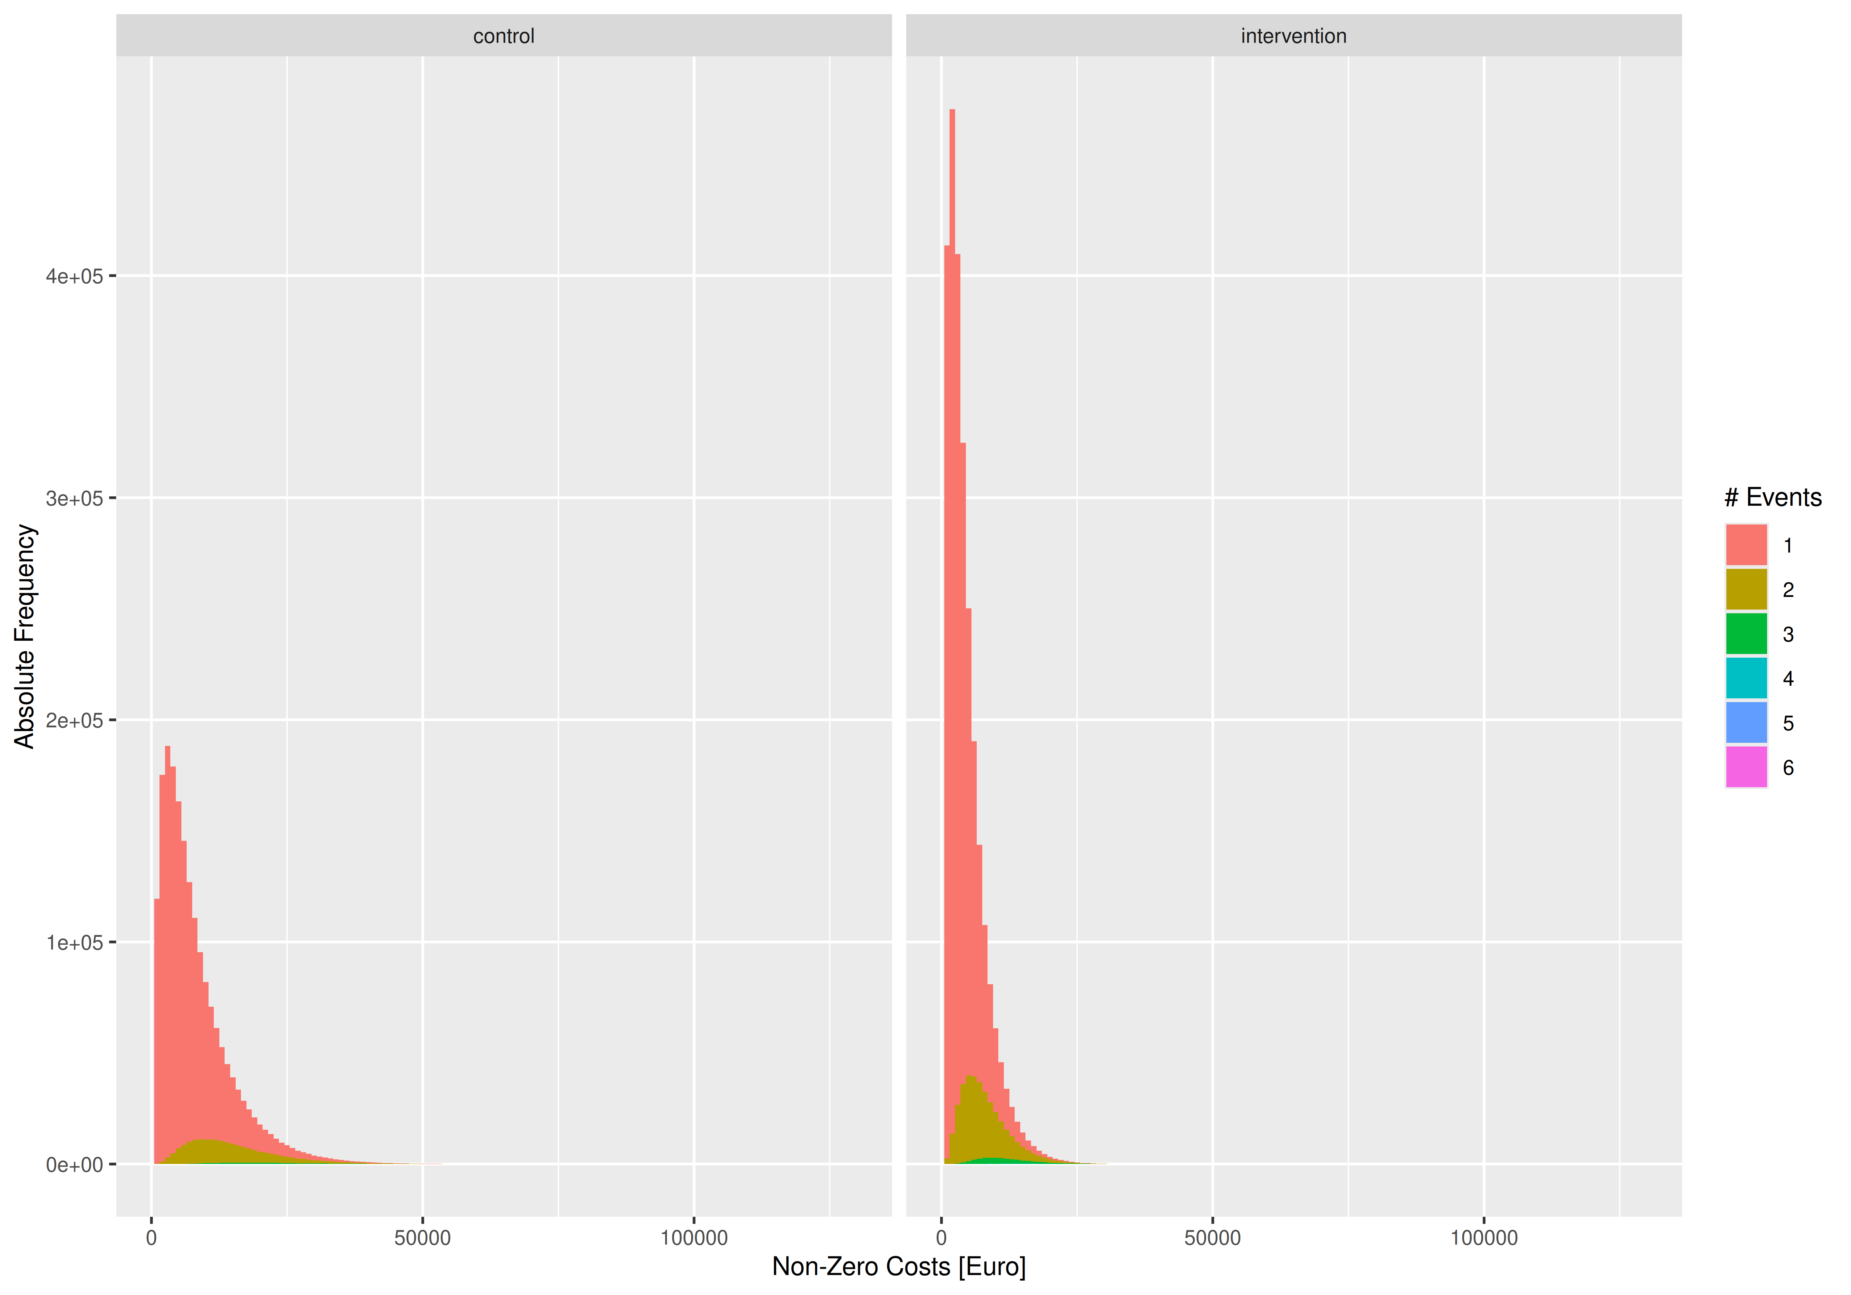 [1] “Maximum cumulative length of stay found in simulated data: 102 days, should be less than 365 days (TRUE)”
Proportion without events
study_group | zero_event
control | 81.0%
intervention | 73.1%
[1] “main: outcome ~ study_group + age_group”
Table S1 (main): Convergence of Gauss(log) and Gamma regressions (perfect = 60000)
Model | Status | 250 | 500 | 1000 | 2000
glm+start | returned | 60,000 | 60,000 | 60,000 | 60,000
glm+start | converged | 59,433 | 59,952 | 59,998 | 60,000
glm+start | valid_RSS | 60,000 | 60,000 | 60,000 | 60,000
glm+start | (co-)optimum | 25,467 | 24,992 | 24,082 | 23,041
glm2+start | returned | 60,000 | 60,000 | 60,000 | 60,000
glm2+start | converged | 59,614 | 59,964 | 59,998 | 60,000
glm2+start | valid_RSS | 60,000 | 60,000 | 60,000 | 60,000
glm2+start | (co-)optimum | 25,338 | 24,979 | 24,082 | 23,041
gam | returned | 60,000 | 60,000 | 60,000 | 60,000
gam | converged | 60,000 | 60,000 | 60,000 | 60,000
gam | valid_RSS | 60,000 | 60,000 | 60,000 | 60,000
gam | (co-)optimum | 25,317 | 25,842 | 26,486 | 27,096
glmmTMB+start | returned | 60,000 | 60,000 | 60,000 | 60,000
glmmTMB+start | converged | 60,000 | 60,000 | 60,000 | 60,000
glmmTMB+start | valid_RSS | 60,000 | 60,000 | 60,000 | 60,000
glmmTMB+start | (co-)optimum | 9,220 | 9,229 | 9,599 | 10,216
Table S2 (main, Cost Difference): Bias, Mean Absolute Error (MAE), and Root Mean Squared Error (RMSE) in EUR with 99%-CIs, 10000 simulation runs
Metric | N | Two-Stage  Poisson-  Gamma | Gaussian  (identity) | Gaussian  +0.01 EUR  (log) | Gaussian  +1.00 EUR  (log) | Gamma  +0.01 EUR  (identity) | Gamma  +1.00 EUR  (identity) | Gamma  +0.01 EUR  (log) | Gamma  +1.00 EUR  (log)
Bias | 250 | -3.45 [-15.73; 8.69] | -1.11 [-12.71; 11.30] | -43.30 [-56.25; -30.72] | -43.29 [-56.26; -30.68] | 63.22 [50.01; 76.26] | 62.99 [49.76; 76.30] | 19.80 [6.97; 33.28] | 19.80 [7.17; 33.04]
Bias | 500 | -1.08 [-9.82; 7.68] | 0.73 [-7.67; 8.93] | -20.90 [-29.68; -12.37] | -20.89 [-29.63; -11.91] | 32.65 [23.88; 41.59] | 32.62 [23.66; 41.37] | 7.30 [-1.24; 15.86] | 7.31 [-1.53; 16.15]
Bias | 1,000 | -0.84 [-6.81; 5.28] | 0.41 [-5.55; 6.26] | -8.88 [-14.91; -2.63] | -8.88 [-14.88; -2.87] | 19.99 [13.85; 26.03] | 19.92 [13.78; 26.21] | 0.82 [-5.19; 7.04] | 0.83 [-5.35; 7.18]
Bias | 2,000 | 0.80 [-3.45; 4.99] | 1.85 [-2.29; 6.03] | -0.32 [-4.53; 4.00] | -0.32 [-4.55; 3.95] | 15.57 [11.22; 19.82] | 15.52 [11.19; 19.80] | -0.80 [-5.02; 3.47] | -0.79 [-4.92; 3.47]
MAE | 250 | 374.56 [367.27; 382.03] | 368.16 [361.20; 375.49] | 401.18 [393.27; 408.99] | 401.17 [393.43; 408.85] | 410.37 [402.34; 418.55] | 410.13 [402.22; 418.33] | 397.94 [390.16; 406.04] | 397.85 [390.01; 405.74]
MAE | 500 | 264.24 [259.06; 269.52] | 260.61 [255.47; 265.83] | 273.84 [268.39; 279.22] | 273.83 [268.49; 279.36] | 275.48 [269.98; 280.90] | 275.35 [269.77; 280.92] | 272.12 [266.98; 277.43] | 272.10 [266.75; 277.57]
MAE | 1,000 | 184.85 [181.18; 188.45] | 182.52 [178.98; 186.01] | 188.50 [184.88; 192.35] | 188.50 [184.83; 192.08] | 189.22 [185.44; 192.98] | 189.23 [185.55; 192.84] | 188.41 [184.78; 192.07] | 188.39 [184.62; 192.22]
MAE | 2,000 | 131.19 [128.74; 133.69] | 129.43 [126.96; 131.87] | 132.39 [129.85; 135.01] | 132.39 [129.80; 134.94] | 132.34 [129.82; 134.87] | 132.31 [129.73; 134.86] | 132.50 [129.99; 135.01] | 132.49 [129.88; 135.02]
RMSE | 250 | 470.32 [461.31; 479.15] | 462.20 [453.85; 470.58] | 503.02 [493.83; 512.05] | 503.01 [494.09; 512.07] | 516.91 [507.49; 526.46] | 516.49 [507.16; 525.92] | 502.44 [493.12; 511.89] | 502.30 [492.83; 511.77]
RMSE | 500 | 332.03 [325.71; 338.07] | 327.94 [321.89; 334.10] | 345.44 [339.08; 351.66] | 345.43 [339.24; 351.85] | 346.62 [340.14; 353.10] | 346.30 [340.11; 352.81] | 342.43 [336.04; 348.81] | 342.40 [336.02; 348.91]
RMSE | 1,000 | 232.46 [228.18; 236.65] | 229.77 [225.64; 233.99] | 237.20 [232.79; 241.64] | 237.20 [232.73; 241.73] | 238.17 [233.69; 242.56] | 238.17 [233.88; 242.46] | 237.18 [232.92; 241.56] | 237.17 [232.91; 241.42]
RMSE | 2,000 | 163.63 [160.69; 166.51] | 161.57 [158.65; 164.50] | 165.39 [162.31; 168.37] | 165.39 [162.47; 168.48] | 165.07 [162.15; 167.98] | 165.04 [162.04; 167.91] | 165.19 [162.10; 168.11] | 165.18 [162.28; 168.11]
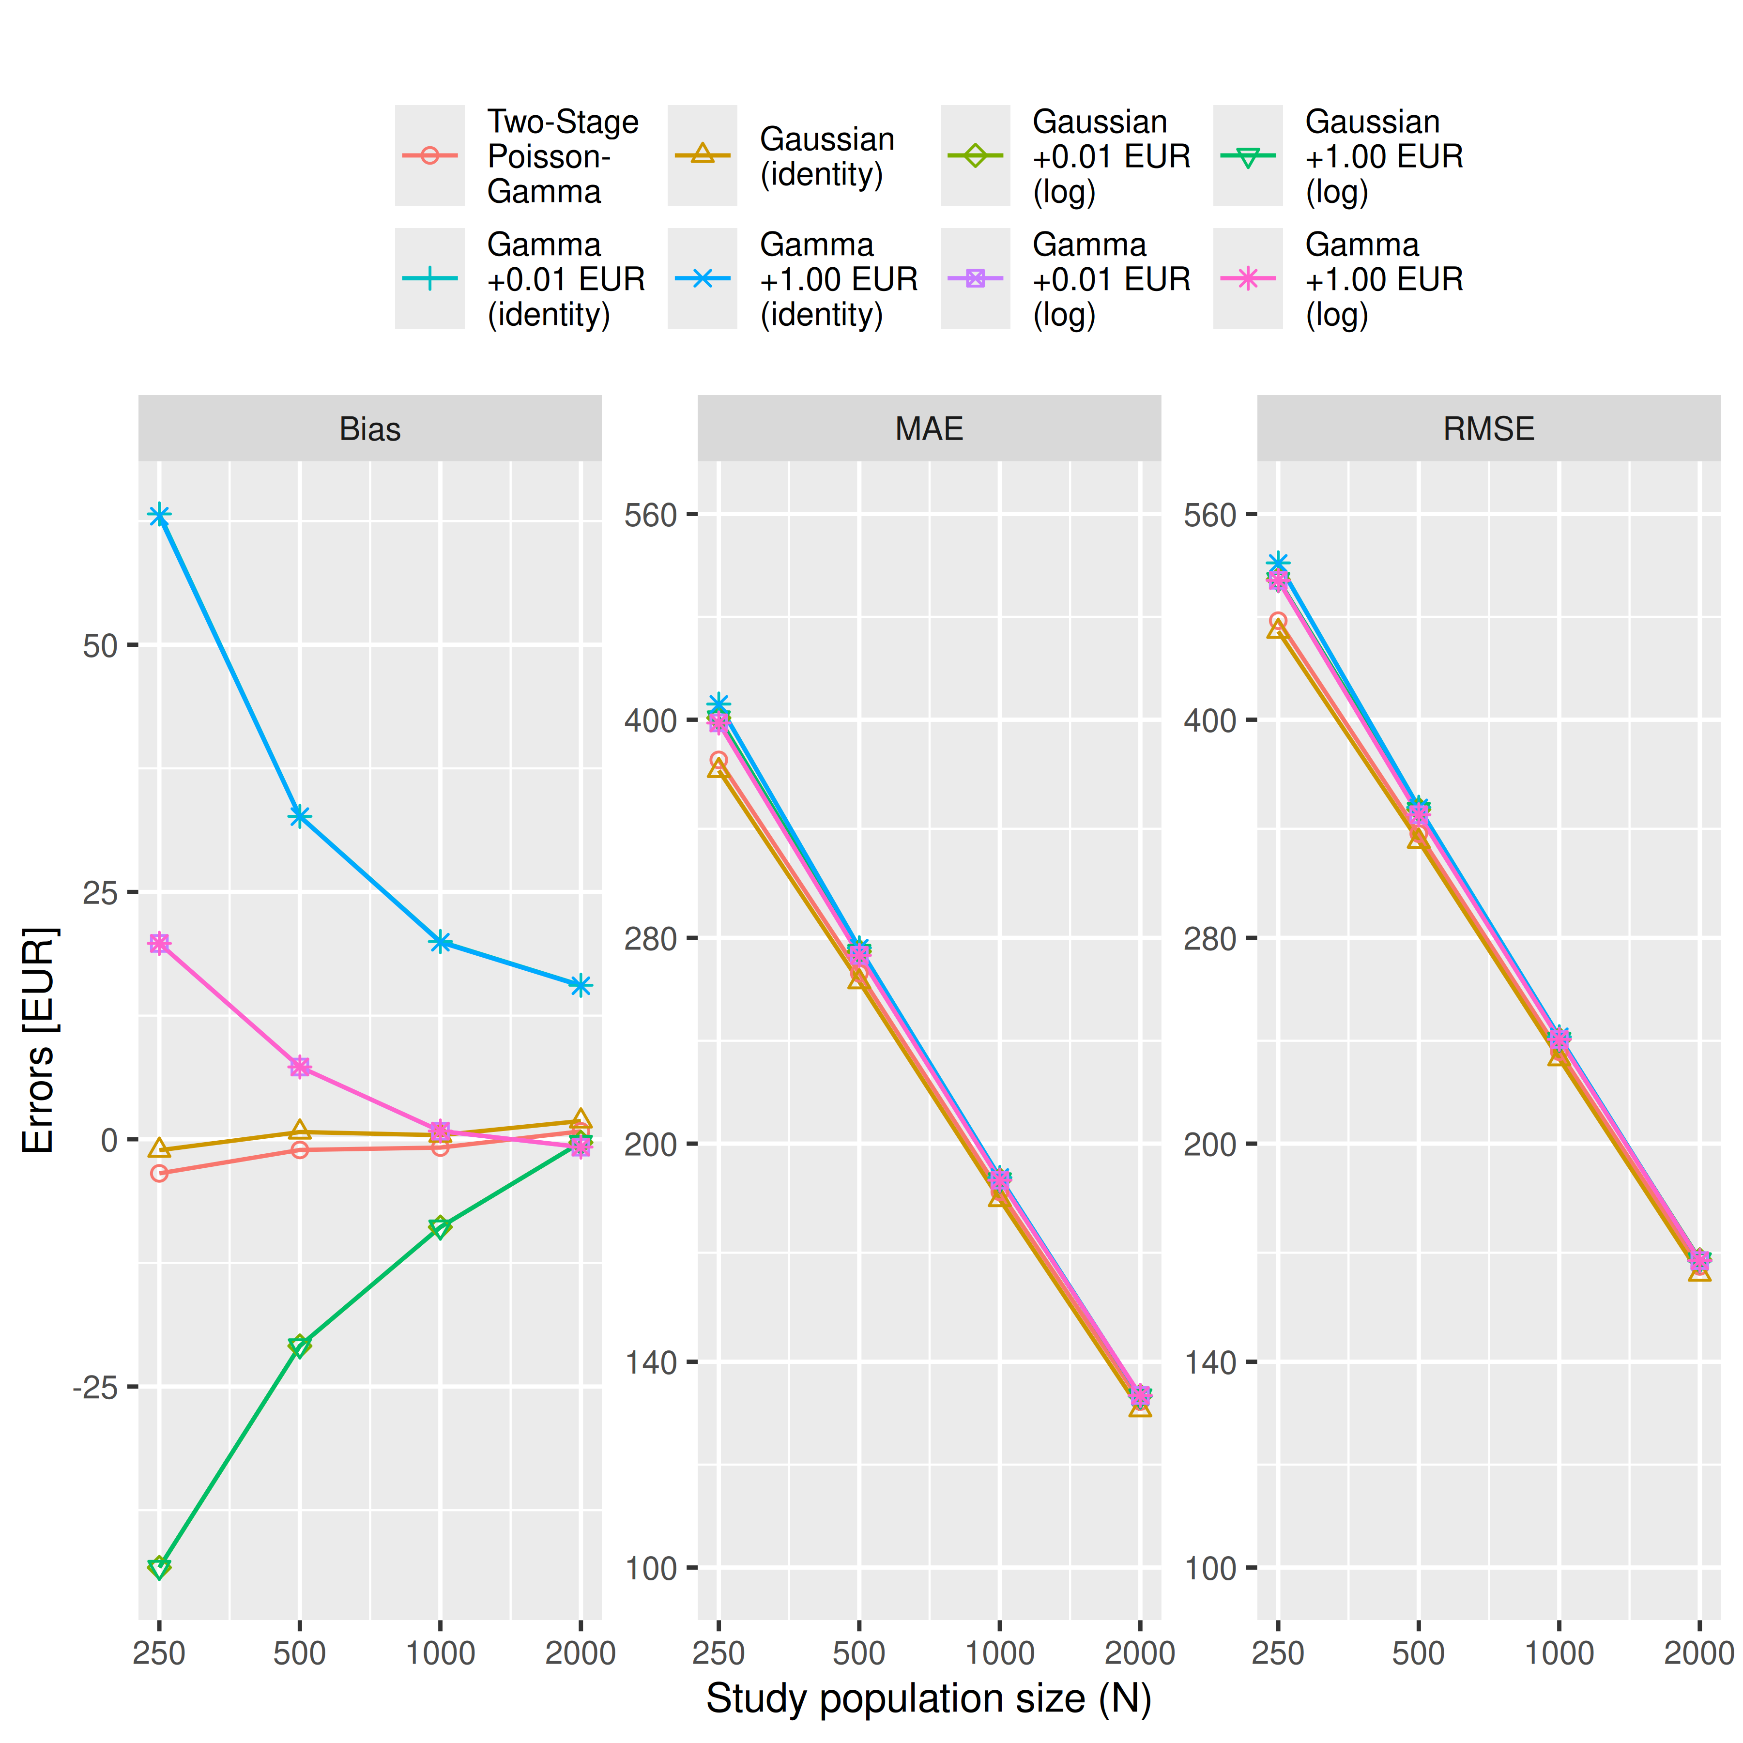
Warning: Removed 128 rows containing missing values or values outside the scale range
(`geom_point()`).
Warning: Removed 128 rows containing missing values or values outside the scale range
(`geom_point()`).
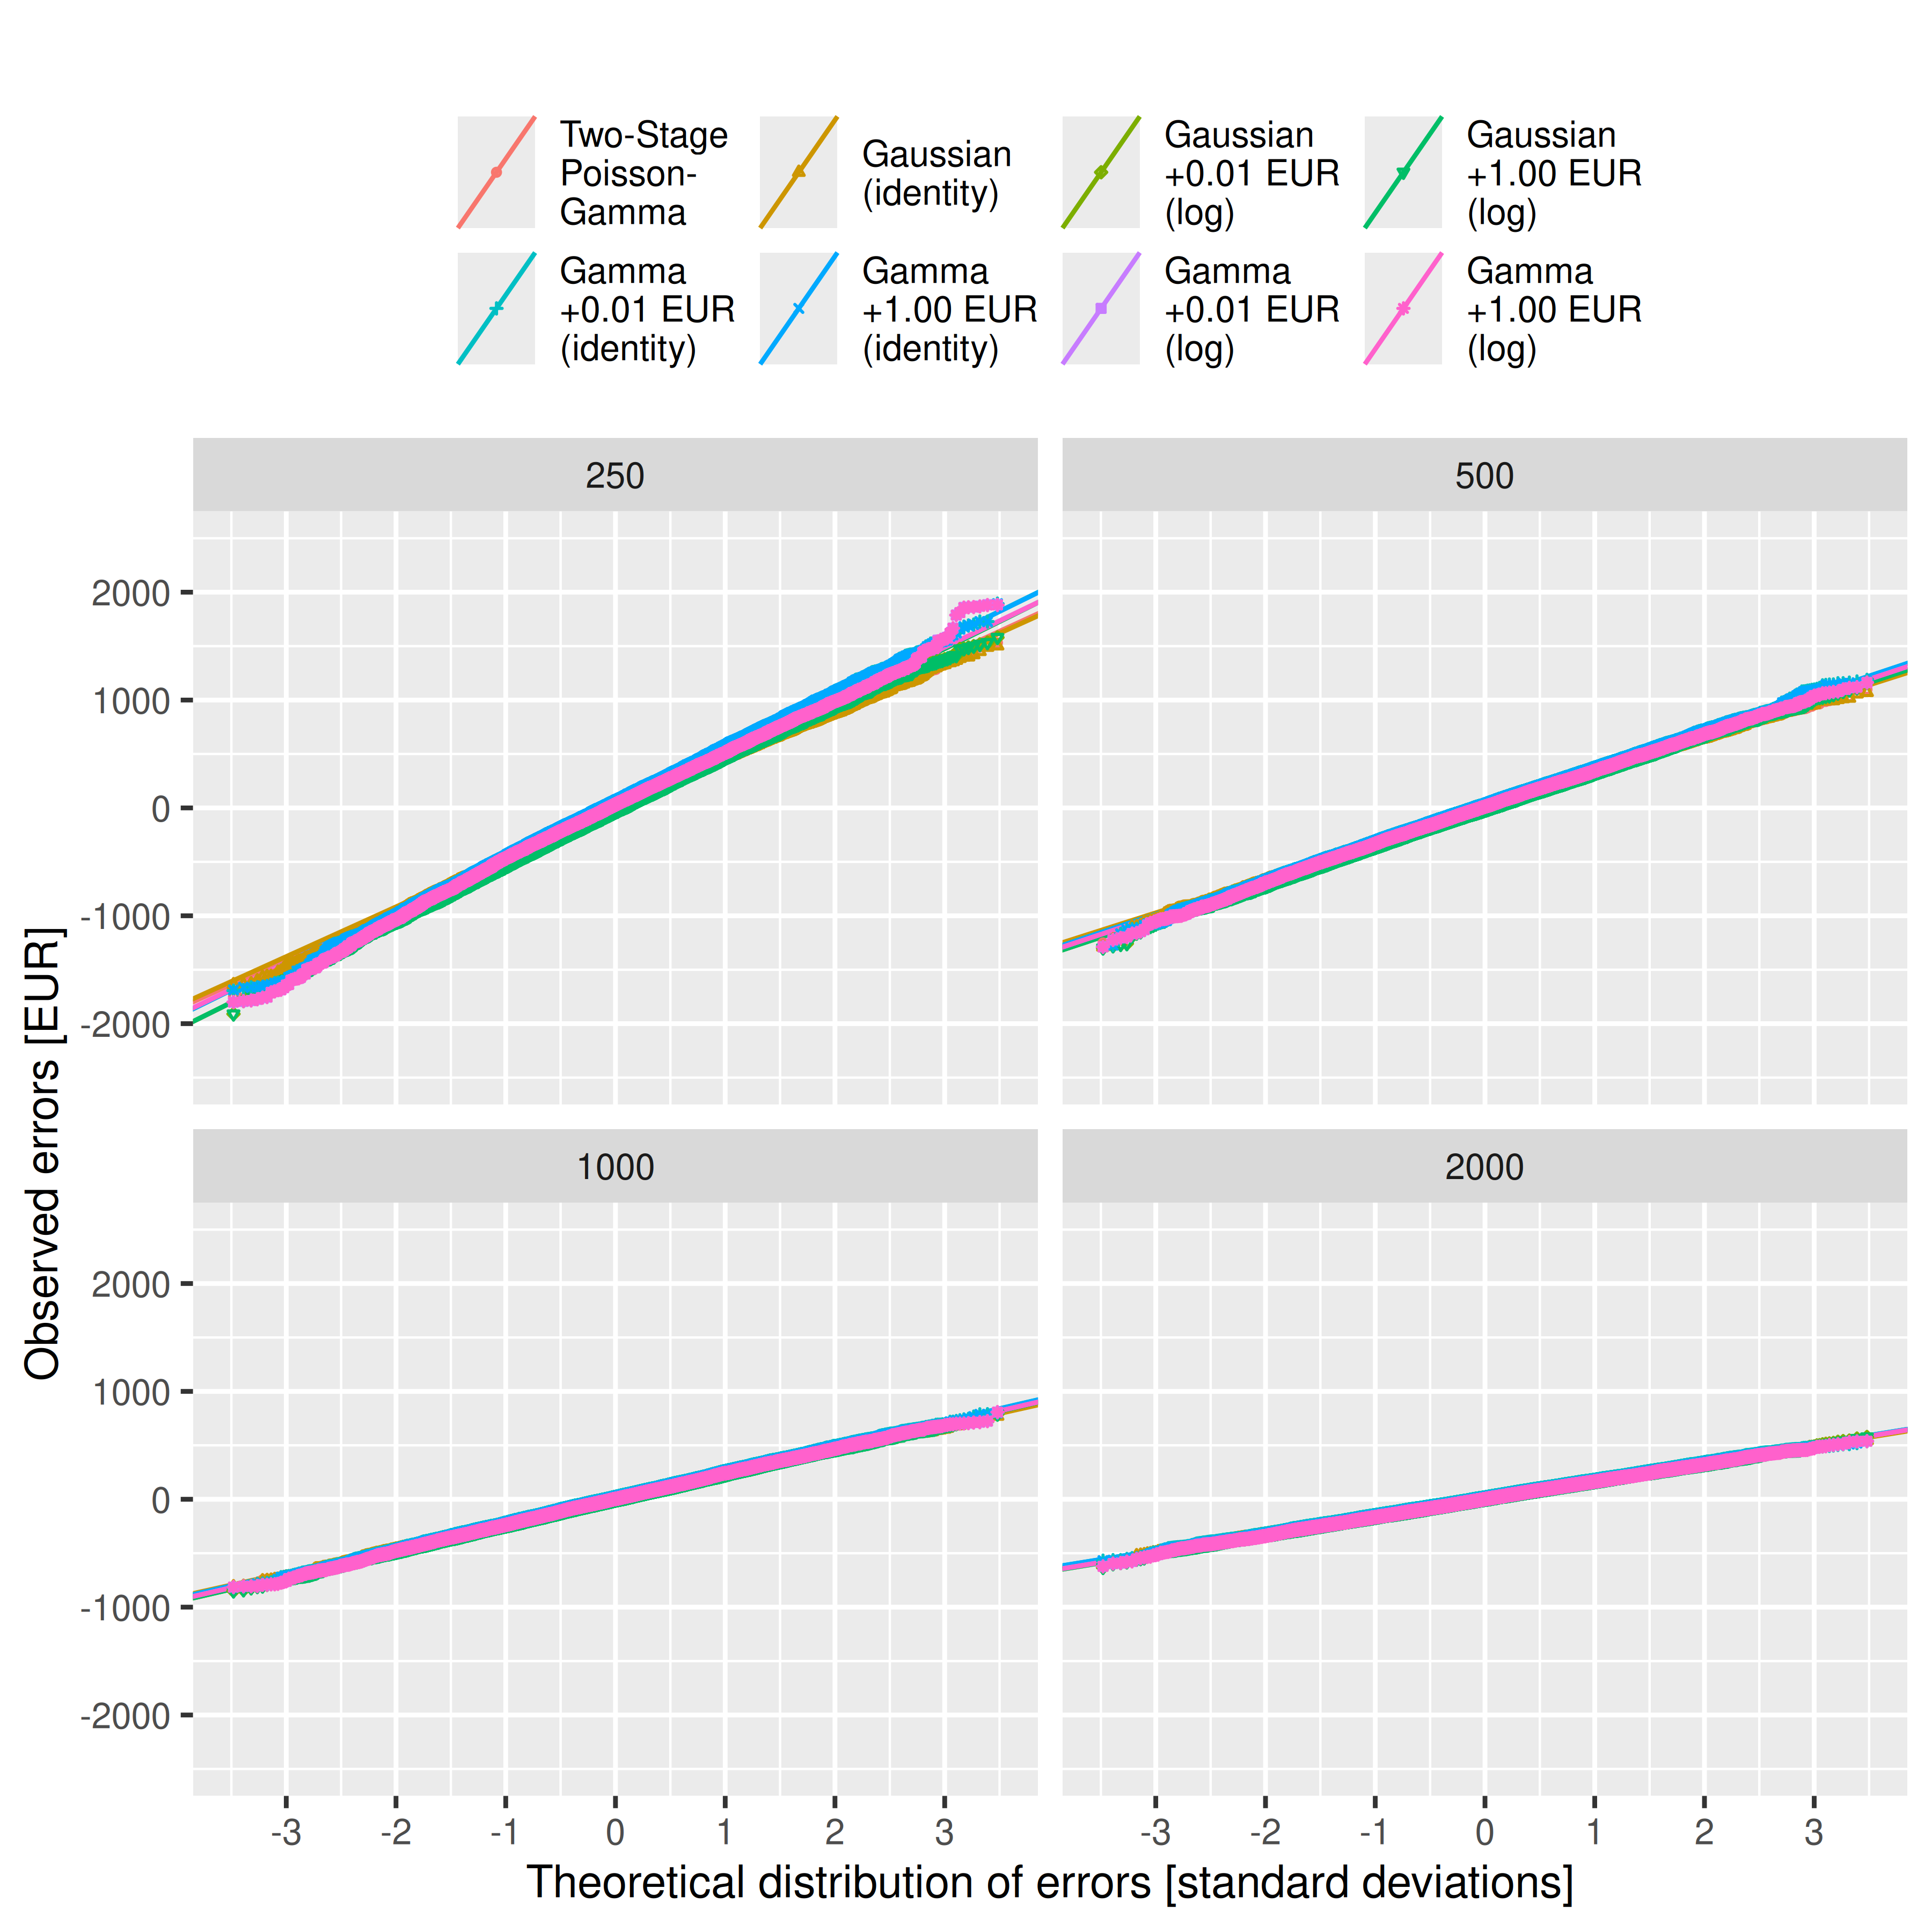
Warning: Removed 130 rows containing missing values or values outside the scale range
(`geom_point()`).
Warning: Removed 130 rows containing missing values or values outside the scale range
(`geom_point()`).
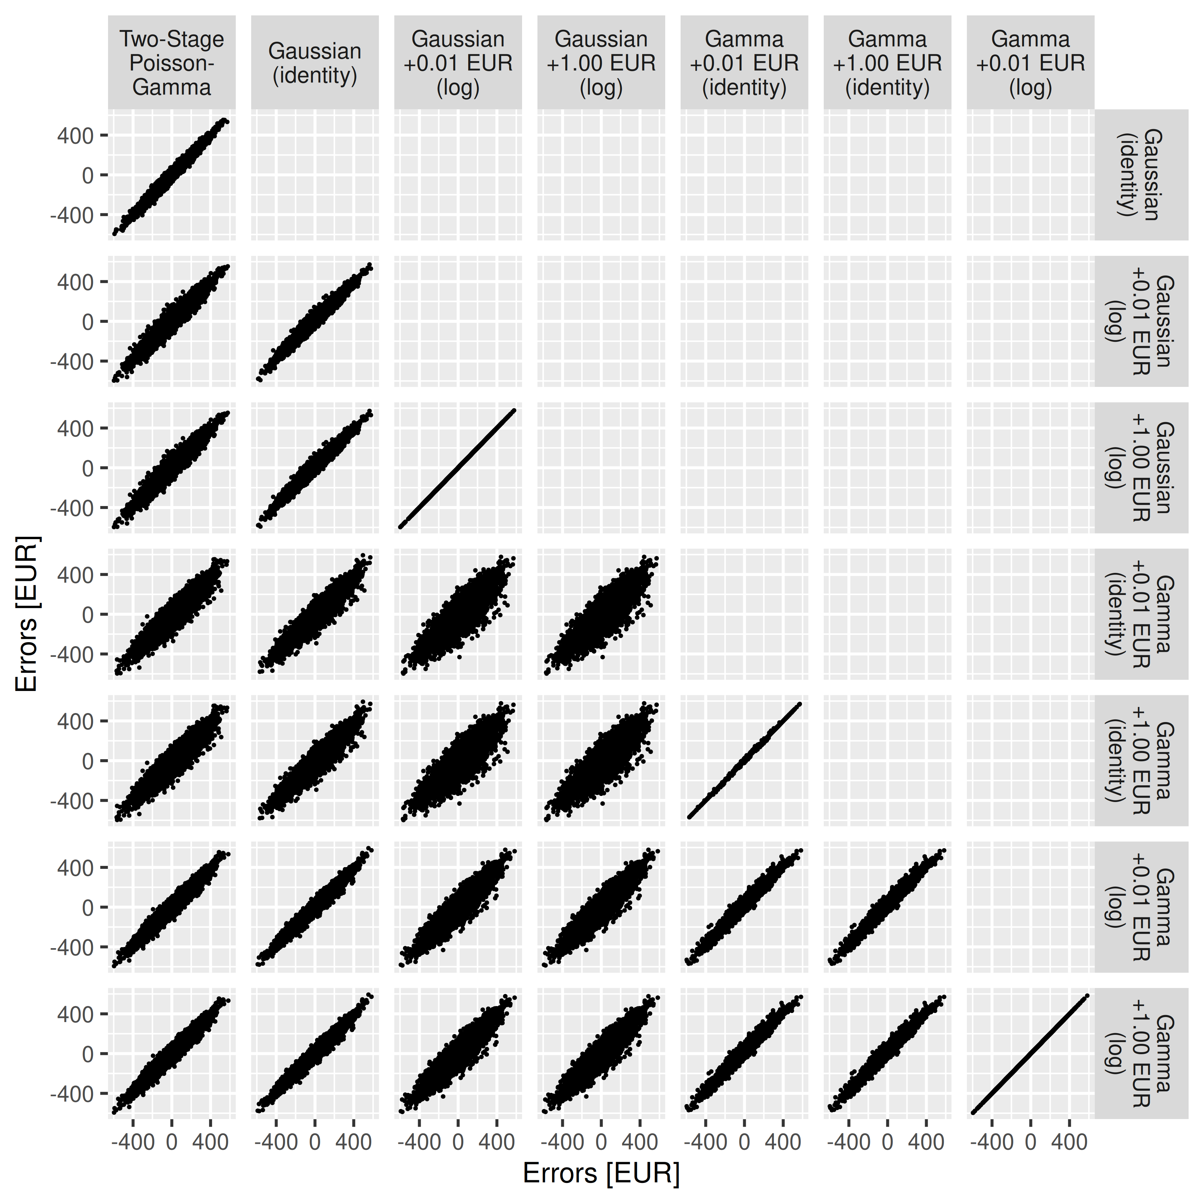 [1] “full: outcome ~ study_group * age_group”
Table S1 (full): Convergence of Gauss(log) and Gamma regressions (perfect = 60000)
Model | Status | 250 | 500 | 1000 | 2000
glm+start | returned | 60,000 | 60,000 | 60,000 | 60,000
glm+start | converged | 60,000 | 60,000 | 60,000 | 60,000
glm+start | valid_RSS | 60,000 | 60,000 | 60,000 | 60,000
glm+start | (co-)optimum | 47,173 | 48,995 | 51,380 | 52,916
glm2+start | returned | 60,000 | 60,000 | 60,000 | 60,000
glm2+start | converged | 60,000 | 60,000 | 60,000 | 60,000
glm2+start | valid_RSS | 60,000 | 60,000 | 60,000 | 60,000
glm2+start | (co-)optimum | 47,173 | 48,995 | 51,380 | 52,916
gam | returned | 60,000 | 60,000 | 60,000 | 60,000
gam | converged | 60,000 | 60,000 | 60,000 | 60,000
gam | valid_RSS | 60,000 | 60,000 | 60,000 | 60,000
gam | (co-)optimum | 53,394 | 54,918 | 55,592 | 55,991
glmmTMB+start | returned | 60,000 | 60,000 | 60,000 | 60,000
glmmTMB+start | converged | 60,000 | 60,000 | 60,000 | 60,000
glmmTMB+start | valid_RSS | 60,000 | 60,000 | 60,000 | 60,000
glmmTMB+start | (co-)optimum | 33 | 43 | 86 | 180
Table S2 (full, Cost Difference): Bias, Mean Absolute Error (MAE), and Root Mean Squared Error (RMSE) in EUR with 99%-CIs, 10000 simulation runs
Metric | N | Two-Stage  Poisson-  Gamma | Gaussian  (identity) | Gaussian  +0.01 EUR  (log) | Gaussian  +1.00 EUR  (log) | Gamma  +0.01 EUR  (identity) | Gamma  +1.00 EUR  (identity) | Gamma  +0.01 EUR  (log) | Gamma  +1.00 EUR  (log)
Bias | 250 | -1.88 [-13.89; 10.15] | -1.46 [-13.14; 10.86] | -1.46 [-13.62; 10.19] | -1.46 [-13.30; 10.17] | -1.46 [-13.48; 10.57] | -1.46 [-13.12; 10.44] | -1.46 [-13.21; 10.89] | -1.46 [-13.25; 10.55]
Bias | 500 | 0.73 [-7.98; 9.46] | 0.75 [-7.64; 8.89] | 0.75 [-7.75; 8.74] | 0.75 [-7.62; 9.39] | 0.75 [-7.74; 9.26] | 0.75 [-8.05; 9.36] | 0.75 [-7.50; 9.13] | 0.75 [-7.76; 9.25]
Bias | 1,000 | 0.77 [-5.16; 6.80] | 0.43 [-5.53; 6.35] | 0.43 [-5.45; 6.40] | 0.43 [-5.38; 6.30] | 0.43 [-5.63; 6.42] | 0.43 [-5.52; 6.42] | 0.43 [-5.36; 6.36] | 0.43 [-5.57; 6.47]
Bias | 2,000 | 2.25 [-1.96; 6.45] | 1.86 [-2.31; 6.07] | 1.86 [-2.26; 6.09] | 1.86 [-2.33; 6.01] | 1.86 [-2.34; 6.05] | 1.86 [-2.45; 6.07] | 1.86 [-2.25; 6.06] | 1.86 [-2.19; 6.04]
MAE | 250 | 373.95 [366.72; 381.38] | 370.14 [363.14; 377.29] | 370.14 [362.95; 377.44] | 370.14 [362.90; 377.32] | 370.14 [362.80; 377.44] | 370.14 [362.97; 377.35] | 370.14 [362.86; 377.67] | 370.14 [363.06; 377.19]
MAE | 500 | 264.53 [259.39; 269.76] | 261.34 [256.15; 266.55] | 261.34 [256.16; 266.58] | 261.34 [256.17; 266.48] | 261.34 [256.30; 266.57] | 261.34 [256.16; 266.52] | 261.34 [256.39; 266.43] | 261.34 [256.15; 266.50]
MAE | 1,000 | 184.96 [181.29; 188.49] | 182.94 [179.34; 186.46] | 182.94 [179.40; 186.64] | 182.94 [179.42; 186.45] | 182.94 [179.26; 186.53] | 182.94 [179.48; 186.49] | 182.94 [179.45; 186.53] | 182.94 [179.33; 186.55]
MAE | 2,000 | 131.03 [128.57; 133.53] | 129.43 [126.93; 131.87] | 129.43 [126.97; 131.92] | 129.43 [126.87; 131.93] | 129.43 [126.95; 131.94] | 129.43 [126.91; 131.91] | 129.43 [126.94; 131.88] | 129.43 [126.90; 131.97]
RMSE | 250 | 469.86 [461.02; 478.65] | 464.64 [456.28; 472.97] | 464.64 [456.23; 473.24] | 464.64 [456.14; 472.96] | 464.64 [456.11; 473.08] | 464.64 [456.29; 473.04] | 464.64 [456.23; 473.24] | 464.64 [456.27; 472.84]
RMSE | 500 | 332.67 [326.38; 338.81] | 328.79 [322.77; 335.01] | 328.79 [322.58; 334.75] | 328.79 [322.90; 334.83] | 328.79 [322.78; 334.88] | 328.79 [322.69; 334.93] | 328.79 [322.64; 334.82] | 328.79 [322.70; 335.05]
RMSE | 1,000 | 232.57 [228.30; 236.75] | 230.23 [226.07; 234.40] | 230.23 [226.07; 234.42] | 230.23 [226.00; 234.65] | 230.23 [225.90; 234.35] | 230.23 [226.03; 234.42] | 230.23 [225.99; 234.41] | 230.23 [226.05; 234.37]
RMSE | 2,000 | 163.44 [160.48; 166.32] | 161.56 [158.65; 164.50] | 161.56 [158.58; 164.44] | 161.56 [158.66; 164.50] | 161.56 [158.64; 164.49] | 161.56 [158.70; 164.42] | 161.56 [158.57; 164.47] | 161.56 [158.71; 164.46]
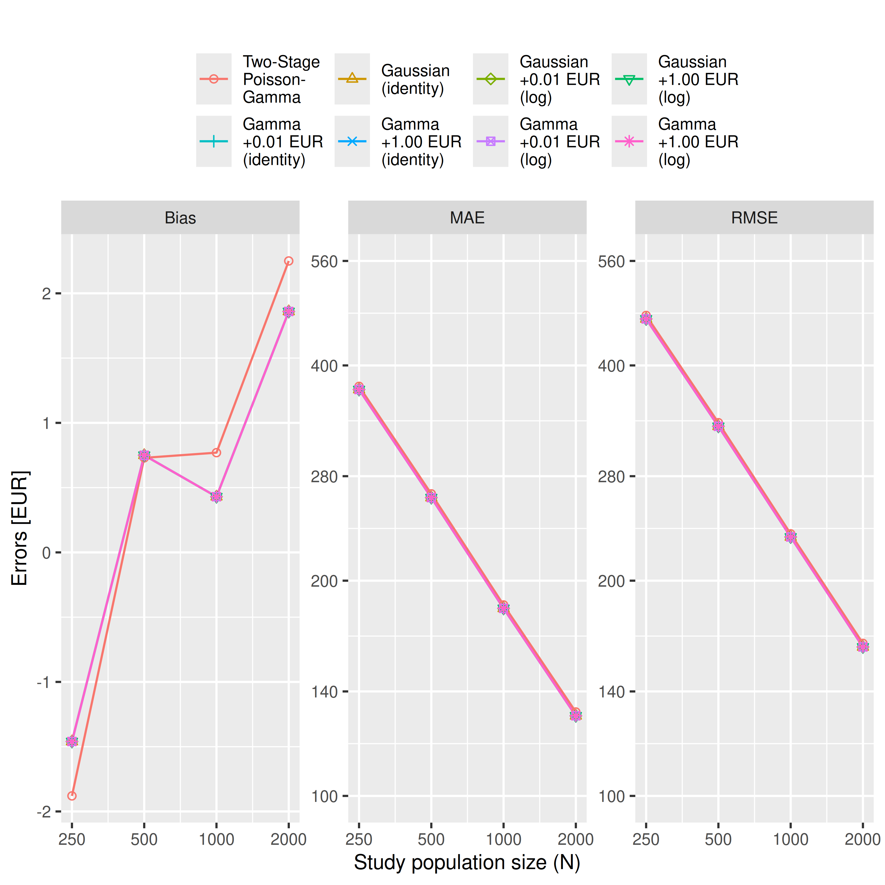
Warning: Removed 128 rows containing missing values or values outside the scale range
(`geom_point()`).
Warning: Removed 128 rows containing missing values or values outside the scale range
(`geom_point()`).
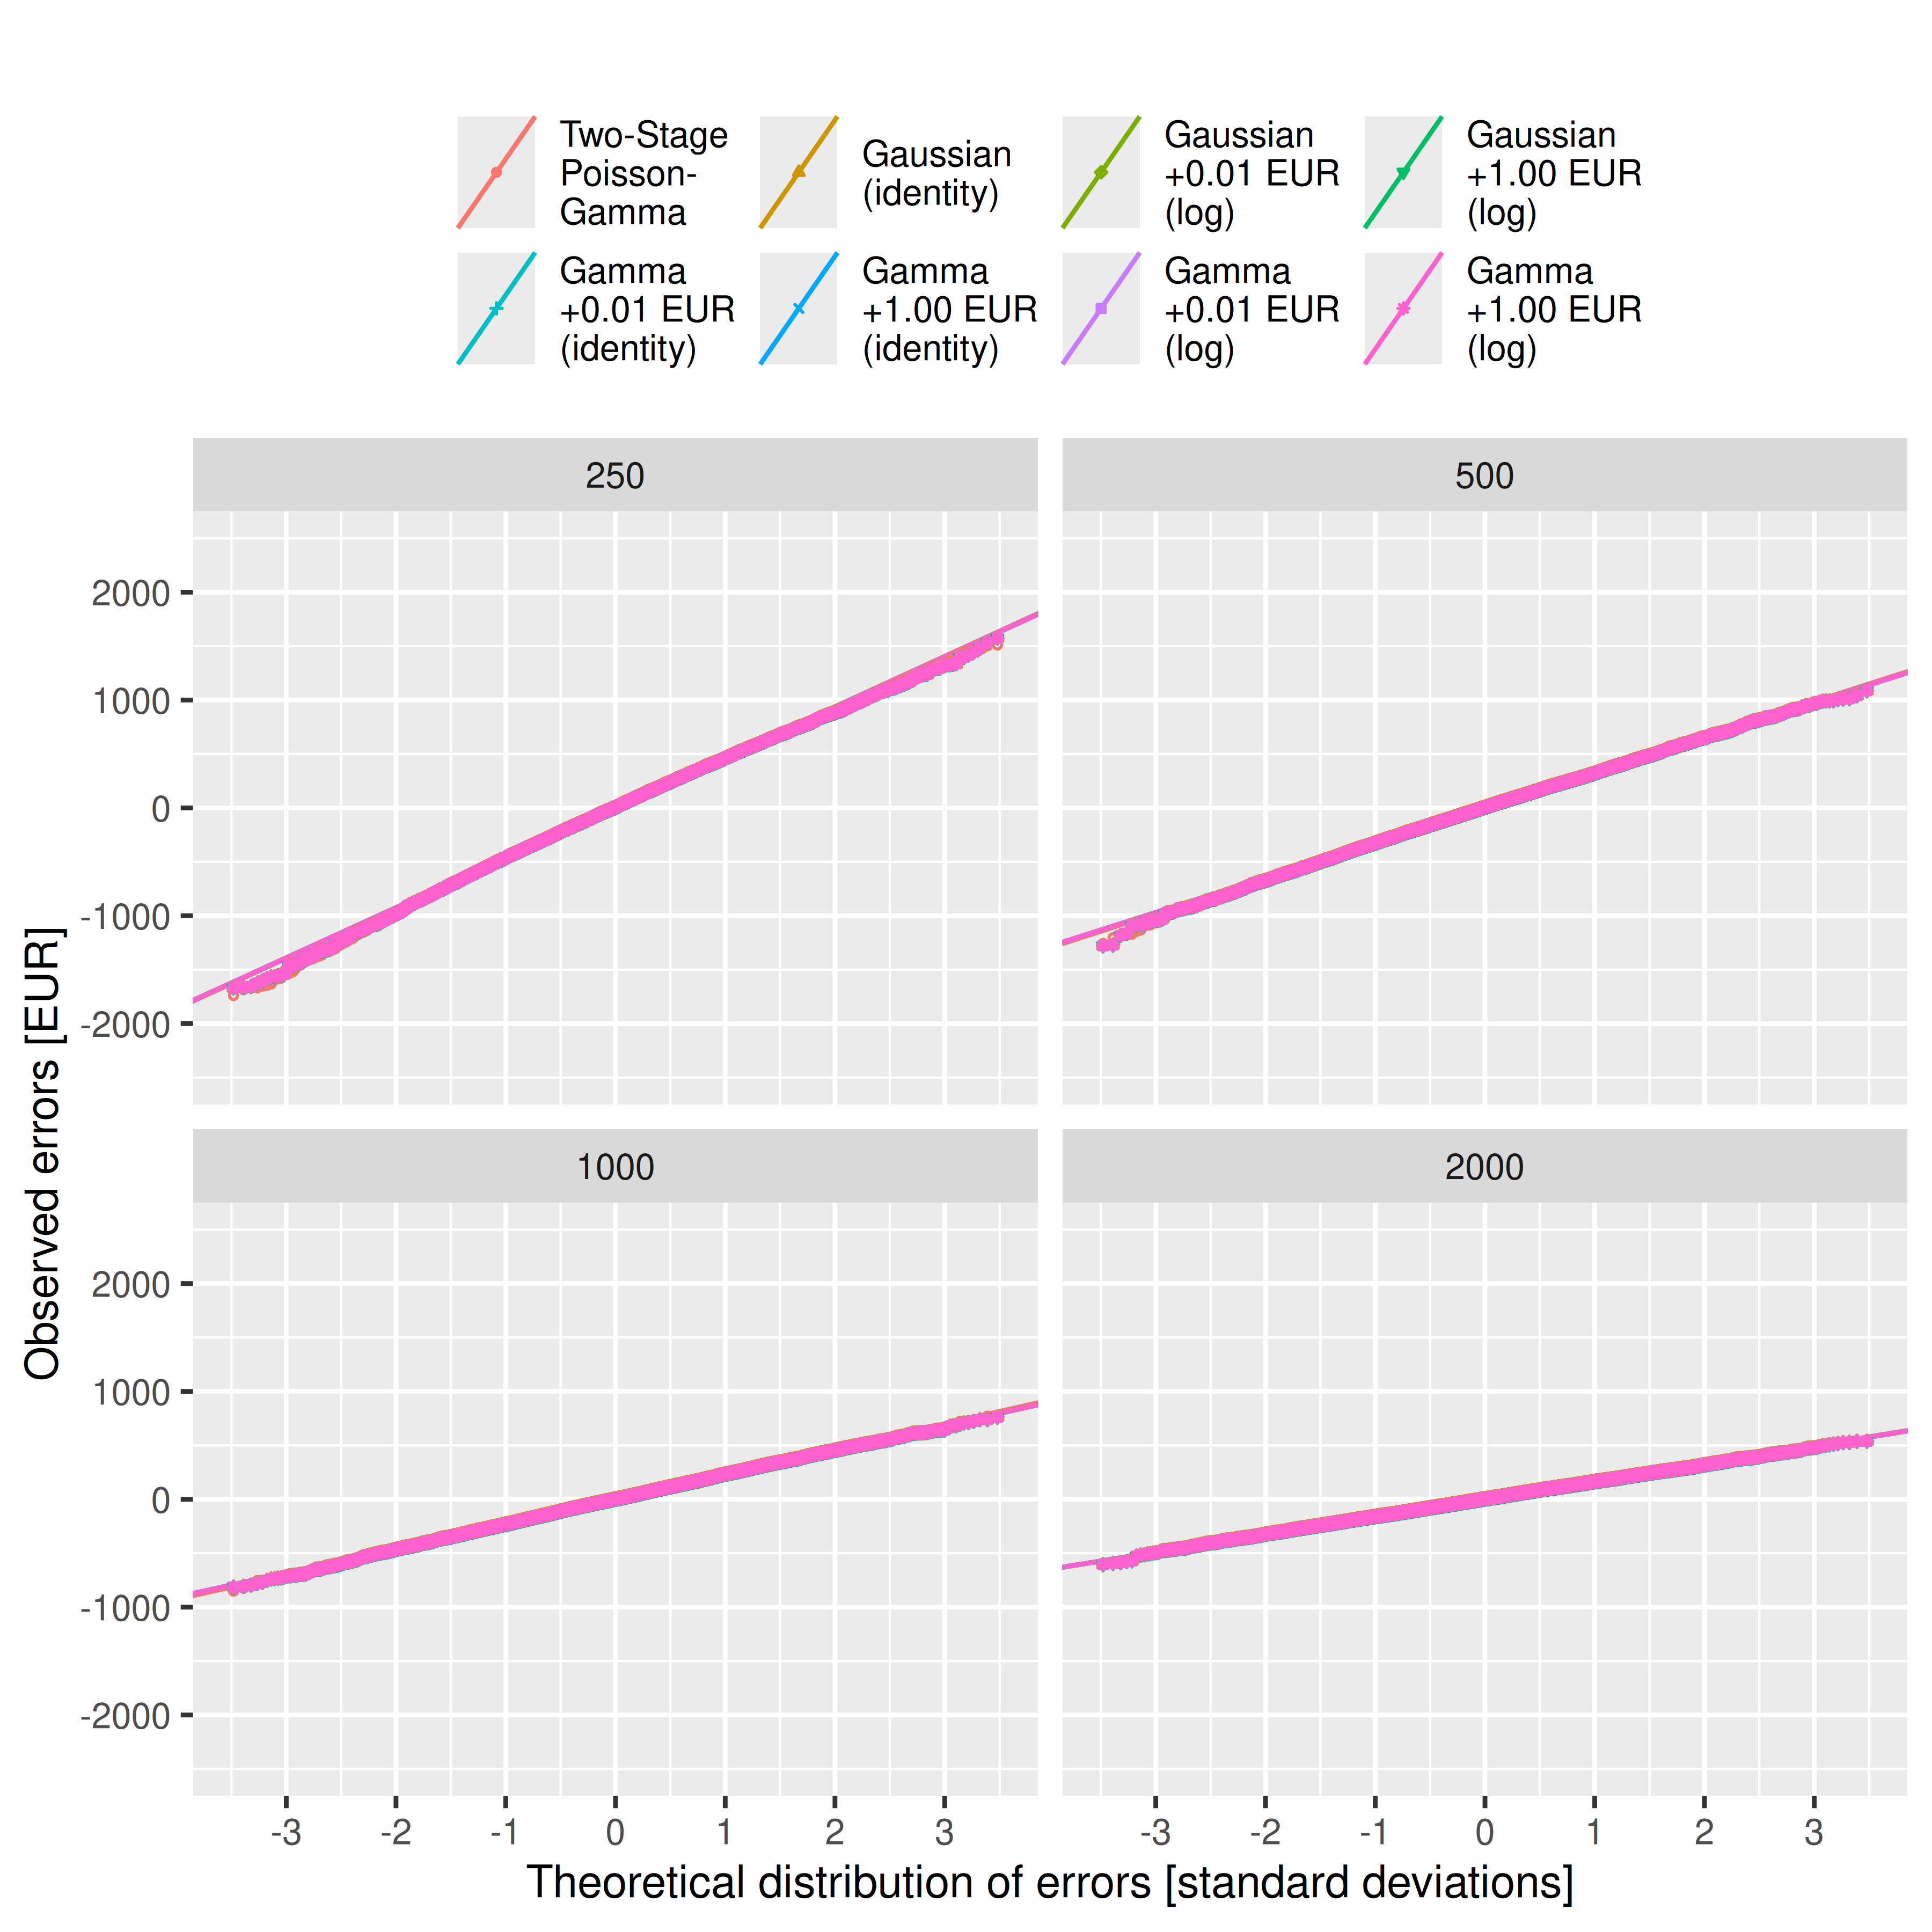
Warning: Removed 98 rows containing missing values or values outside the scale range
(`geom_point()`).
Warning: Removed 98 rows containing missing values or values outside the scale range
(`geom_point()`).


