Patient-level simulation and model comparison for robust incremental cost estimation
  - Online Resource 4: Data Postprocessing
Charité - Universitätsmedizin Berlin
Institute of Public Health
Hans-Aloys Wischmann, Toivo Glatz
Edited: 2026-11-01, Executed: 2026-11-02

Libraries and Utility Functions

Data Postprocessing
Warning: Removed 1 row containing non-finite outside the scale range
(`stat_bin()`).
Warning: Removed 30 rows containing missing values or values outside the scale range
(`geom_bar()`).
Warning: Removed 1 row containing non-finite outside the scale range
(`stat_bin()`).
Warning: Removed 30 rows containing missing values or values outside the scale range
(`geom_bar()`).
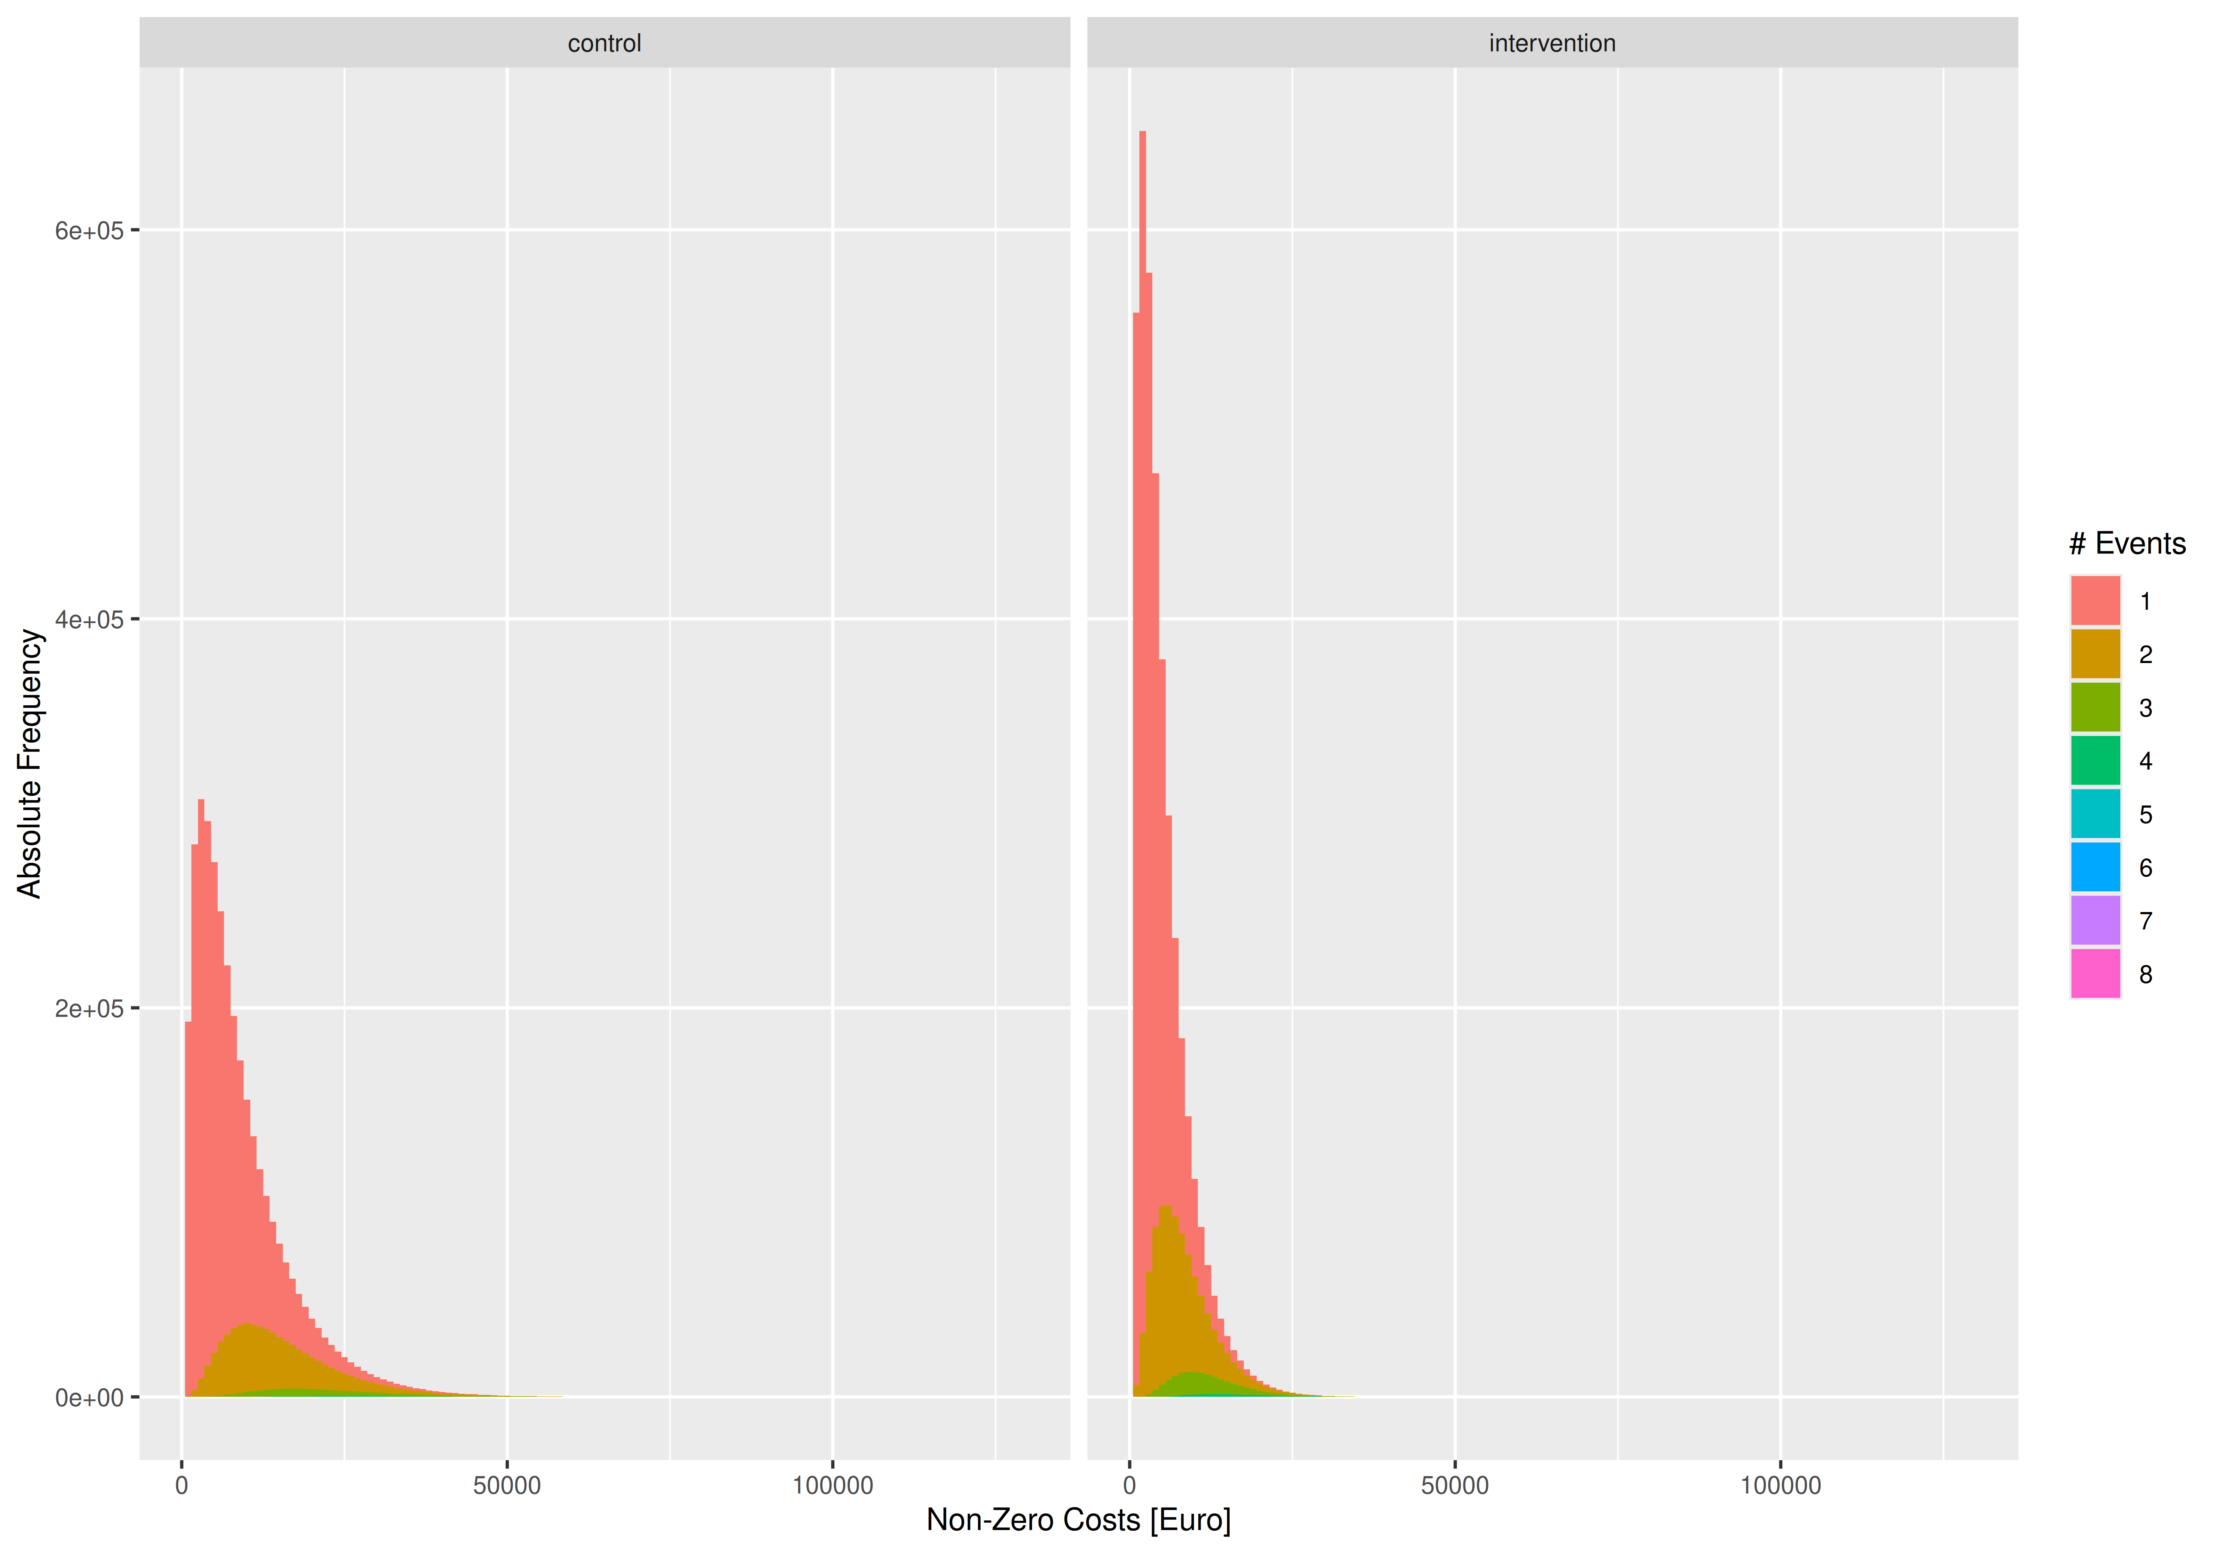 [1] “Maximum cumulative length of stay found in simulated data: 118 days, should be less than 365 days (TRUE)”
Proportion without events
study_group | zero_event
control | 65.7%
intervention | 59.3%
[1] “main: outcome ~ study_group + age_group”
Table S1 (main): Convergence of Gauss(log) and Gamma regressions (perfect = 60000)
Model | Status | 250 | 500 | 1000 | 2000
glm+start | returned | 60,000 | 60,000 | 60,000 | 60,000
glm+start | converged | 59,937 | 60,000 | 60,000 | 60,000
glm+start | valid_RSS | 60,000 | 60,000 | 60,000 | 60,000
glm+start | (co-)optimum | 24,984 | 26,123 | 25,585 | 23,763
glm2+start | returned | 60,000 | 60,000 | 60,000 | 60,000
glm2+start | converged | 59,959 | 60,000 | 60,000 | 60,000
glm2+start | valid_RSS | 60,000 | 60,000 | 60,000 | 60,000
glm2+start | (co-)optimum | 24,972 | 26,123 | 25,585 | 23,763
gam | returned | 60,000 | 60,000 | 60,000 | 60,000
gam | converged | 60,000 | 60,000 | 60,000 | 60,000
gam | valid_RSS | 60,000 | 60,000 | 60,000 | 60,000
gam | (co-)optimum | 25,892 | 26,449 | 27,396 | 28,800
glmmTMB+start | returned | 60,000 | 60,000 | 60,000 | 60,000
glmmTMB+start | converged | 60,000 | 60,000 | 60,000 | 60,000
glmmTMB+start | valid_RSS | 60,000 | 60,000 | 60,000 | 60,000
glmmTMB+start | (co-)optimum | 9,190 | 7,596 | 7,339 | 8,149
Table S2 (main, Cost Difference): Bias, Mean Absolute Error (MAE), and Root Mean Squared Error (RMSE) in EUR with 99%-CIs, 10000 simulation runs
Metric | N | Two-Stage  Poisson-  Gamma | Gaussian  (identity) | Gaussian  +0.01 EUR  (log) | Gaussian  +1.00 EUR  (log) | Gamma  +0.01 EUR  (identity) | Gamma  +1.00 EUR  (identity) | Gamma  +0.01 EUR  (log) | Gamma  +1.00 EUR  (log)
Bias | 250 | -16.80 [-33.78; 0.59] | -11.84 [-28.29; 4.59] | -63.97 [-81.35; -47.19] | -63.97 [-81.33; -47.14] | 65.05 [48.03; 81.65] | 62.91 [46.08; 79.71] | -10.44 [-27.62; 6.91] | -10.41 [-27.41; 6.53]
Bias | 500 | -9.23 [-21.03; 2.47] | -4.99 [-16.32; 6.78] | -28.67 [-40.25; -17.06] | -28.68 [-40.52; -16.81] | 48.21 [36.73; 60.27] | 46.76 [35.10; 58.75] | -9.31 [-21.27; 2.63] | -9.29 [-21.09; 2.69]
Bias | 1,000 | -8.78 [-17.02; -0.25] | -5.42 [-13.64; 2.95] | -13.62 [-22.06; -5.45] | -13.63 [-21.69; -5.35] | 38.28 [30.04; 46.36] | 37.80 [29.60; 46.17] | -12.14 [-20.47; -3.80] | -12.13 [-20.42; -3.72]
Bias | 2,000 | -4.28 [-10.16; 1.66] | -1.50 [-7.35; 4.51] | -1.86 [-7.79; 4.09] | -1.88 [-7.84; 4.20] | 38.18 [32.36; 44.04] | 38.10 [32.22; 43.95] | -9.34 [-15.21; -3.38] | -9.32 [-15.35; -3.52]
MAE | 250 | 519.57 [509.58; 529.69] | 509.94 [499.79; 520.12] | 535.88 [525.44; 546.37] | 535.88 [525.10; 546.51] | 530.05 [520.20; 540.16] | 531.89 [521.65; 542.22] | 531.42 [521.23; 541.90] | 531.39 [520.88; 541.81]
MAE | 500 | 364.57 [357.66; 371.75] | 357.99 [350.97; 365.07] | 369.14 [361.77; 376.50] | 369.14 [362.17; 376.50] | 368.81 [361.43; 376.11] | 368.99 [362.00; 376.23] | 369.04 [361.91; 376.18] | 369.02 [361.57; 376.40]
MAE | 1,000 | 258.83 [254.05; 263.74] | 253.35 [248.68; 258.29] | 258.66 [253.65; 263.63] | 258.66 [253.83; 263.56] | 257.94 [252.93; 263.03] | 257.98 [253.06; 263.11] | 258.91 [253.89; 263.85] | 258.90 [253.81; 264.08]
MAE | 2,000 | 183.32 [179.69; 186.89] | 179.64 [176.11; 183.23] | 182.73 [179.25; 186.37] | 182.73 [179.35; 186.19] | 183.85 [180.25; 187.49] | 183.83 [180.35; 187.41] | 182.71 [179.14; 186.13] | 182.70 [179.16; 186.27]
RMSE | 250 | 655.17 [642.97; 667.47] | 640.46 [628.42; 652.94] | 675.80 [662.41; 688.86] | 675.80 [663.19; 688.98] | 662.84 [651.00; 675.17] | 665.22 [653.44; 677.13] | 667.65 [655.03; 679.88] | 667.61 [655.27; 680.46]
RMSE | 500 | 458.97 [450.64; 467.53] | 449.95 [441.44; 458.02] | 464.64 [455.72; 473.38] | 464.64 [456.18; 473.17] | 461.72 [453.13; 470.41] | 462.04 [453.84; 470.59] | 462.93 [454.46; 471.57] | 462.91 [454.68; 471.50]
RMSE | 1,000 | 323.49 [317.89; 329.34] | 316.76 [310.98; 322.58] | 323.72 [317.86; 329.59] | 323.72 [317.78; 329.69] | 323.12 [317.35; 329.28] | 323.15 [317.44; 328.71] | 324.10 [318.38; 329.96] | 324.10 [318.26; 330.03]
RMSE | 2,000 | 229.66 [225.40; 233.78] | 224.97 [221.06; 229.02] | 228.70 [224.68; 232.91] | 228.70 [224.74; 232.85] | 229.98 [225.71; 234.11] | 229.98 [225.80; 234.14] | 229.21 [224.96; 233.32] | 229.20 [225.07; 233.47]
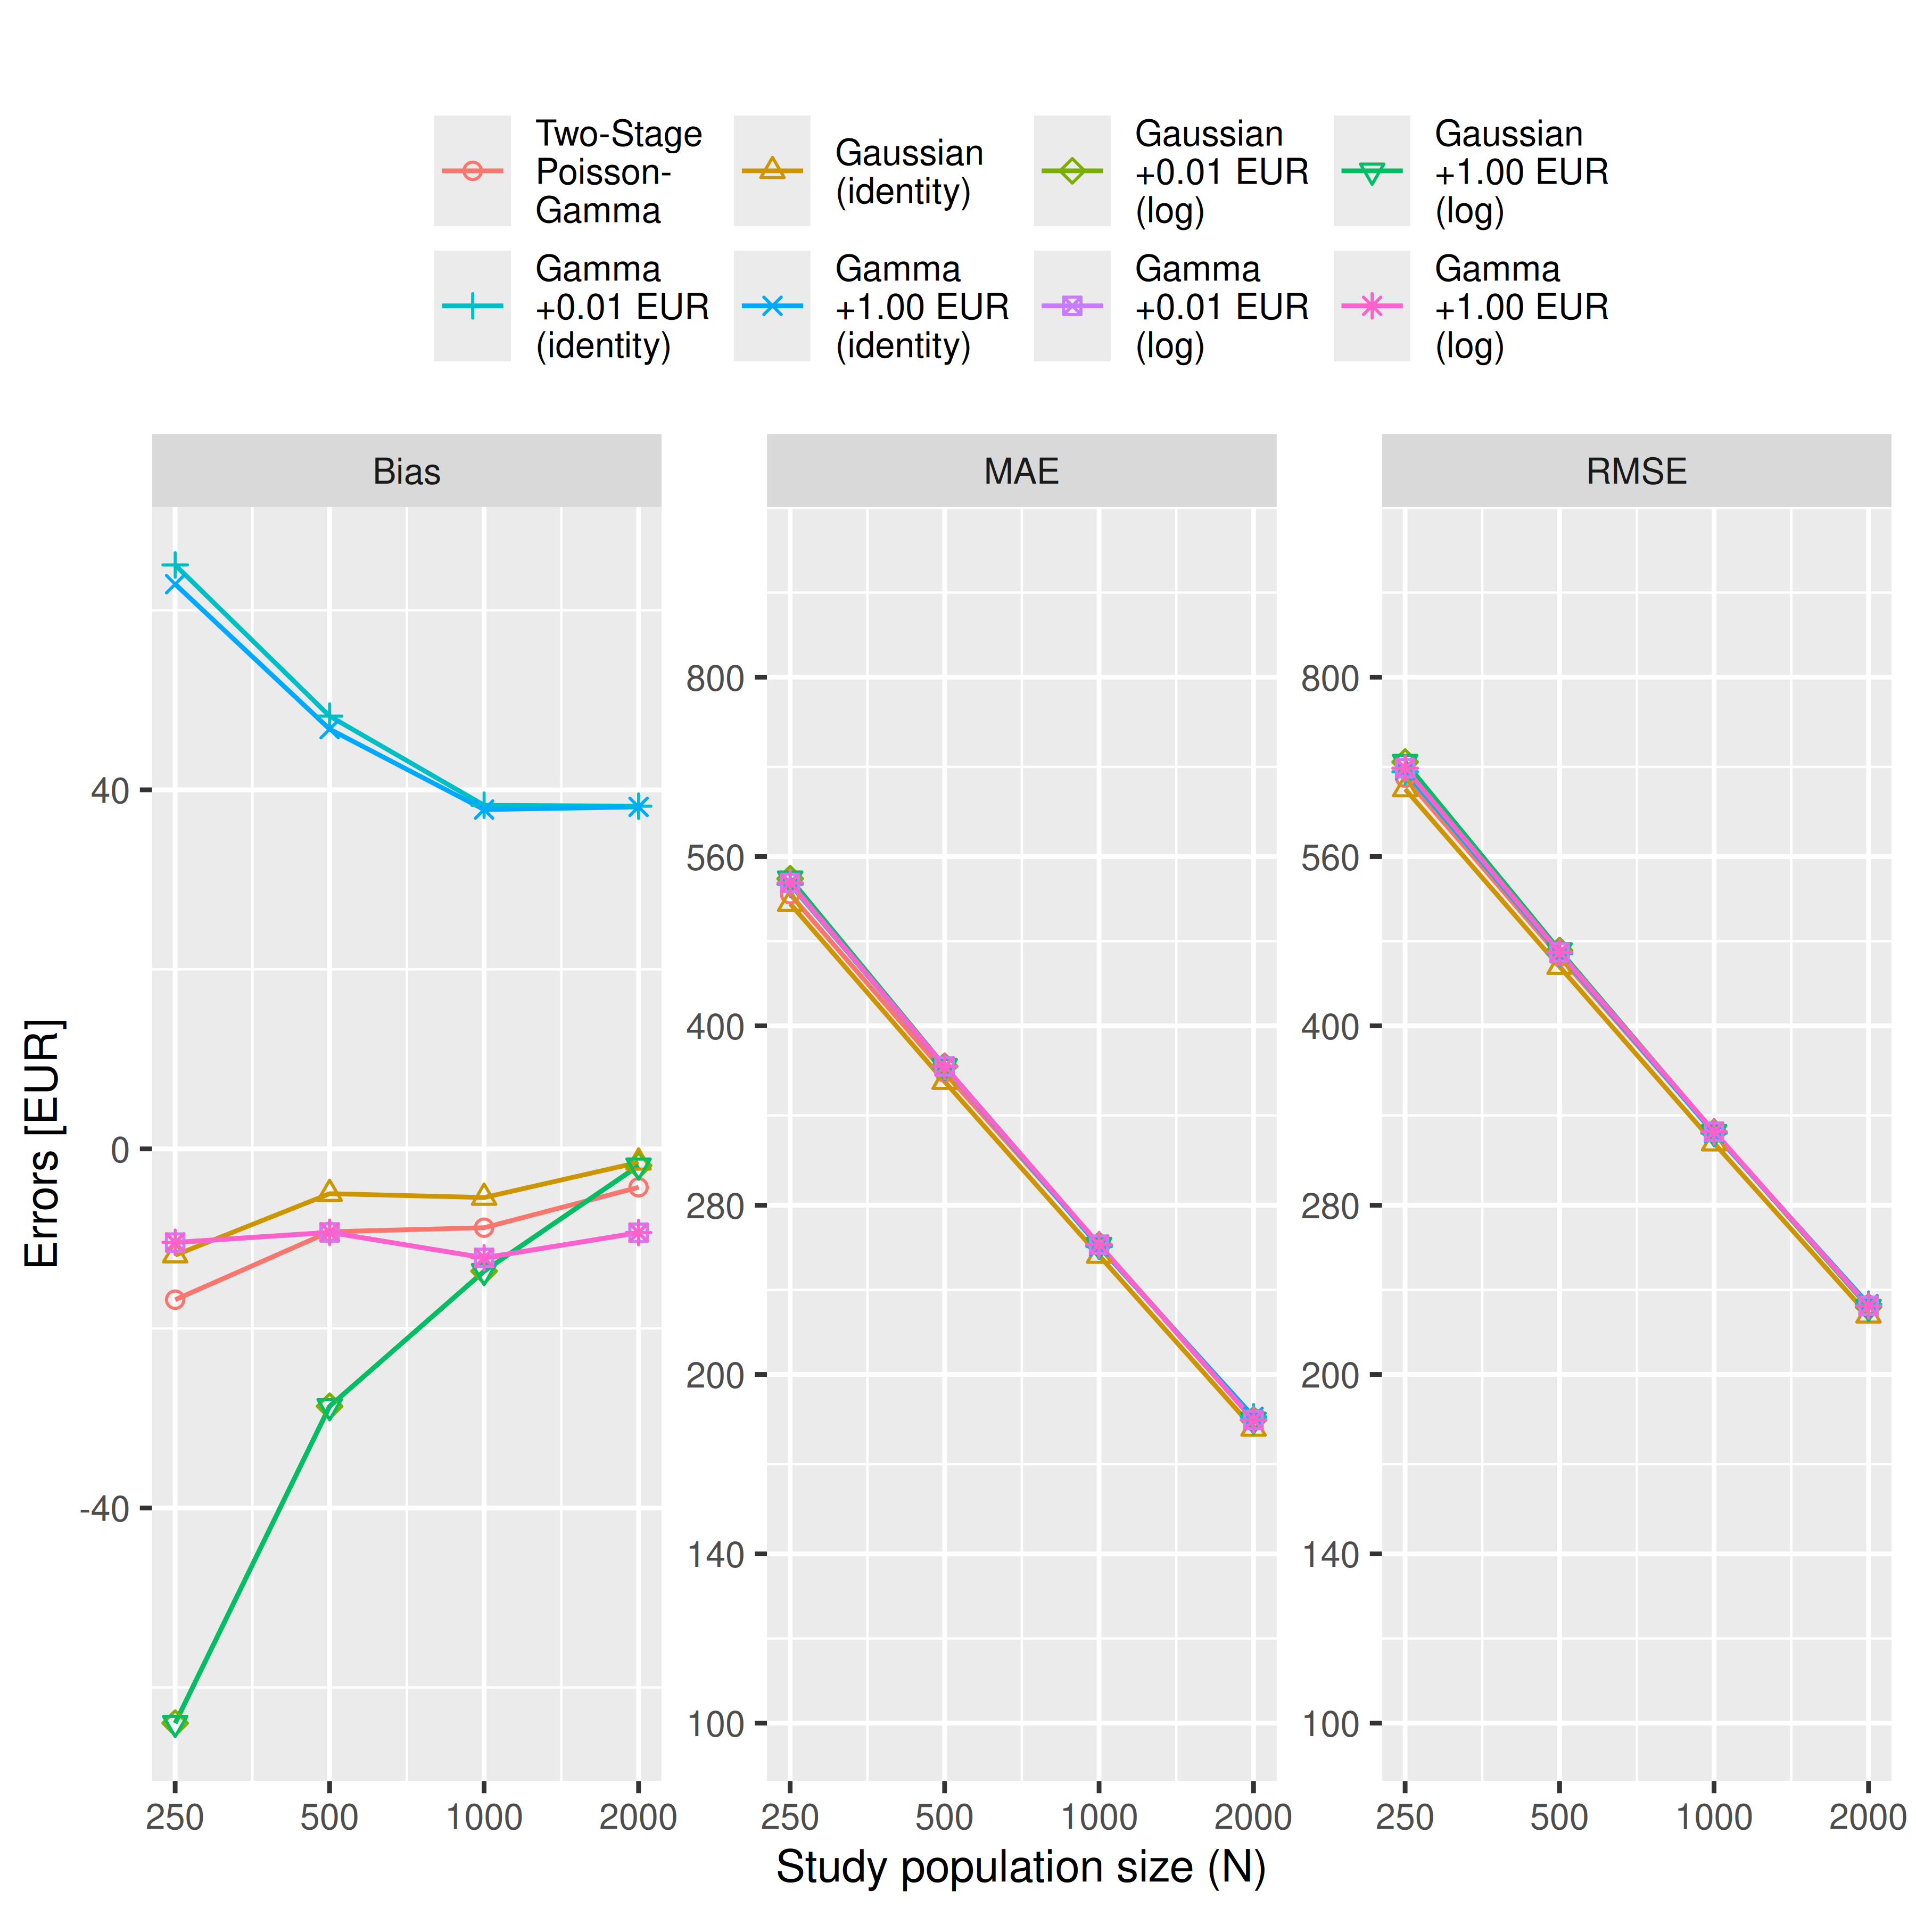
Warning: Removed 142 rows containing missing values or values outside the scale range
(`geom_point()`).
Warning: Removed 142 rows containing missing values or values outside the scale range
(`geom_point()`).
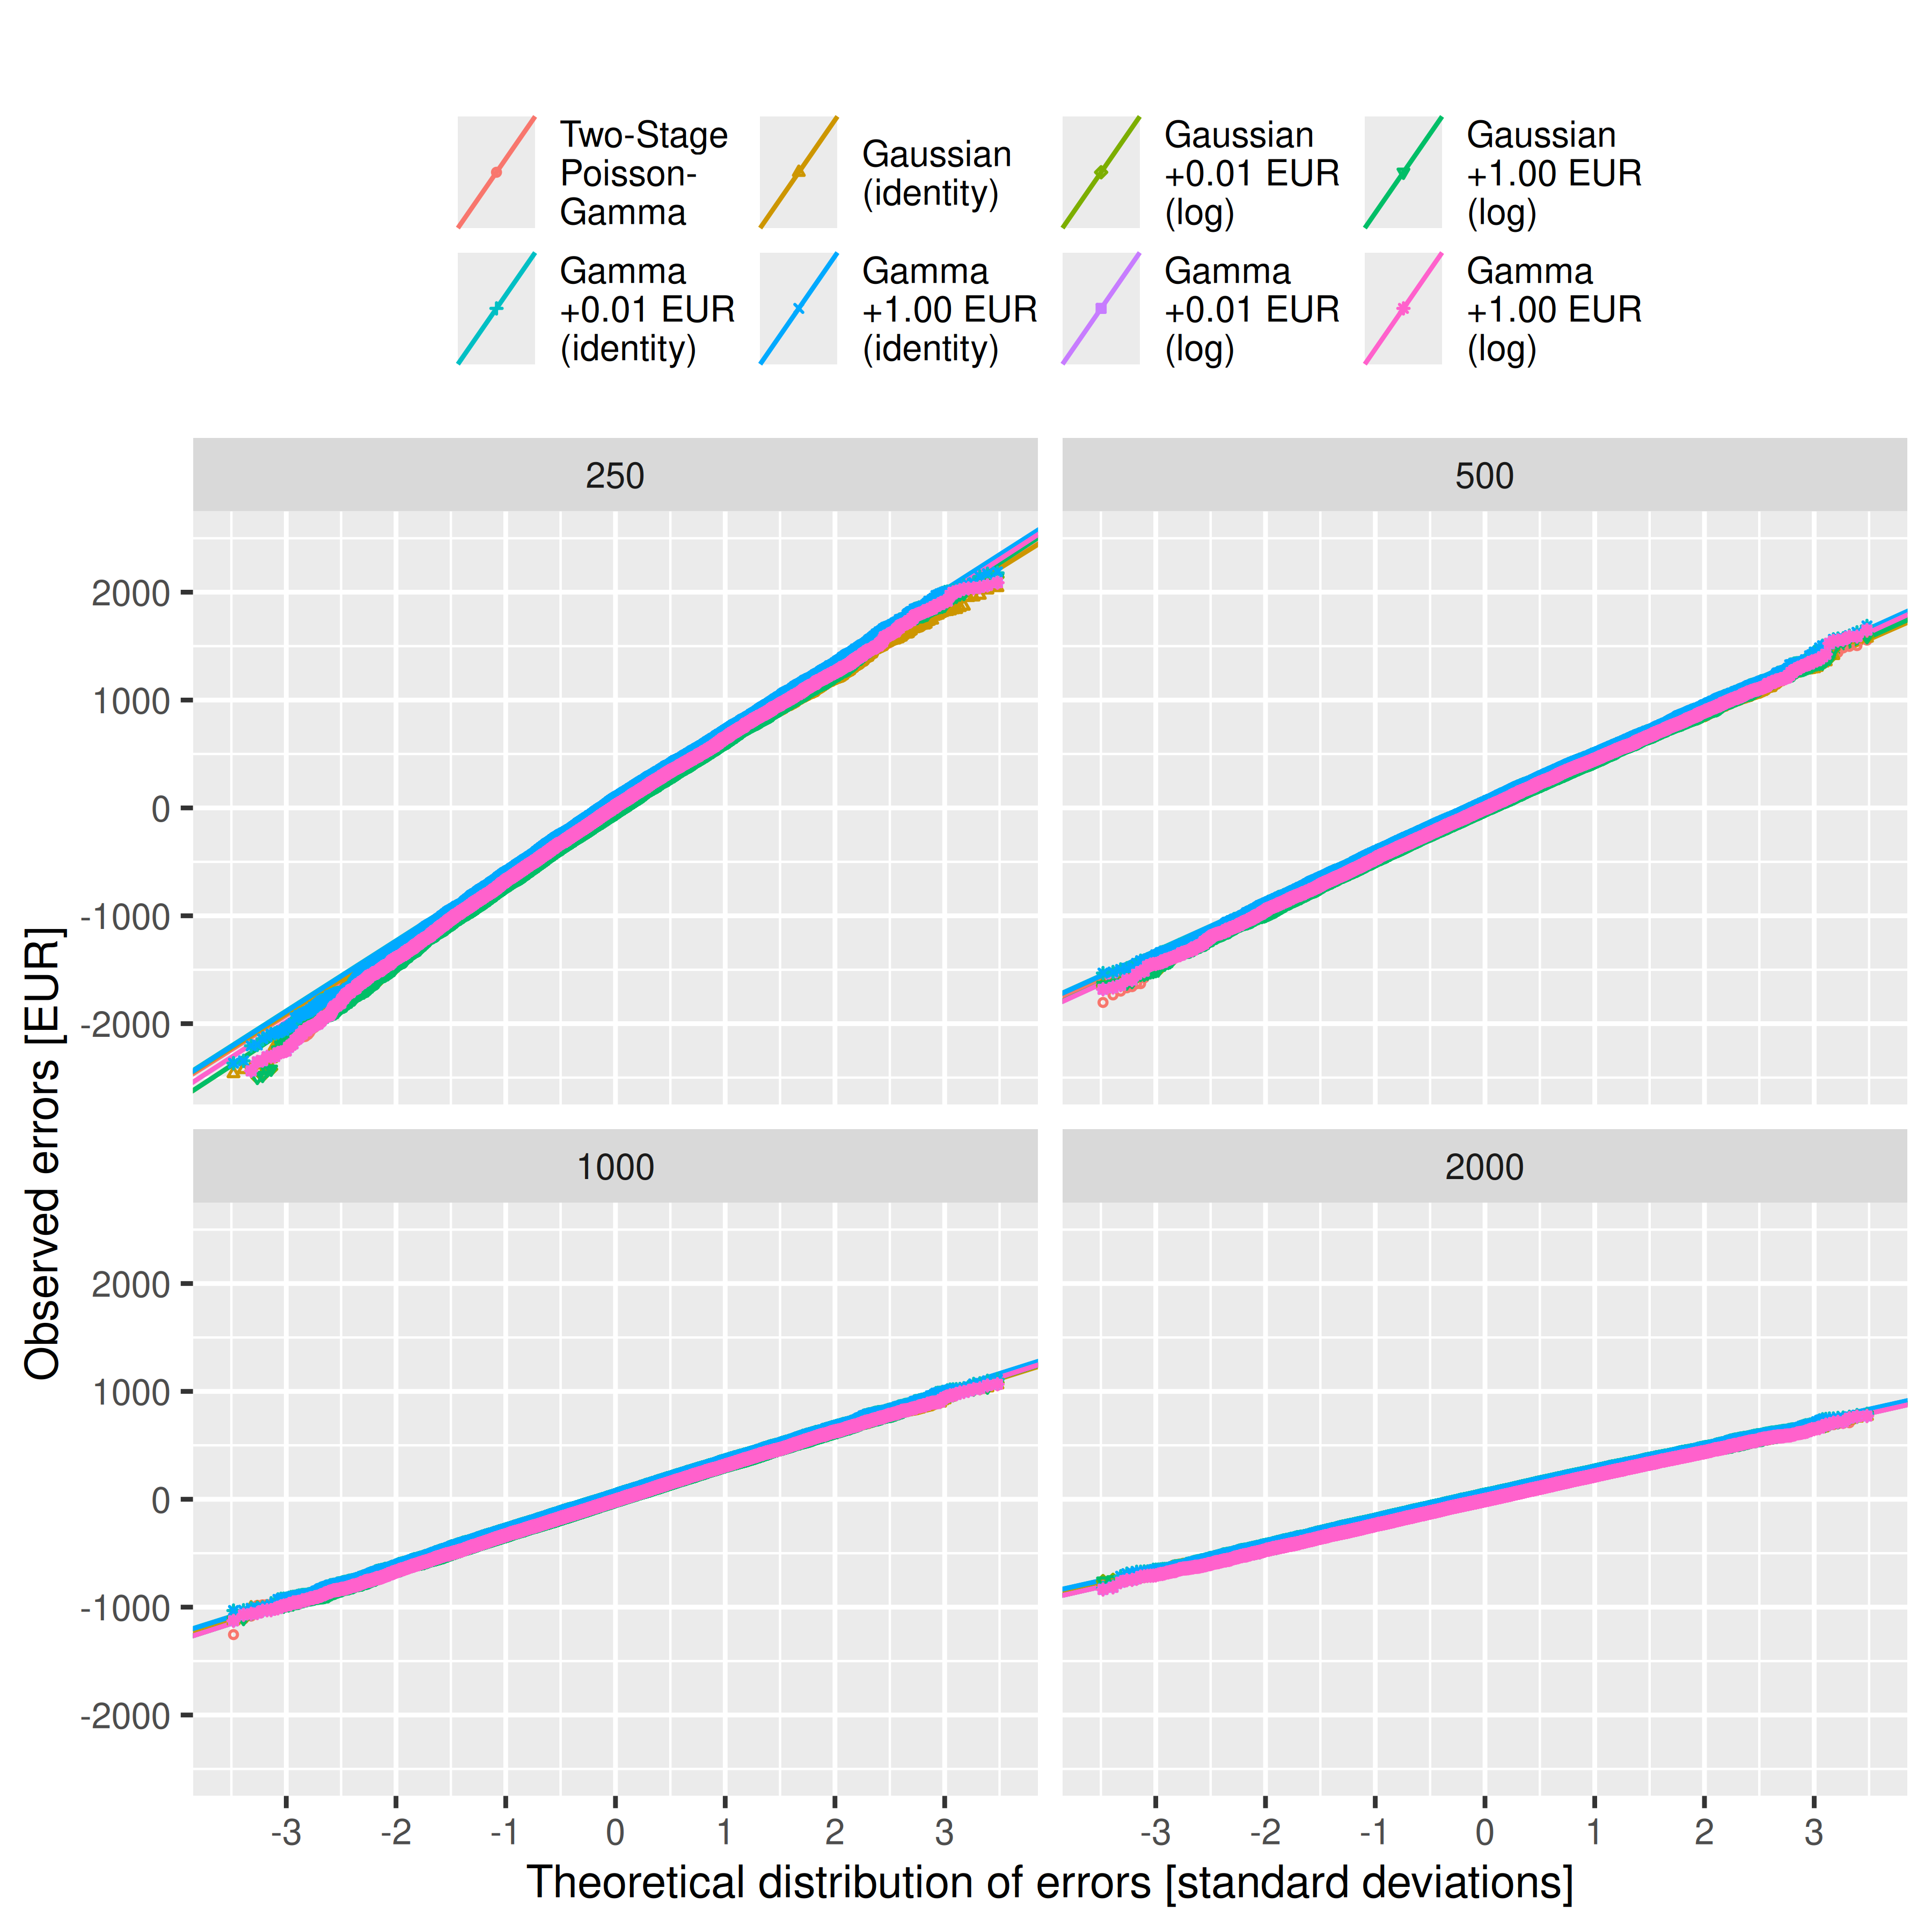
Warning: Removed 3193 rows containing missing values or values outside the scale range
(`geom_point()`).
Warning: Removed 3193 rows containing missing values or values outside the scale range
(`geom_point()`).
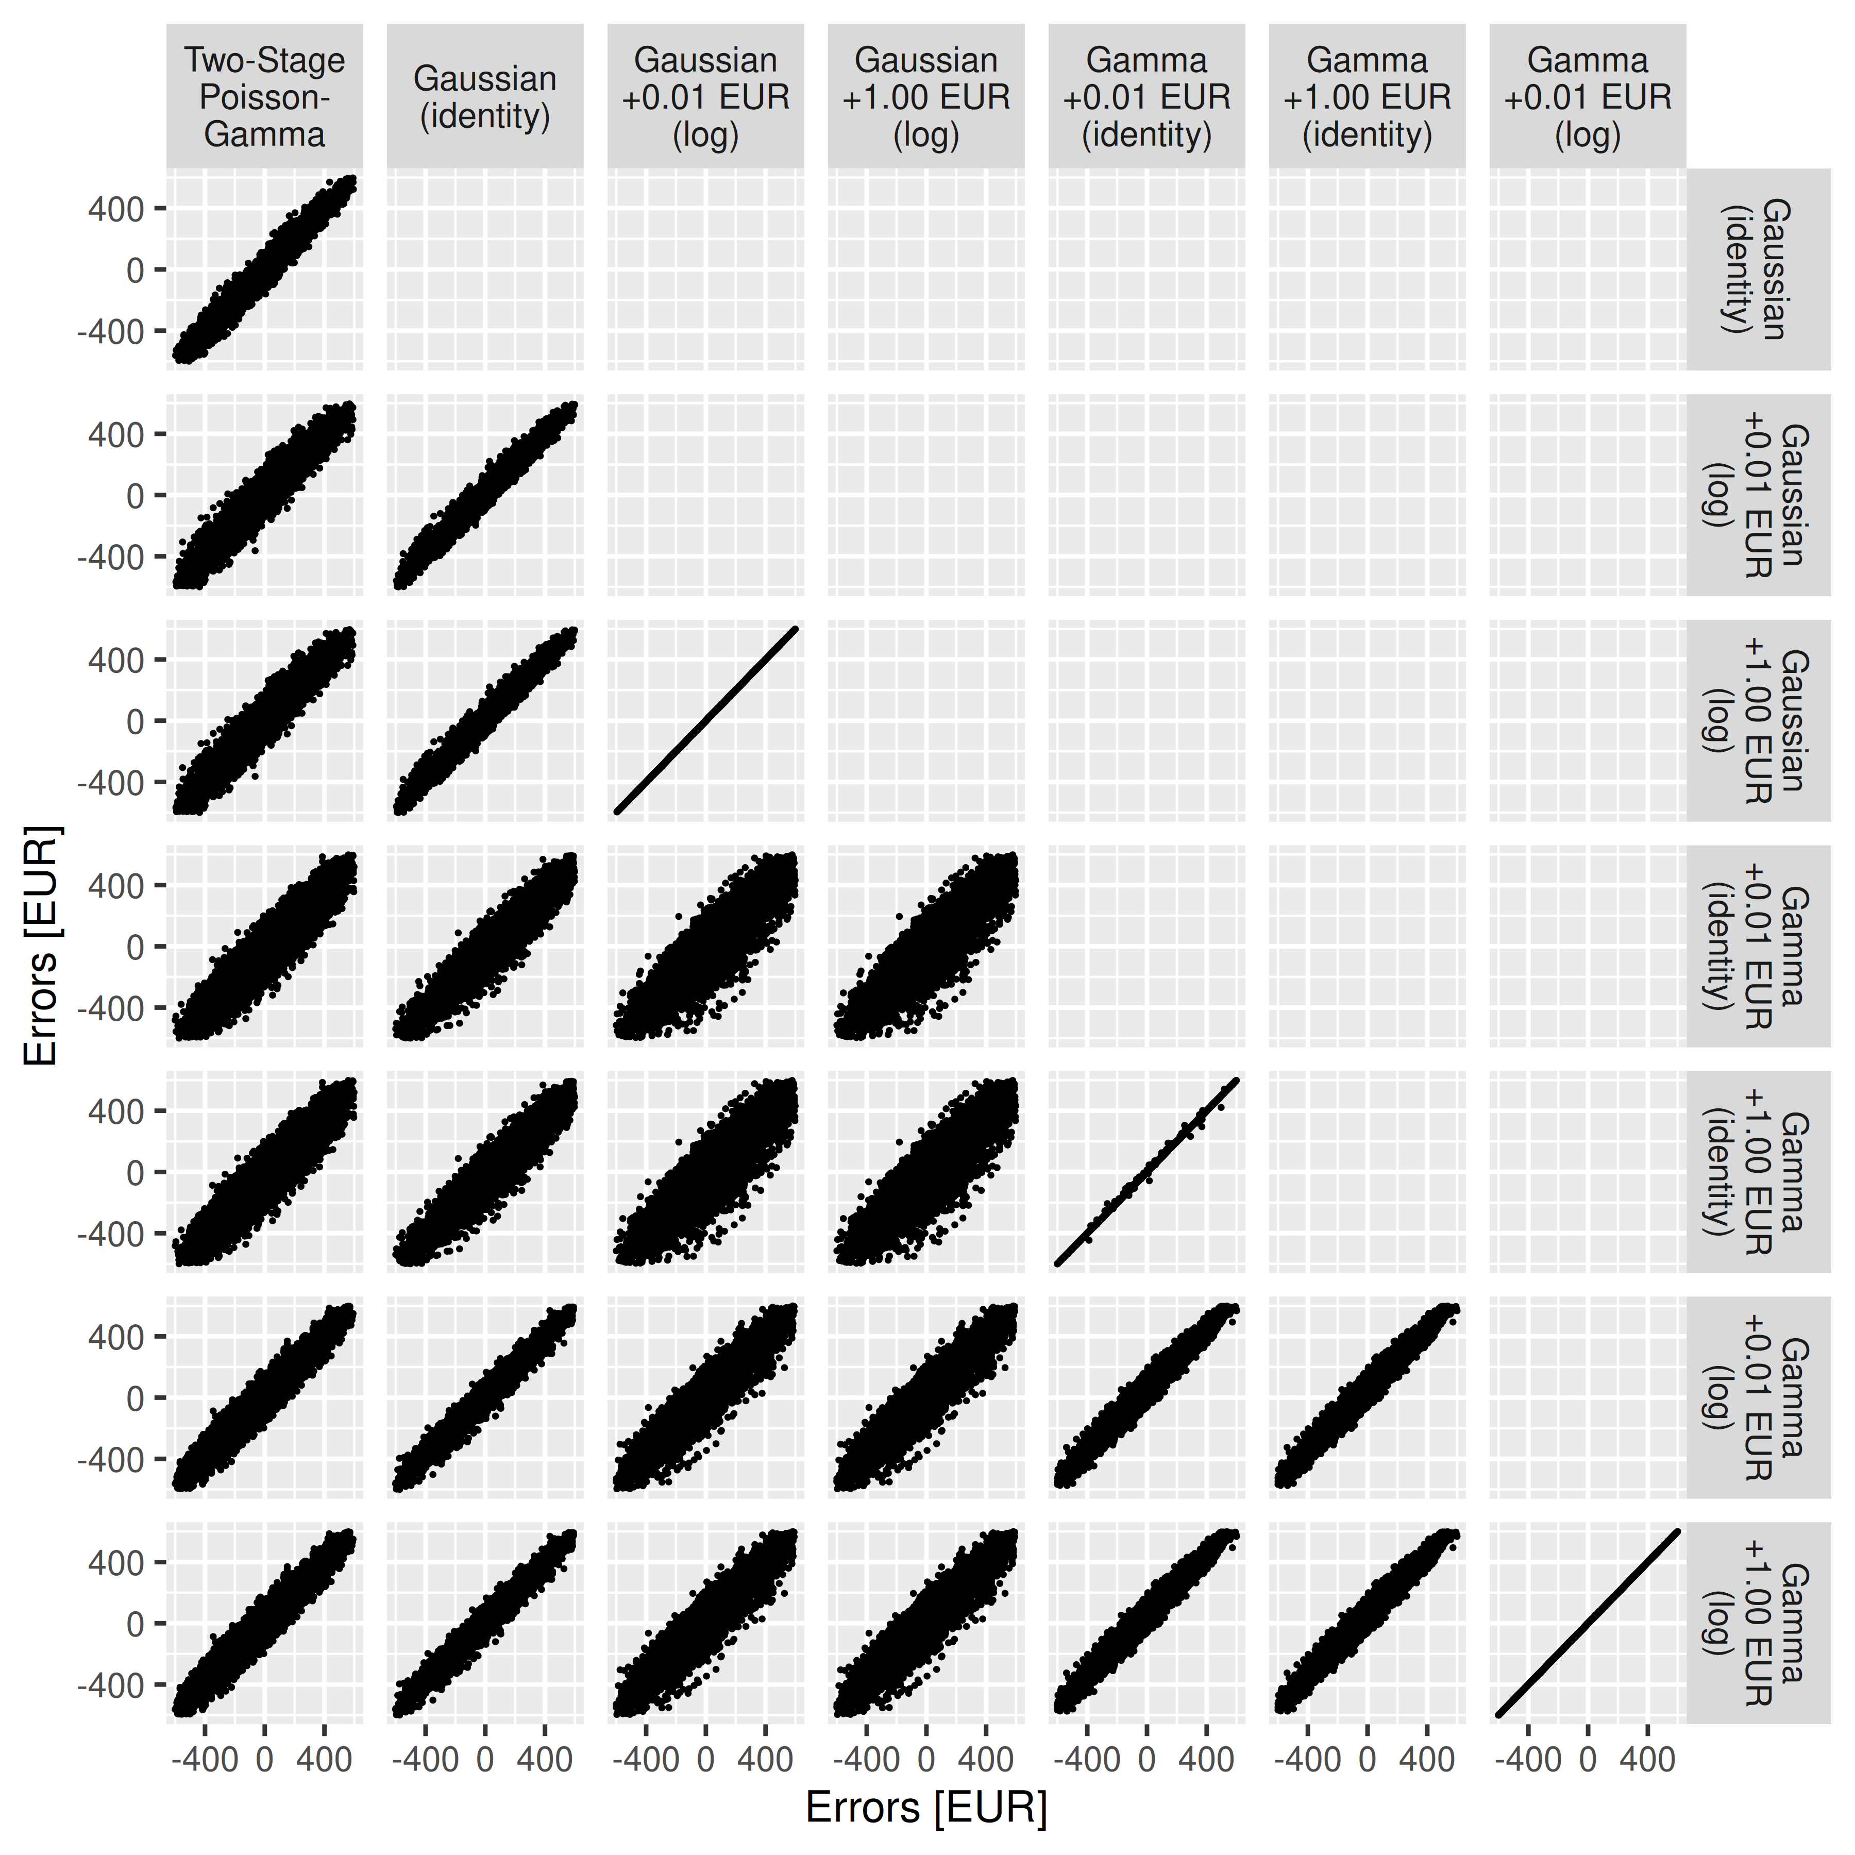 [1] “full: outcome ~ study_group * age_group”
Table S1 (full): Convergence of Gauss(log) and Gamma regressions (perfect = 60000)
Model | Status | 250 | 500 | 1000 | 2000
glm+start | returned | 60,000 | 60,000 | 60,000 | 60,000
glm+start | converged | 60,000 | 60,000 | 60,000 | 60,000
glm+start | valid_RSS | 60,000 | 60,000 | 60,000 | 60,000
glm+start | (co-)optimum | 48,323 | 50,602 | 52,925 | 54,966
glm2+start | returned | 60,000 | 60,000 | 60,000 | 60,000
glm2+start | converged | 60,000 | 60,000 | 60,000 | 60,000
glm2+start | valid_RSS | 60,000 | 60,000 | 60,000 | 60,000
glm2+start | (co-)optimum | 48,323 | 50,602 | 52,925 | 54,966
gam | returned | 60,000 | 60,000 | 60,000 | 60,000
gam | converged | 60,000 | 60,000 | 60,000 | 60,000
gam | valid_RSS | 60,000 | 60,000 | 60,000 | 60,000
gam | (co-)optimum | 54,604 | 55,611 | 55,978 | 56,285
glmmTMB+start | returned | 60,000 | 60,000 | 60,000 | 60,000
glmmTMB+start | converged | 60,000 | 60,000 | 59,999 | 60,000
glmmTMB+start | valid_RSS | 60,000 | 60,000 | 60,000 | 60,000
glmmTMB+start | (co-)optimum | 11 | 38 | 81 | 97
Table S2 (full, Cost Difference): Bias, Mean Absolute Error (MAE), and Root Mean Squared Error (RMSE) in EUR with 99%-CIs, 10000 simulation runs
Metric | N | Two-Stage  Poisson-  Gamma | Gaussian  (identity) | Gaussian  +0.01 EUR  (log) | Gaussian  +1.00 EUR  (log) | Gamma  +0.01 EUR  (identity) | Gamma  +1.00 EUR  (identity) | Gamma  +0.01 EUR  (log) | Gamma  +1.00 EUR  (log)
Bias | 250 | -13.46 [-30.39; 3.71] | -12.42 [-29.18; 4.24] | -12.42 [-28.99; 3.49] | -12.42 [-28.98; 3.72] | -12.42 [-29.10; 3.86] | -12.42 [-28.94; 4.08] | -12.42 [-29.04; 4.18] | -12.42 [-28.55; 3.74]
Bias | 500 | -5.85 [-17.54; 5.97] | -5.13 [-16.40; 6.66] | -5.13 [-16.49; 6.26] | -5.13 [-16.73; 6.55] | -5.13 [-16.74; 6.65] | -5.13 [-16.50; 6.79] | -5.13 [-16.67; 6.82] | -5.13 [-16.57; 6.56]
Bias | 1,000 | -5.66 [-13.98; 2.82] | -5.40 [-13.62; 3.00] | -5.40 [-13.76; 2.66] | -5.40 [-13.33; 2.65] | -5.40 [-13.73; 2.56] | -5.40 [-13.79; 2.87] | -5.40 [-13.46; 2.68] | -5.40 [-13.62; 2.73]
Bias | 2,000 | -1.55 [-7.37; 4.36] | -1.51 [-7.32; 4.48] | -1.51 [-7.36; 4.31] | -1.51 [-7.32; 4.42] | -1.51 [-7.40; 4.37] | -1.51 [-7.17; 4.32] | -1.51 [-7.31; 4.42] | -1.51 [-7.40; 4.21]
MAE | 250 | 521.26 [511.21; 531.61] | 512.45 [502.28; 522.69] | 512.45 [502.54; 522.39] | 512.45 [502.23; 522.37] | 512.45 [502.63; 522.31] | 512.45 [502.35; 522.32] | 512.45 [502.29; 522.74] | 512.45 [502.26; 522.52]
MAE | 500 | 365.63 [358.81; 372.86] | 359.29 [352.25; 366.37] | 359.29 [352.11; 366.63] | 359.29 [352.37; 366.44] | 359.29 [352.13; 366.31] | 359.29 [352.32; 366.52] | 359.29 [352.33; 366.29] | 359.29 [352.13; 366.51]
MAE | 1,000 | 259.01 [254.17; 263.90] | 253.74 [249.11; 258.67] | 253.74 [248.89; 258.58] | 253.74 [248.96; 258.59] | 253.74 [248.93; 258.66] | 253.74 [248.99; 258.73] | 253.74 [248.92; 258.68] | 253.74 [248.76; 258.57]
MAE | 2,000 | 183.28 [179.66; 186.87] | 179.74 [176.20; 183.33] | 179.74 [176.22; 183.32] | 179.74 [176.34; 183.14] | 179.74 [176.40; 183.24] | 179.74 [176.34; 183.21] | 179.74 [176.26; 183.12] | 179.74 [176.33; 183.18]
RMSE | 250 | 657.82 [645.34; 670.26] | 644.30 [631.98; 656.93] | 644.30 [631.92; 656.65] | 644.30 [632.42; 656.60] | 644.30 [632.16; 656.21] | 644.30 [632.42; 656.36] | 644.30 [631.98; 656.41] | 644.30 [632.14; 656.80]
RMSE | 500 | 459.86 [451.49; 468.33] | 451.45 [443.03; 459.46] | 451.45 [443.02; 459.79] | 451.45 [443.38; 459.60] | 451.45 [443.11; 459.94] | 451.45 [443.08; 459.79] | 451.45 [443.07; 459.79] | 451.45 [443.26; 459.73]
RMSE | 1,000 | 323.55 [317.92; 329.43] | 317.14 [311.37; 322.93] | 317.14 [311.51; 322.94] | 317.14 [311.40; 322.95] | 317.14 [311.39; 322.93] | 317.14 [311.47; 322.55] | 317.14 [311.50; 322.83] | 317.14 [311.32; 322.96]
RMSE | 2,000 | 229.56 [225.29; 233.66] | 225.09 [221.16; 229.13] | 225.09 [221.15; 229.28] | 225.09 [221.19; 229.20] | 225.09 [220.93; 229.23] | 225.09 [220.98; 229.29] | 225.09 [221.06; 229.08] | 225.09 [221.02; 229.17]
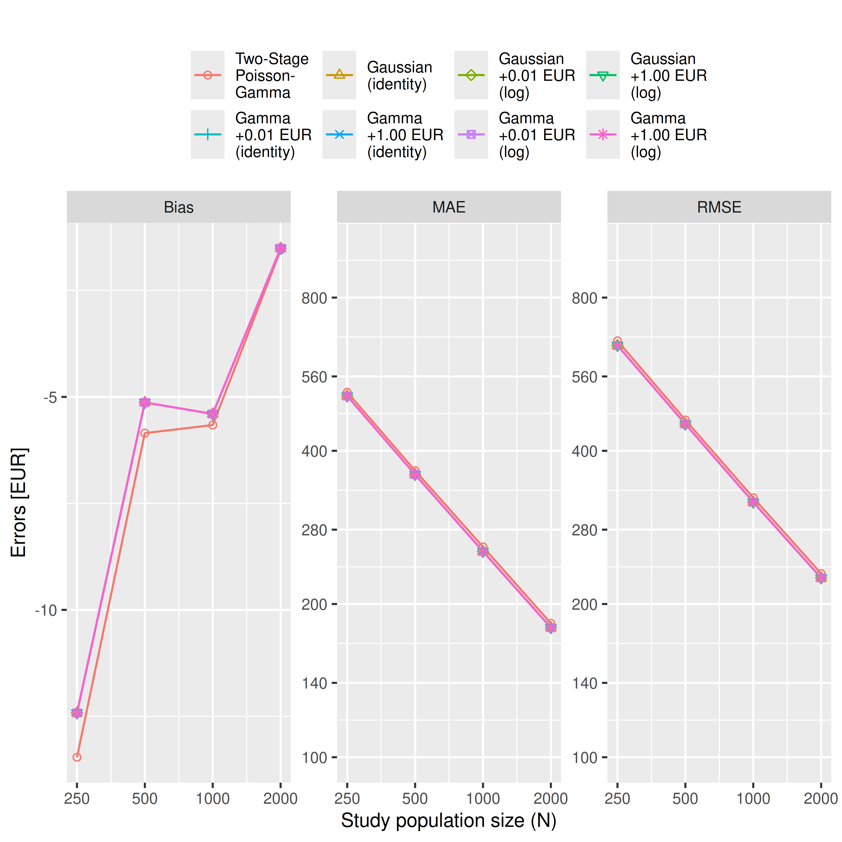
Warning: Removed 139 rows containing missing values or values outside the scale range
(`geom_point()`).
Warning: Removed 139 rows containing missing values or values outside the scale range
(`geom_point()`).
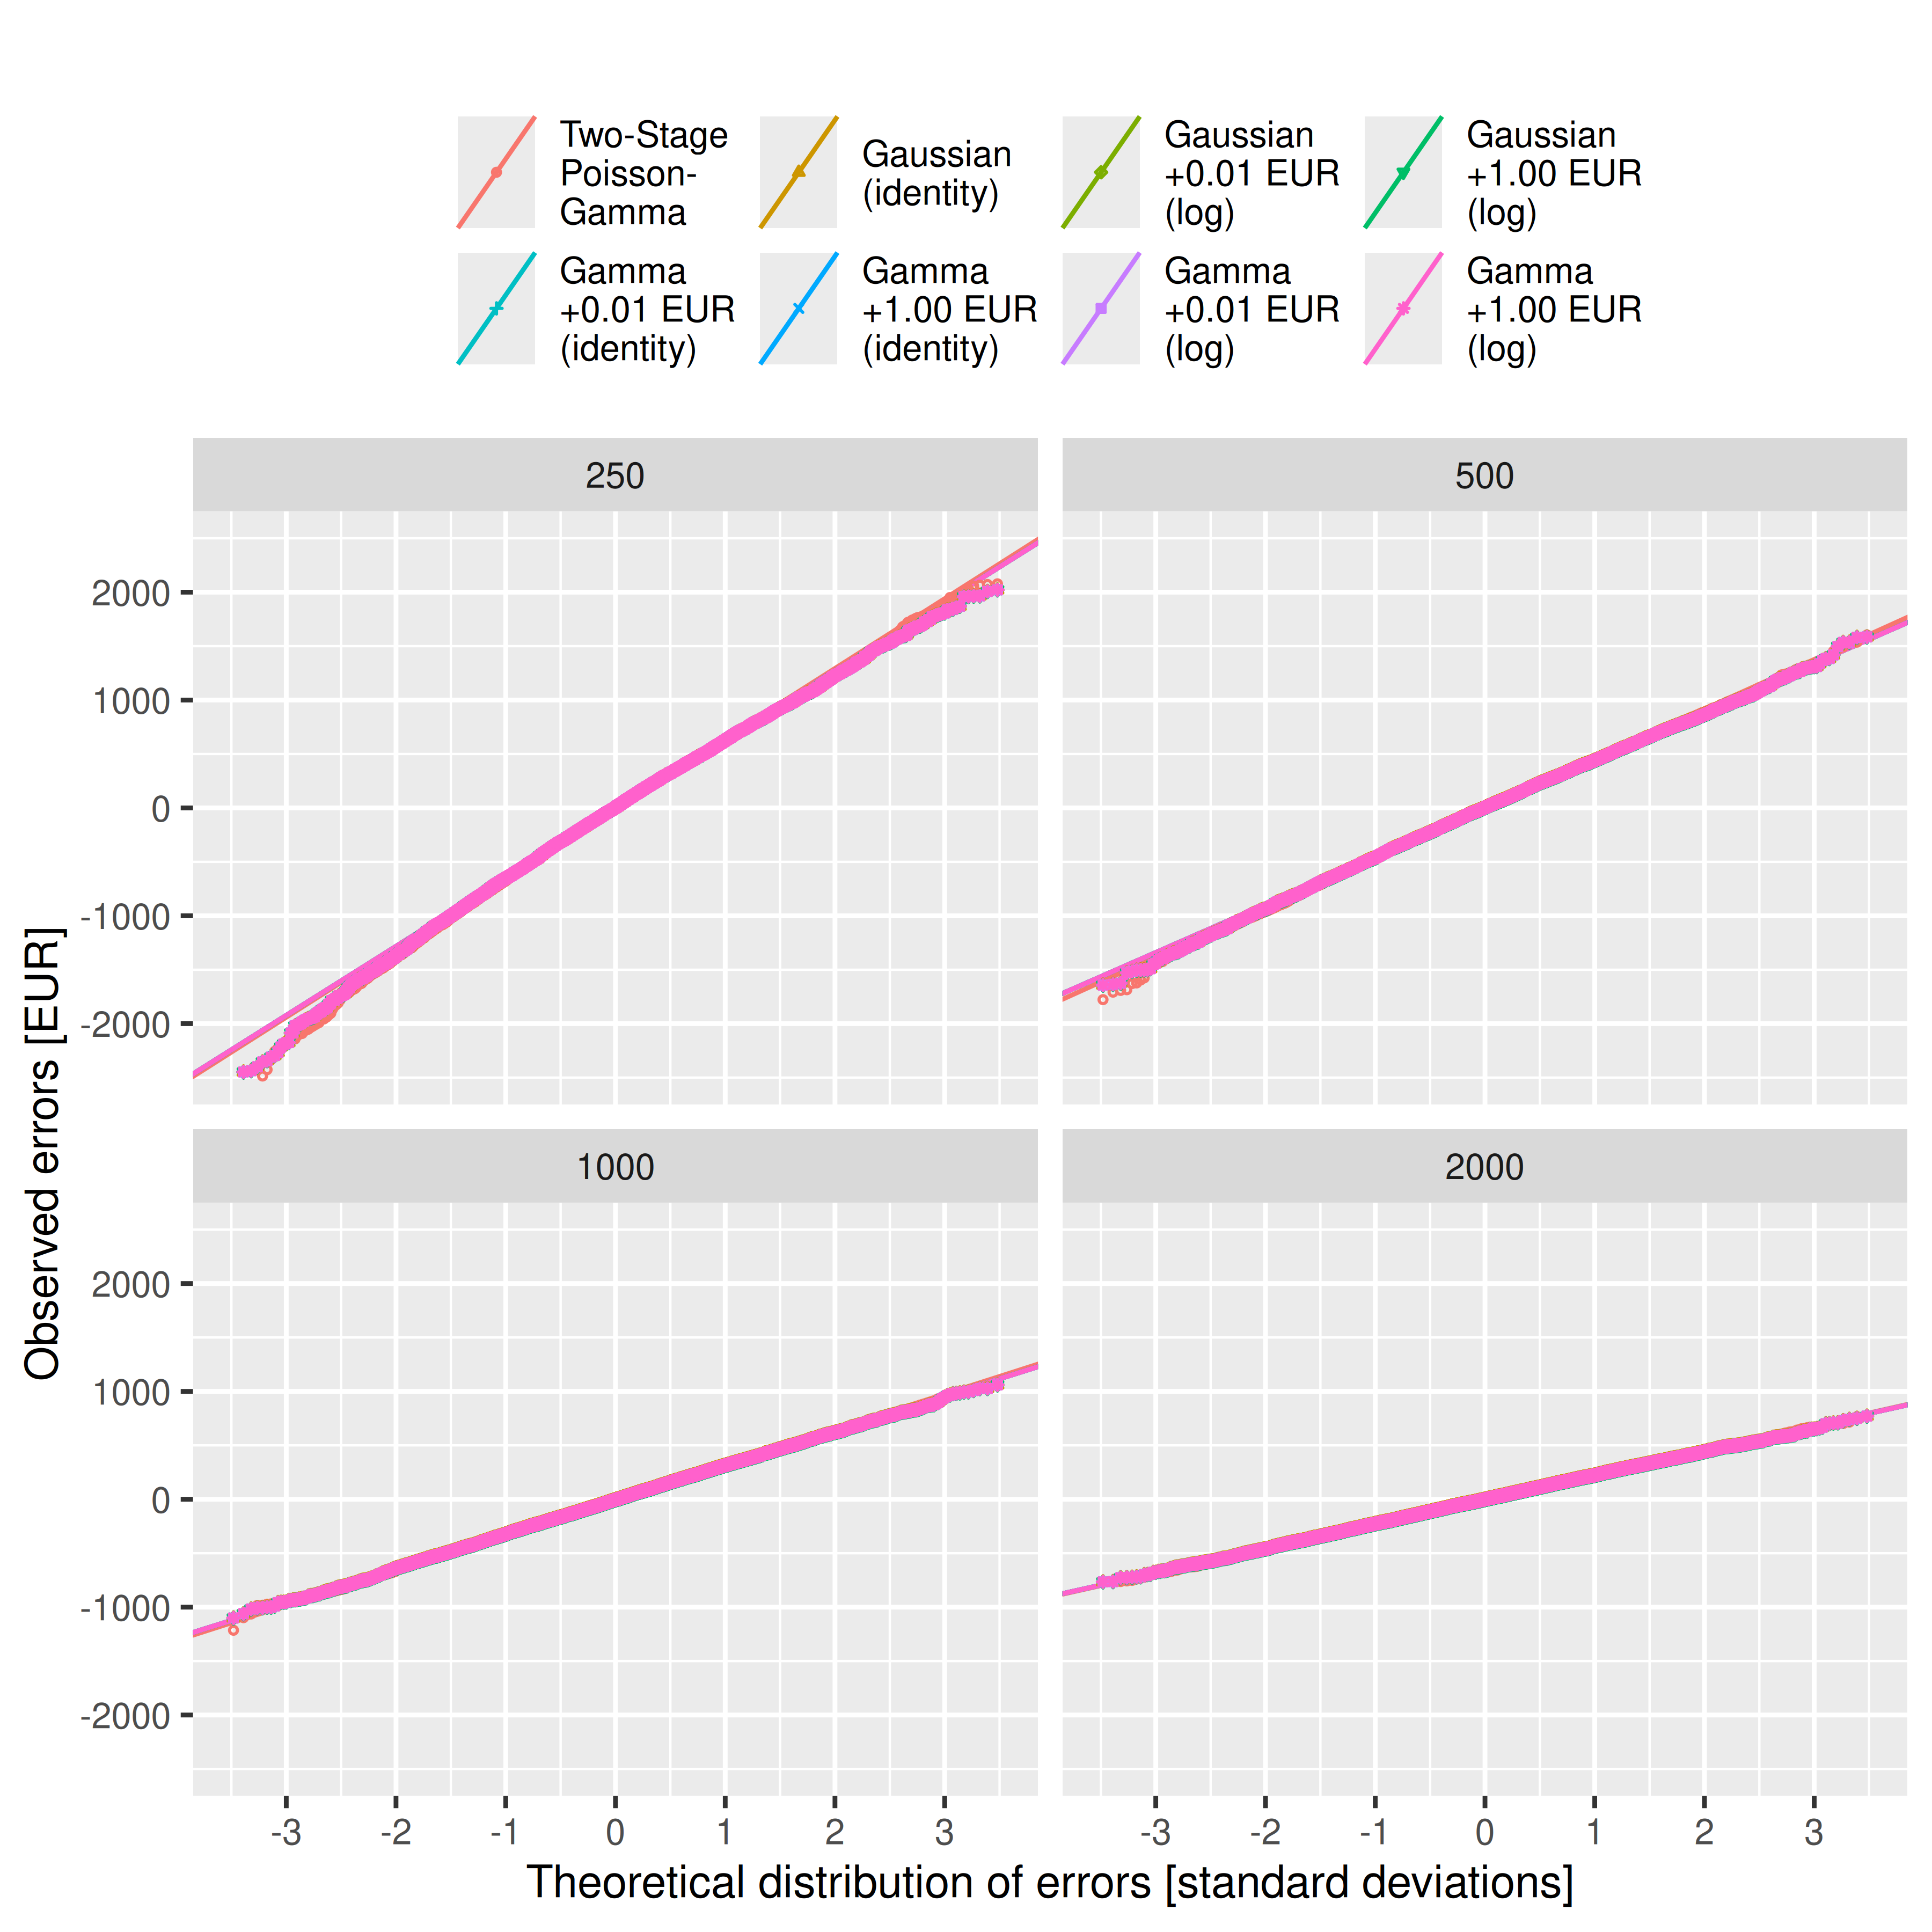
Warning: Removed 2023 rows containing missing values or values outside the scale range
(`geom_point()`).
Warning: Removed 2023 rows containing missing values or values outside the scale range
(`geom_point()`).


