Patient-level simulation and model comparison for robust incremental cost estimation
  - Online Resource 4: Data Postprocessing
Charité - Universitätsmedizin Berlin
Institute of Public Health
Hans-Aloys Wischmann, Toivo Glatz
Edited: 2026-11-01, Executed: 2026-11-02

Libraries and Utility Functions

Data Postprocessing
Warning: Removed 1 row containing non-finite outside the scale range
(`stat_bin()`).
Warning: Removed 40 rows containing missing values or values outside the scale range
(`geom_bar()`).
Warning: Removed 1 row containing non-finite outside the scale range
(`stat_bin()`).
Warning: Removed 40 rows containing missing values or values outside the scale range
(`geom_bar()`).
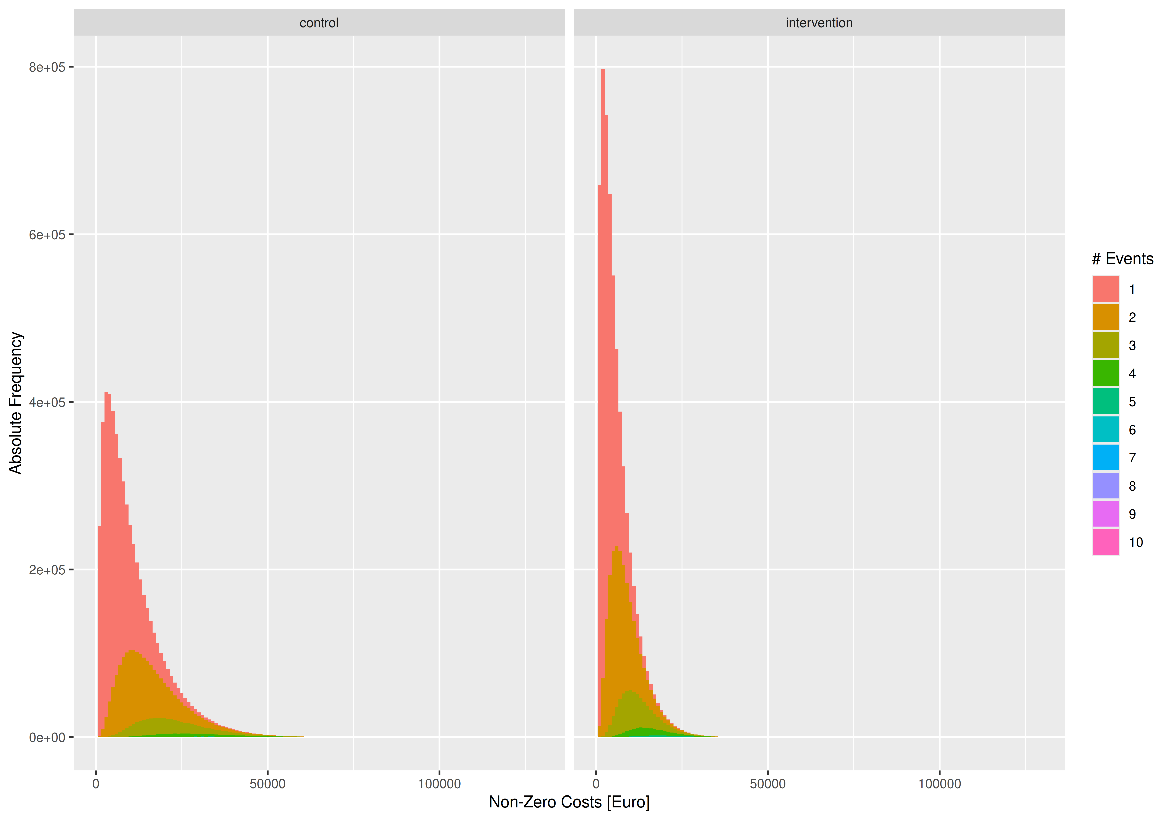 [1] “Maximum cumulative length of stay found in simulated data: 133 days, should be less than 365 days (TRUE)”
Proportion without events
study_group | zero_event
control | 43.3%
intervention | 39.2%
[1] “main: outcome ~ study_group + age_group”
Table S1 (main): Convergence of Gauss(log) and Gamma regressions (perfect = 60000)
Model | Status | 250 | 500 | 1000 | 2000
glm+start | returned | 60,000 | 60,000 | 60,000 | 60,000
glm+start | converged | 60,000 | 60,000 | 60,000 | 60,000
glm+start | valid_RSS | 60,000 | 60,000 | 60,000 | 60,000
glm+start | (co-)optimum | 26,677 | 27,137 | 26,368 | 23,580
glm2+start | returned | 60,000 | 60,000 | 60,000 | 60,000
glm2+start | converged | 60,000 | 60,000 | 60,000 | 60,000
glm2+start | valid_RSS | 60,000 | 60,000 | 60,000 | 60,000
glm2+start | (co-)optimum | 26,677 | 27,137 | 26,368 | 23,580
gam | returned | 60,000 | 60,000 | 60,000 | 60,000
gam | converged | 60,000 | 60,000 | 60,000 | 60,000
gam | valid_RSS | 60,000 | 60,000 | 60,000 | 60,000
gam | (co-)optimum | 25,546 | 26,553 | 27,923 | 30,315
glmmTMB+start | returned | 60,000 | 60,000 | 60,000 | 60,000
glmmTMB+start | converged | 60,000 | 60,000 | 60,000 | 60,000
glmmTMB+start | valid_RSS | 60,000 | 60,000 | 60,000 | 60,000
glmmTMB+start | (co-)optimum | 7,881 | 6,468 | 5,991 | 6,615
Table S2 (main, Cost Difference): Bias, Mean Absolute Error (MAE), and Root Mean Squared Error (RMSE) in EUR with 99%-CIs, 10000 simulation runs
Metric | N | Two-Stage  Poisson-  Gamma | Gaussian  (identity) | Gaussian  +0.01 EUR  (log) | Gaussian  +1.00 EUR  (log) | Gamma  +0.01 EUR  (identity) | Gamma  +1.00 EUR  (identity) | Gamma  +0.01 EUR  (log) | Gamma  +1.00 EUR  (log)
Bias | 250 | -19.02 [-42.62; 4.84] | -11.31 [-33.97; 11.41] | -66.25 [-90.23; -42.14] | -66.26 [-89.21; -43.30] | 137.11 [113.93; 160.42] | 132.47 [109.29; 155.63] | -23.43 [-46.92; 0.05] | -23.40 [-46.67; 0.03]
Bias | 500 | -8.51 [-25.76; 8.25] | -0.71 [-17.09; 15.73] | -23.22 [-39.92; -7.20] | -23.24 [-39.97; -6.41] | 120.99 [104.72; 137.82] | 115.87 [99.23; 132.21] | -13.70 [-30.43; 2.73] | -13.68 [-30.11; 2.80]
Bias | 1,000 | -13.04 [-24.82; -0.97] | -4.53 [-15.63; 6.61] | -9.17 [-20.41; 2.83] | -9.19 [-20.76; 2.24] | 98.69 [87.19; 110.45] | 95.35 [83.97; 107.13] | -19.20 [-30.82; -7.40] | -19.19 [-30.59; -8.00]
Bias | 2,000 | -2.28 [-10.91; 6.18] | 3.92 [-4.19; 12.04] | 7.46 [-0.54; 15.63] | 7.44 [-0.65; 15.60] | 101.32 [92.98; 109.38] | 100.13 [92.06; 108.29] | -10.58 [-18.81; -2.39] | -10.56 [-18.89; -2.11]
MAE | 250 | 735.83 [721.29; 750.21] | 708.97 [695.30; 723.09] | 727.98 [713.56; 742.69] | 727.98 [713.63; 741.94] | 724.51 [710.51; 738.63] | 726.64 [712.67; 740.98] | 731.36 [716.74; 745.65] | 731.34 [717.62; 745.39]
MAE | 500 | 521.87 [511.77; 532.06] | 503.34 [493.31; 513.44] | 513.45 [503.95; 523.69] | 513.45 [503.53; 523.47] | 517.61 [507.62; 527.55] | 519.35 [509.14; 529.54] | 514.78 [504.79; 524.86] | 514.78 [504.76; 524.70]
MAE | 1,000 | 368.01 [360.89; 375.06] | 354.62 [347.88; 361.62] | 360.49 [353.50; 367.43] | 360.49 [353.60; 367.21] | 365.62 [358.54; 372.96] | 365.63 [358.54; 372.66] | 360.42 [353.64; 367.37] | 360.42 [353.54; 367.25]
MAE | 2,000 | 258.28 [253.30; 263.53] | 250.48 [245.76; 255.30] | 253.46 [248.68; 258.44] | 253.46 [248.55; 258.45] | 265.82 [260.71; 271.05] | 265.64 [260.54; 270.67] | 254.16 [249.29; 258.91] | 254.15 [249.24; 259.03]
RMSE | 250 | 926.39 [909.01; 943.91] | 890.97 [874.08; 908.03] | 917.25 [900.26; 934.22] | 917.25 [900.37; 933.79] | 906.33 [889.97; 922.99] | 908.72 [892.28; 924.85] | 918.45 [901.72; 935.19] | 918.43 [901.09; 935.02]
RMSE | 500 | 655.69 [643.75; 667.66] | 632.75 [621.12; 644.44] | 645.43 [632.84; 657.38] | 645.43 [633.40; 657.81] | 646.69 [635.21; 658.85] | 648.50 [636.55; 660.49] | 646.00 [634.13; 658.03] | 645.99 [633.99; 657.87]
RMSE | 1,000 | 461.19 [452.99; 469.45] | 444.01 [435.86; 452.37] | 451.10 [443.22; 459.29] | 451.10 [442.77; 459.07] | 457.62 [449.44; 465.82] | 457.65 [449.76; 465.82] | 451.67 [443.28; 459.72] | 451.67 [443.44; 460.25]
RMSE | 2,000 | 324.17 [318.34; 330.14] | 314.21 [308.44; 320.07] | 317.92 [312.26; 323.82] | 317.92 [312.16; 323.61] | 332.17 [326.09; 338.17] | 332.03 [325.95; 338.10] | 319.19 [313.49; 325.04] | 319.19 [313.23; 325.22]
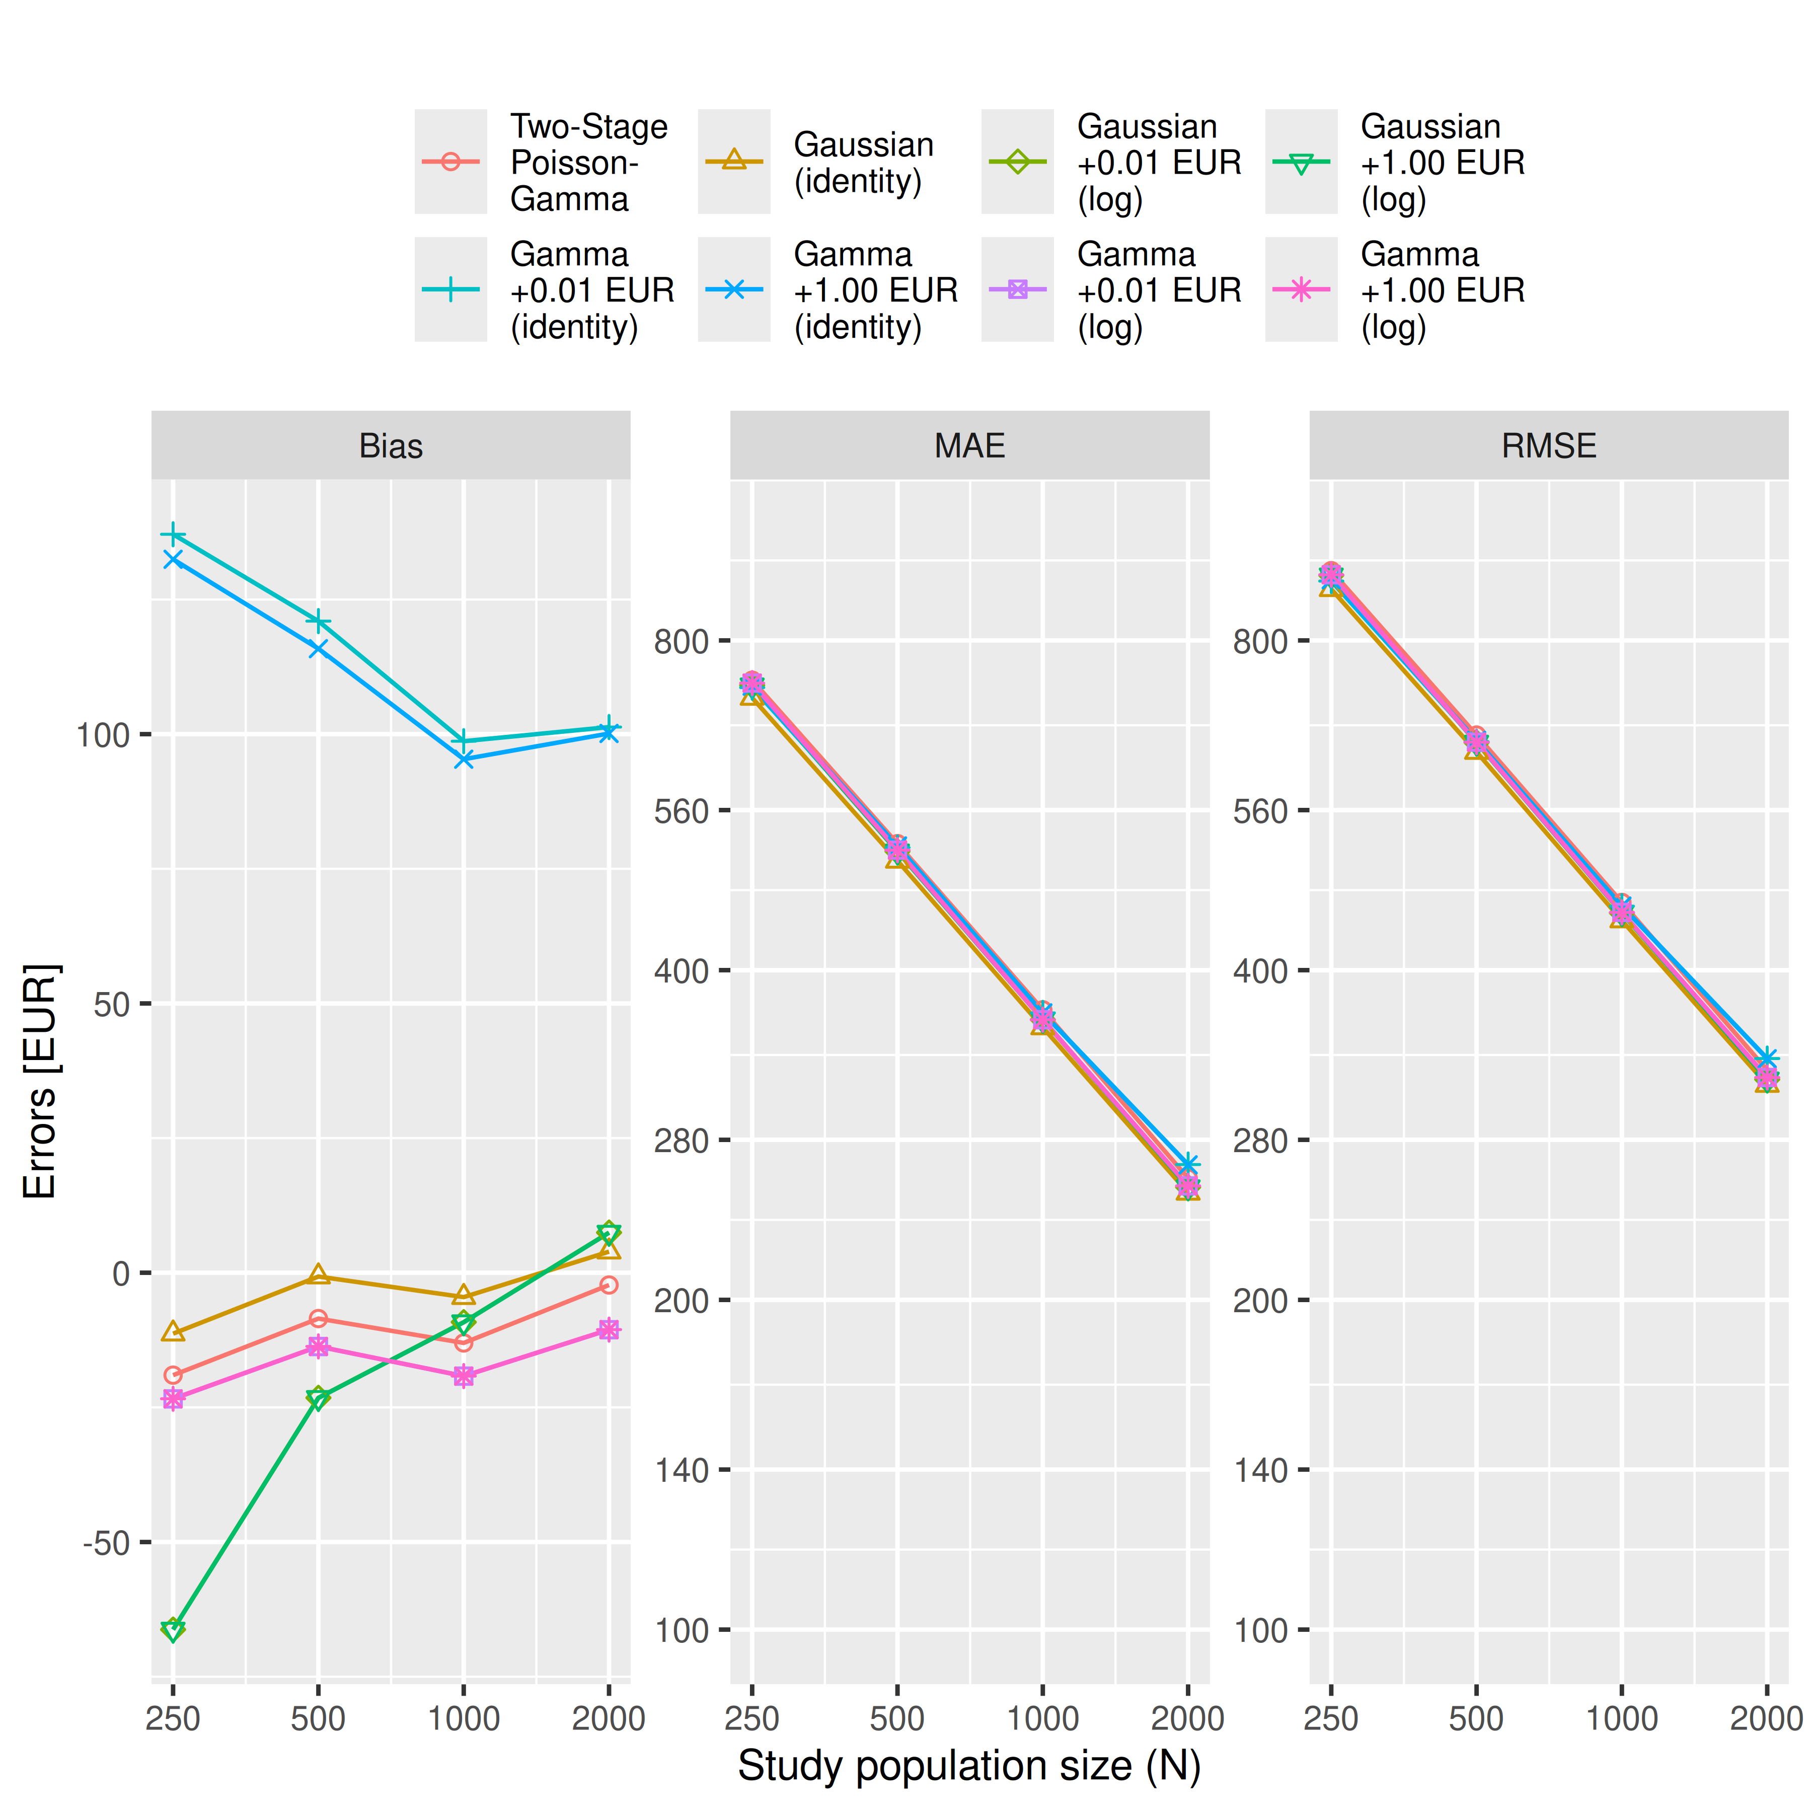
Warning: Removed 616 rows containing missing values or values outside the scale range
(`geom_point()`).
Warning: Removed 616 rows containing missing values or values outside the scale range
(`geom_point()`).
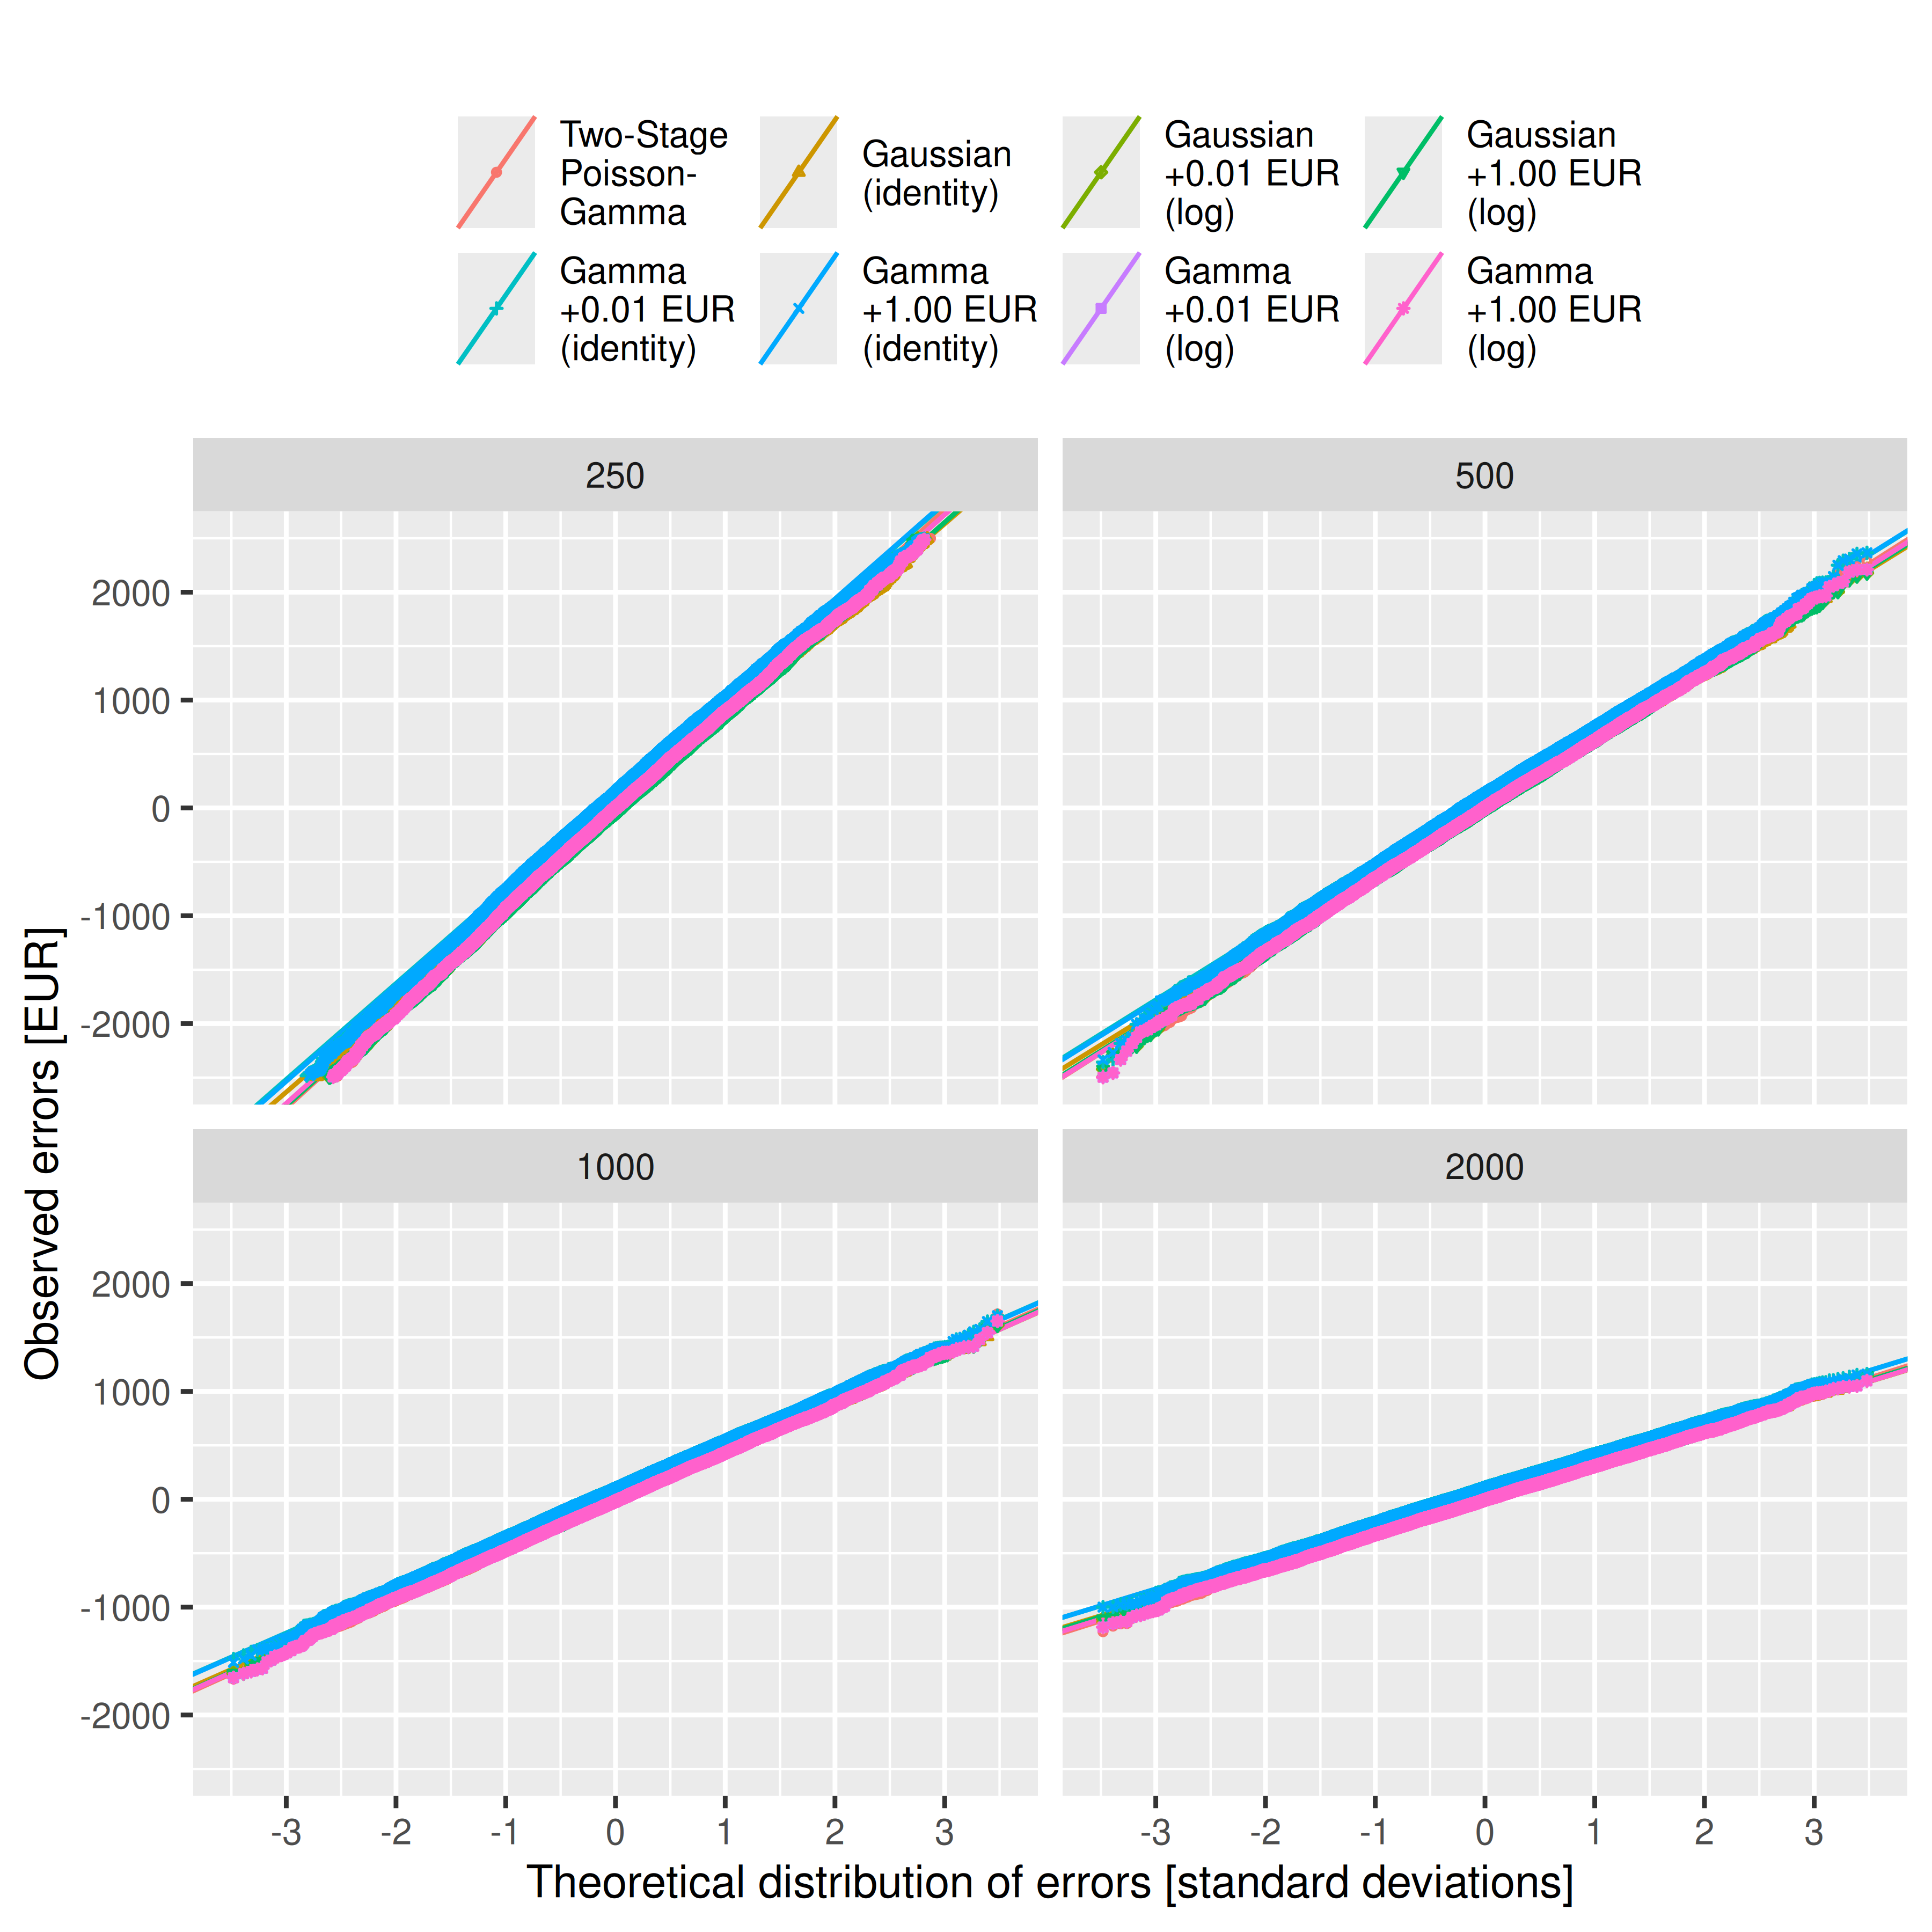
Warning: Removed 22590 rows containing missing values or values outside the scale range
(`geom_point()`).
Warning: Removed 22590 rows containing missing values or values outside the scale range
(`geom_point()`).
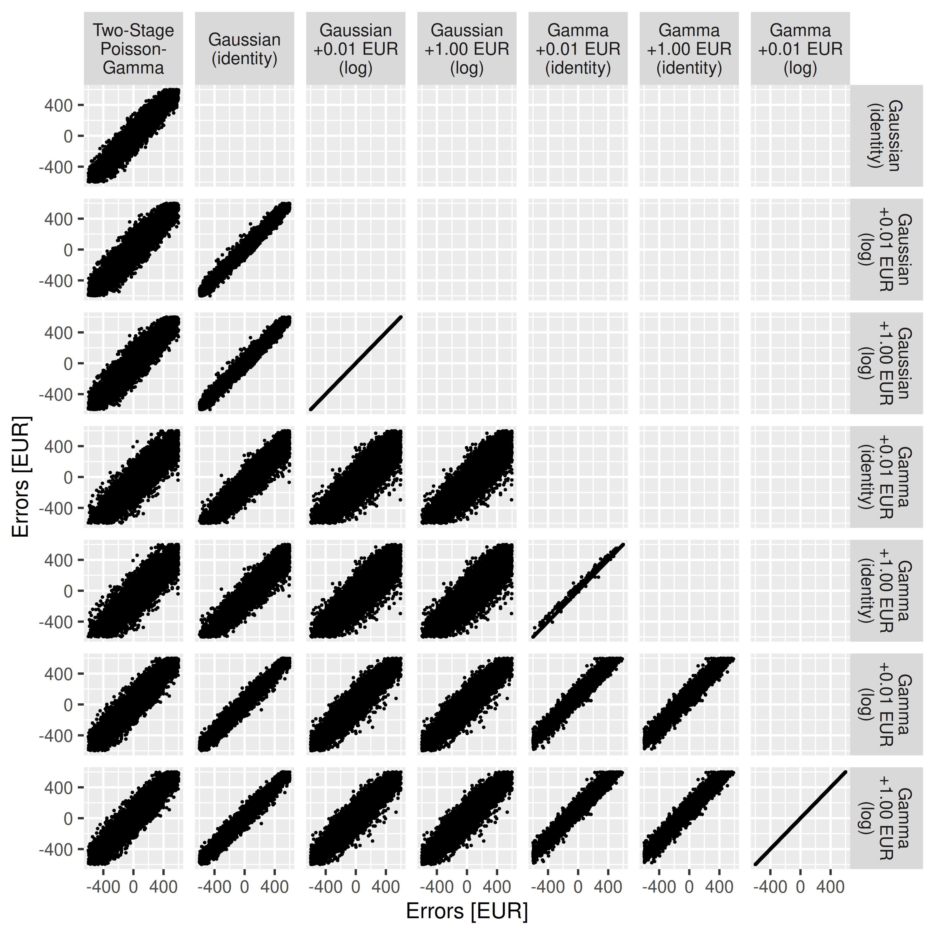 [1] “full: outcome ~ study_group * age_group”
Table S1 (full): Convergence of Gauss(log) and Gamma regressions (perfect = 60000)
Model | Status | 250 | 500 | 1000 | 2000
glm+start | returned | 60,000 | 60,000 | 60,000 | 60,000
glm+start | converged | 60,000 | 60,000 | 60,000 | 60,000
glm+start | valid_RSS | 60,000 | 60,000 | 60,000 | 60,000
glm+start | (co-)optimum | 49,597 | 51,540 | 53,814 | 55,183
glm2+start | returned | 60,000 | 60,000 | 60,000 | 60,000
glm2+start | converged | 60,000 | 60,000 | 60,000 | 60,000
glm2+start | valid_RSS | 60,000 | 60,000 | 60,000 | 60,000
glm2+start | (co-)optimum | 49,597 | 51,540 | 53,814 | 55,183
gam | returned | 60,000 | 60,000 | 60,000 | 60,000
gam | converged | 60,000 | 60,000 | 60,000 | 60,000
gam | valid_RSS | 60,000 | 60,000 | 60,000 | 60,000
gam | (co-)optimum | 55,336 | 55,947 | 56,217 | 56,175
glmmTMB+start | returned | 60,000 | 60,000 | 60,000 | 60,000
glmmTMB+start | converged | 60,000 | 60,000 | 60,000 | 60,000
glmmTMB+start | valid_RSS | 60,000 | 60,000 | 60,000 | 60,000
glmmTMB+start | (co-)optimum | 18 | 44 | 45 | 31
Table S2 (full, Cost Difference): Bias, Mean Absolute Error (MAE), and Root Mean Squared Error (RMSE) in EUR with 99%-CIs, 10000 simulation runs
Metric | N | Two-Stage  Poisson-  Gamma | Gaussian  (identity) | Gaussian  +0.01 EUR  (log) | Gaussian  +1.00 EUR  (log) | Gamma  +0.01 EUR  (identity) | Gamma  +1.00 EUR  (identity) | Gamma  +0.01 EUR  (log) | Gamma  +1.00 EUR  (log)
Bias | 250 | -12.80 [-36.27; 11.13] | -13.30 [-36.29; 9.79] | -13.30 [-36.94; 9.99] | -13.30 [-36.18; 9.38] | -13.30 [-36.54; 10.23] | -13.30 [-35.67; 9.25] | -13.30 [-35.86; 9.20] | -13.30 [-35.90; 9.33]
Bias | 500 | -2.57 [-19.75; 14.29] | -1.28 [-17.73; 15.16] | -1.28 [-17.52; 14.61] | -1.28 [-17.81; 15.02] | -1.28 [-17.37; 15.32] | -1.28 [-18.09; 15.00] | -1.28 [-17.88; 14.88] | -1.28 [-17.53; 14.63]
Bias | 1,000 | -6.29 [-18.17; 5.82] | -4.41 [-15.48; 6.84] | -4.41 [-15.70; 7.27] | -4.41 [-15.93; 6.93] | -4.41 [-15.73; 7.14] | -4.41 [-15.94; 7.05] | -4.41 [-15.79; 6.93] | -4.41 [-15.58; 6.71]
Bias | 2,000 | 3.77 [-4.90; 12.22] | 3.89 [-4.19; 12.02] | 3.89 [-4.07; 12.00] | 3.89 [-4.14; 11.90] | 3.89 [-4.34; 12.02] | 3.89 [-4.30; 11.94] | 3.89 [-4.13; 12.01] | 3.89 [-4.35; 12.07]
MAE | 250 | 737.30 [722.73; 751.67] | 711.31 [697.69; 725.40] | 711.31 [697.27; 725.83] | 711.31 [697.13; 724.93] | 711.31 [697.59; 725.37] | 711.31 [697.55; 725.17] | 711.31 [697.06; 725.29] | 711.31 [697.38; 725.34]
MAE | 500 | 522.30 [512.12; 532.31] | 504.26 [494.35; 514.32] | 504.26 [494.74; 514.13] | 504.26 [494.59; 514.11] | 504.26 [493.99; 514.25] | 504.26 [494.26; 514.19] | 504.26 [494.56; 514.17] | 504.26 [494.48; 513.93]
MAE | 1,000 | 368.46 [361.25; 375.42] | 354.85 [348.12; 361.90] | 354.85 [347.96; 361.67] | 354.85 [348.07; 361.45] | 354.85 [347.84; 361.96] | 354.85 [347.94; 361.74] | 354.85 [348.06; 361.79] | 354.85 [348.15; 361.72]
MAE | 2,000 | 258.41 [253.42; 263.70] | 250.44 [245.69; 255.22] | 250.44 [245.85; 255.30] | 250.44 [245.65; 255.34] | 250.44 [245.52; 255.36] | 250.44 [245.66; 255.25] | 250.44 [245.56; 255.22] | 250.44 [245.65; 255.28]
RMSE | 250 | 928.66 [911.30; 945.95] | 894.16 [877.24; 911.23] | 894.16 [878.18; 910.89] | 894.16 [878.05; 910.21] | 894.16 [877.77; 910.75] | 894.16 [877.95; 910.36] | 894.16 [877.85; 910.55] | 894.16 [877.36; 910.12]
RMSE | 500 | 656.28 [644.22; 668.54] | 633.46 [621.80; 645.19] | 633.46 [621.40; 645.35] | 633.46 [621.73; 645.80] | 633.46 [621.62; 645.00] | 633.46 [621.70; 645.15] | 633.46 [621.28; 645.31] | 633.46 [621.85; 645.21]
RMSE | 1,000 | 461.63 [453.31; 470.09] | 444.35 [436.17; 452.51] | 444.35 [436.36; 452.42] | 444.35 [436.08; 452.26] | 444.35 [436.33; 452.34] | 444.35 [436.50; 452.41] | 444.35 [436.24; 452.15] | 444.35 [436.09; 452.55]
RMSE | 2,000 | 324.14 [318.24; 330.13] | 314.08 [308.29; 319.97] | 314.08 [308.44; 319.83] | 314.08 [308.22; 319.74] | 314.08 [308.36; 319.75] | 314.08 [308.35; 319.88] | 314.08 [308.43; 319.78] | 314.08 [308.43; 319.88]
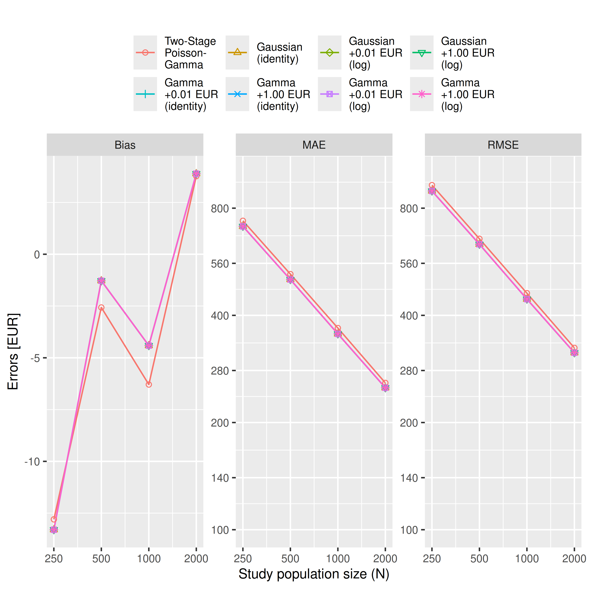
Warning: Removed 593 rows containing missing values or values outside the scale range
(`geom_point()`).
Warning: Removed 593 rows containing missing values or values outside the scale range
(`geom_point()`).
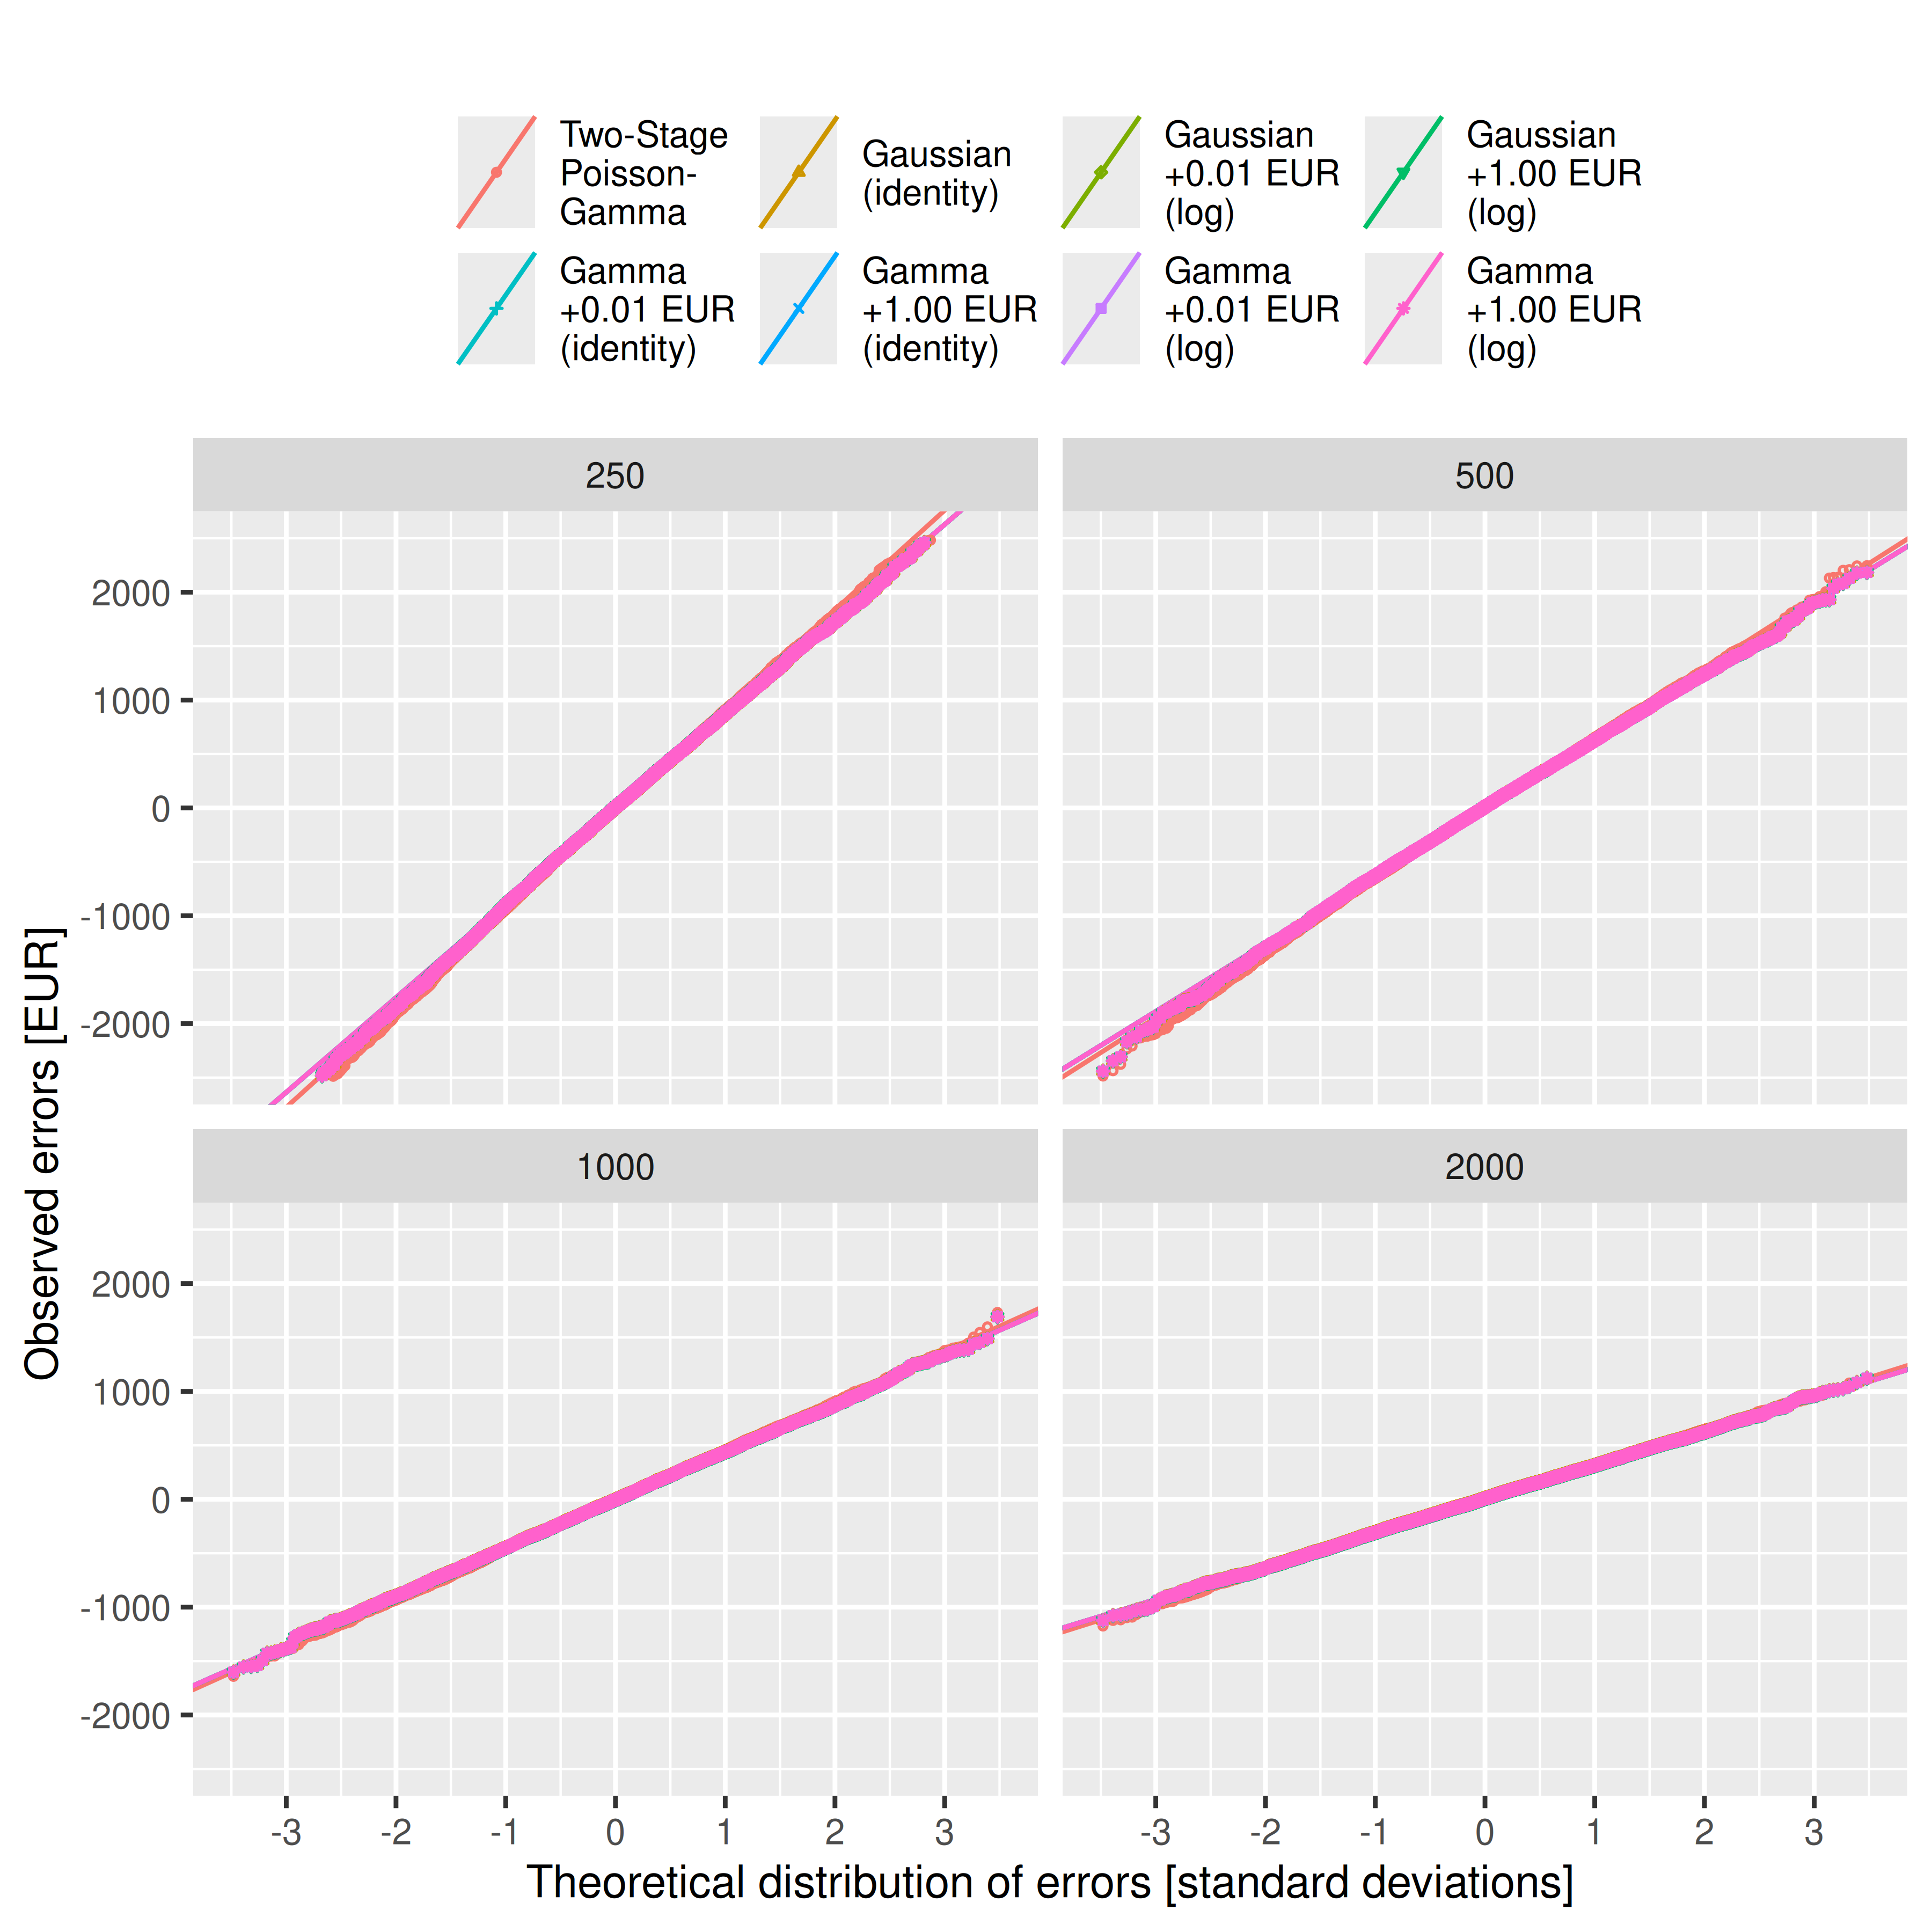
Warning: Removed 17073 rows containing missing values or values outside the scale range
(`geom_point()`).
Warning: Removed 17073 rows containing missing values or values outside the scale range
(`geom_point()`).


