Health Economics Methods - Incremental Costs
  - Gaussian(identity), Gaussian(loglink), Gamma, and Zero-Inflated Gamma (Poisson-Gamma)
Anonymous Institute
Anonymous1, Anonymous2
Edited: 2026-03-25, Executed: 2026-03-26

Conventions and Packages
Due to naming conventions that restrict the use of a variable named group, phase is used for intervention and control groups. To benefit from its more robust step-halving approach and thus improved convergence. glm2::glm2() is used as a drop-in replacement for the generic stats::glm(). A 2nd regression fit with valid starting points is always performed, so as to overcome known failures of glm() and glm2() in determining initial parameter estimates, especially for the log-link. Two additional regression fits are always performed using mgcv::bam() and glmmTMB::glmmTMB() as alternative implementations from different packages. Finally, the best fit, defined as the one with the minimum AIC, is returned and analyzed.

Scenario

Population
Study population N = 250, 500, 1000, 2000, with age uniformly distributed between 50 and 80 years

Intervention
Tele-consultations for timely identification of patients that require hospitalization

Control
Standard care

Outcome
Hospitalization costs, during a fixed follow-up period of 1 year(s)

Modeled Hypothesis
More patients will be hospitalized during the follow-up period, but at a lower cost for each hospitalization.

Model Parameters
Hospitalization rates of 0.1 and 0.15 per year, in control and intervention, respectively, growing linearly with age, i.e., multiplied by age/50.
Gamma distribution for hospitalization costs per event, with mean of 9000 EUR for control and 5000 EUR for intervention.
Standard deviation of hospitalization costs per event of 2000 EUR, in either arm.
All non-hospitalized patients incur zero cost.
Positive costs are computed from the non-negative costs by adding 0.01 EUR.
For the first scenario, an index infection is assumed to confer immunity to the participant, at least for the duration of the follow-up, so that the probability of a single hospitalization event is given by the product of the appropriate rate and the follow-up period. For the second scenario, the number of hospitalizations per patient is sampled from a Poisson distribution with the appropriate rate, so that (some) patients will experience more than one hospitalization within the follow-up period.

True Outcome
Expected difference in cost from true population values: -195 EUR, excluding cost of intervention which is not modeled.

Simulation Results
Within each simulation run, one random sample is created and analyzed by all implemented methods.
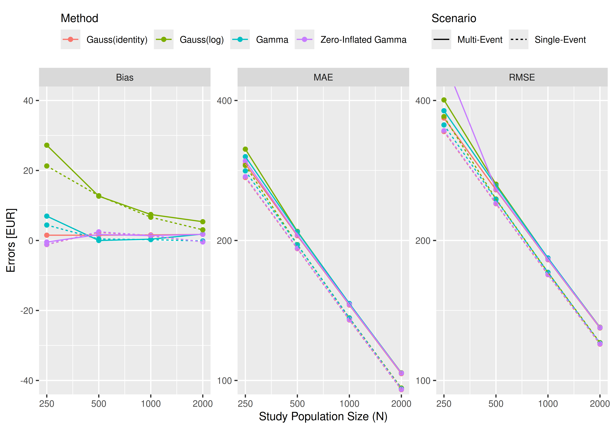
Table S1: Bias, Mean Absolute Error (MAE), Root Mean Square Error (RMSE), in EUR, single-event scenario, 20000 simulations
Metric | N | Gauss(identity) | Gauss(log) | Gamma | Zero-Inflated Gamma
Bias | 250 | -1.17 | 21.29 | 4.41 | -1.11
Bias | 500 | 2.33 | 12.78 | 0.42 | 2.47
Bias | 1,000 | 1.32 | 6.64 | 0.24 | 1.43
Bias | 2,000 | -0.39 | 3.05 | -0.14 | -0.42
SE(Bias) | 250 | 2.43 | 2.61 | 2.51 | 2.43
SE(Bias) | 500 | 1.70 | 1.73 | 1.73 | 1.70
SE(Bias) | 1,000 | 1.19 | 1.21 | 1.21 | 1.20
SE(Bias) | 2,000 | 0.85 | 0.85 | 0.85 | 0.85
MAE | 250 | 273.16 | 289.97 | 282.28 | 274.21
MAE | 500 | 192.05 | 195.92 | 195.68 | 192.38
MAE | 1,000 | 134.94 | 136.34 | 136.18 | 135.15
MAE | 2,000 | 95.55 | 96.31 | 95.95 | 95.71
RMSE | 250 | 342.99 | 369.35 | 354.36 | 344.33
RMSE | 500 | 239.96 | 245.53 | 244.96 | 240.44
RMSE | 1,000 | 168.86 | 170.76 | 170.81 | 169.13
RMSE | 2,000 | 119.71 | 120.59 | 120.23 | 119.93
Converged [%] | 250 | 100.00 | 100.00 | 100.00 | 100.00
Converged [%] | 500 | 100.00 | 100.00 | 100.00 | 100.00
Converged [%] | 1,000 | 100.00 | 100.00 | 100.00 | 100.00
Converged [%] | 2,000 | 100.00 | 100.00 | 100.00 | 100.00
Table S2: Bias, Mean Absolute Error (MAE), Root Mean Square Error (RMSE), in EUR, multi-event scenario, 20000 simulations
Metric | N | Gauss(identity) | Gauss(log) | Gamma | Zero-Inflated Gamma
Bias | 250 | 1.51 | 27.22 | 6.96 | -0.45
Bias | 500 | 1.50 | 12.66 | -0.01 | 1.70
Bias | 1,000 | 1.59 | 7.42 | 0.37 | 1.40
Bias | 2,000 | 1.74 | 5.36 | 1.83 | 1.75
SE(Bias) | 250 | 2.59 | 2.83 | 2.69 | 3.46
SE(Bias) | 500 | 1.82 | 1.87 | 1.85 | 1.82
SE(Bias) | 1,000 | 1.29 | 1.29 | 1.30 | 1.29
SE(Bias) | 2,000 | 0.92 | 0.92 | 0.92 | 0.92
MAE | 250 | 292.23 | 314.34 | 302.88 | 296.54
MAE | 500 | 204.80 | 209.20 | 208.73 | 205.58
MAE | 1,000 | 145.31 | 146.27 | 146.39 | 145.67
MAE | 2,000 | 103.45 | 103.86 | 103.73 | 103.72
RMSE | 250 | 366.70 | 401.09 | 380.18 | 488.97
RMSE | 500 | 257.05 | 264.27 | 262.31 | 258.00
RMSE | 1,000 | 181.85 | 183.24 | 183.43 | 182.27
RMSE | 2,000 | 129.67 | 130.16 | 129.93 | 129.98
Converged [%] | 250 | 100.00 | 100.00 | 100.00 | 99.90
Converged [%] | 500 | 100.00 | 100.00 | 100.00 | 100.00
Converged [%] | 1,000 | 100.00 | 100.00 | 100.00 | 100.00
Converged [%] | 2,000 | 100.00 | 100.00 | 100.00 | 100.00

